**DESIGN AND DEVELOPMENT OF A PERSONAL PORTFOLIO WEBSITE**

**Submitted By:**

* Megha Sherino (2460406): [megha.sherino@btech.christuniversity.in](mailto:megha.sherino@btech.christuniversity.in)
* Sanjana. N. Kothwal (2460443): [sanjana.n@btech.christuniversity.in](mailto:sanjana.n@btech.christuniversity.in)
* Tiya Arora (2460467): [tiya.arora@btech.christuniversity.in](mailto:tiya.arora@btech.christuniversity.in)

Course: UI/ UX Design Fundamentals

Instructor Name: Ms. Nagaveena

Institution: Christ University

Date of Submission: 25- 08- 2025

**Abstract**

We designed a Personal Portfolio Website that is user-friendly and responsive. This is designed to showcase an individual’s skills, projects, and contact information to potential clients or employers.

The project emphasizes a clean, modern interface and smooth user experience while highlighting key sections such as About Me, Portfolio Gallery, and a fully functional Contact Form. Built with HTML5 for semantic structure and CSS3 for styling, the site leverages Bootstrap for a mobile-first, responsive layout and jQuery for dynamic interactions, including form validation and subtle animations. JavaScript enhances interactivity by enabling features such as image gallery effects and responsive navigation. Together, these technologies create a visually appealing, accessible, and easily maintainable website that effectively communicates personal branding and professional accomplishments across a range of devices and screen sizes.

**Objectives**

The goals aimed to achieve in this project are:

1. Design a user-friendly interface using modern UI principles.
2. Develop a fully responsive layout using HTML, CSS, Bootstrap, jQuery and JavaScript.
3. Implement structured HTML5 semantic elements.
4. Apply CSS styles for branding, layout and responsive behaviour.
5. To implement interactivity such as form validation and gallery effects using JavaScript.
6. Simplify DOM manipulation and animation through jQuery.
7. Implement a responsive, mobile- first grid system and pre- built UI components by using Bootstrap.
8. Ensure accessibility and readability across devices.

**Scope of the Project**

This project focuses on the front-end design and development of a personal portfolio website that showcases an individual’s skills, projects, and contact information. Built with HTML5, CSS3, JavaScript, jQuery, and Bootstrap, it ensures compatibility across desktop, tablet, and mobile viewports. The scope is limited to client-side implementation, with no server-side integration or database connectivity. Emphasis is placed on creating a visually appealing, responsive, and accessible user interface that highlights key sections such as About Me, Portfolio Gallery, and a Contact Form. By leveraging open-source technologies and well-structured code, the project delivers an engaging, professional platform for personal branding and easy interaction with potential clients or employers.

**Limitations**

While the Personal Portfolio Website delivers a responsive, visually engaging interface, certain limitations remain within its defined scope:

* **No Backend or Database** – The site does not support server-side processing or data storage; all portfolio content must be managed manually in the source code.
* **No User Authentication** – Features such as login, registration, or personalized dashboards are not implemented.
* **Limited Dynamic Content** – Updates to projects, skills, or contact information require direct code modifications.
* **Front-End Focused** – Functionality is restricted to client-side technologies (HTML5, CSS3, JavaScript, jQuery, Bootstrap) without integration of APIs or server-based services.
* **Basic Interactivity Only** – JavaScript and jQuery provide animations and simple effects, but no advanced real-time interactions or complex data handling.

These constraints keep the project lightweight and maintain its focus on delivering a clean, professional, and easily deployable front-end portfolio.

**Tools and Technologies used**

|  |  |
| --- | --- |
| Tools and Technologies | Purpose |
| HTML5 | Markup and content structure |
| CSS3 | Styling and Layout Management |
| JavaScript | Adds interactivity such as form validation, dynamic content updates, and gallery effects |
| jQuery | Simplifies JavaScript tasks like DOM manipulation, event handling, and animations |
| Bootstrap | Provides a responsive grid system, pre-built UI components, and mobile-first design utilities |
| VS Code | Code Editor |
| Chrome Dev Tools | Testing and debugging |

**Key Features**

|  |  |
| --- | --- |
| Feature | Description |
| Responsive Design | Adapts seamlessly to all screen sizes |
| Smooth Navigation | Fixed top nav with anchor links |
| Project Cards | Flex- based layouts with hover effects |
| Contact Form | Clean, user-friendly form layout for name, email, and message fields; includes JavaScript/jQuery validation |
| Accessible fonts and colours | Subtle colour pallete and readability typography |

**Challenges Faced and Solutions**

|  |  |
| --- | --- |
| Challenge | Solution |
| Navigation bar breaking on smaller screens | Implemented Bootstrap’s responsive navbar with a collapsible hamburger menu. |
| Form elements losing proportion on mobiles | Applied relative units (em/rem) and Bootstrap form classes to maintain proper scaling and spacing. |
| Smooth scroll and animation glitches | Integrated jQuery’s animate() method and optimized JavaScript for reliable scrolling and transitions. |

**Outcomes**

* Achieved a clean, consistent, and visually engaging front end layout.
* All key components function as intended using just HTML, CSS, JavaScript, Bootstrap and jQuery.
* Learned about layout responsiveness and UI hierarchy in depth.

**Future Enhancements**

To expand the functionality and usability of the Personal Portfolio Website, the following improvements can be implemented in future versions:

* **Backend Integration** – Connect to a database or CMS (e.g., Firebase, Node.js with MongoDB) to allow dynamic updates of projects, blogs, or achievements without editing the source code.
* **Functional Contact Form** – Implement a working form using server-side scripts or services such as PHP, Flask, or an email API to enable real-time messaging.
* **User Authentication** – Add secure login functionality so that only the owner can update content directly through a web interface.
* **Blog or Article Section** – Provide a platform to share technical articles, project updates, or learning experiences, enhancing audience engagement.
* **Progressive Web App (PWA) Features** – Enable offline access, app-like performance, and push notifications for returning visitors.
* **Advanced Animations & Interactivity** – Incorporate richer JavaScript frameworks or libraries (e.g., React, GSAP) for enhanced transitions, dynamic galleries, and interactive timelines.
* **Search Engine Optimization (SEO)** – Implement structured data and meta optimizations to improve discoverability on search engines.

**Sample Code**

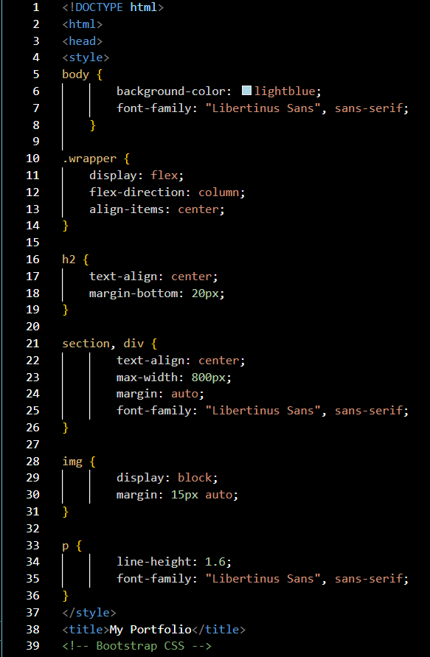

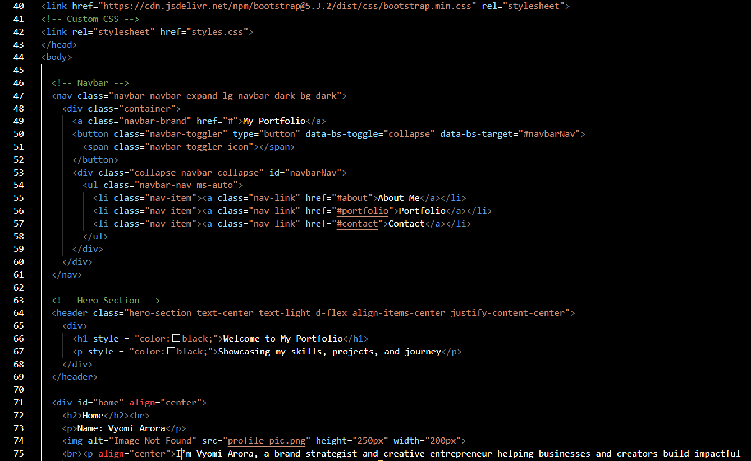 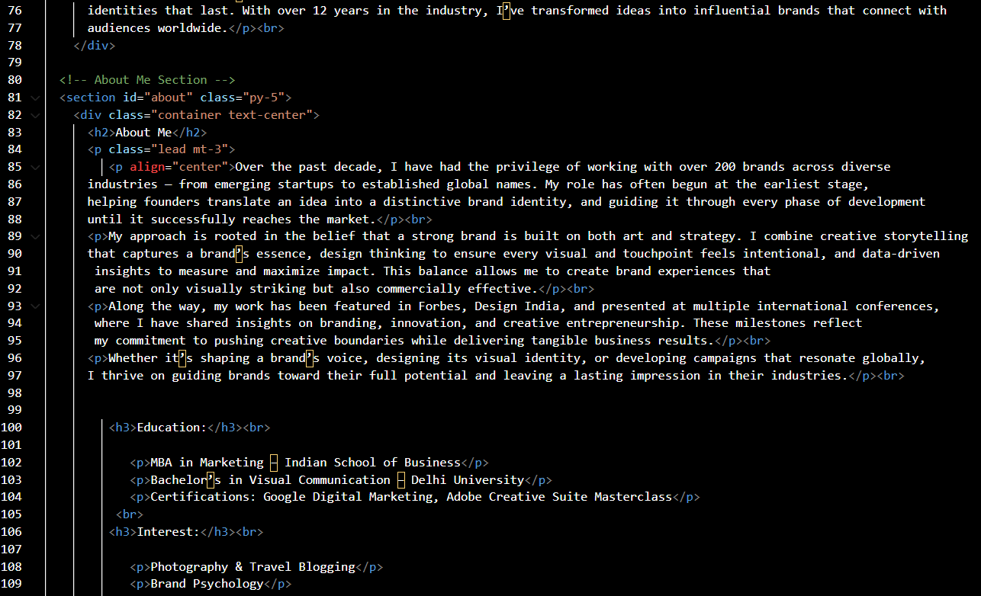 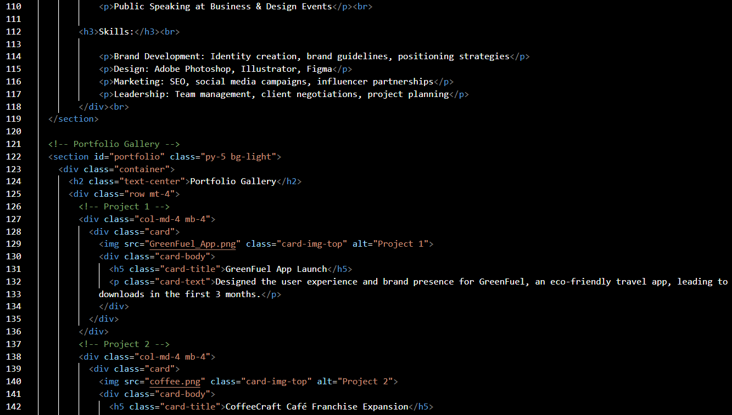 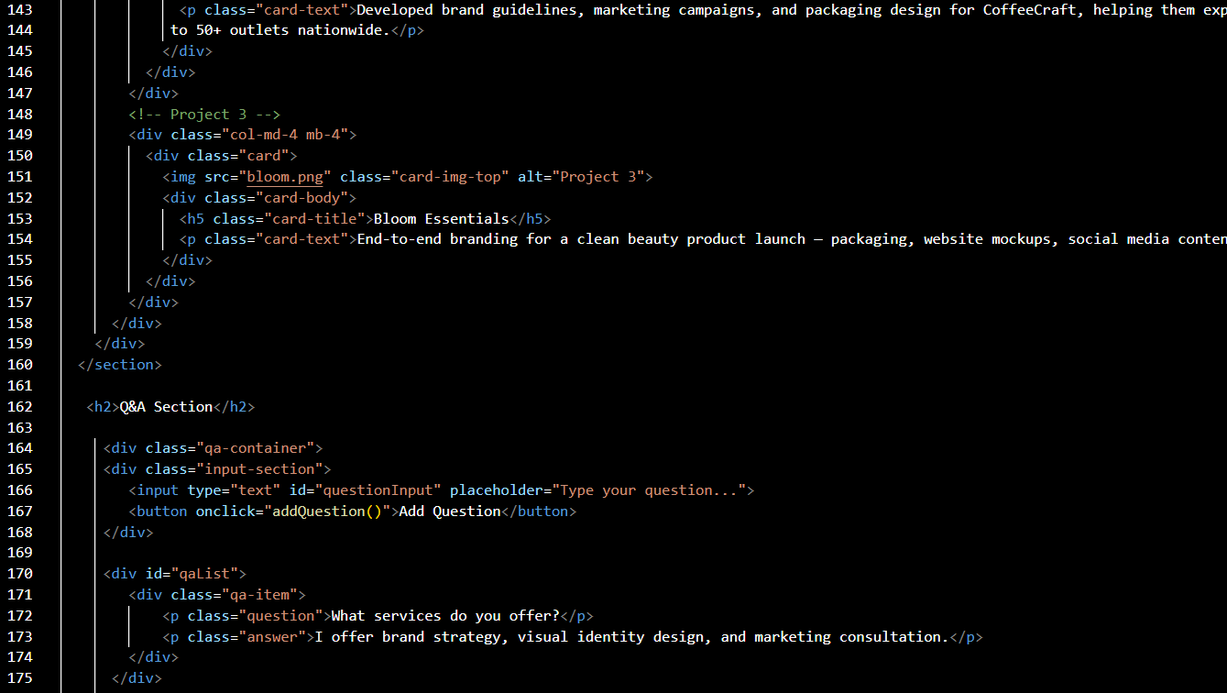 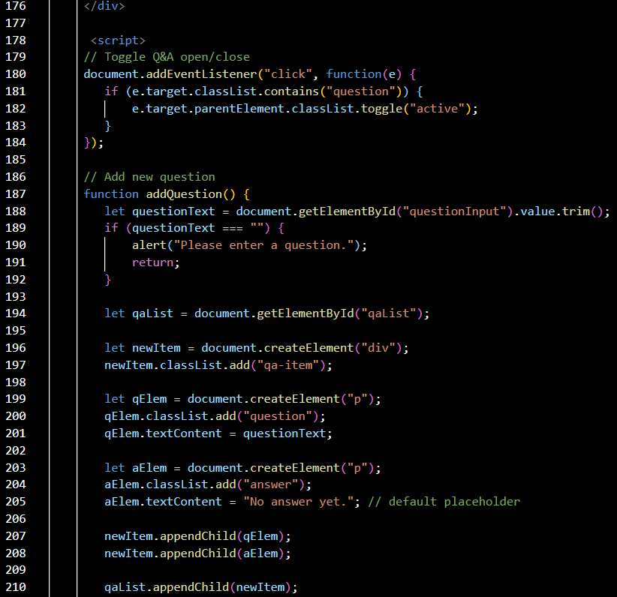 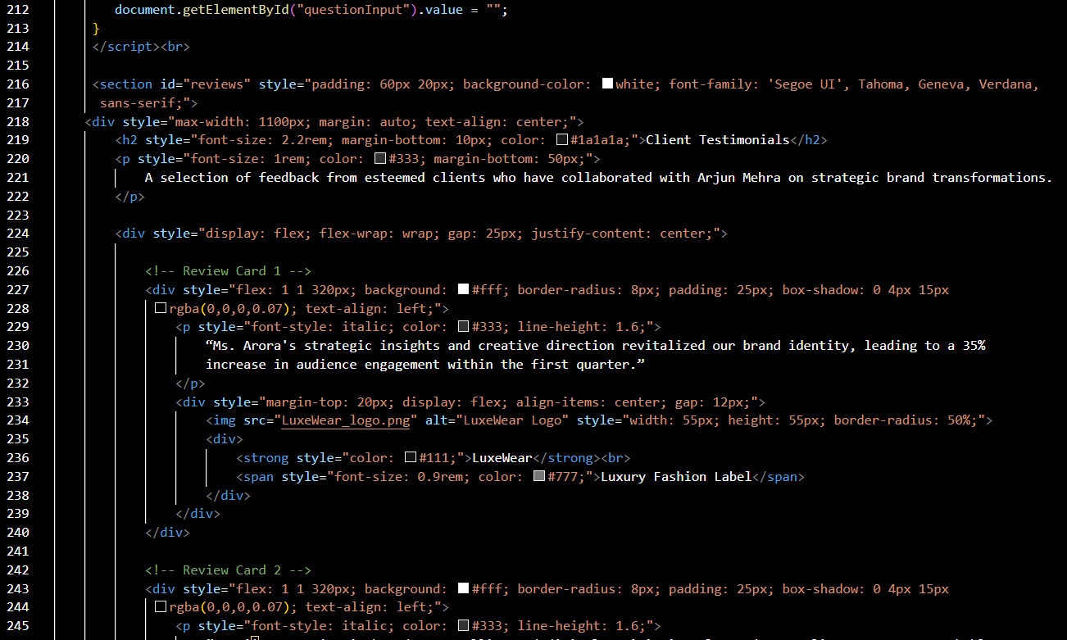 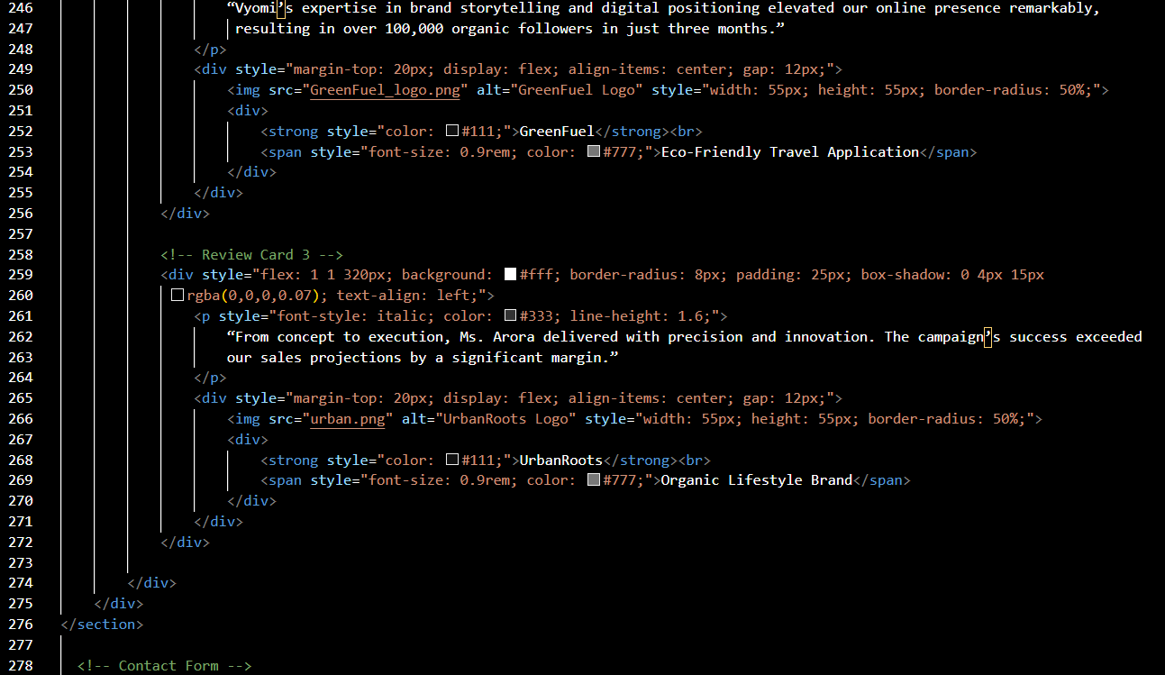 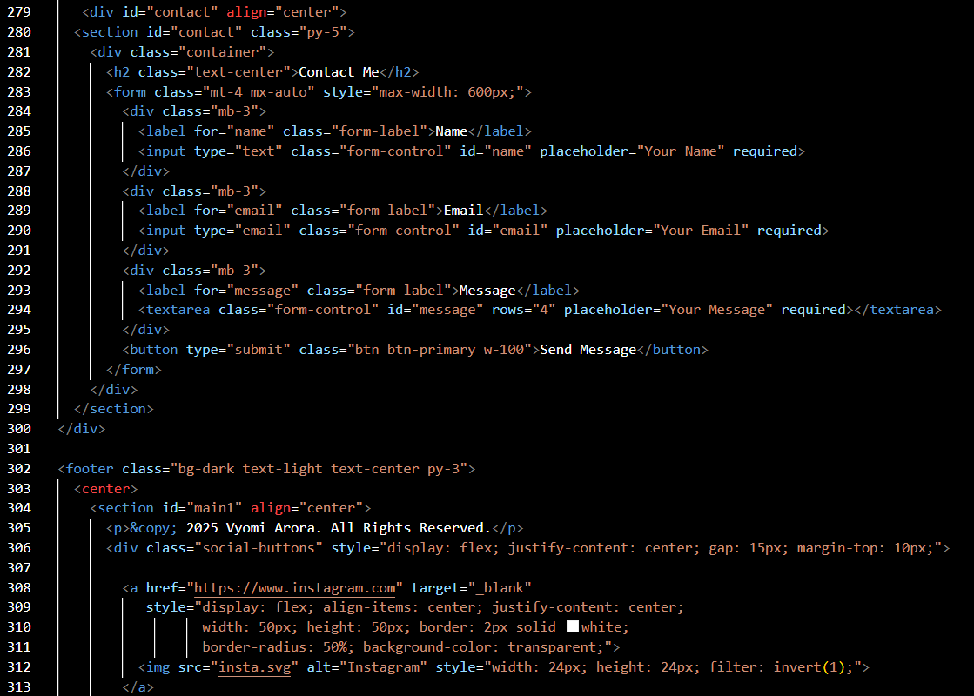 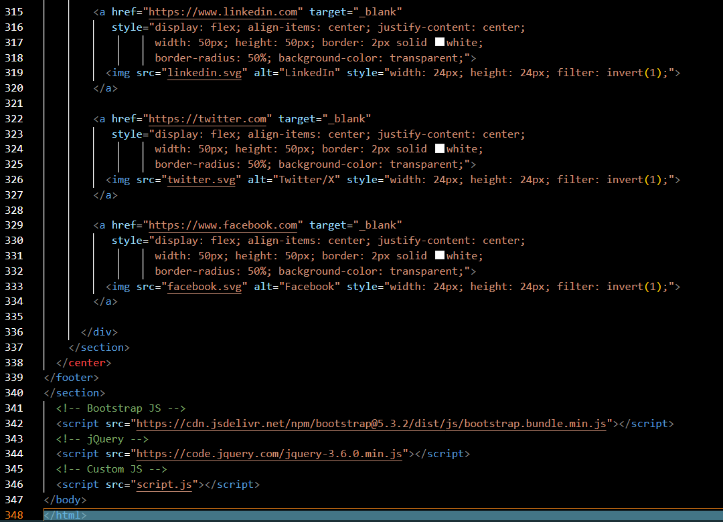

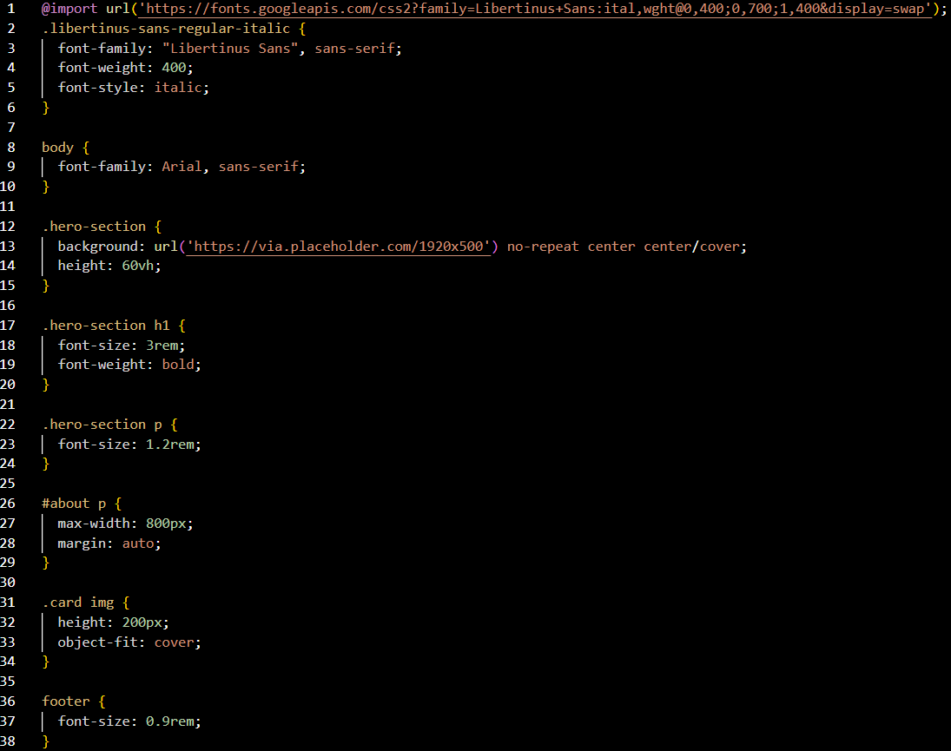 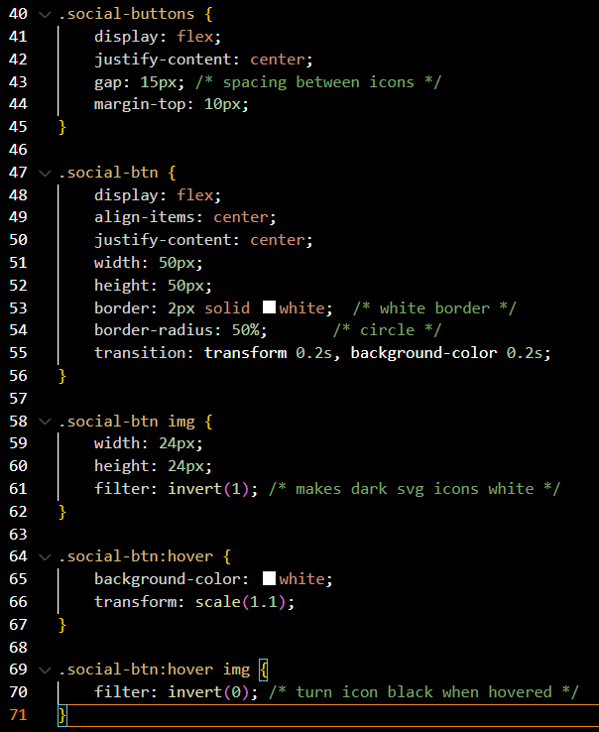

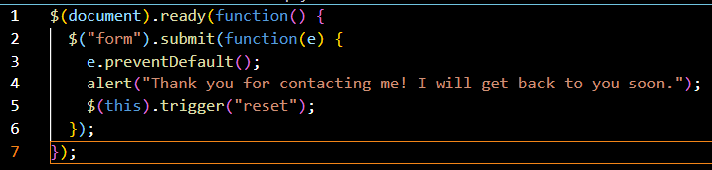

**Screenshots of final output**

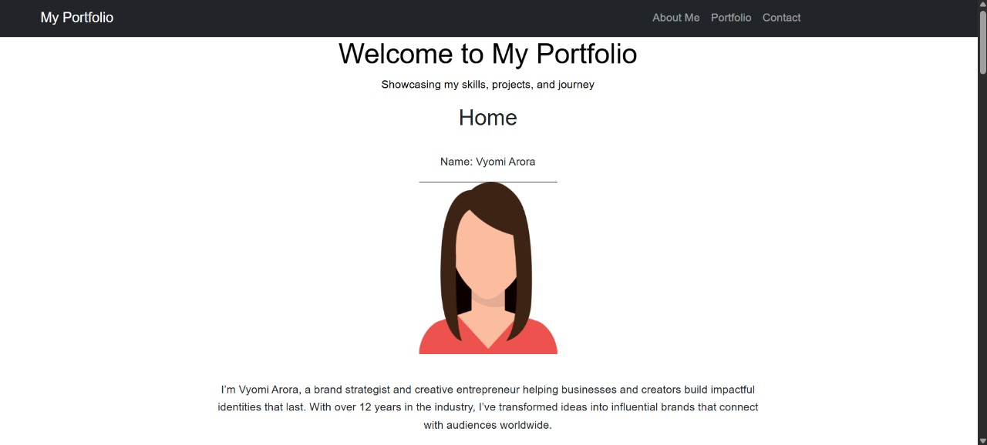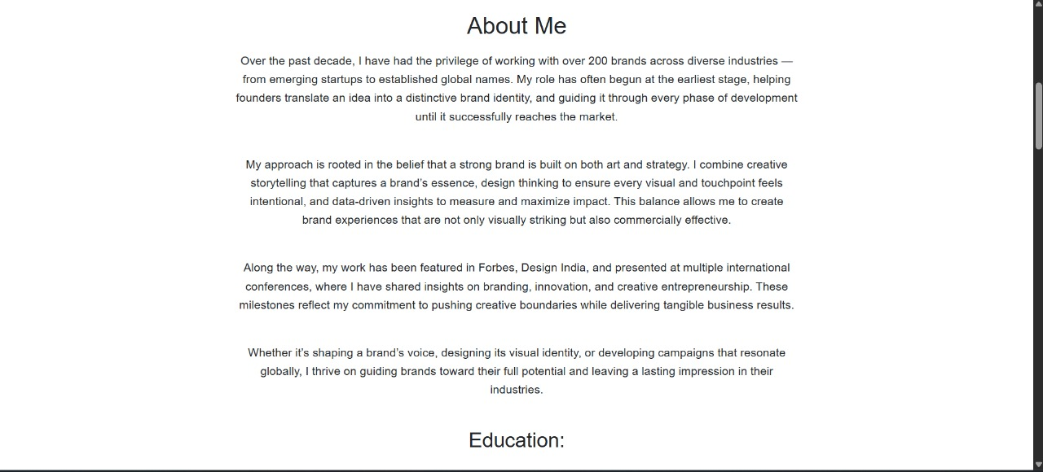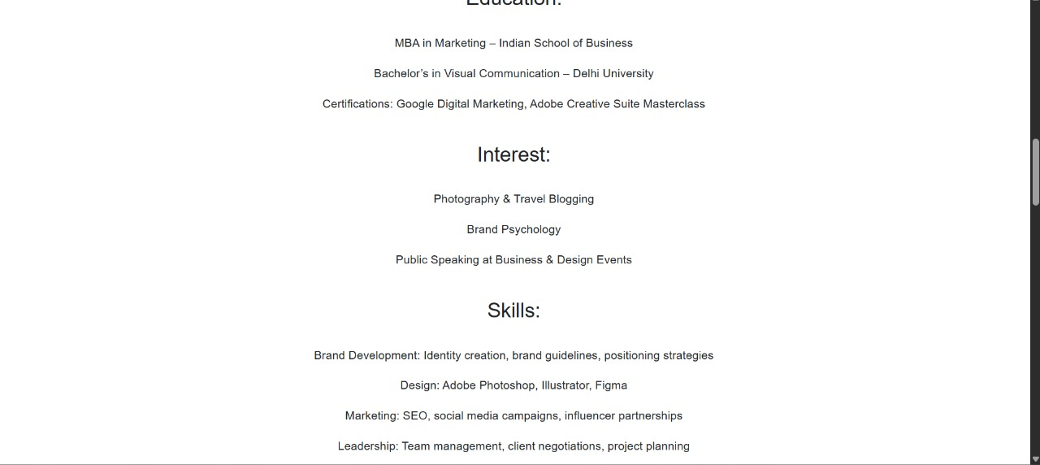

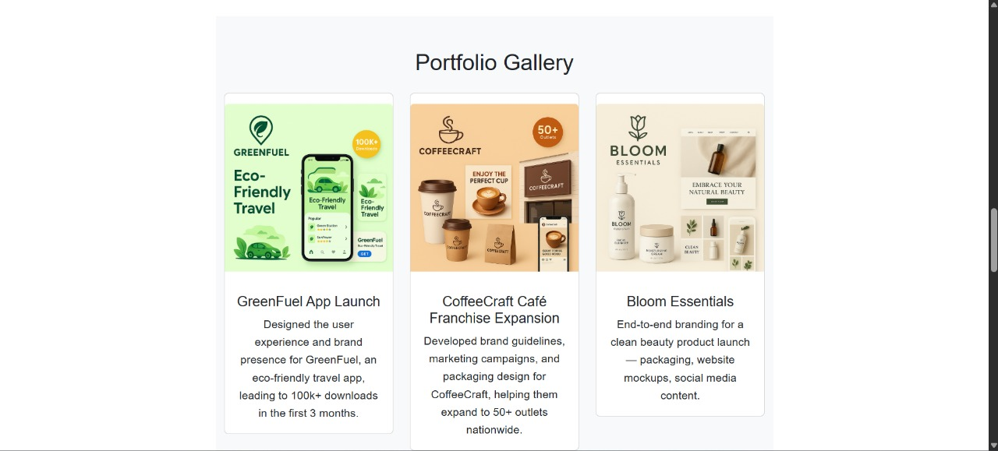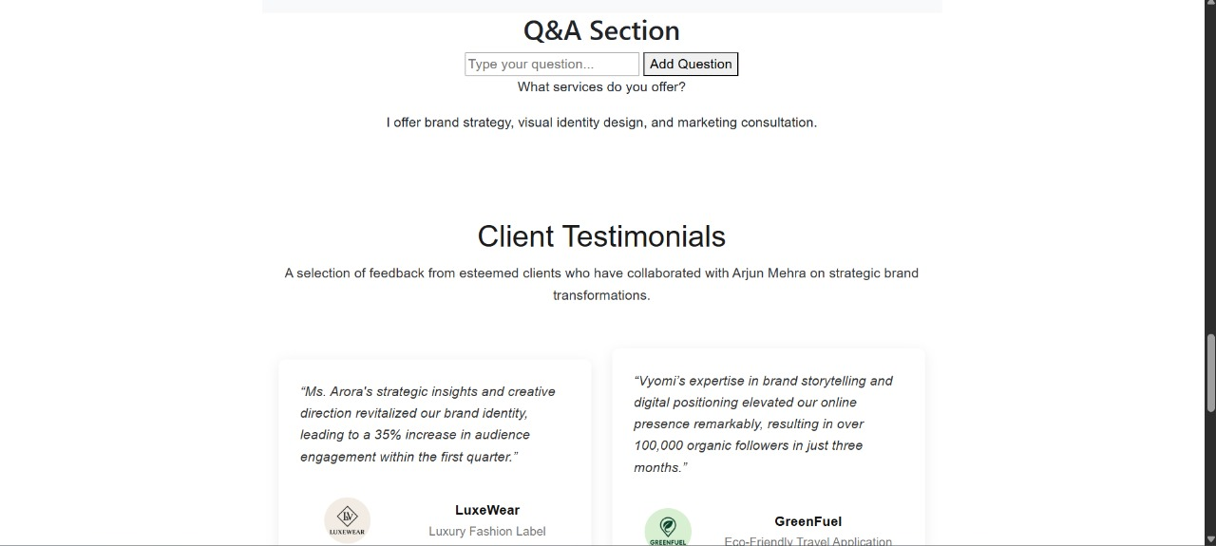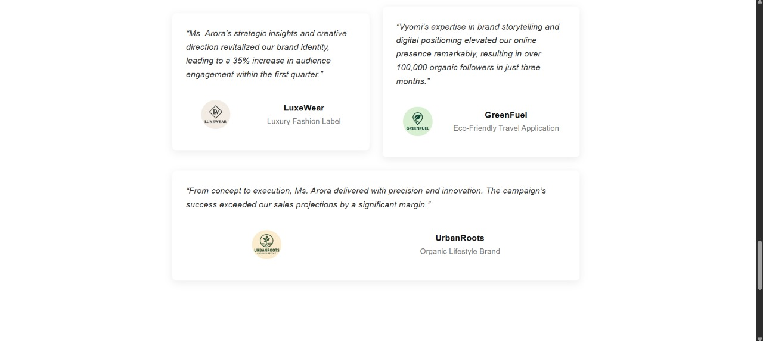

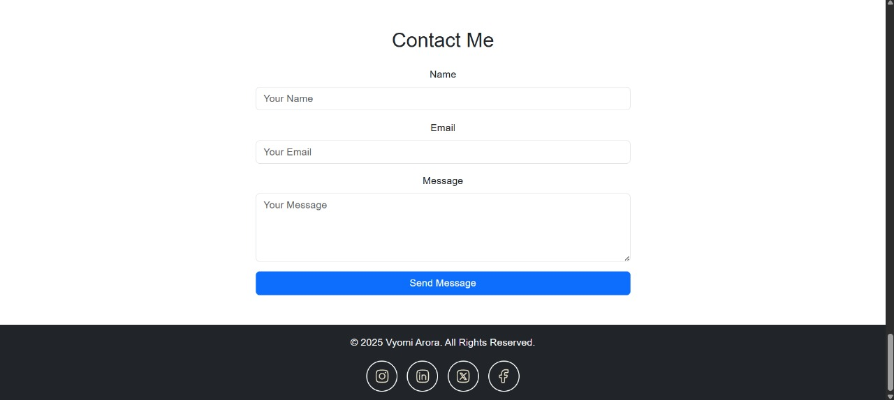

**Conclusion**

The development of this personal portfolio website demonstrates the seamless integration of HTML, CSS, JavaScript, jQuery, and Bootstrap to create a visually appealing, highly interactive, and well-structured digital platform. The HTML structure lays a clear and semantic foundation, organizing key sections such as the navigation bar, project showcases, skill highlights, and contact forms for easy accessibility and intuitive navigation. Semantic elements improve both accessibility and search engine optimization, ensuring that the content is meaningful and easily discoverable.

From a styling perspective, CSS is employed to establish a cohesive and professional aesthetic, while Bootstrap's prebuilt responsive classes allow the site to adapt effortlessly to various screen sizes, enhancing user experience across devices. JavaScript and jQuery introduce dynamic interactivity, from smooth scroll effects to animated project displays, engaging visitors and creating a more immersive browsing experience. The combination of hover effects, responsive grids, and well-chosen typography ensures both visual harmony and functional clarity.

Overall, this project illustrates how the thoughtful integration of modern web technologies—HTML, CSS, JavaScript, jQuery, and Bootstrap—can transform a personal portfolio into an engaging and polished showcase of skills and projects. Beyond the technical execution, the website reflects careful attention to design principles, responsiveness, and user engagement, serving not only as a functional platform but also as a professional representation of the developer’s capabilities.