**BRIEF INSIGHTS FROM THE DATA**

Registration vehicles data for New Zealand has been used for this analysis. For any details of the analysis please refer to the detailed section of the report.

**Findings**:

1. ~60% of new vehicle registration are passenger car/van.
2. As per the last 10 year trend, the highest number of new vehicle registration happens in a month of Q4 of a year, whereas the lowest is in the month of April.

Z Energy can utilise this insight to a) plan their marketing cycle; b) improve their demand forecast; c) plan their logistics of fuel distribution to different stations.

1. Petrol Hybrid demand for newly registered passenger vehicles is increasing compared to other categories according to the past 3 year’s trend. However, other sources of fuel (electric, petrol, diesel, LPG and Gas) are either stagnant or have started to decrease.
2. The number of new vehicle registration is increasing in Christchurch area, whereas it is decreasing in Dunedin and Tauranga areas. The new vehicle registration is stagnant in Auckland and Hamilton areas. There is approximately a 10.3% increase in registration count across two years in Christchurch.

Z Energy can utilise this insight to a) rationalise their geographic distribution of fuel stations - open new stations in Christchurch, if the existing stations cannot serve the increased demand; b) improve their demand forecast

1. Yamaha has the highest number of new vehicle sales in the passenger car/van segment for the last 5 years. Z Energy can utilise this insight to collaborate with Yamaha to create new marketing campaigns. For eg: Z Energy can offer membership or loyalty points to new Yamaha vehicle buyers.
2. Registration count with cc ratings greater than 3500 and vehicle mass more than 3500, has increased in Auckland and Christchurch, whereas decreased in Hamilton in 2019 when compared to previous year.

In general, with increase in CC rating, the petrol consumption by vehicle is more hence increasing the fuel demand.

**DETAILED EXPLANATION:**

**---------------------------------------------------------------------------------------------------------**

1. **Which Vehicle Type is Registered the Most?**

**---------------------------------------------------------------------------------------------------------**

Most of the registrations are for passenger car/van thus dividing further analysis to passenger cars and goods van/trucks.

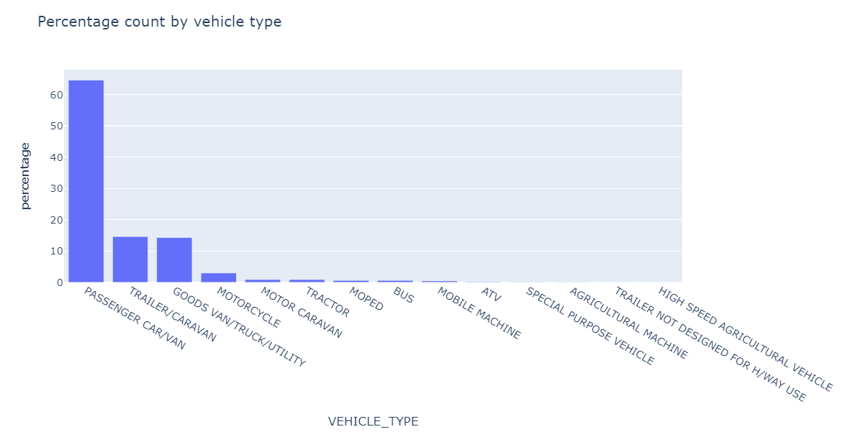

**Insight-** According to the data there are more passenger car/van compared to other vehicle types.

**-----------------------------------------------------------------------------------------------------**

1. **Which Month has Maximum Registration by Year**

**-----------------------------------------------------------------------------------------------------**

**Steps Followed:**

* Year of registration from **2015 till 2019**.
* For 2019 we have data till November 30.
* Finding the count of registrations of all vehicles based on year and month.

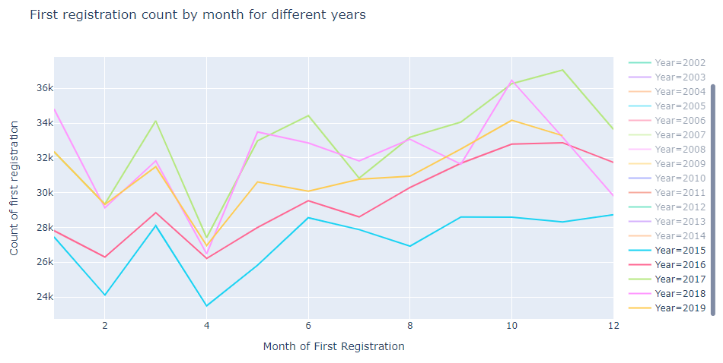

The below table gives a clear picture of the **month receiving maximum and minimum registration** from 2000 to 2019.

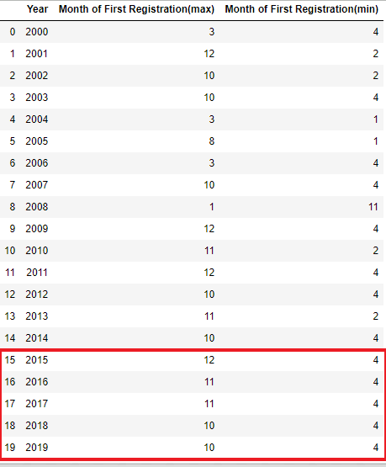

**Insight - End of the year receives more registration** whereas **April seems to get less registration**.

**-----------------------------------------------------------------------------------------------------**

1. **Which Fuel is mostly used in Passenger Cars/Van?**

**-----------------------------------------------------------------------------------------------------**

**Steps followed-**

* Year from 2000 till 2019
* Removed December- data for 2019 is till November
* Analysis is only for passenger car/van
* Count by motive power/type of power primarily used for the vehicle

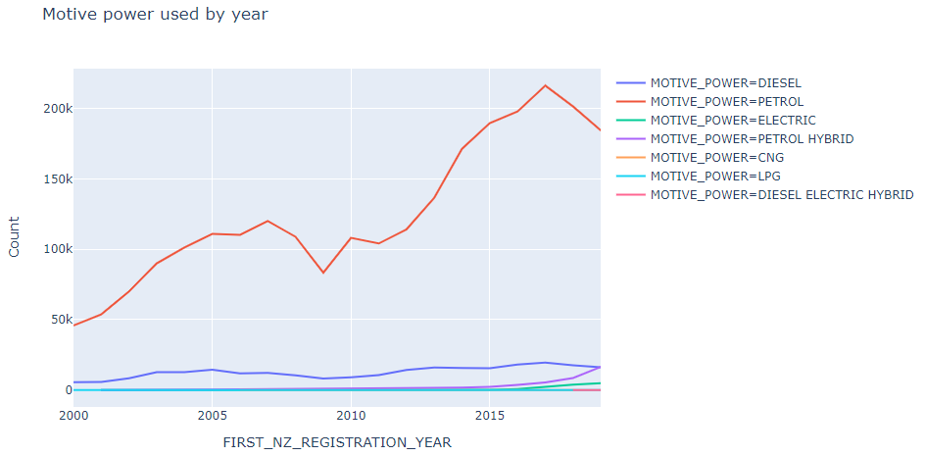

Checking how much registrations count shifted compared to previous year

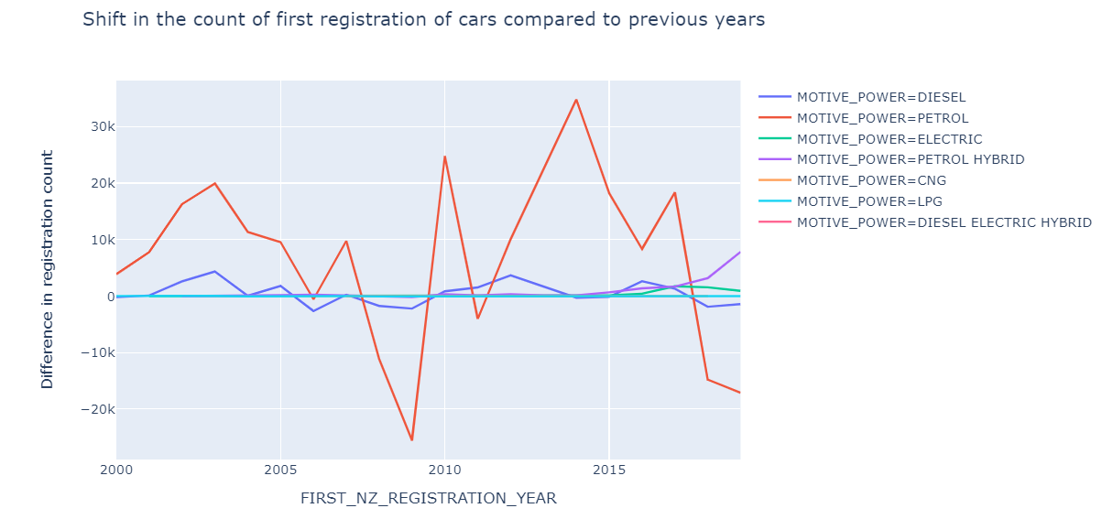

Above graphs filtered for motive power as electric-

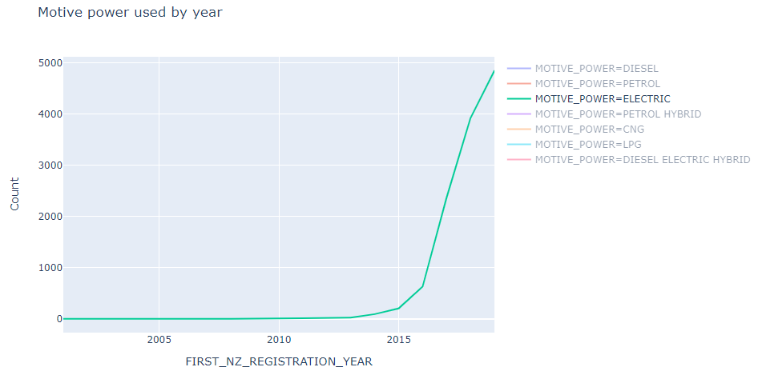

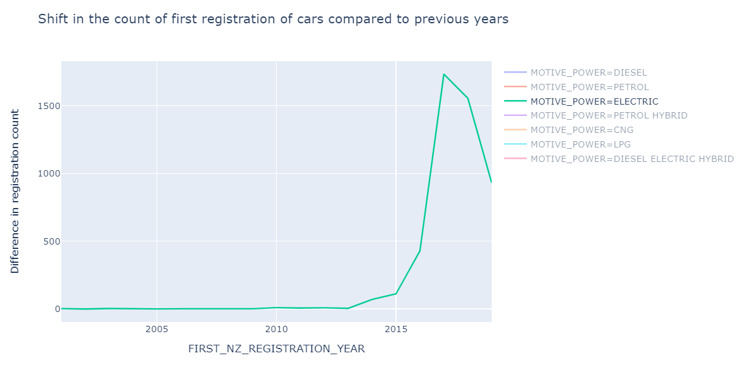

Graphs filtered for Petrol Hybrid. The below graph is the difference in the count of first registration when compared to the previous year.

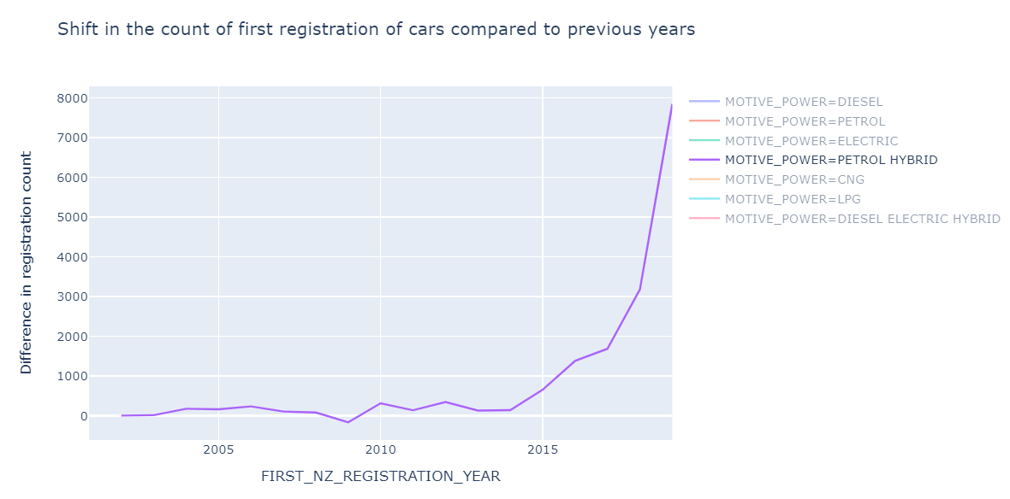

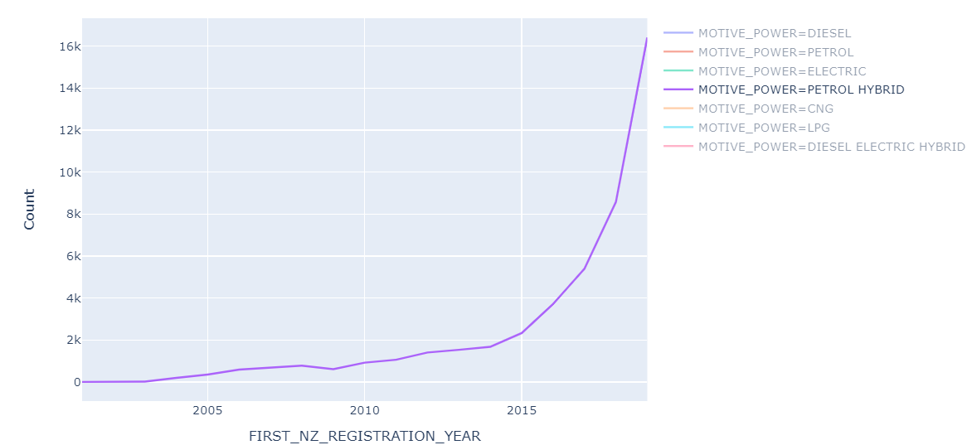

**Insight** - There is continuous increase in usage of petrol hybrid in passenger car/van compared to other motive powers.

**---------------------------------------------------------------------------------------------------------**

1. **Regional Analysis of the Registered Vehicle**

**---------------------------------------------------------------------------------------------------------**

**Steps Followed:**

* December Month is removed as for 2019, we have data till month of November
* Year of registration is from 2000 till 2019

The **Territorial Authority that the registered owner of the vehicle resides** in (one of 67 Districts, Cities, Territories or the Auckland Unitary Authority) is denoted by **TLA** and its count is shown below-

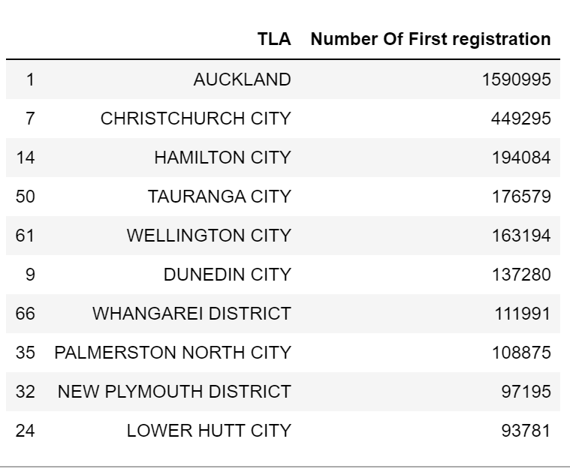

The above table shows **most of the owners** of the registered cars **reside in Auckland, Christchurch, Hamilton, Tauranga and Wellington.**

Selecting the **top 5 regions** and finding the count of registration by year for each region. For this analysis I have **removed the month of December** as the file does not have data for 2019, December->

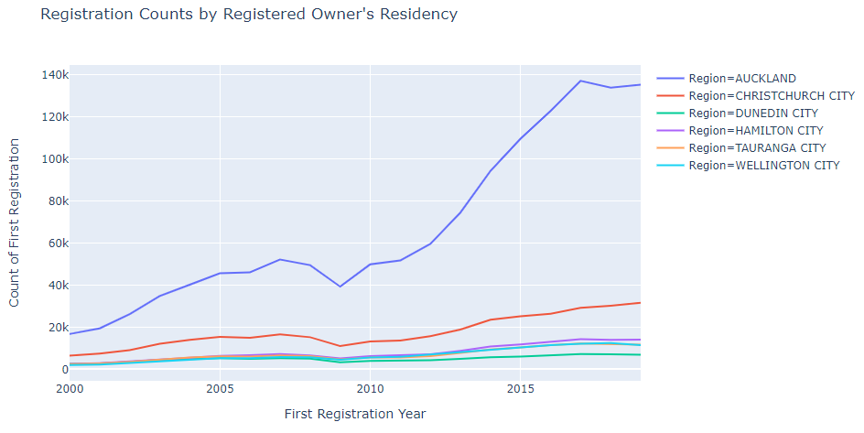

If we see particularly at **Christchurch city**, there is increase in the registration counts with the increase in year-

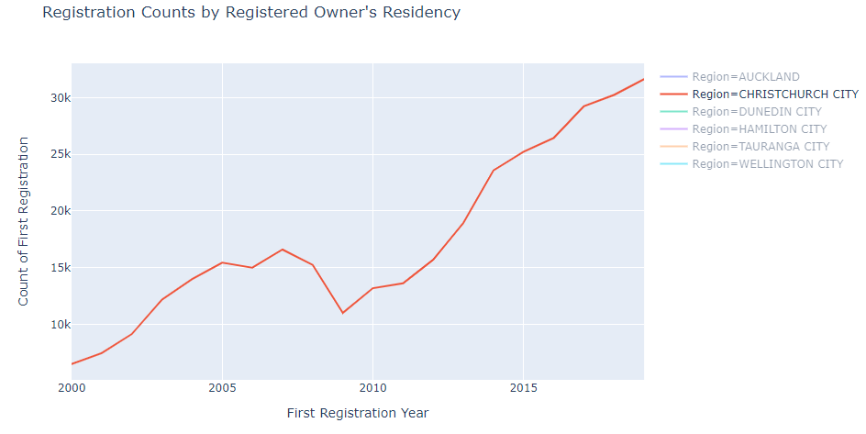

However, **registration counts have decreased** in the regions like Dunedin City, Tauranga City and Wellington City in 2019 compared to 2018-

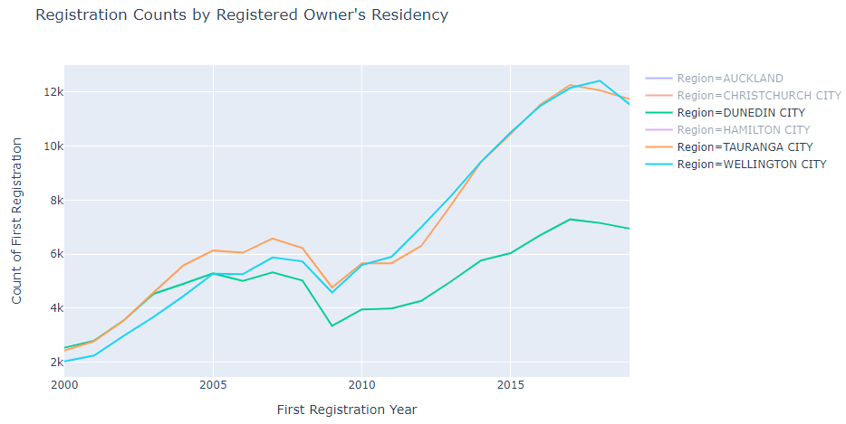

There is **not much change in the registration count** of the Auckland and Hamilton City in year 2019 compared to previous 2018

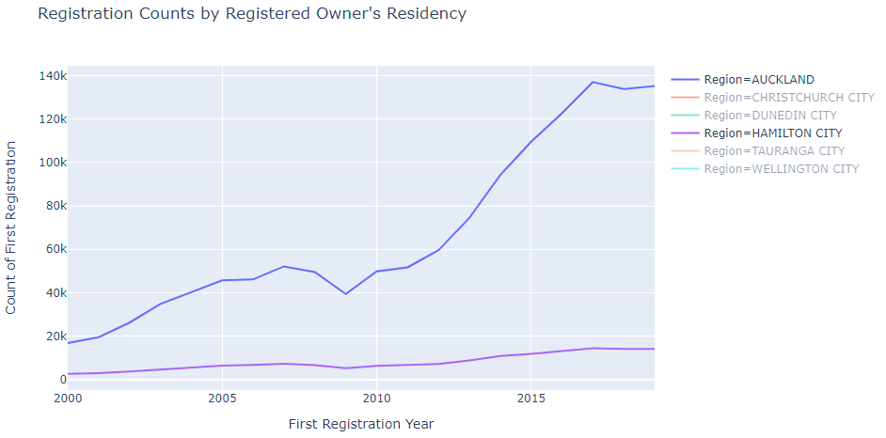

**Insight** - In Auckland and Hamilton new vehicle registration is stagnating whereas in Dunedin, Tauranga and Wellington, the market for new vehicle registration has already started decreasing.

Registration counts in Christchurch city is increasing thus Z energy can focus more in terms of logistics, in this region. This insight can be explored further.

**---------------------------------------------------------------------------------------------------------**

1. **Manufacturer of the Registered Vehicle by Year**

**---------------------------------------------------------------------------------------------------------**

**Steps followed:**

* Year of first registration from 2000 to 2019
* Vehicle Type as only Passenger car or Van

The column Manufacturer(max) gives us information about the manufacturer of **most of the passenger car/van registered**. The manufacturer of the maximum vehicle from 2014 till 2019 is **YAMAHA**.

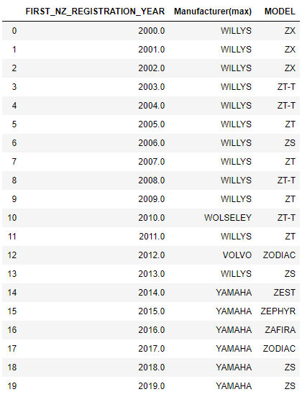

Using this information, we can target the customers based on their car’s manufacturing company or model of the car.

**---------------------------------------------------------------------------------------------------------**

1. **Analysis of Vehicles with CC Rating > 3500 by Region**

**---------------------------------------------------------------------------------------------------------**

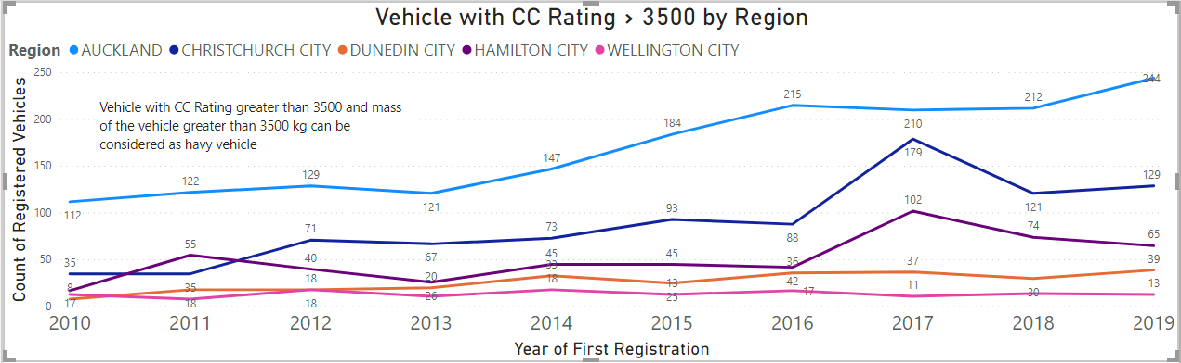

There is an increase in the registration count in 2019 in comparison to previous year for Auckland and Christchurch, whereas in Hamilton there is a decrease in registration count.

More the CC rating or the mass of the vehicle, more fuel is burnt by the vehicle. Thus Z Energy can also focus on the regions where heavy vehicles are used.