**BUG REPORTS**

## DEFECT_01: Zip Code Validation Missing - Allows Alphabetic Characters in Zip Code Field on User Registration page

### Title:

* + - Zip code Field Accepts Alphabets Instead of Only Numeric Values on user registration page

### Steps to Reproduce:

* + - Navigate to the [User Registration page](https://www.automationexercise.com/).
    - Enter valid details in all required fields except the "Zip Code" field.
    - In the "Zip Code" field, enter a combination of alphabetic characters (e.g., "abc123").
    - Complete the registration process by submitting the form.

### Expected Result:

* + - The system should validate the "Zip Code" field to ensure only numeric values are allowed, displaying an error message if alphabetic characters are entered.

### Actual Result:

* + - The user is able to successfully register even when alphabetic characters are entered in the "Zip Code" field, bypassing validation.

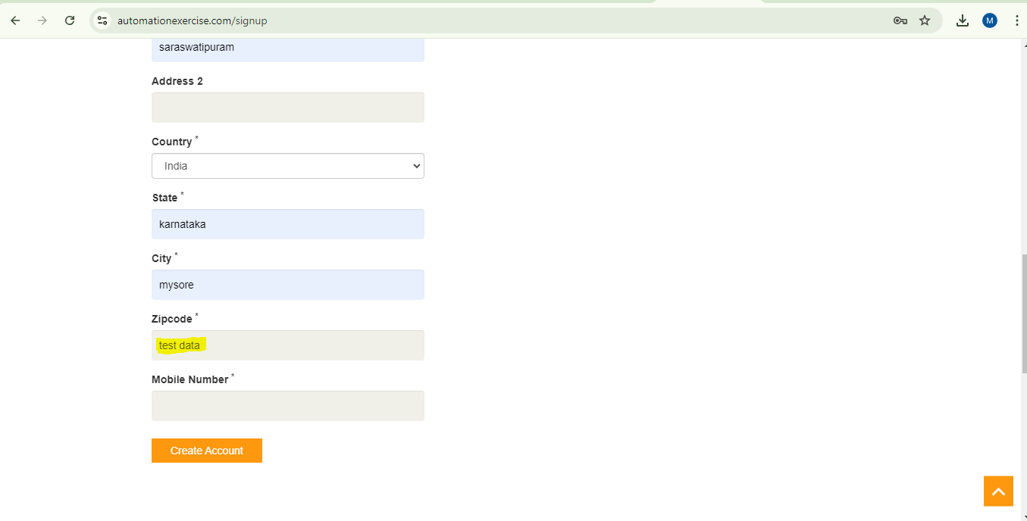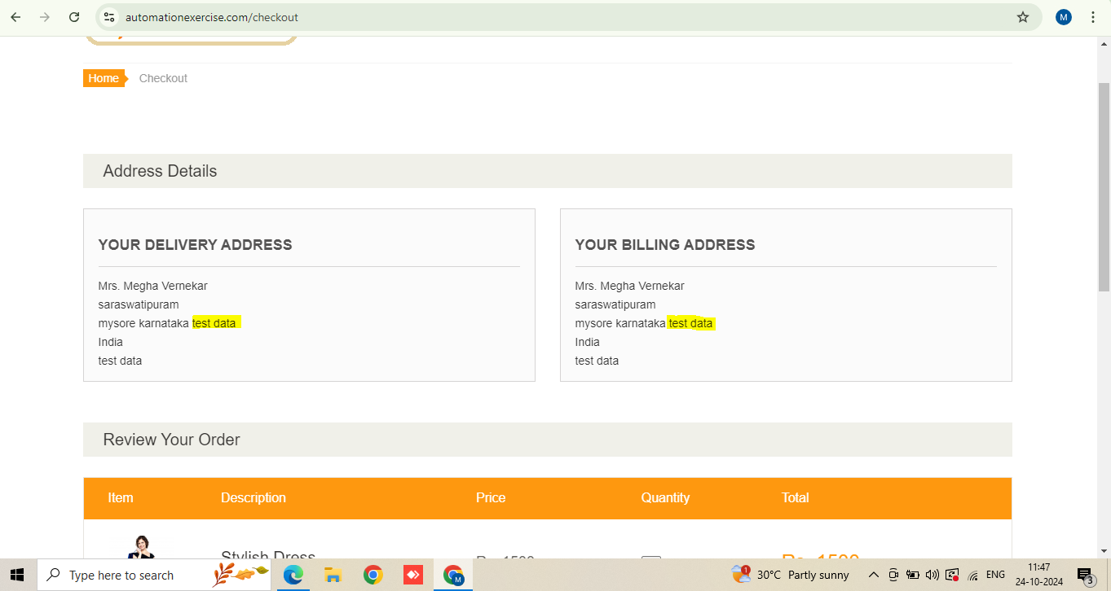

### Severity: Medium

### Priority: High

## DEFECT_02: Mobile Number Validation Missing on User Registration Page

### Title:

* + - Mobile Number Field Accepts Alphabets Instead of Only Numeric Values

### Steps to Reproduce:

* + - Navigate to the User Registration page on the application at [Automation Exercise](https://www.automationexercise.com/).
    - Fill in the required fields (Name, Email, etc.).
    - In the "Mobile Number" field, enter a string that includes alphabets (e.g., "abc123").
    - Complete the registration process by clicking on the "Register" or equivalent submit button.

### Expected Result:

* + - The system should validate the "Mobile Number" field to accept only numeric characters. If the user enters anything other than numbers, an error message should be displayed, prompting the user to enter a valid phone number.

### Actual Result:

* + - The system allows the user to input alphabetic characters in the "Mobile Number" field and successfully completes the registration process without any validation error.

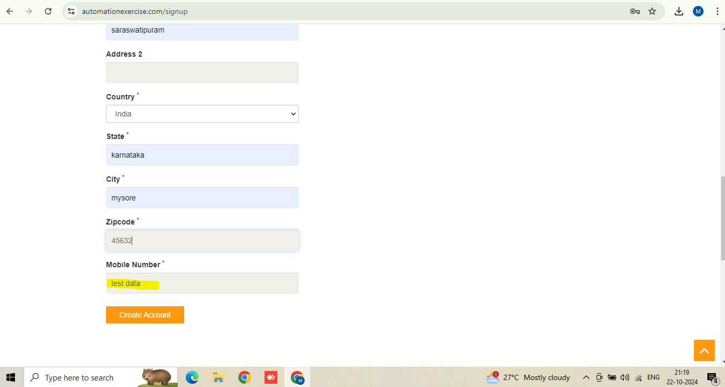

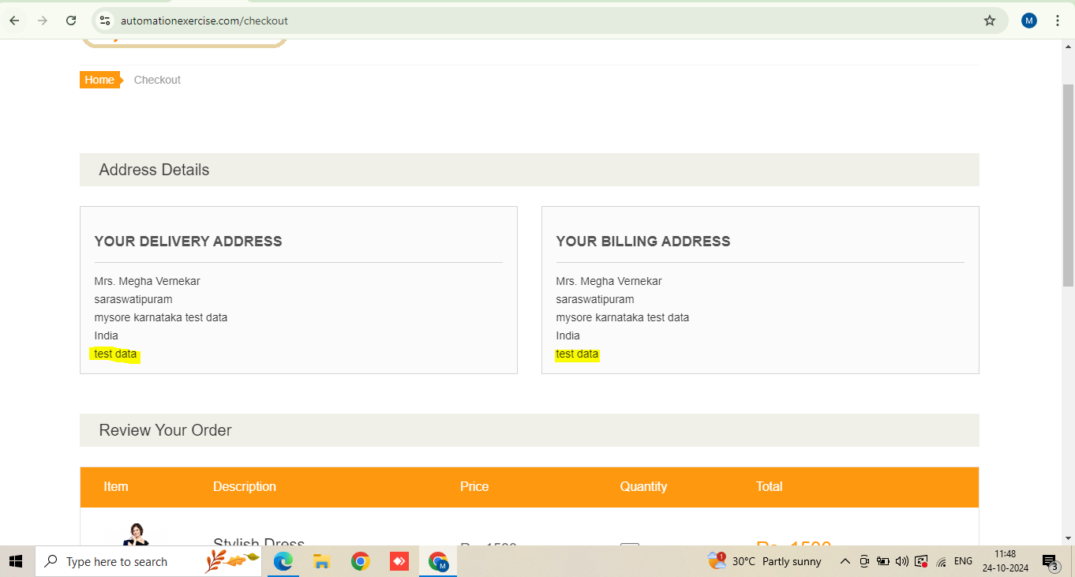

### Severity: Medium

### Priority: High

## DEFECT_03: Invalid State and City Selection for Country on User Registration

### Title:

* + - State and City Fields Accept Values that Do Not Belong to the Selected Country

### Steps to Reproduce:

* + - Navigate to the User Registration page on the application at [Automation Exercise](https://www.automationexercise.com/).
    - Fill in the required fields (Name, Email, etc.).
    - Select any country from the "Country" dropdown list (e.g.,India).
    - In the "State" field, enter a value that does not belong to the selected country (e.g., "Bavaria").
    - In the "City" field, enter a value that also does not belong to the selected country (e.g., "Munich").
    - Complete the registration process by clicking on the "Register" or equivalent submit button.

### Expected Result:

* + - The system should validate that the state and city match the selected country. If the user enters a state or city that does not belong to the selected country, an error message should be displayed, prompting the user to input valid information.

### Actual Result:

* + The system allows the user to input any state or city, regardless of whether it matches the selected country, and successfully completes the registration process without any validation error.

### Severity: Medium

### Priority: Medium

## DEFECT_04: Missing Text Area Length Validation on User Registration Page

### Title:

* + - Text Area Field Allows Excessively Long Inputs Without Validation

### Steps to Reproduce:

* + - Navigate to the User Registration page on the application at [Automation Exercise](https://www.automationexercise.com/).
    - Locate any text area field.
    - Enter an excessively long string of characters (e.g., 10,000 characters or more).
    - Complete the registration process by clicking on the "Register" or equivalent submit button.

### Expected Result:

* + - The system should limit the length of input for the text area field (e.g., a maximum of 255 or 500 characters). If the user exceeds this limit, an error message should be displayed, asking the user to shorten the input.

### Actual Result:

* + - The system allows the user to input an excessively long string of characters into the text area field without any validation or error, and the registration process is completed successfully.

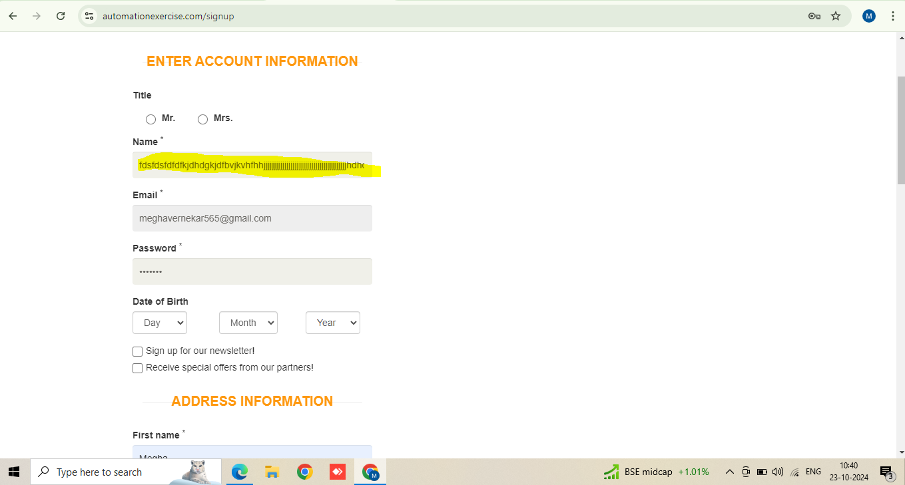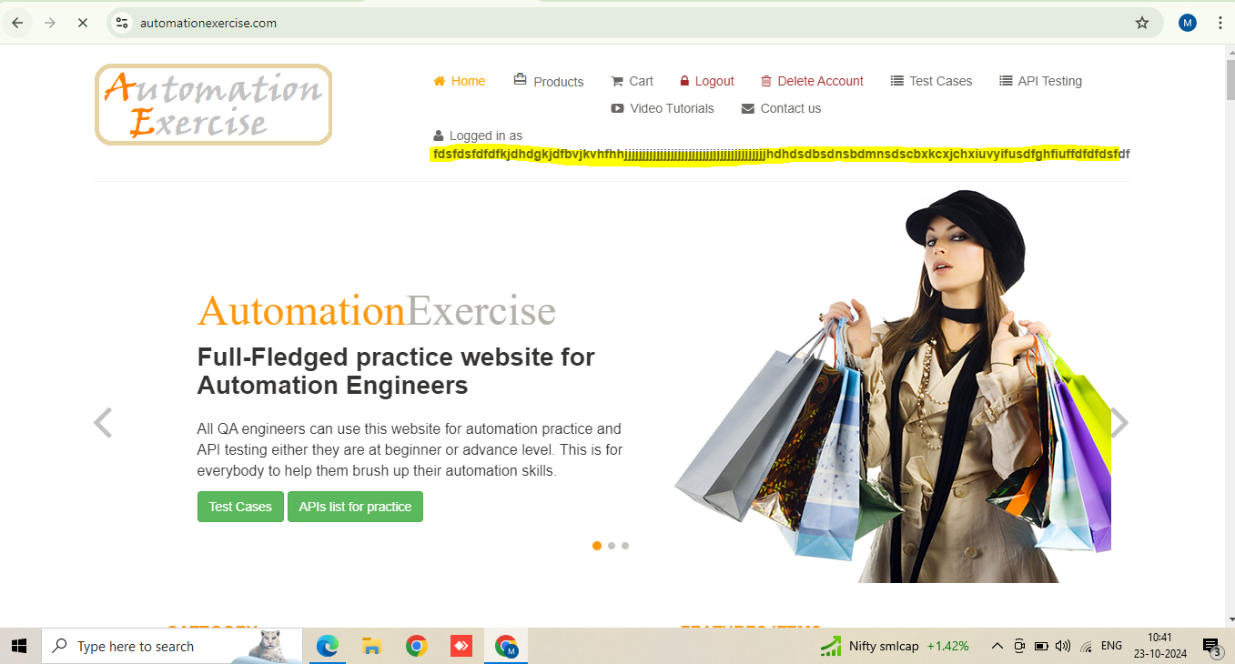

### Severity: Low

### Priority: Low

## DEFECT_05: Missing Email Format Validation in User Registration, Login, Subscription, and Contact Form

### Title:

* + - Email Format Validation Missing in User Registration, Login, Subscription, and Contact Forms

### Steps to Reproduce:

* + - **User Registration Page:**
      * Navigate to the User Registration page on the application at [Automation Exercise](https://www.automationexercise.com/).
      * Enter an invalid email address format in the "Email" field (e.g., "user@domain" or "user@domain,com").
      * Fill in the remaining fields and submit the form.
    - **Login Page:**
      * Navigate to the Login page.
      * Enter an invalid email format (e.g., "example.com") in the "Email" field and attempt to log in.
    - **Subscription Section:**
      * Navigate to homepage and scroll down for subscription.
      * Enter an invalid email format in the "Subscribe" field (e.g., "email@.com").
      * Attempt to submit the subscription form.
    - **Contact Form:**
      * Navigate to the Contact Us page.
      * In the email field, enter an invalid email format (e.g., "test@com" or "user@domaincom").
      * Fill in the other fields and attempt to submit the form.

### Expected Result:

* + - The system should validate the "Email" fields across all forms to accept only valid email formats (e.g., "sbc@domain.com). If an invalid email format is entered, an error message should be displayed, prompting the user to enter a valid email address.

### Actual Result:

* + - The system accepts invalid email formats without any validation error in the User Registration, Login, Subscription, and Contact forms, allowing the submission of the forms with incorrect email addresses.
    - User Regirstration page

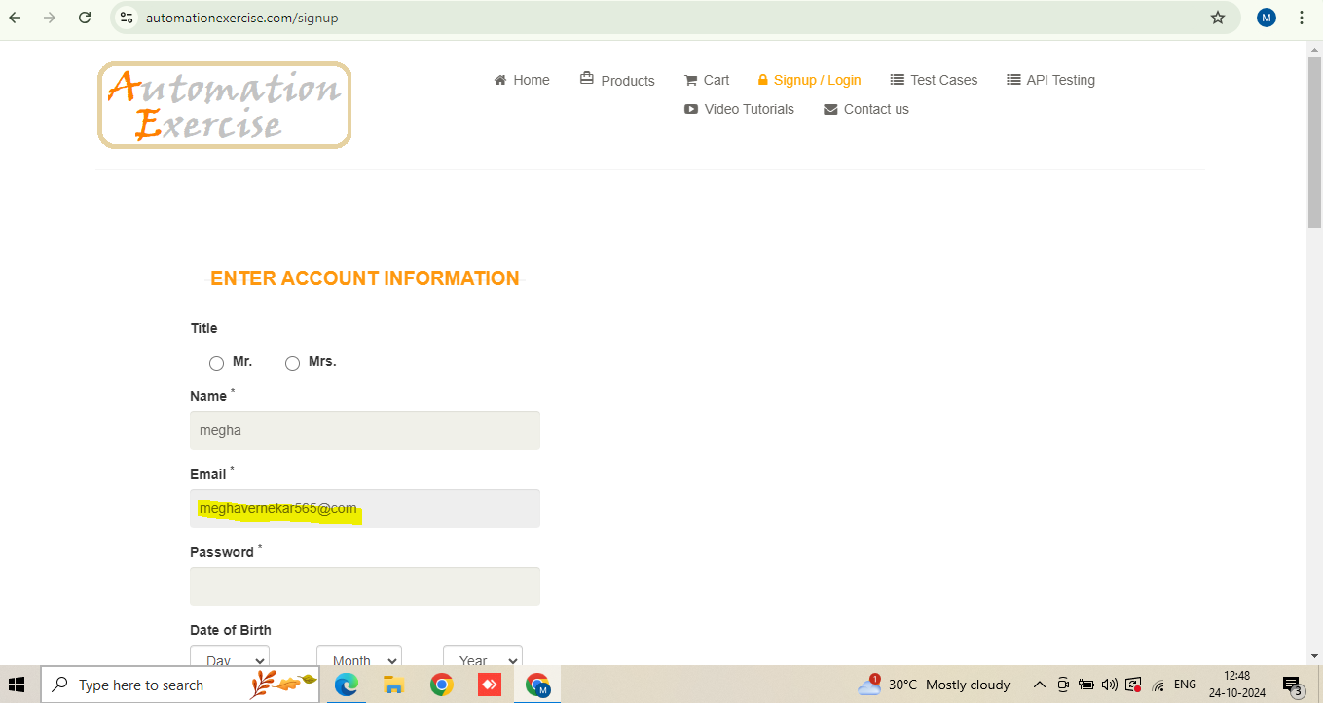Login Page

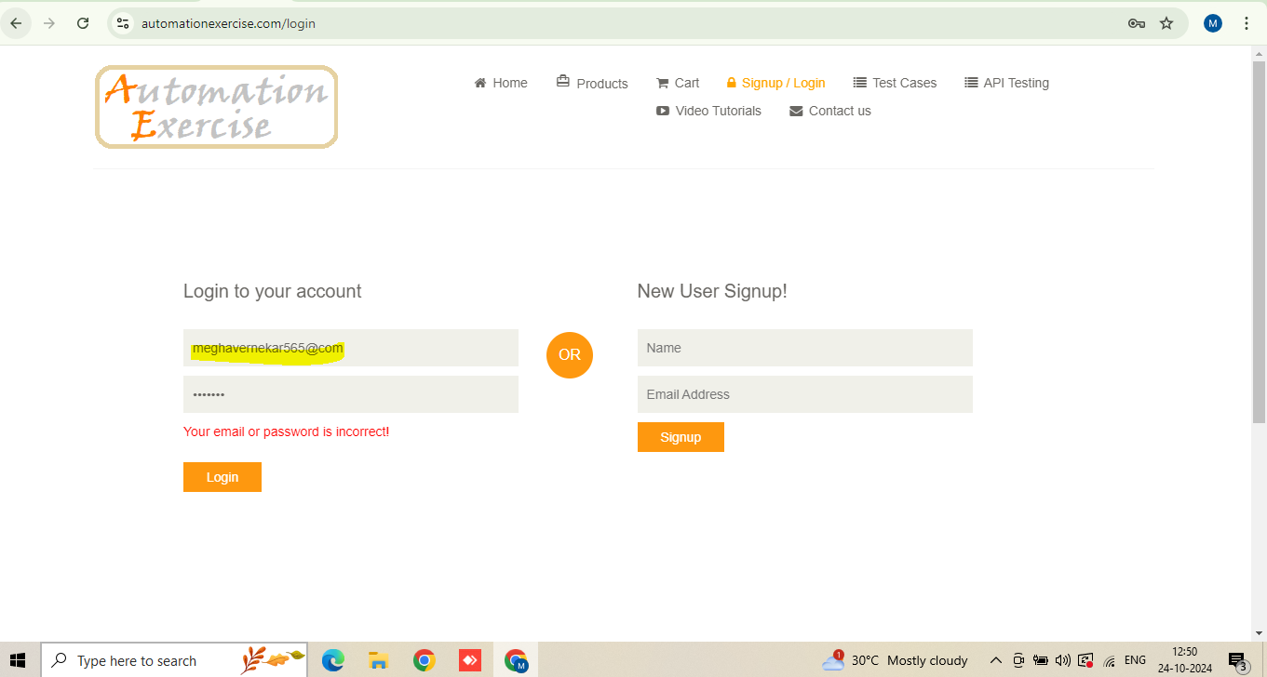

* + Subscription Page

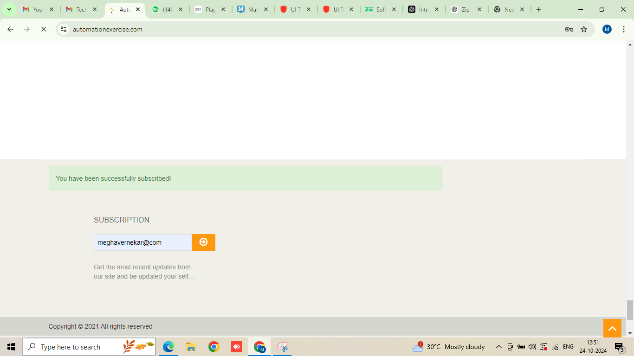

* + Contact form

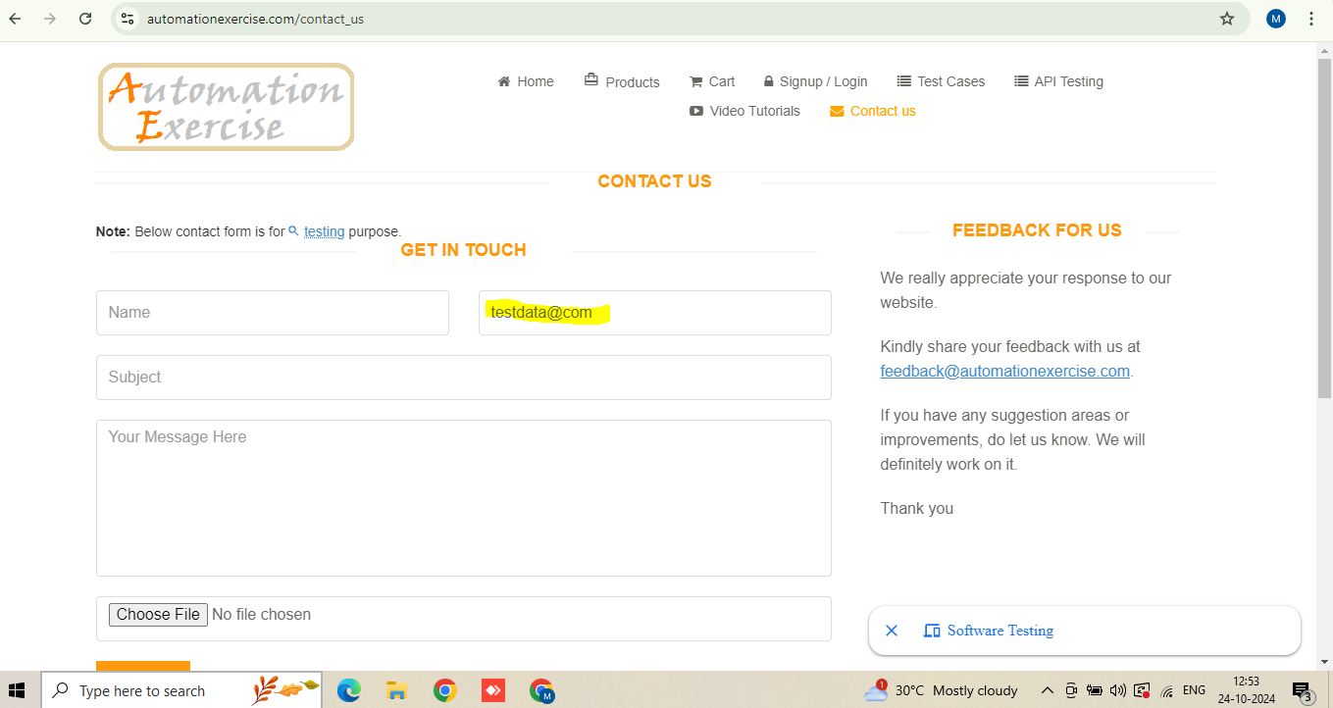

### Severity: Medium

### Priority: Medium

## DEFECT_06: Special Characters Allowed in Name Field on User Registration Page

### Title:

* + - User Registration Allows Special Characters in the Name Field

### Steps to Reproduce:

* + - Navigate to the User Registration page on the application at [Automation Exercise](https://www.automationexercise.com/).
    - In the "Name" field, enter a string that includes special characters (e.g., "John@Doe!", "Alice#123").
    - Fill in the remaining required fields and submit the registration form by clicking the "Register" or equivalent submit button.

### Expected Result:

* + - The system should validate the "Name" field to accept alphabetic characters and spaces. If the user enters any special characters, an error message should be displayed, prompting the user to enter a valid name.

### Actual Result:

* + - The system allows the user to register with a name that contains special characters, and the registration is completed without any validation error.

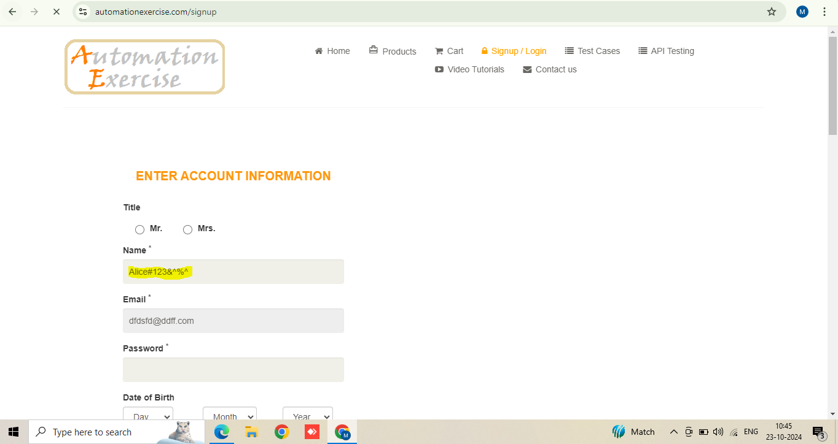

### Severity: Medium

### Priority: Medium

## DEFECT_07: Missing Card Details Validation in Payment Process

### Title:

* + - Card Number, CVC, and Expiration Fields Accept Alphabetic Characters in Payment Process

### Steps to Reproduce:

* + - Navigate to the checkout or payment page on the application at [Automation Exercise](https://www.automationexercise.com/).
    - In the "Card Number" field, enter a string that includes alphabetic characters (e.g., "abcd1234").
    - In the "CVC" field, enter a string that includes alphabetic characters (e.g., "xyz").
    - In the "Expiration Date" field, enter a string that includes alphabetic characters (e.g., "Jan2024").
    - Submit the form to complete the payment process.

### Expected Result:

* + - The system should validate the "Card Number," "CVC," and "Expiration Date" fields to ensure only numeric input is allowed. The following should be the validation rules:
    - **Card Number**: Accept only numeric characters (typically 16 digits).
    - **CVC**: Accept only numeric characters (typically 3 or 4 digits).
    - **Expiration Date**: Accept only valid date formats (e.g., MM/YY or MM/YYYY).
    - If the user enters alphabetic characters or an invalid format, an error message should be displayed, preventing form submission until valid input is provided.

### Actual Result:

* + - The system allows the user to enter alphabetic characters in the "Card Number," "CVC," and "Expiration Date" fields and successfully processes the payment without validation errors.

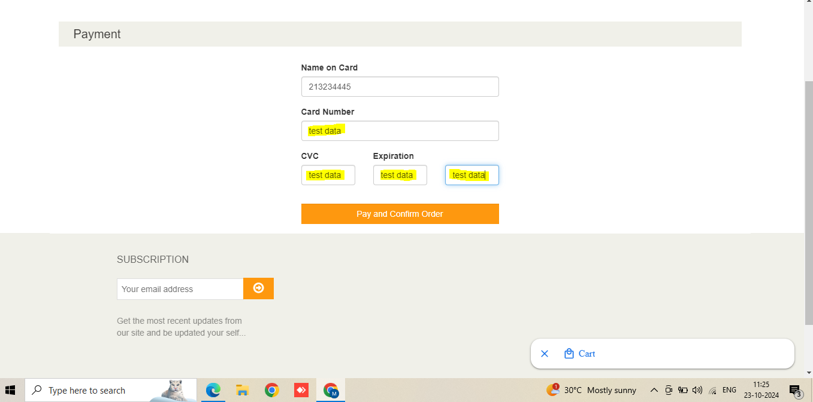

### Severity: High

### Priority: High

## DEFECT_08: Missing Validation for Cardholder Name in Payment Process

### Title:

* + - Cardholder Name Field Allows Numeric Input in Payment Process

### Steps to Reproduce:

* + - Navigate to the checkout or payment page on the application at [Automation Exercise](https://www.automationexercise.com/).
    - In the "Cardholder Name" field, enter a string that includes numeric characters
    - Fill in the remaining required card details (e.g., Card Number, CVC, Expiration Date).
    - Submit the form to complete the payment process.

### Expected Result:

* + - The system should validate the "Cardholder Name" field to only accept alphabetic characters and spaces. If the user enters any numeric characters, an error message should be displayed, prompting the user to provide a valid cardholder name without numbers.

### Actual Result:

* + - The system allows the user to enter numeric characters in the "Cardholder Name" field and successfully processes the payment without any validation errors.

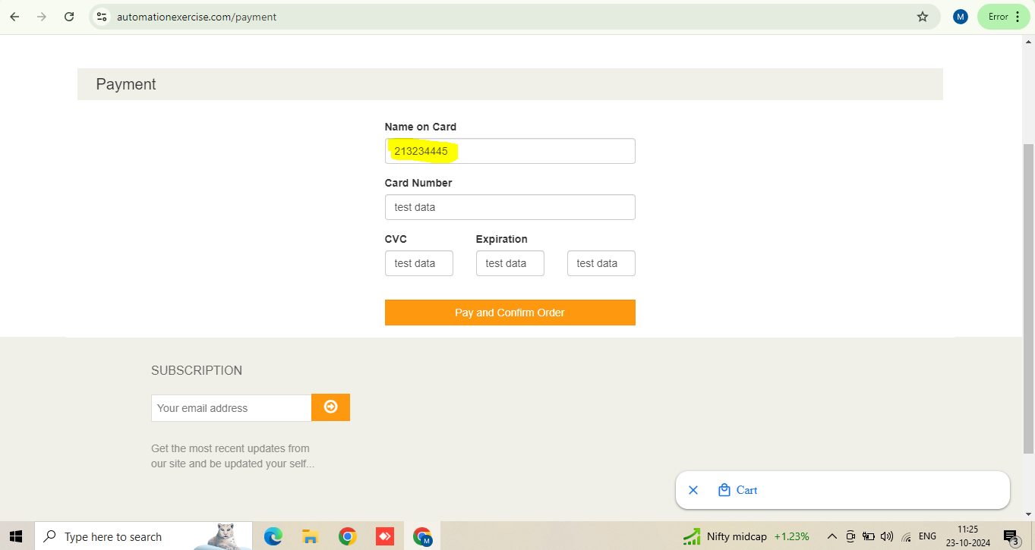

### Severity: Medium

### Priority: Medium

## DEFECT_09: Unable to Modify Product Quantity in Shopping Cart

### Title:

* + - User Cannot Decrease or Increase the Quantity of Products in the Cart

### Steps to Reproduce:

* + - Navigate to the shopping cart page on the application at [Automation Exercise](https://www.automationexercise.com/).
    - Add one or more products to the cart.
    - Try to modify the product quantity by either increasing or decreasing the quantity using the available controls (e.g., "+" or "-" buttons or by manually editing the quantity field).
    - Attempt to update the cart or proceed to checkout.

### Expected Result:

* + - The system should allow users to modify the quantity of products in their cart by either increasing or decreasing the quantity and automatically updating the cart's total cost based on the new quantity.

### Actual Result:

* + - The system does not allow users to change the quantity of products in the cart. The quantity modification controls (e.g., "+" or "-" buttons) either do not function or the manual quantity input field does not update the cart.

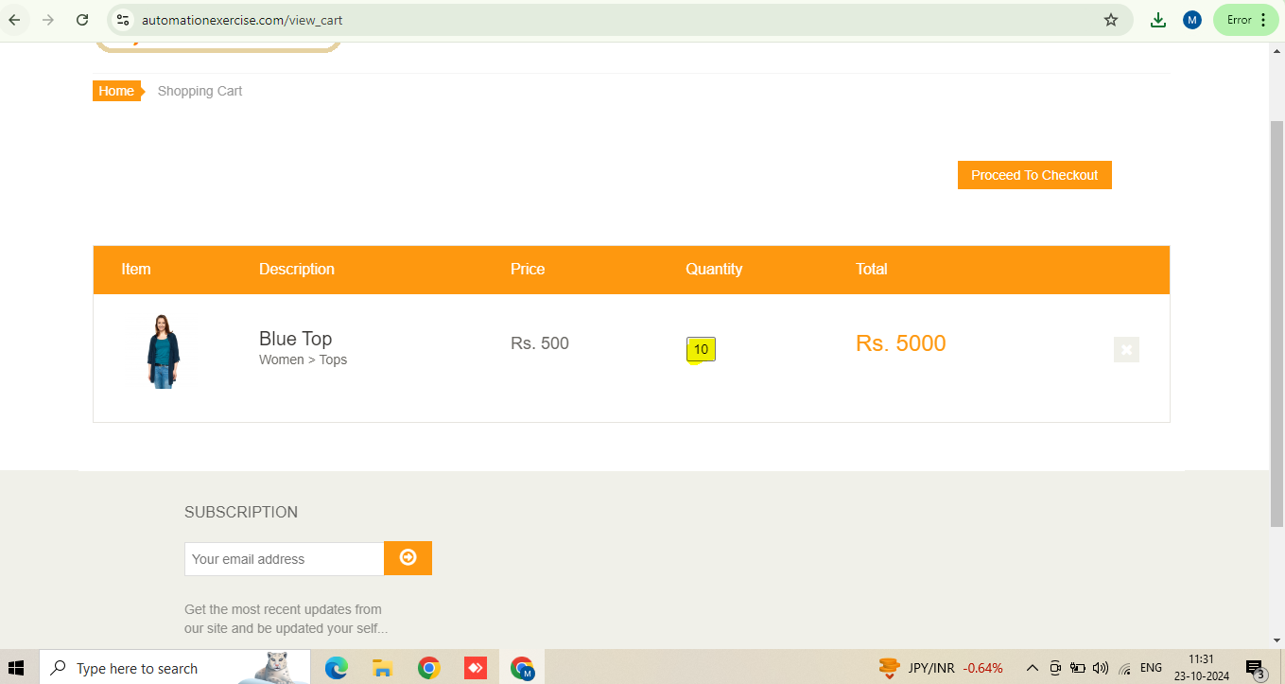

### Severity: Low

### Priority: High

## DEFECT_10: Purchase Amount Displays as 0 in Downloaded Invoice After Payment

### Title:

* + Invoice Shows Purchase Amount as 0 After Successful Payment

### Steps to Reproduce:

* + Navigate to the shopping cart and add one or more products to the cart.
  + Proceed to checkout and complete the payment process successfully.
  + After the payment, download the invoice from the confirmation page .
  + Open the downloaded invoice and check the "Purchase Amount" field.

### Expected Result:

* + The invoice should display the correct purchase amount that reflects the total cost of the products and any applied taxes or discounts.

### Actual Result:

* + The invoice displays the purchase amount as **0** despite a successful payment and an actual product cost during checkout.

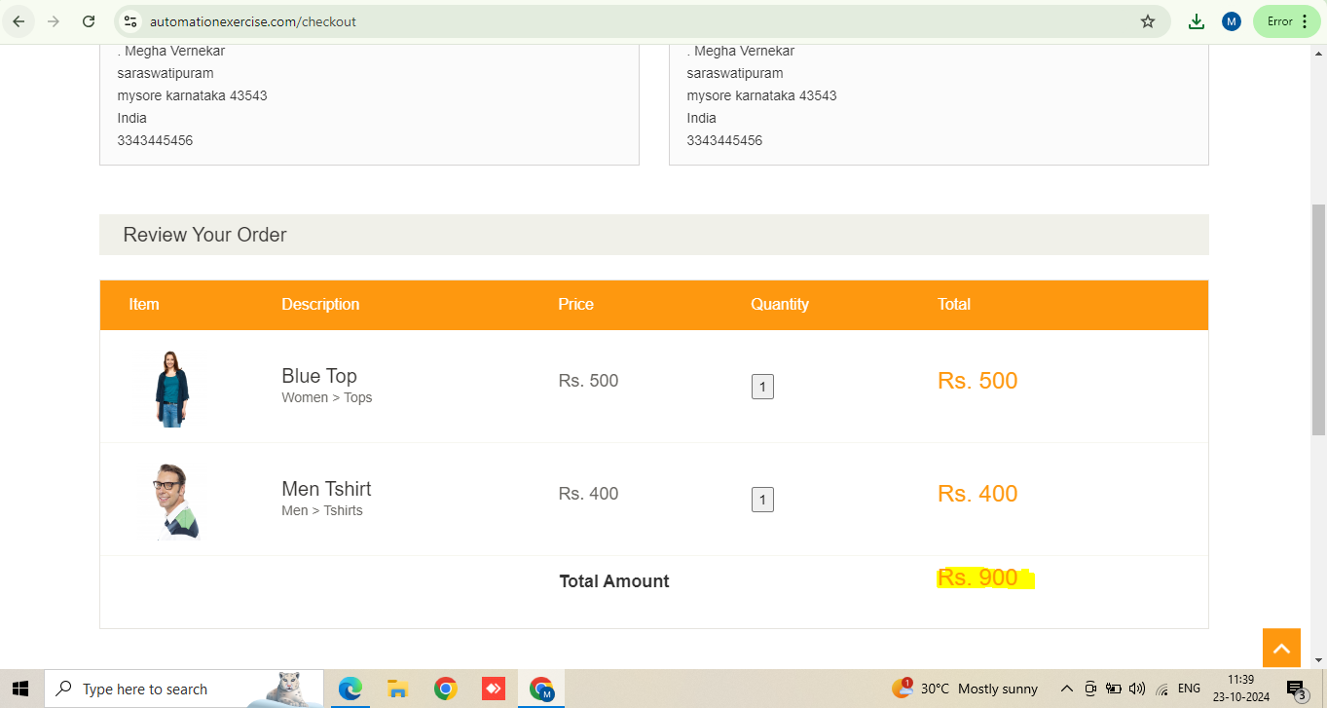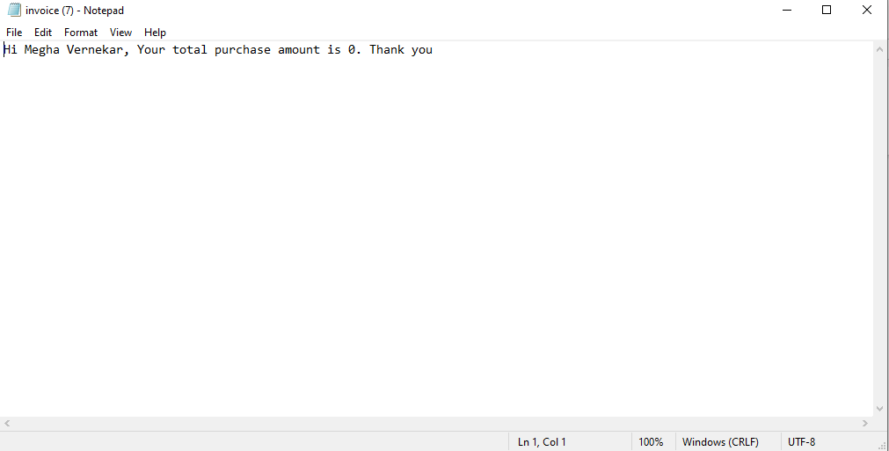

### Severity : High

### Priority:High