Lab-04

Demonstrate adding and removing fragments at run time

**Follow the Step1 of Lab1 Program**

Step2 Create the two Fragment in the project.

Note: please give valid name to fragment

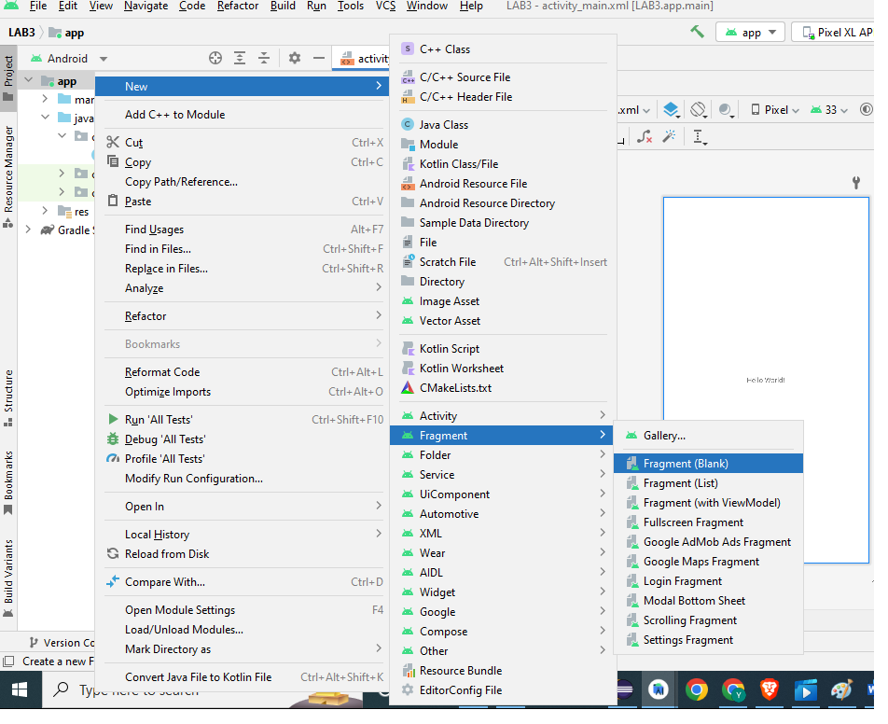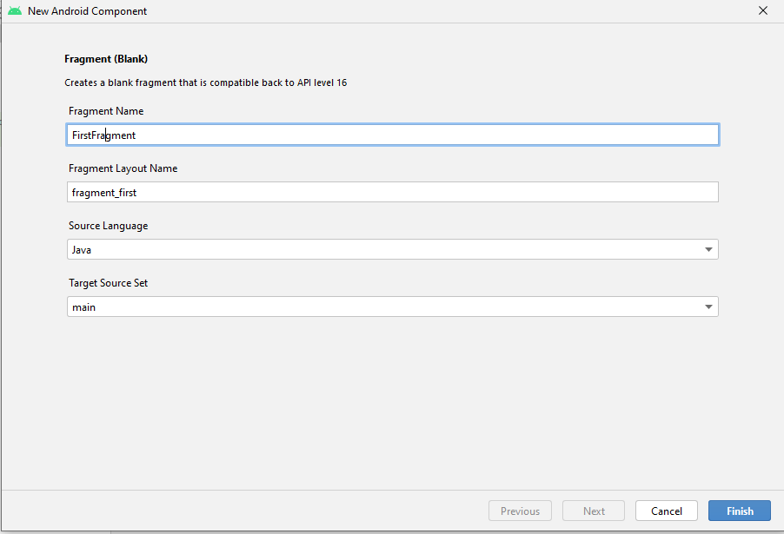

*please repeat the step once Again Create the second Fragment(blank)

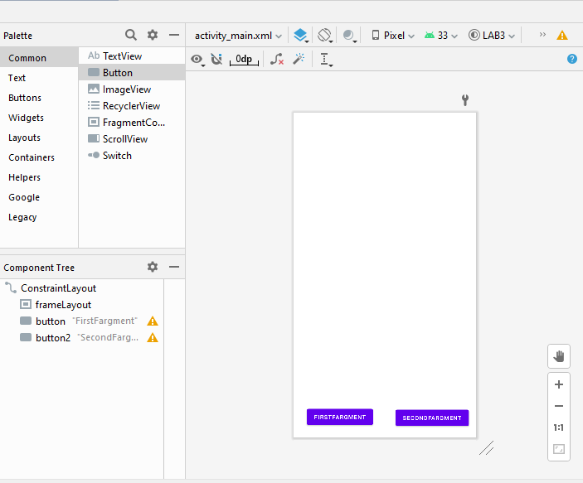Step4: Add the Frame Layout and two buttons from the Palette to the main activity

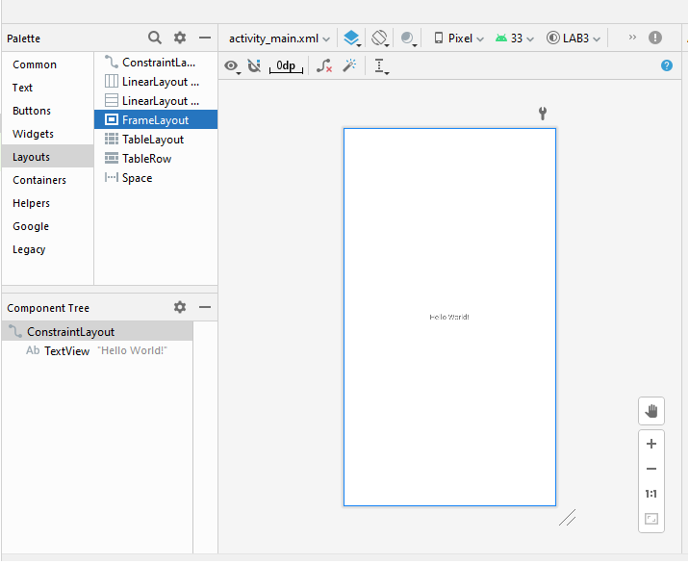

Xml Code for the activity_main.xml

<**FrameLayout  
 android:id="@+id/frameLayout"  
 android:layout_width="411dp"  
 android:layout_height="0dp"  
 android:layout_marginStart="1dp"  
 android:layout_marginEnd="1dp"  
 android:layout_marginBottom="56dp"  
 app:layout_constraintBottom_toTopOf="@+id/button"  
 app:layout_constraintEnd_toEndOf="parent"  
 app:layout_constraintHorizontal_bias="1.0"  
 app:layout_constraintStart_toStartOf="parent"  
 app:layout_constraintTop_toTopOf="parent"  
 app:layout_constraintVertical_bias="0.0"**>  
  
</**FrameLayout**>  
  
<**Button  
 android:id="@+id/button"  
 android:layout_width="wrap_content"  
 android:layout_height="wrap_content"  
 android:layout_marginBottom="22dp"  
 android:text="FirstFargment"  
 android:textSize="13dp"  
 app:layout_constraintBottom_toBottomOf="parent"  
 app:layout_constraintEnd_toEndOf="parent"  
 app:layout_constraintHorizontal_bias="0.114"  
 app:layout_constraintStart_toStartOf="parent"  
 app:layout_constraintTop_toBottomOf="@+id/frameLayout"** />  
  
<**Button  
 android:id="@+id/button2"  
 android:layout_width="wrap_content"  
 android:layout_height="wrap_content"  
 android:layout_marginEnd="10dp"  
 android:layout_marginBottom="20dp"  
 android:text="SecondFargment"  
 android:textSize="13dp"  
 app:layout_constraintBottom_toBottomOf="parent"  
 app:layout_constraintEnd_toEndOf="parent"  
 app:layout_constraintHorizontal_bias="0.89"  
 app:layout_constraintStart_toEndOf="@+id/button"** />

Fragment one xml code

<**TextView  
 android:id="@+id/textView2"  
 android:layout_width="wrap_content"  
 android:layout_height="wrap_content"  
 android:text="FirstFragment"  
 android:textSize="48dp"  
 android:textColor="#FFFFFF"  
 app:layout_constraintBottom_toBottomOf="parent"  
 app:layout_constraintEnd_toEndOf="parent"  
 app:layout_constraintStart_toStartOf="parent"  
 app:layout_constraintTop_toTopOf="parent"** />

Note Please change the Background of Fragment

**android:background="#83E111"**

Fragment Second xml code

<**TextView  
 android:id="@+id/textView"  
 android:layout_width="wrap_content"  
 android:layout_height="wrap_content"  
 android:text="SecondFragment"  
 android:textSize="48dp"  
 android:textColor="#FFFFFF"  
 app:layout_constraintBottom_toBottomOf="parent"  
 app:layout_constraintEnd_toEndOf="parent"  
 app:layout_constraintStart_toStartOf="parent"  
 app:layout_constraintTop_toTopOf="parent"** />

Note Please change the Background of Fragment

**android:background="#AA7D7D"**

Java Code for Main Activity

@Override  
**protected void** onCreate(Bundle savedInstanceState) {  
 **super**.onCreate(savedInstanceState);  
 setContentView(R.layout.***activity_main***);  
 FirstFragment fragment1=**new** FirstFragment();  
 secondFragment fragment2=**new** secondFragment();  
 FragmentManager managerF = getSupportFragmentManager();  
 *// FragmentManager is the class responsible for performing actions  
 // on your app's fragments,  
 // such as adding, removing, or replacing them* FragmentTransaction Ftransaction = managerF.beginTransaction();  
 *//a FragmentManager can add, remove, replace, and perform other actions with fragments  
 // in response to user interaction. Each set of fragment changes that you  
 // commit is called a transaction* Ftransaction.add(R.id.***frameLayout***,fragment1);  
 *//add the Fragment* Button b1 = findViewById(R.id.***button***);  
 Button b2 = findViewById(R.id.***button2***);  
 b1.setOnClickListener(**new** View.OnClickListener() {  
 @Override  
 **public void** onClick(View view) {  
 FragmentManager managerF = getSupportFragmentManager();  
 FragmentTransaction Ftransaction = managerF.beginTransaction();  
 Ftransaction.replace(R.id.***frameLayout***,fragment1);  
 *//replace the Fragment* Toast.*makeText*(MainActivity.**this**,**"Changed to Fragment1"**,Toast.***LENGTH_LONG***).show();  
 Ftransaction.commit();  
 *//Commit the changes in the Activity Main.* }  
 });  
 b2.setOnClickListener(**new** View.OnClickListener() {  
 @Override  
 **public void** onClick(View view) {  
 FragmentManager managerF = getSupportFragmentManager();  
 FragmentTransaction Ftransaction = managerF.beginTransaction();  
 Ftransaction.replace(R.id.***frameLayout***,fragment2);  
 Toast.*makeText*(MainActivity.**this**,**"Changed to Fragment1"**,Toast.***LENGTH_LONG***).show();  
 Ftransaction.commit();  
 }  
 });  
  
  
  
  
}

Output

