**Lab 6**

**Develop an application to send SMS to a particular contact from the phonebook**

Follow the Step1 and create the Lab6 Project

Step2 : Wait till gradle Build is successful and open the Manifests file android studio add the send message Permission

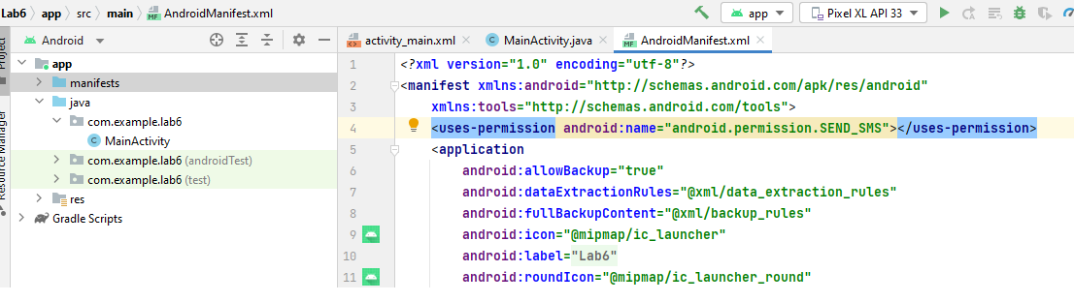

Step3:Desgin the activity_main.xml for sending the message minimum requirement is to get phone number and message two EditText and one button to send Message.

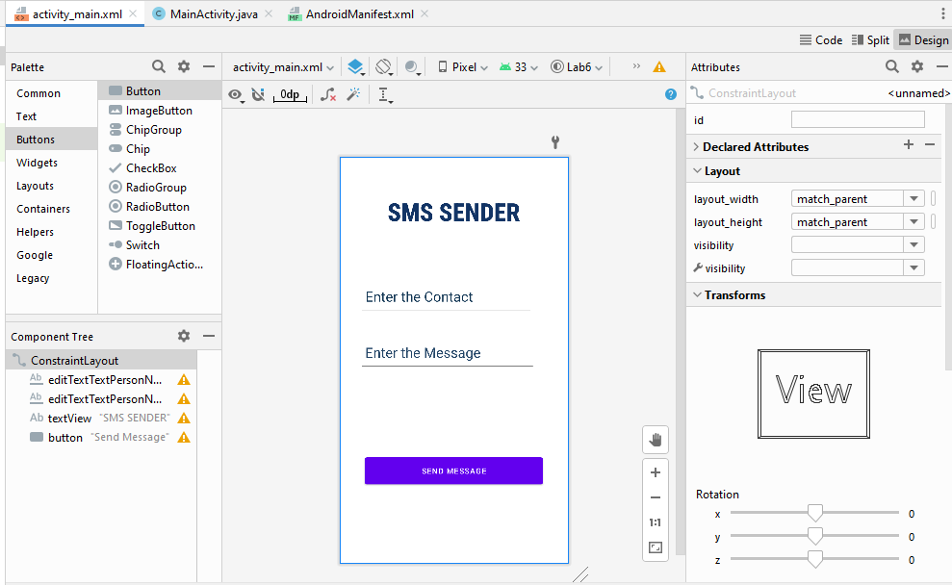

Activity_main.xml code

<**EditText  
 android:id="@+id/EMessage"  
 android:layout_width="316dp"  
 android:layout_height="65dp"  
 android:layout_marginTop="192dp"  
 android:ems="10"  
 android:hint="Enter the Message"  
 android:inputType="textPersonName"  
 android:paddingLeft="10dp"  
 android:textColorHint="#234567"  
 android:textSize="25dp"  
 app:layout_constraintEnd_toEndOf="parent"  
 app:layout_constraintHorizontal_bias="0.375"  
 app:layout_constraintStart_toStartOf="parent"** />  
  
<**EditText  
 android:id="@+id/Contact"  
 android:layout_width="311dp"  
 android:layout_height="65dp"  
 android:ems="10"  
 android:hint="Enter the Contact"  
 android:inputType="textPersonName"  
 android:paddingLeft="10dp"  
 android:textColorHint="#123654"  
 android:textSize="25dp"  
 app:layout_constraintBottom_toBottomOf="parent"  
 app:layout_constraintEnd_toEndOf="parent"  
 app:layout_constraintHorizontal_bias="0.36"  
 app:layout_constraintStart_toStartOf="parent"  
 app:layout_constraintTop_toTopOf="parent"  
 app:layout_constraintVertical_bias="0.329"** />  
  
<**TextView  
 android:id="@+id/Title"  
 android:layout_width="match_parent"  
 android:textAlignment="center"  
 android:layout_height="wrap_content"  
 android:layout_marginTop="65dp"  
 android:layout_marginBottom="91dp"  
 android:fontFamily="sans-serif-condensed-medium"  
 android:text="SMS SENDER"  
 android:textColor="#123465"  
 android:textSize="45dp"  
 android:textStyle="bold"  
  
 app:layout_constraintEnd_toEndOf="parent"  
 app:layout_constraintHorizontal_bias="0.261"  
 app:layout_constraintStart_toStartOf="parent"  
 app:layout_constraintTop_toTopOf="parent"  
 app:layout_constraintVertical_bias="1.0"** />  
  
<**Button  
 android:id="@+id/Send"  
 android:layout_width="match_parent"  
 android:layout_margin="45dp"  
 android:layout_height="60dp"  
 android:text="Send Message"  
 app:layout_constraintBottom_toBottomOf="parent"  
 app:layout_constraintEnd_toEndOf="parent"  
 app:layout_constraintHorizontal_bias="0.448"  
 app:layout_constraintStart_toStartOf="parent"  
 app:layout_constraintTop_toTopOf="parent"  
 app:layout_constraintVertical_bias="0.844"** />

Java Code for Main Activity

Note Please Add contacts before Running the Program in the AVD

EditText **Contact** ,**Emessage**;  
Button **send**;  
@Override  
**protected void** onCreate(Bundle savedInstanceState) {  
 **super**.onCreate(savedInstanceState);  
 setContentView(R.layout.***activity_main***);  
 **send** = findViewById(R.id.***Send***);  
 **Contact**=findViewById(R.id.***Contact***);  
 **Emessage**=findViewById(R.id.***EMessage***);  
 **Contact**.setOnClickListener(**new** View.OnClickListener() {  
 @Override  
 **public void** onClick(View view) {  
 Intent i = **new** Intent(Intent.***ACTION_GET_CONTENT***);

i.setType(ContactsContract.CommonDataKinds.Phone.***CONTENT_ITEM_TYPE***);  
 *// this is to Enable the intent to Access the Contacts present in the Android Contact  
 // and send the Contact details to app* startActivityForResult(i,1);  
 }  
 });  
 **send**.setOnClickListener(**new** View.OnClickListener() {  
 @Override  
 **public void** onClick(View view) {  
 **try** {  
 SmsManager smg = SmsManager.*getDefault*();

//This is used get the smsManager from the android Device

smg.sendTextMessage(**Contact**.getText().toString(), **null**, **Emessage**.getText().toString(), **null**, **null**);

//This is line will use smsManager to send mail from the app.

Toast.*makeText*(MainActivity.**this**, **"Message Send"**, Toast.***LENGTH_LONG***).show();  
 }**catch** (Exception e)  
 { Log.*e*(**"Message"**,e.toString());  
 Toast.*makeText*(MainActivity.**this**, e.toString(), Toast.***LENGTH_LONG***).show();  
 }  
 }  
 });  
}  
  
@Override  
**protected void** onActivityResult(**int** requestCode, **int** resultCode, @Nullable Intent data) {  
 **super**.onActivityResult(requestCode, resultCode, data);  
 **if**(requestCode==1)  
 {  
 **if**(resultCode==***RESULT_OK***)  
 {  
 **try**{  
  
 Uri contactData = data.getData();

//Accessing the data which is send by the intent Activity  
 Cursor = managedQuery(contactData,**null**,**null**,**null**,**null**);

//Use to traversal the data which is got from activity  
 cursor.moveToFirst();

//Accessing the First Data in Got data  
 String number=**"Contact Numbere"**;  
  
  
  
 **int** xz=cursor.getColumnIndex(**"data1"**);

//Getting the Index where Phone Number Exists  
 number=cursor.getString(xz);

//Getting the phone number from the Contact Data;  
  
 **Contact**.setText(number);  
  
 }  
 **catch** (Exception e )  
 {  
 **Contact**.setText(e.toString());  
 }  
 }  
 }  
}

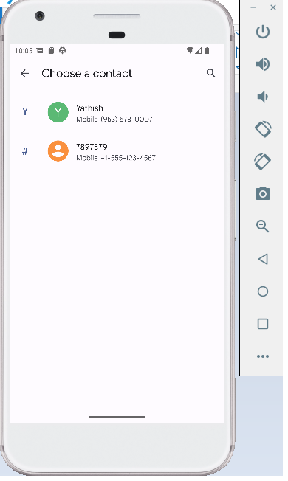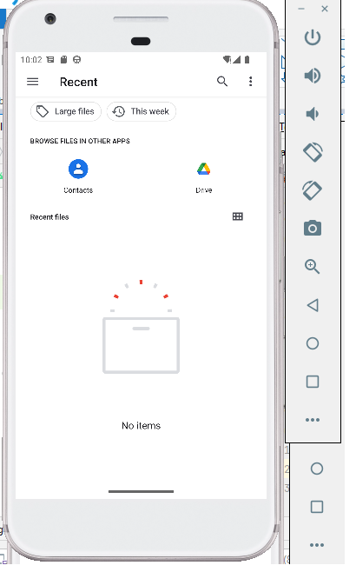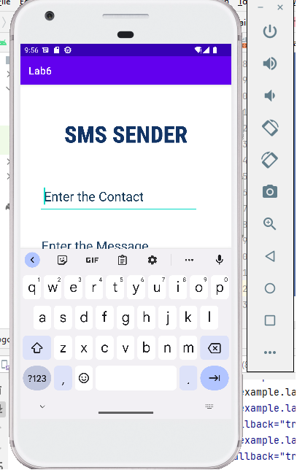Output

