**SALES MONITORING SYSTEM**

**A PROJECT REPORT**

**for**

**Major Project (KCA451)**

**Session (2023-24)**

**Submitted by:**

**MEGHA CHAUDHARY**

**(2200290140091)**

**Submitted in partial fulfilment of the**

**Requirements for the Degree of**

**MASTER OF COMPUTER APPLICATION**

**Under the Supervision of**

**Dr. Amit Kumar**

**(Assistant Professor)**



**Submitted to**

**Department Of Computer Applications**

**KIET Group of Institutions, Ghaziabad**

**Uttar Pradesh-201206**

**(May 2024)**

**CERTIFICATE**

Certified that**, Megha Chaudhary (2200290140091)** have carried out the project work having “**SALES MONITORING SYSTEM**” (**Major Project-KCA451**) for **Master of Computer Application** from Dr. A.P.J. Abdul Kalam Technical University (AKTU**)** (formerly UPTU), Lucknow under my supervision. The project report embodies original work, and studies are carried out by the student himself/herself and the contents of the project report do not form the basis for the award of any other degree to the candidate or to anybody else from this or any other University/Institution.

**Date:**

**Megha Chaudhary**

**(2200290140091)**

This is to certify that the above statement made by the candidate is correct to the best of my knowledge.

**Dr. Arun Tripathi**

**Head of Department**

**Department of Computer Applications**

**Kiet Group of Institutions, Ghaziabad**

**Dr. Amit Kumar**

**Assistant Professor**

**Department of Computer Applications**

**KIET Group of Institutions, Ghaziabad**

**Sales Monitoring System**

**Megha Chaudhary**

**ABSTRACT**

In today's competitive business environment, an efficient and reliable sales monitoring system is crucial for the success of any organization. This paper presents the design and implementation of a Sales Monitoring System (SMS) that aims to streamline the process of tracking sales activities, analyzing sales data, and generating actionable insights. The system integrates various functionalities, including real-time sales tracking, data analytics, and reporting, to provide a comprehensive overview of sales performance.

The SMS is built using a robust architecture that ensures data accuracy, scalability, and user-friendliness. Key features include a centralized database for storing sales data, a user-friendly interface for data entry and visualization, and advanced analytical tools for identifying sales trends and forecasting future sales. The system also incorporates automated alerts and notifications to help sales managers stay informed about critical sales events and performance metrics.

By leveraging the SMS, organizations can enhance their decision-making process, improve sales strategies, and ultimately increase revenue. The system's ability to provide real-time insights and detailed reports empowers sales teams to respond swiftly to market changes and customer demands. This paper discusses the system's design, implementation, and potential benefits, providing a valuable resource for businesses seeking to optimize their sales operations.

Keywords: Sales Monitoring System, real-time tracking, data analytics, sales performance, sales trends, forecasting, decision-making.

**ACKNOWLEDGEMENTS**

Success in life is never attained single-handedly. My deepest gratitude goes to my project supervisor, **Dr**. **AMIT KUMAR** for his guidance, help, and encouragement throughout my project work. Their enlightening ideas, comments, and suggestions.

Words are not enough to express my gratitude to **Dr. Arun Kumar Tripathi**, Professor and Head, Department of Computer Applications, for his insightful comments and administrative help on various occasions.

Fortunately, I have many understanding friends, who have helped me a lot on many critical conditions.

Finally, my sincere thanks go to my family members and all those who have directly and indirectly provided me with moral support and other kind of help. Without their support, completion of this work would not have been possible in time. They keep my life filled with enjoyment and happiness.

**Megha Chaudhary**

**TABLE OF CONTENTS**

|  |  |  |
| --- | --- | --- |
|  | Certificate | 1. 1 |
|  | Abstract |  |
|  | Acknowledgement |  |
|  | Table of Content |  |
|  | List of Tables |  |
|  | Table of Figures |  |
|  | Abbreviation & Acronym |  |
| **1** | **INTRODUCTION** | 1 |
|  | 1.1 OVERVIEW | 1 |
|  | 1.2 BACKGROUND | 3 |
|  | 1.3 PROBLEM STATEMENT | 5 |
|  | 1.4 OBJECTIVE | 6 |
|  | 1.4.1 General Objective |  |
|  | 1.4.2 Specific Objective |  |
|  | 1.5 SIGNIFICANCE | 8 |
|  | 1.6 SCOPE |  |
| **2** | **LITERATURE REVIEW** | 9 |
|  | 2.1 OVERVIEW |  |
|  | 1. 2.2 RECORDS & ELECTRONIC RECORDS |  |
|  | 2.3 DATABASES AS RECORD KEEPING SYSTEM |  |
|  | 2.4 IMPORTANCE OF ADMIN-EXCLUSSIVE ACCESS |  |
| **3** | **METHODOLOGY** | 14 |
|  | 3.1 INTRODUCTION |  |
|  | 3.2 SYSTEM DEVELOPMENT LIFECYCLE |  |
| **4** | **SYSTEM DESCRIPTION** | 18 |
|  | 4.1 SYSTEM OVERVIEW |  |
|  | 4.1.1 Accessing the System |  |
|  | 4.1.2 User Privileges |  |
|  | 4.2 SYSTEM REQUIREMENTS | 20 |
|  | 4.2.1 Hardware Specifications |  |
|  | 4.2.2 Software Specifications |  |
|  | 4.3 SYSTEM ARCHITECTURE | 36 |
|  | 4.3.1 Backend Engine |  |
|  | 4.3.2 Frontend Interface Module |  |
|  | 4.3.3 Logical System Design |  |
|  | 4.3.4 Physical System Design |  |
|  | 4.4 ERD & DFD USE CASE | 25-27 |
|  | 4.4.1 ER Diagram |  |
|  | 4.4.2 DFD Diagram |  |
|  | 4.2.3 USE CASE Diagram |  |
|  |  |  |
|  | 4.6 DATA INPUT | 28 |
|  | 4.6.1 Login Form |  |
|  | 4.6.2 Dashboard |  |
|  | 4.6.3 Report Uploading Form |  |
|  | 4.6.4 Data Entry & Manipulation Form |  |
|  | 4.6.5 Adding product Form |  |
|  | 4.7 DATA OUTPUT | 30 |
|  | 4.7.1 Data Storage Interface |  |
|  | 4.7.2 Data Reports |  |
|  | 4.8 IMPLEMENTATION & TESTING | 31 |
|  | 4.8.1 Implementation |  |
|  | 4.8.2 Testing |  |
|  | 4.8.2.1 Unit Testing |  |
|  | 4.8.2.2 Integration Testing |  |
|  | 4.8.2.3 System Testing |  |
| **5** | **EVALUATION & CONCLUSION** | 36 |
|  | 5.1 EVALUATION |  |
|  | 5.2 LIMITATIONS OF SYSTEM |  |
|  | 5.3 PROBLEMS ENCOUNTERED |  |
|  | 5.4 RECOMMENDATION/FUTURE RESEARCH |  |
|  | 5.5 CONCLUSION |  |
|  | REFERENCES & BIBLIOGRAPHY | 40 |

**LIST OF TABLES**

|  |  |  |
| --- | --- | --- |
| **Table No.** | **Name of Table** | **Page** |
| 4.1 | Sales | 23 |
| 4.2 | Inventory | 23 |
| 4.3 | Sales detail | 23 |
| 4.4 | Product | 24 |
| 4.6 | Reports | 24 |
| 4.7 | Users | 25 |

## LIST OF FIGURES

|  |  |  |
| --- | --- | --- |
| **Figure No.** | **Name of Figure** | **Page No.** |
| 4.1 | Logical Database Design | 23 |
| 4.2 | ER Diagram | 25 |
| 4.3 | DFD Level-1 | 26 |
| 4.4 | DFD Level-2 | 27 |
| 4.7 | Login Form | 28 |
| 4.8 | Dashboard | 29 |
| 4.9 | Uploading Report Form | 29 |
| 4.11 | Add Product Form | 30 |
| 4.12 | Data Storage interface for Sales History | 30 |
| 4.13 | Interface for viewing uploaded Report | 31 |
| 4.14 | Interface to generate Report | 31 |

## ABBREVIATIONS & ACRONYMS

|  |  |
| --- | --- |
| **ADMIN** | Administrator |
| **GUI** | Graphical User Interface |
| **HTML** | Hyper Text Markup Language |
| **IS** | Information System |
| **Lab** | Laboratory |
| **LAN** | Local Area Network |
| **PHP** | Hypertext Pre-Processor |
| **RAM** | Random Access Memory |
| **RM** | Records Management |
| **SMS** | Sales Monitoring System |
| **SQL** | Structured Query Language |

**CHAPTER 1**

**INTRODUCTION**

## OVERVIEW

In the competitive landscape of the 21st century, businesses face numerous challenges that necessitate the adoption of advanced technologies to maintain and enhance their market position. Among these challenges, the ability to monitor and analyze sales activities accurately and efficiently stands out as a critical factor in achieving business success. The emergence of digital technologies and data analytics has paved the way for sophisticated solutions, such as Sales Monitoring Systems (SMS), which offer comprehensive and real-time insights into sales operations.

Sales Monitoring Systems are designed to capture and process sales data continuously, providing a holistic view of an organization's sales performance. These systems integrate data from various sources, including point-of-sale systems, customer relationship management (CRM) platforms, and e-commerce sites, ensuring that sales managers have access to up-to-date and accurate information. This integration is crucial for identifying sales trends, monitoring key performance indicators (KPIs), and making informed decisions that can drive revenue growth.

The core components of a robust Sales Monitoring System include a centralized database, real-time data processing capabilities, user-friendly dashboards, and advanced analytical tools. The centralized database serves as the repository for all sales data, ensuring consistency and reliability. Real-time data processing allows for immediate updates and insights, enabling sales teams to respond swiftly to emerging opportunities and challenges. User-friendly dashboards provide intuitive interfaces for visualizing sales data, making it easier for users at all levels of the organization to understand and act on the information presented. Advanced analytical tools offer capabilities such as predictive analytics, trend analysis, and performance forecasting, empowering businesses to anticipate market changes and plan strategically.

The benefits of implementing a Sales Monitoring System extend beyond mere data tracking. These systems can enhance overall sales efficiency by automating routine tasks, reducing manual errors, and freeing up valuable time for sales teams to focus on customer engagement and strategic planning. Moreover, the ability to generate detailed reports and actionable insights can lead to better resource allocation, targeted marketing efforts, and improved customer satisfaction. By leveraging the power of data, organizations can gain a competitive edge, optimize their sales processes, and ultimately achieve sustainable growth.

In this paper, we will explore the detailed design and implementation of a Sales Monitoring System, highlighting its key features, technological underpinnings, and practical applications. We will examine case studies and examples from various industries to illustrate how the SMS can be tailored to meet specific business needs and drive success. Additionally, we will discuss the potential challenges and considerations involved in deploying such a system, providing best practices and recommendations for organizations seeking to implement their own sales monitoring solutions.

Through this comprehensive analysis, we aim to demonstrate the transformative impact of Sales Monitoring Systems on modern business operations. By understanding the capabilities and advantages of these systems, business leaders and stakeholders can make informed decisions about investing in technology that supports their strategic objectives and enhances their overall performance. The journey towards effective sales monitoring begins with recognizing the importance of data-driven insights and committing to the continuous improvement of sales processes through innovative technological solutions.

## BACKGROUND

Sales monitoring has long been a cornerstone of business management, essential for tracking performance, understanding market trends, and informing strategic decisions. Traditionally, sales monitoring relied on manual processes and disparate data collection methods, which were often time-consuming, prone to errors, and provided limited actionable insights. The advent of digital technologies and data analytics has revolutionized this landscape, offering more efficient, accurate, and comprehensive approaches to sales monitoring.

Historically, sales teams recorded transactions and customer interactions in paper logs or simple spreadsheets. These methods, while functional, presented significant challenges in terms of data consolidation, accuracy, and timely analysis. As businesses grew and sales operations became more complex, the need for a more integrated and scalable solution became evident. The rise of computer technology in the late 20th century marked the beginning of automated sales monitoring systems, which could handle larger volumes of data and provide faster processing times.

The 1990s and early 2000s saw the proliferation of Customer Relationship Management (CRM) systems, which played a significant role in centralizing customer data and sales activities. CRMs helped streamline sales processes and offered basic analytical tools, but they were often limited in scope, focusing primarily on customer interactions rather than comprehensive sales data analysis. As a result, many organizations still faced challenges in gaining a holistic view of their sales performance.

In the past decade, advancements in big data, cloud computing, and artificial intelligence have further transformed sales monitoring capabilities. Modern Sales Monitoring Systems (SMS) leverage these technologies to provide real-time data processing, advanced analytics, and intuitive visualization tools. These systems integrate data from multiple sources, such as point-of-sale systems, e-commerce platforms, and social media, ensuring a unified and up-to-date view of sales activities.

Key technological developments that have influenced the evolution of Sales Monitoring Systems include:

1. Big Data Analytics: The ability to process and analyze vast amounts of data from diverse sources has enabled businesses to uncover patterns, trends, and insights that were previously inaccessible. Big data analytics helps in identifying customer preferences, predicting sales trends, and optimizing inventory management.

2. Cloud Computing: Cloud-based solutions offer scalability, flexibility, and accessibility, allowing businesses of all sizes to deploy powerful sales monitoring tools without significant upfront investments in IT infrastructure. Cloud computing also facilitates real-time data sharing and collaboration among sales teams, regardless of their geographic location.

3. Artificial Intelligence and Machine Learning: AI and ML algorithms enhance sales monitoring by providing predictive analytics, anomaly detection, and automated decision-making support. These technologies can identify potential sales opportunities, forecast future sales, and recommend actions to improve performance.

4. Real-Time Data Processing: The capability to process data in real-time is crucial for modern sales monitoring. Real-time insights enable businesses to respond quickly to market changes, adjust strategies on the fly, and maintain a competitive edge.

5. User-Friendly Interfaces: Advanced visualization tools and dashboards make it easier for users to interact with and interpret sales data. These interfaces are designed to be intuitive, providing clear and actionable insights that can be understood by stakeholders at all levels of the organization.

The integration of these technologies into Sales Monitoring Systems has significantly enhanced their functionality and utility, making them indispensable tools for contemporary business operations. As businesses continue to navigate the complexities of the modern marketplace, the ability to monitor and analyze sales effectively will remain a key driver of success.

In this paper, we will delve into the components and features of a state-of-the-art Sales Monitoring System, exploring how it can be implemented to address the specific needs of different businesses. By understanding the historical context and technological advancements that have shaped these systems, we can better appreciate their role in driving business growth and operational excellence.

## 1.3 PROBLEM STATEMENT

In the highly competitive and rapidly evolving business environment, organizations face significant challenges in monitoring and managing their sales activities effectively. Traditional sales tracking methods, which often rely on manual data entry, disparate data sources, and periodic reporting, are inadequate for providing the timely, accurate, and comprehensive insights needed to make informed decisions and drive business growth. This inadequacy leads to several critical issues:

1. **Data Inaccuracy and Inconsistency**: Manual data entry and siloed information systems result in errors and inconsistencies, making it difficult for sales teams to trust the data and base their decisions on it. Inaccurate data hampers the ability to assess true sales performance and forecast future trends reliably.

2. **Lack of Real-Time Insights**: Traditional sales monitoring systems typically provide historical data rather than real-time updates. This lag in information prevents businesses from responding swiftly to market changes, customer demands, and emerging opportunities, leading to missed sales opportunities and decreased competitiveness.

3. **Inefficient Sales Processes**: Without a centralized and automated system, sales teams spend a significant amount of time on administrative tasks such as data entry, report generation, and information consolidation. This inefficiency reduces the time available for customer engagement and strategic activities, ultimately impacting sales productivity and effectiveness.

4. **Limited Analytical Capabilities**: Traditional systems often lack advanced analytical tools needed to derive meaningful insights from sales data. This limitation restricts the ability to perform in-depth analysis, identify trends, and make data-driven decisions that can enhance sales strategies and performance.

5. **Inadequate Reporting and Visualization**: The inability to generate comprehensive and easily interpretable reports and visualizations hampers the ability of sales managers and executives to understand the current state of sales operations. This lack of clarity can lead to suboptimal decision-making and missed opportunities for optimization and growth.

6. Difficulty in Tracking Key Performance Indicators (KPIs): Monitoring essential KPIs, such as sales targets, conversion rates, and customer acquisition costs, is challenging without an integrated system. This difficulty impedes the ability to set realistic goals, measure progress accurately, and hold sales teams accountable.

To address these challenges, there is a need for a robust Sales Monitoring System (SMS) that integrates data from multiple sources, provides real-time insights, automates routine tasks, and offers advanced analytical and reporting capabilities. Such a system should enable businesses to:

- Ensure data accuracy and consistency by automating data collection and integration from various sales channels.

- Provide real-time visibility into sales activities, allowing for timely and informed decision-making.

- Streamline sales processes by reducing the administrative burden on sales teams, thus enhancing productivity.

- Offer powerful analytical tools to uncover trends, forecast sales, and optimize strategies.

- Generate comprehensive and user-friendly reports and visualizations that facilitate better understanding and communication of sales performance.

- Track and monitor KPIs effectively to ensure alignment with business goals and objectives.

By implementing an advanced Sales Monitoring System, organizations can overcome the limitations of traditional methods, improve their sales operations, and achieve sustainable growth in a competitive marketplace.

## 1.5 SIGNIFICANCE

The implementation of a Sales Monitoring System (SMS) holds substantial significance for businesses across various industries. It not only addresses the challenges associated with traditional sales tracking methods but also provides a host of strategic and operational benefits that can significantly enhance overall business performance. The following points underscore the importance of adopting an advanced Sales Monitoring System:

1. Enhanced Decision-Making:

- Data-Driven Insights: An SMS provides accurate, real-time data, enabling managers and executives to make informed decisions based on current sales performance and trends.

- Predictive Analytics: Advanced analytical tools within an SMS can forecast future sales trends, helping businesses anticipate market changes and adjust their strategies proactively.

2. Improved Sales Efficiency:

- Automation of Routine Tasks: Automating data collection, entry, and report generation reduces the administrative burden on sales teams, allowing them to focus more on customer interactions and strategic planning.

- Streamlined Processes: By centralizing sales data and providing intuitive dashboards, an SMS simplifies the process of tracking and managing sales activities, leading to more efficient operations.

3. Increased Revenue and Profitability:

- Opportunity Identification: Real-time monitoring and advanced analytics help identify emerging sales opportunities and areas for improvement, enabling businesses to capitalize on them quickly.

- Enhanced Sales Strategies: With detailed insights into sales performance, businesses can refine their sales strategies, target the right customer segments, and optimize pricing models to maximize revenue.

4. Better Customer Relationship Management:

- Personalized Customer Insights: An SMS can track customer behavior and preferences, allowing sales teams to tailor their approaches and offer personalized experiences, thereby increasing customer satisfaction and loyalty.

- Timely Follow-Ups: Automated alerts and notifications ensure that sales teams follow up with leads and customers promptly, improving conversion rates and customer retention.

## 1.6 SCOPE

The scope provides for the boundary of the research in terms of depth of investigation, content, and methodology, geographical and theoretical coverage.

The Sales Monitoring system was designed in such a way that makes it possible to access it through any web browser programme. This serves as the user interface. The web browser supported interface created is dynamic and as a result backed by a database system that enables users to have the ability to input, access, manipulate and delete data from the database

* **Functional Scope**:

Using PHP in the backend allows for seamless integration of user authentication, data processing, and server-side logic. HTML/CSS are employed to create an intuitive and responsive user interface for various functionalities like sales overview, sales records management, and staff administration.

* **JavaScript Integration**:

The use of JavaScript enhances user interaction, enabling real-time updates, form validations, and interactive features within the system’s frontend, improving user experience and system responsiveness.

* **MySQL Database**:

XAMPP an integrated database creation software tool was used as the software for creating the MYSQL database.

MySQL serves as the central repository for storing sales data, sales records, schedules, and administrative information. Its role encompasses data management, retrieval, and ensuring the system’s scalability and reliability.

* **Technology Constraints**:

While these technologies offer robust capabilities, considerations such as compatibility, browser support, and scalability should be addressed to ensure the system’s seamless functioning across various platforms and devices.

# CHAPTER 2

# LITERATURE REVIEW

## 2.1 OVERVIEW

The concept of sales monitoring systems has evolved significantly over the past few decades, driven by advancements in technology and the increasing complexity of business environments. This literature overview examines the development, features, and impact of sales monitoring systems as discussed in academic and industry research.

Early Sales Monitoring Methods

Early studies on sales monitoring primarily focused on manual and paper-based systems, which were labor-intensive and prone to errors. Traditional approaches involved periodic collection of sales data, manual entry into spreadsheets, and rudimentary analysis. The limitations of these methods were widely acknowledged, including issues of data accuracy, timeliness, and the inability to provide real-time insights (Kotler, 1984).

Emergence of Automated Systems

The advent of computer technology in the late 20th century marked a significant shift in sales monitoring practices. With the introduction of automated systems, businesses began to experience improvements in data collection, processing, and reporting (Cravens, 1998). Customer Relationship Management (CRM) systems emerged as pivotal tools, centralizing customer and sales data, and offering basic analytical capabilities (Buttle, 1996). Research during this period highlighted the efficiency gains and improved data accuracy brought about by these systems (Dyché, 2002).

Integration with Big Data and Analytics

The early 2000s saw a surge in the integration of big data and analytics into sales monitoring systems. Big data technologies enabled the processing of vast amounts of sales data from diverse sources, including social media, e-commerce platforms, and IoT devices (Chen, Chiang, & Storey, 2012). Studies emphasized the role of big data in enhancing the granularity and accuracy of sales insights, enabling more precise trend analysis and forecasting (McAfee & Brynjolfsson, 2012).

Cloud Computing and Real-Time Processing

The adoption of cloud computing has been a transformative development in the realm of sales monitoring systems. Cloud-based solutions offer scalability, flexibility, and cost-effectiveness, making advanced sales monitoring tools accessible to businesses of all sizes (Armbrust et al., 2010). Real-time data processing capabilities have further revolutionized sales monitoring, allowing businesses to obtain immediate insights and respond swiftly to market changes (Hashem et al., 2015).

Advanced Analytical Tools and Machine Learning

Recent literature has focused on the integration of advanced analytical tools and machine learning algorithms into sales monitoring systems. These technologies facilitate predictive analytics, anomaly detection, and automated decision support, significantly enhancing the strategic value of sales data (Waller & Fawcett, 2013). Research has demonstrated the potential of machine learning to improve sales forecasting accuracy and optimize sales strategies (Brynjolfsson & McElheran, 2016).

User Experience and Interface Design

The importance of user experience (UX) and interface design in sales monitoring systems has also been a subject of study. Effective visualization tools and intuitive dashboards are crucial for enabling users to interact with and interpret sales data efficiently (Few, 2006). Research indicates that well-designed interfaces can significantly enhance user engagement and the overall effectiveness of sales monitoring systems (Shneiderman, Plaisant, Cohen, & Jacobs, 2009).

Impact on Business Performance

Empirical studies have consistently shown that the implementation of advanced sales monitoring systems positively impacts business performance. Key benefits include improved sales efficiency, enhanced decision-making capabilities, and increased revenue (Chen & Lin, 2009). Moreover, research highlights the role of sales monitoring systems in fostering a data-driven culture within organizations, leading to continuous improvement and innovation (Davenport & Harris, 2007).

Future Trends and Research Directions

Looking ahead, the literature suggests several emerging trends and future research directions for sales monitoring systems. These include the integration of artificial intelligence for more sophisticated predictive and prescriptive analytics, the use of blockchain technology for secure and transparent sales data management, and the development of more personalized and adaptive user interfaces (Ngai, Hu, Wong, Chen, & Sun, 2011). Additionally, the impact of evolving consumer behaviors and market dynamics on sales monitoring practices remains an important area for ongoing research.

Conclusion

The evolution of sales monitoring systems, as chronicled in the literature, underscores their critical role in modern business operations. From early manual methods to sophisticated, data-driven solutions, these systems have continually adapted to meet the changing needs of businesses. The integration of advanced technologies such as big data, cloud computing, and machine learning has significantly enhanced their capabilities, offering powerful tools for sales management and strategic decision-making. As businesses continue to navigate complex and competitive environments, the development and refinement of sales monitoring systems will remain a key focus of both academic research and practical innovation.

## 2.2 RECORDS & ELECTRONIC RECORDS

A record is recorded information produced or received in the initiation, conduct or completion of an institutional or individual activity and that comprises content, context and structure sufficient to provide evidence of the activity regardless of the form or medium.

The distinctive feature of electronic records is that the content is recorded on a medium and in symbols (binary digits) that need a computer or similar technology to read and understand.

The concepts of "record" and "electronic record" are linked to the concept of the "archival function" which was defined as that group of related activities contributing to, and necessary for accomplishing the goals of identifying, safeguarding and preserving archival records, and ensuring that such records are accessible and understandable.

## 2.3 DATABASES & RECORDKEEPING SYSTEM

Recordkeeping systems in the electronic, as well as in the paper, world is designed for the use of operational staff in current office operations.

Recordkeeping systems have concrete boundaries and definable properties, and they are critical to the preservation of the records’ origin and evidential value. In the paper world, recordkeeping systems range from a simple filing system to a central registry.

Databases are being used as the records management systems of preference because of their informational value. Such databases are created for their informational value -- as an information resource. Statistical databases are good examples of this kind of database.

## 2.4 IMPORTANCE OF ADMIN-EXCLUSIVE ACCESS

In the context of a Sales Monitoring System, administering exclusive access rights to authorized personnel holds immense significance. PHP serves as a robust platform for implementing stringent user authentication and access control mechanisms. These features ensure that only authorized administrators have privileged access to critical functionalities and sensitive patient data. The MySQL database, integral to the system’s architecture, supports secure storage of user roles, permissions, and access credentials. This amalgamation of PHP and MySQL allows for the establishment of a secure framework, maintaining the integrity and confidentiality of Sales records, thereby preventing unauthorized access and ensuring data security.

**CHAPTER 3**

# METHODOLOGY

### **3.1 INTRODUCTION**

The methodology for developing and implementing a Sales Monitoring System (SMS) involves several stages, from requirement analysis and system design to deployment and evaluation. This section outlines a comprehensive approach to creating an effective SMS, ensuring it meets the needs of the organization and enhances overall sales performance.

1. Requirement Analysis

Objectives:

- Define the goals and objectives of the SMS.

- Identify the key stakeholders and their requirements.

- Determine the scope and functionality of the system.

Activities:

- Conduct interviews and surveys with sales teams, managers, and other stakeholders to gather requirements.

- Analyze existing sales processes and identify pain points and areas for improvement.

- Define the key performance indicators (KPIs) that the system will track.

Deliverables:

- Requirement Specification Document

- Use Case Diagrams

- Functional and Non-Functional Requirements

2. System Design

Objectives;

- Develop a detailed blueprint for the SMS.

- Ensure the system architecture supports scalability, reliability, and security.

Activities:

- Design the overall system architecture, including the data flow, database schema, and integration points with other systems (e.g., CRM, ERP).

- Develop wireframes and prototypes for the user interface.

- Choose the appropriate technology stack (programming languages, frameworks, databases, etc.).

Deliverables:

- System Architecture Diagram

- Database Schema

- User Interface Prototypes

- Technology Stack Selection

3. Development

Objectives:

- Build the SMS according to the design specifications.

- Ensure code quality and system performance through rigorous testing.

Activities:

- Set up the development environment and version control system.

- Implement the backend components, including data collection, storage, and processing modules.

- Develop the frontend components, ensuring an intuitive and user-friendly interface.

- Integrate the system with existing software and data sources.

- Conduct unit testing, integration testing, and system testing.

Deliverables:

- Source Code

- Testing Plan and Test Cases

- Integration Documentation

4. Implementation

Objectives:

- Deploy the SMS in a live environment.

- Ensure smooth transition and minimal disruption to existing operations.

Activities:

- Prepare the deployment environment (servers, cloud infrastructure, etc.).

- Migrate existing sales data to the new system.

- Deploy the SMS and conduct final testing in the live environment.

- Provide training and support to users.

Deliverables:

- Deployed Sales Monitoring System

- Migration Plan and Documentation

- Training Materials and User Manuals

5. Evaluation and Optimization

Objectives:

- Assess the performance and impact of the SMS.

- Identify opportunities for further improvement and optimization.

Activities:

- Monitor system performance and user feedback.

- Analyze sales data to evaluate the impact of the SMS on sales performance.

- Conduct regular reviews and update the system as needed to address any issues or incorporate new features.

Deliverables:

- Performance Reports

- User Feedback and Satisfaction Surveys

- Improvement and Optimization Plan

6. Maintenance and Support

Objectives:

- Ensure the long-term reliability and effectiveness of the SMS.

- Provide ongoing support and updates.

Activities:

- Establish a maintenance schedule for regular updates and bug fixes.

- Provide a support system for users to report issues and request new features.

- Monitor the system continuously to ensure data integrity and performance.

Deliverables:

- Maintenance Plan

- Support Documentation

- Regular Updates and Patch Releases

The methodology for developing a Sales Monitoring System involves a structured approach that begins with understanding the needs of the organization and ends with the continuous improvement of the system. By following these steps, businesses can ensure that their SMS is robust, user-friendly, and capable of delivering valuable insights that drive sales performance and strategic decision-making. This comprehensive methodology ensures that the system not only meets initial requirements but also adapts to evolving business needs over time.

# 

# CHAPTER 4

# SYSTEM DESCRIPTION

## 4.1 SYSTEM OVERVIEW

The Sales Monitoring System (SMS) is a comprehensive, integrated solution designed to track, analyze, and report on sales activities in real-time. This system is built to support the strategic and operational needs of businesses by providing accurate and timely sales data, advanced analytics, and user-friendly interfaces. The following sections describe the key components and functionalities of the SMS.

1. System Architecture

The SMS is designed with a multi-tier architecture to ensure scalability, reliability, and security. The main components include:

- Data Layer: This layer handles the collection, storage, and management of sales data. It includes databases, data warehouses, and data lakes to accommodate various data types and volumes.

- Application Layer: This layer contains the core logic of the SMS, including data processing, analytics, and business rules. It is built using robust frameworks and supports integration with other systems like CRM and ERP.

- Presentation Layer: This layer provides the user interface for accessing and interacting with the SMS. It includes web-based dashboards, mobile apps, and reporting tools.

2. Data Collection and Integration

The SMS integrates data from multiple sources to provide a comprehensive view of sales activities:

- Sales Channels: Data is collected from various sales channels, including online stores, physical retail points, and B2B transactions.

- CRM Systems: Customer interactions and transaction histories from CRM systems are integrated into the SMS for a unified view of customer relationships.

- External Data Sources: Market trends, competitor data, and other external sources are incorporated to enhance the analysis and forecasting capabilities.

3. Real-Time Data Processing

The SMS employs real-time data processing technologies to ensure that sales data is captured and analyzed as soon as it becomes available. This includes:

- Streaming Data Pipelines: Tools like Apache Kafka or AWS Kinesis are used to process data streams in real-time.

- Event-Driven Architecture: The system is designed to respond to sales events (e.g., new order placed, payment received) immediately, triggering necessary actions and updates.

4. Advanced Analytics

The SMS provides powerful analytical tools to extract insights from sales data:

- Descriptive Analytics: Summarizes historical sales data to provide a clear picture of past performance.

- Diagnostic Analytics: Identifies patterns and relationships in the data to understand the reasons behind sales trends.

- Predictive Analytics: Uses machine learning algorithms to forecast future sales based on historical data and external factors.

- Prescriptive Analytics: Recommends actions to optimize sales strategies and operations.

5. Reporting and Visualization

The SMS features advanced reporting and visualization capabilities to make data accessible and actionable:

- Dashboards: Interactive dashboards provide real-time updates on key sales metrics and KPIs. Users can customize views to focus on specific data points.

- Reports: Automated and customizable reports can be generated for different stakeholders, including sales teams, managers, and executives.

- Data Visualization: Graphs, charts, and heat maps are used to present data visually, making it easier to identify trends and insights.

## 4.2. SYSTEM REQUIREMENTS

The system requires a client-server architecture where a server is necessary to host the application and the database. The users will access the server to retrieve information from their desktops through their web-based interfaces. For this to work, the following will be required:

* + 1. **Hardware Specifications**
* **Operating System:**

Windows 10/11, macOS, or Linux distributions supported by XAMPP.

* **Processor:**

Intel Core i5 or AMD equivalent for optimal performance.

* **RAM:**

Minimum 4GB RAM for smooth operation; 8GB or higher recommended for better performance.

* **Storage:**

At least 20GB of available disk space for system files and data storage.

* + 1. **Software Specifications**
* **XAMPP Installation:**

Download and install the latest version of XAMPP compatible with your operating system.

Ensure Apache, MySQL, PHP, and phpMyAdmin are installed and running within XAMPP.

* **Web Browser:**

Latest versions of browsers like Google Chrome, Mozilla Firefox, Safari, or Microsoft Edge for accessing the SMS web application.

* **Code Editor:**

Optional: Install a code editor like Visual Studio Code, Sublime Text, or PHPStorm for code customization or review.

**Other Considerations**

* **User Account:**

Admin credentials to log in to the SMS with appropriate access rights.

* **Internet Connectivity (Optional):**

Stable internet connection may be required for certain functionalities, such as remote access or cloud-based features (if implemented).

## 4.3 SYSTEM ARCHITECTURE

The Sales Monitoring System is architected to efficiently handle data storage, processing, and user interaction. The system's backbone is a robust backend engine, comprising a MYSQL database, PHP as the primary programming language, and Apache as the web server. Additionally, the frontend is structured using HTML and CSS, forming the user interface modules.

* + 1. **Backend Engine**
* **MYSQL Database:**

The MYSQL database serves as the foundational repository, storing sales Records, Purchase histories, and associated data. It is structured to ensure data integrity, reliability, and efficient retrieval of information. The database architecture employs normalization techniques to minimize redundancy and optimize data storage.

* **PHP Programming Language**

PHP acts as the bridge between the MYSQL database and the user interface modules. It facilitates seamless interaction with the database, enabling data manipulation, validation, and logic implementation. PHP also handles server-side scripting, ensuring secure and dynamic content generation.

* **Apache Web Server**

Apache serves as the robust web server, managing HTTP requests and responses. It hosts the PHP scripts and coordinates communication between the MYSQL database and the user interface modules. Apache's efficiency and stability contribute to the system's seamless operation.

* + 1. **Frontend Interface Modules**
* **HTML (Hyper Text Markup Language)**

HTML forms the structural foundation of the user interface, defining the layout and structure of web pages. It provides the framework for presenting data and interacting with the system.

* **CSS (Cascading Style Sheets)**

CSS complements HTML by enhancing the presentation and visual appeal of the user interface. It controls the styling, layout, and design elements of the web pages, ensuring a cohesive and visually appealing interface for administrators.

**4.3.3** **Logical Database Design**

The logical database design is meant to describe the representation of the database in terms of its entities in form of tables and the existing relationships. Below is an illustration of the systems logical design as generated by the MYSQL workbench design tool.

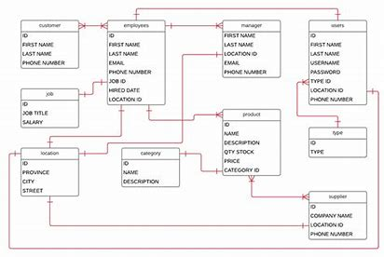

**Fig.** **4.1:**  **Logical Database Design**

**4.3.4 Physical Database Design**

As one of the core elements of a Health record management system, the database had to be designed in a meticulous systematic manner. This process started at the analysis phase of the project. From the analysis, the researcher was able to identify the necessary tables required for the database and the associated field names, format and length of each table. Below is a list of these tables.

#### **Table 4.1: Sales**

|  |  |  |  |
| --- | --- | --- | --- |
| **Attribute** | **Field** **type** | **Length/size** | **Description** |
| Id | int | 11 | Primary Key, Auto Increment |
| Sales_name | varchar | 60 | To store the Sales Name |

#### **Table 4.2:** **Inventory**

|  |  |  |  |
| --- | --- | --- | --- |
| **Attribute** | **Field** **type** | **Length/size** | **Description** |
| S_no | | Int | 11 | Auto increment, primary key |
| Po_name | | varchar | 100 | Available Inventory |

#### **Table 4.3:** **Sales Details**

|  |  |  |  |
| --- | --- | --- | --- |
| **Attribute** | **Field** **type** | **Length/size** | **Description** |
| id | int | 11 | Auto Increment, Primary Key |
| Sales_id | int | 11 | Foreign Key |
| Inventory | varchar | 60 | Purchasing |

#### **Table 4.4:** **Products**

|  |  |  |  |
| --- | --- | --- | --- |
| **Attribute** | **Field** **type** | **Length/size** | **Description** |
| Id | Int | 11 | Auto Increment, Primary Key |
| Product_name | Varchar | 60 | product name |
| Category | Varchar | 100 | category |
| Brand | Varchar | 12 | Brand number |
| inventory | Date | - | Purchase date |
| Dealer contacts | Varchar | 10 | contact number |
| purchase | varchar | 6 | purchase |

#### **Table 4.6:** **reports**

|  |  |  |  |
| --- | --- | --- | --- |
| **Attribute** | **Field** **type** | **Length/size** | **Description** |
| Sno | Int | 11 | Auto increment, primary key |
| Report | Varchar | 400 | Report location |
| Rep_name | Varchar | 100 | Type of report |
| id | int | 11 | Foreign key, Patient id |

#### **Table 4.7:** **users**

|  |  |  |  |
| --- | --- | --- | --- |
| **Attribute** | **Field** **type** | **Length/size** | **Description** |
| Id | Int | 11 | Auto increment, primary key |
| Display_name | Varchar | 30 | Name Displayed |
| User_name | Varchar | 30 | User name |
| Password | Varchar | 100 | Encrypted password |
| Profile_picture | varchar | 40 | Profile picture |

## 4.4 ER DIAGRAMS & DFDs

**4.4.1 ERD (Entity Relationship Diagram)**

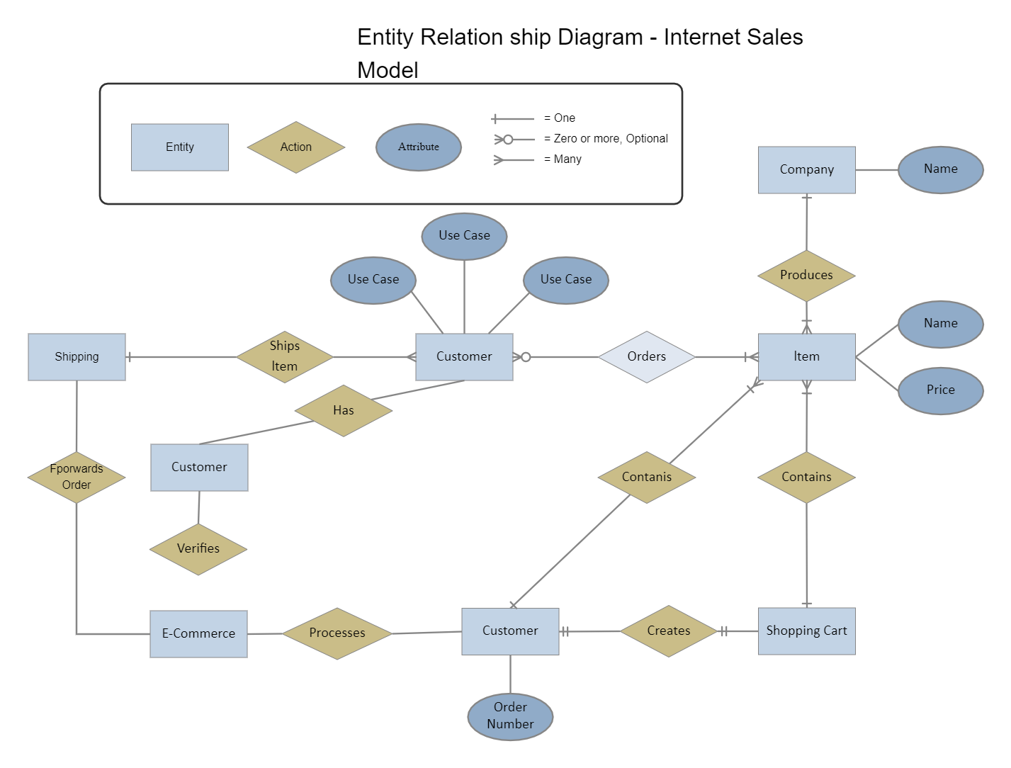

**Fig** **4.2:**  **ER Diagram**

**4.4.2 DFD (Data Flow Diagram)**

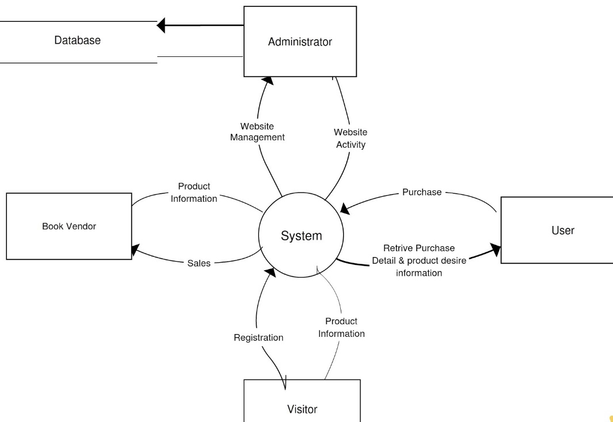

**Fig** **4.3:** **DFD Level-1**

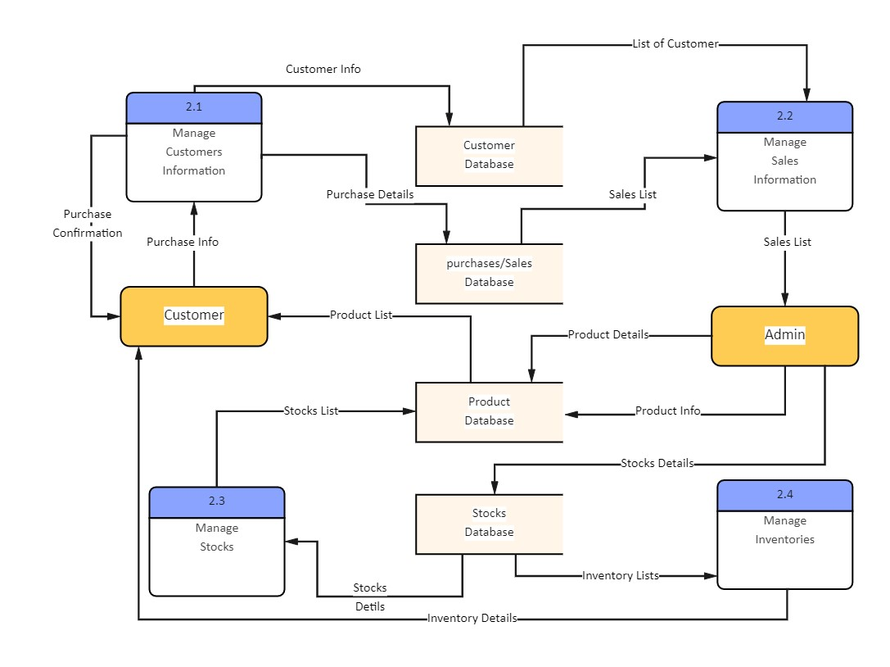

**Fig** **4.4:**  **DFD Level-2**

**4.4.3 USE CASE DIAGRAM**

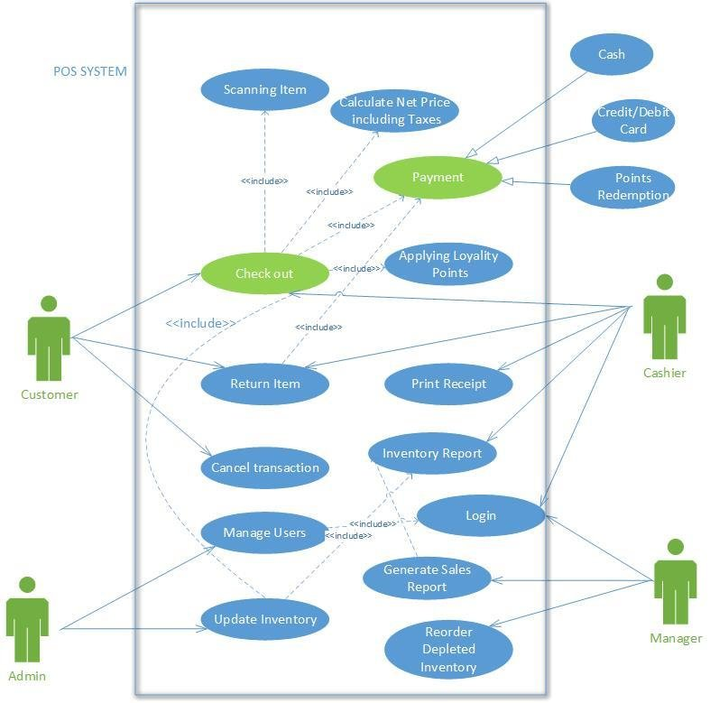

4.6 DATA INPUTS

Outputs are selected from the database based on a certain criteria and displayed using forms. The entire SMS itself contains a number of forms, However, for the systems main components, below are some snap shots of the key forms.

**4.6.1 Login Form**

The login form above is the first page a person accessing the system sees. It is used to gain access to the system resources and determines, based on the user type, which users should acess which resources



**Fig 4.7: Login form**

**4.6.2 dashboard**

The addition interface, managed by the admin, serves as the portal for integrating new patients into the system. Admins utilize this interface to input comprehensive patient details, facilitating seamless incorporation of individuals into the Sales Monitoring system. This feature empowers administrators to curate patient profiles while governing access to specific resources within the system, ensuring streamlined data input and appropriate categorization of sales network.

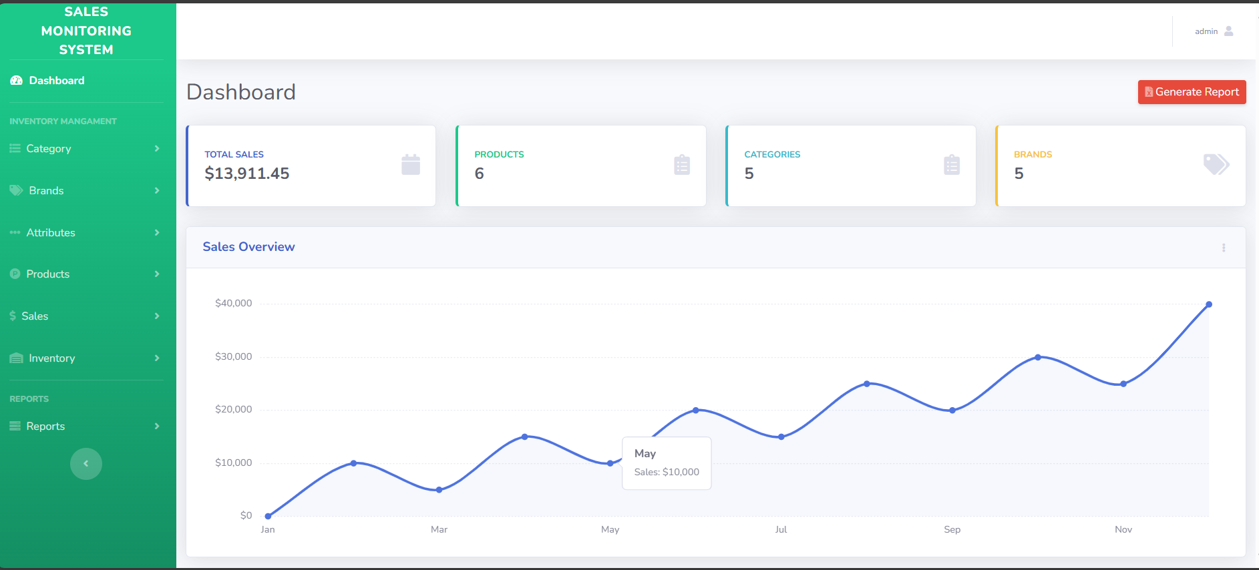

**Fig 4.8: Dashboard**

**4.6.3 Report Uploading Form**

The report uploading feature, managed by the admin, serves as the gateway for integrating essential Sales and Other reports into the system. This functionality empowers administrators to securely upload and integrate diverse reports, enriching the system’s repository of Sales information.

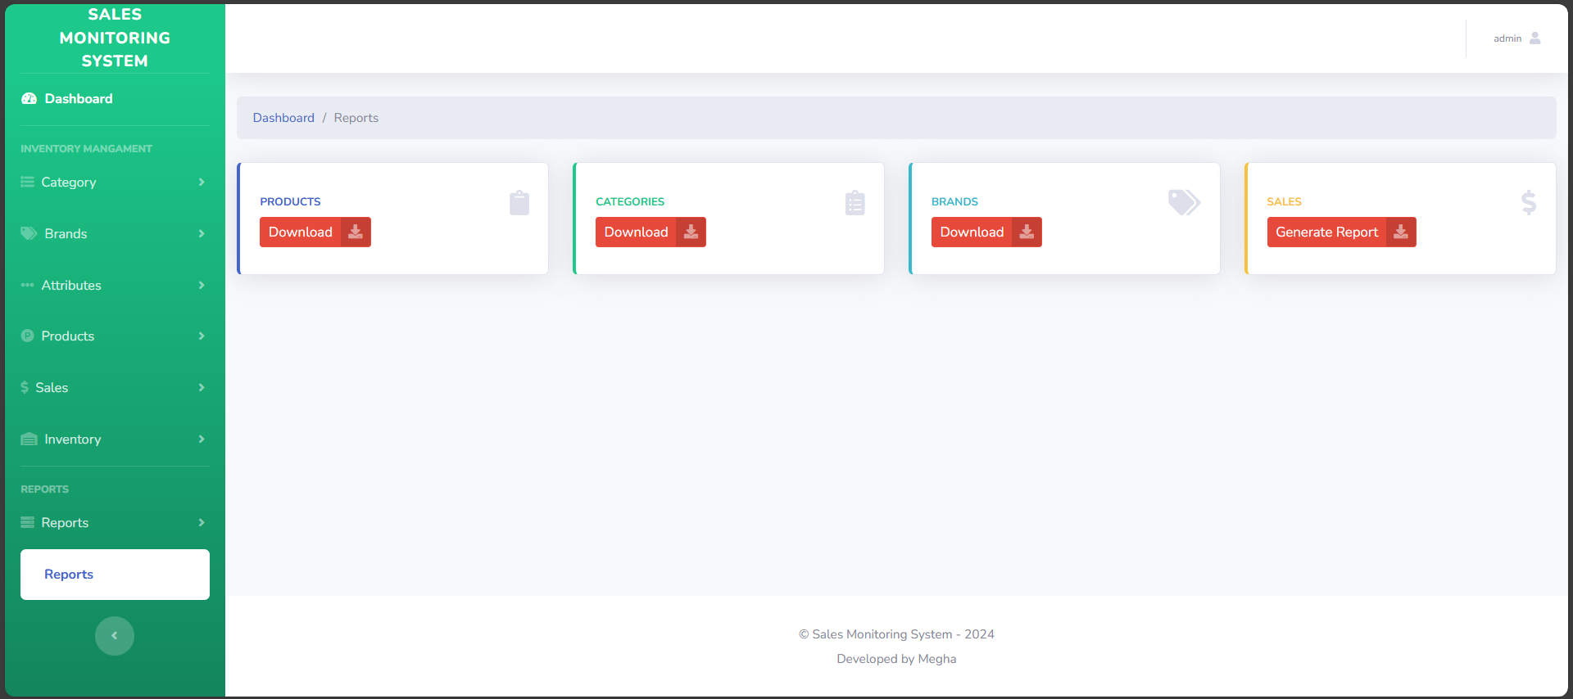

**Fig 4.9: Uploading Report form**

**4.6.4 Adding Product Form**

The user addition form serves as a gateway for authorized personnel to add new users into the system. This interface empowers designated administrators to securely integrate diverse users, ensuring controlled access and streamlined user management within the Sales system.

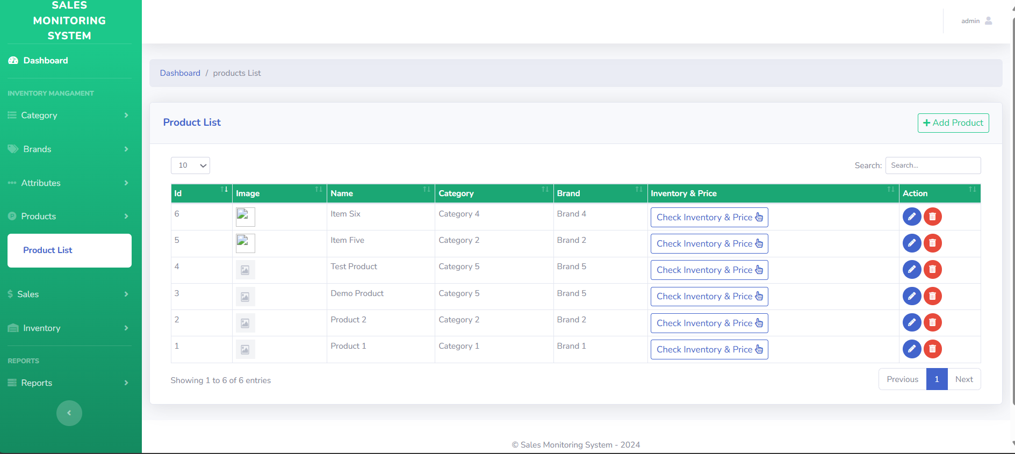

**Fig 4.11: Add Product form**

## 4.7 DATA OUTPUTS

Outputs are selected from the database based on a certain criteria and displayed using forms . The entire HRMS itself contains a number of forms, However, for the systems main components, below are some snap shots of the key forms.

**4.7.1 Data Storage Interface**

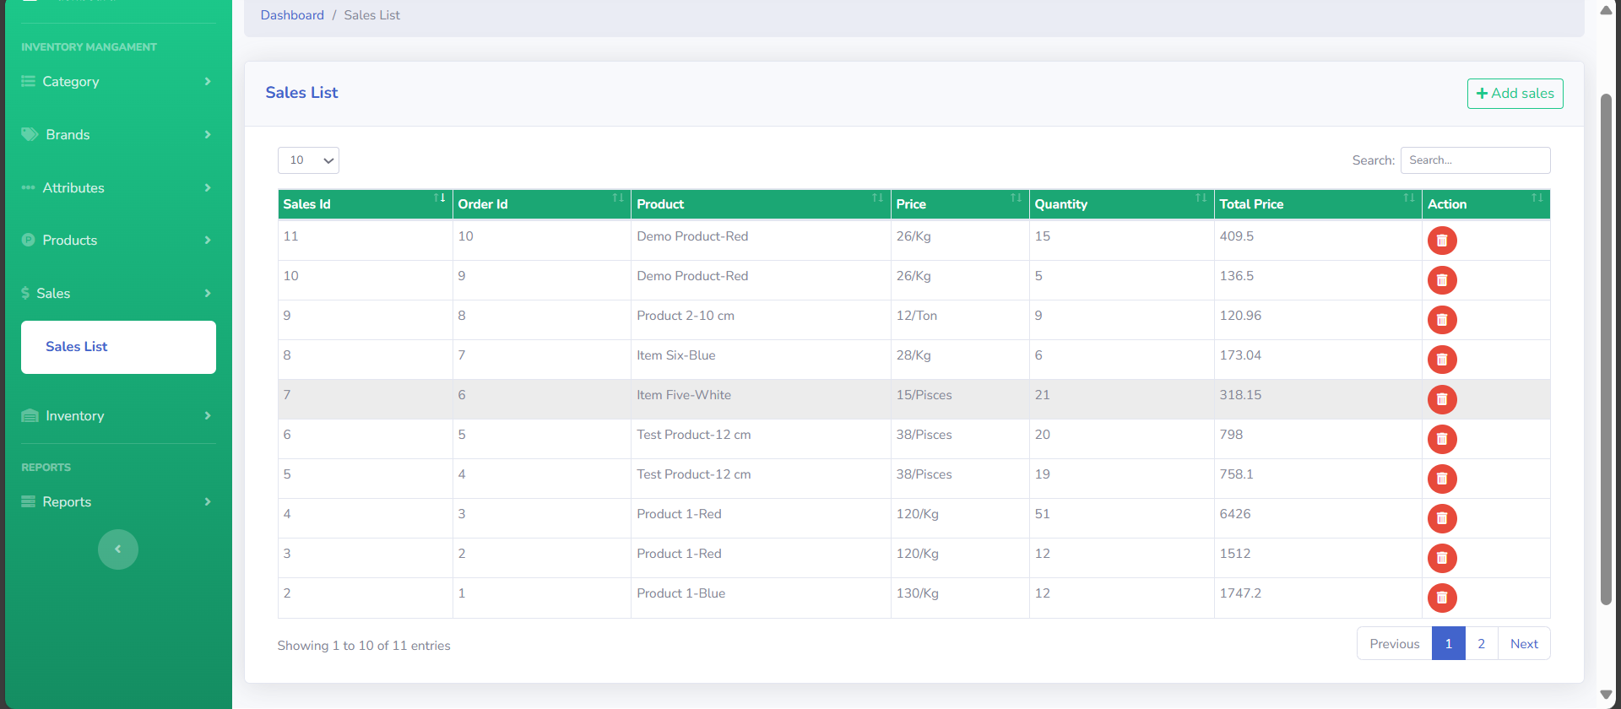After the data in entered into the system, it is stored and can be retrieved at any time using the search functionality.

**Fig 4.12:** **Data** **Storage** **interface** **for** **Sales** **History**

**4.7.2 Data Reports**

The system was designed with a system of generating pdf reports for the records using the pdf package. This functionality was integrated in order to facilitate printing of the records in the system.



## 4.8 IMPLEMENTATION & TESTING

**4.8.1 Implementation**

* **Overview of Technologies Used**

The Sales Monitoring system was developed using a combination of XAMPP, PHP, MySQL, JavaScript, HTML, and CSS. Each technology played a crucial role in the development and functionality of the system.

* **Development Environment Setup**

The initial phase involved setting up a local development environment using XAMPP. This provided a server environment comprising Apache, MySQL, PHP, and Perl, facilitating seamless testing and development.

* **Database Design**

The backbone of the SMS relied on a well-structured database. The design incorporated multiple tables enabling efficient data storage and retrieval.

* **Backend Development (PHP and MySQL)**

PHP was extensively utilized for server-side scripting, handling database interactions, and business logic implementation. MySQL was the chosen database management system, ensuring robust data management. PHP scripts were developed to manage various HRMS functionalities:

**Patient Registration**: Created PHP scripts to capture and store Patient details in the database.

**Sales Record:** Implemented functionality to record and update Sales records based on timestamps.

* **Frontend Development (HTML, CSS, JavaScript)**

The user interface was designed using HTML for structure, CSS for styling, and JavaScript for interactivity. Key aspects of the frontend development included:

**User-friendly Interface:** Designed intuitive layouts and forms for easy navigation and data input.

**Responsive Design**: Ensured compatibility across different devices and screen sizes for enhanced accessibility.

**Interactive Elements**: Implemented JavaScript functionalities for dynamic features such as real-time data updates and form validations.

**4.8.2 Testing**

Testing a sales monitoring system is crucial to ensure its functionality, accuracy, and reliability. Here’s a detailed approach to testing such a system:

1. Functional Testing:

- Data Input and Validation:

- Test various scenarios for data input (e.g., sales transactions, customer information).

- Validate that input fields enforce correct data types (e.g., numeric fields only accept numbers).

- Report Generation:

- Generate sample reports and verify that they contain accurate and relevant data.

- Check calculations within reports (e.g., total sales, average order value).

- User Management:

- Test user roles and permissions to ensure that different users have appropriate access levels.

- Verify that administrators can add, modify, and deactivate users as needed.

2. Performance Testing:

- Load Testing:

- Simulate multiple users accessing the system simultaneously.

- Measure system response times and ensure they remain within acceptable limits.

- Stress Testing:

- Test the system under extreme loads to determine its breaking point.

- Identify any bottlenecks or performance issues.

3. Security Testing:

- Authentication and Authorization:

- Test login credentials to ensure only authorized users can access the system.

- Check that sensitive data is encrypted during transmission and storage.

- Assessment:

- Conduct tests for common security vulnerabilities such as SQL injection, cross-site scripting (XSS), and cross-site request forgery (CSRF).

4. Usability Testing:

- User Interface (UI) Testing:

- Evaluate the ease of use and intuitiveness of the system's interface.

- Ensure consistency in design elements and navigation.

- Accessibility Testing:

- Verify that the system is accessible to users with disabilities (e.g., screen readers for visually impaired users).

5. Integration Testing:

- Third-Party Integrations:

- Test integrations with other systems or services (e.g., payment gateways, CRM systems).

- Ensure data exchange and synchronization are seamless and accurate.

6. Compatibility Testing:

- Cross-Browser Testing:

- Test the system on different web browsers (e.g., Chrome, Firefox, Safari, Edge).

- Ensure compatibility with various browser versions.

- Device Compatibility:

- Test on different devices (e.g., desktops, tablets, smartphones) to ensure responsive design and functionality.

7. Regression Testing:

- Change Management:

- Perform regression tests whenever updates or enhancements are made to the system.

- Ensure that new changes do not introduce unintended side effects or break existing functionality.

8. Data Integrity Testing:

- Data Accuracy:

- Validate that data stored in the system matches the expected results from test cases.

- Check for consistency and accuracy in data retrieval and storage.

9. Disaster Recovery Testing:

- Backup and Restore:

- Test backup procedures to ensure data can be securely backed up and restored.

- Verify recovery processes in case of system failures or data loss.

10. User Acceptance Testing (UAT):

- End-User Feedback:

- Involve end-users in testing to gather feedback on the system’s usability and functionality.

- Address any issues or concerns raised by users before final deployment.

Documentation:

- Test Documentation:

- Maintain comprehensive documentation of test cases, test results, and any issues encountered during testing.

- Document procedures for future reference and troubleshooting.

By following this structured testing approach, you can ensure that your sales monitoring system meets quality standards, performs reliably under various conditions, and delivers accurate insights for effective decision-making.

# CHAPTER 5

# EVALUATIONS & CONCLUSIONS

## 5.1 EVALUATION

Evaluating and concluding on a sales monitoring system involves assessing its performance, usability, effectiveness, and alignment with business goals. Here’s a structured approach to evaluate and draw conclusions about such a system:

1. Performance Evaluation:

- Functionality:

- Evaluate whether the system meets all specified functional requirements.

- Check if all features (e.g., data input, report generation, user management) perform as expected without errors.

- Scalability:

- Assess how well the system handles increasing volumes of data and users.

- Determine if it can scale up effectively to support future growth.

- Reliability:

- Measure system uptime and availability.

- Evaluate how often the system encounters downtime or issues affecting operations.

- Performance Metrics:

- Review performance metrics such as response times for queries and reports.

- Compare against benchmarks to ensure performance meets acceptable standards.

2. Usability Assessment:

- User Interface (UI):

- Gather feedback on the intuitiveness and ease of navigation within the system.

- Evaluate if the UI design facilitates efficient use and minimizes user errors.

- Accessibility:

- Ensure the system accommodates users with diverse needs (e.g., accessibility for visually impaired users).

- Confirm adherence to accessibility standards and guidelines.

3. Effectiveness:

- Data Accuracy:

- Verify the accuracy and reliability of data generated by the system.

- Cross-check reports and analytics against real-world data to validate insights.

- Decision Support:

- Evaluate how well the system supports decision-making processes.

- Assess if it provides relevant and timely insights that aid in strategic and operational decisions.

4. Business Alignment:

- Alignment with Goals:

- Assess whether the system aligns with the organization’s strategic objectives and business processes.

- Evaluate if it contributes to improving sales performance, optimizing operations, or enhancing customer satisfaction.

- Return on Investment (ROI):

- Calculate the ROI based on factors such as cost savings, efficiency gains, and revenue increases attributed to the system.

- Determine if the benefits outweigh the initial investment and ongoing maintenance costs.

5. User Feedback and Adoption:

- User Satisfaction:

- Gather feedback from end-users (e.g., sales teams, managers) on their overall satisfaction with the system.

- Address any usability issues or pain points identified during feedback sessions.

- Adoption Rate:

- Evaluate the adoption rate of the system within the organization.

- Determine if users embrace the system and utilize it effectively in their daily tasks.

## 5.5 CONCLUSION

In Conclusion, from a proper analysis and assessment of the designed system, it can be safely concluded that the system is an efficient, usable and reliable Sales management system. It is working properly and adequately meets the minimum expectations that were set for it initially.

Based on the evaluation criteria above, draw conclusions about the sales monitoring system:

- Strengths: Highlight key strengths of the system, such as robust functionality, reliable performance, user-friendly interface, and alignment with business goals.

- Areas for Improvement: Identify any weaknesses or areas where the system could be enhanced, such as improving certain features, addressing performance bottlenecks, or enhancing data visualization capabilities.

- Recommendations: Provide recommendations for further optimization or enhancements to maximize the system’s effectiveness and ROI.

- Future Roadmap: Outline future plans for the system, including potential upgrades, integrations with new technologies, or expansions to support evolving business needs.

By conducting a thorough evaluation and drawing clear conclusions, stakeholders can make informed decisions about the sales monitoring system, ensuring it continues to support business objectives effectively. Regular reviews and updates based on feedback and evolving requirements will help maintain the system’s relevance and value over time.

## REFERENCES & BIBLIOGRAPHY

["Software Reliability,". Available: 1 ttps://users.ece.cmu.edu/~koopman/des_s99/sw_reliability/. ] [“Testing”, Available: 2 https://www.vogella.com/tutorials/JUnit/article.html ] [“UML diagram”, Available: 3 https://www.uml-diagrams.org/sequence-diagrams.html ] [“Requirement”, Available: 4 https://www.tutorialspoint.com/software_engineering/software_requirements.html