**SYNOPSIS**

**Report on**

**“HEALTH RECORD MANAGEMENT SYSTEM”**

**By**

**MEGHA CHAUDHARY**

**Session: 2023-2024 (III Semester)**

**Under the supervision of**

**Dr. AMIT KUMAR(Asst. Professor)**

### KIET Group of Institutions, Delhi-NCR, Ghaziabad



### Department Of Computer Applications

**KIET GROUP OF INSTITUTIONS, DELHI-NCR, GHAZIABAD-201206**

(2023- 2024)

**ABSTRACT**

The Health Record Management System (HRMS) is a comprehensive digital solution designed to streamline the storage, retrieval, and management of patient health records within healthcare facilities. This innovative system aims to address the challenges associated with traditional paper-based record keeping and enhance the overall efficiency and quality of patient care.

The HRMS project offers a user-friendly interface accessible to healthcare professionals, administrators, and patients. The Health Record Management System project represents a significant leap forward in healthcare administration and patient care. By digitizing and centralizing health records, it minimizes the risk of errors, improves data accessibility, and enhances the overall patient experience. Moreover, it provides healthcare facilities with the tools they need to streamline operations, reduce administrative burdens, and focus on delivering high-quality care.

**TABLE OF CONTENTS**

Page Number

1. Introduction --
2. Problem Statement --
3. Project Objective --
4. Project Outcome --
5. System Description/Modules --
6. System Requirement --
7. DFD --

References --

**INTRODUCTION**

Hospital are the essential part of our lives which provides us with the best medical facilities for various sickness, it may be due to the change in climatic conditions, stress (emotional trauma) etc. It is necessary for the hospital to keep track of all activities and records day in and day out of its patient, doctors, nurses and other staffs that keeps the hospital in its operation

Keeping track of all activities and reports on paper is very inefficient and time consuming and also error prone. Keeping records on paper is a traditional base system that sometimes do not make it robust, in any case of damage all files will be lost that will cost a lot to the organization Day in and day out many people visit the hospital and when using the traditional base system it make it unreliable in the sense that it will take longer time to enter or access data and also maintaining. It is not economically and technically feasible to maintain these records on paper.

Health Record Management System (HRMS) is a comprehensive web-based application designed to streamline healthcare facilities and enhance health record management. This project aims to provide a centralized platform that allows doctors, patients, and clinic administrators to efficiently manage medical records, appointments, and communication.

The primary objective of the Health Record Management System is to improve the patient experience, optimize healthcare provider efficiency, and maintain accurate and secure medical records. By leveraging technology, the system simplifies the management of healthcare facilities and enhances the overall quality of care provided.

**BACKGROUND/PROBLEM STATEMENT**

In today's healthcare landscape, the management of patient health records continues to be a significant challenge. The traditional paper-based record-keeping system is cumbersome, error-prone, and inefficient. Healthcare facilities are facing the following problems:

1. **Inefficient Record Storage:** Paper-based health records are difficult to organize, store, and retrieve. This inefficiency leads to delays in accessing critical patient information, potentially impacting patient care outcomes.
2. **Data Inaccuracy:** Handwritten records are susceptible to errors, including illegible handwriting and data entry mistakes. Such inaccuracies can result in misdiagnoses, incorrect treatments, and compromised patient safety.
3. **Limited Accessibility:** Paper records are typically stored in physical files or cabinets, making it challenging for healthcare providers to access patient information remotely. This limitation hinders timely decision-making and patient care coordination.
4. **Security Risks:** Traditional records are vulnerable to physical damage, theft, or unauthorized access. Ensuring the confidentiality and security of patient data is a constant concern.
5. **Administrative Overhead:** Maintaining paper records necessitates extensive administrative work, including manual filing, record retrieval, and appointment scheduling. This diverts valuable resources away from patient care.
6. **Patient Engagement:** Patients often lack convenient access to their health records and face difficulties in scheduling appointments or refilling prescriptions, reducing their involvement in their own healthcare management.

**PROJECT OBJECTIVE**

1. **Digitization of Health Records:** The primary objective of the HRMS project is to transition from paper-based health records to electronic health records (EHRs). This involves the conversion of existing patient data into a digital format and the creation of a system to manage all future health records electronically.
2. **Efficient Record Retrieval:** Develop a user-friendly interface that allows healthcare providers to quickly access and retrieve patient health records, reducing the time spent searching for information and enhancing the quality of patient care.
3. **Data Accuracy and Integrity:** Ensure that the HRMS captures and maintains accurate and up-to-date patient information, reducing errors associated with handwritten records and data entry mistakes..
4. **Streamlined Administrative Processes:** Simplify administrative tasks, such as appointment scheduling, prescription management, and billing, to reduce administrative overhead and allow healthcare providers to focus more on patient care.
5. **Improved Patient Engagement:** Provide patients with convenient access to their own health records, enabling them to schedule appointments, request prescription refills, and actively participate in their healthcare management.
6. **Remote Access:** Enable healthcare providers to access patient records remotely, promoting better care coordination, especially in cases of emergencies or when healthcare professionals are working from different locations.
7. **Scalability and Flexibility:** Design the HRMS to be scalable and adaptable to accommodate the changing needs of healthcare facilities of various sizes and specialties.
8. **Cost Reduction:** Reduce costs associated with paper record storage, retrieval, and maintenance while improving operational efficiency and reducing the likelihood of errors.
9. **Enhanced Patient Care:** Ultimately, the HRMS project aims to enhance the overall quality of patient care by providing healthcare providers with easy access to comprehensive and accurate patient information, enabling timely and informed decisions in the provision of healthcare services.

**PROJECT OUTCOME**

The successful outcome of a Health Record Management System (HRMS) project can bring about numerous benefits and positive changes in the healthcare sector. Here are some of the key outcomes that can be expected:

1. **Efficient Record Management:** The transition from paper-based records to electronic health records (EHRs) leads to efficient and organized management of patient health data. Records are easily searchable, accessible, and secure.
2. **Improved Data Accuracy:** Electronic records reduce the risk of errors associated with manual data entry and illegible handwriting, enhancing the accuracy and reliability of patient information.
3. **Enhanced Patient Care:** Healthcare providers have quick access to comprehensive patient histories, enabling more informed and timely clinical decisions. This can result in improved patient care, reduced medical errors, and better treatment outcomes.
4. **Streamlined Administrative Processes:** Administrative tasks like appointment scheduling, prescription management, and billing become more efficient, reducing administrative overhead and allowing staff to focus on patient care.
5. **Increased Patient Engagement:** Patients can actively participate in their healthcare management by accessing their own records, scheduling appointments online, and requesting prescription refills, leading to greater patient satisfaction and engagement in their health.
6. **Remote Access:** Healthcare providers can access patient records remotely, which is particularly valuable in emergencies, telemedicine, and situations requiring cross-team collaboration.

In summary, the successful implementation of a Health Record Management System project can lead to a transformative shift in healthcare operations, resulting in improved patient care, streamlined processes, enhanced data security and compliance, and significant cost savings for healthcare facilities.

**SYSTEM DESCRIPTION**

The system consists of the following three major modules and their sub-modules:

* **Admin:**

1. **Login:**

* The admin can log in using their credentials.

1. **Manage Doctor:**

* The admin can add, update, delete and view doctors’ details.

1. **View Patients:**

* The admin can search patients by their name and patient Id.
* They can view the patients’ details and their past treatments.

1. **View Appointments:**

* The admin can view the appointment details by filtering the dates.

1. **View Feedback:**

* They can also view the feedback given by patients.
* **Doctor:**

1. **Login**:

* The doctor can log in using their credentials.

1. **Profile**:

* The doctor can manage their profile.

1. **Change Password:**

* They can change their passwords if they want.

1. **View Appointments:**

* The doctor can view the appointment details by filtering the dates.
* They can also view patient details and their past treatments.
* They can add treatment for their patients.

1. **View Patients**

* The doctor can search for patients by their names or patient Ids.
* They can view patient details and their past treatments.
* **Patient:**

1. **Register:**

* The patient would need to register first to log in.

1. **Login:**

* The patient can log in after registering.

1. **Profile**:

* They can manage their profile.

1. **Change Password:**

* They can change their password if they want.

1. **New Booking:**

* The patient can choose the doctor, date and slot.
* After making all the selections, they can book an appointment.

1. **Booking History:**

* The patient can view all their appointments here.
* They can cancel bookings anytime they want.

1. **Search Doctor:**

* The patient can search doctors by their name, type and locality.
* They can view the doctors’ details.

1. **Feedback**

* They can give feedback to Admin.

1. **Treatments:** The patient can view treatments and the details added by doctors.

**System Requirements**

1. **Hardware Requirement**
2. **Laptop or PC**

* Windows 7 or higher
* I3 processor system or higher
* 4 GB RAM or higher
* 100 GB ROM or higher

1. **Software Requirement**
2. **Laptop or PC**

* php
* MySql
* VS Code
* XAMP Server

**DATA FLOW DIAGRAM (DFD)**

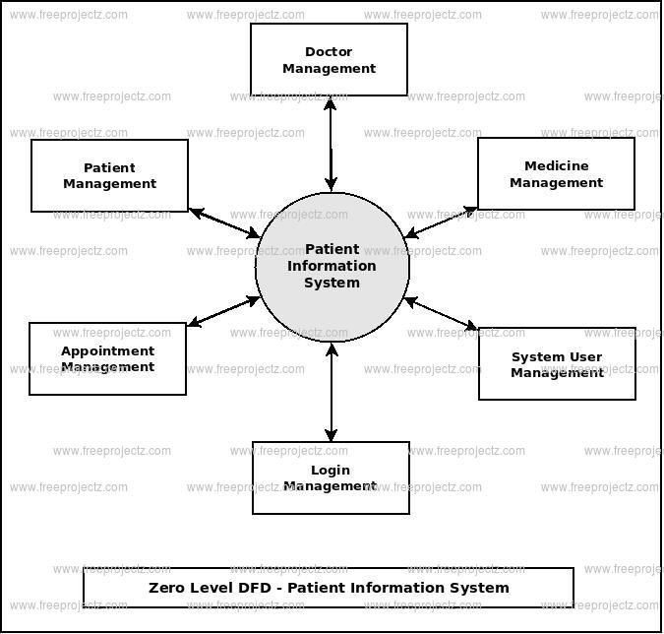

**Reference**

* <https://www.jetir.org/papers/JETIR2005455.pdf>
* <https://www.academia.edu/26066176/Design_and_Development_of_Online_Doctor_Appointment_System>
* <https://ijcrt.org/papers/IJCRT1812133.pdf>
* <https://arxiv.org/ftp/arxiv/papers/1701/1701.08786.pdf>