Arduino -Based Caesar Cipher
Encryption and Decryption
System Using LCD Display

GORHTI MEGHANA
Dept. of ECE
G. Pullaiah College of Engineering & Technology
Kurnool, India
BALIJA CHAMAKURA SREE GOWRI
Dept. of ECE
G. Pullaiah College of Engineering & Technology
Kurnool, India

GOLLA LALITHA
Dept. of ECE
G. Pullaiah College of Engineering & Technology
Kurnool, India
Abstract:

This paper presents a secure data encryption and decryption system using a microcontroller like Arduino Uno R3. The system utilizes a keypad for input and an LCD for output display. A simple Caesar cipher algorithm is implemented to perform encryption and decryption operations. The system takes letters A–Z as input and displays encrypted and decrypted text on an LCD. A Caesar cipher algorithm (+3/-3 shift) is used for encryption and decryption. The entered plaintext is converted into ciphertext to ensure data security, and it is later decrypted back to its original form. The system demonstrates a basic yet effective approach to protecting sensitive information from unauthorized access. This project highlights the importance of cryptographic techniques in real-time applications such as secure communication and password protection.

Keywords— Arduino, Encryption, Decryption, Caesar Cipher, LCD, Data Security.

INTRODUCTION:

In today’s digital era, the importance of data security has increased significantly due to the rapid growth of communication technologies and internet-based applications. Sensitive information such as passwords, personal data, banking details, and confidential messages are frequently transmitted over networks. This makes them vulnerable to unauthorized access, hacking, and cyber-attacks. Therefore, protecting data from such threats has become a major concern. To ensure secure communication, cryptographic techniques such as encryption and decryption are widely used. Encryption is the process of converting readable data, known as plaintext, into an unreadable format called ciphertext, making it difficult for unauthorized users to understand the information. Decryption is the reverse process, which converts the ciphertext back into its original readable form. These techniques play a vital role in maintaining data confidentiality, integrity, and security. Among various encryption methods, the Caesar cipher is one of the simplest and most widely known techniques. In this method, each character of the plaintext is shifted by a fixed number of positions. Although it is a basic technique, it provides a clear understanding of how encryption and decryption work in real-world applications.

In this project, a simple and efficient encryption and decryption system is developed using Arduino Uno R3, which acts as the main processing unit. The system takes input from the user through the Serial Monitor (and can be extended to a keypad in hardware implementation). The entered text is processed using the Caesar cipher algorithm with a +3 shift for encryption and a −3 shift for decryption. The results are displayed on a 16×2 LCD module, providing a real-time visual output.

This project not only demonstrates the basic principles of cryptography but also shows how hardware and software can be integrated to build practical embedded systems. It can be further extended for applications such as secure communication systems, password protection mechanisms, and data transmission security.
With the increasing use of embedded systems in daily life, the need for implementing security at the hardware level has also grown. Microcontrollers like Arduino provide a simple and cost-effective platform to develop such security-based applications. By integrating both hardware and software, embedded systems can perform real-time data processing and provide immediate output.
Cryptography plays a crucial role in modern communication systems, ensuring data confidentiality, integrity, and authentication. Even though advanced encryption techniques are widely used in industries, basic algorithms like the Caesar cipher are still important for understanding the fundamental concepts of encryption and decryption.
In this project, a simple encryption and decryption system is implemented using Arduino Uno R3 as the main processing unit. The system accepts input from the user through the Serial Monitor and processes the data using the Caesar cipher algorithm with a fixed shift value. The output is then displayed on a 16×2 LCD module, providing real-time results.
This project demonstrates the integration of hardware and software to develop a basic embedded security system. It also highlights the fundamental concepts of cryptography and provides a foundation for developing more advanced secure communication systems in the future.

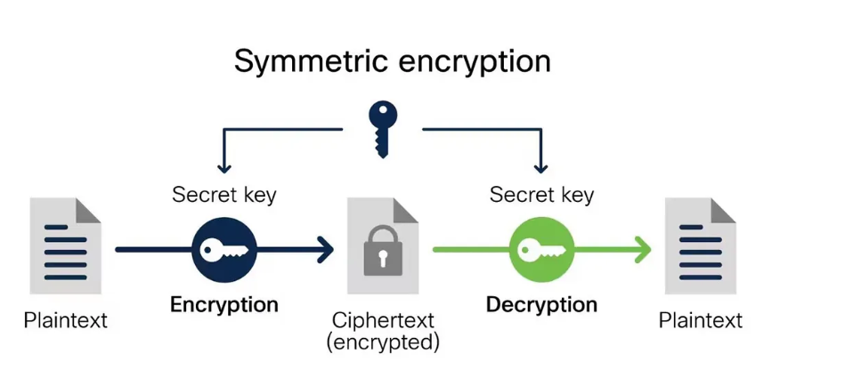 The overall encryption and decryption process is shown in Fig. 1.

LITERATURE SURVEY:

The study of data encryption and decryption using embedded systems has been a focus of research for both educational and practical purposes. Many researchers have implemented microcontroller-based encryption systems to secure sensitive information.
Smith et al. [1] designed a hardware-based encryption system using microcontrollers, demonstrating the use of the Caesar cipher algorithm for converting plain text into cipher text. The work highlighted the feasibility of simple encryption methods on embedded platforms.
Johnson et al. [2] proposed a simulation-based educational encryption system, showing how Caesar cipher and other simple cryptographic techniques can be effectively used to teach the fundamentals of data security.
Other researchers, like Kumar [3], implemented embedded systems with LCD displays to provide real-time visual feedback of encryption and decryption processes. These systems enhanced understanding by allowing users to observe input, encrypted, and decrypted data simultaneously.
Most prior work focused on either software-only encryption or limited hardware demonstration. This project fills the gap by combining Arduino hardware, LCD display, and a Caesar cipher (+3/−3 shift), offering a complete, interactive system for learning and demonstration purposes. The system provides real-time encryption and decryption, making it suitable for educational expos and embedded systems labs.

METHODOLOGY :

The proposed system is designed to implement a simple and efficient data encryption and decryption mechanism using a microcontroller-based approach. The methodology focuses on three main stages: data input, processing (encryption/decryption), and output display. The entire system is developed using Arduino Uno R3, which acts as the central processing unit.
A. System Architecture
The system architecture consists of three major components:
- Input Unit: The input is provided by the user through the Serial Monitor interface (in simulation) or a keypad (in hardware implementation). The user enters alphabetic characters (A–Z), which are taken as plaintext input.
- Processing Unit: The Arduino Uno R3 processes the input data. It reads the characters, stores them in memory, and applies the Caesar cipher algorithm to perform encryption and decryption operations.
- Output Unit: The output is displayed on a 16×2 LCD module. The LCD shows the original input text, encrypted text, and decrypted text sequentially.

B. Input Handling
The system continuously monitors the Serial communication channel using the Serial .available() function. When data is received, it reads the complete input string using read String Until('\n'). The input is then processed to remove unwanted characters such as spaces or newline symbols. To ensure consistency, the input text is converted into uppercase format using a standard conversion method. Only alphabetic characters (A–Z) are considered for encryption, while other characters are ignored or passed without modification.

C. Encryption Process
The encryption process is carried out using the Caesar Cipher algorithm, which is a substitution technique. In this method, each character of the plaintext is shifted forward by a fixed number of positions (key value = +3).
The ASCII value of each character is used to perform the shifting operation. If the shifted value exceeds the range of uppercase alphabets (‘A’ to ‘Z’), it is wrapped around using modulo arithmetic.
The mathematical representation of encryption is:

C = (P + K) mod 26

where:
P = plaintext character position
C = ciphertext character position
K = shift value (3 in this system)

The encrypted characters are stored in a separate string and displayed on the LCD module.

- D. Decryption Process
Decryption is the reverse of the encryption process. The encrypted text is processed using the same Caesar cipher algorithm but with a negative shift value (−3).
Each character of the ciphertext is shifted backward to retrieve the original plaintext. If the value goes below the range of ‘A’, it is adjusted using modulo arithmetic to maintain the correct range.
The mathematical representation of decryption is:
P = (C − K) mod 26
This ensures that the original message is accurately reconstructed. The decrypted text is then displayed on the LCD after a predefined delay.

- E. Display Mechanism
The LCD module is interfaced with the Arduino using 4-bit mode to reduce the number of required pins. The display operates in two rows:
- First row: Displays the operation (Input / Encrypted / Decrypted)
- Second row: Displays the corresponding text
The system uses lcd.clear() and lcd.setCursor() functions to update the display dynamically. Delays are introduced between operations to allow the user to clearly observe each stage of the process.

- F. System Flow
The overall system flow is as follows:
- Initialize LCD and Serial communication
- Wait for user input
- Read and store input text
- Display input text on LCD
- Perform encryption using +3 shift
- Display encrypted text
- Perform decryption using −3 shift
- Display decrypted text
- Reset system for next input

COMPONENTS :

The proposed system is implemented using a software simulation environment. Instead of physical hardware, virtual components are used to demonstrate the working of the encryption and decryption system. The components used in this project are listed below:
1. Arduino Uno R3 (Virtual)
It acts as the main processing unit of the system. It reads the input data, performs encryption and decryption using the Caesar cipher algorithm, and controls the output display.
2. 16×2 LCD Display (Virtual)
The LCD module is used to display the input text, encrypted text, and decrypted text. It provides a clear visual representation of the process.
3. Serial Monitor (Input Interface)
The Serial Monitor is used to provide input text to the system. The user enters alphabetic characters (A–Z), which are processed by the Arduino.
4. Wokwi Simulation Platform
The entire system is designed and tested using the Wokwi simulation platform. It allows the implementation of Arduino-based projects without physical hardware, making it efficient for testing and demonstration purposes.

IV. ALGORITHM:

The proposed system uses a Caesar Cipher algorithm to perform encryption and decryption operations on the input text. Initially, the user enters a message through the Serial Monitor, and the system reads the input string. The input is processed character by character, and all letters are converted into uppercase (A–Z) to maintain uniformity.
During the encryption phase, each character of the plaintext is shifted forward by a fixed key value of +3. If the shifted value exceeds the letter ‘Z’, the algorithm performs a wrap-around operation, continuing from ‘A’ to maintain the range within the alphabet. The resulting characters form the encrypted text (ciphertext), which is stored temporarily.
The encrypted message is then displayed on the LCD screen with a label indicating the encryption result. After displaying the encrypted output, the system proceeds to the decryption phase. In this stage, each character of the ciphertext is shifted backward by the same key value (−3). If the value goes below ‘A’, it wraps around to ‘Z’, ensuring proper recovery of the original text.
Finally, the decrypted message is displayed on the LCD, confirming that the original plaintext has been successfully retrieved. This algorithm is simple, efficient, and suitable for implementation in embedded systems, as it requires minimal computational resources while effectively demonstrating the concept of data security.

The system uses a Caesar Cipher algorithm, which is a simple substitution technique where each character is shifted by a fixed number of positions.

Step 1: Input
- The user enters text through the Serial Monitor.
- The system reads the input string.
- The input characters are converted into uppercase letters (A–Z).

Step 2: Encryption
- Take each character of the input text.
- Shift the character forward by +3 positions using the Caesar cipher.
- If the character exceeds ‘Z’, wrap around to ‘A’.
- Store the result as the encrypted text.

Step 3: Display Encrypted Text
- Display the message “Encrypted:” on the LCD.
- Show the encrypted output on the LCD screen.

fStep 4: Decryption
- Take each character of the encrypted text.
- Shift the character backward by −3 positions.
- If the character goes below ‘A’, wrap around to ‘Z’.
- Retrieve the original plaintext.

Step 5: Display Decrypted Text
- Display the message “Decrypted:” on the LCD.
- Show the original message on the LCD screen.

Example
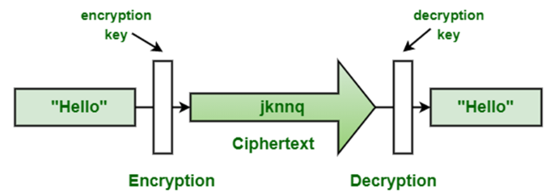

RESULTS AND DISCUSSION:

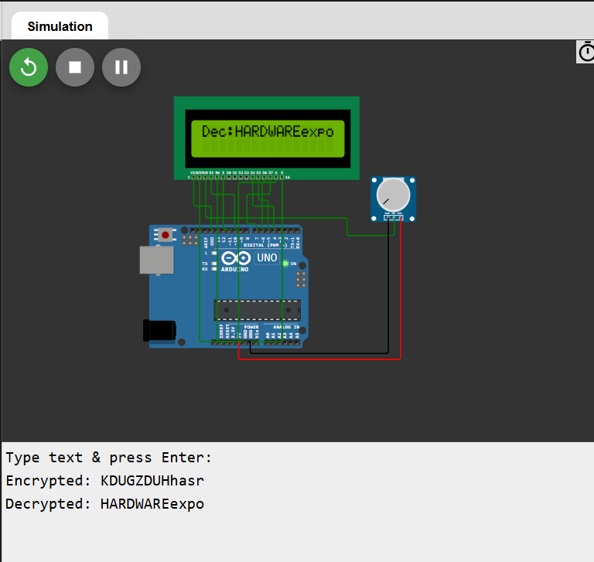

The proposed system was successfully implemented using the Wokwi simulation platform. The Arduino-based encryption and decryption system was tested with different input strings consisting of uppercase alphabetic characters (A–Z).
The system correctly reads the input from the Serial Monitor and displays it on the LCD. Upon processing, the encryption operation shifts each character by +3 positions, generating the corresponding ciphertext. The encrypted output is clearly displayed on the LCD module.
After a predefined delay, the system performs decryption by shifting the characters back by −3 positions, successfully retrieving the original plaintext. The decrypted output matches the input text, confirming the correctness of the algorithm.
The results demonstrate that the system works efficiently in real-time and provides a clear understanding of basic cryptographic operations. Although the Caesar cipher is a simple technique, it effectively illustrates the concept of secure data transformation.

CONCLUSION:
In this project, a simple encryption and decryption system has been successfully implemented using Arduino Uno R3. The main objective was to demonstrate the basic concept of data security using the Caesar cipher algorithm. The system takes input text from the user, processes it using a fixed key value, and displays both encrypted and decrypted outputs on a 16×2 LCD display.
The working of the system involves shifting each character of the input text by +3 positions for encryption, converting plaintext into ciphertext. The encrypted message is displayed on the LCD, providing a clear visual output. During the decryption process, the system shifts each character backward by −3, restoring the original message. This confirms that the algorithm is simple, reversible, and efficient for basic data security applications.
The project highlights how cryptographic techniques can be integrated with embedded systems to achieve real-time data processing and visualization. The use of Arduino makes the system easy to implement and understand, while the LCD display enhances user interaction by showing the results clearly.
Although the Caesar cipher provides only basic security, this project serves as a strong foundation for understanding encryption and decryption concepts. It can be further extended with advanced algorithms and hardware components for real-world applications.

FUTURE SCOPE:

The proposed encryption and decryption system demonstrates a basic implementation of data security using the Caesar cipher algorithm. However, the system can be further enhanced in several ways to improve its functionality and security. In future, the system can be upgraded by replacing the Serial Monitor input with a matrix keypad, making it a fully hardware-based system. Advanced encryption algorithms such as AES or RSA can be implemented to provide stronger security compared to the simple Caesar cipher. The project can also be extended by integrating wireless communication modules like Bluetooth or Wi-Fi, enabling secure data transmission between devices. Additionally, a mobile or web interface can be developed to control and monitor the system remotely.
Further improvements include adding password protection, data storage, and multi-user access systems. Thus, the project can be expanded into a real-time secure communication system with enhanced features and applications.

REFERENCE PAPERS:
- [1] A. J. Menezes, P. C. van Oorschot, and S. A.Vanstone,
“Handbook of Applied Cryptography”, CRC Press, 1996.
- [2] D. R. Stinson,
“Cryptography: Theory and Practice”, 2nd Edition, CRC Press, 2002.
- [3] W. Stallings,
“Cryptography and Network Security: Principles and Practice”, 3rd Edition, Prentice Hall, 2003
- [4] B. Schneier,
“Applied Cryptography: Protocols, Algorithms, and Source Code in C”, 2nd Edition, Wiley, 1996
- [5] N. Koblitz,
“A Course in Number Theory and Cryptography”, Springer, 1994.
- [6] W. Stallings,
“Network Security Essentials: Applications and Standards”, 6th Edition, Pearson, 2016.
- • [7] C. Paar and J. Pelzl,
“Understanding Cryptography: A Textbook for Students and Practitioners”, Springer, 2010.
- • [8] J. Katz and Y. Lindell,
“Introduction to Modern Cryptography”, 2nd Edition, CRC Press, 2014.
- • [9] M. Bishop,
“Computer Security: Art and Science”, Addison-Wesley, 2003.
- • [10] Arduino Official Documentation,
“Arduino Uno R3 Datasheet and User Guide”, Available: https://www.arduino.cc
- • [11] OWASP Foundation,
“OWASP Top Ten Web Application Security Risks”, Available: https://owasp.org
- [12] William Stallings,
“Data and Computer Communications”, 10th Edition, Pearson, 2013.

