Name: Meghaj Nandumar BarhateProgramme: M.Tech. in Fluid and Thermal SciencesRoll Number: 261050047

Rectangular Plate: Steady-State Heat Conduction
A thin rectangular plate of width $a$ and height $b$ has three sides held at $0^\circ\mathrm{C}$ while the fourth (top) side is held at a uniform temperature $T_0$. There is no internal heat generation and the plate is thin enough that conduction may be treated as two-dimensional, so that the steady-state temperature field satisfies Laplace's equation
$$
\frac{\partial^2 T}{\partial x^2}
+
\frac{\partial^2 T}{\partial y^2}
=0,
\qquad
0 \le x \le a,
\qquad
0 \le y \le b.
$$

Boundary Conditions
$$
T(x,0)=0,
\qquad
T(0,y)=0,
\qquad
T(a,y)=0,
\qquad
T(x,b)=T_0.
$$

Data
$$
a=0.4\ \mathrm{m},
\qquad
b=0.2\ \mathrm{m},
\qquad
T_0=100^\circ\mathrm{C}.
$$

Analytical Solution

By separation of variables,
$$
T(x,y)
\frac{4T_0}{\pi}
\sum_{n=1,3,5,\ldots}^{\infty}
\frac{1}{n}
\sin\left(\frac{n\pi x}{a}\right)
\frac{
\sinh\left(\frac{n\pi y}{a}\right)
}{
\sinh\left(\frac{n\pi b}{a}\right)
}.
$$
Use enough terms to ensure the series has converged to at least five significant figures before using it as your benchmark.
Fig. 1: Rectangular plate with three sides at $0^\circ\mathrm{C}$ and the top side at $T_0$; inset shows the interior 5-point stencil at node $(i,j)$.

Tasks

$$
[A]{T}={b}
$$
for a uniform grid with
$$
\Delta x = \Delta y = h.
$$

$$
h = 0.02,; 0.01,; 0.005\ \mathrm{m}.
$$
• Jacobi
• Gauss-Seidel
• SOR
For SOR, try at least three values of the relaxation factor $\omega$, including the theoretical optimum for a rectangular Dirichlet problem.
Record the number of iterations and CPU time for each method.
$$
\left(\frac{a}{4},\frac{b}{2}\right),
\qquad
\left(\frac{a}{2},\frac{b}{2}\right),
\qquad
\left(\frac{3a}{4},\frac{b}{2}\right),
\qquad
\left(\frac{a}{2},\frac{3b}{4}\right).
$$
Tabulate the maximum absolute error versus $h$ and confirm the expected accuracy of the 5-point scheme.
$$
O(h^2)
$$

Numerical Methods Project Requirements

1. Discretization Derivation
Derive the finite-difference (or control-volume) discretization from first principles before writing any code.

2. Analytical Validation
Wherever an analytical solution is given, validate your numerical solution against it at several interior points and report the maximum absolute and percentage errors, not just a visual comparison of plots.

3. Linear System Solution
Solve the linear system $[A]{T} = {b}$ by:
• (i) Direct method: Gaussian elimination / LU decomposition, exploiting bandedness where possible.
• (ii) Iterative methods: Jacobi, Gauss–Seidel, and SOR, as specified in each problem.
For each method, report:
• Number of iterations
• Wall-clock time
• Memory footprint (as the grid is refined)
Then discuss which approach you would recommend and why.

4. Grid-Refinement (Convergence) Study
Perform a grid-refinement study for every problem. Use at least three grid sizes, with error plotted or tabulated against $\Delta x$, $\Delta r$, or $\Delta \theta$ as appropriate.

5. Convergence Criteria and Parameters
State all of the following clearly:
• Convergence criteria (e.g., $\max |T^{p+1} - T^p| < 10^{-6}$)
• Initial guesses used
• Relaxation factors used (for SOR or other iterative methods)

Import Libraries
import matplotlib.pyplot as plt
import numpy as np
from scipy.linalg import lu_factor, lu_solve
import os
import time as t
%pip install -qq numpy scipy matplotlib psutil ipympl
%matplotlib widget
%matplotlib widget
from pathlib import Path
from matplotlib.cm import ScalarMappable
from matplotlib.colors import Normalize
Note: you may need to restart the kernel to use updated packages.

Generate Problem Statement Schematic (Figure 1)
from matplotlib.patches import Rectangle
from matplotlib.lines import Line2D
# ------------------------------------------------------------
# Geometry
# ------------------------------------------------------------
length = 0.4
breadth = 0.2
#Placeholder for Graphical representation of the domain and the stencil points
dx = 0.02
dy = 0.02
y_shift = 0.1
#Problem has 1 Axis of Symmetry, so we can use half the domain for the simulation. The other half can be obtained by mirroring the results.
xmin, xmax = -length / 2, length / 2
ymin_ref, ymax_ref =0.0 , breadth
ymin, ymax = ymin_ref , ymax_ref
# ------------------------------------------------------------
# Mesh coordinates
# ------------------------------------------------------------
x_grid = np.arange(xmin, xmax + 1e-12, dx)
y_grid = np.arange(ymin_ref, ymax_ref + 1e-12, dy) + y_shift
# ------------------------------------------------------------
# Stencil points measured from the origin
# ------------------------------------------------------------
points = {
"(i,j)": (3 * dx, 3 * dy + y_shift), # red
"(i,j-1)": (3 * dx, 2 * dy + y_shift), # blue
"(i,j+1)": (3 * dx, 4 * dy + y_shift), # violet
"(i-1,j)": (2 * dx, 3 * dy + y_shift), # green
"(i+1,j)": (4 * dx, 3 * dy + y_shift), # purple
}
# ------------------------------------------------------------
# Location to move delta x and delta y arrows: grid point (8,3)
# ------------------------------------------------------------
base_x = 8 * dx
base_y = 3 * dy + y_shift
# ------------------------------------------------------------
# Plot
# ------------------------------------------------------------
fig, ax = plt.subplots(figsize=(10, 5))
# Faint light-grey dashed mesh
for x in x_grid:
ax.plot([x, x], [ymin , ymax], linestyle="--", linewidth=0.7, color="lightgrey", alpha=0.8, zorder=1)
for y in y_grid:
ax.plot([xmin, xmax], [y - y_shift, y - y_shift], linestyle="--", linewidth=0.7, color="lightgrey", alpha=0.8, zorder=1)
# Rectangle boundary in LaTeX blue
ax.add_patch(Rectangle((xmin, ymin), length, breadth, fill=False, edgecolor="#0000FF", linewidth=2.2, zorder=2))
# Cartesian axes through origin
ax.axhline(0, color="black", linewidth=0.9, zorder=0)
ax.axvline(0, color="Red", linewidth=0.9, zorder=0)
# ------------------------------------------------------------
# Stencil points
# ------------------------------------------------------------
ax.scatter(*points["(i,j)"], s=90, color="red", zorder=5)
ax.scatter(*points["(i,j-1)"], s=75, color="#0000FF", zorder=5)
ax.scatter(*points["(i,j+1)"], s=75, color="violet", zorder=5)
ax.scatter(*points["(i-1,j)"], s=75, color="green", zorder=5)
ax.scatter(*points["(i+1,j)"], s=75, color="purple", zorder=5)
# Mark the reference location (8,3)
ax.scatter(base_x, base_y, s=25, color="black", zorder=6)
# ------------------------------------------------------------
# Move delta x and delta y arrows to grid point (8,3)
# ------------------------------------------------------------
ax.annotate("", xy=(base_x + dx, base_y), xytext=(base_x, base_y), arrowprops=dict(arrowstyle="<->", color="black", linewidth=1.5), zorder=6)
ax.annotate("", xy=(base_x, base_y + dy), xytext=(base_x, base_y), arrowprops=dict(arrowstyle="<->", color="black", linewidth=1.5), zorder=6)
ax.text(base_x + dx / 2, base_y - 0.012, r"$\Delta x$", ha="center", va="top", fontsize=11)
ax.text(base_x - 0.012, base_y + dy / 2, r"$\Delta y$", ha="right", va="center", rotation=90, fontsize=11)
# ------------------------------------------------------------
# Index / legend for stencil-point colors
# ------------------------------------------------------------
legend_handles = [
Line2D([0], [0], marker='o', linestyle='None', markerfacecolor='red', markeredgecolor='red', markersize=8, label=r"Red Point: $(i,j)$"),
Line2D([0], [0], marker='o', linestyle='None', markerfacecolor='#0000FF', markeredgecolor='#0000FF', markersize=8, label=r"Blue Point: $(i,j-1)$"),
Line2D([0], [0], marker='o', linestyle='None', markerfacecolor='violet', markeredgecolor='violet', markersize=8, label=r"Violet Point: $(i,j+1)$"),
Line2D([0], [0], marker='o', linestyle='None', markerfacecolor='green', markeredgecolor='green', markersize=8, label=r"Green Point: $(i-1,j)$"),
Line2D([0], [0], marker='o', linestyle='None', markerfacecolor='purple', markeredgecolor='purple', markersize=8, label=r"Purple Point: $(i+1,j)$"),
]
ax.legend(handles=legend_handles, loc="lower center", bbox_to_anchor=(0.5, -0.32), ncol=3, frameon=True, fontsize=10, title="Stencil Point Index")
# ------------------------------------------------------------
# Formatting
# ------------------------------------------------------------
ax.set_aspect("equal", adjustable="box")
ax.set_xlim(xmin - 0.03, xmax + 0.03)
ax.set_ylim(ymin_ref - 0.03, ymax_ref + 0.03)
ax.set_xlabel(r"$x$")
ax.set_ylabel(r"$y$")
ax.set_title(r"Rectangular Domain with 5-Point Stencil with uniform $\Delta x$, $\Delta y$, with Symmetry about Y axis")
plt.show()
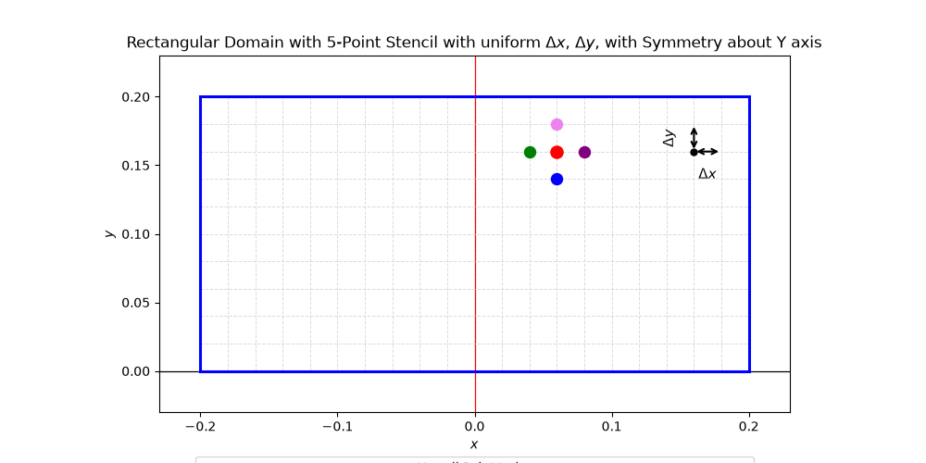

Task (A)

For the reduced half-domain,
$$
0 \le x \le \frac{a}{2},
\qquad
0 \le y \le b,
$$
with a uniform grid spacing
$$
\Delta x = \Delta y = h,
$$
the number of grid points in the $x$-direction is
$$
\boxed{
n_x = \frac{a/2}{h} + 1
= \frac{a}{2h}+1
}
$$
and the number of grid points in the $y$-direction is
$$
\boxed{
n_y = \frac{b}{h}+1
}
$$
where $n_x$ and $n_y$ include the boundary points. Therefore,
$$
\boxed{
n_x = \frac{a}{2h}+1,
\qquad
n_y = \frac{b}{h}+1
}
$$
given that
$$
\frac{a}{2h}
\qquad \text{and} \qquad
\frac{b}{h}
$$
are integers.

Matrix is given as:
Define
$$
N_x=n_x-1,
$$
This is because the last column of the rectangular grid will have no finite difference form as it is a dirichlet boundary condition (i=nx)
$$
N_y=n_y-2,
$$
This is because the top and bottom row of the rectangular grid will have no finite difference form as it is a dirichlet boundary condition (j = 0 and j = ny)
so that the total number of unknown temperatures is
$$
N=N_xN_y=(n_x-1)(n_y-2).
$$
The unknown vector is ordered row-by-row as

$$
\mathbf{x}
\begin{bmatrix}
T_{0,1} \
T_{1,1} \
T_{2,1} \
\vdots \
T_{N_x-1,1} \
T_{0,2} \
T_{1,2} \
\vdots \
T_{N_x-1,N_y}
\end{bmatrix}.
$$
For a uniform square mesh, $\Delta x=\Delta y=h$, the system is
$$
\boxed{\mathbf{A}\mathbf{x}=\mathbf{b}}
$$
where

Discretized Linear System
For a 9 rows × 10 columns grid i.e. h = 0.02, the linear system $\mathbf{A}\mathbf{x}=\mathbf{b}$ is:
Let (\mathbf{D}) be the (10\times 10) horizontal‑direction matrix (left boundary: Neumann, right boundary: Dirichlet):
$$
\mathbf{D}=
\begin{bmatrix}
-4 & 2 & 0 & 0 & \cdots & 0 & 0 & 0 \
1 & -4 & 1 & 0 & \cdots & 0 & 0 & 0 \
0 & 1 & -4 & 1 & \cdots & 0 & 0 & 0 \
\vdots & \vdots & \vdots & \vdots & \ddots & \vdots & \vdots & \vdots \
0 & 0 & 0 & 0 & \cdots & 1 & -4 & 1 \
0 & 0 & 0 & 0 & \cdots & 0 & 1 & -4
\end{bmatrix}_{10\times 10}
$$
and (\mathbf{I}) the (10\times 10) identity matrix.
Then the (90\times 90) matrix (\mathbf{A}) is block‑tridiagonal with 9 block rows and columns:
$$
\mathbf{A}=
\begin{bmatrix}
\mathbf{D} & \mathbf{I} & \mathbf{0} & \cdots & \mathbf{0} \
\mathbf{I} & \mathbf{D} & \mathbf{I} & \ddots & \vdots \
\mathbf{0} & \mathbf{I} & \mathbf{D} & \ddots & \mathbf{0} \
\vdots & \ddots & \ddots & \ddots & \mathbf{I} \
\mathbf{0} & \cdots & \mathbf{0} & \mathbf{I} & \mathbf{D}
\end{bmatrix}.
$$
Unknown vector (row‑wise ordering, (i)=row, (j)=column):
$$
\mathbf{x}=
\begin{bmatrix}
T_{0,0}, T_{0,1}, \ldots, T_{0,9}, ;
T_{1,0}, \ldots, T_{1,9}, ;
\ldots, ;
T_{8,0}, \ldots, T_{8,9}
\end{bmatrix}^T.
$$
Right‑hand side (source term on the bottom row only):
$$
\mathbf{b}=
\begin{bmatrix}
\underbrace{0,\ldots,0}{80\text{ entries}},
\underbrace{-100,\ldots,-100}{10\text{ entries}}
\end{bmatrix}^T.
$$
Thus the system is fully defined without expanding the (90\times 90) matrix explicitly.

Prescribed Boundary Conditions
Bottom boundary:
$$
T_{i,0}=0,
\qquad
i=0,1,\ldots,n_x-1
$$
Right boundary:
$$
T_{n_x-1,j}=0,
\qquad
j=0,1,\ldots,n_y-1
$$
Top boundary:
$$
T_{i,n_y-1}=T_0=100^\circ\mathrm{C},
\qquad
i=0,1,\ldots,n_x-1
$$
The left boundary is the symmetry boundary and is therefore not Dirichlet:
$$
\left.
\frac{\partial T}{\partial x}
\right|_{i=0}
=0.
$$
with
$$
T_0=100^\circ\mathrm C.
$$
Thus,

$$
\boxed{
\mathbf A_{,N\times N}
\mathbf x_{,N\times1}
\mathbf b_{,N\times1},
\qquad
N=(n_x-1)(n_y-2)
}
$$

Variable and Mesh Setup
Following section allows to edit with the mesh grid and boundary conditions to solve for various cases for a similar domain.
a = 0.4/2 # Length of the rectangular domain
b = 0.2 # Width of the rectangular domain
TNorthWall = 100 # Temperature at the North wall
TSouthWall = 0 # Temperature at the South wall
TEastWall = 0 # Temperature at the East wall
TWestWall = 0 # Temperature at the West wall // Not used as we are exploiting symmetry.
N = 0 # Total number of unknowns in the domain (excluding boundary points)
nX = 0 # Number of grid points in x direction
nY = 0 # Number of grid points in y direction
linaearizedMeshGrid = {}
meshGrid = []
unifiedIndexMap = []
def MeshSetup(a, b, h):
global nX
global nY
nX = int(a/h) + 1 # Number of grid points in x direction
global nY
nY = int(b/h) + 1 # Number of grid points in y direction
i = range(0, nX-1) # x index for interior points
j = range(1, nY-2) # y index for interior points
global N
N = (nX-1)*(nY-2) # Total number of unknowns in the domain (excluding boundary points)
global linaearizedMeshGrid
global meshGrid
global unifiedIndexMap
# Defined a meshGrid dictionary to store the mapping of grid point indices to their corresponding (row, column) coordinates in the mesh.
# The loop iterates over the interior points of the grid (excluding boundary points) and populates the meshGrid dictionary with the appropriate mappings.
linaearizedMeshGrid = {}
meshGrid = np.zeros((nY-2,nX-1), dtype=float)
unifiedIndexMap = []
for rowId in range(nY - 2):
for columnId in range(0, nX - 1):
unifiedIndex = columnId + (nX - 1)*rowId
unifiedIndexMap.append(unifiedIndex)
if rowId == 0:
linaearizedMeshGrid[unifiedIndex] = [meshGrid[rowId][columnId], "SouthEnd"]
elif rowId == nY - 3:
linaearizedMeshGrid[unifiedIndex] = [meshGrid[rowId][columnId], "NorthEnd"]
elif columnId == 0:
linaearizedMeshGrid[unifiedIndex] = [meshGrid[rowId][columnId], "WestEnd"]
elif columnId == nX - 2:
linaearizedMeshGrid[unifiedIndex] = [meshGrid[rowId][columnId], "EastEnd"]
else:
linaearizedMeshGrid[unifiedIndex] = [meshGrid[rowId][columnId], "Interior"]
if unifiedIndex == 0:
linaearizedMeshGrid[unifiedIndex][1] = "SymmetricSouthWestCorner"
if unifiedIndex == nX - 2:
linaearizedMeshGrid[unifiedIndex][1] = "DirichletSouthEastCorner"
if unifiedIndex == (nX - 1)*(nY - 2) - (nX - 1):
linaearizedMeshGrid[unifiedIndex][1] = "SymmetricNorthWestCorner"
if unifiedIndex == (nX - 1)*(nY - 2) - 1:
linaearizedMeshGrid[unifiedIndex][1] = "DirichletNorthEastCorner"

Mesh Validation
def MeshValidation(a,b,h):
# Physical coordinates
x_coords = np.linspace(0, a-h, nX-1) # columns: 0 to nX-2
y_coords = np.linspace(h, b-h, nY-2) # rows: 1 to nY-2 in physical space
# ------------------------------------------------------------
# Colors for each node type
# ------------------------------------------------------------
#Set colors for mesh node type:
colors = {
"SouthEnd": "red",
"NorthEnd": "blue",
"WestEnd": "green",
"EastEnd": "orange",
"Interior": "gray",
"SymmetricSouthWestCorner": "purple",
"DirichletSouthEastCorner": "cyan",
"SymmetricNorthWestCorner": "magenta",
"DirichletNorthEastCorner": "yellow"
}
# ------------------------------------------------------------
# Plot the grid points
# ------------------------------------------------------------
plt.figure(figsize=(16, 8))
for rowId in range(nY - 2):
for columnId in range(0, nX - 1):
unifiedIndex = columnId + (nX - 1)*rowId
nodeType = linaearizedMeshGrid[unifiedIndex][1]
x = x_coords[columnId]
y = y_coords[rowId]
plt.scatter(x, y, color=colors[nodeType], s=80)
plt.text(x + 0.002, y + 0.002, str(unifiedIndex), fontsize=8)
# Domain outline
plt.plot([0, a, a, 0, 0], [0, 0, b, b, 0], 'k--', linewidth=1)
# Legend
for label, color in colors.items():
plt.scatter([], [], color=color, s=80, label=label)
plt.xlabel("x")
plt.ylabel("y")
plt.title("Grid Points with Boundary Classification and Unified Index")
plt.axis("equal")
plt.grid(True)
# Put legend below the plot
plt.legend(
loc="upper center",
bbox_to_anchor=(0.5, -0.15),
ncol=3,
fontsize=10,
frameon=True
)
# Add space at bottom for legend
plt.tight_layout(rect=[0, 0.08, 1, 1])
plt.show()

Setting Up System Matrix
Following section now uses the carefully setup linearMesgGrid, stored as a dictionary, for ease of naming and indexing and generates the Matrix Equations which will give us the solution to our problem at hand.
#Data Structures for Finite Difference Stencil
class StencilPointIds:
def __init__(self, point, N, S, E, W):
self.point = point
self.N = N
self.S = S
self.E = E
self.W = W
def ComputeNSEWPointIds(meshPointId):
# Compute the North, South, East, and West point IDs based on the current meshPointId
northId = meshPointId + (nX - 1) if (meshPointId + (nX - 1)) < N else None
southId = meshPointId - (nX - 1) if (meshPointId - (nX - 1)) >= 0 else None
eastId = meshPointId + 1 if (meshPointId + 1) % (nX - 1) != 0 else None
westId = meshPointId - 1 if meshPointId % (nX - 1) != 0 else None
return StencilPointIds(meshPointId, northId, southId, eastId, westId)
def GenerateSymmetricBoundaryCornerEquations(meshPointId):
dependencyMap = ComputeNSEWPointIds(meshPointId)
if(linaearizedMeshGrid[meshPointId][1] == "SymmetricSouthWestCorner"):
systemMatrix[meshPointId, dependencyMap.point] = -4.0;
systemMatrix[meshPointId, dependencyMap.N] = 1.0;
systemMatrix[meshPointId, dependencyMap.E] = 2.0;
temperatureVector[dependencyMap.point] = -TSouthWall;
elif linaearizedMeshGrid[meshPointId][1] == "SymmetricNorthWestCorner":
systemMatrix[meshPointId,dependencyMap.point] = -4.0;
systemMatrix[meshPointId,dependencyMap.S] = 1.0;
systemMatrix[meshPointId,dependencyMap.E] = 2.0;
temperatureVector[dependencyMap.point] = -TNorthWall;
elif linaearizedMeshGrid[meshPointId][1] == "WestEnd":
systemMatrix[meshPointId,dependencyMap.point] = -4.0;
systemMatrix[meshPointId,dependencyMap.N] = 1.0;
systemMatrix[meshPointId,dependencyMap.S] = 1.0;
systemMatrix[meshPointId,dependencyMap.E] = 2.0;
temperatureVector[dependencyMap.point] = 0.0;
def GenerateDirichletBoundaryCornerEquations(meshPointId):
dependencyMap = ComputeNSEWPointIds(meshPointId)
if (linaearizedMeshGrid[meshPointId][1] == "NorthEnd"):
systemMatrix[meshPointId, dependencyMap.point] = -4.0;
systemMatrix[meshPointId, dependencyMap.S] = 1.0;
systemMatrix[meshPointId, dependencyMap.W] = 1.0;
systemMatrix[meshPointId, dependencyMap.E] = 1.0;
temperatureVector[dependencyMap.point] = -TNorthWall;
elif (linaearizedMeshGrid[meshPointId][1] == "SouthEnd"):
systemMatrix[meshPointId, dependencyMap.point] = -4.0;
systemMatrix[meshPointId, dependencyMap.N] = 1.0;
systemMatrix[meshPointId, dependencyMap.W] = 1.0;
systemMatrix[meshPointId, dependencyMap.E] = 1.0;
temperatureVector[dependencyMap.point] = -TSouthWall;
elif (linaearizedMeshGrid[meshPointId][1] == "EastEnd"):
systemMatrix[meshPointId, dependencyMap.point] = -4.0;
systemMatrix[meshPointId, dependencyMap.N] = 1.0;
systemMatrix[meshPointId, dependencyMap.S] = 1.0;
systemMatrix[meshPointId, dependencyMap.W] = 1.0;
temperatureVector[dependencyMap.point] = -TEastWall;
elif (linaearizedMeshGrid[meshPointId][1] == "DirichletSouthEastCorner"):
systemMatrix[meshPointId, dependencyMap.point] = -4.0;
systemMatrix[meshPointId, dependencyMap.N] = 1.0;
systemMatrix[meshPointId, dependencyMap.W] = 1.0;
temperatureVector[dependencyMap.point] = -TEastWall - TSouthWall;
elif (linaearizedMeshGrid[meshPointId][1] == "DirichletNorthEastCorner"):
systemMatrix[meshPointId, dependencyMap.point] = -4.0;
systemMatrix[meshPointId, dependencyMap.S] = 1.0;
systemMatrix[meshPointId, dependencyMap.W] = 1.0;
temperatureVector[dependencyMap.point] = -TEastWall - TNorthWall;
def GenerateInternalNodeEquations(meshPointId):
dependencyMap = ComputeNSEWPointIds(meshPointId)
if (linaearizedMeshGrid[meshPointId][1] == "Interior"):
systemMatrix[meshPointId, dependencyMap.point] = -4.0;
systemMatrix[meshPointId, dependencyMap.N] = 1.0;
systemMatrix[meshPointId, dependencyMap.S] = 1.0;
systemMatrix[meshPointId, dependencyMap.E] = 1.0;
systemMatrix[meshPointId, dependencyMap.W] = 1.0;
temperatureVector[dependencyMap.point] = 0.0;
def GenerateSystemOfEquations():
for(meshPointId) in range(N):
if linaearizedMeshGrid[meshPointId][1] == "SymmetricSouthWestCorner" or linaearizedMeshGrid[meshPointId][1] == "SymmetricNorthWestCorner" or linaearizedMeshGrid[meshPointId][1] == "WestEnd":
GenerateSymmetricBoundaryCornerEquations(meshPointId)
elif linaearizedMeshGrid[meshPointId][1] == "NorthEnd" or linaearizedMeshGrid[meshPointId][1] == "SouthEnd" or linaearizedMeshGrid[meshPointId][1] == "EastEnd" or linaearizedMeshGrid[meshPointId][1] == "DirichletSouthEastCorner" or linaearizedMeshGrid[meshPointId][1] == "DirichletNorthEastCorner":
GenerateDirichletBoundaryCornerEquations(meshPointId)
elif linaearizedMeshGrid[meshPointId][1] == "Interior":
GenerateInternalNodeEquations(meshPointId)
print("System Matrix is Generated. The shape of the system matrix is:", systemMatrix.shape)
print("Temperature Vector is Generated. The shape of the temperature vector is:", temperatureVector.shape)
print("Funtion Setup for system of equations is complete. Please call the functions in the following order:")
Funtion Setup for system of equations is complete. Please call the functions in the following order:

Task B
$$
h = 0.02,; 0.01,; 0.005\ \mathrm{m}.
$$

Solve the System Using LU Decomposition
import Logger
import importlib
importlib.reload(Logger)
meshStepSizes = [
0.02,
0.01,
0.005
]
meshRefinementResults = Logger.RunMeshRefinementStudy(
a=a,
b=b,
meshStepSizes=meshStepSizes,
MeshSetup=MeshSetup,
MeshValidation=MeshValidation,
GenerateSystemOfEquations=GenerateSystemOfEquations,
notebookGlobals=globals(),
RunMeshValidation=True
)
from contextlib import redirect_stdout
with open("../../Dumps/Problem1/MeshRefinementResults.txt", "w") as outputFile, redirect_stdout(outputFile):
meshRefinementResults = Logger.RunMeshRefinementStudy(
a=a,
b=b,
meshStepSizes=meshStepSizes,
MeshSetup=MeshSetup,
MeshValidation=MeshValidation,
GenerateSystemOfEquations=GenerateSystemOfEquations,
notebookGlobals=globals(),
RunMeshValidation=False
)
====================================================================================================
STARTING MESH REFINEMENT STUDY
====================================================================================================
Number of mesh refinements : 3
Mesh step sizes : 0.02000 m, 0.01000 m, 0.00500 m
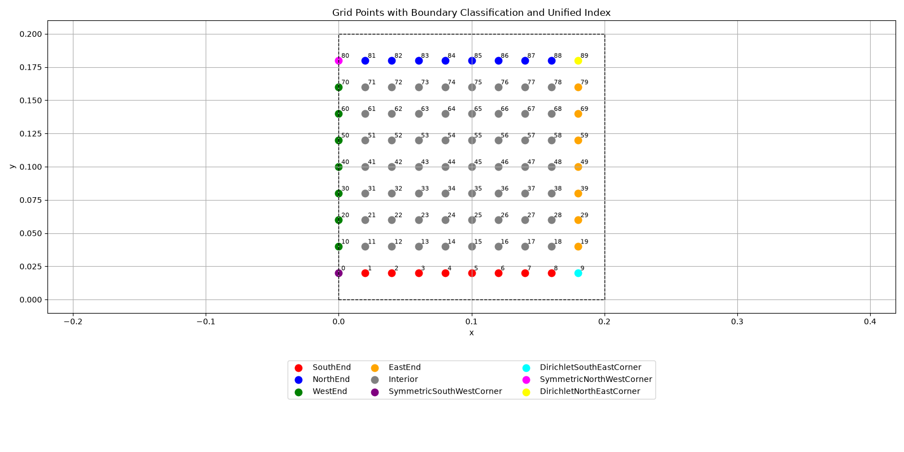
System Matrix is Generated. The shape of the system matrix is: (90, 90)
Temperature Vector is Generated. The shape of the temperature vector is: (90, 1)
====================================================================================================
FINITE DIFFERENCE PERFORMANCE REPORT — h = 0.020000 m
====================================================================================================
----------------------------------------------------------------------------------------------------
MESH INFORMATION
----------------------------------------------------------------------------------------------------
Domain length in x-direction : 0.200000 m
Domain length in y-direction : 0.200000 m
Computational domain area : 0.040000 m^2
Requested mesh spacing, h : 0.020000 m
Actual x-direction spacing, dx : 0.020000 m
Actual y-direction spacing, dy : 0.020000 m
Grid points in x-direction, nX : 11
Grid points in y-direction, nY : 11
x-direction intervals : 10
y-direction intervals : 10
Computational columns : 10
Computational rows : 9
Total unknowns, N : 90
----------------------------------------------------------------------------------------------------
COMPUTATIONAL NODE CLASSIFICATION
----------------------------------------------------------------------------------------------------
Interior nodes : 56
North boundary nodes : 8
South boundary nodes : 8
East boundary nodes : 7
West symmetry boundary nodes : 7
Symmetric south-west corner : 1
Symmetric north-west corner : 1
Dirichlet south-east corner : 1
Dirichlet north-east corner : 1
Total classified nodes : 90
Expected number of nodes, N : 90
Node classification consistency : PASS
----------------------------------------------------------------------------------------------------
LINEAR SYSTEM INFORMATION
----------------------------------------------------------------------------------------------------
System matrix dimensions : 90 x 90
Temperature vector dimensions : 90 x 1
Number of equations : 90
Matrix data type : float64
Total matrix coefficients : 8,100
Non-zero matrix coefficients : 412
Matrix sparsity : 94.9136 %
Exact system matrix storage : 0.061798 MB
Exact temperature vector storage : 0.000687 MB
Exact matrix + RHS storage : 0.062485 MB
----------------------------------------------------------------------------------------------------
PERFORMANCE OF MAJOR COMPUTATIONAL STEPS
----------------------------------------------------------------------------------------------------
Computational Step CPU Time [s] Wall Time [s] Delta Memory [MB]
----------------------------------------------------------------------------------------
1. Mesh Setup 0.000044 0.000044 0.000
2. Mesh Validation 0.251614 0.251873 9.039
3. Matrix / RHS Allocation 0.000018 0.000018 0.000
4. System Matrix Setup 0.000149 0.000137 0.000
5. LU Factorization 0.000185 0.000182 0.426
6. System Solution 0.000062 0.000062 0.188
----------------------------------------------------------------------------------------
TOTAL 0.252523 0.252687 9.656
----------------------------------------------------------------------------------------------------
DIRECT SOLVER SUMMARY
----------------------------------------------------------------------------------------------------
Solution method : LU decomposition with partial pivoting
LU factorization CPU time : 0.000185 s
System solution CPU time : 0.000062 s
Total direct solver CPU time : 0.000247 s
LU factorization wall time : 0.000182 s
System solution wall time : 0.000062 s
Total direct solver wall time : 0.000244 s
----------------------------------------------------------------------------------------------------
MEMORY USAGE
----------------------------------------------------------------------------------------------------
Process memory before simulation : 123.332 MB
Process memory after simulation : 132.988 MB
Net process memory change : 9.656 MB
System matrix storage : 0.061798 MB
Temperature vector storage : 0.000687 MB
Factorized system matrix storage : 0.061798 MB
Pivot indices storage : 0.000343 MB
Temperature solution vector storage : 0.000687 MB
Total tracked numerical storage : 0.125313 MB
----------------------------------------------------------------------------------------------------
NUMERICAL VERIFICATION
----------------------------------------------------------------------------------------------------
Temperature solution vector shape : (90, 1)
Temperature index range : 0 to 89
Minimum temperature : 1.55917038
Maximum temperature : 88.18601578
Residual norm ||A*T - b|| : 2.171178e-13
----------------------------------------------------------------------------------------------------
TEMPERATURE DATA OUTPUT
----------------------------------------------------------------------------------------------------
Temperature CSV : ../../Dumps/Problem1/TemperatureSolution_h_0.02000.csv
CSV index range : 0 to 89
CSV number of temperature values : 90
====================================================================================================
SIMULATION COMPLETE
====================================================================================================
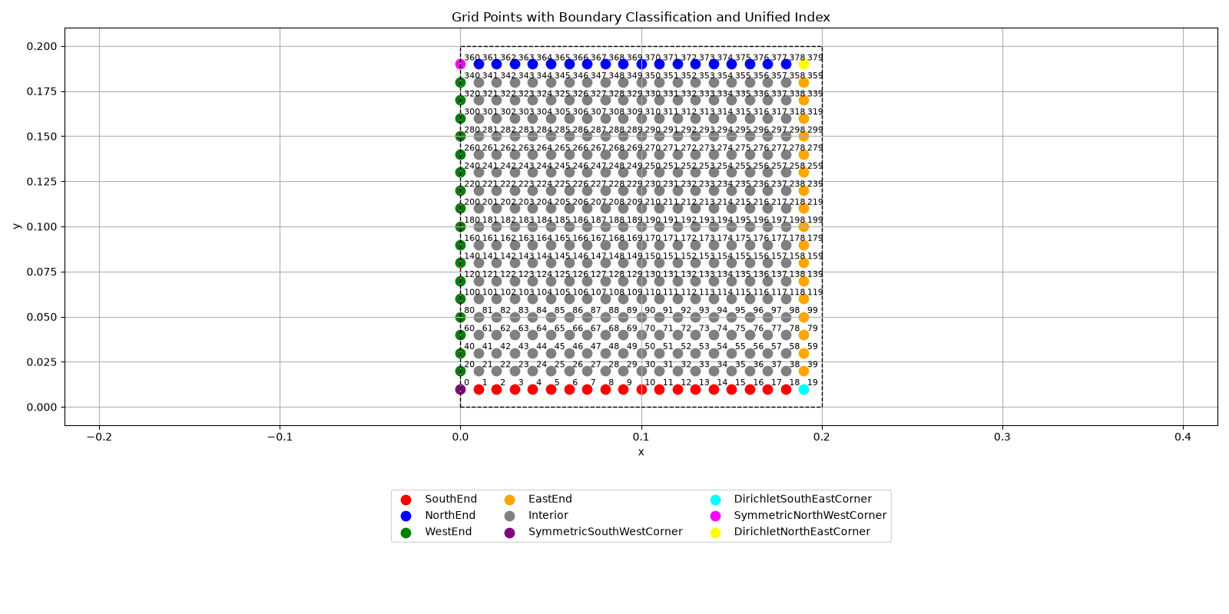
System Matrix is Generated. The shape of the system matrix is: (380, 380)
Temperature Vector is Generated. The shape of the temperature vector is: (380, 1)
====================================================================================================
FINITE DIFFERENCE PERFORMANCE REPORT — h = 0.010000 m
====================================================================================================
----------------------------------------------------------------------------------------------------
MESH INFORMATION
----------------------------------------------------------------------------------------------------
Domain length in x-direction : 0.200000 m
Domain length in y-direction : 0.200000 m
Computational domain area : 0.040000 m^2
Requested mesh spacing, h : 0.010000 m
Actual x-direction spacing, dx : 0.010000 m
Actual y-direction spacing, dy : 0.010000 m
Grid points in x-direction, nX : 21
Grid points in y-direction, nY : 21
x-direction intervals : 20
y-direction intervals : 20
Computational columns : 20
Computational rows : 19
Total unknowns, N : 380
----------------------------------------------------------------------------------------------------
COMPUTATIONAL NODE CLASSIFICATION
----------------------------------------------------------------------------------------------------
Interior nodes : 306
North boundary nodes : 18
South boundary nodes : 18
East boundary nodes : 17
West symmetry boundary nodes : 17
Symmetric south-west corner : 1
Symmetric north-west corner : 1
Dirichlet south-east corner : 1
Dirichlet north-east corner : 1
Total classified nodes : 380
Expected number of nodes, N : 380
Node classification consistency : PASS
----------------------------------------------------------------------------------------------------
LINEAR SYSTEM INFORMATION
----------------------------------------------------------------------------------------------------
System matrix dimensions : 380 x 380
Temperature vector dimensions : 380 x 1
Number of equations : 380
Matrix data type : float64
Total matrix coefficients : 144,400
Non-zero matrix coefficients : 1,822
Matrix sparsity : 98.7382 %
Exact system matrix storage : 1.101685 MB
Exact temperature vector storage : 0.002899 MB
Exact matrix + RHS storage : 1.104584 MB
----------------------------------------------------------------------------------------------------
PERFORMANCE OF MAJOR COMPUTATIONAL STEPS
----------------------------------------------------------------------------------------------------
Computational Step CPU Time [s] Wall Time [s] Delta Memory [MB]
----------------------------------------------------------------------------------------
1. Mesh Setup 0.000134 0.000134 0.012
2. Mesh Validation 0.693111 0.695032 20.316
3. Matrix / RHS Allocation 0.000112 0.000087 0.000
4. System Matrix Setup 0.000469 0.000461 0.000
5. LU Factorization 0.013539 0.002095 1.922
6. System Solution 0.000138 0.000079 0.000
----------------------------------------------------------------------------------------
TOTAL 0.732198 0.698194 22.254
----------------------------------------------------------------------------------------------------
DIRECT SOLVER SUMMARY
----------------------------------------------------------------------------------------------------
Solution method : LU decomposition with partial pivoting
LU factorization CPU time : 0.013539 s
System solution CPU time : 0.000138 s
Total direct solver CPU time : 0.013676 s
LU factorization wall time : 0.002095 s
System solution wall time : 0.000079 s
Total direct solver wall time : 0.002174 s
----------------------------------------------------------------------------------------------------
MEMORY USAGE
----------------------------------------------------------------------------------------------------
Process memory before simulation : 132.992 MB
Process memory after simulation : 155.246 MB
Net process memory change : 22.254 MB
System matrix storage : 1.101685 MB
Temperature vector storage : 0.002899 MB
Factorized system matrix storage : 1.101685 MB
Pivot indices storage : 0.001450 MB
Temperature solution vector storage : 0.002899 MB
Total tracked numerical storage : 2.210617 MB
----------------------------------------------------------------------------------------------------
NUMERICAL VERIFICATION
----------------------------------------------------------------------------------------------------
Temperature solution vector shape : (380, 1)
Temperature index range : 0 to 379
Minimum temperature : 0.38761747
Maximum temperature : 94.09687399
Residual norm ||A*T - b|| : 5.633659e-13
----------------------------------------------------------------------------------------------------
TEMPERATURE DATA OUTPUT
----------------------------------------------------------------------------------------------------
Temperature CSV : ../../Dumps/Problem1/TemperatureSolution_h_0.01000.csv
CSV index range : 0 to 379
CSV number of temperature values : 380
====================================================================================================
SIMULATION COMPLETE
====================================================================================================
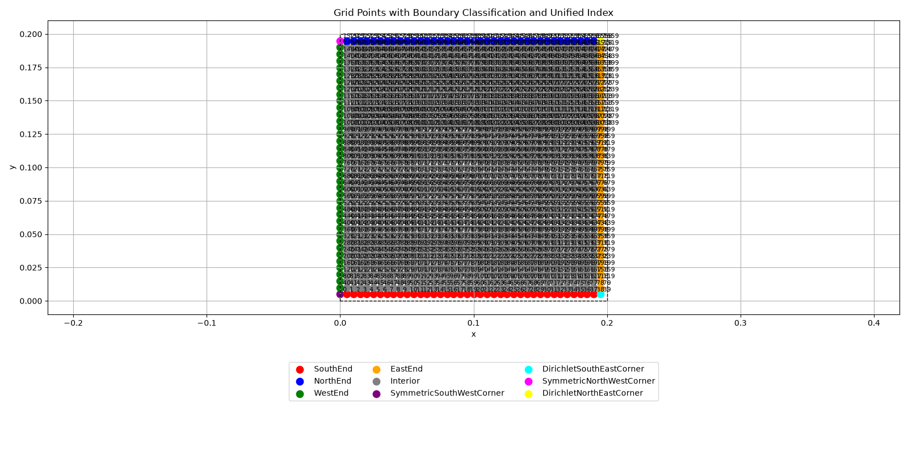
System Matrix is Generated. The shape of the system matrix is: (1560, 1560)
Temperature Vector is Generated. The shape of the temperature vector is: (1560, 1)
====================================================================================================
FINITE DIFFERENCE PERFORMANCE REPORT — h = 0.005000 m
====================================================================================================
----------------------------------------------------------------------------------------------------
MESH INFORMATION
----------------------------------------------------------------------------------------------------
Domain length in x-direction : 0.200000 m
Domain length in y-direction : 0.200000 m
Computational domain area : 0.040000 m^2
Requested mesh spacing, h : 0.005000 m
Actual x-direction spacing, dx : 0.005000 m
Actual y-direction spacing, dy : 0.005000 m
Grid points in x-direction, nX : 41
Grid points in y-direction, nY : 41
x-direction intervals : 40
y-direction intervals : 40
Computational columns : 40
Computational rows : 39
Total unknowns, N : 1,560
----------------------------------------------------------------------------------------------------
COMPUTATIONAL NODE CLASSIFICATION
----------------------------------------------------------------------------------------------------
Interior nodes : 1,406
North boundary nodes : 38
South boundary nodes : 38
East boundary nodes : 37
West symmetry boundary nodes : 37
Symmetric south-west corner : 1
Symmetric north-west corner : 1
Dirichlet south-east corner : 1
Dirichlet north-east corner : 1
Total classified nodes : 1,560
Expected number of nodes, N : 1,560
Node classification consistency : PASS
----------------------------------------------------------------------------------------------------
LINEAR SYSTEM INFORMATION
----------------------------------------------------------------------------------------------------
System matrix dimensions : 1,560 x 1,560
Temperature vector dimensions : 1,560 x 1
Number of equations : 1,560
Matrix data type : float64
Total matrix coefficients : 2,433,600
Non-zero matrix coefficients : 7,642
Matrix sparsity : 99.6860 %
Exact system matrix storage : 18.566895 MB
Exact temperature vector storage : 0.011902 MB
Exact matrix + RHS storage : 18.578796 MB
----------------------------------------------------------------------------------------------------
PERFORMANCE OF MAJOR COMPUTATIONAL STEPS
----------------------------------------------------------------------------------------------------
Computational Step CPU Time [s] Wall Time [s] Delta Memory [MB]
----------------------------------------------------------------------------------------
1. Mesh Setup 0.001811 0.000526 0.000
2. Mesh Validation 3.729411 2.860269 58.766
3. Matrix / RHS Allocation 0.000030 0.000030 0.004
4. System Matrix Setup 0.003336 0.003241 16.961
5. LU Factorization 0.974353 0.050144 23.719
6. System Solution 0.022972 0.000986 0.000
----------------------------------------------------------------------------------------
TOTAL 5.063236 2.928674 99.824
----------------------------------------------------------------------------------------------------
DIRECT SOLVER SUMMARY
----------------------------------------------------------------------------------------------------
Solution method : LU decomposition with partial pivoting
LU factorization CPU time : 0.974353 s
System solution CPU time : 0.022972 s
Total direct solver CPU time : 0.997326 s
LU factorization wall time : 0.050144 s
System solution wall time : 0.000986 s
Total direct solver wall time : 0.051129 s
----------------------------------------------------------------------------------------------------
MEMORY USAGE
----------------------------------------------------------------------------------------------------
Process memory before simulation : 152.188 MB
Process memory after simulation : 252.012 MB
Net process memory change : 99.824 MB
System matrix storage : 18.566895 MB
Temperature vector storage : 0.011902 MB
Factorized system matrix storage : 18.566895 MB
Pivot indices storage : 0.005951 MB
Temperature solution vector storage : 0.011902 MB
Total tracked numerical storage : 37.163544 MB
----------------------------------------------------------------------------------------------------
NUMERICAL VERIFICATION
----------------------------------------------------------------------------------------------------
Temperature solution vector shape : (1560, 1)
Temperature index range : 0 to 1559
Minimum temperature : 0.09676357
Maximum temperature : 97.04896763
Residual norm ||A*T - b|| : 1.336582e-12
----------------------------------------------------------------------------------------------------
TEMPERATURE DATA OUTPUT
----------------------------------------------------------------------------------------------------
Temperature CSV : ../../Dumps/Problem1/TemperatureSolution_h_0.00500.csv
CSV index range : 0 to 1559
CSV number of temperature values : 1,560
====================================================================================================
SIMULATION COMPLETE
====================================================================================================
====================================================================================================
MESH REFINEMENT PERFORMANCE COMPARISON
====================================================================================================
h [m] N Matrix MB Setup CPU LU CPU Solve CPU Direct CPU Total CPU
----------------------------------------------------------------------------------------------------------
0.02000 90 0.062 0.000149 0.000185 0.000062 0.000247 0.252523
0.01000 380 1.102 0.000469 0.013539 0.000138 0.013676 0.732198
0.00500 1,560 18.567 0.003336 0.974353 0.022972 0.997326 5.063236
----------------------------------------------------------------------------------------------------------
----------------------------------------------------------------------------------------------------
OUTPUT FILES
----------------------------------------------------------------------------------------------------
Performance report : ../../Dumps/Problem1/MeshRefinementResults.txt
Temperature CSV for h = 0.02000 m : ../../Dumps/Problem1/TemperatureSolution_h_0.02000.csv
Temperature CSV for h = 0.01000 m : ../../Dumps/Problem1/TemperatureSolution_h_0.01000.csv
Temperature CSV for h = 0.00500 m : ../../Dumps/Problem1/TemperatureSolution_h_0.00500.csv
====================================================================================================
MESH REFINEMENT STUDY COMPLETE
====================================================================================================
length, width, halfLength = 0.4, 0.2, 0.2
TNorthWall, TSouthWall, TEastWall, TWestWall = 100.0, 0.0, 0.0, 0.0
hValues = [0.02, 0.01, 0.005]
dumpPath = Path("../../Dumps/Problem1")
fig = plt.figure(figsize=(19, 6))
axes = []
for plotId, h in enumerate(hValues, 1):
temperatureValues = np.loadtxt(dumpPath / f"TemperatureSolution_h_{h:.5f}.csv", delimiter=",", skiprows=1, usecols=1)
xHalf = np.arange(0, halfLength, h); yInterior = np.arange(h, width, h)
THalf = temperatureValues.reshape(len(yInterior), len(xHalf))
# Mirror about physical symmetry plane x = 0.2 m
xRight = halfLength + xHalf
xInterior = np.concatenate((length - xRight[:0:-1], xRight))
TInterior = np.concatenate((THalf[:, :0:-1], THalf), axis=1)
# Add physical boundaries x = 0, x = 0.4, y = 0 and y = 0.2
xFull = np.concatenate(([0.0], xInterior, [length]))
yFull = np.concatenate(([0.0], yInterior, [width]))
TFull = np.zeros((len(yFull), len(xFull)))
TFull[1:-1, 1:-1] = TInterior
TFull[1:-1, 0] = TWestWall
TFull[1:-1, -1] = TEastWall
TFull[0, :] = TSouthWall
TFull[-1, :] = TNorthWall
XFull, YFull = np.meshgrid(xFull, yFull)
axis = fig.add_subplot(1, 3, plotId, projection="3d"); axes.append(axis)
axis.plot_surface(XFull, YFull, TFull, cmap="coolwarm", vmin=0, vmax=100, alpha=0.72, edgecolor="none")
axis.scatter(XFull, YFull, TFull, c=TFull, cmap="coolwarm", vmin=0, vmax=100, s=10)
axis.set_xlabel("x [m]"); axis.set_ylabel("y [m]"); axis.set_zlabel("Temperature [°C]")
axis.set_title(f"h = {h:.3f} m")
axis.set_xlim(0, length); axis.set_ylim(0, width); axis.set_zlim(0, 100)
fig.colorbar(ScalarMappable(norm=Normalize(0, 100), cmap="coolwarm"), ax=axes, shrink=0.70, pad=0.06, label="Temperature [°C]")
fig.suptitle("Temperature Distribution: Symmetry-Reconstructed and Shifted back to original Domain", fontsize=15)
plt.show()
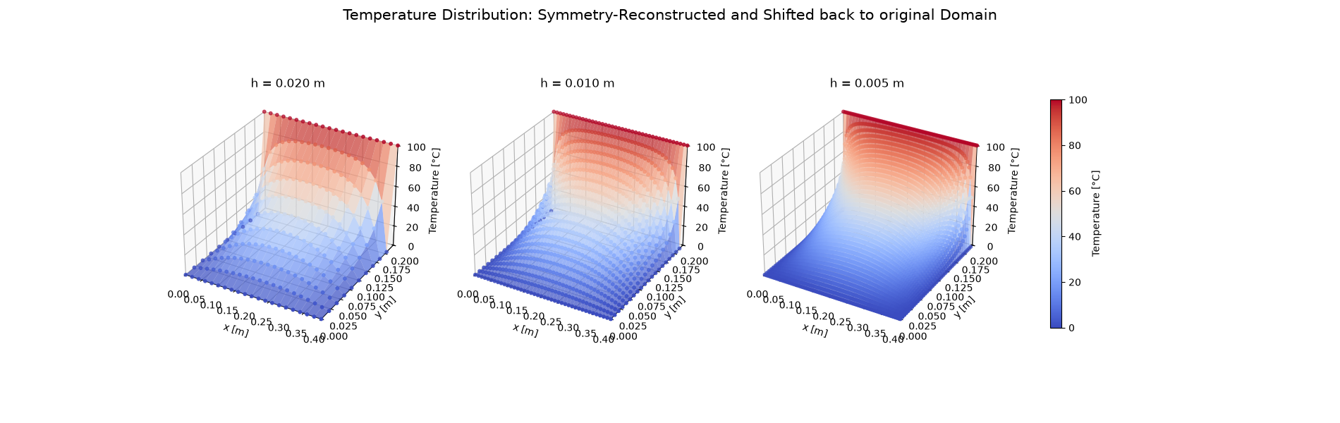

Task C

Comparison with Analytical Solution
import numpy as np
def AnalyticalSolution(x, y, a, b, T0, numberOfTerms):
temperature = 0.0
for termId in range(numberOfTerms):
n = 2*termId + 1
# This form avoids overflow for large values of n
sinhRatio = np.exp((n*np.pi/a)*(y-b))*(1-np.exp(-2*n*np.pi*y/a))/(1-np.exp(-2*n*np.pi*b/a))
temperature += (1/n)*np.sin(n*np.pi*x/a)*sinhRatio
return (4*T0/np.pi)*temperature
def FindNumberOfTermsForConvergence(a, b, T0, h=0.005, tolerance=1e-5):
# Use the smallest mesh because it has the largest number of comparison points
xCoordinates = np.arange(h, a, h)
yCoordinates = np.arange(h, b, h)
numberOfTerms = 10
while True:
maximumAbsoluteError = 0.0
maximumRelativeError = 0.0
worstPoint = None
# Check convergence at every interior point on the finest mesh
for y in yCoordinates:
for x in xCoordinates:
previousTemperature = AnalyticalSolution(x, y, a, b, T0, numberOfTerms)
currentTemperature = AnalyticalSolution(x, y, a, b, T0, numberOfTerms + 10)
absoluteError = abs(currentTemperature-previousTemperature)
relativeError = absoluteError/abs(currentTemperature) if abs(currentTemperature) > 1e-12 else 0.0
# Store the largest error found on the mesh
if absoluteError > maximumAbsoluteError:
maximumAbsoluteError = absoluteError
worstPoint = (x, y)
if relativeError > maximumRelativeError:
maximumRelativeError = relativeError
print(
f"Terms: {numberOfTerms:3d} -> {numberOfTerms+10:3d} | "
f"Max. Absolute Error: {maximumAbsoluteError:.8e} | "
f"Max. Relative Error: {maximumRelativeError:.8e} | "
f"Worst Point: ({worstPoint[0]:.3f}, {worstPoint[1]:.3f})"
)
# The series is considered converged when every point satisfies the tolerance
if maximumAbsoluteError < tolerance:
numberOfTerms += 10
break
numberOfTerms += 10
print(f"\nAnalytical solution converged using {numberOfTerms} odd terms.")
print(f"Highest value of n used = {2*numberOfTerms-1}")
print(f"Maximum absolute error at convergence = {maximumAbsoluteError:.8e}")
print(f"Maximum relative error at convergence = {maximumRelativeError:.8e}")
return numberOfTerms
numberOfAnalyticalTerms = FindNumberOfTermsForConvergence(
a=a,
b=b,
T0=TNorthWall,
h=0.005,
tolerance=1e-5
)
Terms: 10 -> 20 | Max. Absolute Error: 4.06046696e+00 | Max. Relative Error: 8.07775410e-02 | Worst Point: (0.005, 0.195)
Terms: 20 -> 30 | Max. Absolute Error: 3.53399268e-01 | Max. Relative Error: 5.53533269e-03 | Worst Point: (0.010, 0.195)
Terms: 30 -> 40 | Max. Absolute Error: 6.71461961e-02 | Max. Relative Error: 1.34498402e-03 | Worst Point: (0.195, 0.195)
Terms: 40 -> 50 | Max. Absolute Error: 8.32477700e-03 | Max. Relative Error: 1.33066086e-04 | Worst Point: (0.010, 0.195)
Terms: 50 -> 60 | Max. Absolute Error: 1.79884330e-03 | Max. Relative Error: 3.60259633e-05 | Worst Point: (0.005, 0.195)
Terms: 60 -> 70 | Max. Absolute Error: 2.47468314e-04 | Max. Relative Error: 3.98523645e-06 | Worst Point: (0.010, 0.195)
Terms: 70 -> 80 | Max. Absolute Error: 5.63475412e-05 | Max. Relative Error: 1.12849453e-06 | Worst Point: (0.005, 0.195)
Terms: 80 -> 90 | Max. Absolute Error: 8.15179155e-06 | Max. Relative Error: 1.31803978e-07 | Worst Point: (0.010, 0.195)
Analytical solution converged using 90 odd terms.
Highest value of n used = 179
Maximum absolute error at convergence = 8.15179155e-06
Maximum relative error at convergence = 1.31803978e-07
from scipy.interpolate import RegularGridInterpolator
fullLength = 2*a
fullWidth = b
comparisonPoints = [
(fullLength/4, fullWidth/2),
(fullLength/2, fullWidth/2),
(3*fullLength/4, fullWidth/2),
(fullLength/2, 3*fullWidth/4)
]
hValues = [0.02, 0.01, 0.005]
dumpPath = Path("../../Dumps/Problem1")
comparisonResults = []
for xPoint, yPoint in comparisonPoints:
analyticalTemperature = AnalyticalSolution(xPoint, yPoint, fullLength, fullWidth, TNorthWall, numberOfAnalyticalTerms)
rowResults = [xPoint, yPoint, analyticalTemperature]
for h in hValues:
temperatureValues = np.loadtxt(dumpPath/f"TemperatureSolution_h_{h:.5f}.csv", delimiter=",", skiprows=1, usecols=1)
xHalf = np.arange(0, fullLength/2, h)
yInterior = np.arange(h, fullWidth, h)
temperatureHalf = temperatureValues.reshape(len(yInterior), len(xHalf))
# Mirror the half-domain solution about x = a/2
xRight = fullLength/2 + xHalf
xInterior = np.concatenate((fullLength-xRight[:0:-1], xRight))
temperatureFull = np.concatenate((temperatureHalf[:, :0:-1], temperatureHalf), axis=1)
# Interpolate in case the requested point does not lie exactly on the mesh
numericalInterpolator = RegularGridInterpolator((yInterior, xInterior), temperatureFull)
numericalTemperature = float(numericalInterpolator((yPoint, xPoint)))
absoluteError = abs(numericalTemperature-analyticalTemperature)
rowResults.extend([numericalTemperature, absoluteError])
comparisonResults.append(rowResults)
comparisonResults = np.array(comparisonResults)
print(f"{'x':>8}{'y':>8}{'Analytical':>14}{'h=0.020':>14}{'Error':>14}{'h=0.010':>14}{'Error':>14}{'h=0.005':>14}{'Error':>14}")
print("-"*114)
for row in comparisonResults:
print(f"{row[0]:8.3f}{row[1]:8.3f}{row[2]:14.6f}{row[3]:14.6f}{row[4]:14.6e}{row[5]:14.6f}{row[6]:14.6e}{row[7]:14.6f}{row[8]:14.6e}")
x y Analytical h=0.020 Error h=0.010 Error h=0.005 Error
------------------------------------------------------------------------------------------------------------------
0.100 0.100 36.405666 36.373679 3.198750e-02 36.397647 8.019647e-03 36.403660 2.006283e-03
0.200 0.100 44.511510 44.418976 9.253433e-02 44.488087 2.342332e-02 44.505636 5.873986e-03
0.300 0.100 36.405666 36.373679 3.198750e-02 36.397647 8.019647e-03 36.403660 2.006283e-03
0.200 0.150 70.995329 70.961193 3.413612e-02 70.972786 2.254262e-02 70.989692 5.636675e-03
def AnalyticalSolution(x, y, a, b, T0, numberOfTerms):
temperature = 0.0
for termId in range(numberOfTerms):
n = 2*termId + 1
sinhRatio = np.exp((n*np.pi/a)*(y-b))*(1-np.exp(-2*n*np.pi*y/a))/(1-np.exp(-2*n*np.pi*b/a))
temperature += (1/n)*np.sin(n*np.pi*x/a)*sinhRatio
return (4*T0/np.pi)*temperature
fullLength, fullWidth, halfLength, T0 = 0.4, 0.2, 0.2, 100.0
hValues = [0.02, 0.01, 0.005]
dumpPath = Path("../../Dumps/Problem1")
fig, axes = plt.subplots(1, 3, figsize=(18, 5), constrained_layout=True)
for plotId, h in enumerate(hValues):
numericalHalf = np.loadtxt(dumpPath / f"TemperatureSolution_h_{h:.5f}.csv", delimiter=",", skiprows=1, usecols=1)
xHalf, yInterior = np.arange(0, halfLength, h), np.arange(h, fullWidth, h)
THalf = numericalHalf.reshape(len(yInterior), len(xHalf))
# Mirror the half-domain solution about x = 0.2 m to get the full interior field
xRight = halfLength + xHalf
xInterior = np.concatenate((fullLength - xRight[:0:-1], xRight))
TNumerical = np.concatenate((THalf[:, :0:-1], THalf), axis=1)
X, Y = np.meshgrid(xInterior, yInterior)
# Compute analytical solution at the same interior points
TAnalytical = np.zeros_like(TNumerical)
for rowId in range(Y.shape[0]):
for columnId in range(X.shape[1]):
TAnalytical[rowId, columnId] = AnalyticalSolution(X[rowId, columnId], Y[rowId, columnId], fullLength, fullWidth, T0, numberOfAnalyticalTerms)
absoluteError = np.abs(TNumerical - TAnalytical)
heatMap = axes[plotId].pcolormesh(X, Y, absoluteError, shading="auto", cmap="coolwarm")
contourLines = axes[plotId].contour(X, Y, absoluteError, colors="black", linewidths=0.4, levels=10)
axes[plotId].set_title(f"h = {h:.3f} m\nMax Error = {np.max(absoluteError):.6e}")
axes[plotId].set_xlabel("x [m]")
axes[plotId].set_ylabel("y [m]")
axes[plotId].set_aspect("equal")
fig.colorbar(heatMap, ax=axes, shrink=0.85, label="Absolute Error")
fig.suptitle("Absolute Error Between Numerical and Analytical Solutions", fontsize=14)
plt.show()
