Budgetly
- Layout
  - Header
    - Company Logo/ login/ Logout/ profile
    - Combined/upi/cash/dropdown for categories/Date range
  - Sidebar (Only when Logged In)
    - Add Expenditure
    - Monthly Expenditure
      - Current Month’s Expenditure
      - Previous Month’s Expenditure
      - Graph
      - List of transaction
      - Transaction Detail
    - Yearly Expenditure
      - Current Month’s Expenditure
      - Previous Month’s Expenditure
      - Graph
      - List of transaction
      - Transaction Detail
    - Weekly Expenditure
      - Current Month’s Expenditure
      - Previous Month’s Expenditure
      - Graph
      - List of transaction
      - Transaction Detail
    - Custom Range Expenditure
      - Current Month’s Expenditure
      - Previous Month’s Expenditure
      - Graph
      - List of transaction
      - Transaction Detail
    - Search Transaction

- Specs
  - Responsive

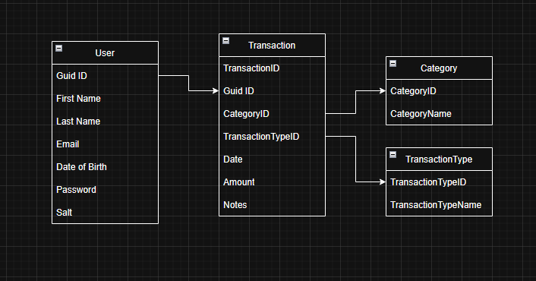
admin access to add category and transaction type

