**INTRODUCTION TO BIG DATA**

**ASSIGNMENT -1**

**SUBMITTED BY-**

Meghali Nandi

4th semester

M.Tech (CSE)

Roll. No. – 2102021

Indian Institute of Information Technology Guwahati

**MYSQL**

**1. What are the Gender wise % of patients across various states?**

SELECT s.State, r.Gender, COUNT(*)*100.0 / SUM(COUNT(*)) OVER(PARTITION BY r.`State code`) AS percent

FROM state_wise s

JOIN (

  SELECT Gender, `State code` FROM raw_data1

  UNION ALL SELECT Gender, `State code` FROM raw_data2

  UNION ALL SELECT Gender, `State code` FROM raw_data3

  UNION ALL SELECT Gender, `State code` FROM raw_data4

  UNION ALL SELECT Gender, `State code` FROM raw_data5

  UNION ALL SELECT Gender, `State code` FROM raw_data6

  UNION ALL SELECT Gender, `State code` FROM raw_data7

  UNION ALL SELECT Gender, `State code` FROM raw_data8

  UNION ALL SELECT Gender, `State code` FROM raw_data9

  UNION ALL SELECT Gender, `State code` FROM raw_data10

  UNION ALL SELECT Gender, `State code` FROM raw_data11

  UNION ALL SELECT Gender, `State code` FROM raw_data12

  UNION ALL SELECT Gender, `State code` FROM raw_data13

  UNION ALL SELECT Gender, `State code` FROM raw_data14

  UNION ALL SELECT Gender, `State code` FROM raw_data15

  UNION ALL SELECT Gender, `State code` FROM raw_data16

  UNION ALL SELECT Gender, `State code` FROM raw_data17

  UNION ALL SELECT Gender, `State code` FROM raw_data18

  UNION ALL SELECT Gender, `State code` FROM raw_data19

  UNION ALL SELECT Gender, `State code` FROM raw_data20

  UNION ALL SELECT Gender, `State code` FROM raw_data21

  UNION ALL SELECT Gender, `State code` FROM raw_data22

  UNION ALL SELECT Gender, `State code` FROM raw_data23

  UNION ALL SELECT Gender, `State code` FROM raw_data24

  UNION ALL SELECT Gender, `State code` FROM raw_data25

  UNION ALL SELECT Gender, `State code` FROM raw_data26

  UNION ALL SELECT Gender, `State code` FROM raw_data27

  UNION ALL SELECT Gender, `State code` FROM raw_data28

  UNION ALL SELECT Gender, `State code` FROM raw_data29

  UNION ALL SELECT Gender, `State code` FROM raw_data30

  UNION ALL SELECT Gender, `State code` FROM raw_data31

  UNION ALL SELECT Gender, `State code` FROM raw_data32

) r ON s.State_code = r.`State code`

GROUP BY s.State, r.Gender, r.`State code`;

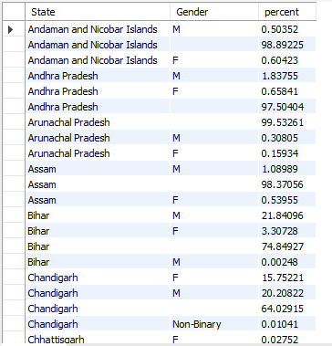

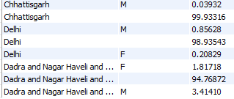

**2. Which age group (in multiple of five like 0-5,5-10,10-15 etc.) has been**

**affected the most?**

SET sql_mode=(SELECT REPLACE(@@sql_mode,'ONLY_FULL_GROUP_BY',''));

SELECT CONCAT(FLOOR(`Age Bracket`/5)*5, '-', FLOOR(`Age Bracket`/5)*5+4) AS age_group, COUNT(*) AS num_patients

FROM raw_data1

UNION

SELECT CONCAT(FLOOR(`Age Bracket`/5)*5, '-', FLOOR(`Age Bracket`/5)*5+4) AS age_group, COUNT(*) AS num_patients

FROM raw_data2

UNION

SELECT CONCAT(FLOOR(`Age Bracket`/5)*5, '-', FLOOR(`Age Bracket`/5)*5+4) AS age_group, COUNT(*) AS num_patients

FROM raw_data3

UNION

SELECT CONCAT(FLOOR(`Age Bracket`/5)*5, '-', FLOOR(`Age Bracket`/5)*5+4) AS age_group, COUNT(*) AS num_patients

FROM raw_data4

UNION

SELECT CONCAT(FLOOR(`Age Bracket`/5)*5, '-', FLOOR(`Age Bracket`/5)*5+4) AS age_group, COUNT(*) AS num_patients

FROM raw_data5

UNION

SELECT CONCAT(FLOOR(`Age Bracket`/5)*5, '-', FLOOR(`Age Bracket`/5)*5+4) AS age_group, COUNT(*) AS num_patients

FROM raw_data6

UNION

SELECT CONCAT(FLOOR(`Age Bracket`/5)*5, '-', FLOOR(`Age Bracket`/5)*5+4) AS age_group, COUNT(*) AS num_patients

FROM raw_data7

UNION

SELECT CONCAT(FLOOR(`Age Bracket`/5)*5, '-', FLOOR(`Age Bracket`/5)*5+4) AS age_group, COUNT(*) AS num_patients

FROM raw_data8

UNION

SELECT CONCAT(FLOOR(`Age Bracket`/5)*5, '-', FLOOR(`Age Bracket`/5)*5+4) AS age_group, COUNT(*) AS num_patients

FROM raw_data9

UNION

SELECT CONCAT(FLOOR(`Age Bracket`/5)*5, '-', FLOOR(`Age Bracket`/5)*5+4) AS age_group, COUNT(*) AS num_patients

FROM raw_data10

UNION

SELECT CONCAT(FLOOR(`Age Bracket`/5)*5, '-', FLOOR(`Age Bracket`/5)*5+4) AS age_group, COUNT(*) AS num_patients

FROM raw_data11

UNION

SELECT CONCAT(FLOOR(`Age Bracket`/5)*5, '-', FLOOR(`Age Bracket`/5)*5+4) AS age_group, COUNT(*) AS num_patients

FROM raw_data12

UNION

SELECT CONCAT(FLOOR(`Age Bracket`/5)*5, '-', FLOOR(`Age Bracket`/5)*5+4) AS age_group, COUNT(*) AS num_patients

FROM raw_data13

UNION

SELECT CONCAT(FLOOR(`Age Bracket`/5)*5, '-', FLOOR(`Age Bracket`/5)*5+4) AS age_group, COUNT(*) AS num_patients

FROM raw_data14

UNION

SELECT CONCAT(FLOOR(`Age Bracket`/5)*5, '-', FLOOR(`Age Bracket`/5)*5+4) AS age_group, COUNT(*) AS num_patients

FROM raw_data15

UNION

SELECT CONCAT(FLOOR(`Age Bracket`/5)*5, '-', FLOOR(`Age Bracket`/5)*5+4) AS age_group, COUNT(*) AS num_patients

FROM raw_data16

UNION

SELECT CONCAT(FLOOR(`Age Bracket`/5)*5, '-', FLOOR(`Age Bracket`/5)*5+4) AS age_group, COUNT(*) AS num_patients

FROM raw_data17

UNION

SELECT CONCAT(FLOOR(`Age Bracket`/5)*5, '-', FLOOR(`Age Bracket`/5)*5+4) AS age_group, COUNT(*) AS num_patients

FROM raw_data18

UNION

SELECT CONCAT(FLOOR(`Age Bracket`/5)*5, '-', FLOOR(`Age Bracket`/5)*5+4) AS age_group, COUNT(*) AS num_patients

FROM raw_data19

UNION

SELECT CONCAT(FLOOR(`Age Bracket`/5)*5, '-', FLOOR(`Age Bracket`/5)*5+4) AS age_group, COUNT(*) AS num_patients

FROM raw_data20

UNION

SELECT CONCAT(FLOOR(`Age Bracket`/5)*5, '-', FLOOR(`Age Bracket`/5)*5+4) AS age_group, COUNT(*) AS num_patients

FROM raw_data21

UNION

SELECT CONCAT(FLOOR(`Age Bracket`/5)*5, '-', FLOOR(`Age Bracket`/5)*5+4) AS age_group, COUNT(*) AS num_patients

FROM raw_data22

UNION

SELECT CONCAT(FLOOR(`Age Bracket`/5)*5, '-', FLOOR(`Age Bracket`/5)*5+4) AS age_group, COUNT(*) AS num_patients

FROM raw_data23

UNION

SELECT CONCAT(FLOOR(`Age Bracket`/5)*5, '-', FLOOR(`Age Bracket`/5)*5+4) AS age_group, COUNT(*) AS num_patients

FROM raw_data24

UNION

SELECT CONCAT(FLOOR(`Age Bracket`/5)*5, '-', FLOOR(`Age Bracket`/5)*5+4) AS age_group, COUNT(*) AS num_patients

FROM raw_data25

UNION

SELECT CONCAT(FLOOR(`Age Bracket`/5)*5, '-', FLOOR(`Age Bracket`/5)*5+4) AS age_group, COUNT(*) AS num_patients

FROM raw_data26

UNION

SELECT CONCAT(FLOOR(`Age Bracket`/5)*5, '-', FLOOR(`Age Bracket`/5)*5+4) AS age_group, COUNT(*) AS num_patients

FROM raw_data27

UNION

SELECT CONCAT(FLOOR(`Age Bracket`/5)*5, '-', FLOOR(`Age Bracket`/5)*5+4) AS age_group, COUNT(*) AS num_patients

FROM raw_data28

UNION

SELECT CONCAT(FLOOR(`Age Bracket`/5)*5, '-', FLOOR(`Age Bracket`/5)*5+4) AS age_group, COUNT(*) AS num_patients

FROM raw_data29

UNION

SELECT CONCAT(FLOOR(`Age Bracket`/5)*5, '-', FLOOR(`Age Bracket`/5)*5+4) AS age_group, COUNT(*) AS num_patients

FROM raw_data30

UNION

SELECT CONCAT(FLOOR(`Age Bracket`/5)*5, '-', FLOOR(`Age Bracket`/5)*5+4) AS age_group, COUNT(*) AS num_patients

FROM raw_data31

UNION

SELECT CONCAT(FLOOR(`Age Bracket`/5)*5, '-', FLOOR(`Age Bracket`/5)*5+4) AS age_group, COUNT(*) AS num_patients

FROM raw_data32

GROUP BY FLOOR(`Age Bracket`/5)

ORDER BY num_patients DESC limit 1;



**3. Which state has the highest recovery rate and lowest death rate?**

SELECT State,

       SUM(CASE WHEN Patient_Status = 'Recovered' THEN 1 ELSE 0 END) / COUNT(1) AS recovery_rate,

       SUM(CASE WHEN Patient_Status = 'Deceased' THEN 1 ELSE 0 END) / COUNT(1) AS death_rate

FROM death_and_recovered1

UNION

SELECT State,

       SUM(CASE WHEN Patient_Status = 'Recovered' THEN 1 ELSE 0 END) / COUNT(1) AS recovery_rate,

       SUM(CASE WHEN Patient_Status = 'Deceased' THEN 1 ELSE 0 END) / COUNT(1) AS death_rate

FROM death_and_recovered

UNION

SELECT State,

       SUM(CASE WHEN Patient_Status = 'Recovered' THEN 1 ELSE 0 END) / COUNT(1) AS recovery_rate,

       SUM(CASE WHEN Patient_Status = 'Deceased' THEN 1 ELSE 0 END) / COUNT(1) AS death_rate

FROM death_and_recovered2

GROUP BY State

ORDER BY recovery_rate DESC, death_rate ASC limit 1;



**4. Which are the top 10 districts where no of infection is more than national average for more than a month?**

SELECT `Date`, District, AVG(Value) AS avg_cases

FROM district_testing_count

WHERE Status = 'Positive'

GROUP BY District

HAVING AVG(Value) > (

    SELECT AVG(Value)

    FROM district_testing_count

    WHERE Status = 'Positive'

) AND `Date` < DATE_SUB(NOW(), INTERVAL 1 MONTH)

ORDER BY avg_cases DESC

LIMIT 10;

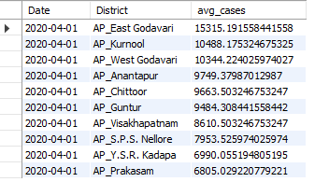

**5. Which are the worst (top 10) affected citied among best (top 10) states?**

SELECT c.District, c.confirmed

FROM (SELECT State, MAX(confirmed) AS confirmed

      FROM state_wise

      WHERE State NOT IN ('State Unassigned', 'Total')

      GROUP BY state

      ORDER BY confirmed DESC

      LIMIT 10) s

JOIN district_wise c ON s.State = c.State

WHERE c.District != 'Unknown'

ORDER BY confirmed DESC

LIMIT 10;

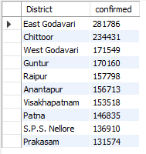

**MONGO**

1. **What are the Gender wise % of patients across various states?**

db.raw_data1.create_index("raw_data.gender")

db.raw_data1.create_index("raw_data.detectedstate")

db.raw_data1.aggregate( [

    {"$match": {"raw_data.gender": {"$exists": True}}},

    {"$unwind": "$raw_data"},

    {"$group": {"_id": {"state": "$raw_data.detectedstate", "gender": "$raw_data.gender"},

                "count": {"$sum": {"$toInt": "$raw_data.numcases"}}}},

    {"$group": {"_id": "$_id.gender",

                "stateCount": {"$push": {"state": "$_id.state", "count": "$count"}},

                "total": {"$sum": "$count"}}},

    {"$project": {"_id": 0, "gender": "$_id",

                  "percentage": {"$map": {"input": "$stateCount",

                                          "as": "sc",

                                          "in": {"state": "$$sc.state",

                                                 "count": {"$multiply": [{"$divide": ["$$sc.count", "$total"]}, 100]}}}}}}

]);

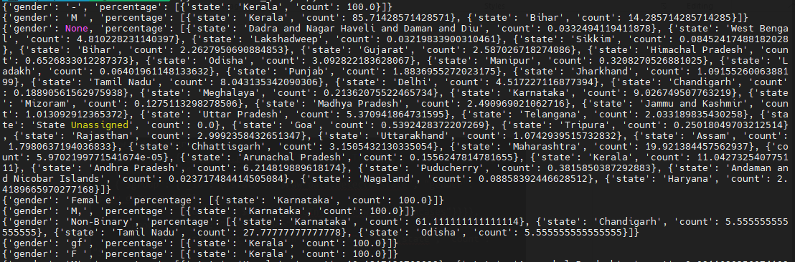

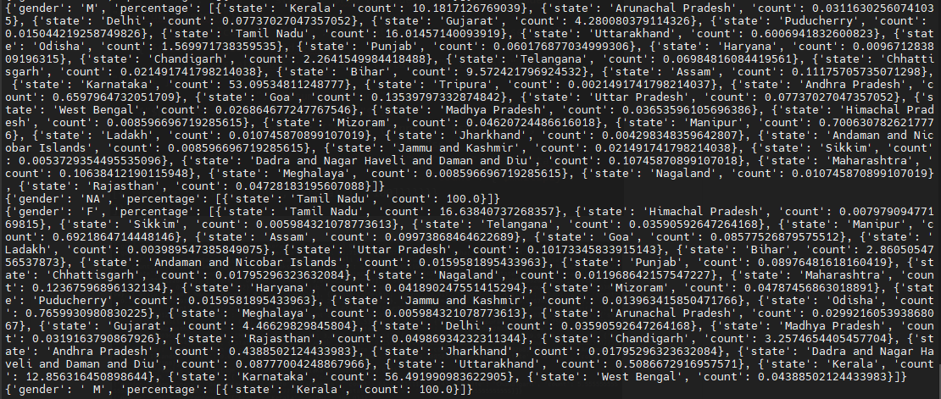

1. **Which age group (in multiple of five like 0-5,5-10,10-15 etc.) has been affected the most?**

db.raw_data1.create_index("raw_data.agebracket")

db["raw_data1"].aggregate([

    {"$unwind": "$raw_data"},

    {

        "$project": {

            "age_group": {

                "$switch": {

                    "branches": [

                        # {"case": {"raw_data.agebracket":{ "$regex": "/.*-.*/"}}, "then":"Unknown"},

                        {"case": {"$and":[{"$lte": [{"$toDouble":"$raw_data.agebracket"}, 5]},{"$gte": [{"$toDouble":"$raw_data.agebracket"}, 0]}]}, "then": "0-5"},

                        {"case": {"$lte": [{"$toDouble":"$raw_data.agebracket"}, 10]}, "then": "6-10"},

                        {"case": {"$lte": [{"$toDouble":"$raw_data.agebracket"}, 15]}, "then": "11-15"},

                        {"case": {"$lte": [{"$toDouble":"$raw_data.agebracket"}, 20]}, "then": "16-20"},

                        {"case": {"$lte": [{"$toDouble":"$raw_data.agebracket"}, 25]}, "then": "21-25"},

                        {"case": {"$lte": [{"$toDouble":"$raw_data.agebracket"}, 30]}, "then": "26-30"},

                        {"case": {"$lte": [{"$toDouble":"$raw_data.agebracket"}, 35]}, "then": "31-35"},

                        {"case": {"$lte": [{"$toDouble":"$raw_data.agebracket"}, 40]}, "then": "36-40"},

                        {"case": {"$lte": [{"$toDouble":"$raw_data.agebracket"}, 45]}, "then": "41-45"},

                        {"case": {"$lte": [{"$toDouble":"$raw_data.agebracket"}, 50]}, "then": "46-50"},

                        {"case": {"$lte": [{"$toDouble":"$raw_data.agebracket"}, 55]}, "then": "51-55"},

                        {"case": {"$lte": [{"$toDouble":"$raw_data.agebracket"}, 60]}, "then": "56-60"},

                        {"case": {"$lte": [{"$toDouble":"$raw_data.agebracket"}, 65]}, "then": "61-65"},

                        {"case": {"$lte": [{"$toDouble":"$raw_data.agebracket"}, 70]}, "then": "66-70"},

                        {"case": {"$lte": [{"$toDouble":"$raw_data.agebracket"}, 75]}, "then": "71-75"},

                        {"case": {"$lte": [{"$toDouble":"$raw_data.agebracket"}, 80]}, "then": "76-80"},

                        {"case": {"$lte": [{"$toDouble":"$raw_data.agebracket"}, 85]}, "then": "81-85"},

                        {"case": {"$lte": [{"$toDouble":"$raw_data.agebracket"}, 90]}, "then": "86-90"},

                        {"case": {"$lte": [{"$toDouble":"$raw_data.agebracket"}, 95]}, "then": "91-95"},

                        {"case": {"$lte": [{"$toDouble":"$raw_data.agebracket"}, 100]}, "then": "96-100"},

                        {"case": {"$gt": [{"$toDouble":"$raw_data.agebracket"}, 100]}, "then": ">100"}

                    ],

                    "default": "Unknown"

                }

            }

        }

    },

    {

        "$group": {

            "_id": "$age_group",

            "count": {"$sum": 1}

        }

    },

    {

        "$sort": {"count": -1}

    },

    {"$limit":1}

])



3. **Which state has the highest recovery rate and lowest death rate?**

db.deaths_recoveries.create_index("deaths_recoveries.state")

db["deaths_recoveries"].aggregate([

    {"$unwind": "$deaths_recoveries"},

    {"$group": {

        "_id": "$deaths_recoveries.state",

        "total_cases": {"$sum": 1},

        "total_deaths": {"$sum": {"$cond": {"if": {"$eq": ["$deaths_recoveries.patientstatus", "Deceased"]}, "then": 1, "else": 0}}},

        "total_recovered": {"$sum": {"$cond": {"if": {"$eq": ["$deaths_recoveries.patientstatus", "Recovered"]}, "then": 1, "else": 0}}}

    }},

    {"$addFields": {"recovery_rate": {"$divide": ["$total_recovered", "$total_cases"]}, "death_rate": {"$divide": ["$total_deaths", "$total_cases"]}}},

    {"$sort": {"recovery_rate": -1, "death_rate": 1}},

    {"$limit": 1}

])



4. **Which are the top 10 districts where no of infection is more than national average for more than a month?**

db.raw_data1.create_index([("raw_data.detecteddistrict", 1), ("raw_data.numcases", 1)])

db.top_states.create_index([("districts.totalCases", -1), ("districts.district", 1)])

db.raw_data1.aggregate([

  {"$unwind": "$raw_data"},

  {

    "$group": {

      "_id": "$raw_data.detecteddistrict",

      "totalCases": {

        "$sum": {

          "$toInt": "$raw_data.numcases"

        }

      }

    }

  },

  {

    "$group": {

      "_id": None,

      "nationalAverage": {

        "$avg": "$totalCases"

      },

      "districts": {

        "$push": {

          "district": "$_id",

          "totalCases": "$totalCases"

        }

      }

    }

  },

  {

    "$unwind": "$districts"

  },

  {

    "$match": {

      "gte":["$districts.totalCases","$nationalAverage"]

      }

  },

  {

    "$sort": {

      "districts.totalCases": -1

    }

  },

  {

    "$limit": 10

  },

  {

    "$project": {

      "_id": 0,

      "district": "$districts.district",

      "totalCases": "$districts.totalCases"

    }

  }

])

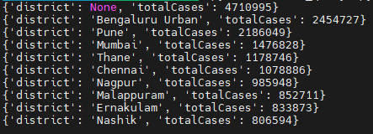

5. **Which are the worst (top 10) affected citied among best (top 10) states?**

db.state_district_wise.create_index("state")

top_states = db.state_district_wise.aggregate([

    { "$project": { "states": { "$objectToArray": "$$ROOT" } } },

    { "$unwind": "$states" },

    { "$replaceRoot": { "newRoot": "$states" } },

    { "$match": { "v.districtData": { "$exists": True } } },

    { "$project": { "state": "$$ROOT.k", "districts": { "$objectToArray": "$$ROOT.v.districtData" } } },

    { "$unwind": "$districts" },

    { "$project": { "state": 1, "district": "$districts.k", "confirmed": "$districts.v.confirmed" } },

    { "$group": { "_id": "$state", "total_confirmed": { "$sum": "$confirmed" }, "cities": { "$push": { "name": "$district", "confirmed": "$confirmed" } } } },

    { "$sort": { "total_confirmed": -1 } },

    { "$limit": 10 },

    {"$unwind": "$cities"},

    {"$sort": {"cities.confirmed": -1}},

    {"$group": {"_id": "$cities.name", "confirmed": {"$sum": "$cities.confirmed"}}},

    {"$sort": {"confirmed": -1}},

    {"$limit": 10}

]

)

