CUSTOMER BEHAVIOUR
& SALES ANALYSIS
Project Report

Data Cleaning • Exploratory Analysis • SQL Business Analysis • Power Bi Dashboard

Project Information | Details
Dataset | Customer Behavior Dataset
Final cleaned records | 3,900
Final fields | 19
Primary tools | Python, Pandas, SQL, Power Bi
Analysis focus | Customer behaviour, purchases, discounts, subscriptions, shipping, products and demographics

Executive Summary
This project presents a structured customer behaviour and sales analysis workflow using Python/Pandas and SQL. The work begins with data inspection and preparation, followed by missing-value treatment, column standardisation, feature creation and removal of redundant information. The cleaned dataset contains 3,900 records and 19 fields.
The SQL stage translates the prepared data into business questions covering revenue by gender and age group, discount behaviour, product ratings, shipping methods, subscription status, customer segmentation and product demand. The final dataset contains total recorded purchase revenue of $233,081, with an average purchase amount of $59.76.
The project demonstrates an end-to-end analytical process: preparing raw customer data, converting it into an analysis-ready structure, querying it for meaningful business questions, and organising findings for dashboard-oriented decision support.

1. Introduction
Project background, business context and analytical approach
Customer behaviour data can help an organisation understand who purchases, what customers purchase, how frequently they purchase, which commercial mechanisms influence transactions, and where opportunities for better customer engagement may exist. This project uses a customer behaviour dataset to demonstrate how raw transactional information can be converted into structured business insights.
The project follows a practical analytics workflow rather than treating data cleaning, SQL analysis and reporting as separate tasks. The Python/Pandas stage establishes a consistent and analysis-ready dataset. The SQL stage then uses that prepared dataset to answer specific business questions. This creates a clear link between technical data preparation and decision-oriented analysis.

Project Context
- The dataset contains customer-level purchase records with demographic, product, transaction, review, subscription, shipping and frequency-related attributes.
- The final cleaned dataset has 3,900 records and 19 columns.
- The analysis includes both categorical and numerical variables, allowing customer segmentation and comparative analysis.
- SQL queries were designed around practical business questions rather than only basic aggregation.
- The project is suitable for an interactive reporting/dashboard layer using the prepared metrics.

Analytical Workflow
Stage | Purpose | Primary output
1. Data inspection | Understand structure, types and completeness | Initial data profile
2. Data cleaning | Resolve missing values and standardise fields | Cleaned dataset
3. Feature engineering | Create age groups and purchase-frequency days | Analysis-ready features
4. SQL analysis | Answer business questions using aggregation and window logic | Business insights
5. Reporting | Organise findings into decision-support metrics | Dashboard/report structure

2. Objectives and Scope

Project Objectives
- Inspect and understand the structure, variables and quality of the customer behaviour dataset.
- Clean the dataset using Python and Pandas so it can be reliably used for analysis.
- Handle missing review-rating values using a category-level median strategy.
- Standardise column names and create useful analytical features such as age groups and purchase-frequency days.
- Remove redundant information where two fields represented the same business concept.
- Use SQL to answer practical questions about revenue, products, discounts, shipping, subscriptions and customer loyalty.
- Segment customers using previous purchase behaviour.
- Translate analytical results into clear business-oriented findings suitable for dashboard presentation.

Project Scope
Included | Description
Data preparation | Inspection, missing-value treatment, naming standardisation and feature creation
Customer analysis | Gender, age group, subscription and previous-purchase behaviour
Product analysis | Purchase counts, review ratings and discount rates
Transaction analysis | Purchase amount, shipping, discount and payment-related fields
SQL analysis | Aggregation, filtering, CASE logic, CTE and window-function approach
Reporting | Business findings and dashboard-oriented KPI organisation

Out of Scope
- The submitted files do not contain a separate dashboard workbook or dashboard image; therefore, this report documents the dashboard-oriented analysis and the metrics available from the submitted dataset and SQL work.
- No causal claims are made about why customers behave in a particular way; the analysis is descriptive.
- The dataset is analysed as provided and does not establish external market benchmarks.

3. Dataset, Variables and Tools
The final cleaned CSV contains 3,900 customer purchase records and 19 fields. The variables cover customer identity, demographics, products, transaction values, location, seasonality, reviews, subscription status, shipping, discounts, previous purchases, payment methods and purchase frequency.
Field | Meaning
customer_id | Customer identifier
age | Customer age
gender | Customer gender
item_purchased | Purchased product
category | Product category
purchse_amount | Purchase amount
location | Customer location
size | Product size
color | Product colour
season | Season
review_rating | Customer review rating
subscription_status | Subscription status
shipping_type | Shipping method
discount_applied | Whether a discount was applied
previous_purchases | Number of previous purchases
payment_method | Payment method
frequency_of_purchases | Original purchase-frequency category
age_group | Engineered age-group feature
purchase_frequency_days | Numeric representation of purchase frequency

Tools and Technologies
Tool | Role in the project
Python | Data preparation and analytical preprocessing
Pandas | Data loading, inspection, missing-value treatment and feature engineering
SQL | Business-question analysis and aggregation
CSV | Storage of the final cleaned analytical dataset
Power Bi | Presentation of KPIs and findings for business decision support

4. Data Cleaning and Preprocessing
Python/Pandas workflow
The notebook demonstrates a structured cleaning workflow. The dataset is first loaded into a Pandas DataFrame and examined using head(), info(), describe() and null-value checks. This establishes the structure and quality of the data before transformations are applied.

Cleaning Steps Implemented
Data inspection: Loaded the source CSV and reviewed sample records, data types, descriptive statistics and missing values.
Missing review ratings: Filled missing Review Rating values using the median review rating within the corresponding product category.
Column standardisation: Converted column names to lowercase and replaced spaces with underscores.
Column rename: Renamed purchase_amount_(usd) to purchase_amount for simpler downstream analysis.
Age-group feature: Created four age groups using quartile-based binning: Young Adult, Adult, Middle-aged and Senior.
Frequency conversion: Mapped textual purchase frequencies to day values such as Weekly = 7, Fortnightly/Bi-Weekly = 14, Monthly = 30, Quarterly/Every 3 Months = 90 and Annually = 365.
Redundancy removal: Compared discount_applied and promo_code_used and removed promo_code_used after confirming the values matched.
Export: Saved the resulting 3,900-row, 19-column dataset as customer_behaviour_cleaned.csv.

Data Quality Outcome
The submitted cleaned CSV contains no null values across its 19 fields. The preprocessing therefore produced a complete, standardised dataset suitable for the SQL analysis that follows.

5. SQL Analysis Methodology
The SQL script uses the cleaned customer_behaviour table as the analytical source. The queries are structured around business questions and use several SQL techniques, including GROUP BY, aggregate functions, filtering, subqueries, CASE expressions, common table expressions (CTEs), and the ROW_NUMBER window function.

Business Questions Addressed
- What is the total revenue generated by male and female customers?
- Which customers used a discount but still spent at or above the overall average purchase amount?
- Which five products have the highest average review rating?
- How does average purchase amount compare between Standard and Express shipping?
- Do subscribed customers spend more, based on average and total purchase values?
- Which five products have the highest percentage of purchases with a discount?
- How can customers be segmented into new, returning and loyal groups using previous purchases?
- What are the top three purchased items within each product category?
- Are customers with more than five previous purchases also represented among subscribers?
- What is the revenue contribution of each age group?

SQL Techniques Demonstrated
Technique | Application
GROUP BY + SUM/AVG/COUNT | Revenue, purchase and customer summaries
WHERE | Filtering discount, shipping and repeat-buyer conditions
Subquery | Comparing individual purchases against overall average purchase amount
CASE | Creating customer segments and calculating discount rates
CTE | Organising customer segmentation and category-level item ranking
ROW_NUMBER() | Ranking products within each category
ORDER BY + LIMIT | Identifying top products and ranked results

6. Key Findings and Results
The following results are calculated from the submitted cleaned CSV using the same business logic represented in the SQL script. They provide a quantitative summary of customer behaviour and sales patterns.
Metric | Result
Total purchase revenue | $233,081
Average purchase amount | $59.76
Total records | 3,900
Unique customer IDs | 3,900
Male revenue | $157,890
Female revenue | $75,191
Express average purchase | $60.48
Standard average purchase | $58.46

Customer and Subscription Results
Customers marked as not subscribed account for 2,847 records and $170,436 in recorded purchase revenue, while subscribed customers account for 1,053 records and $62,645. The average purchase amounts are $59.87 for non-subscribed customers and $59.49 for subscribed customers.
Using the SQL segmentation rule, 83 records fall into the New segment, 701 into Returning, and 3,116 into Loyal based on previous purchase counts.

Product Results
The five products with the highest average review ratings are Gloves (3.86), Sandals (3.84), Boots (3.82), Hat (3.80) and Skirt (3.78).
The five products with the highest percentage of purchases involving a discount are Hat (50.00%), Sneakers (49.66%), Coat (49.07%), Sweater (48.17%) and Pants (47.37%).

7. Dashboard-Oriented Analysis and Visual Reporting
The prepared dataset and SQL outputs support an interactive sales dashboard focused on customer behaviour and business performance. The dashboard can be organised around KPI cards, customer segmentation, revenue comparisons, product performance and transaction behaviour. The figures below are generated from the submitted cleaned dataset to illustrate the core analytical story.

Revenue by Gender
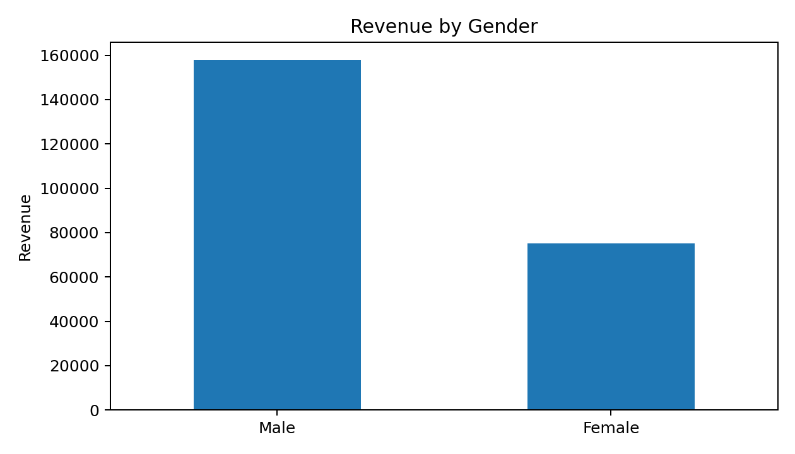
The gender revenue aggregation shows a larger recorded revenue contribution from male customers in this dataset. This is a descriptive result from the available records and should not be interpreted as a causal difference in customer value.

Revenue by Age Group
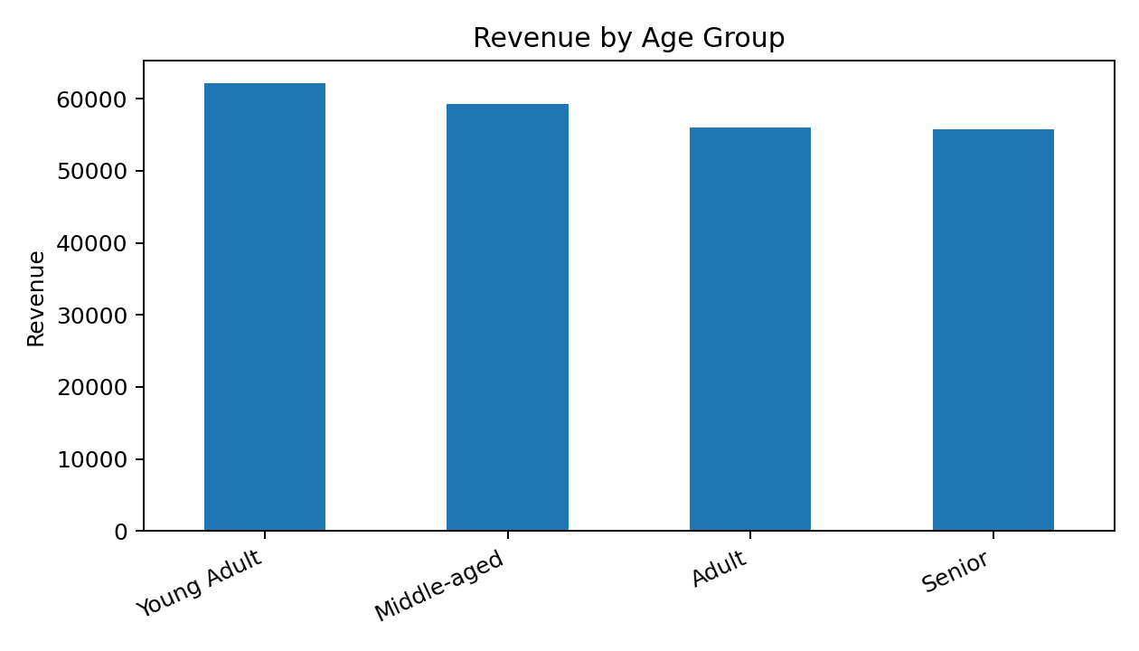
Young Adult records contribute the highest total revenue among the four engineered age groups, followed by Middle-aged, Adult and Senior groups.

8. Business Insights, Outcomes and Recommendations

Seasonal and Customer Findings
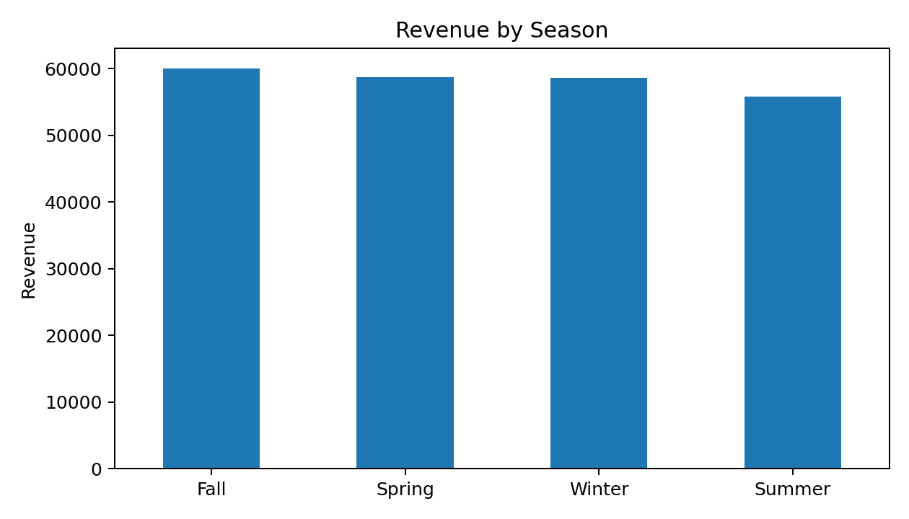
Fall records generate the highest total revenue among the four seasons in the cleaned dataset, followed by Spring, Winter and Summer. Average purchase values should be considered alongside total revenue when interpreting seasonality because total revenue also depends on record volume.

Customer Segmentation
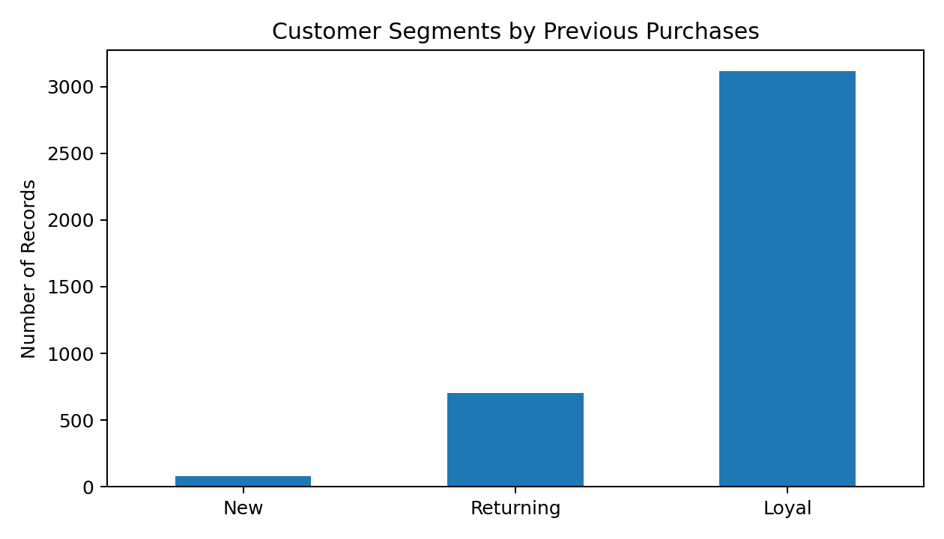
The SQL-defined customer segments are based on previous purchase counts: one previous purchase is classified as New, two to ten as Returning, and more than ten as Loyal. The resulting distribution is strongly concentrated in the Loyal segment, which provides a useful starting point for analysing repeat-purchase behaviour.

Decision-Support Outcomes
- A consistent analytical dataset was created from the original customer behaviour data.
- The cleaning process improved consistency through standardised names, derived analytical fields and removal of redundant information.
- SQL converted raw records into business-focused measures that can be used directly in reports and dashboards.
- Product-level review and discount metrics provide separate views of customer satisfaction and promotional exposure.
- Customer segmentation provides a framework for distinguishing customers by purchase history.
- Revenue analysis by gender, age group and season provides descriptive dimensions for dashboard filtering and comparison.

9. Conclusion, Limitations and Future Scope

Conclusion
This project demonstrates an end-to-end customer behaviour and sales analytics workflow. Python and Pandas were used to inspect and prepare the dataset, handle missing review values, standardise field names, engineer age and frequency features, and remove redundant information. The resulting 3,900-record, 19-field dataset was then analysed using SQL.
The SQL analysis goes beyond basic totals by addressing practical business questions around customer spending, discounts, product ratings, shipping, subscriptions, customer loyalty and age-group revenue. These outputs form a strong analytical foundation for an interactive dashboard where users can filter and compare customer and sales dimensions.

Limitations
- The analysis is descriptive and does not establish causal relationships between customer characteristics and purchasing behaviour.
- The submitted project files do not include a separate dashboard file or screenshots, so the report documents the dashboard-oriented analytical structure rather than reproducing a specific dashboard layout.
- The dataset is treated as the available analytical population; no external market benchmark is used.
- The customer segmentation rule is defined by previous purchase counts in the SQL script and is therefore a project-specific analytical definition.

Business findings
- Target high-revenue customer segments
Focus marketing campaigns and personalised offers on customer groups contributing higher revenue, particularly the Young Adult segment identified in the analysis.
- Plan seasonal promotions
Since Fall generated the highest total revenue, the business can consider stronger promotional campaigns, product visibility, and inventory planning during high-performing seasons.
- Strengthen customer loyalty
Target Loyal customers with loyalty rewards, personalised offers, and retention campaigns to encourage continued purchases.
- Optimise discount strategies
Review products with high discount usage and determine whether discounts are supporting sales. This can help the business make more targeted promotional decisions instead of applying discounts broadly.
- Promote highly rated products
Products such as Gloves, Sandals, Boots, Hat, and Skirt have the highest average review ratings in the analysis and could be considered for featured-product placements and recommendation campaigns.

