Weekly Project Report – Power BI Sales Performance Dashboard

Week of: 4
Prepared by: Meghamala Lagudu

1. Project Overview
Sales Performance Analysis
The Sales Performance Analysis project focuses on analysing sales and financial data to understand business performance across different products, countries, customer segments, and discount bands. Python, SQL, Excel, and Power BI are used to clean, analyse, and visualize the data.
The project aims to identify sales trends, evaluate profitability, compare product and country performance, and generate meaningful business insights to support data-driven decision-making.
2. Project Objectives
- Clean and prepare the dataset using Python.
- Analyse sales, profit, discounts, and units sold using SQL.
- Compare the performance of different products, countries, and business segments.
- Examine the relationship between discount bands and profitability.
- Develop an interactive Power BI dashboard with KPI cards, charts, and slicers.
- Present key findings and business recommendations based on the analysis.
3. Dataset Description
The dataset contains 700 records and 16 columns related to sales and financial performance. It includes information about products, countries, business segments, discounts, sales revenue, manufacturing costs, profit, and dates.
The dataset covers the period from September 2013 to December 2014.
Key columns include:
- segment, country, and product
- discount_band
- units_sold
- gross_sales, discounts, and sales
- cogs and profit
- date, month_number, month_name, and year
4. Data Cleaning Using Python
Python was used to prepare the dataset for analysis.
The following cleaning steps were performed:
- Standardized column names to make them consistent and easier to use.
- Converted the date column into the appropriate datetime format.
- Handled 53 missing discount-band values by assigning them to the category None.
- Checked for duplicate records; no duplicates were found.
- Checked the dataset for missing values after cleaning.
The cleaned dataset was then used for further analysis in SQL and Power BI.
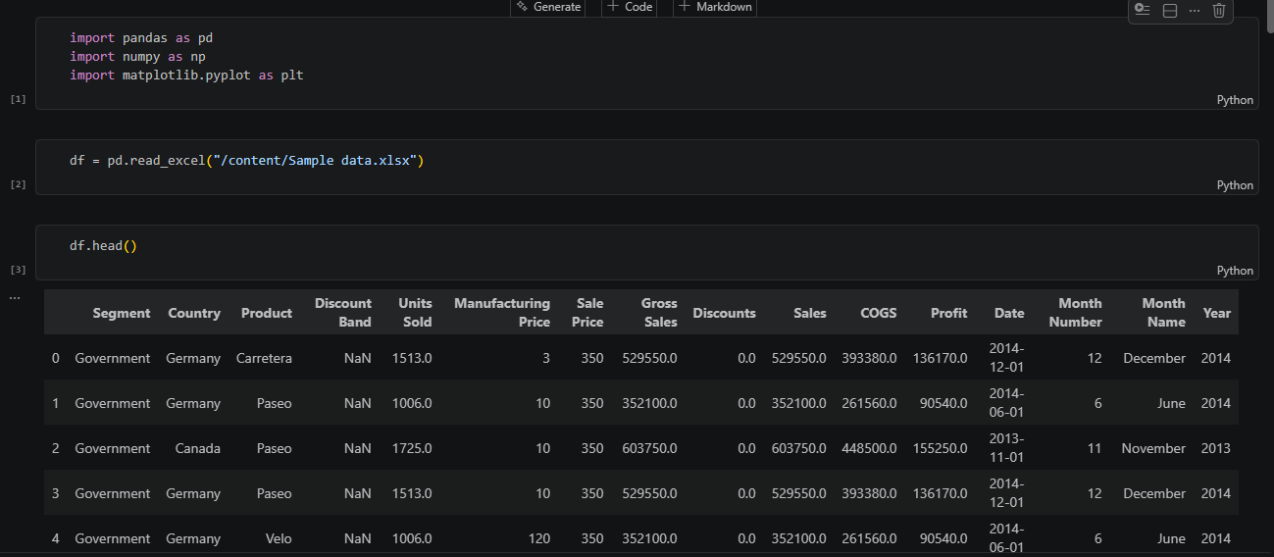
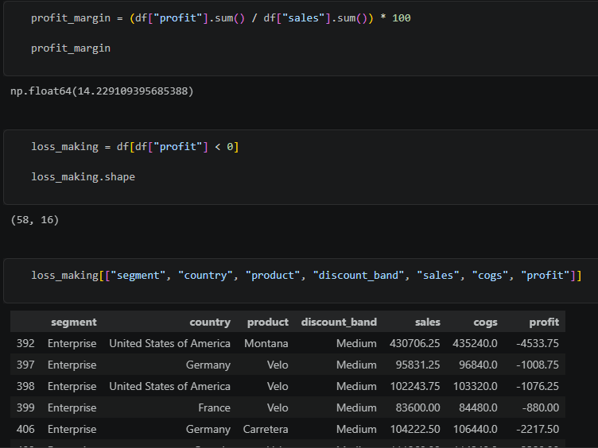
5. SQL Analysis and Key Findings
SQL was used to analyse sales and financial performance across products, countries, business segments, months, years, and discount bands.
The analysis focused on identifying top-performing products, comparing country-level performance, understanding sales trends, and evaluating profitability.
Key Findings
- Overall performance: Total sales reached $118.73 million, with total profit of $16.89 million.
- Profitability: The overall profit margin was approximately 14.23%.
- Discount analysis: The Medium discount band generated the highest total sales among the discount categories, while the Low discount band generated the highest total profit among the discounted categories.
- High discounts: The High discount band generated lower total profit than the Medium and Low discount bands.
- Product and country performance: SQL queries were used to rank products and countries by sales and profit, helping identify differences in business performance.
- Time-based analysis: Monthly and yearly sales and profit were analysed to understand changes in performance over time.
- Loss-making products: The overall product-level analysis did not identify any products with negative total profit.

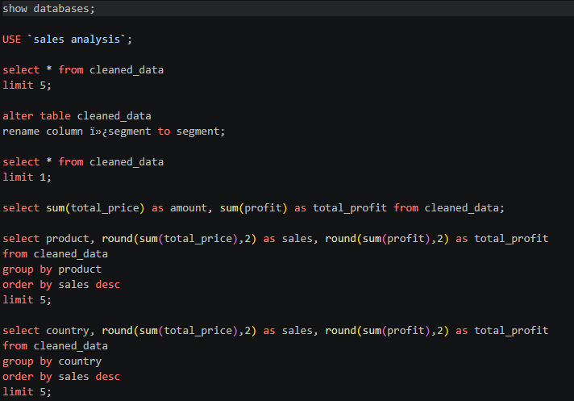
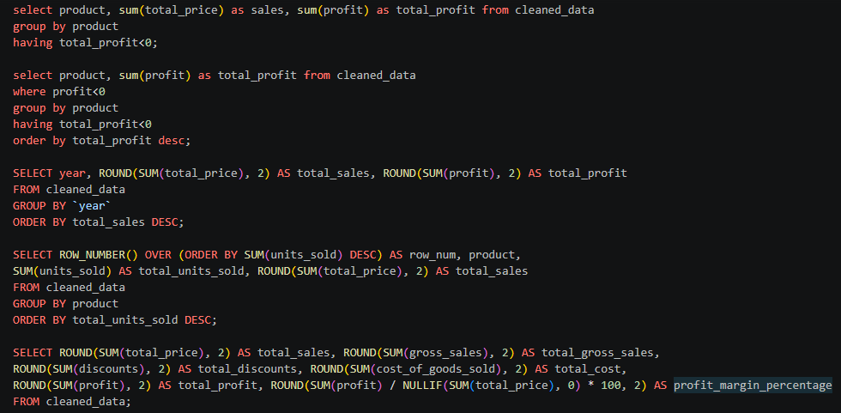
6. Power BI Dashboard
An interactive dashboard was developed using Power BI to present the key findings of the Sales Performance Analysis project. It provides a visual overview of sales, profit, units sold, and profit margin.
Key Dashboard Components
- KPI Cards: Display total sales, total profit, total units sold, and profit margin.
- Sales Trend: A line chart showing sales performance over time.
- Product Analysis: Charts comparing sales and units sold across products.
- Country Analysis: Charts comparing profit and units sold across countries.
- Discount Analysis: A chart comparing profit across discount bands.
- Interactive Slicers: Year, country, discount band, and month filters allow users to explore the data interactively.
Dashboard Design
The dashboard uses a green-themed colour palette with contrasting KPI cards to improve readability and visual consistency. Charts and slicers are arranged to make important performance indicators and comparisons easy to understand.
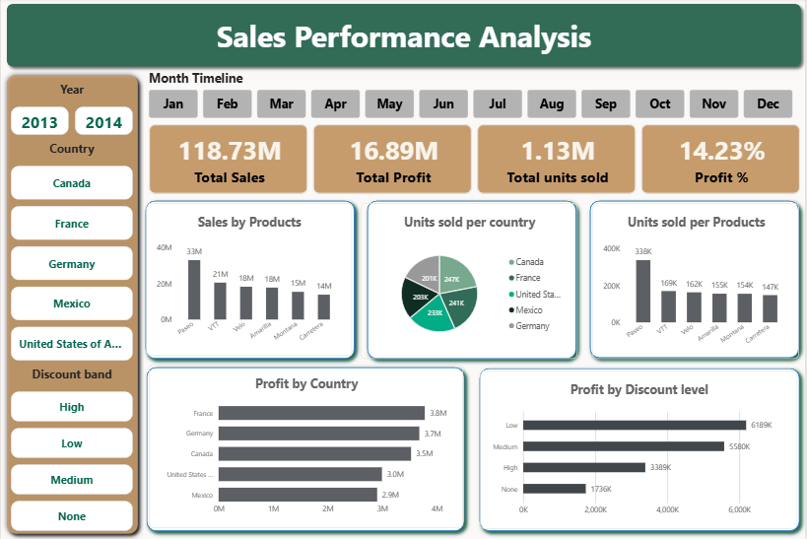
7. Business Recommendations
Based on the sales and profitability analysis, the following recommendations can help improve business performance:
- Review discount strategies: The Low discount band generated the highest total profit among the discounted categories. The business should evaluate discount levels carefully to balance sales growth and profitability.
- Monitor high discounts: The High discount band generated lower total profit than the Medium and Low discount bands. The business should assess whether high discounts provide sufficient financial benefits.
- Focus on product performance: Regularly monitor sales and profit by product to identify strong performers and products that may need improvement.
- Compare country performance: Evaluate sales and profitability across countries to identify opportunities for growth and areas requiring further investigation.
- Track sales trends: Use monthly and yearly sales analysis to monitor changes in performance and support planning and forecasting.
- Use interactive reporting: Continue using the Power BI dashboard to monitor key performance indicators and explore results by year, month, country, and discount band.
These recommendations are based on the observed data patterns. Further analysis would be required to establish the causes of performance differences.
8. Conclusion
The Sales Performance Analysis project demonstrated how Python, SQL, Excel, and Power BI can be used to transform raw sales data into meaningful business insights.
Python was used to clean and prepare the dataset, while SQL helped analyse sales, profit, discounts, products, countries, and time-based performance. Power BI was used to create an interactive dashboard that presents key performance indicators and business trends.
The analysis found total sales of approximately $118.73 million and total profit of $16.89 million, with an overall profit margin of approximately 14.23%. The discount analysis also highlighted differences in sales and profitability across discount bands.
Overall, this project strengthened practical skills in data cleaning, SQL analysis, data visualization, and business insight generation. It demonstrates the value of data analytics in supporting informed business decisions.

