**Email:** meghanabadgujar07@gmail.com

**Name:** Meghana Samadhan Badgujar  
**Batch Name:** WiproNGA_DWS_B5_25VID2550

**User ID:** 34737

**Batch ID:** 25VID2550

**Date:** 18th August 2025

**Assignment Topic:**

* **Overview of Application Virtualization**
* **Common platforms (Microsoft App-V, VMware ThinApp, Citrix App Layering)**
* **Benefits, limitations, and comparison with other technologies other than appv.**

**1. Overview of Application Virtualization :**

- Application Virtualization is a technology that separates applications from the underlying operating system. Instead of installing an application directly on Windows, the app runs inside a “virtual environment” or sandbox.

**- Purpose**: Allows applications to be deployed, updated, and managed more easily without conflicts.

**- How it works**:

* + Captures application files, registry changes, and dependencies into a package.
  + Redirects these changes to a virtual layer at runtime.
  + The OS “thinks” the app is installed, but it’s actually running in isolation.

**2. Common Platforms for Application Virtualization**

**- Microsoft App-V**

* Agent-based virtualization (requires App-V client).
* Supports application streaming from central servers.
* Provides good isolation & conflict management.
* Discontinued on Windows 11, replaced by MSIX.

**- VMware ThinApp**

* Agentless virtualization (no client needed).
* Packages the app into a single portable EXE.
* Good for mobility and older OS support.
* Limited advanced management features compared to App-V.

**- Citrix App Layering**

* Focuses on layering technology rather than sandboxing.
* Separates OS, platform, and apps into independent layers.
* Allows IT admins to update apps once and apply changes across environments.
* Strong integration with Citrix Virtual Apps and Desktops.
* Better for VDI environments than standalone PCs.

**3. Benefits, Limitations & Comparison**

**- Benefits**

* Resolves DLL conflicts (aka DLL hell).
* Faster deployment & rollback.
* Easier testing, updates, and migration.
* Reduced dependency on local installations.

- **Limitations**

* Some apps can’t be virtualized (kernel drivers, antivirus, VPNs).
* Possible performance overhead.
* Vendor support restrictions.

- **Comparison with Other Technologies**

* MSI: Standard installer, fully integrates into OS.
* MSIX: Modern package (Windows 10/11), combines benefits of App-V and MSI, more secure and future-proof.
* App-V: Strong app isolation, but being phased out.
* ThinApp: Portable apps but less enterprise management.
* Citrix App Layering: Great for enterprise & VDI, not for standalone PCs.

**4. Hands-On with PSADT v4 Prompts (Where to Place)**

function Install-ADTDeployment {

# Step 1: Show welcome message

Show-ADTInstallationWelcome -Message "Welcome! VLC Media Player will be installed. Please save your work."

# Step 2: Show installation progress

Show-ADTInstallationProgress -StatusMessage "Installing VLC, please wait..."

# Step 3: Check for pending reboot before install

if (Get-ADTPendingReboot) {

Show-ADTInstallationPrompt -Message "A reboot is pending. Please restart your system before installation." -ButtonRightText "OK"

Exit-Script -ExitCode 1618

}

# Step 4: Run installer

Start-ADTProcess -FilePath "$dirFiles\VLC.exe" -ArgumentList "/S" -Wait

# Step 5: Show dialog after install

Show-ADTInstallationPrompt -Message "VLC has been installed successfully!" -ButtonRightText "OK"

# Step 6: Balloon tip notification

Show-ADTBalloonTip -BalloonTipText "VLC Installed Successfully" -BalloonTipTitle "Install Complete" -BalloonTipIcon Info

# Step 7: Optional reboot prompt

Restart-Computer -Force

}

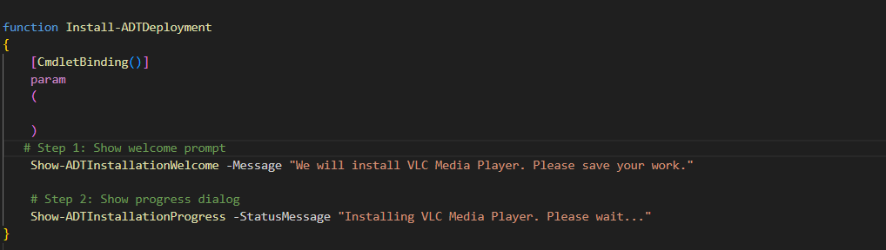

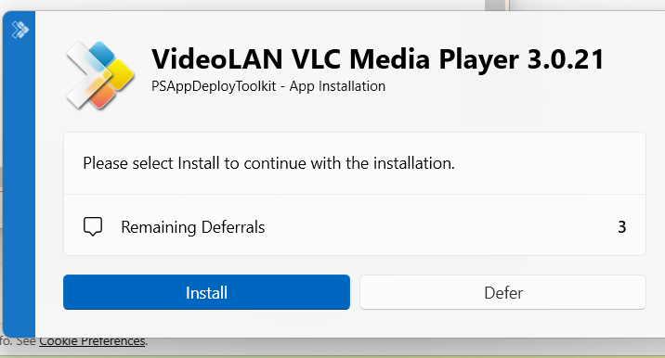

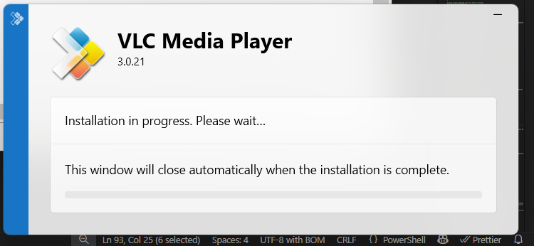

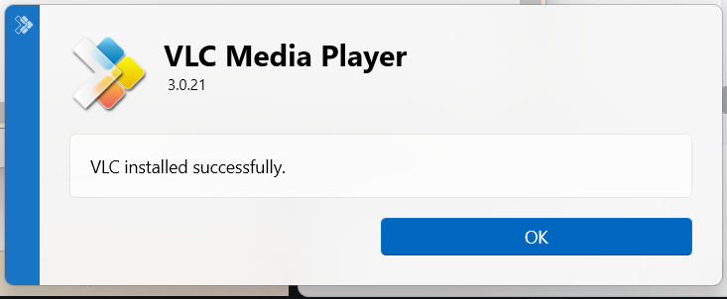

**5. Steps to Create VMs in Oracle VirtualBox Manager**

**1. Install VirtualBox (done once)**

* Download Oracle VirtualBox from the official site.
* Install it on your system/cloud lab environment.
* (Optional) Install **VirtualBox Extension Pack** for USB and advanced features.

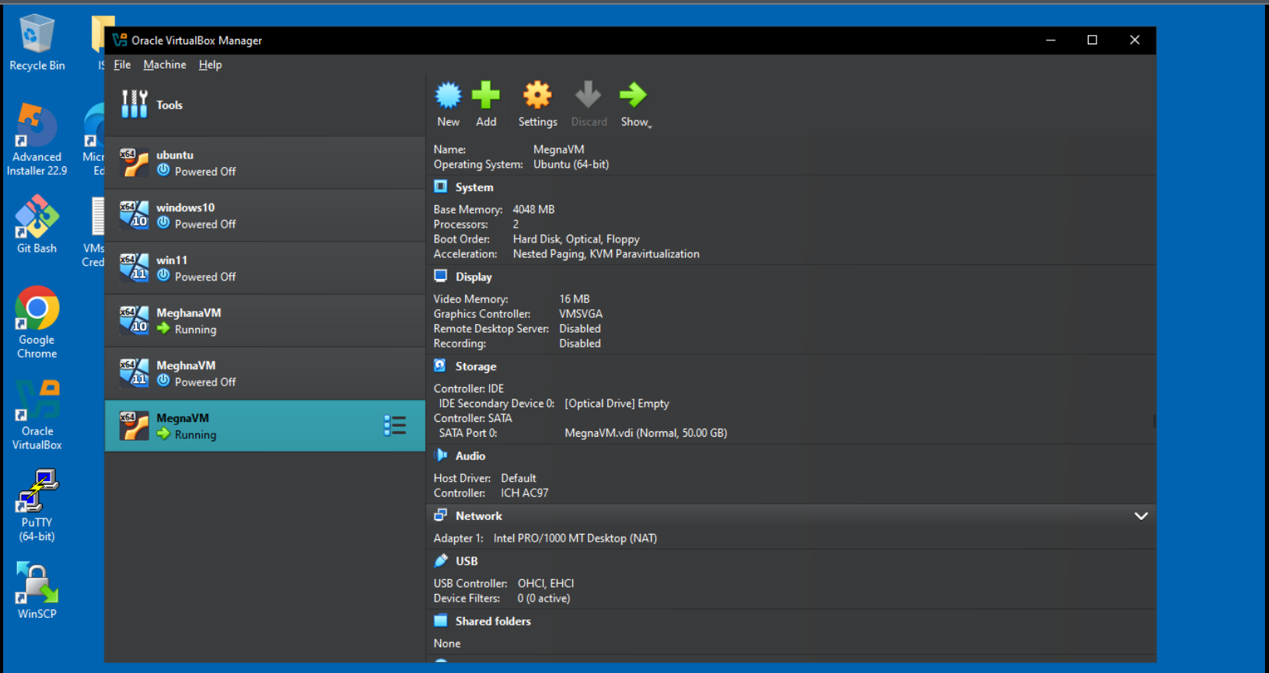

**2. Create a New Virtual Machine**

1. Open **Oracle VM VirtualBox Manager**.
2. Click **New**.
3. Enter:
   * **Name**: Windows10_VM, Windows11_VM, or Ubuntu_VM.
   * **Type**: Microsoft Windows / Linux.
   * **Version**: Choose Windows 10 (64-bit), Windows 11 (64-bit), or Ubuntu (64-bit).

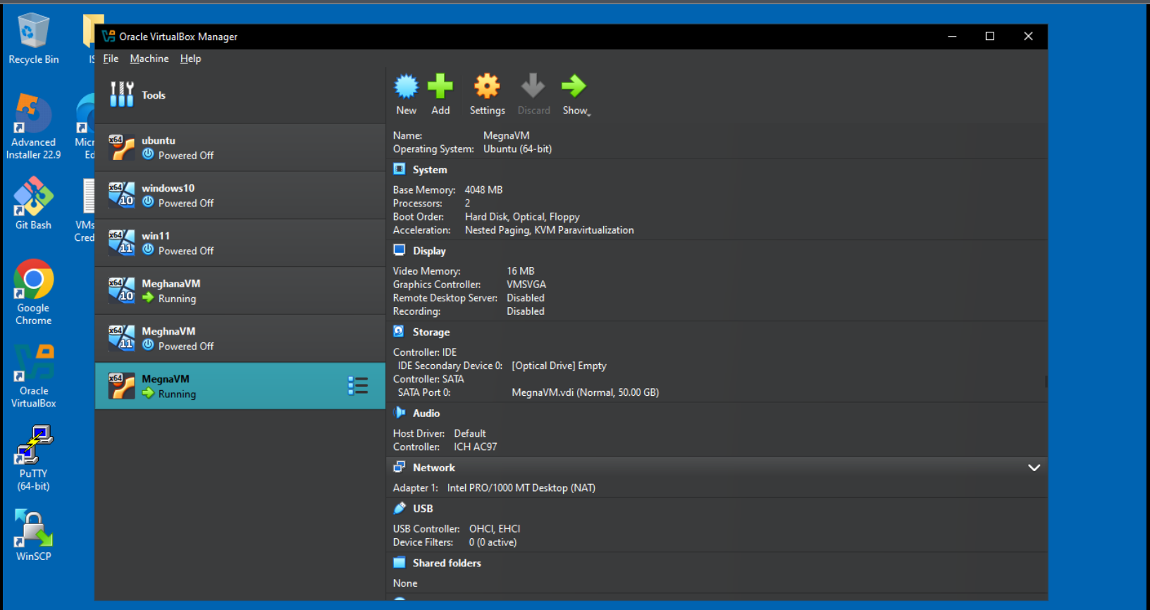

**3. Allocate Memory (RAM)**

* Assign recommended memory (green zone in slider).
* Windows 10/11: **4 GB minimum (4096 MB)**.
* Ubuntu: **2 GB minimum (2048 MB)**.

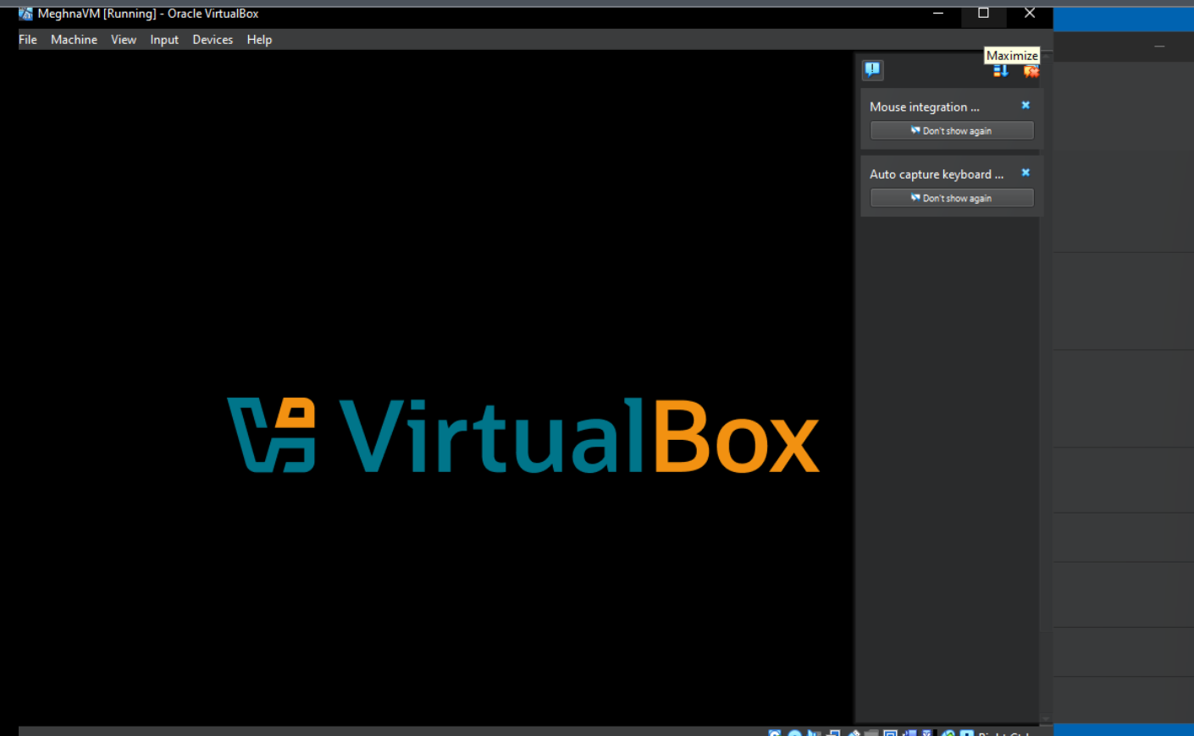

**4. Create Virtual Hard Disk**

* Choose **Create a virtual hard disk now**.
* Disk type: **VDI (VirtualBox Disk Image)**.
* Storage: **Dynamically allocated** (saves space).
* Size:
  + Windows 10/11 → at least **50 GB**.
  + Ubuntu → at least **25 GB**.

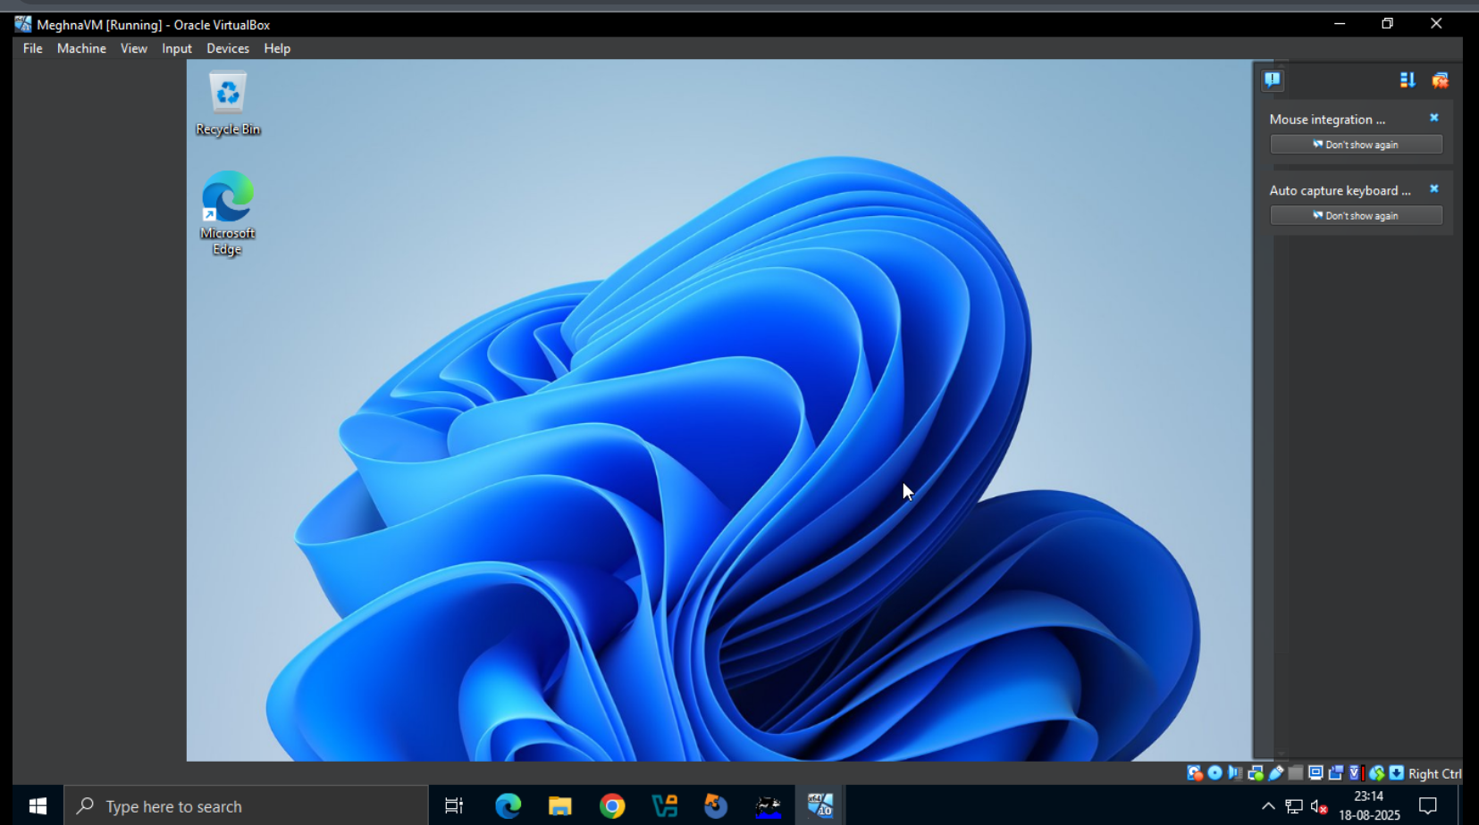

**5. Mount ISO File**

* Select your VM → **Settings** → **Storage**.
* Under “Controller: IDE” → add a new disk → **Choose a disk file**.
* Select the **Windows 10 ISO**, **Windows 11 ISO**, or **Ubuntu ISO** file.

**6. Start the VM**

* Click **Start**.
* The VM boots from the mounted ISO.
* You’ll see the installer for Windows or Ubuntu.

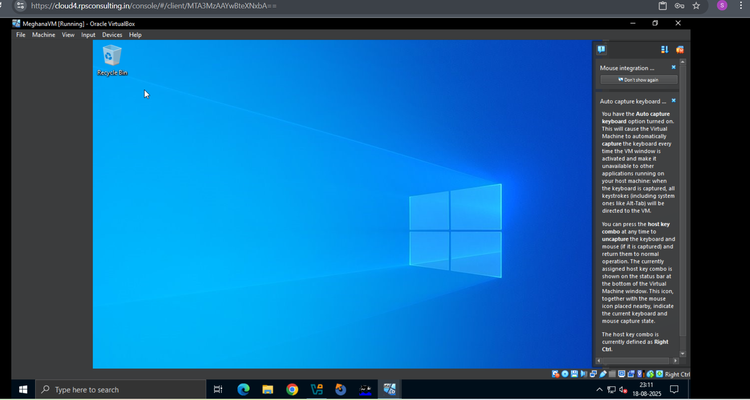

**7. Install the OS**

* **Windows 10/11**: Choose edition install.
* **Ubuntu**: Choose language, keyboard layout → install Ubuntu → create user → finish.

