**Email:** meghanabadgujar07@gmail.com

**Name:** Meghana Samadhan Badgujar  
**Batch Name:** WiproNGA_DWS_B5_25VID2550

**User ID:** 34737

**Batch ID:** 25VID2550

**Date:** 11th August 2025

**Assignment Topic:**

* **How to Deploy an App Using PSAppDeployToolkit (PSADT)**

**1. Introduction**

The PowerShell App Deployment Toolkit (PSADT) is a framework that simplifies the deployment of applications using PowerShell scripts.  
It provides a consistent user interface (UI) for installations, handles application closure prompts, logging, and many other deployment tasks.

In this exercise, we deployed Google Chrome Enterprise using PSADT.

**2. Prerequisites**

* Windows system with PowerShell installed.
* PSAppDeployToolkit downloaded from [GitHub](https://github.com/PSAppDeployToolkit/PSAppDeployToolkit).
* Application installer file (e.g., GoogleChromeStandaloneEnterprise64.msi).
* Administrative rights on the system.

**3. Steps to Deploy an App**

**Step 1: Download PSAppDeployToolkit**

1. Go to the official GitHub repository and download the latest release as a .zip file.
2. Extract the .zip file to a preferred folder -**C:\Users\Meghna\Downloads\PSAppDeployToolkit_v3.8.4**

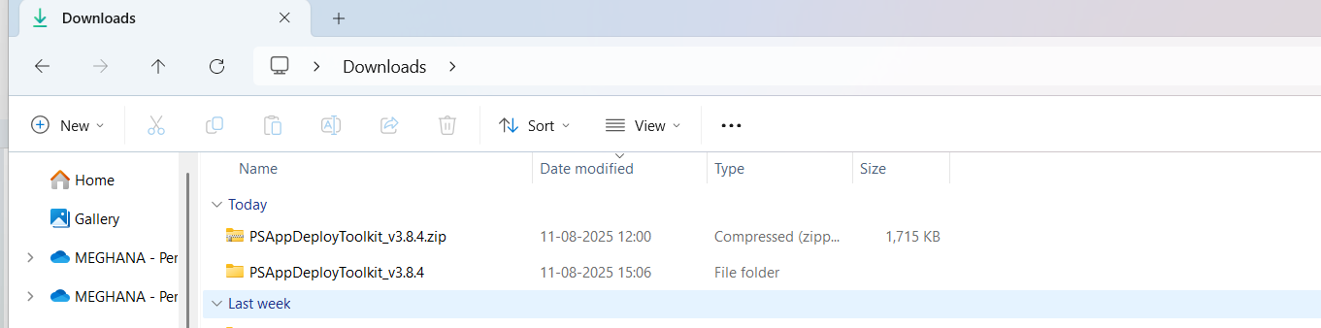

**Step 2: Prepare the Application Files**

1. Place the installer file - GoogleChromeStandaloneEnterprise64.msi inside the Files folder located in:

PSAppDeployToolkit_v3.8.4\Toolkit\Files

1. Ensure the file name is correct and matches what will be referenced in the script.

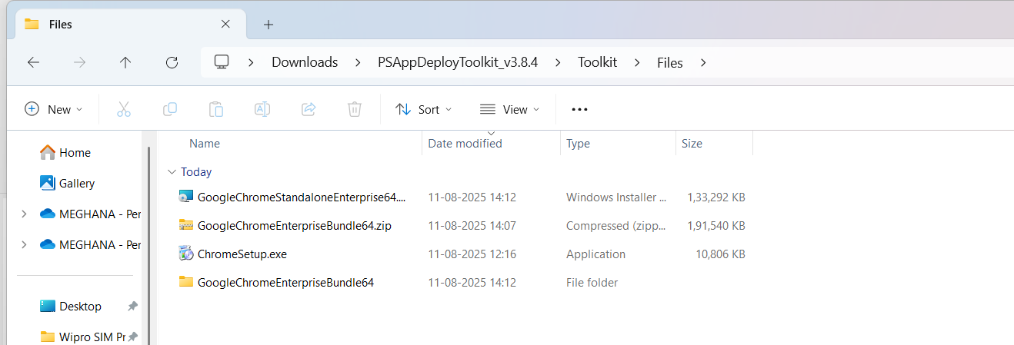

**Step 3: Edit Deploy-Application.ps1**

1. Open the file Deploy-Application.ps1 (located inside Toolkit) in PowerShell ISE or any text editor.
2. In the Installation section, add the following code:

##*===============================================

##* INSTALLATION

##*===============================================

[string]$installPhase = 'Installation'

## Show installation welcome prompt

Show-InstallationWelcome -CloseApps 'chrome' -AllowDefer -DeferTimes 3

Show-InstallationProgress

## Install Google Chrome

Execute-MSI -Action Install -Path 'GoogleChromeStandaloneEnterprise64.msi'

## Show installation completion message

Show-InstallationPrompt -Message 'Google Chrome has been installed successfully.' -ButtonRightText 'OK'

1. Save the script.

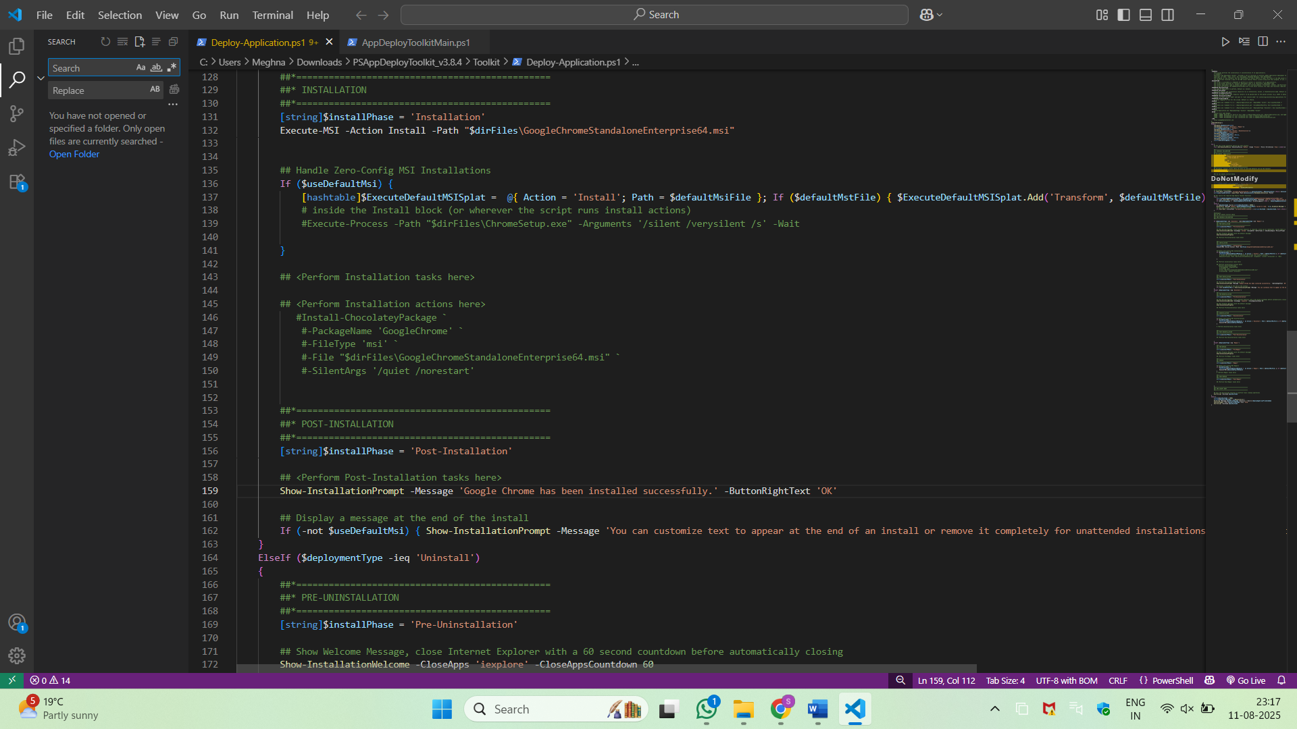

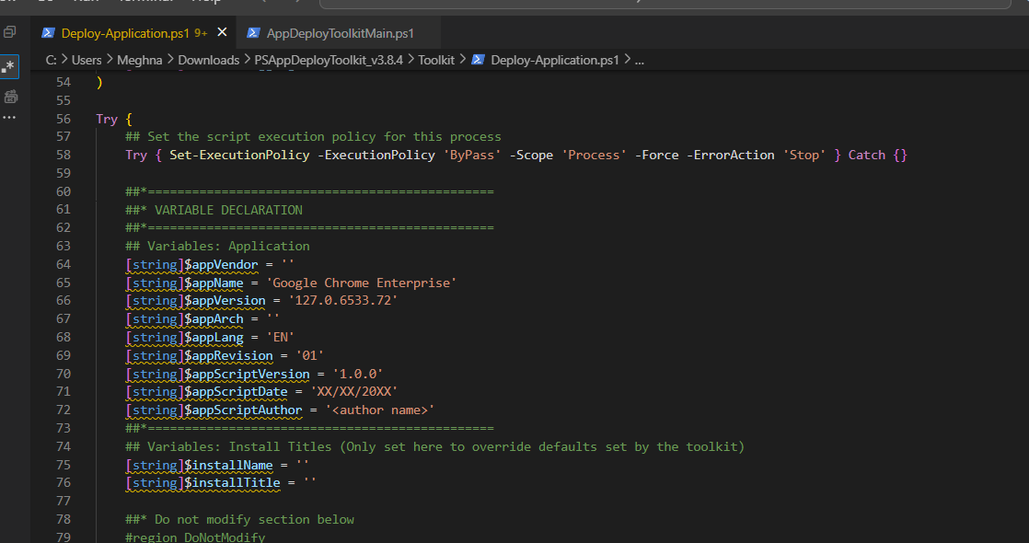

**Step 4: Run PowerShell as Administrator**

1. Search for **Windows PowerShell ISE** in the Start Menu.
2. Right-click and select **Run as Administrator**.

**Step 5: Navigate to the Toolkit Folder**

In the PowerShell console, run:

cd "C:\Users\Meghna\Downloads\PSAppDeployToolkit_v3.8.4\Toolkit"

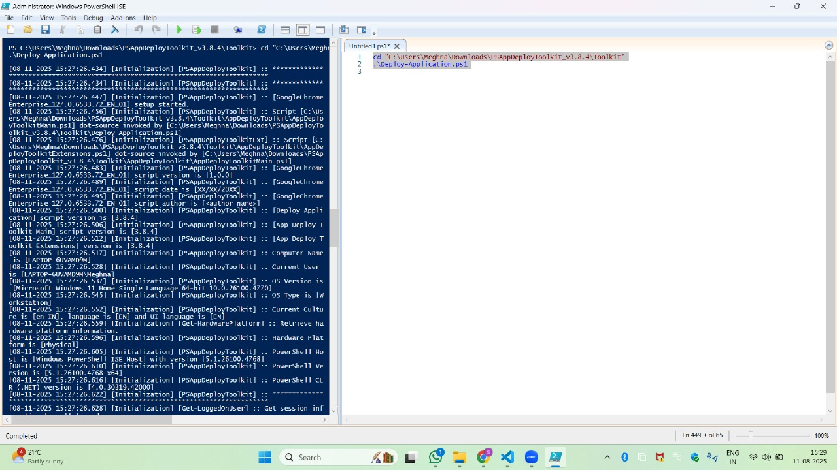

**Step 6: Execute the Deployment Script**

Run:

.\Deploy-Application.ps1

The PSADT UI will appear:

* **Welcome screen** prompting to close conflicting apps or defer installation.
* **Progress bar** showing installation status.
* **Completion prompt** after successful installation.

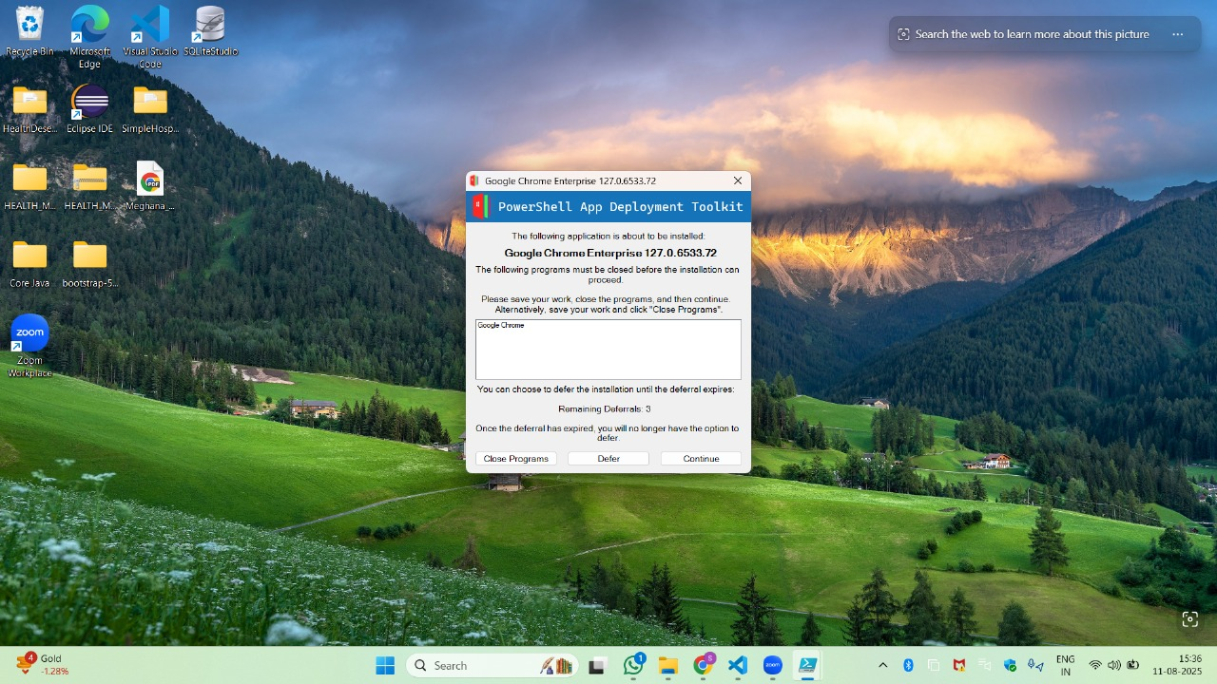

**4. Output**

* The application (Google Chrome) is installed silently with a professional UI.
* Logs are automatically saved in the Logs folder inside the toolkit for troubleshooting.

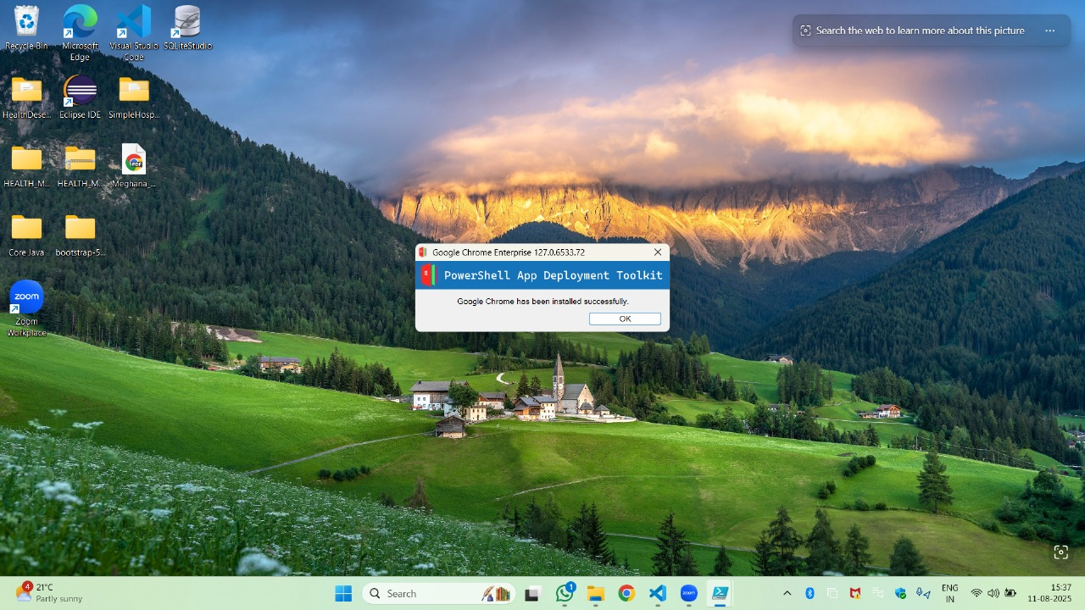

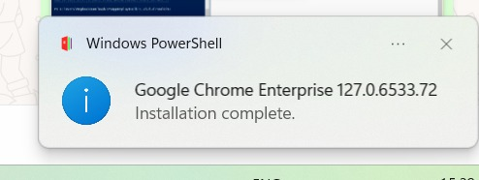

**5. Uninstallation Steps**

**Step 1: Edit Deploy-Application.ps1 for Uninstallation**

1. In **Deploy-Application.ps1**, locate the **Uninstallation** section.
2. Add:

##*===============================================

##* UNINSTALLATION

##*===============================================

[string]$installPhase = 'Uninstallation'

## Show welcome screen

Show-InstallationWelcome -CloseApps 'chrome' -AllowDefer -DeferTimes 0

Show-InstallationProgress

## Uninstall Google Chrome

Execute-MSI -Action Uninstall -Path 'GoogleChromeStandaloneEnterprise64.msi'

## Completion message

Show-InstallationPrompt -Message 'Google Chrome has been uninstalled successfully.' -ButtonRightText 'OK'

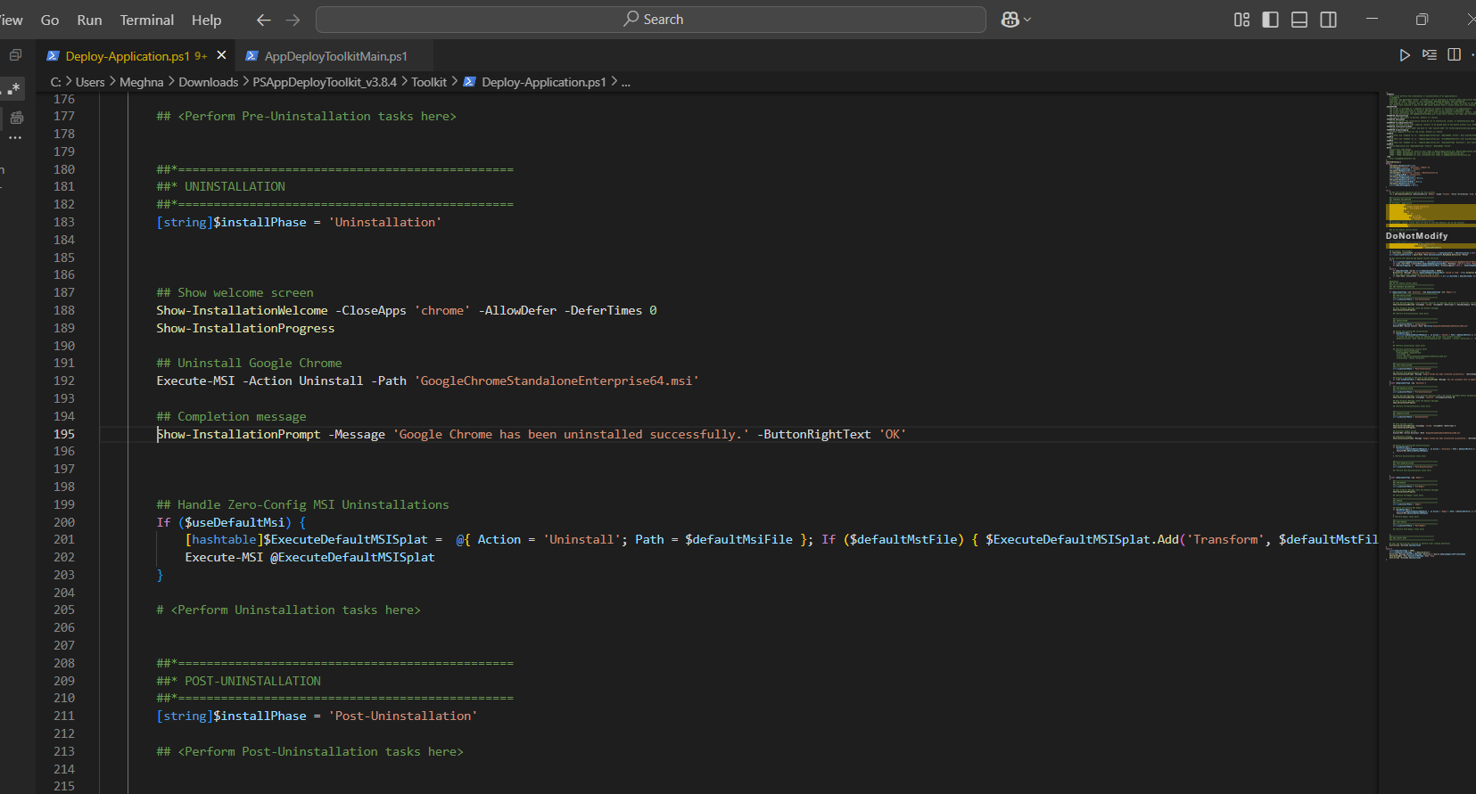

**Step 2: Run Uninstallation**

1. In PowerShell (Admin), navigate to the Toolkit folder:

cd "C:\Users\Meghna\Downloads\PSAppDeployToolkit_v3.8.4\Toolkit"

1. Execute:

.\Deploy-Application.ps1 Uninstall

