**Email:** meghanabadgujar07@gmail.com

**Name:** Meghana Samadhan Badgujar  
**Batch Name:** WiproNGA_DWS_B5_25VID2550

**User ID:** 34737

**Batch ID:** 25VID2550

**Date:** 12th August 2025

**Assignment Topic:**

* **Execute Process in PowerShell, File Operations in PSADT, and Active Setup in PSADT**

**1. Execute Process in PowerShell (Using PSADT)**

In the PSAppDeployToolkit v4(PSADT), the Execute-Process function is used to run executable files (.exe, .msi, .bat, etc.) from the deployment script with more control than basic PowerShell commands.

**Example – Installing VLC Media silently:**

Start-ADTProcess -FilePath "$dirFiles\VLC.exe" -ArgumentList "/S" -WindowStyle Hidden

**Explanation:**

In v3.x, you could run:

Execute-Process "$dirFiles\vlc.exe" /S

because it used positional parameters.

But in v4, that function was renamed to Start-ADTProcess and now positional parameters are not allowed — we must explicitly use -FilePath.

**-WindowStyle** → "Normal" will show the installer window normally (can also be Hidden or Minimized).

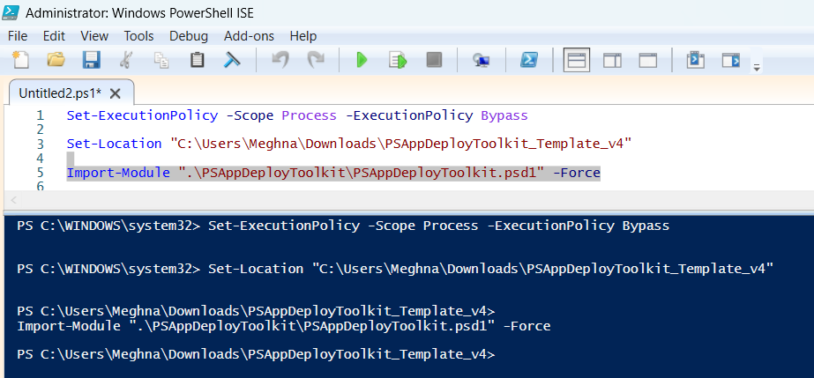

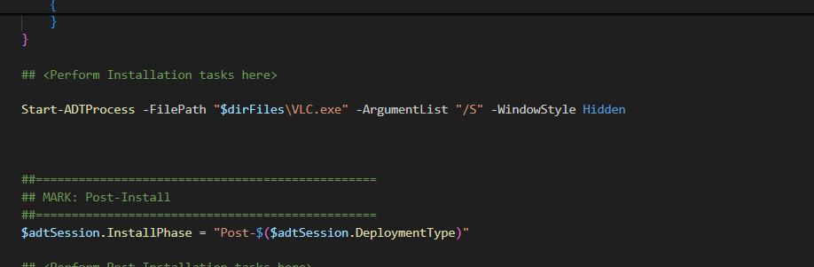

Runs the VLC.exe installer silently (/S parameter) with no visible console window (Hidden mode). $dirFiles ensures the script looks for the installer in the toolkit’s Files folder.

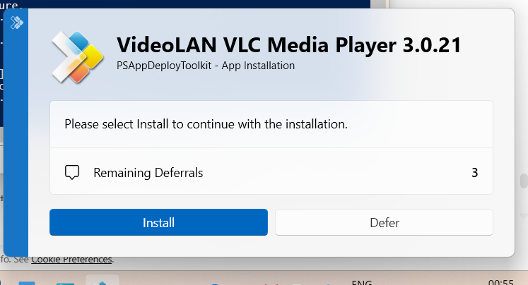

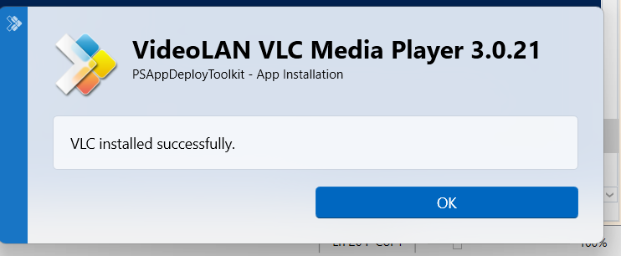

**2.File Operations in PSADT:**

**- Copy File:**

Copies a file from the toolkit’s Files folder to a system directory. -Force overwrites existing files without prompting

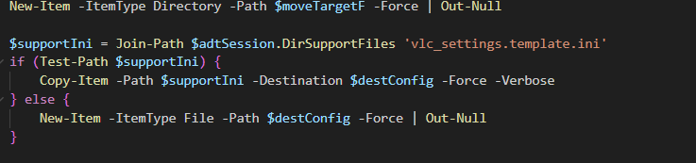

**- Delete File :**Deletes the file, forcing removal without confirmation.

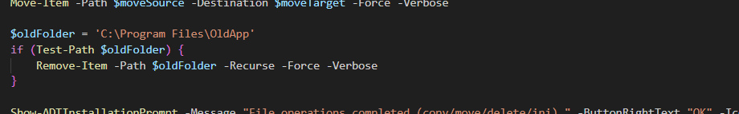

**-Move File:**

Moves a file to a new location, replacing any existing file.

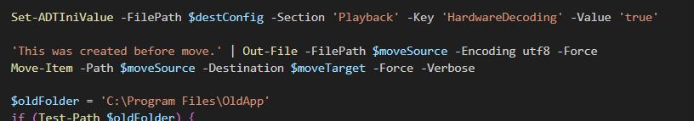

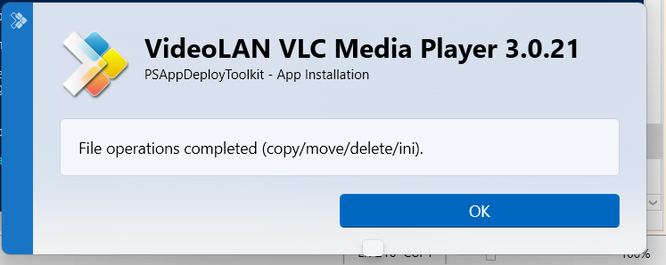

**3.Active Setup in PSADT:**

This block creates a registry entry in Active Setup so that the $perUserScript will run automatically for each user the next time they log in.

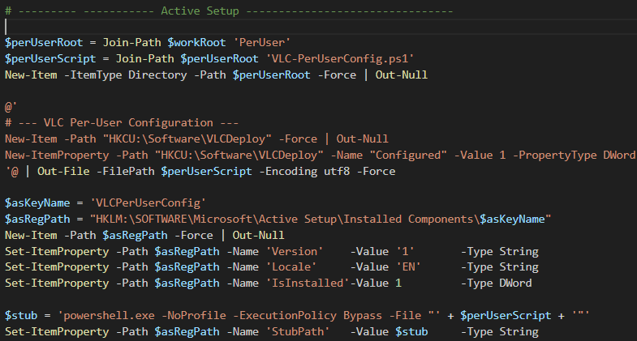

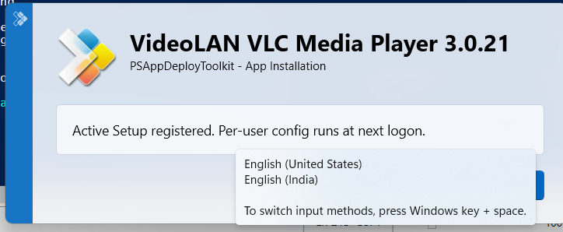

**– Completion Prompt**

This is the **completion pop-up** telling the user that Active Setup has been registered successfully.



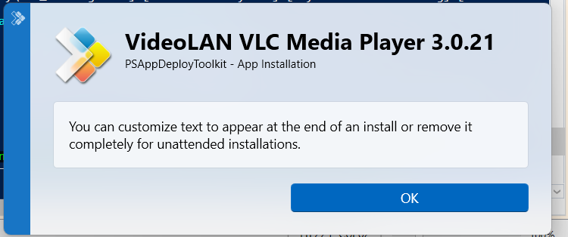

**4.VLC Uninstall process:**

**– Uninstall via EXE:**

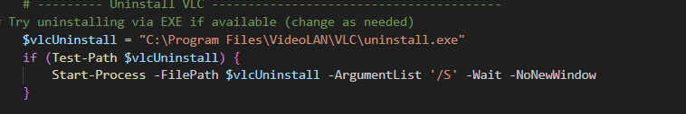

* Checks if VLC’s built-in uninstaller exists at the default installation location.
* If found, runs it silently (/S) and waits for it to complete.

– **Remove ProgramData folder:**

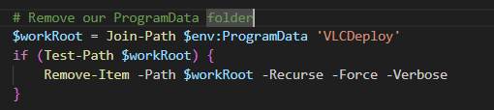

* Deletes the custom deployment folder we created earlier in C:\ProgramData\VLCDeploy.
* -Recurse ensures all files and subfolders are removed.

– **Remove Active Setup registry entry**

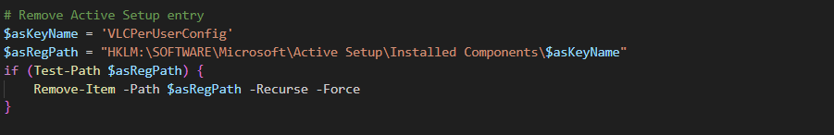

* Removes the registry key that was created during Active Setup registration.
* Prevents the per-user configuration script from running for new users after uninstall.

**– Show Uninstall Completion Prompt**

Displays a final pop-up message confirming that VLC and its configurations have been completely removed.

