**Email:** meghanabadgujar07@gmail.com

**Name:** Meghana Samadhan Badgujar  
**Batch Name:** WiproNGA_DWS_B5_25VID2550

**User ID:** 34737

**Batch ID:** 25VID2550

**Date:** 13th August 2025

**Assignment Topic:**

* **MSIX Benefits and Why MSIX**
* **MSIX Packaging Tool**
* **Handing Application Updates in msix**
* **User Settings along with Data Associated within the Packages in MSIX**

**1. MSIX Benefits and Why MSIX**

MSIX is Microsoft’s modern packaging format that combines the best features of MSI, AppX, and App-V.

**Benefits:**

* Reliable Install/Uninstall → No leftover files or registry entries after uninstall.
* Security → All packages are digitally signed to prevent tampering.
* Compression → Smaller package size compared to MSI/EXE.
* Universal Deployment → Works with Intune, SCCM, Microsoft Store, and manual install.
* Simplified Updates → Differential updates only download changed files.
* Predictable Behavior → Runs in a container for consistency across devices.

**Why MSIX over MSI/EXE:**

* More secure and lightweight.
* Built-in version control and auto-updates.
* Easier to manage in enterprise environments.

**2. MSIX Packaging Tool**

**Introduction:**

The MSIX Packaging Tool is a Microsoft utility that enables IT professionals and application packagers to convert existing installers (EXE, MSI) into the MSIX format.  
MSIX is the modern deployment format for Windows applications, offering:

* Reliable installations and clean uninstalls
* Security with containerization
* Simplified updates
* Reduced OS pollution (no leftover registry/files)

**Steps – From Installation to Creating an App Package**

1. Download & Install MSIX Packaging Tool
   * Open Microsoft Store → Search for MSIX Packaging Tool.
   * Click Install.

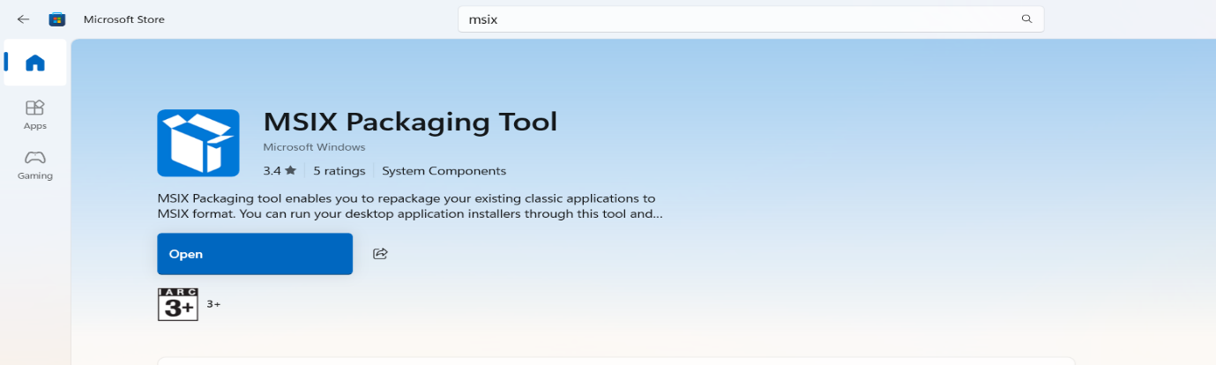

1. Launch the Tool
   * Start menu → Search MSIX Packaging Tool → Open.

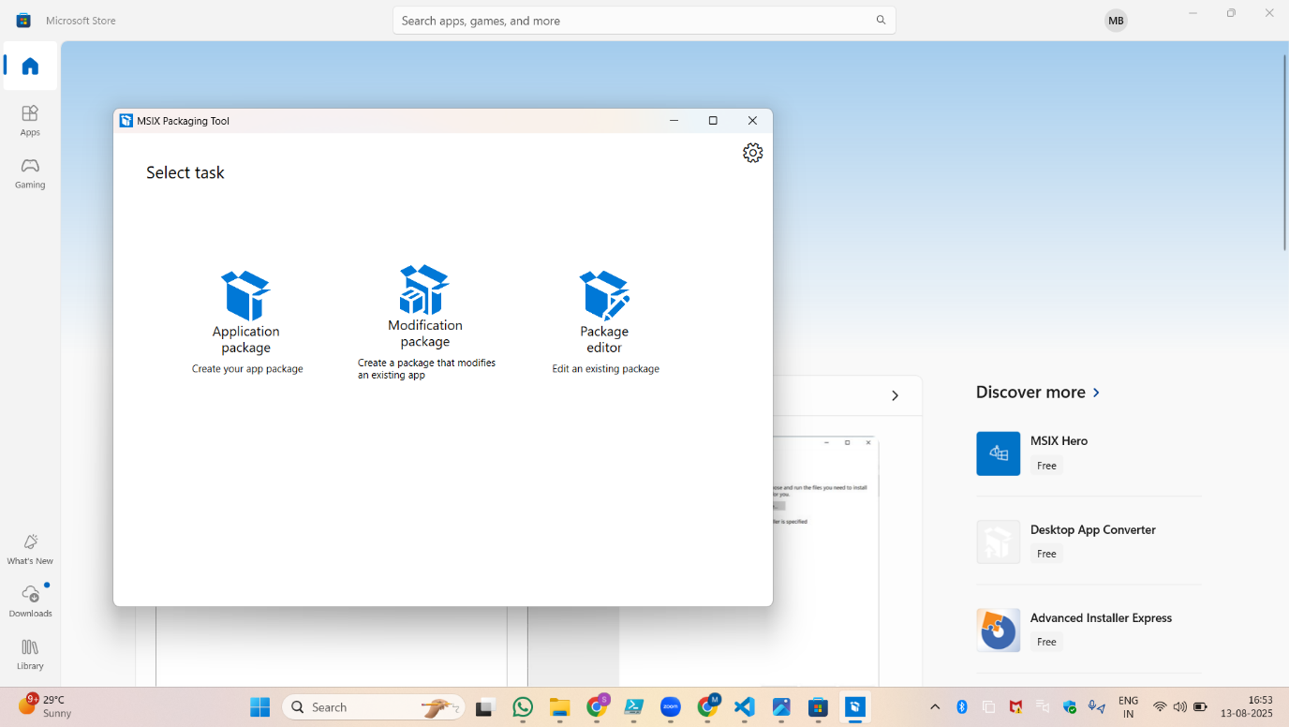

1. Start a New Package
   * Click Application package → Choose Create package on this computer.

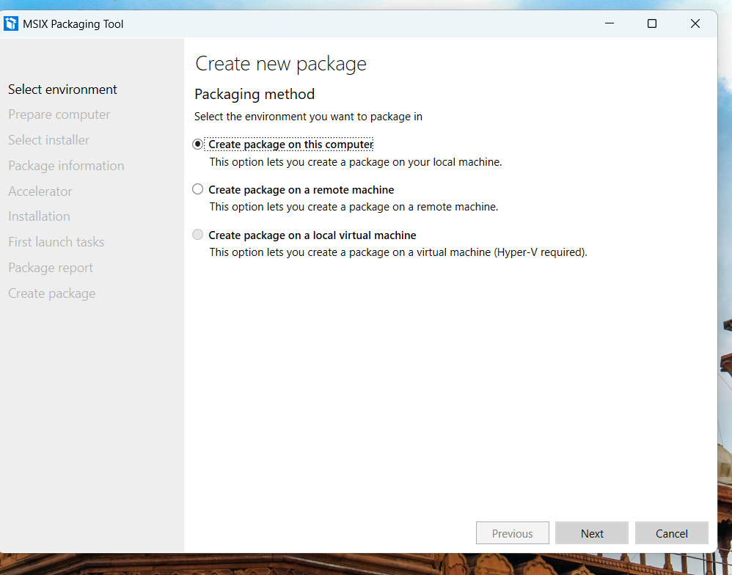

1. Package Information
   * Enter Package Name, Publisher, Version, and Display Name.
   * Set Installation Location if needed.

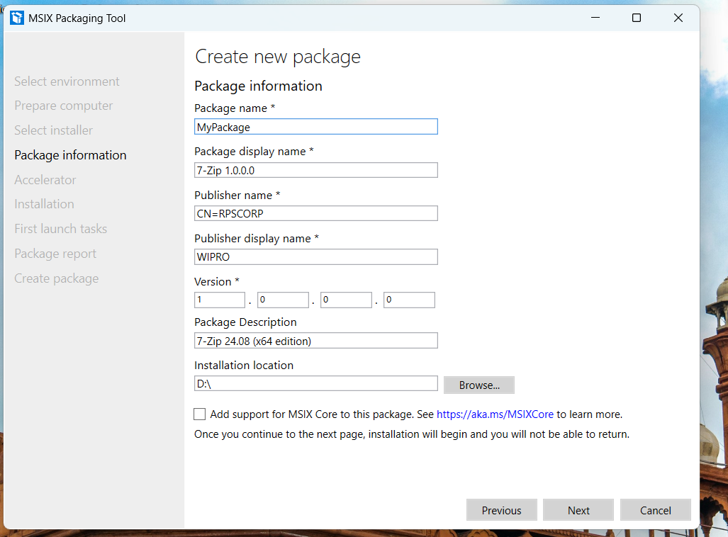

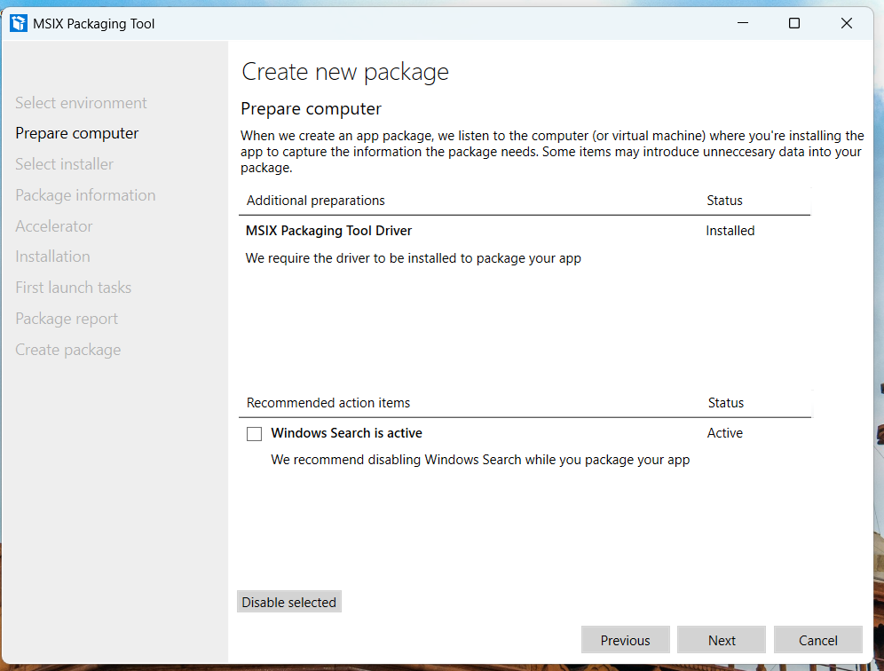

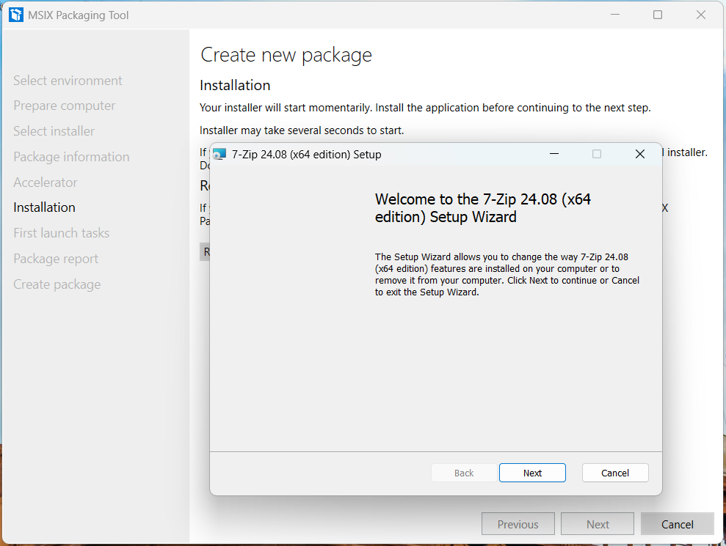

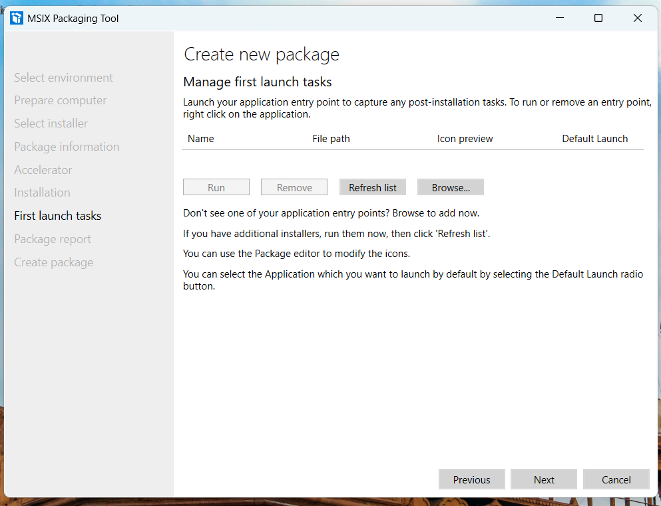

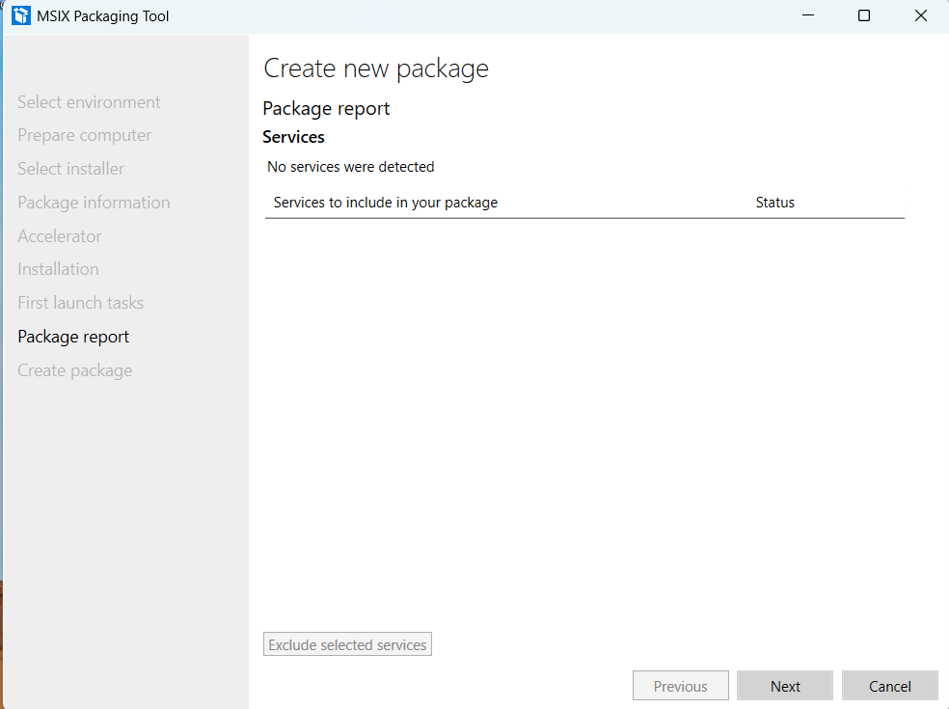

1. Save MSIX Package
   * Choose where to save the .msix or .appx package.
   * Finish the wizard.

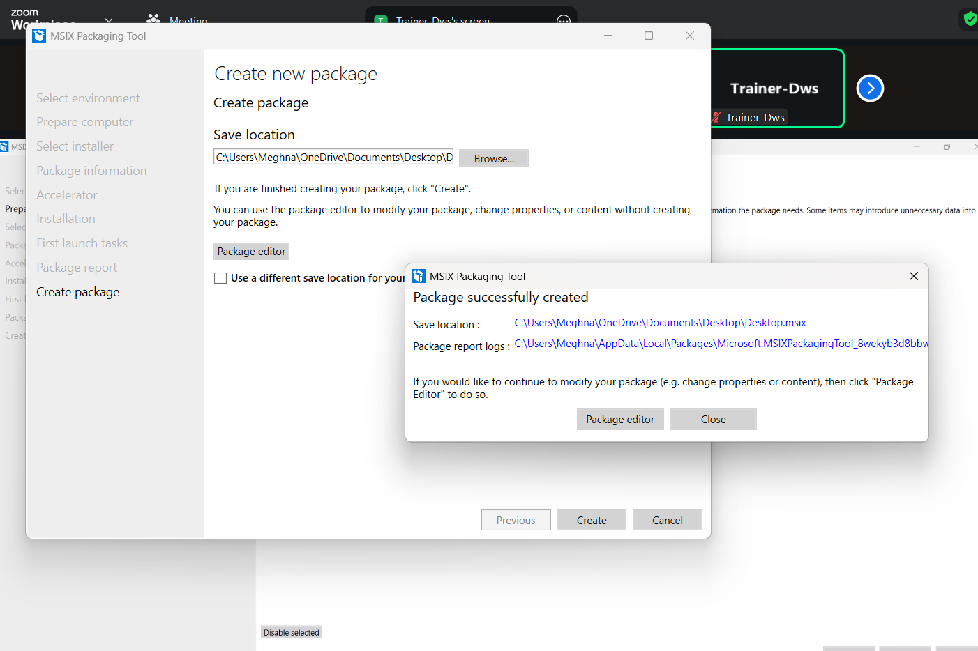

1. Test Deployment
   * Install the MSIX package on a test machine.
   * Verify app works correctly.



**3. Handling Application Updates in MSIX**

* MSIX supports **automatic updates** via:
  1. **App Installer** → Checks update source and applies new version automatically.
  2. **Enterprise Tools** (Intune/SCCM) → Pushes updated package to devices.
  3. **Manual Update** → User downloads and installs newer MSIX package.

**Differential Updates:**

* Only changed files are downloaded instead of the full package, saving bandwidth.

**4. User Settings along with Data Associated within the Packages in MSIX**

When an app is packaged in MSIX, the application files are read-only inside the package container.  
This means user settings, documents, and any app-generated data are stored outside the package in separate user-specific folders.

**Where the data is stored:**

**- Local App Data (per-user, device-specific)**

Exa- C:\Users\Meghna\AppData\Local\Packages\Microsoft.WindowsNotepad_8wekyb3d8bbweContains cache files, logs, and temporary app data.

* + Does not roam between devices.

**Advantages**

* Prevents data loss during updates or repairs.
* Cleaner uninstall — removes only app package files, not user-created data (unless explicitly removed).
* Makes roaming profiles easier in enterprise environments.

