**Email:** meghanabadgujar07@gmail.com

**Name:** Meghana Samadhan Badgujar  
**Batch Name:** WiproNGA_DWS_B5_25VID2550

**User ID:** 34737

**Batch ID:** 25VID2550

**Date:** 14th August 2025

**Assignment Topic:**

* **Get-Process, For Loop, If Statement, ForEach Loop,**

**SetADTIniValue, MSI/MSP Logging**

**1. Get-Process**

The Get-Process cmdlet in PowerShell retrieves information about all processes running on a local or remote computer. It’s similar to Task Manager, but it’s scriptable, filterable, and can be combined with other cmdlets for automation.

**Key Features of Get-Process**

1. **View running processes** – See what programs and background services are active.
2. **Monitor CPU and memory usage** – Identify resource-heavy processes.
3. **Control processes** – Combine with Stop-Process to end a program.
4. **Remote management** – Get process info from another computer (if you have permissions).

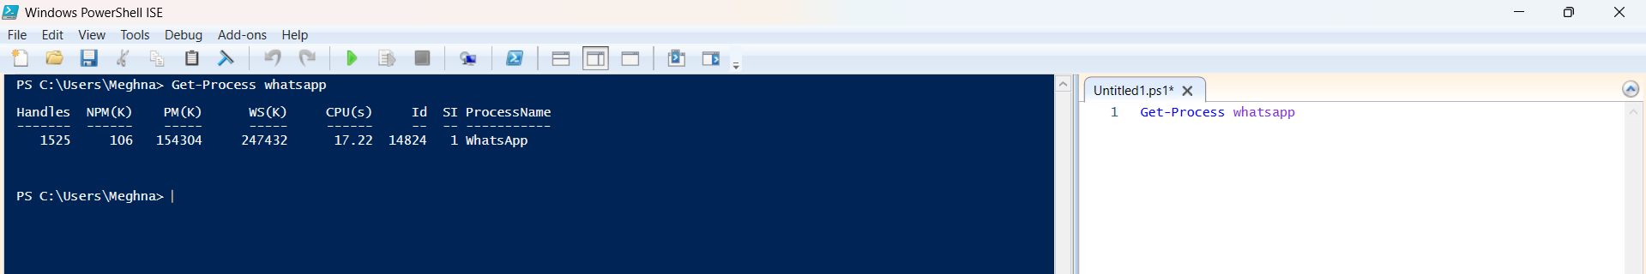

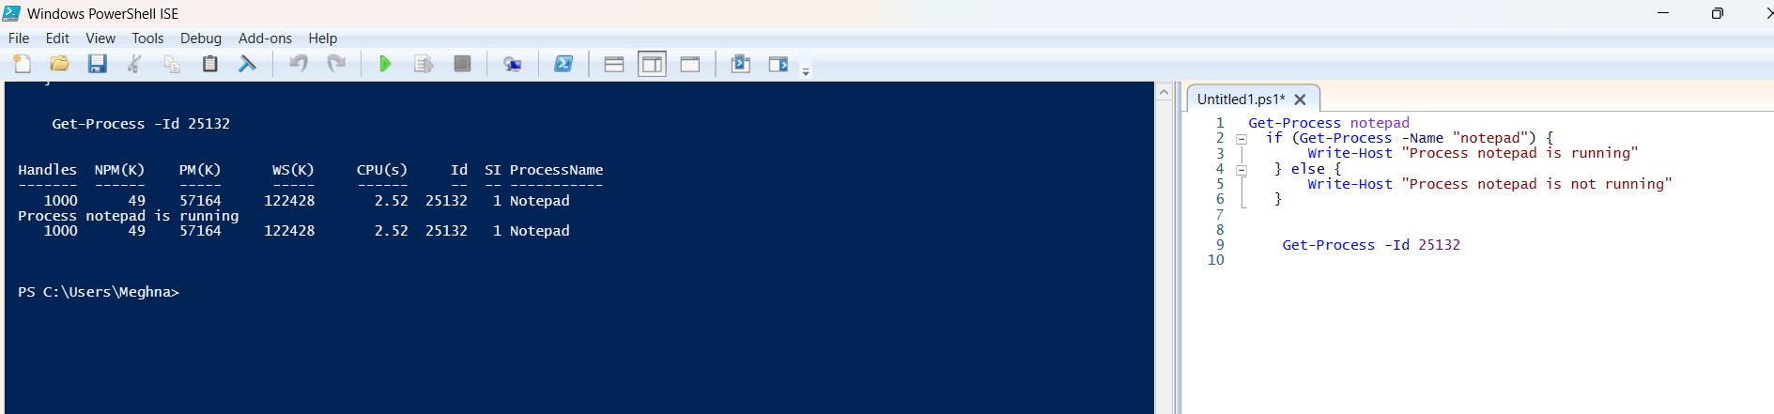

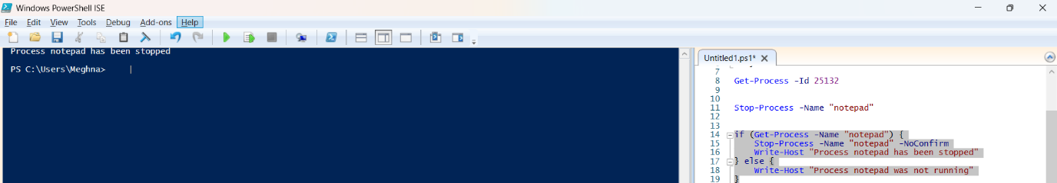

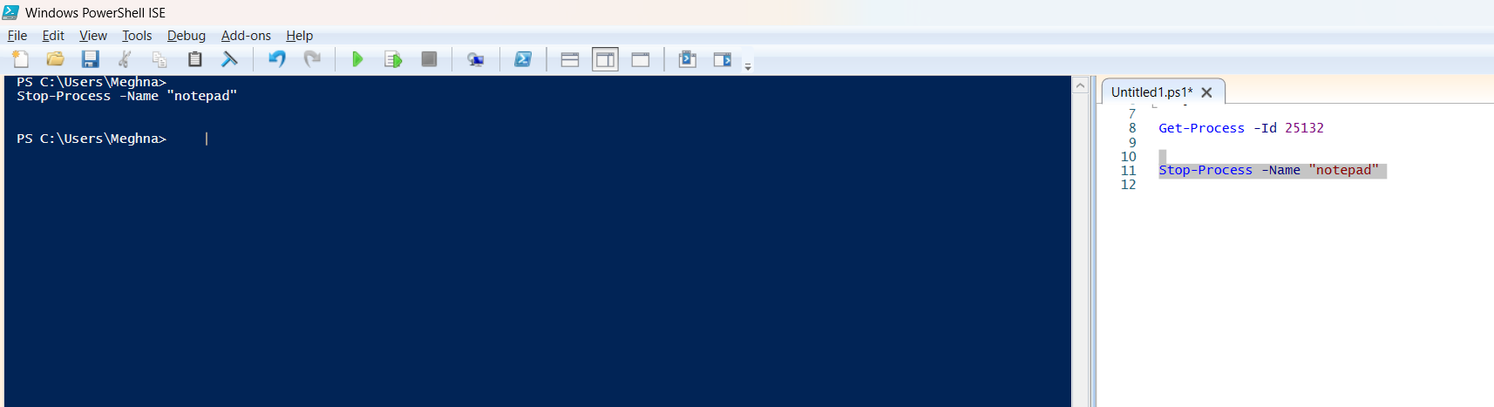

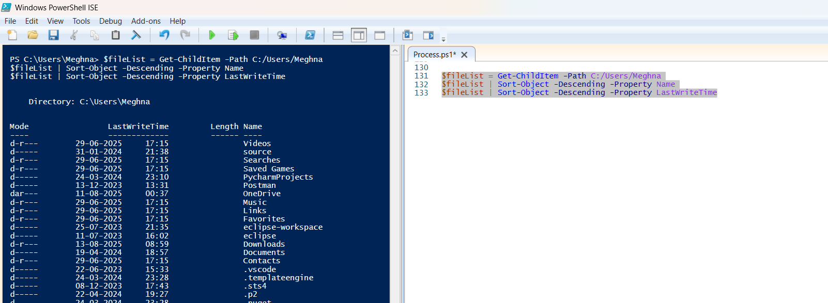

**2. For Loop**

**Purpose:**  
Repeats a block of code a fixed number of times or until a condition is met.

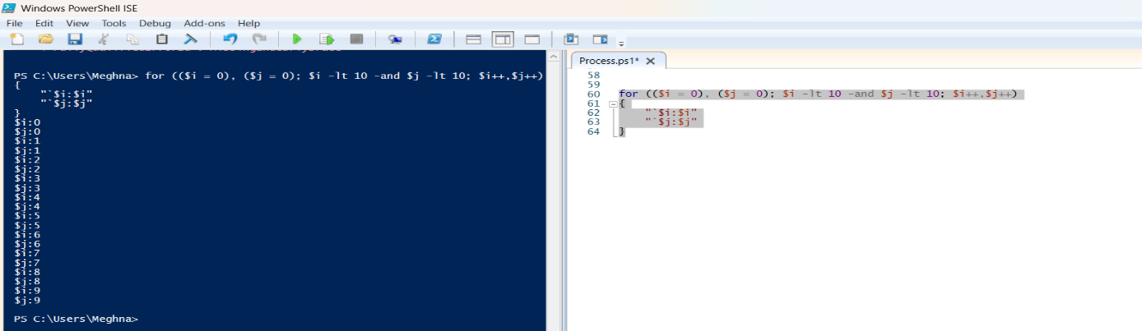

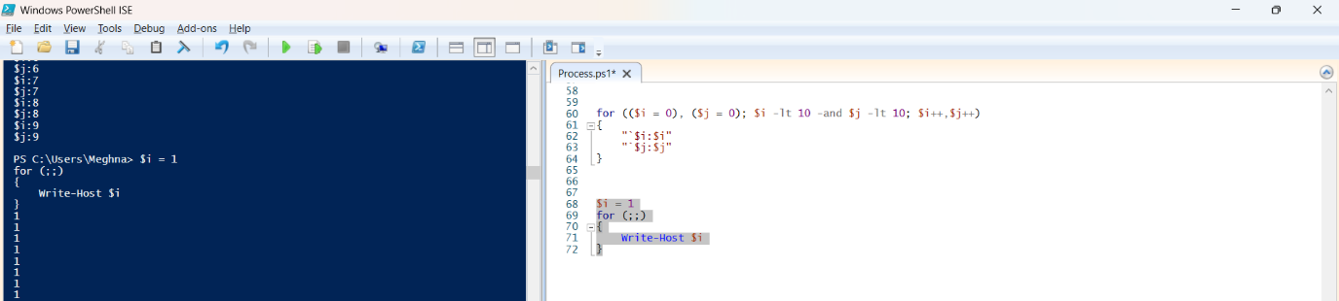

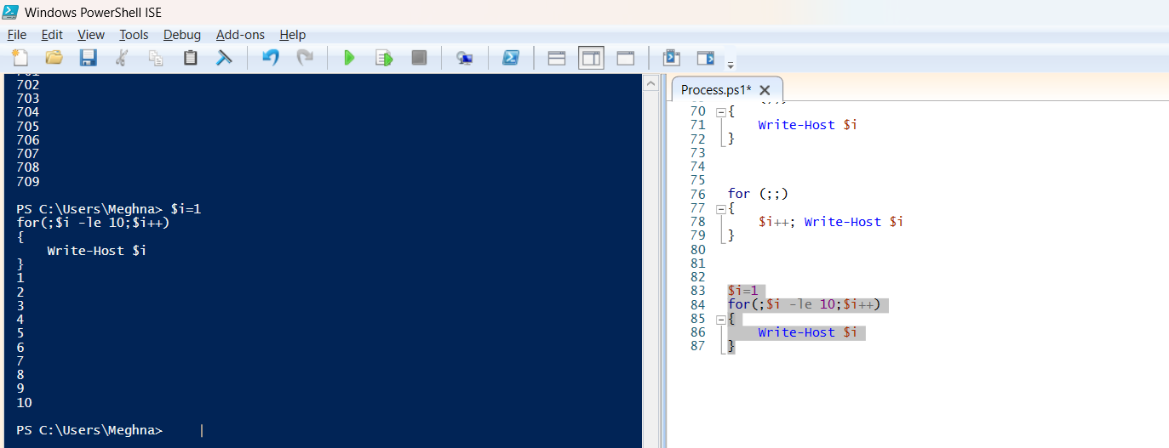

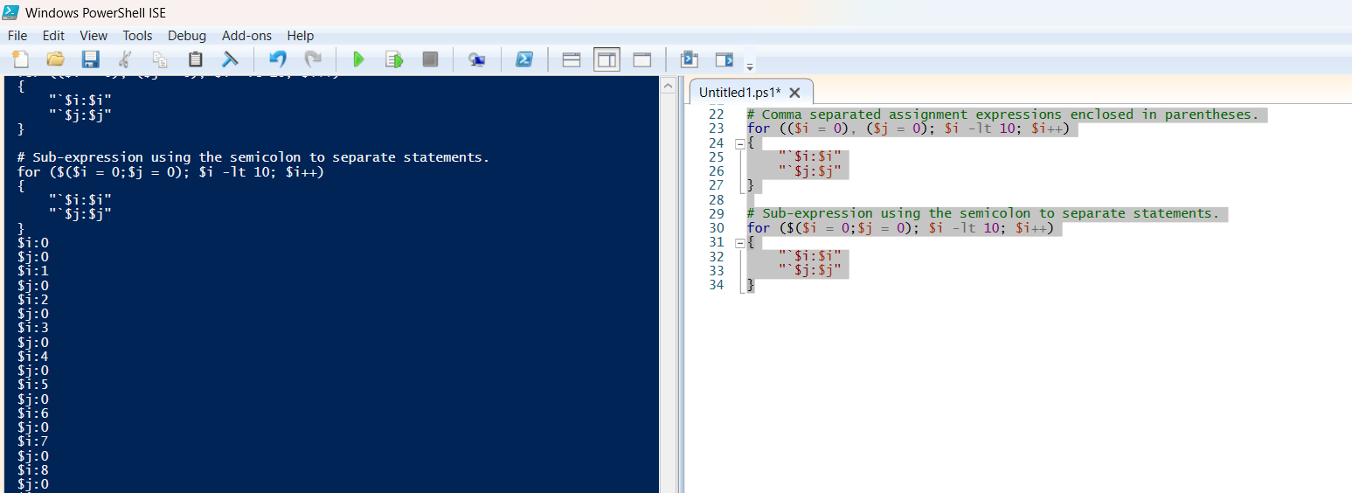

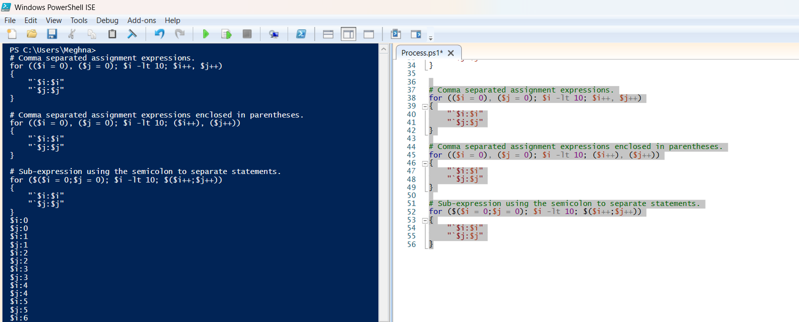

**3. If Statement**

**Purpose:**  
Executes code only if a condition is true (optional else/elseif for other cases).

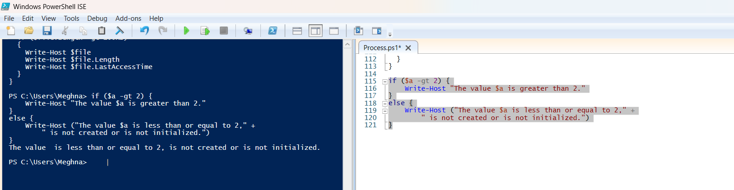

**4. ForEach Loop**

**Purpose:**  
Runs a block of code for each item in a collection (like a list of processes or files).

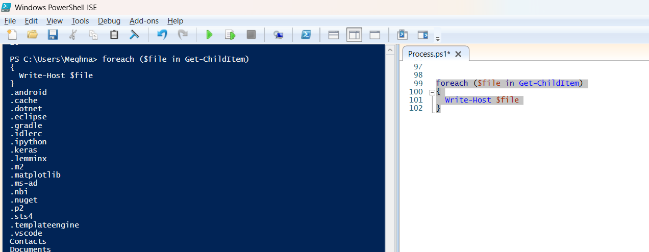

**5. Set-ADTIniValue**

**Purpose:**  
Set-ADTIniValue is a function in **PowerShell App Deployment Toolkit (PSADT)** used to update or add settings in an INI configuration file.  
INI files store settings in a **key–value** format under sections.

**Why it’s useful in deployments:**

* Configure app settings before a user opens it.
* Avoid manual edits to config files.
* Works silently during installations.

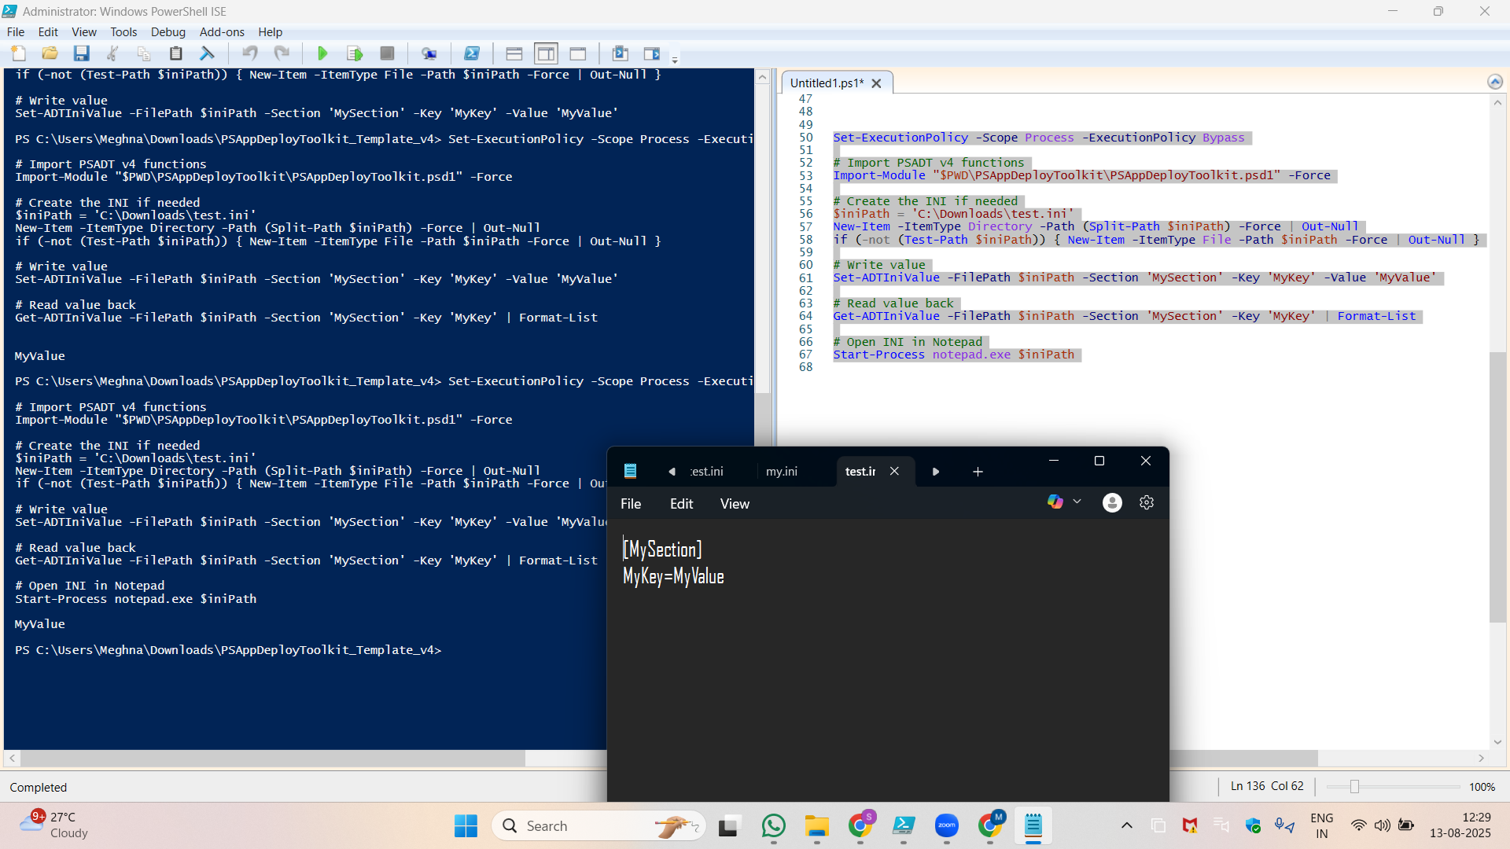

**6. MSI/MSP Logging**

**Purpose:**  
MSI/MSP logging records detailed information about installation or update processes for troubleshooting.

* **MSI** → Microsoft Installer package (.msi).
* **MSP** → Microsoft Installer Patch (.msp).

**Benefits of Logging:**

* Identify **install errors** and **failure points**.
* Verify **install/uninstall** actions.
* Check if files, registry keys, or components installed correctly.

**Installing VLC MSI with Logging in PSADT**

Execute-MSI -Action Install -Path "$dirFiles\vlc.msi" -LogName "$envWinDir\Logs\VLC_Install"

**Breakdown:**

* **-Action Install** → Tells PSADT to perform an installation.
* **-Path "$dirFiles\vlc.msi"** → $dirFiles points to your **Files** folder inside the PSADT package (replace with your MSI name).
* **-LogName "$envWinDir\Logs\VLC_Install"** → Saves the log in C:\Windows\Logs\VLC_Install.log (PSADT will automatically add .log).