BA001

Meghana Reddy

2022-09-30

library(ISLR)  
library(readr)  
archive_1_ <- read_csv("C:/Users/Windows/Downloads/archive (1).zip")

## Rows: 400 Columns: 12  
## ── Column specification ────────────────────────────────────────────────────────  
## Delimiter: ","  
## chr (3): ShelveLoc, Urban, US  
## dbl (9): No, Sales, CompPrice, Income, Advertising, Population, Price, Age, ...  
##   
## ℹ Use `spec()` to retrieve the full column specification for this data.  
## ℹ Specify the column types or set `show_col_types = FALSE` to quiet this message.

summary(archive_1_)

## No Sales CompPrice Income   
## Min. : 1.0 Min. : 0.000 Min. : 77 Min. : 21.00   
## 1st Qu.:100.8 1st Qu.: 5.390 1st Qu.:115 1st Qu.: 42.75   
## Median :200.5 Median : 7.490 Median :125 Median : 69.00   
## Mean :200.5 Mean : 7.496 Mean :125 Mean : 68.66   
## 3rd Qu.:300.2 3rd Qu.: 9.320 3rd Qu.:135 3rd Qu.: 91.00   
## Max. :400.0 Max. :16.270 Max. :175 Max. :120.00   
## Advertising Population Price ShelveLoc   
## Min. : 0.000 Min. : 10.0 Min. : 24.0 Length:400   
## 1st Qu.: 0.000 1st Qu.:139.0 1st Qu.:100.0 Class :character   
## Median : 5.000 Median :272.0 Median :117.0 Mode :character   
## Mean : 6.635 Mean :264.8 Mean :115.8   
## 3rd Qu.:12.000 3rd Qu.:398.5 3rd Qu.:131.0   
## Max. :29.000 Max. :509.0 Max. :191.0   
## Age Education Urban US   
## Min. :25.00 Min. :10.0 Length:400 Length:400   
## 1st Qu.:39.75 1st Qu.:12.0 Class :character Class :character   
## Median :54.50 Median :14.0 Mode :character Mode :character   
## Mean :53.32 Mean :13.9   
## 3rd Qu.:66.00 3rd Qu.:16.0   
## Max. :80.00 Max. :18.0

max(archive_1_$Advertising)

## [1] 29

IQR(archive_1_$Price)

## [1] 31

data <- plot(archive_1_$Sales,archive_1_$Price)

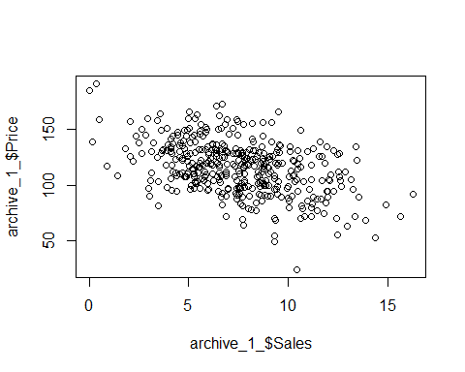

cor(archive_1_$Sales,archive_1_$Price)

## [1] -0.4449507

##It is observed that the price and sales correlation is negative and not perfectly correlated with 44%