COVID_19_INDIA

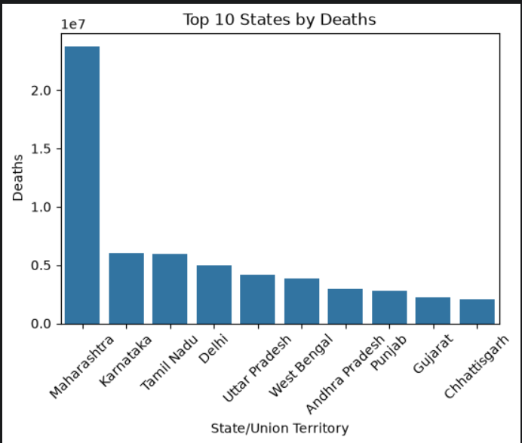

INDIAN_TRAFFIC_VIOLATION

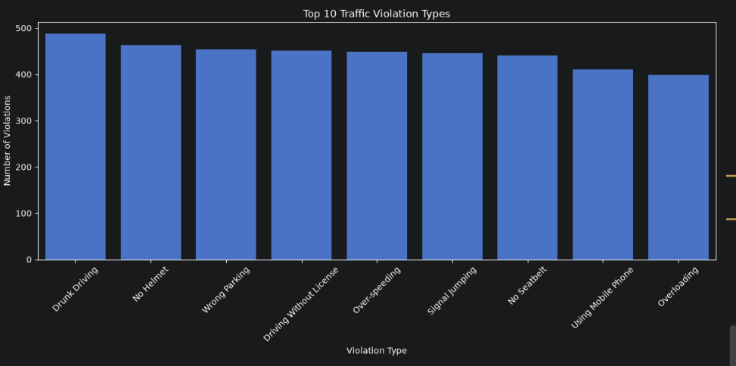

INDIA_CANCER_PATIENTS
