BONAFIDE CERTIFICATE

This is to certify that this dissertation report entitled “Identification and Prevention of Dos and Fuzzy attacks using Quantum machine-learning Integration” submitted to AMRITA VISHWA VIDYAPEETHAM, Mysuru Campus, is a bonafide record of work done by “Meghana R and Sowmyashree Sakrepatna Ramesha” under my supervision from June 2024 to May 2025

Adwitiya Mukhopadhyay
Vice-Chairperson

Dr. R. Sudharshan
CHAIRPERSON

Place: Mysuru
Date:

Internal Examiner External Examiner

1…………………………………… ……………………………………

2……………………………………

Table of Contents
Acknowledgements
Abstract
Table of contents
List of figures
List of tables

1 INTRODUCTION 1
1.1 Introduction to the broad area of research 2
1.2 Objectives of Research
1.3 Introduction to the specific area of research
1.4 Applications
1.5 Highlights of proposed methods 3
2 LITERATURE SURVEY 4
2.1 Papers Reviewed 5
2.2 Motivation 7
2.3 Comparison study 8
3 PROPOSED METHOD 1
3.1 Preamble 19
3.2 Introduction 19
3.3 Working of the proposed method 20
3.4 Experimental analysis 20
3.5 Conclusion 25
(Note: Subsections can be increased as per the stages in your research)
4. PROPOSED METHOD 2
4.1 Preamble 26
4.2 Introduction 26
4.3 Working of the proposed method
4.4 Experimental analysis
4.5 Conclusion 26
5. CONCLUSIONS 28
5.1 Summary
5.2 Future directions
ANNEXURE A 45
<<Include all the input /output specifications>>
<<Dataset collection sources or snapshots of datasets>>
<<Programming tools used>>
ANNEXURE B
<<Any other metadata details you need to convey>> 50
Authors' Research Publications 60
Bibliography

ABSTRACT

<Abstract in here
<The major purpose of the abstract is to give information which will enable the scholar to decide whether to read the complete work. The following information is generally included:

A brief description of the problem
A description of the methods, techniques, and data used
The major finding of the study
The abstract should not exceed 600 words.
Text should in the same font style as represented in template.>

Acknowledgement
We would like to express our sincere thanks to Amma, our beloved chancellor “Mata Amritanandamayi Devi”.
We would like to express our sincere thanks to Br. Anantaananda Chaitanya, Director, Mysuru Campus, Mysuru who supported us with continuous encouragement, motivation and lending us with right direction throughout our tenure of studies.
We would like to express our sincere thanks to Br. Muktidamrta Chaitanya, Correspondent, Mysuru Campus, Mysuru for providing us with well supported peaceful studying environment with excellent infrastructure and support.
We would like to express our sincere thanks to our beloved principal Dr. G Ravindranath for giving us moral support and continuous encouragement, which has been the key to the successful completion of the project.
We are pleased to acknowledge Dr. R. Sudharshan, Chairperson, Department of Computer Science, for his encouragement and support throughout the project.
We would like to express our heart-felt gratitude to our Project Co-Ordinator Mrs. Nisha Raveendran, Assistant Professor and Department of Computer Science for his valuable suggestions and excellent guidance rendered throughout this project.
We would like to express our heart-felt gratitude to our guide Dr. Adwitiya Mukhopadhyay, Vice-Chairperson, Department of Computer Science for his valuable suggestions and excellent guidance rendered throughout this project.
Further, we extend our thanks to all the faculty members and technical staff of our department and ICTS for their suggestions, support and providing resources at needed times.
Finally, we express our sincere gratitude to our parents and friends who have been the embodiment of love and affection which helped us to carry out the project in a smooth and successful way.

List of Figures

1.1 Image Analysis and its classifications (title) 5
1.2 Overview of processing 7

List of Tables

3.1 Performance metrics (title) 5
5.2 Statistics of datasets 7

2. LITERATURE SURVEY

2.1 Papers Reviewed
Recent advancements in connected and autonomous vehicles (CAVs) have dramatically increased the attack surface, making cybersecurity a critical area of research. The reviewed papers cover various attack detection methods, defensive frameworks, AI integrations, and protocol-level protections aimed at securing autonomous systems. The survey can be grouped into several themes:

(a) Intrusion Detection Systems (IDS) for In-Vehicle Networks
Multiple studies focused on designing or improving IDS for the Controller Area Network (CAN) bus, the backbone of internal vehicle communication:

1. Bari et al. (2023) performed a comparative analysis of ML classifiers (e.g., SVM, Random Forest, k-NN) to detect anomalies in CAN bus traffic.
2. Yang et al. (2024) utilized convolutional neural networks (CNNs) with transfer learning for improved threat detection in motor drive systems.
3. Bi et al. (2022) developed a matrix-based approach that leveraged message and timing patterns to flag intrusions.
4.Shi et al. (2024) introduced IDS-DEC, a deep embedded clustering framework to detect CAN traffic anomalies with higher accuracy than traditional models.

(b) Blockchain and Cryptographic Security
Blockchain has been leveraged as a tamper-proof log system or to enhance trust in vehicular communications:

1.Andreica et al. (2024) combined blockchain with ISO/SAE 21434 compliance to create secure, reportable IDS systems.
2.Ahmad et al. (2024) and Zia et al. (2024) explored blockchain for securing V2X communications, ensuring the integrity of broadcast data and peer authentication.

(c) GPS Spoofing and Sensor Attacks
As AVs rely on GPS and perception systems, sensor spoofing poses a significant risk:

1.Shabbir et al. (2023) proposed a DL model to detect GPS spoofing attempts, a critical vulnerability in AV navigation.
2.Begum et al. (2024) presented a multi-layered DL model to detect and classify sensor attacks in a 6G-V2X environment.
3.Ghosh et al. (2023) focused on a threat analysis framework for AV perception systems, showing how visual spoofing can impair decision-making.

(d) Artificial Intelligence (AI)-Driven Cybersecurity
Many researchers applied ML/DL models to develop adaptive, data-driven security solutions:

1.ElKashlan et al. (2023) introduced an ML-based IDS for electric vehicle charging stations—extending protection to infrastructure-level assets.
2.Almehdhar et al. (2024) offered a survey on advanced DL-based IDS, categorizing models by attack type and network context.
3.Alsaade et al. (2023) applied autoencoders for anomaly detection in vehicular networks with promising results in reducing false positives.

(e) Attack Simulations and Defense Strategy Modeling
Some studies focused on evaluating system resilience under simulated attacks:

1.Wu et al. (2023) analyzed learning-based action-space attacks on AV agents, highlighting control vulnerabilities.
2.Wang et al. (2022) evaluated control stability in mixed-traffic scenarios under cyberattacks and proposed robust recovery strategies.
3.Giannaros et al. (2023) presented a comprehensive survey addressing sophisticated attack vectors, safety threats, and blockchain-based countermeasures.

(f) Datasets and Simulation Platforms
1. Rajapaksha et al. released the CAN-MIRGU dataset, designed to replicate real-world CAN bus scenarios with moving vehicles, aiding researchers in IDS validation.
2.Sandakelum et al. (2024) used a deep learning model trained on real vehicular data to detect embedded malware.

2.2 Motivation
The rising integration of autonomous navigation, cloud services, AI algorithms, and 6G networks in modern vehicles has created complex, dynamic environments prone to novel cyber threats. Key motivations from the reviewed works include:
- Increased Vulnerability: As CAVs connect to broader networks (V2V, V2X), they inherit new threat surfaces including DoS, spoofing, adversarial ML attacks, and protocol exploitation.
- Reactive vs. Proactive Security: Traditional IDS approaches tend to be reactive. Recent studies argue for adaptive, proactive defences leveraging AI to anticipate zero-day attacks.
- Interdisciplinary Approach Needed: Effective AV cybersecurity requires the integration of hardware protection, software integrity checks, secure communication protocols, and real-time data analytics.
- Need for Standardization: ISO/SAE 21434 and other regulations are still being adapted to AI-augmented AVs. Research shows a lack of standard-compliant IDS models.
- Scarcity of Realistic Datasets: Many proposed models use simulation or outdated datasets, limiting generalizability. New datasets like CAN-MIRGU and custom testbeds are needed for benchmarking.

2.3 Comparison study
The research on cybersecurity in autonomous and connected vehicles spans various techniques, including traditional rule-based systems, machine learning (ML)-driven solutions, and emerging blockchain-integrated frameworks. These approaches differ significantly in their performance, flexibility, and practical deployment.
Traditional security mechanisms, such as rule-based Intrusion Detection Systems (IDS), operate by matching network behavior against predefined rules or known signatures. While these are computationally lightweight and quick in response time, they struggle to detect zero-day or novel attacks. Their rigidity makes them ineffective in highly dynamic environments like vehicular networks, which are exposed to evolving threat vectors.
In contrast, ML-based approaches have gained momentum due to their ability to learn from data and adapt over time. Deep learning models, including CNNs, RNNs, and autoencoders, have shown high accuracy in identifying complex attack patterns, including GPS spoofing, CAN-bus anomalies, and sensor manipulations. Techniques like transfer learning further enhance their capability to generalize across different datasets or vehicle types. However, these models are resource-intensive, sometimes resulting in delayed detection, especially when deployed on embedded vehicle systems with limited computational power.
To bridge the gap between detection accuracy and system integrity, blockchain and hybrid solutions are being explored. Blockchain adds a secure and immutable layer for logging events, sharing intrusion reports, and validating network transactions. Studies have also integrated blockchain with ML-based IDS to ensure tamper-proof decision-making. While these frameworks excel in transparency and trustworthiness, they introduce additional computational and storage overheads, which can affect real-time performance.
Furthermore, hybrid systems combining ML, blockchain, and secure communication protocols (e.g., ISO/SAE 21434 compliance) are emerging as robust multi-layered defenses. These systems offer both proactive detection and resilient response strategies but are more complex to design, deploy, and maintain.
In summary, the literature reveals a trade-off between performance, adaptability, and system complexity. Traditional models offer simplicity but limited effectiveness. AI-based systems provide high accuracy and adaptability at the cost of resources, while blockchain-integrated frameworks offer security and traceability with increased computational overhead. A well-balanced, context-aware fusion of these methods appears to be the future direction for securing autonomous vehicles.

TABLE FORMAT to be used
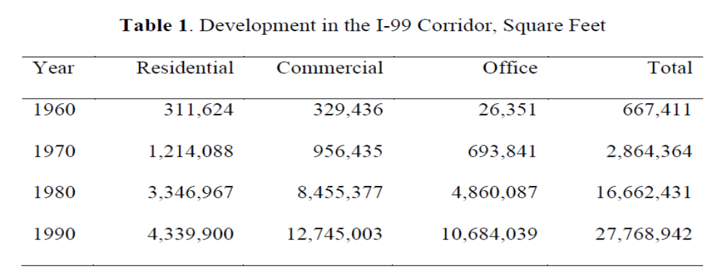

MARGINS

Leave a 1 ½ inch margin on the left side and a 1 inch margin at the right side, the top and the bottom.
The following pages should have a 2-inch margin at the top of the page:
• Table of Contents (first page only)
• List of Figures (first page only)
• List of Tables (first page only)
• Acknowledgements
• The first page of each chapter
Font style Times New Roman
Font size of each chapter name 20 pt (Bold and aligned to center)
Font size of text 12 pt
List of Figures format

Figure 7.1 Architecture diagram Page no
Figure 7.2 DFD Page no
Figures:

Figures and tables should be numbered like

Example: Figure 7.1 is the first figure in chapter 7
Table 7.2 is the second table in chapter 7

Authors Research Publications(20 pt)

1. Author name 1, author name 2,” Title of paper”, Journal/conference title, Vol. no, issue no, pp. 1-16, month year.

2.

