ETHICAL HACKING TASK 01

Information Gathering & Reconnaissance
Name: Meghana S
Internship: Ethical Hacking Internship
Task: Task 01 – Information Gathering & Reconnaissance

Objective
The objective of this task is to understand the reconnaissance phase of ethical hacking by collecting publicly available information about a target website. This task focuses on passive information gathering techniques without interacting with or attempting to exploit the target system. Various online tools were used to identify domain information, DNS records, website technologies, HTTP security headers, and publicly accessible configuration files.

Part A – Target Selection

Target Website
Website Name:
Kristu Jayanti (Deemed to be University)
Website URL:
https://www.kristujayanti.edu.in
Reason for Choosing the Target
I selected Kristu Jayanti University as the target because it is the university where I study, and its website is publicly accessible. It serves as a suitable example for learning passive reconnaissance techniques in an ethical and responsible manner. The website provides enough publicly available information to understand how information gathering is performed during the initial phase of a penetration test while remaining within ethical guidelines.
Screenshot


Part B – WHOIS Lookup

Objective
The WHOIS lookup was performed to collect publicly available information about the domain registration details of the selected website.
Field | Details
Domain Name | kristujayanti.edu.in
Registry Domain ID | D6200543-IN
Registration Date | 20 April 2012
Expiry Date | 20 April 2035
Domain Status | Active
Name Servers | ns-1333.awsdns-38.orgns-265.awsdns-33.comns-812.awsdns-37.netns-1857.awsdns-40.co.uk

Observation
The WHOIS lookup shows that the domain kristujayanti.edu.in has been active since April 2012 and is registered until April 2035. The domain uses Amazon Web Services (AWS) DNS name servers, indicating that the university relies on a cloud-based DNS infrastructure. This information is publicly available and helps identify the domain's registration details during the reconnaissance phase.
Screenshots:
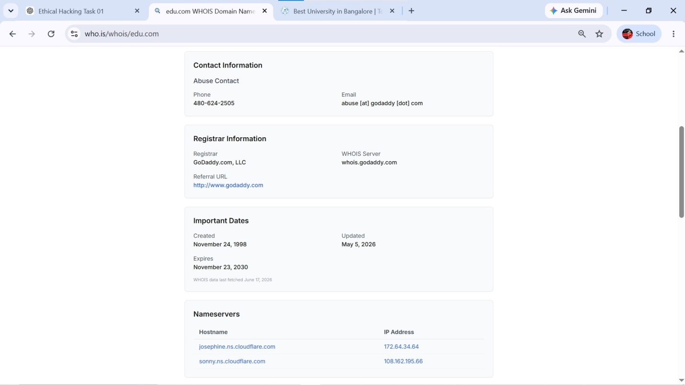
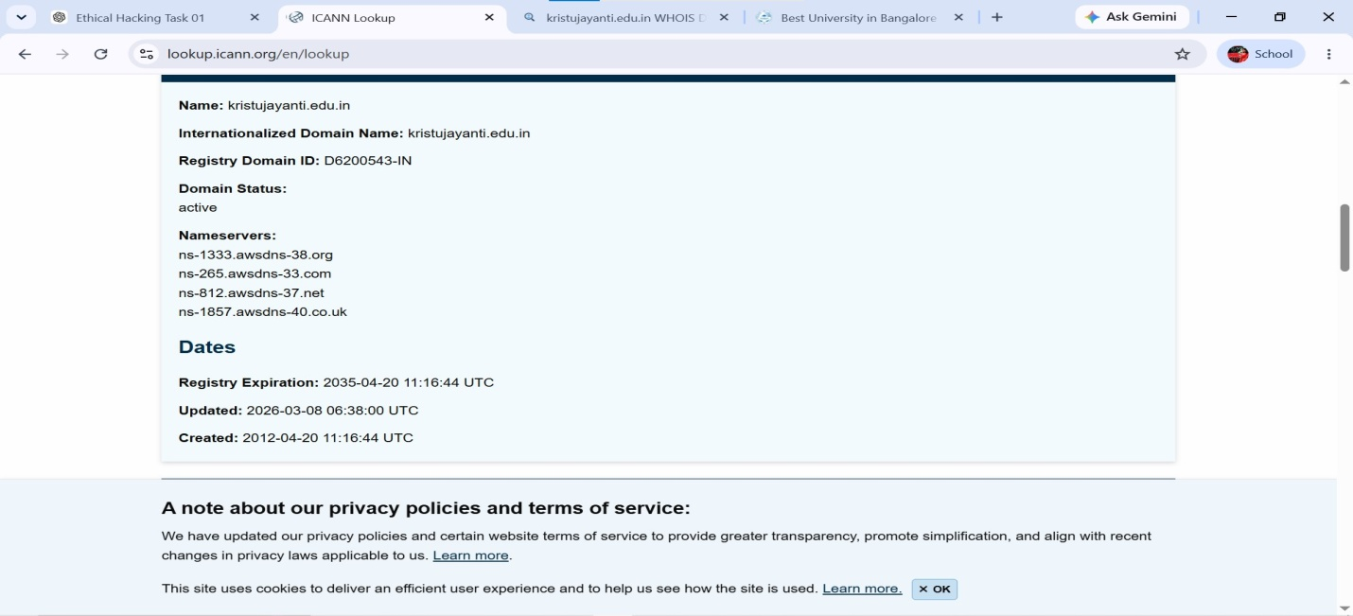

Part C – DNS Enumeration
DNS enumeration was performed to identify the publicly available DNS records associated with the target domain.

A Record
The A Record maps the domain name to its IPv4 address, allowing users to access the website through a browser.
Screenshot: 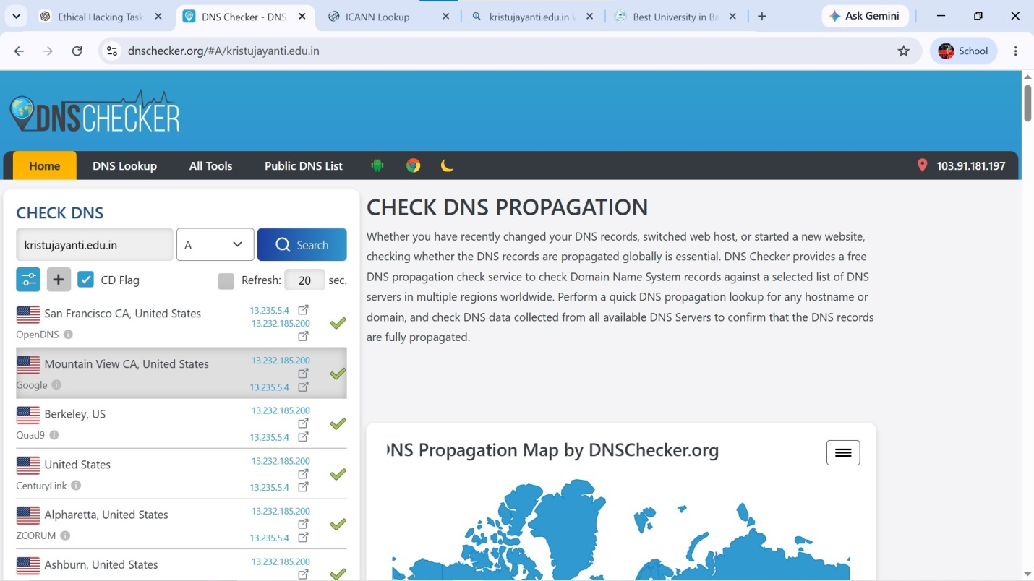

MX Record
The MX (Mail Exchange) Record identifies the mail servers responsible for receiving emails for the domain.
Screenshot:
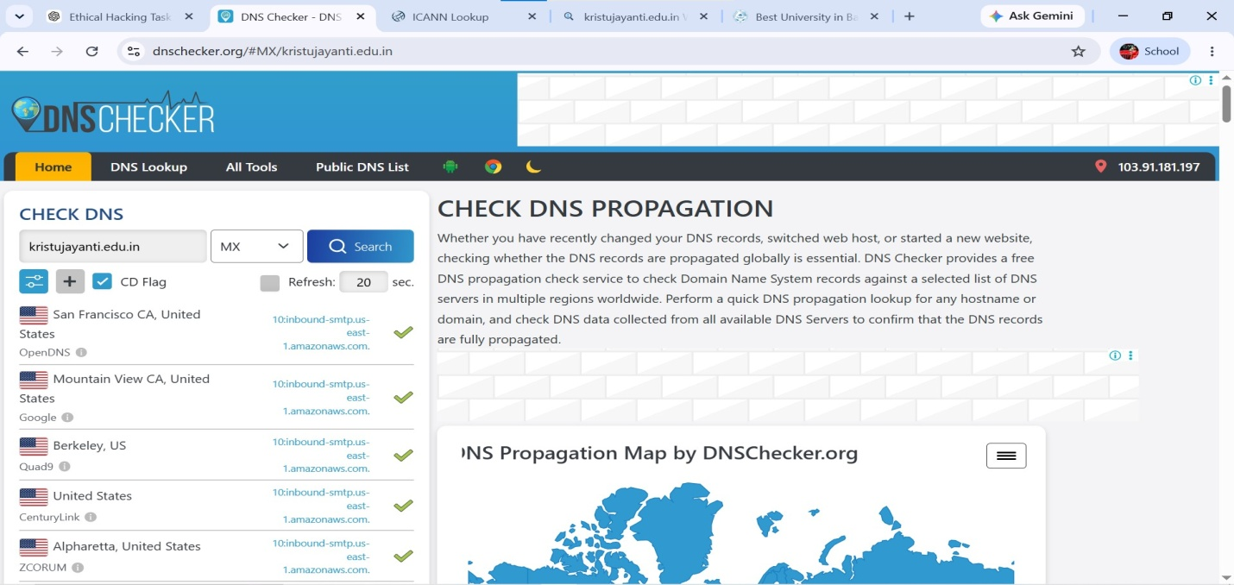

NS Record
The NS (Name Server) Record identifies the authoritative DNS servers responsible for managing the domain's DNS records
Screenshot: 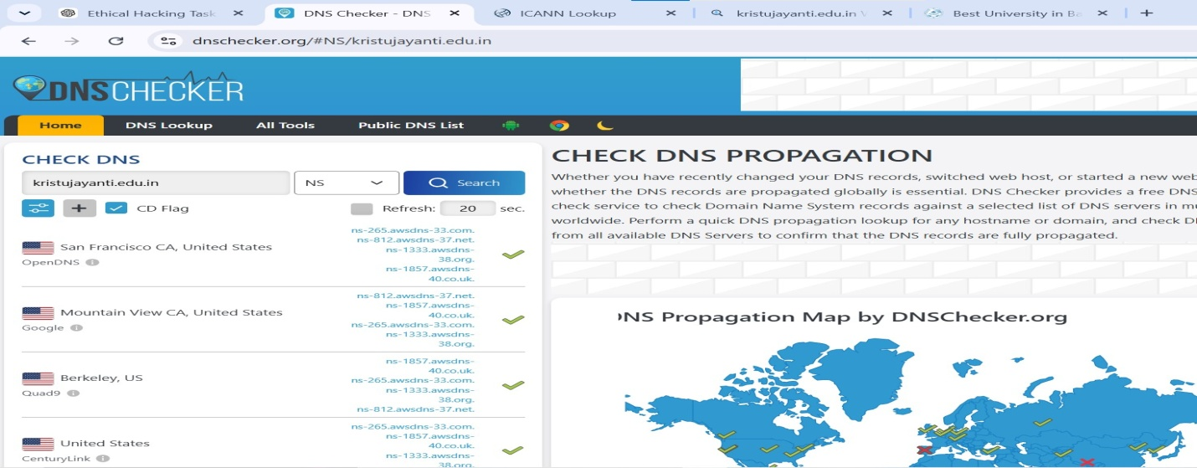

TXT Record
The TXT Record contains additional information such as email verification, SPF, or other security-related configurations published by the domain owner.
Screenshot: 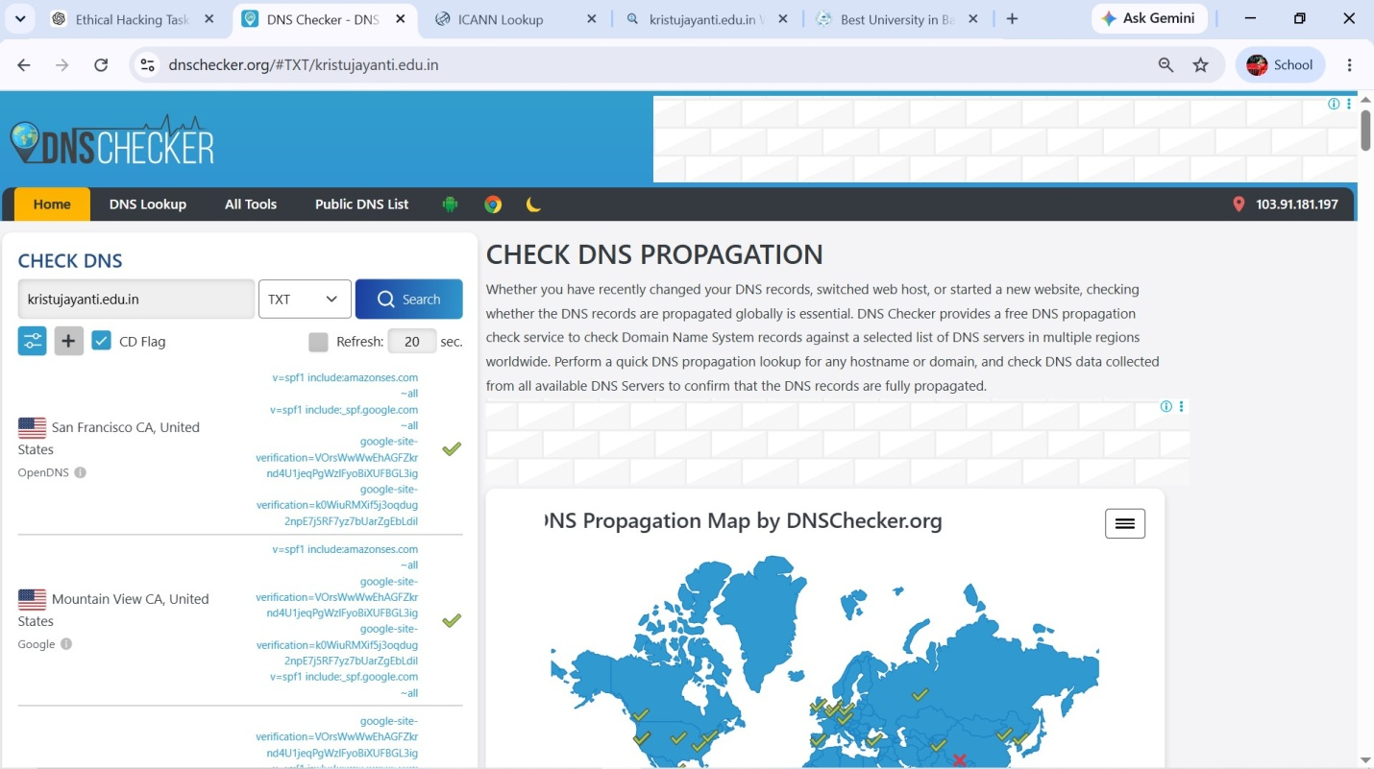

Observation
The DNS records confirm that the domain is properly configured with IP addressing, email routing, authoritative name servers, and additional verification records. These records are publicly accessible and provide useful information during passive reconnaissance without interacting with the target system.

Part D – Website Technology Identification

Objective
The purpose of this section is to identify the technologies used to develop and host the target website. Public technology detection tools help ethical hackers understand the software stack without directly interacting with the server.

Technologies Identified
Technology | Observation
Web Server | The website is hosted using modern web server infrastructure.
Hosting/DNS | The domain uses Amazon Web Services (AWS) DNS servers.
JavaScript | The website uses JavaScript to provide interactive web pages.
SSL/TLS | HTTPS is enabled to provide secure communication between users and the website.
Content Delivery | The website uses modern web technologies to improve performance and accessibility.

Summary
The technology analysis indicates that Kristu Jayanti University uses a secure and modern web infrastructure. HTTPS is enabled for secure communication, and AWS-based DNS services help provide reliable domain management. The website incorporates standard web technologies to ensure good performance and user accessibility.
Screenshot:


Part E – HTTP Security Headers

Objective
HTTP Security Headers were analyzed using the SecurityHeaders online scanner to identify the security-related HTTP response headers implemented by the target website.

Scan Result
Item | Result
Website | https://www.kristujayanti.edu.in
Overall Grade | F
HTTP Status | 200 OK
Web Server | Apache/2.4.41 (Ubuntu)

Missing Security Headers
Security Header | Status
Strict-Transport-Security (HSTS) | Missing
Content-Security-Policy (CSP) | Missing
X-Frame-Options | Missing
X-Content-Type-Options | Missing
Referrer-Policy | Missing
Permissions-Policy | Missing

Observation
The SecurityHeaders scan assigned an F rating because several recommended HTTP security headers were not present in the server's response. Missing headers such as HSTS, CSP, X-Frame-Options, and X-Content-Type-Options reduce browser-side protection against attacks including clickjacking, MIME-type sniffing, and certain cross-site scripting scenarios. This observation is based on publicly available information and is intended solely for educational purposes.
Screenshots:
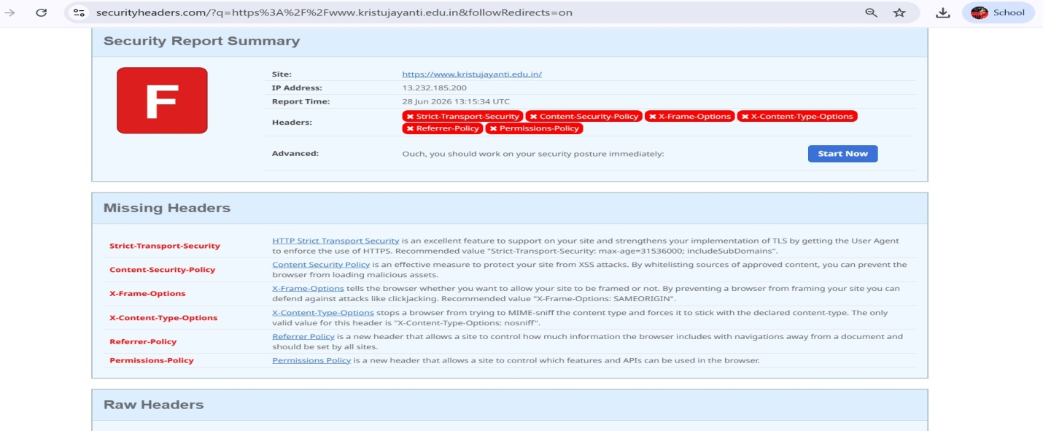
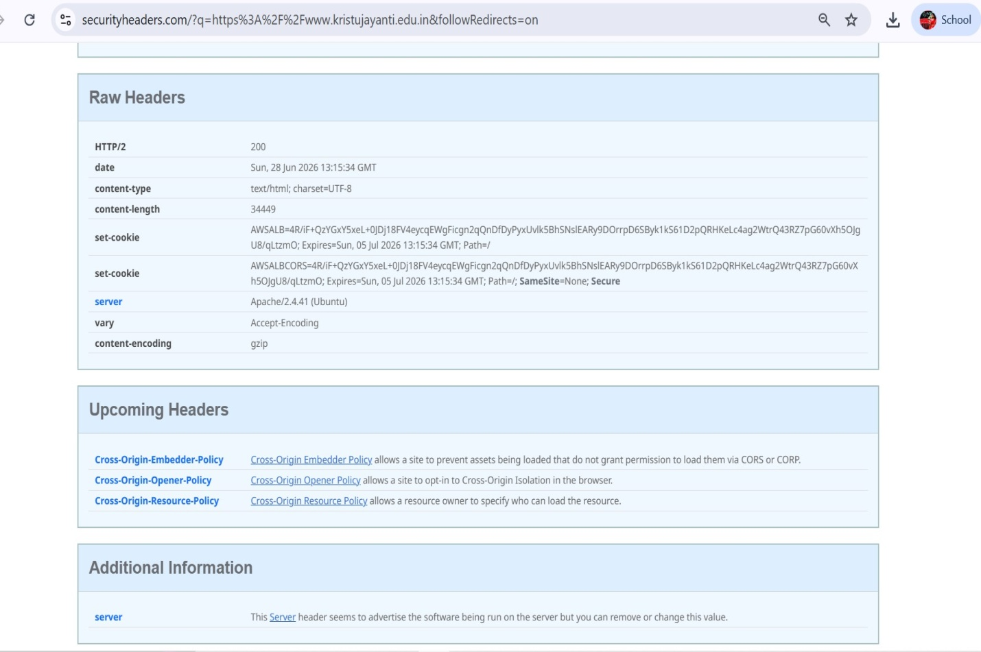

Part F – robots.txt and sitemap.xml

Objective
The purpose of this section is to identify publicly accessible configuration files that provide information about website crawling and indexing.

robots.txt
The robots.txt file is used to instruct search engine crawlers about which parts of a website can or cannot be accessed.
Observation
The robots.txt file was checked during the reconnaissance process. The result was recorded for documentation purposes.
Screenshot
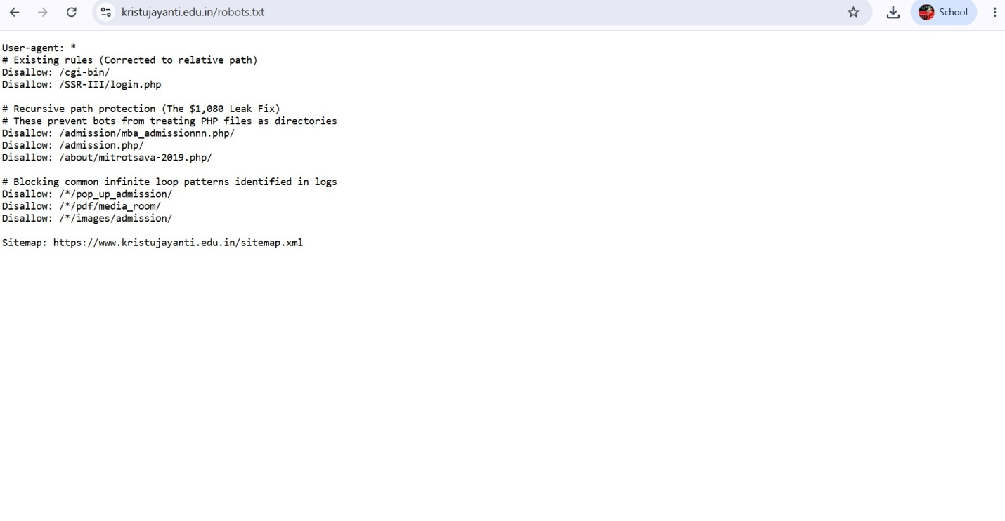

sitemap.xml
The sitemap.xml file provides a structured list of website pages to help search engines index the website efficiently.
Observation
The sitemap was examined to determine whether the website publishes a sitemap for search engine indexing.
Screenshot
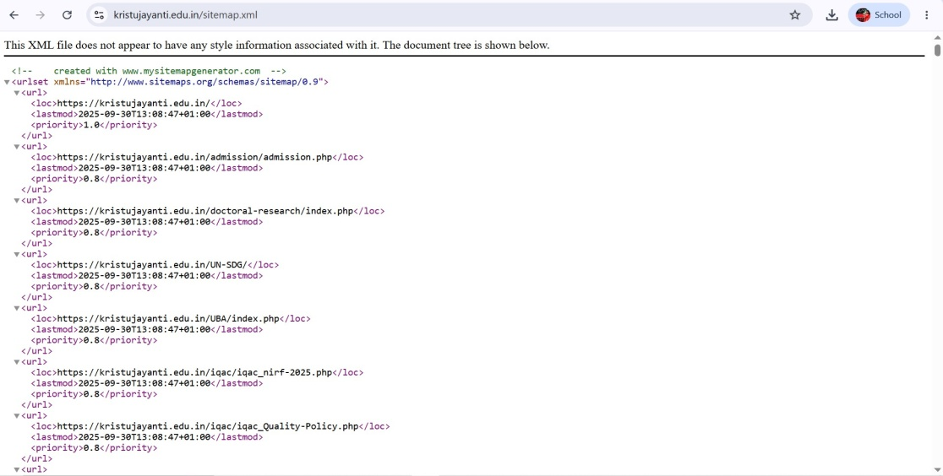

Overall Findings
The reconnaissance activity successfully collected publicly available information about the target website without interacting with or attempting to exploit the system.
The following information was identified:
- Domain registration details through WHOIS lookup.
- DNS records including A, MX, NS, and TXT records.
- Website technologies and hosting information.
- HTTP Security Headers configuration.
- Publicly accessible configuration files such as robots.txt and sitemap.xml.
The information gathered demonstrates how passive reconnaissance can help security professionals understand the architecture and security posture of a website while remaining within ethical boundaries.

Conclusion
Reconnaissance is the first and one of the most important phases of ethical hacking because it helps collect publicly available information before any security assessment begins. In this task, passive reconnaissance techniques were used to gather domain registration details, DNS information, website technologies, HTTP security headers, and publicly accessible configuration files for the Kristu Jayanti University website.
The activity was performed entirely using publicly available online tools without attempting to access restricted resources or exploit the target. The collected information provided useful insights into the website's infrastructure and highlighted areas such as missing HTTP security headers that could be improved. This task strengthened my understanding of information gathering techniques and demonstrated the importance of ethical practices while performing reconnaissance activities.

References
- ICANN Lookup – https://lookup.icann.org
- DNSChecker – https://dnschecker.org
- BuiltWith – https://builtwith.com
- SecurityHeaders – https://securityheaders.com
- Kristu Jayanti University – https://www.kristujayanti.edu.in

