Assignment – 8.4
Task 1: Developing a Utility Function Using TDD
Scenario
You are working on a small utility library for a larger software system. One of
the required functions should calculate the square of a given number, and
correctness is critical because other modules depend on it.
Code :
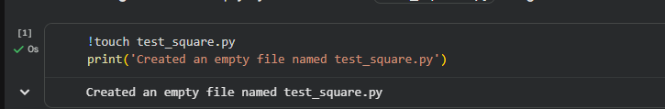
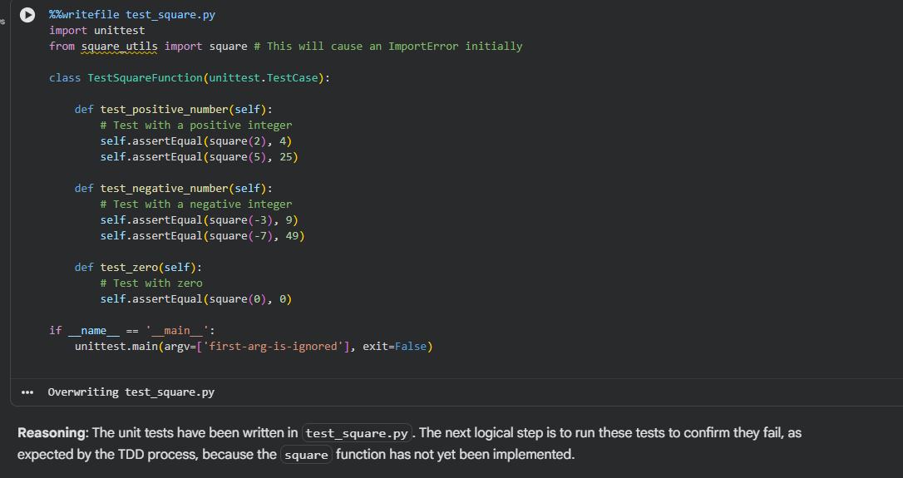
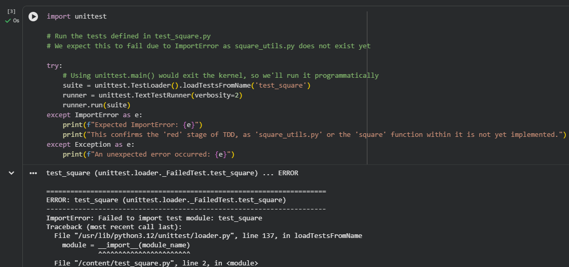
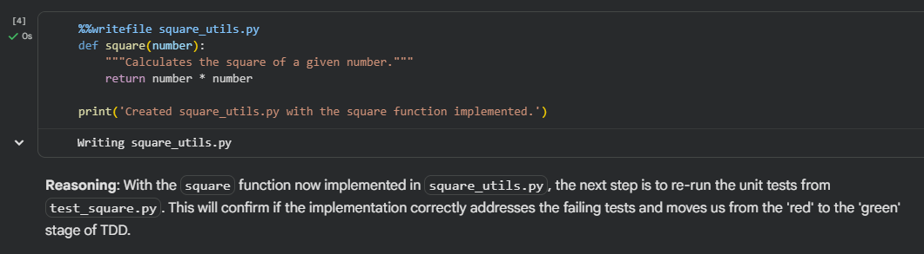
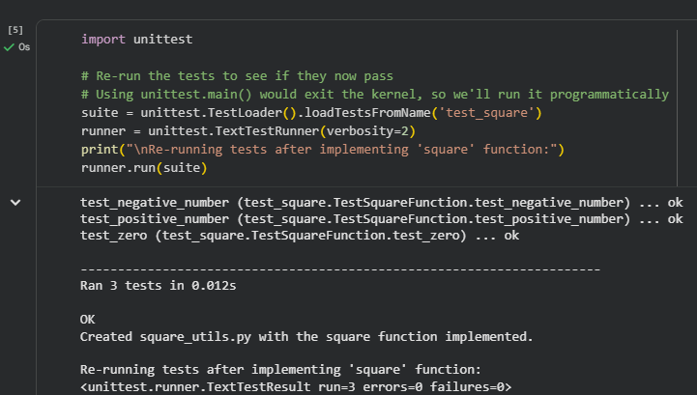
Task 2: Email Validation for a User Registration System
Scenario
You are developing the backend of a user registration system. One
requirement is to validate user email addresses before storing them in the
database.
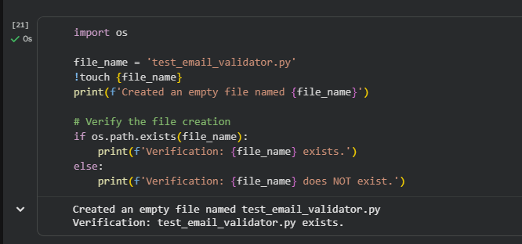
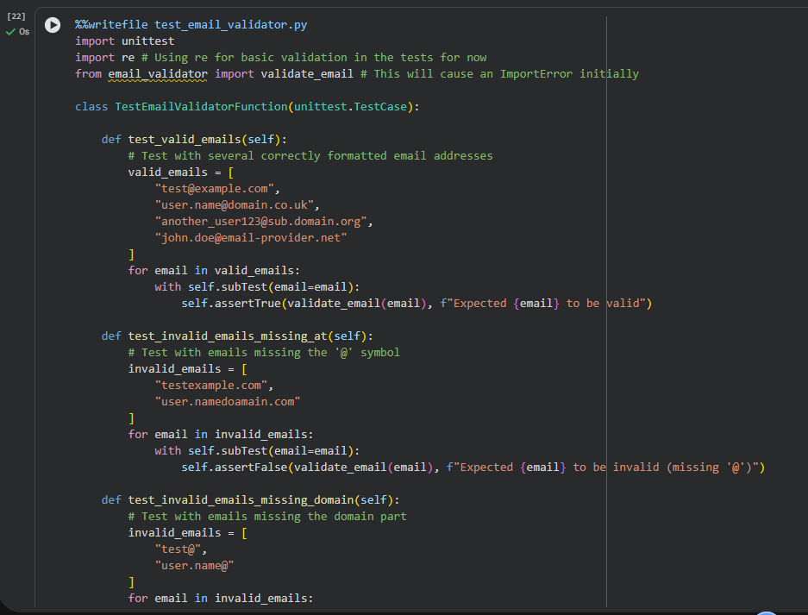
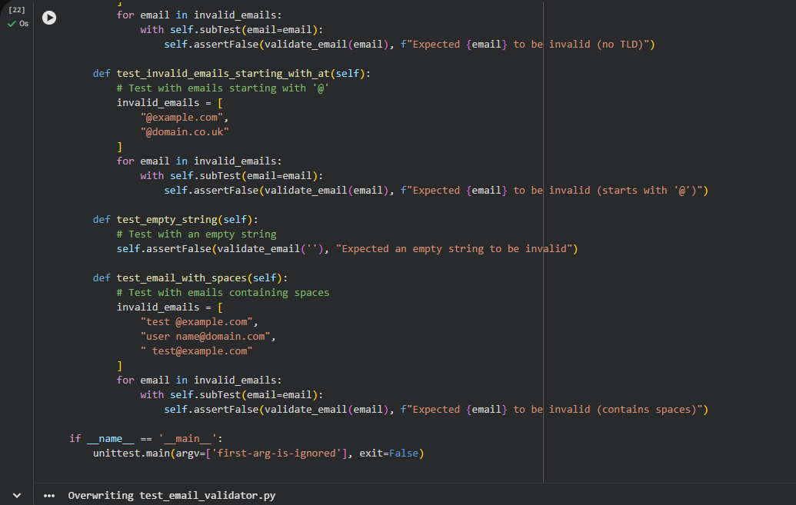
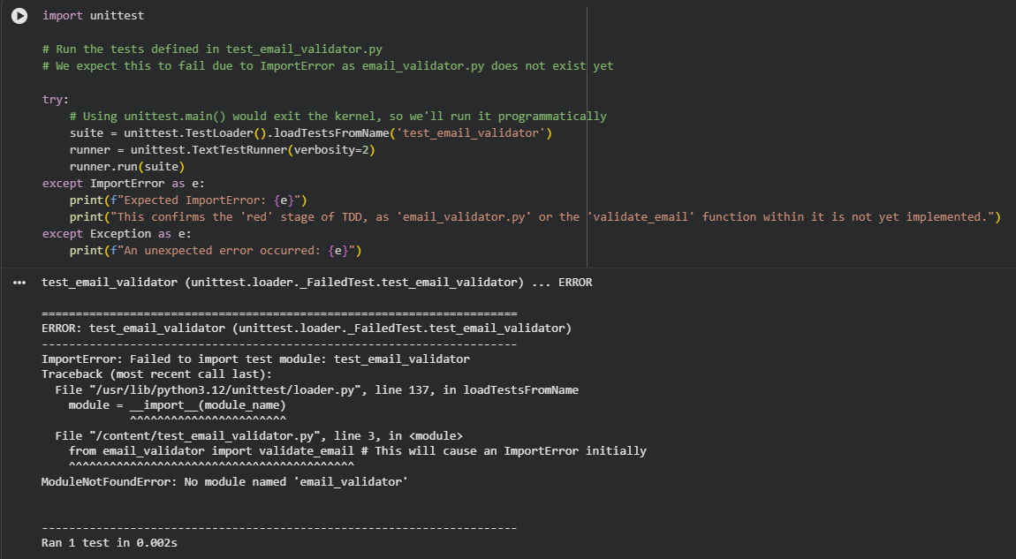
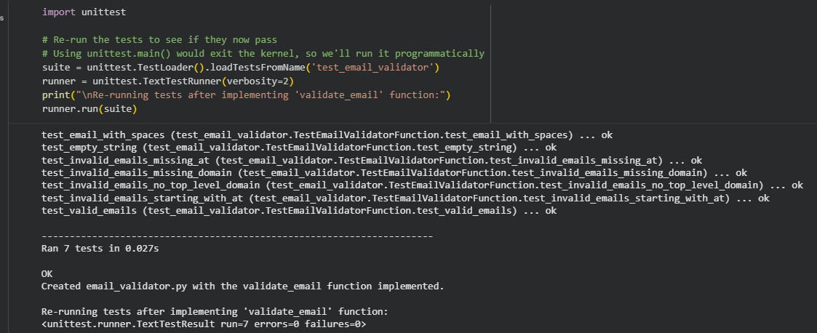
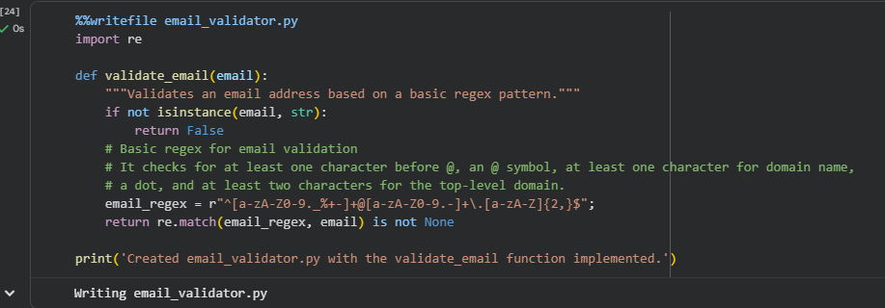
Task 3: Decision Logic Development Using TDD
Scenario
In a grading or evaluation module, a function is required to determine the
maximum value among three inputs. Accuracy is essential, as incorrect results
could affect downstream decision logic.
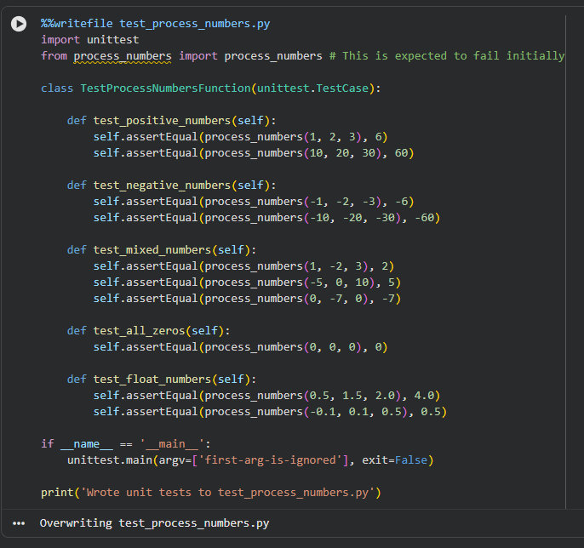
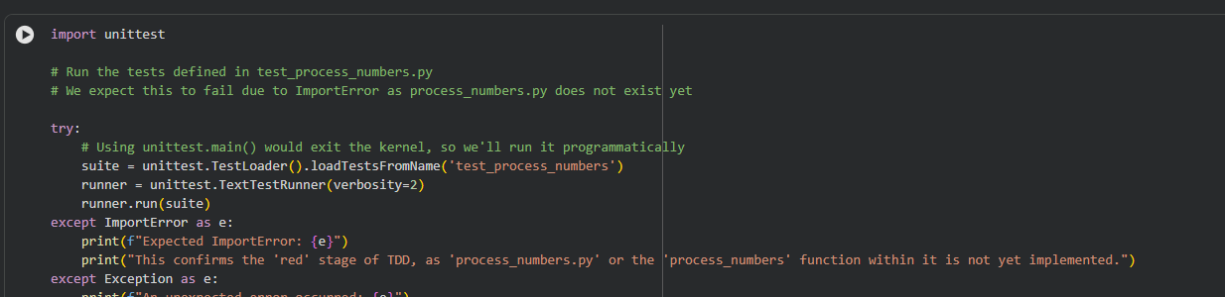
Task 4: Shopping Cart Development with AI-Assisted TDD
Scenario
You are building a simple shopping cart module for an e-commerce
application. The cart must support adding items, removing items, and
calculating the total price accurately.
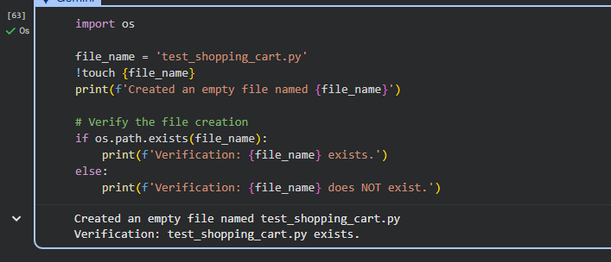
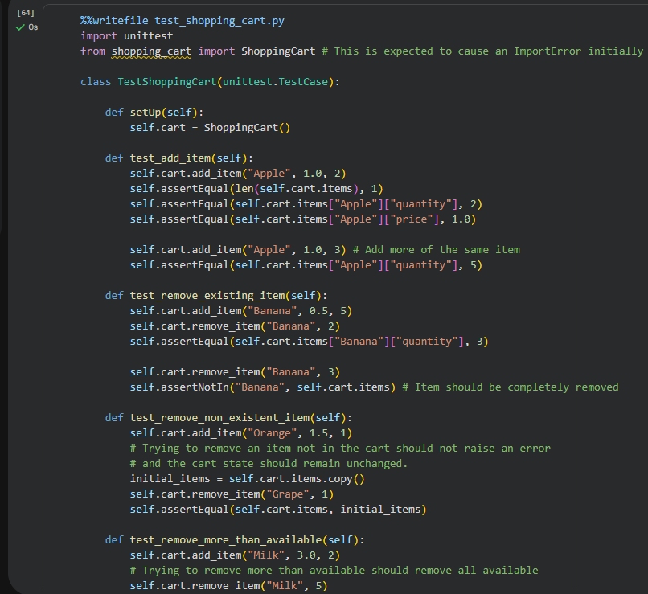
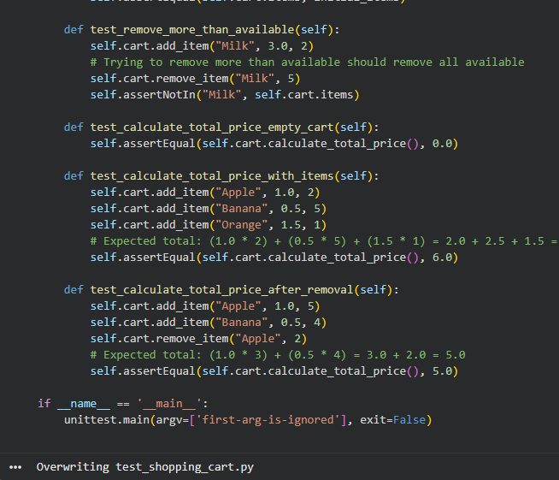
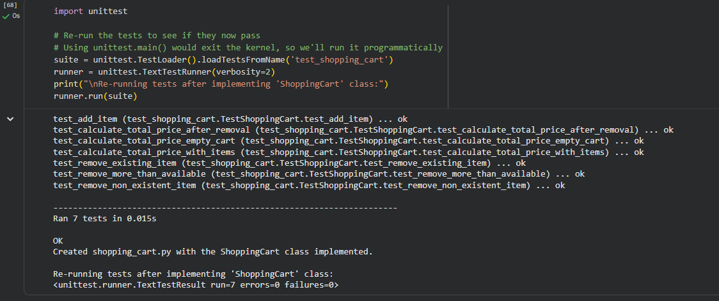
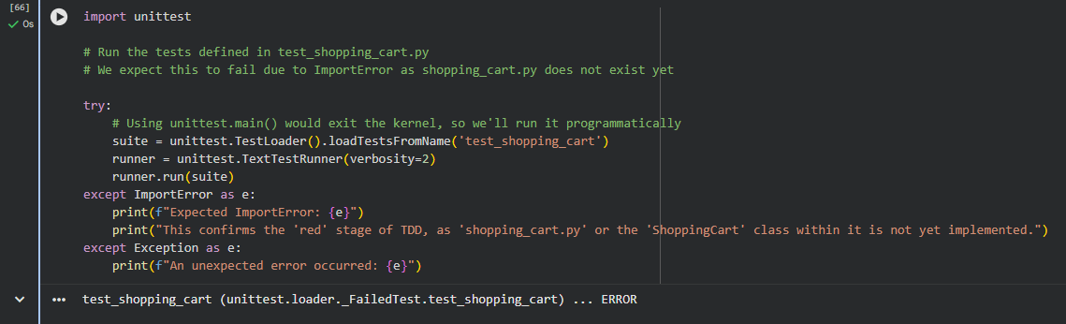
Task 5: String Validation Module Using TDD
Scenario
You are working on a text-processing module where a function is required to
identify whether a given string is a palindrome. The function must handle
different cases and inputs reliably.
