Nmae:Meghana Nimmala
Hallticket No.2303A51380
Assignment-9.3

Task 1: Basic Docstring Generation
Scenario
You are developing a utility function that processes numerical lists and must be properly
documented for future maintenance.
Requirements
• Write a Python function to retum the sum of even numbers and sum of odd numbers in a
given list
• Manually add a Google Style docstring to the function
• Use an Al-assisted tool (Copilot / Cursor AI) to generate a function-level docstring
• Compare the Al-generated docstring with the manually written docstring
• Analyze clarity, correctness, and completeness.
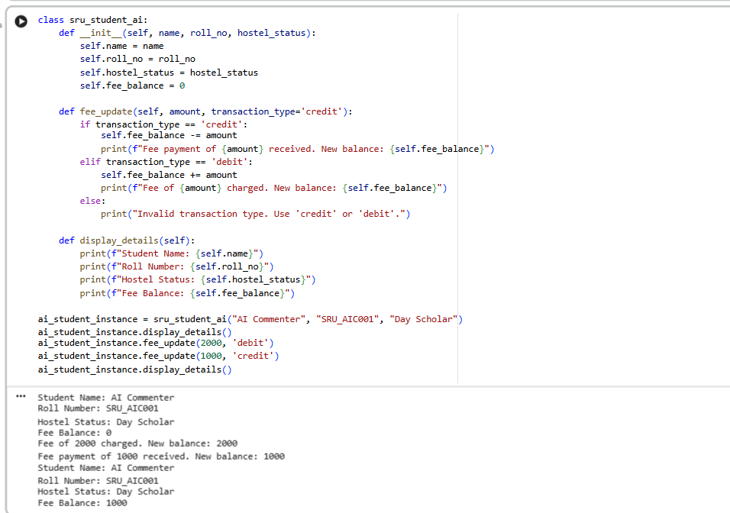
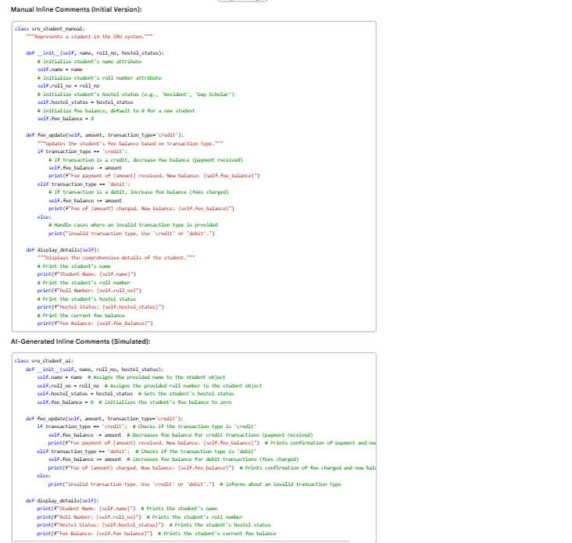

Task 2: Automatic Inline Comments
Scenario
You are developing a student management module that must be easy to
developers.
Requirements
• Write a Python program for an sru_student class with the following:
— Attributes: name, roll no, hostel status
— Methods: fee_update() and
• Manually write inline comments for each line or logical block
• Use an Al-assisted tool to automatically add inline comments
• Compare manual comments with Al-generated comments
• Identify missing, redundant, or incorrect AI comments

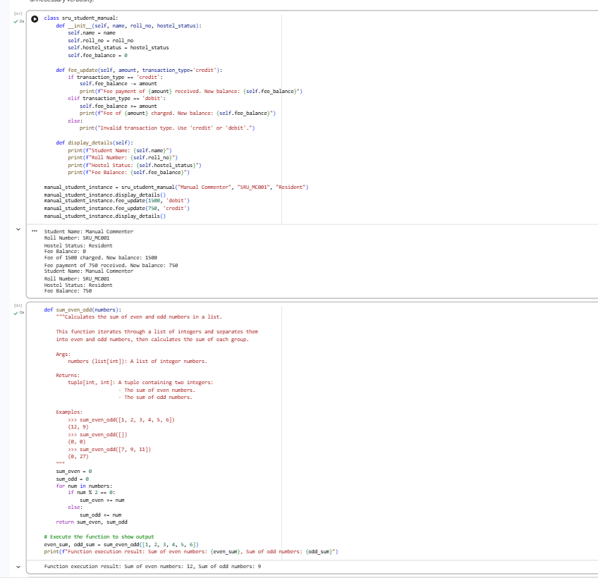
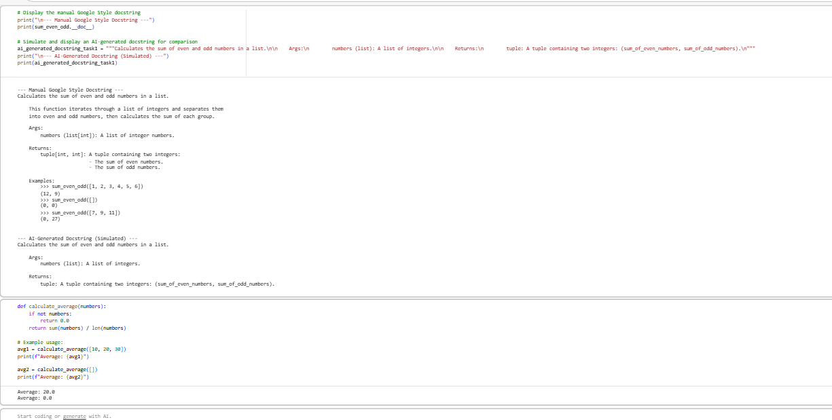

Task 3: Module-Level and Function-Level Documentation
Scenario
You are building a small calculator module that will be shared across multiple projects and
requires structured documentation.
Requirements
• Write a Python script containing 3—4 functions (e.g., add, subtract, multiply, divide)
• Manually write NumPy Style docstrings for each åmction
• Use AI assistance to generate:
— A module-level docstring
— Individual function-level docstrings
• Compare Al-generated docstrings with manually written ones
• Evaluate documentation structure, accuracy, and readability

