DevOps

* DevOps is development and operations together .
* Before devOps there was conflict between operation and development team. In traditional waterfall model, requirements would be clear and fixed but if the developers wish to change the requirements, it was hard. It was less secure and also there was less scope for innovation.
* If frequent changes are required, we opt for Agile development. So DevOps uses agile development and operation.
* DevOps address several limitations of waterfall model as it is more flexible. Improved collaboration is possible.
* The concept of continuous integration was introduced. The developers get feedbacks regularly so they can work on improving the code and deploying reliable code.
* Rapid Delivery was also possible

Tools like Docker, Kubernetes is used.

Life Cycle of devOps

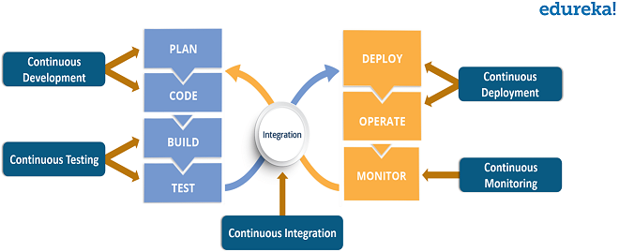

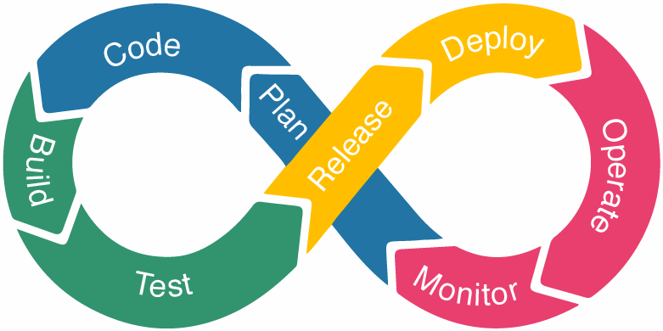

Life cycle includes:

* Continuous Development:

Involves planning and coding. The aim of the project is decided.

Tools used are Git(Version control tool) ,CVS etc.

Tools like Maven are also used for building code to executable files.

* Continuous Integration:

Updated code is merged or integrated with existing code.

Tools used- Jenkins

* Continuous Testing:

Testing is done here. Once code is tested it is integrated with the existing code.

Tools used-TestNG(Automation testing tool), Selenium

* Continuous Deployment:

The code is deployed to production environment or servers. Also make sure to keep configurations consistent.

Scaling up and down.

Tools used- Ansible , chef, puppet

* Continuous Monitoring:

Improving quality of software. Monitor user activity.

Increases productivity. Monitoring tools used like Nagios, Splunk.