

**GUESTURE CONTROL USING ARDUINO AND OPENCV**

**ABSTRACT** : With the increasing prevalence of smartphones, gesture-based interaction has arrived in our everyday life, but we still do not exploit its full potential. This paper describes the benefits of gestural input and presents interaction techniques that address these drawbacks. Gestures provide the user with a new form of interaction that mirrors their experience in the real world. Our project is mainly concerned about controlling led using gesture recognition which can be enhanced further to achieve home automation. This gesture control not only limits to small scale applications but also employed in many fields like gaming control, gesture control car driving, communication etc.

**KEYWORDS** : Image processing, gesture control, camera, Open-cV, python, Arduino, led, Mediapipe, cvzone, pyfirmata.

**INTRODUCTION:**

Gesture recognition helps computes to understand human body language. This helps to build a more potent link between humans and machines, rather than just the basic text user interfaces or graphical user interfaces (GUIs). Some of the libraries used are:

Open-cv : It is a source computer vision and machine learning software. It provides wide range of algorithms and functions for image processing, video processing, face recognition, camera calibration and so on.

Mediapipe : Open source machine learning library of google which has some solutions for face recognition and gesture recognition. Mediapipe Hand is a high fidelity hand and finger tracking solution.

.

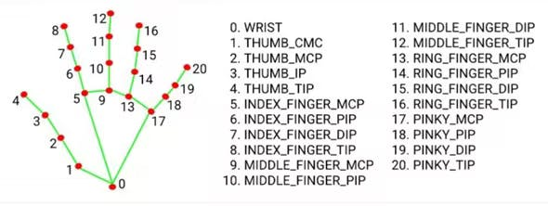

Cvzone : Library that develops a bridge between arduino and python.

Pyfirmata : Library that allows you to communicate with Arduino Board using the firmata protocol. It allows you to write programs that can send commands to board, read data from sensors and connected to the board and control actuators connected to the board such as led and motors.

WORKING :

In this project, we are using gestures with the help of mediapipe library. Using this based on its finger tracking solutions it goes on counting the number of fingers that you are presenting to the camera module. This python program is send to arduino board using pyfirmata library thst is present in arduino software. Hence based on this instructions arduino controls led. The gesture **1** lets you turn on LED-1, **2** for LED- 2, 3 for LED-3, 4 for LED-4, 5 for LED-5, **0** for exiting.

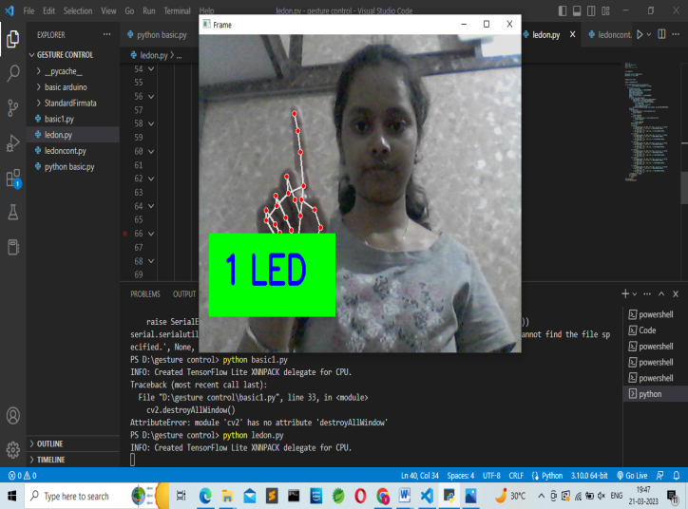 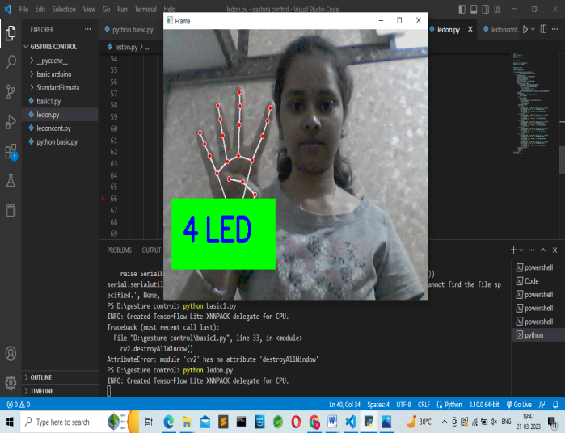

**PROGRAM CODE**

[**https://github.com/Meghana4S/For_Resume/blob/main/ledon.py**](https://github.com/Meghana4S/For_Resume/blob/main/ledon.py)

[**https://github.com/Meghana4S/For_Resume/blob/main/ledoncont.py**](https://github.com/Meghana4S/For_Resume/blob/main/ledoncont.py)

**RESULTS**

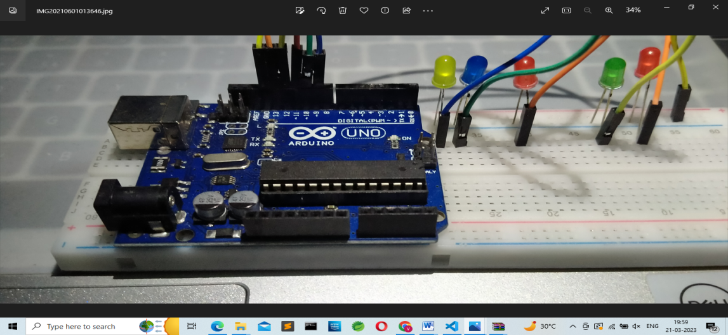

**CONCLUSION:**

In this paper, a hand gesture controlled robot using simple image processing is proposed. The webcam sent individual frames and the gesture recognition algorithm was processed on them and instruction based on certain gestures of hand was performed. The program can be modified to take into account different external factors like inadequate lighting, one way of doing this could be improving the segmentation process by filtering the image. The proposed system could then be used in hazardous conditions. Using specially designed filters depending upon particular environment the accuracy of the gesture prediction can improve significantly. One good application is the gesture controlled wheel chair which will help disabled people in locomotion.

**REFERENCES:**

* <https://www.hackster.io/as4527/control-led-with-open-cv-python-hand-gestures-and-arduino-93b020>
* A. Mulder, “Hand gestures for HCI”, Technical Report 96-1, vol. Simon Fraster University, 1996.
* **https://maker.pro/arduino/projects/how-to-make-a-gesture-controlled-led-strip-with-arduino**