**Project- Foodbox**

**Overview:** Foodbox is an e-commerce food ordering platform where users can order foods and admin manages it.

**Specifications:** This application is a prototype of the actual application which depicts the functionality and capabilities. The app here allows the admin with basic options like

* Login to admin profile
* View the available products
* Add New products

**Appearance:**

Outputs attached below.

**Concepts used:** Angular, json-server(fakeapi).

**Git hub link:** https://github.com/Meghana9892/Angularproject1-Foodbox

**Outputs:**

Login: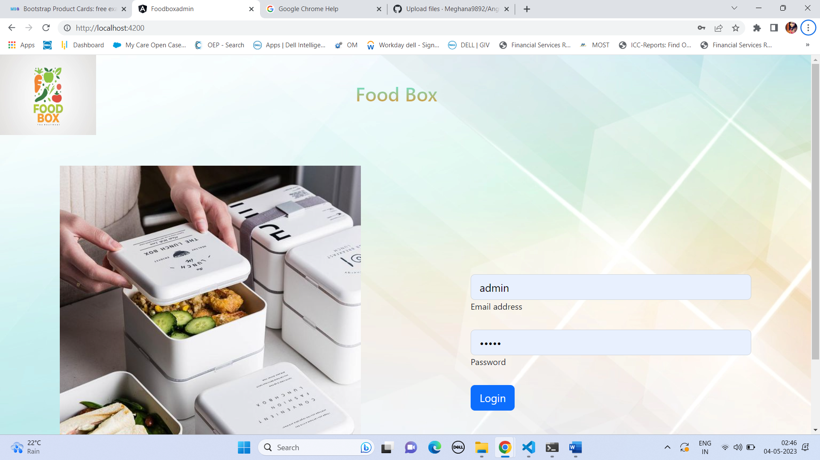

Home:

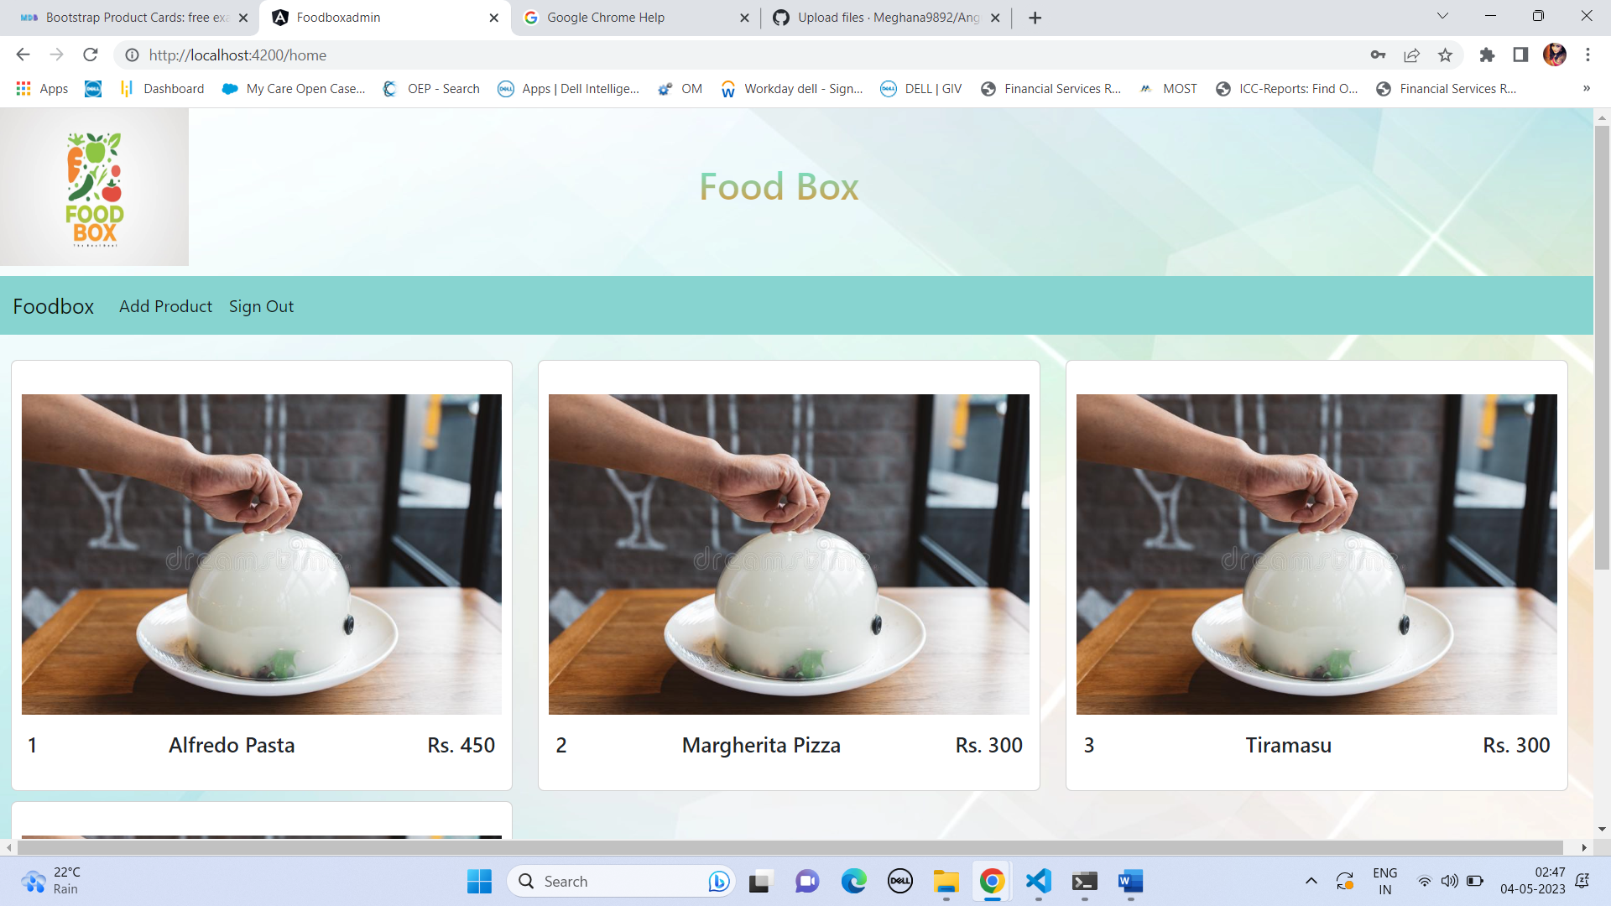

Add product:

