PIZZA SALES SQL QUERIES

1. KPI’S
2. **Revenue Total**

SELECT SUM(TOTAL_PRICE) AS TOTAL_REVENUE FROM Pizzasales

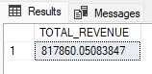

1. **Average order value**

select sum(total_price)/count(distinct order_id) as Avg_order_value from Pizzasales



1. **Total Pizzas Sold**

select sum(quantity) as Total_Pizzas_sold from Pizzasales



1. **Total Orders**

select count(distinct order_id) as Total_orders from Pizzasales

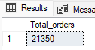

1. **Average Pizzas per order**

select cast(cast(sum(quantity) as decimal(10,2))/cast(count(distinct order_id) as decimal(10,2)) as decimal(10,2)) as Avg_pizzas_per_order from Pizzasales

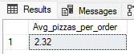

1. CHARTS REQUIREMENT
2. **Daily Trends for Total Orders**

select datename(dw,order_date) as order_day,count(distinct order_id) as Total_Orders from pizzaSales group by datename(dw,order_date)

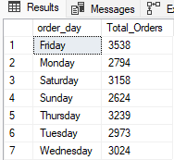

1. **Monthly Trend for Total Orders**

select datename(month,order_date) as Month_Name, count(distinct order_id) as Total_orders

from Pizzasales

group by datename(month,order_date)

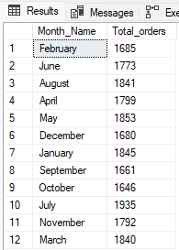

1. **Percentage of sales by pizza category**

select pizza_category,sum(total_price)*100/(select sum(total_price) from Pizzasales) as percentage_ofeach from Pizzasales

group by pizza_category

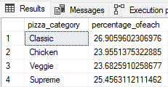

1. **Percentage of sales by pizza size**

select pizza_size,sum(total_price)*100/(select sum(total_price) from Pizzasales) as percentage_ofeach from Pizzasales

group by pizza_size

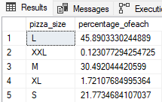

1. **Top 5 best sellers by revenue, total quantity and Total Orders**

select top 5 pizza_name,sum(total_price) as Revenue from Pizzasales group by pizza_name order by Revenue desc

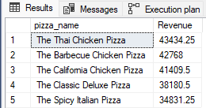

Same repeats with total quantity and total orders