1. Identify the error in program

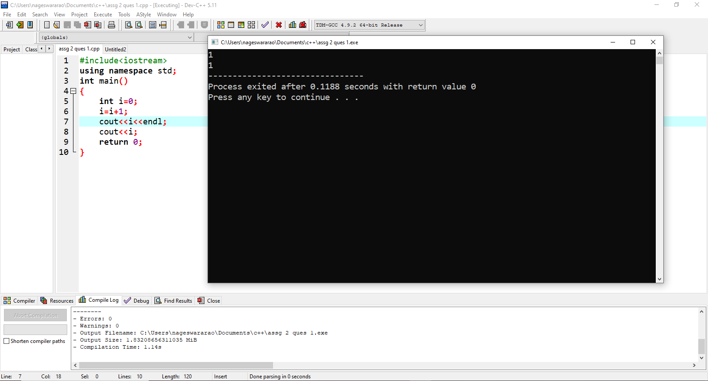

1. Identify the error

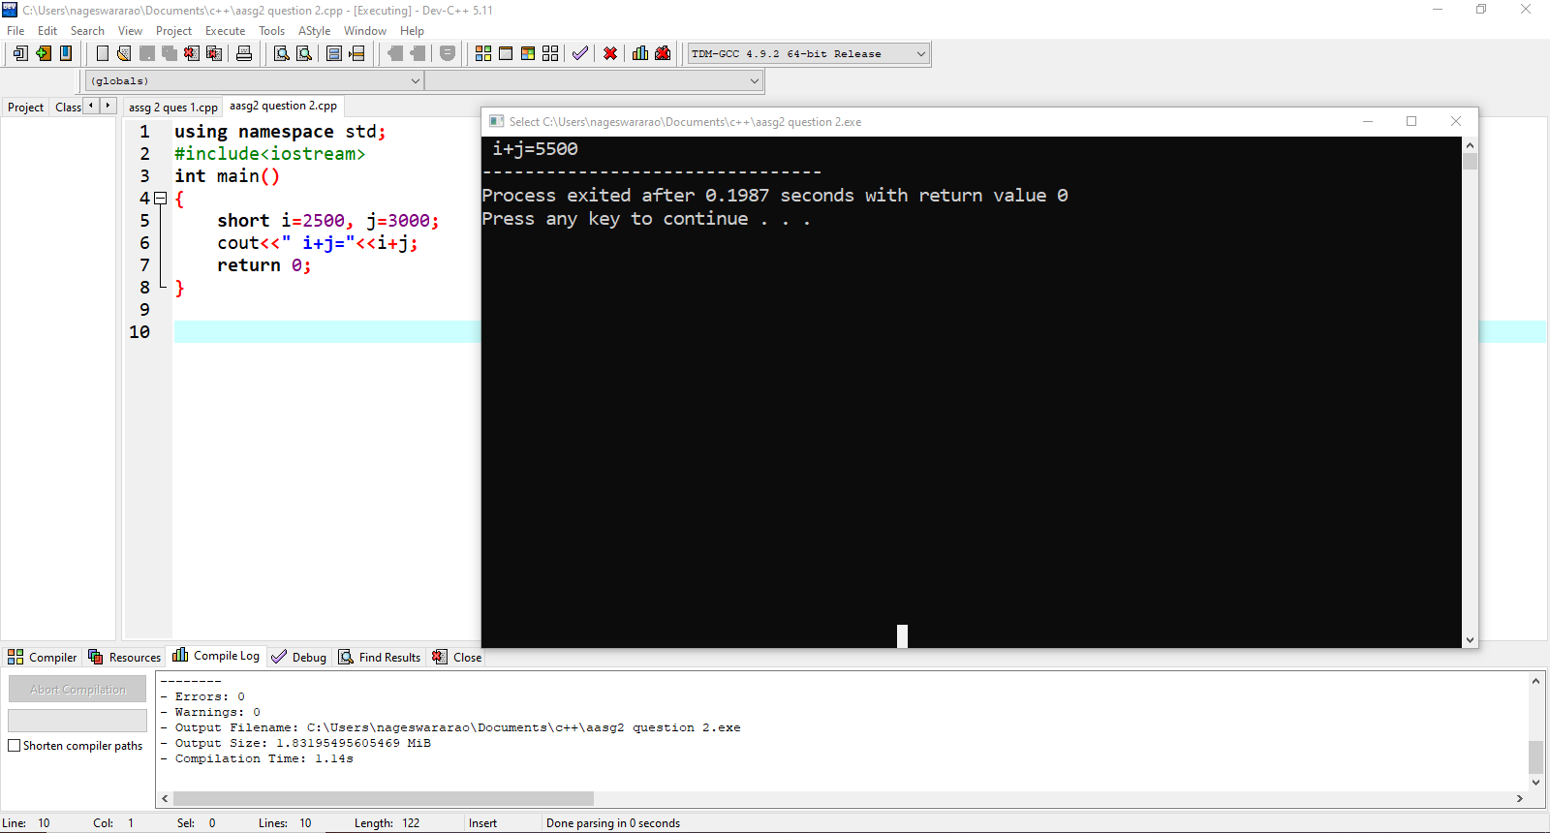

1. What will happen when you run following program.



**4.Write a c++ program**

}

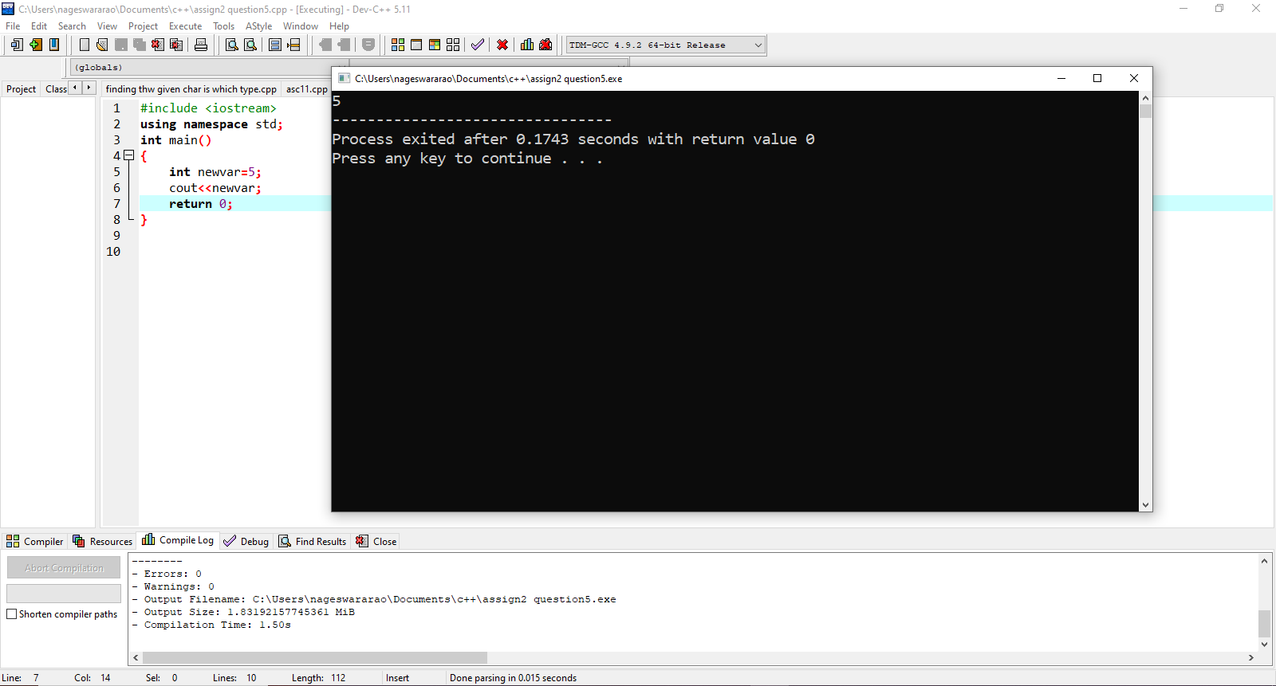

5.What happens if the following program is executed in C and C++?



6.Write c++ program for finding Square root of number.

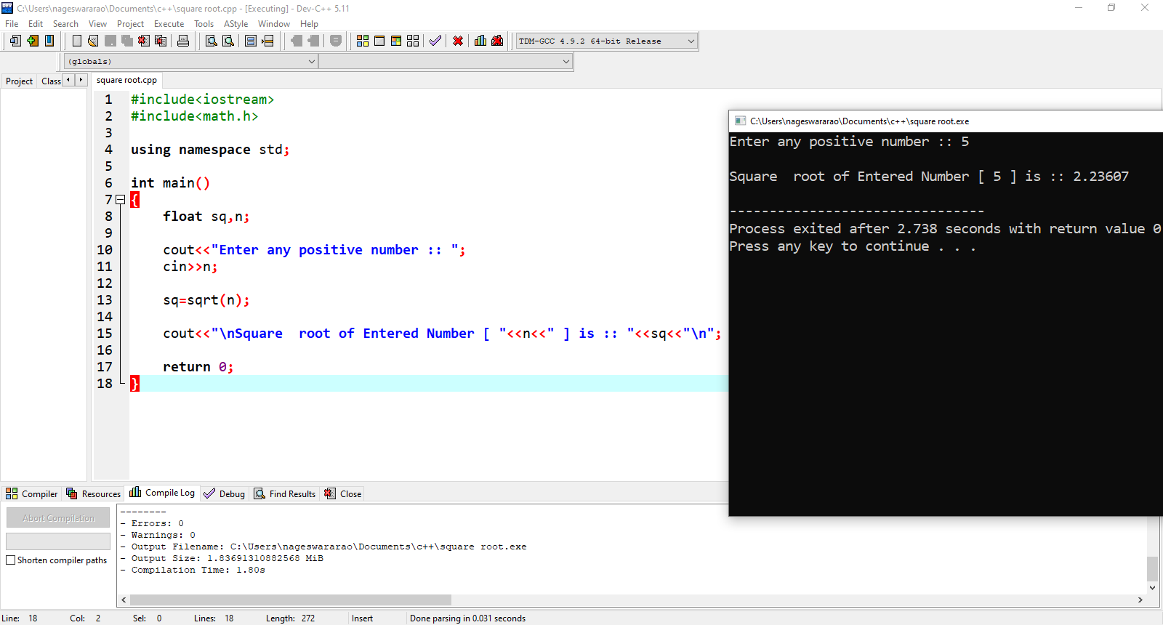

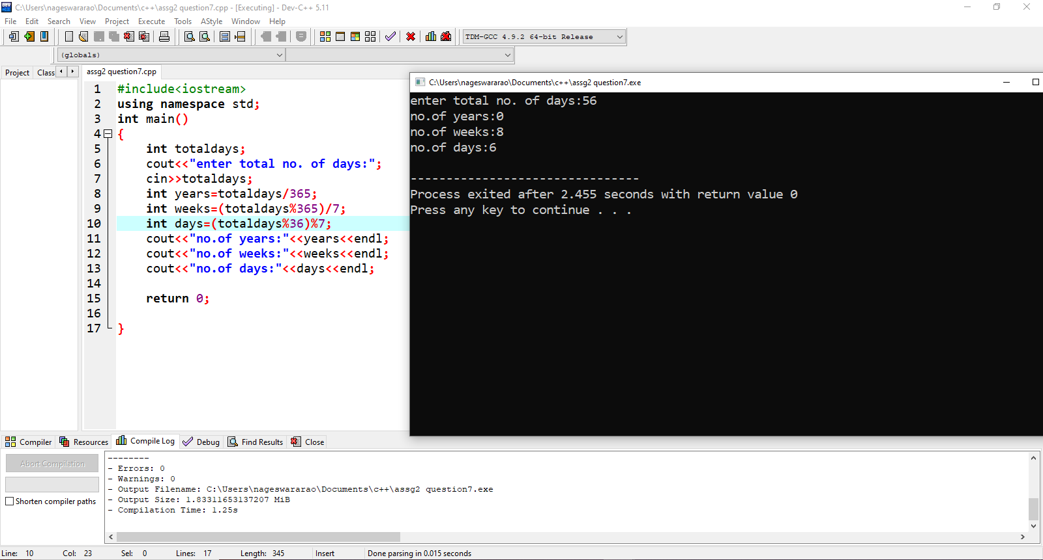8.A person wants to invest amount in financial institution and he wants find the compounded interest he will get, if no of year 385000, roi is 13.89 and time period is 4.

Write the code for above scenario.

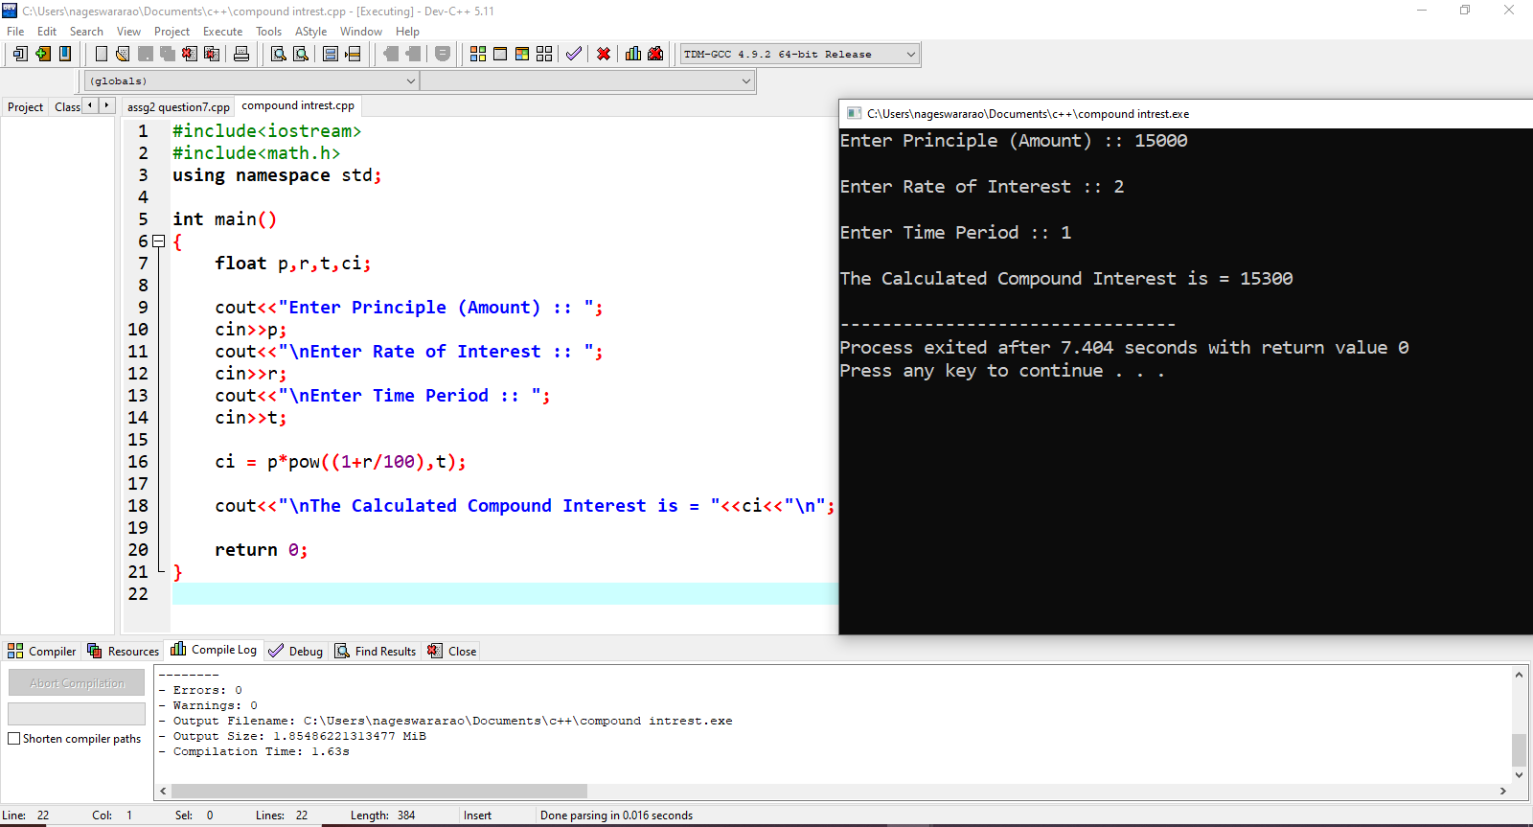

9.C++ Program to Check Character is Uppercase, Lowercase, Digit or Special

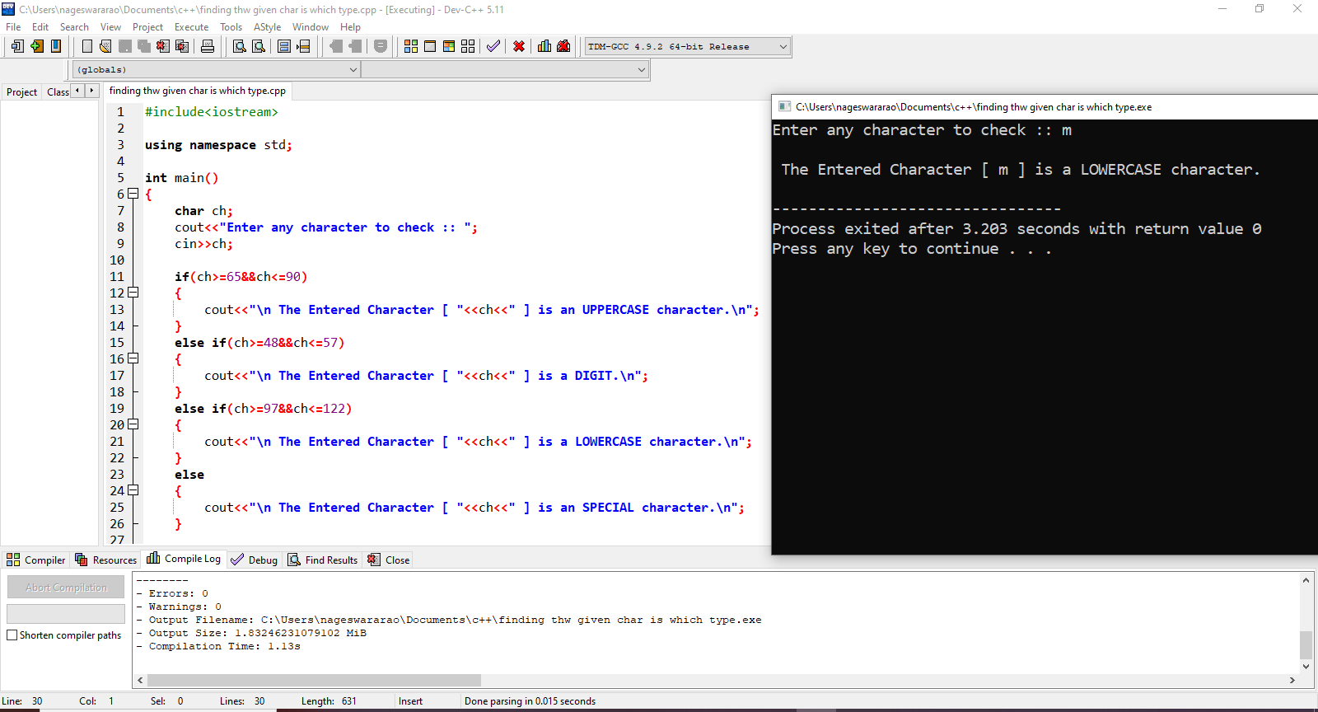

10.Write a program to display ascii value of character.

