**Web Application Security Lab**

**Assignment-1**

**Meghana D Duttargi**

**[241059042]**

**Cyber Security**

**Task 1: Create a Simple HTML Page**

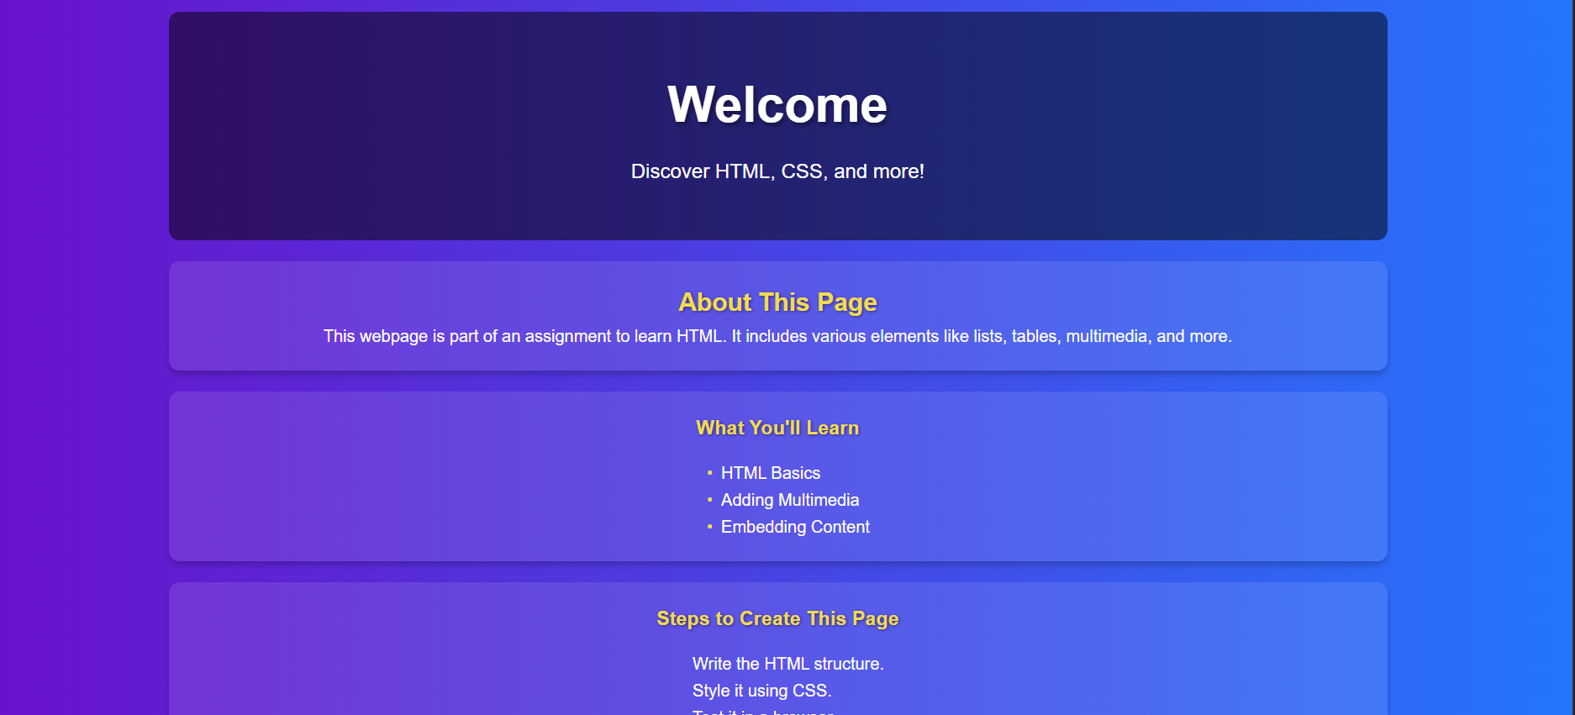

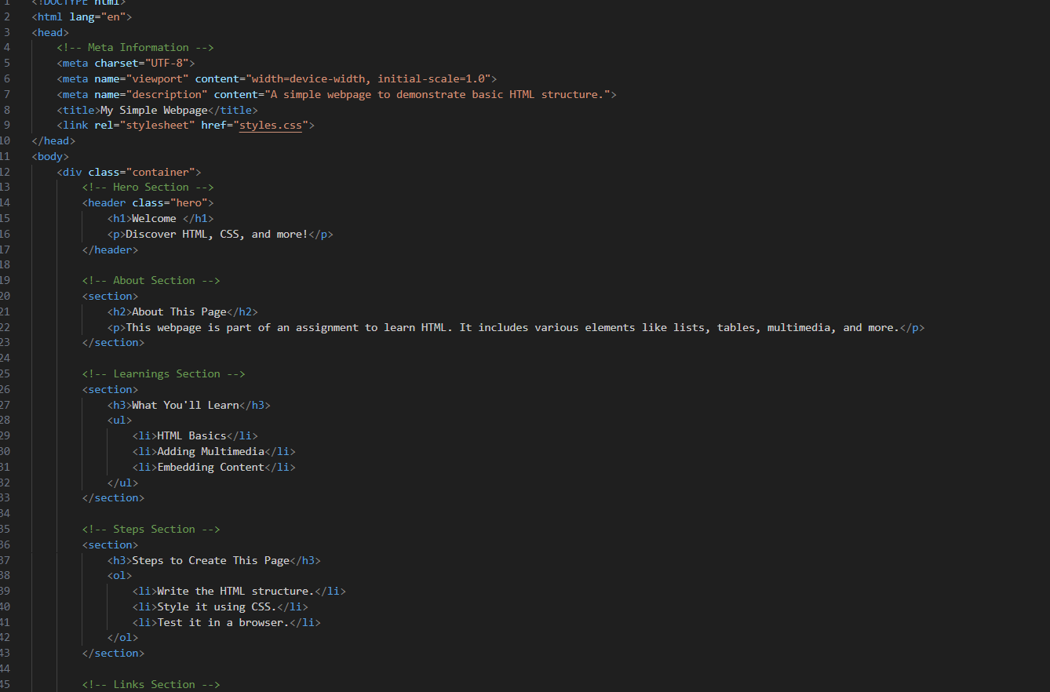

**Task 2: Inspect the Source Code of a Website**

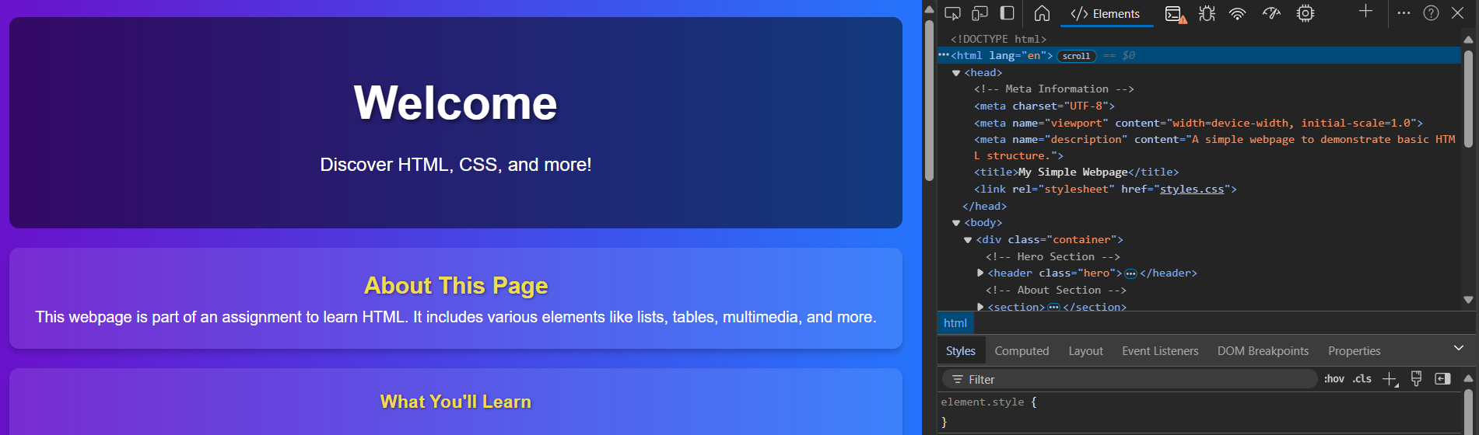

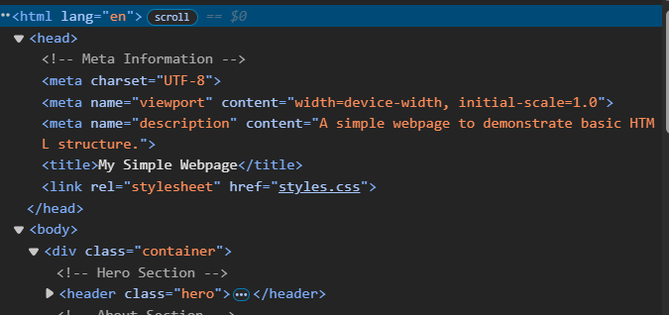

**Identifying Elements:**

* **Metadata**:
  + <meta charset="UTF-8">: Specifies the character encoding.
  + <meta name="viewport" content="width=device-width, initial-scale=1.0">: Ensures responsive design.
  + <meta name="description" content="Search the world's information...">: Describes the content of the page for search engines.
* **Headings and Semantic Elements**:
  + The use of <h1>: Often used to mark the main heading of the page, such as “Google Search.”
  + **Semantic tags** like <header>, <footer>, <nav>, and <section> help improve page accessibility and SEO.
* **Multimedia**:
  + Look for embedded content such as **videos** or **iframes**. Google may use embedded media or advertisements via iframes.
* **Security-Relevant Tags**:
  + **CSP (Content Security Policy)**: Often used to restrict what external resources can be loaded.
  + **Iframe with sandbox attribute**: <iframe src="https://www.youtube.com" sandbox="allow-scripts"> restricts certain actions within the iframe.
* **CORS (Cross-Origin Resource Sharing)**:
  + CORS headers like Access-Control-Allow-Origin might appear in the network responses and determine which domains are allowed to access certain resources.
* **SRI (Subresource Integrity)**:
  + External resources like CSS or JS files may include integrity attributes to ensure that the file content has not been tampered with.

**Task 3: Inspect the Source Code of Your Page**



**Task 4: Apply Styles Using CSS**

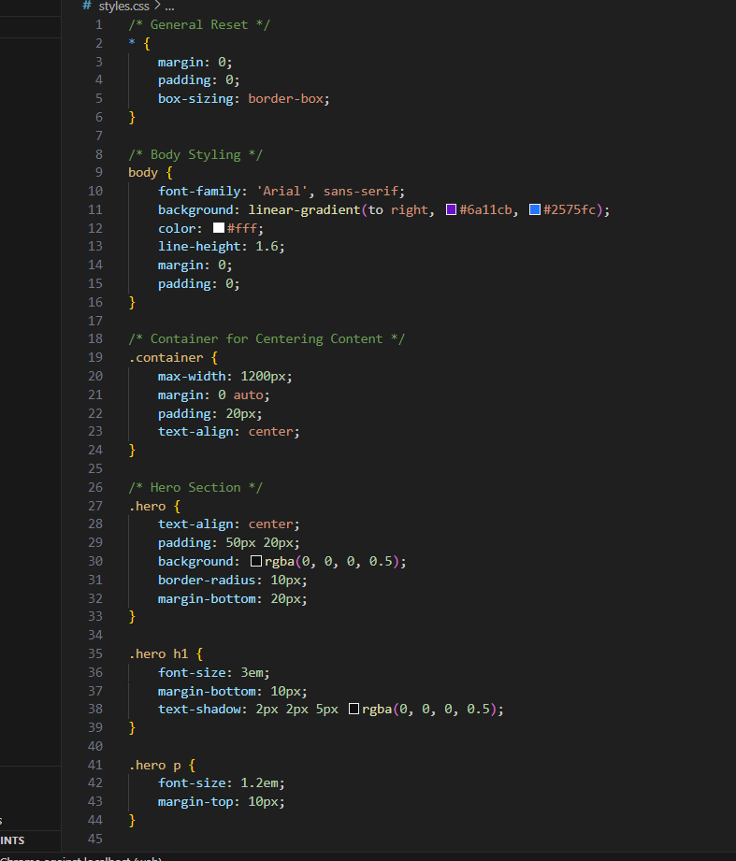

1. **h1**: Changes the text color to green (#2E8B57).
2. **body**: Sets a light gray background color.
3. **p**: Defines the font size of paragraphs as 16px.
4. **ul**: Applies a square bullet style and padding for lists.
5. **ul li**: Adds a margin between each list item.
6. **div**: Adds a border and padding to any <div> container for separation