Correlation

‘Correlation’ term refers to the handling of dynamic values coming from the server. These dynamic values are the unique values that are generated by the server for security purposes like the session ID, authorization token etc. In some cases, dynamic values also refer to the web content like values in a drop-down list, calendar date, item ID, product ID, order number etc. Through correlation, you can capture these dynamic values and pass them in the subsequent requests. This is the basic concept of ‘Correlation’ in LoadRunner.

# Why do we need to correlate the dynamic values?

To get the answer to this question, firstly you need to understand what exactly happens at the time of script recording, script replay and after correlating the dynamic values.

Let’s see, how the client and server act when some dynamic values are exchanged between them. This is the scenario while you record a script:

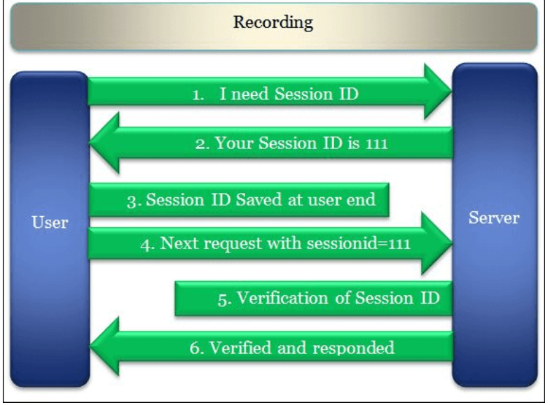

When you replay the script without any changes then the script fails because of the dynamic value (sessionid) generated by the server does not match the value returned by the client. while replaying the script, the server generated the session id as 222, but vuser script sent the recorded value i.e. 111 which was captured during recording Hence the server refused to serve the request and threw an error.

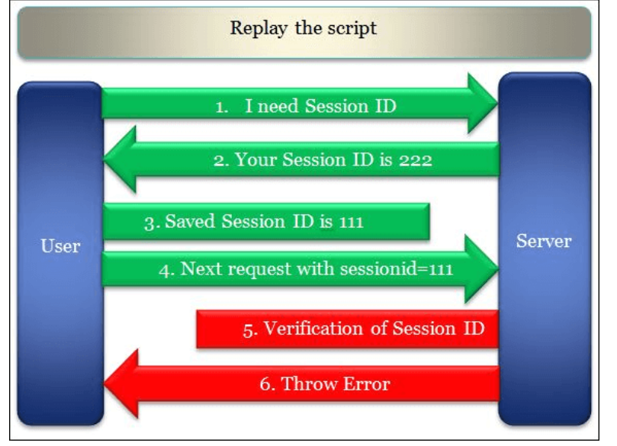

Now, when you correlate the dynamic value (sessionid) and replay the script then the vuser script captures and saves the latest value generated by the server and sends it back to the server in the next request. The server validates the returned value with the generated value and gives the proper response. Hence the request is marked as passed at the user end.

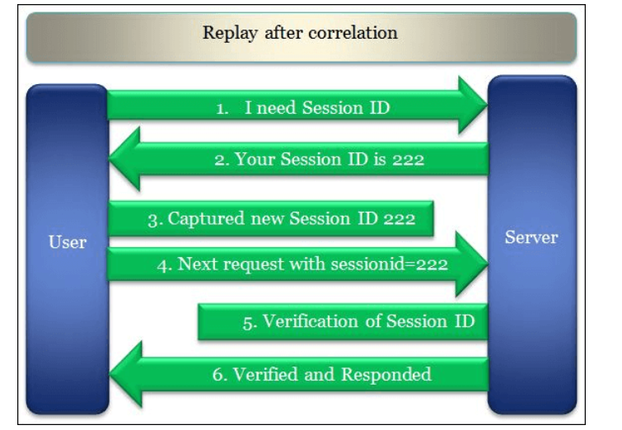

Some common correlations:

1. Session ID
2. Access Token
3. Customer Name / ID
4. Order Number
5. Bill Number
6. Number of records displayed on a page
7. Current Date and Time

Two ways of adding correlations:

1. Automatic Correlations
2. Manual Correlations