Selenium

Q: What is Testing?

Ans: Verifying whether the application works as expected or not

Q: What is Automation Testing?

Ans:

* It is the process of validating and verifying whether the software program works as expected using any  automation tool. (Automation tool performs the testing instead of a tester).
* The main purpose of Automation Testing is to automate Regression Testing.

# Advantages of automation

Benefits of automation testing

* Time saving
* Accuracy
* Avoids human errors
* Reusability
* Running tests 24/7
* Overnight execution
* Early bug detection
* Less human resource
* Cost saving
* Consistency

# Automation testing tools

* Selenium
* Unified functional testing One
* Appium
* Tricentis Tosca
* Rational Functional Tester

# What to automate?

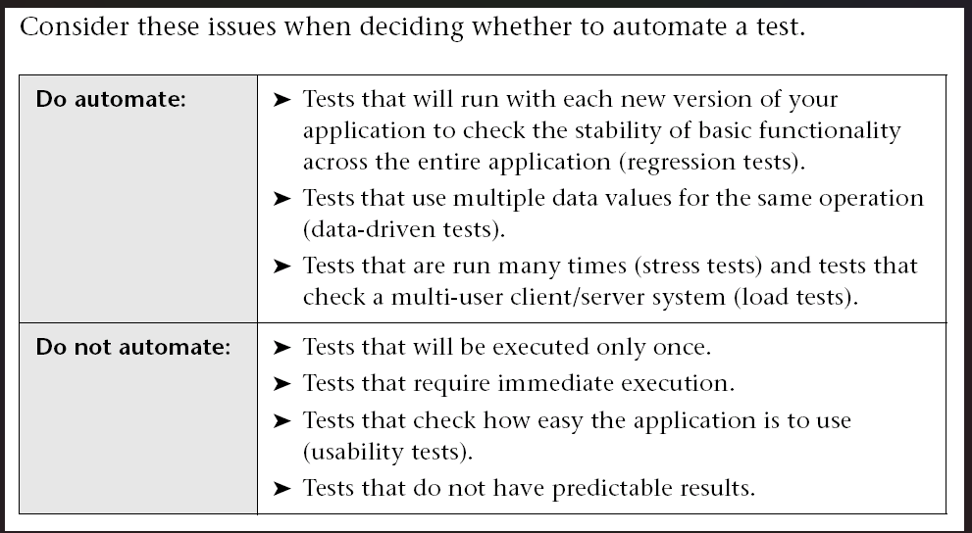

Smoke and Sanity tests are also good candidates for automation.

# Selenium history

Selenium is one of the most popular open-source automated testing tools available in the market..

Q: What Test Cases Can be automated?

Ans:

* Regression Test
* Data Driven Test
* Smoke and Sanity Test

Selenium was first introduced in the Year 2004. This variant of selenium had:

1. Selenium Remote Control.
2. Selenium Grid
3. Selenium IDE

Selenium 2nd generation was launched in 2011. It Had the following components

1. Selenium RC
2. Selenium Grid
3. Selenium IDE
4. Selenium Web Driver

Selenium 3rd generation was released in Oct 2016 when Selenium RC was removed

1. Selenium Web Driver
2. Selenium IDE
3. Selenium Grid

Selenium 4th generation was released on October 13, 2021 with the following upgrades

1. Enhanced selenium grid
2. Upgraded selenium IDE
3. Improved documentation
4. Complete W3C compliance of the WebDriver APIs

Stable version of Selenium – 4.1.0

Supported Platforms

* Selenium is a Cross-Platform tool – Windows/Linux/Mac
* Cross Browser – Edge, Chrome, Safari, Opera, Firefox
* Supports – Java, C#, Javascript, Ruby, Python

Selenium Vs UFT

|  |  |
| --- | --- |
| **Selenium** | **QTP/UFT** |
| 1. Open Source Tool | 1.Commercial Tool |
| 2. Supports only Web Applications | 2. Supports Desktop & Web Applications |
| 3. Cross Platform | 3. Not Cross Platform |