Selenium , Maven and Jenkins

# **Installing Maven**

1. Download Maven

Download the Binary zip file for Maven from below URL(Binary Zip Archive)

<http://maven.apache.org/download.cgi>

1. Extract the zip File
2. Set the path of Maven in Environment Variables under user variables.

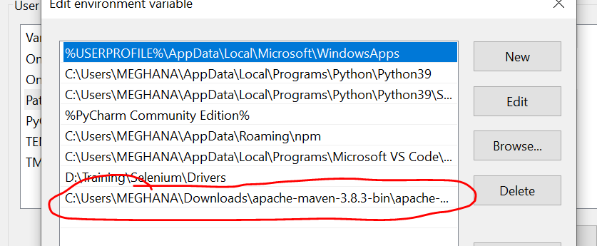

1. Set the path of Maven bin folder under system variables

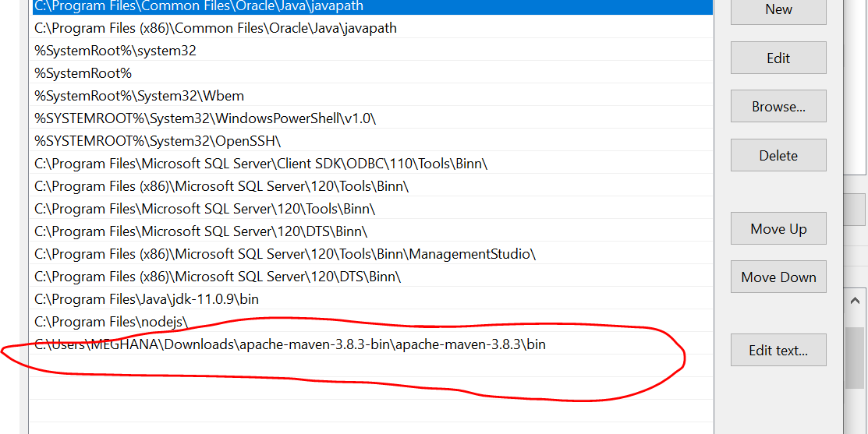

**Configuring Jenkins**

Jenkins is a Continuous integration tool

Before opening Jenkins, run the below line in common prompt

java -jar Jenkins.war --httpPort=8822

# **Installing Maven Plugin in Jenkins**

1. Go to Dashboard in Jenkins and Click on Manage Jenkins.
2. Click on Manage Plugins
3. Click on Available tab and search for “Maven Integration”
4. Click on Install Without Restart.
5. Jenkins 🡪 Manage Jenkins 🡪 Global tool Configuration 🡪 Under Maven 🡪 Maven Installations, set the path where maven in installed

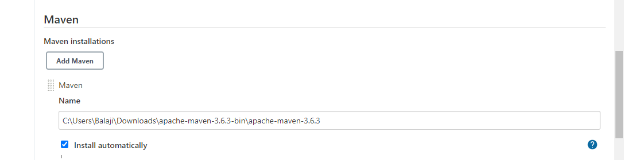

1. Under JDK installations, uncheck “install automatically”
2. Give Name as JAVA
3. Specify the path of jdk under JAVA_HOME

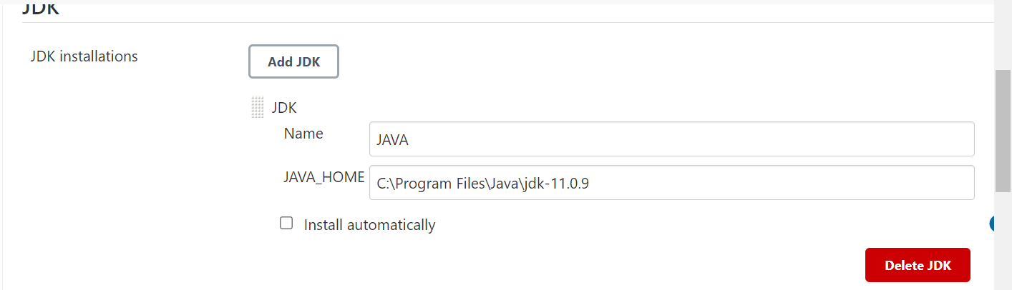

1. Click on Apply and then Save.

# **Adding the path of testing.xml file in pom.xml**

1. In Eclipse, open pom.xml file available in maven project.
2. Specify the path of testing.xml file as below

<configuration>

<suiteXmlFiles>

<suiteXmlFile>testng.xml</suiteXmlFile>

</suiteXmlFiles>

</configuration>

1. Make sure to add it under the maven-surefire-plugin tag as below

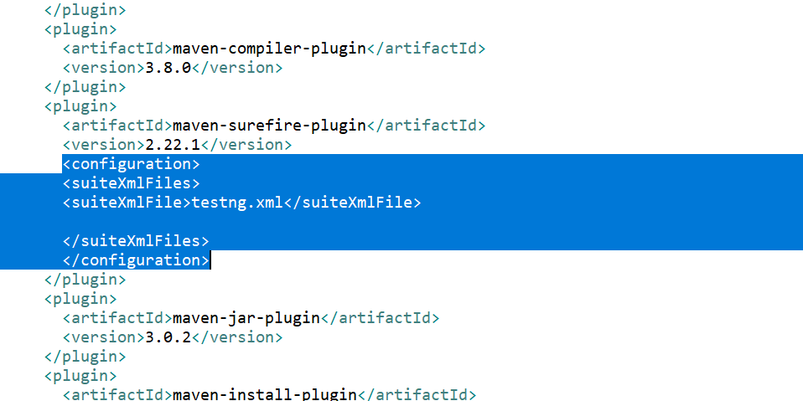

# **Running Maven Project through jenkins**

1. Login to Jenkins
2. Click on New Item
3. Select Maven Project
4. Under build, given the Path of pom.xml file
5. In goals, type “clean install”
6. Apply 🡪 Save
7. Back to Dashboard
8. Click on Build now.

# **To Schedule run:**

1. Under Build Triggers Option, select Build Periodically.
2. Provide the schedule time using Cron Job.
3. Ex: 50 12 * * * 🡪 Execution will start at 12:50 am every day
4. Click on Apply and Save.
5. Go back to DashBoard.
6. Exactly at the scheduled time, execution will start.

Jenkins Symbol

1. Red🡪 Last execution has failed
2. Blue 🡪 Last Execution has Passed
3. Grey 🡪 Not Executed

Weather Report

1. Sunny 🡪 All the builds have passed
2. Cloudy 🡪 Some of the builds have failed.
3. Thunder 🡪 All the builds have failed.

Wiki Link for Cron Job

<https://en.wikipedia.org/wiki/Cron>

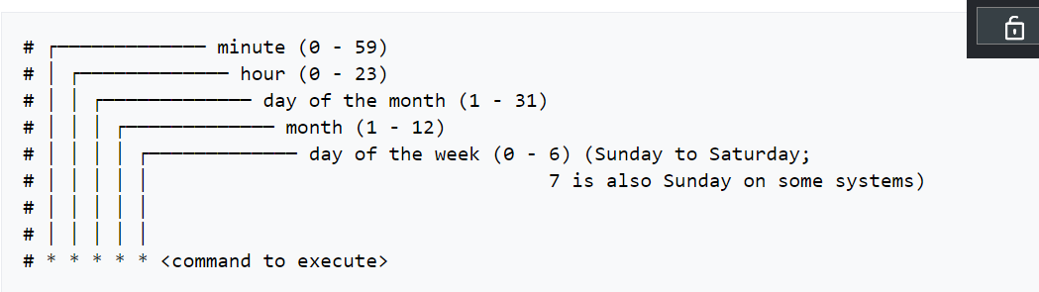

Maven Using freestyle project

Use the **Build Step** called **Invoke top-level Maven targets** in a Free-Style project, then set its goals (e.g., clean install, or clean install -f subdir/pom.xml (if your pom.xml is not in the root)).

Configure the "Maven" tool (via **Manage Jenkins** | **Global Tool Configuration**). Scroll down to "Maven" to "add" an installation (ignore the "Maven Configuration" at the top).