Software Architecture and Design Document
Supply Chain Management Simulator
Software Engineering Mini Project
Document ID | SCM-SAD-001
Project | Supply Chain Management Simulator
Version | 1.1
Date | 10-11-2026
Status | Draft
Authors | Siri Krishna C R, Spoorthi Poornachandra, D R Rushmitha, Kallepalli Sai Meghana, Shraddha
Related documents | Software Requirements Specification v1.1 (SCM-SRS-001), Software Test Plan v1.1

Revision History
Version | Date | Author | Change Summary
0.1 | 10-10-2026 | Project team | Initial architecture outline, module decomposition and ownership
1.0 | 11-10-2026 | Project team | Complete architecture and design: UML views, decisions, interfaces, threat model and traceability
1.1 | 10-11-2026 | Project team | Updated to match the build: test-time coverage tools in 3.6, run_simulation engine interface in 3.3, 3.4, 3.8 and 4.4, wider configuration validation in 3.4 and 4.3.5, finite costs and full CustomerOrder validation. Every change is listed in docs/Deviation_Log.md (DV-01 to DV-10)

Approvals
Role | Name | Signature / Date
Course Coordinator
Repository owner and scrum master | Kallepalli Sai Meghana
QA lead | D R Rushmitha
Developer | Siri Krishna C R
Developer | Spoorthi Poornachandra
Developer | Shraddha

1. Introduction

1.1 Purpose
This document describes the software architecture and design of the Supply Chain Management Simulator (SCM Simulator). It records the architectural decisions taken, the static structure of the system, the behaviour of its key runtime flows, and the interfaces between its components. It is the reference for implementation, code review and testing, and it is traceable to the Software Requirements Specification (SRS) and the Software Test Plan (STP).

1.2 Scope
The SCM Simulator is a command-line application that simulates, one day at a time, a single warehouse that supplies multiple products to customers and replenishes its stock from multiple suppliers. The architecture covers the following capabilities:
- Customer demand generation using constant, uniform random and seasonal patterns.
- Customer order fulfilment on a first-in-first-out basis, with unmet demand held as backorders.
- Demand forecasting by moving average or exponential smoothing, with forecast error measurement.
- Replenishment decisions using safety stock, reorder point and Economic Order Quantity (EOQ).
- Supplier selection by price, lead time or a weighted balance of price, lead time and reliability.
- Purchase order lifecycle management, including reliability-based delivery delays.
- Inbound transport costing, cost accounting, KPI computation and reporting to CSV and console.
Out of scope: multi-warehouse or multi-echelon networks, integration with real ERP or supplier systems, a graphical user interface, persistent databases, and user accounts or authentication.

1.3 Audience
- Developers implementing and reviewing the modules described in Sections 3 and 4.
- Test engineers and reviewers deriving and verifying test cases against the design.
- Course faculty and evaluators assessing the architecture, process compliance and traceability.
- Future maintainers extending the simulator, for example with additional warehouses or policies.

1.4 Definitions
Table 1: Acronyms and abbreviations
Term | Definition
ADR | Architecture Decision Record
CI | Continuous Integration
CLI | Command-Line Interface
COGS | Cost of Goods Sold
CSV | Comma-Separated Values
EOQ | Economic Order Quantity
FIFO | First In, First Out
JSON | JavaScript Object Notation
KPI | Key Performance Indicator
MAE / MAPE | Mean Absolute Error / Mean Absolute Percentage Error
PO | Purchase Order
RNG | Random Number Generator
ROP | Reorder Point
RTM | Requirements Traceability Matrix
SRS / STP | Software Requirements Specification / Software Test Plan
STRIDE | Spoofing, Tampering, Repudiation, Information disclosure, Denial of service, Elevation of privilege
UML | Unified Modeling Language

2. Document Overview

2.1 How to use this document
Section 3 describes the architecture: goals and constraints, stakeholders, the logical and deployment views, component responsibilities, architecture decisions, technology choices, risks, traceability and security architecture. Section 4 describes the design: the processing model, behavioural views (state and sequence diagrams), component interfaces, error handling and the user experience. Section 5 contains the glossary, references and tools.
The document follows the viewpoint approach of ISO/IEC/IEEE 42010. The views used are:
Table 2: Architecture views
View | Concern addressed | Location
Logical view | Decomposition into components and classes, and their dependencies | Section 3.3, 3.4
Deployment view | Runtime environment and delivery pipeline | Section 3.6
Behavioural view | Object lifecycles and the main runtime interactions | Section 4.1, 4.2
Interface view | Contracts between components and with the user | Section 4.3
Decision view | Significant architecture decisions and alternatives | Section 3.5
Security view | Assets, trust boundaries, threats and controls | Section 3.9

Requirement identifiers follow the SRS: SCM-F-nnn (functional), SCM-NF-nnn (non-functional) and SCM-SR-nnn (security). Test case identifiers follow the STP, for example TC-INV-07.

2.2 Related Documents
Table 3: Related documents
Document | Version | Relationship
Software Requirements Specification (SRS) | 1.0 | Source of all requirements realised by this design
Software Test Plan (STP) | 1.0 | Verifies the design through the test cases referenced in Section 3.8
Requirements Traceability Matrix (RTM) | 1.0 | Maps requirements to modules and tests; SRS Section 8
Team Context Document | 1.0 | Development workflow, module ownership and delivery plan
Source repository scm-simulator, including .github/workflows/ci.yml | main branch | Implementation of this design and its CI pipeline

3. Architecture

3.1 Goals & Constraints
Table 4: Architecture goals
ID | Goal | Driver
AG-1 | Correctness: every functional rule is verified by automated tests that run on every change. | SCM-NF-003
AG-2 | Reproducibility: the same configuration and seed always produce identical results. | SCM-NF-002
AG-3 | Configurability: all scenario data (products, suppliers, demand, costs, policy) is supplied through configuration; none is hardcoded. | SRS 2.5
AG-4 | Modifiability: components interact only through published interfaces, so four developers can build them in parallel. | SCM-NF-003
AG-5 | Performance: a 365-day run of the reference scenario completes in under 2 seconds on a standard laptop. | SCM-NF-001
AG-6 | Portability: runs on Windows, macOS and Linux with Python 3.12 and no third-party runtime dependencies. | SCM-NF-005
AG-7 | Secure delivery: no unreviewed or untested change can reach the main branch. | SCM-SR-004

Table 5: Architecture constraints
ID | Constraint
C-1 | Python 3.12 using the standard library only at runtime; pytest is used for testing.
C-2 | Command-line interface only; single process on a single machine; no network access at runtime.
C-3 | One warehouse; time advances in fixed steps of one day.
C-4 | Mandated development process: one shared GitHub repository, protected main branch, one feature branch per feature, pull request with at least one approval, and CI tests that must pass before merge.
C-5 | Team of four with equal contribution; the system is partitioned so that each member owns distinct modules.

3.2 Stakeholders & Concerns
Table 6: Stakeholders and concerns
Stakeholder | Concerns | Addressed in
Supply Chain Analyst (end user) | Trustworthy, explainable results; ability to compare policies and scenarios | 3.6, 4.1, 4.5
Scenario Planner | Change products, suppliers and demand without code changes; clear validation errors | 3.6, 4.3.5, 4.4
Developers | Parallel work without conflicts; stable interfaces; fast feedback on defects | 3.4, 3.5, 4.3
Test engineers and reviewers | Testability of every rule; traceability from requirement to test | 3.8, 4.3
Course faculty and evaluators | Process compliance (CI, protected main, reviews), documentation quality, balanced contribution | 3.6, 3.9
Maintainers | Low coupling, documented decisions, room to extend | 3.5, 4.6

3.3 Component (UML) Diagram
Figure 1 shows the logical decomposition into four layers. Dependencies point downwards only: the Presentation layer uses the Application and Data Access layers, the Application layer uses the Domain layer, and Domain components do not depend on the layers above them. The Simulation Engine is the only component that orchestrates other domain components.
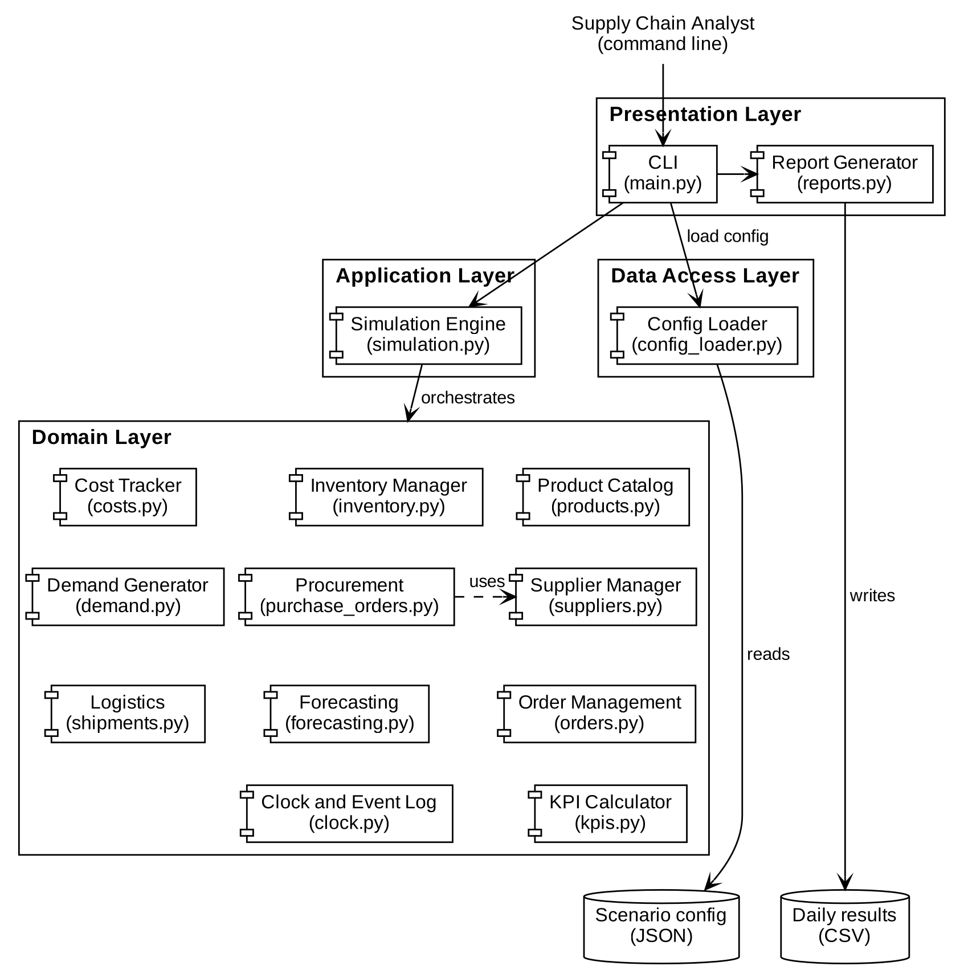
Figure 1: Component diagram (layered logical view)
Figure 2 shows the principal classes and their relationships. The engine, run_simulation(config) in simulation.py, creates one instance of each domain service and one DemandGenerator per product. Catalogues and order books aggregate their entity objects. Figure 2 and Figure 5 label the engine as a SupplyChainSimulation class; read that as run_simulation (DV-08).
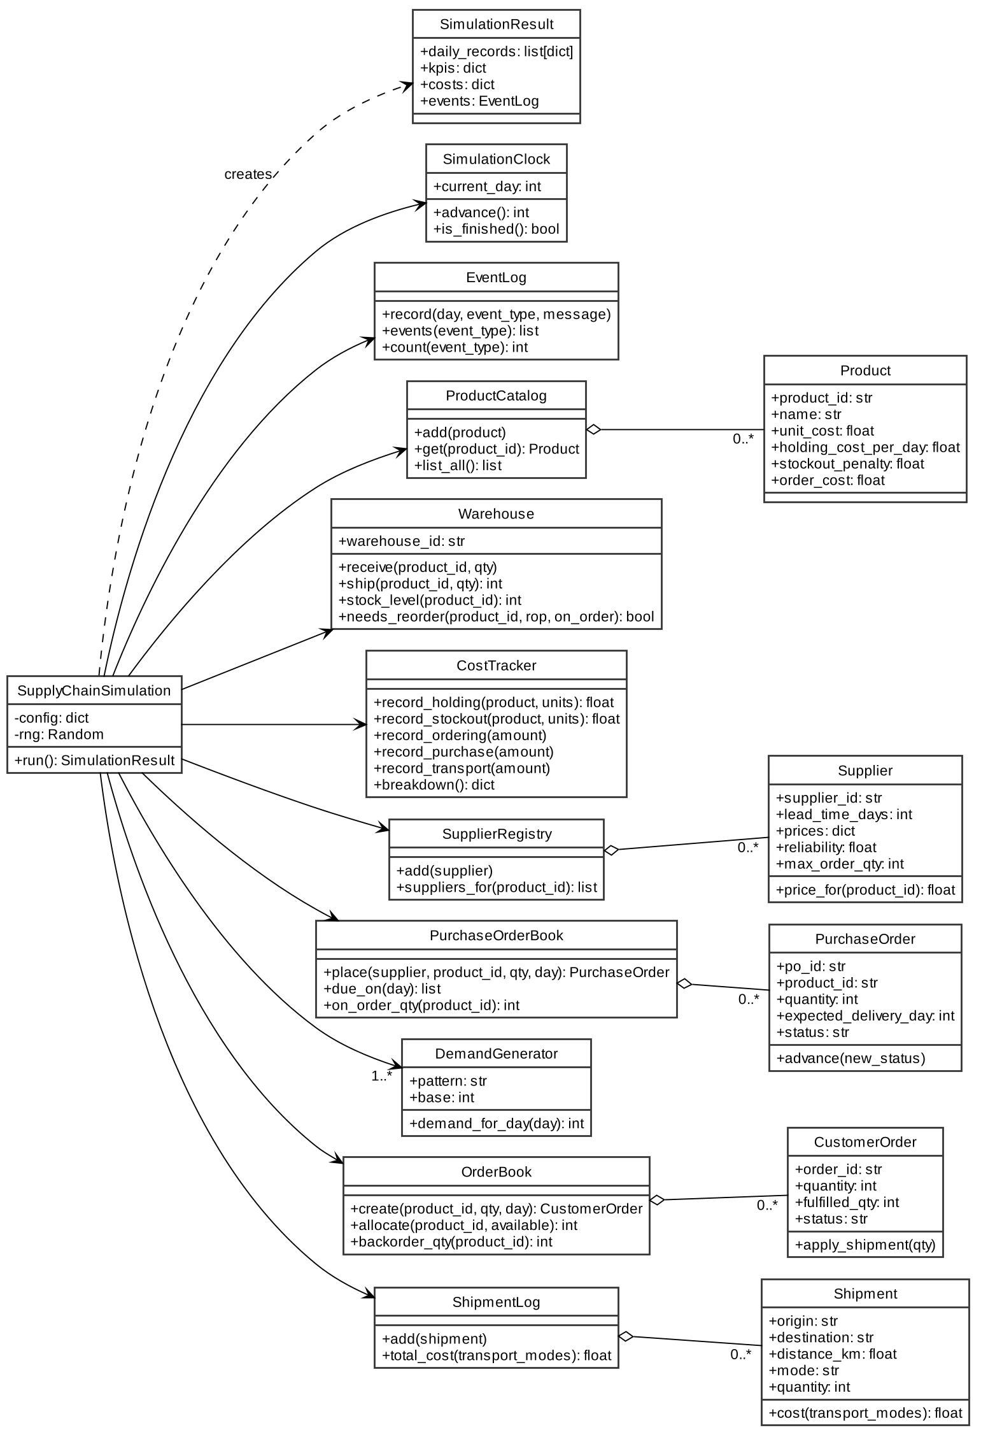
Figure 2: UML class diagram

3.4 Component Descriptions
Table 7: Component responsibilities and interfaces
Component (module) | Responsibility | Provided interface | Depends on
CLI (main.py) | Parses arguments, loads configuration, runs the simulation, exports results, prints the summary and maps errors to exit codes. | main(argv) | Config Loader, Simulation Engine, Report Generator
Report Generator (reports.py) | Writes daily records to CSV with formula-injection protection; formats the text summary. | export_daily_csv, format_summary | None
Simulation Engine (simulation.py) | Holds simulation state, executes the daily loop, orchestrates domain components, assembles the result. | run_simulation(config), SimulationResult | All Domain components
Product Catalog (products.py) | Product master data and validation. | Product, ProductCatalog | None
Inventory Manager (inventory.py) | Stock levels per product; EOQ, safety stock and reorder point calculations; reorder decision. | Warehouse, economic_order_quantity, safety_stock, reorder_point | None
Cost Tracker (costs.py) | Accumulates holding, stockout, ordering, purchase and transport cost. | CostTracker | Product
Supplier Manager (suppliers.py) | Supplier master data, lookup by product, selection strategy. | Supplier, SupplierRegistry, select_supplier | None
Procurement (purchase_orders.py) | Purchase order creation, status lifecycle, open-order tracking, delivery delays. | PurchaseOrder, PurchaseOrderBook, apply_random_delay | Supplier
Demand Generator (demand.py) | Daily demand per configured pattern. | DemandGenerator | None
Order Management (orders.py) | Customer orders, FIFO allocation of stock, backorder tracking. | CustomerOrder, OrderBook | None
Forecasting (forecasting.py) | Moving average, exponential smoothing, demand variability, forecast error. | moving_average, demand_std, exponential_smoothing, mean_absolute_error, mean_absolute_percentage_error | None
Logistics (shipments.py) | Inbound shipments and mode-based transport cost. | Shipment, ShipmentLog | None
KPI Calculator (kpis.py) | Fill rate, service level, average inventory, inventory turnover. | compute_kpis and helper functions | None
Clock and Event Log (clock.py) | Simulation day counter and structured event recording. | SimulationClock, EventLog | None
Config Loader (config_loader.py) | Reads JSON, enforces the size limit, and validates schema, ranges, references, policy settings and field values before day 0. | load_config, validate_config | None

3.5 Chosen Architecture Pattern and Rationale
Chosen pattern: layered architecture with a central orchestrator. The system is organised into Presentation, Application, Domain and Data Access layers. The Simulation Engine in the Application layer is the single orchestrator; Domain components are cohesive, independently testable units that hold their own state and expose small interfaces.
Rationale:
- The workload is a deterministic batch computation with a feedback loop (today's reorder affects future stock), which maps naturally onto one orchestrator calling domain services in a fixed order.
- Isolating Domain components lets each be unit-tested without the engine and lets four developers work in parallel with no shared files.
- Keeping file and console I/O in the outer layers makes the Domain layer free of side effects other than its own state, which supports reproducibility (AG-2).
Table 8: Alternatives considered
Alternative | Reason not chosen
Web application (Flask or Django with a database) | No graphical interface or persistence is required; it would add deployment effort and attack surface without serving a requirement.
Microservices | A single-process batch computation gains nothing from network boundaries; latency, deployment and failure handling would increase substantially.
Discrete-event simulation library (for example SimPy) | Introduces a third-party dependency (violates C-1); all decisions occur at daily granularity, so a fixed time-step loop is simpler and easier to test deterministically.
Pipe-and-filter | Processing is not a linear flow; reorder decisions feed back into later days.

Table 9: Architecture decision records
ID | Decision | Rationale | Consequence
ADR-001 | Layered architecture with a single orchestrator | Clear separation of concerns; parallel development; testability | Engine depends on every domain interface; it is integrated last
ADR-002 | Fixed daily time step | Matches the granularity of all business rules; simple and deterministic | Intra-day timing (for example morning versus evening deliveries) is not modelled
ADR-003 | Standard library only at runtime | Portability; no dependency failures in CI; minimal supply-chain risk | Statistics and CSV handling are implemented with standard modules
ADR-004 | Scenario defined in a validated JSON file | Scenario changes need no code; validation fails fast on bad input | A schema must be maintained (Section 3.6)
ADR-005 | One seeded random number generator injected into all stochastic components | Bit-for-bit reproducible runs | Components must never call the global random module
ADR-006 | Unmet demand is backordered, not lost | Captures service failure and penalty cost explicitly | Lost-sales policies are a future enhancement (Section 4.6)
ADR-007 | One feature per branch and pull request, merged by squash | One commit per feature on main; clean history; balanced attribution | Intermediate branch commits are not preserved on main

3.6 Technology Stack & Data Stores
Table 10: Technology stack
Concern | Technology | Notes
Language and runtime | Python 3.12 | CPython; executed inside a virtual environment
Runtime libraries | Python standard library | dataclasses, json, csv, math, random, statistics, argparse, pathlib
Testing | pytest 8.3.3, pytest-cov 5.0.0, pytest-html 4.1.1 | Pinned in requirements.txt; configured by pytest.ini. Coverage and HTML reports are test-time only (DV-03)
Continuous integration | GitHub Actions on ubuntu-latest | actions/checkout@v4, actions/setup-python@v5; job name test; line and branch coverage with an 80% gate
Version control | Git with GitHub | Branch ruleset protect-main on the default branch
Design documentation | PlantUML | Source for all UML figures in this document

Data stores. The system uses no database. Three stores exist:
Table 11: Data stores
Store | Format | Direction | Lifetime
Scenario configuration | JSON file (default data/sample_config.json) | Input, read once at start | Persistent, version controlled
Daily results | CSV file (default output/results.csv) | Output, written once at end | Persistent, not version controlled
Simulation state | Python objects in memory | Internal | One run

Table 12: Configuration schema
Section | Key fields | Validation
simulation | days, seed | days is an integer from 1 to 3650
policy | supplier_strategy, service_z, forecast_method, forecast_window, smoothing_alpha, max_supplier_delay_days | Strategy and method from the allowed sets; window and delay at least 1; alpha in (0, 1]
warehouse | warehouse_id, name, initial_stock | Initial stock non-negative; every product exists in products
products | product_id, name, unit_cost, holding_cost_per_day, stockout_penalty, order_cost | Unique IDs; non-empty names; costs non-negative
suppliers | supplier_id, name, lead_time_days, prices, reliability, max_order_qty, distance_km, transport_mode | Lead time at least 1; reliability in [0, 1]; mode exists in transport_modes
demand | Per product: pattern, base, and spread or amplitude and period | Pattern in constant, uniform, seasonal; product exists
transport_modes | Per mode: cost_per_unit_km | Non-negative
Cross-section |  | Every product is sold by at least one supplier; file size at most 1 MB

Table 13: Daily results record (CSV columns, in order)
Column | Type | Description
day | int | Simulation day, starting at 0
product_id | str | Product identifier
demand | int | New customer demand on the day
shipped | int | Units shipped on the day, including fulfilment of earlier backorders
stock_end | int | Warehouse stock at end of day
backorder | int | Units owed to customers at end of day
on_order | int | Units on open purchase orders at end of day
forecast | float | Daily demand forecast made at end of day

Deployment and delivery view. The application runs locally inside a Python virtual environment on the user's workstation, reading the scenario file and writing results to the output folder (Figure 3). Source changes reach the shared repository only through feature branches and pull requests. Every pull request and every push to main triggers the CI workflow, which checks out the code, installs Python 3.12 and the pinned requirements, and runs the full pytest suite. The repository ruleset blocks merging until the status check test passes, at least one other team member approves, stale approvals are dismissed after new commits, conversations are resolved and the branch is up to date with main. Only squash merges are allowed, force pushes and branch deletion are blocked, and the bypass list is empty.
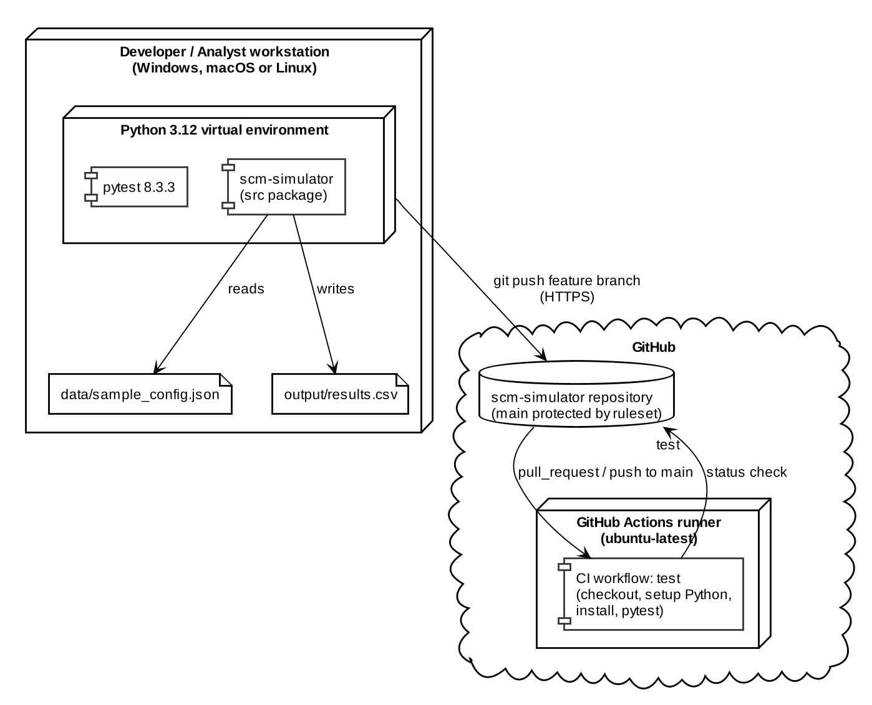
Figure 3: Deployment and delivery view

3.7 Risks & Mitigations
Table 14: Architecture risks
ID | Risk | Likelihood | Impact | Mitigation
R-1 | Integration defects when the engine composes all modules late in development | Medium | High | Interfaces fixed in Section 4.3; engine merged last; integration tests TC-SIM-01 to 06
R-2 | Merge conflicts between four developers | Medium | Medium | Single owner per module; shared files frozen after setup
R-3 | Floating-point noise causes off-by-one results in rounded-up quantities | Medium | Medium | Round to 6 decimals before ceiling; known-value unit tests
R-4 | Non-reproducible results from unseeded randomness | Low | High | Single injected RNG (ADR-005); TC-DEM-03, TC-PO-13, TC-SIM-03
R-5 | Malformed or extreme configuration crashes or stalls the run | Medium | Medium | Schema and range validation, 1 MB size limit, 3650-day limit
R-6 | Required CI check never reported, blocking pull requests | Low | Medium | No path filters in the workflow; fixed check name test
R-7 | Simplified model reduces realism (single warehouse, no capacity limits) | High | Low | Scope agreed in the SRS; enhancements listed in Section 4.6

3.8 Traceability to Requirements
Table 15: Requirement to design element to test traceability
Req ID | Summary | Component (module) | Design element | Test cases
SCM-F-001 | Product model and validation | products.py | Product | TC-PRD-01 to 04
SCM-F-002 | Product catalog | products.py | ProductCatalog | TC-PRD-05 to 10
SCM-F-003 | Warehouse stock receive and ship | inventory.py | Warehouse | TC-INV-01 to 06
SCM-F-004 | Economic order quantity | inventory.py | economic_order_quantity | TC-INV-07 to 10
SCM-F-005 | Safety stock, reorder point, reorder check | inventory.py | safety_stock, reorder_point, Warehouse.needs_reorder | TC-INV-11 to 15
SCM-F-006 | Cost tracking | costs.py | CostTracker | TC-CST-01 to 04
SCM-F-010 | Supplier model and validation | suppliers.py | Supplier | TC-SUP-01 to 05
SCM-F-011 | Supplier registry | suppliers.py | SupplierRegistry | TC-SUP-06 to 09
SCM-F-012 | Supplier selection strategies | suppliers.py | select_supplier | TC-SUP-10 to 15
SCM-F-013 | Purchase order creation | purchase_orders.py | PurchaseOrder, create_purchase_order | TC-PO-01 to 05
SCM-F-014 | PO lifecycle and order book | purchase_orders.py | PurchaseOrder.advance, PurchaseOrderBook | TC-PO-06 to 10
SCM-F-015 | Supplier delivery delays | purchase_orders.py | apply_random_delay | TC-PO-11 to 14
SCM-F-020 | Demand generation | demand.py | DemandGenerator | TC-DEM-01 to 05
SCM-F-021 | Customer order model | orders.py | CustomerOrder | TC-ORD-05 to 09
SCM-F-022 | Customer order book | orders.py | OrderBook | TC-ORD-10 to 13
SCM-F-023 | FIFO allocation and backorders | orders.py | OrderBook.allocate, OrderBook.backorder_qty | TC-ORD-14 to 17
SCM-F-024 | Moving average forecast and variability | forecasting.py | moving_average, demand_std | TC-FC-01 to 05
SCM-F-025 | Exponential smoothing and error metrics | forecasting.py | exponential_smoothing, mean_absolute_error, mean_absolute_percentage_error | TC-FC-06 to 10
SCM-F-030 | Simulation clock and event log | clock.py | SimulationClock, EventLog | TC-CLK-01 to 05
SCM-F-031 | Configuration loading and validation | config_loader.py | load_config, validate_config | TC-CFG-01 to 06
SCM-F-032 | Shipments and transport cost | shipments.py | Shipment, ShipmentLog | TC-SHP-01 to 04
SCM-F-033 | KPI computation | kpis.py | compute_kpis and helpers | TC-KPI-01 to 05
SCM-F-034 | CSV export and summary | reports.py | export_daily_csv, format_summary | TC-RPT-01 to 05
SCM-F-035 | Simulation engine and CLI | simulation.py, main.py | run_simulation, SimulationResult, main | TC-SIM-01 to 06
SCM-NF-001 | Performance | simulation.py | Linear daily loop, in-memory state | TC-NFR-01
SCM-NF-002 | Reproducibility | simulation.py, demand.py, purchase_orders.py | Injected seeded RNG (ADR-005) | TC-NFR-02, TC-SIM-03
SCM-NF-003 | Maintainability and test coverage | tests/, ci.yml | Unit tests per module, CI on every change | CI run history
SCM-NF-004 | Usability of CLI and errors | main.py | argparse help, one-line errors, exit codes | TC-SIM-06
SCM-NF-005 | Portability | All modules | Standard library only (ADR-003) | TC-NFR-03
SCM-SR-001 | Configuration validation | config_loader.py | validate_config | TC-CFG-02 to 06
SCM-SR-002 | Input size and run length limits | config_loader.py | MAX_CONFIG_BYTES, MAX_DAYS | TC-CFG-06
SCM-SR-003 | CSV formula injection protection | reports.py | Cell sanitisation in export_daily_csv | TC-RPT-03, TC-RPT-04
SCM-SR-004 | Protected main branch | Repository settings | Ruleset protect-main | Ruleset inspection; direct push rejected
SCM-SR-005 | Pinned dependencies, no secrets committed | requirements.txt, .gitignore | Exact version pins; ignore rules | Pull request review

3.9 Security Architecture
The simulator processes no personal data, stores no credentials and exposes no network service at runtime, so its attack surface is small. The relevant assets are the integrity of the source code and delivery pipeline, the integrity of the scenario configuration, and the safety of the exported results for the person who opens them.
Table 16: Trust boundaries
ID | Boundary | Data crossing | Control point
TB-1 | Configuration file to Config Loader | Untrusted JSON supplied by the user | load_config, validate_config
TB-2 | CSV output to spreadsheet application | Simulation results containing configuration-derived strings | export_daily_csv
TB-3 | Developer workstation to shared repository | Source code changes | Pull request, review, CI, branch ruleset

Table 17: Threat model (STRIDE)
Threat | Scenario | Boundary | Control | Req ID
Spoofing | A non-member pushes code or impersonates a team member | TB-3 | Only invited collaborators can push; every change needs another member's approval | SCM-SR-004
Tampering | Configuration edited with invalid or inconsistent values; direct edits to main | TB-1, TB-3 | Schema, range and reference validation; protected main with required CI | SCM-SR-001, SCM-SR-004
Repudiation | A change or simulation outcome cannot be attributed | TB-3 | Git history, pull request reviews, CI logs; EventLog for each run | SCM-SR-004
Information disclosure | Secrets or local environment files committed | TB-3 | .gitignore for environment files; review checklist | SCM-SR-005
Denial of service | Oversized file or excessive run length exhausts resources | TB-1 | 1 MB file limit; maximum 3650 days | SCM-SR-002
Elevation of privilege | A CSV cell executes as a spreadsheet formula; a member bypasses review | TB-2, TB-3 | Prefix cells starting with =, +, - or @; empty ruleset bypass list | SCM-SR-003, SCM-SR-004

4. Design

4.1 Design Overview
Design principles.
- One responsibility per module; each module has a single owner.
- Dependencies point downward only; Domain modules never import the engine, the CLI or each other except where shown in Figure 1.
- The Simulation Engine is the only orchestrator; all business rules live in Domain modules.
- Input is validated at the boundary (fail fast); invalid values inside the Domain raise exceptions rather than being silently corrected.
- All randomness comes from one seeded RNG passed in by the engine; products are processed in ascending product_id order. Together these make runs reproducible.
- File and console I/O occur only in config_loader.py, reports.py and main.py.
Processing model. Each simulated day the engine performs the following steps:
- Receive purchase orders due on or before the day: add stock, mark the order DELIVERED, record transport cost and log PO_RECEIVED.
- For each product in catalog order: generate demand and create a customer order (Figure 7).
- Allocate available stock to open customer orders oldest first, ship the allocated units, and record holding and stockout cost (Figure 7).
- Forecast demand, select a supplier, compute safety stock and reorder point, and if stock plus open orders is at or below the reorder point, place a purchase order sized by EOQ and apply a possible delivery delay (Figure 6).
- Append the daily record for the product, then advance the clock.
After the final day, the engine computes KPIs from the daily records, adds the forecast error, and returns the cost breakdown, KPIs, records and event log as a SimulationResult.
Table 18: Core formulas
Quantity | Formula | Component
Economic order quantity | EOQ = ceil( sqrt( 2 x D x S / H ) ); D = annual demand, S = order cost, H = annual holding cost per unit | inventory.py
Safety stock | SS = ceil( z x sigma_d x sqrt(L) ); sigma_d = daily demand standard deviation, L = lead time in days | inventory.py
Reorder point | ROP = ceil( d x L + SS ); d = forecast daily demand | inventory.py
Reorder condition | stock + on_order <= ROP | inventory.py
Balanced supplier score | 0.5 x (price / max price) + 0.3 x (lead time / max lead time) + 0.2 x (1 - reliability); lowest wins | suppliers.py
Exponential smoothing | F(t+1) = alpha x A(t) + (1 - alpha) x F(t), with F(1) = A(1) | forecasting.py
Holding / stockout cost per day | stock_end x holding_cost_per_day; backorder x stockout_penalty | costs.py
Transport cost | distance_km x quantity x cost_per_unit_km(mode) | shipments.py
Fill rate | total shipped / total demand | kpis.py
Service level | 1 - (product-days with backorder > 0) / (product-days) | kpis.py
Inventory turnover | COGS / average inventory value | kpis.py

Object lifecycles. Figure 4 shows the permitted state transitions for purchase orders and customer orders. Any transition not shown raises an error.
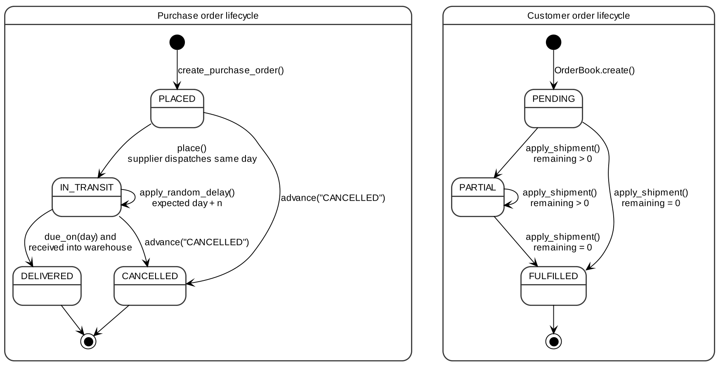
Figure 4: State diagrams for purchase orders and customer orders

4.2 UML Sequence Diagrams
Three sequence diagrams describe the main runtime flows. Figure 5 shows the end-to-end run, including a complete simulated day; it references Figures 6 and 7 for the per-product steps. Figure 6 shows the replenishment decision and purchase order placement. Figure 7 shows demand capture and order fulfilment with backorders.
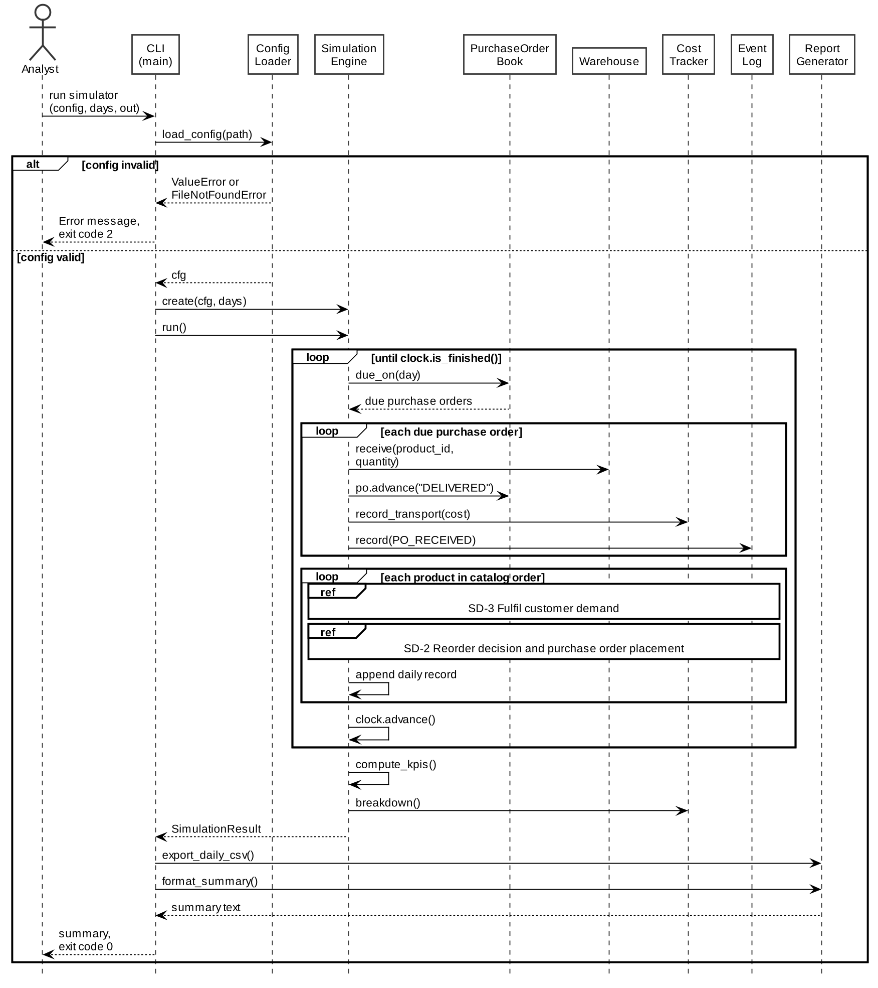
Figure 5: SD-1 Run simulation and process one day
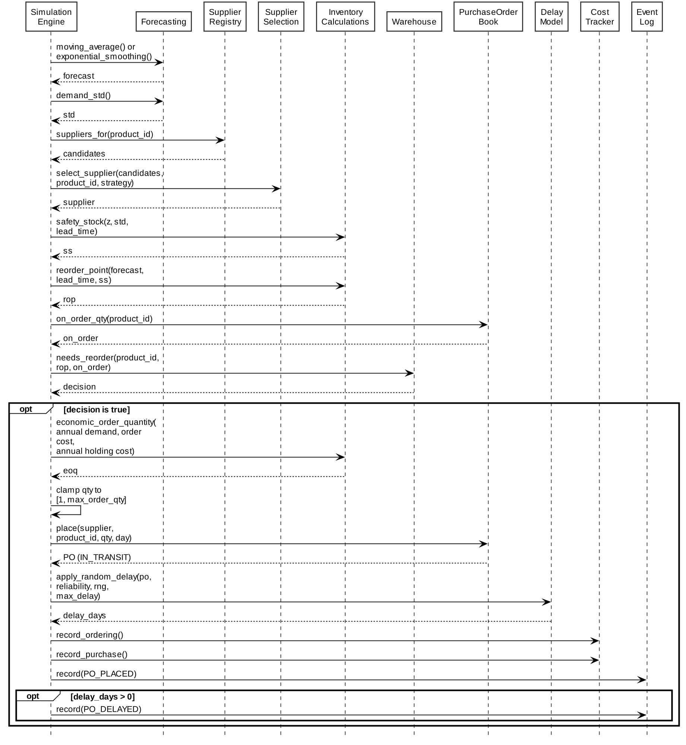
Figure 6: SD-2 Reorder decision and purchase order placement
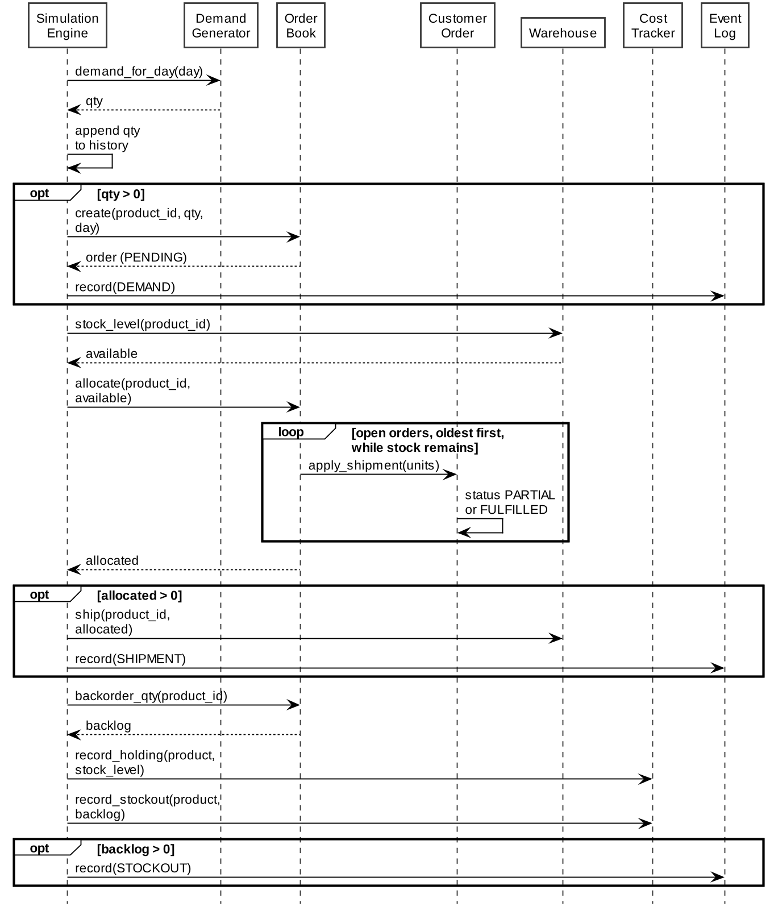
Figure 7: SD-3 Fulfil customer demand with backorders

4.3 API Design
The simulator exposes one external interface (the command line) and a set of internal component interfaces. Internal interfaces are Python callables; their contracts below are binding for all modules. Errors are raised as Python exceptions.

4.3.1 Command-line interface (external)
Table 19: CLI contract
Item | Definition
Command | python -m src.main [--config PATH] [--days N] [--out PATH]
--config | Scenario file. Default: data/sample_config.json
--days | Overrides simulation.days. Integer from 1 to 3650
--out | CSV output path; parent folders are created. Default: output/results.csv
--help | Prints usage and exits with code 0
Response | Summary printed to standard output; CSV written to --out
Exit codes | 0 success; 2 invalid input (missing or invalid configuration, invalid arguments); 1 unexpected internal error
Error output | One line on standard error, prefixed with Error:, no stack trace

4.3.2 Inventory component (inventory.py)
Table 20: Inventory interface
Operation | Input | Output | Errors
Warehouse(warehouse_id, name, initial_stock) | IDs as strings; initial_stock as product_id to units | Warehouse instance | ValueError: negative initial stock
Warehouse.receive(product_id, qty) | qty: positive int | None; stock increases by qty | ValueError: qty not positive
Warehouse.ship(product_id, qty) | qty: positive int | int: units shipped = min(qty, stock) | ValueError: qty not positive
Warehouse.stock_level(product_id) | product_id | int: current stock, 0 if never stocked | None
Warehouse.needs_reorder(product_id, reorder_point, on_order) | Non-negative ints | bool: stock + on_order <= reorder_point | ValueError: negative input
economic_order_quantity(annual_demand, order_cost, annual_holding_cost_per_unit) | Non-negative floats; holding cost > 0 | int: EOQ rounded up; 0 if demand is 0 | ValueError: holding cost <= 0 or negative input
safety_stock(z, demand_std_per_day, lead_time_days) | Non-negative numbers | int: safety stock rounded up | ValueError: negative input
reorder_point(avg_daily_demand, lead_time_days, safety_stock_units) | Non-negative numbers | int: reorder point rounded up | ValueError: negative input

4.3.3 Procurement component (suppliers.py, purchase_orders.py)
Table 21: Procurement interface
Operation | Input | Output | Errors
SupplierRegistry.suppliers_for(product_id) | product_id | list[Supplier] sorted by supplier_id; empty if none | None
select_supplier(candidates, product_id, strategy, weights) | strategy: cheapest, fastest or balanced | Supplier with the best value; ties to lower supplier_id | ValueError: no supplier for product or unknown strategy
PurchaseOrderBook.place(supplier, product_id, quantity, order_day) | 1 <= quantity <= supplier.max_order_qty | PurchaseOrder with next ID (PO-0001, ...), status IN_TRANSIT, expected_delivery_day = order_day + lead time | ValueError: quantity out of range or product not supplied
PurchaseOrderBook.due_on(day) | day: int | Open orders with expected_delivery_day <= day, sorted by po_id | None
PurchaseOrderBook.on_order_qty(product_id) | product_id | int: units on PLACED and IN_TRANSIT orders | None
PurchaseOrder.advance(new_status) | Target status | None; status updated | ValueError: transition not permitted (Figure 4)
apply_random_delay(order, reliability, rng, max_delay_days) | 0 <= reliability <= 1; max_delay_days >= 1 | int: delay in days (0 if on time); expected_delivery_day updated | ValueError: invalid input or closed order

4.3.4 Order management component (orders.py)
Table 22: Order management interface
Operation | Input | Output | Errors
OrderBook.create(product_id, quantity, day) | quantity >= 1 | CustomerOrder with next ID (CO-0001, ...), status PENDING | ValueError: quantity < 1
OrderBook.open_orders(product_id) | product_id | PENDING and PARTIAL orders, oldest first | None
OrderBook.allocate(product_id, available_qty) | available_qty >= 0 | int: units allocated, oldest orders first | ValueError: negative quantity
OrderBook.backorder_qty(product_id) | product_id | int: units still owed on open orders | None
CustomerOrder(order_id, product_id, quantity, day, fulfilled_qty, status) | quantity >= 1; day >= 0; 0 <= fulfilled_qty <= quantity; status matching fulfilled_qty | CustomerOrder instance | ValueError: any field invalid or inconsistent
CustomerOrder.apply_shipment(qty) | 1 <= qty <= remaining | None; status PARTIAL or FULFILLED | ValueError: qty out of range

4.3.5 Configuration component (config_loader.py)
Table 23: Configuration interface
Operation | Input | Output | Errors
load_config(path) | Path to a JSON file of at most 1 MB | dict: validated configuration | FileNotFoundError: missing file; ValueError: oversized file, invalid JSON or failed validation
validate_config(cfg) | dict | None | ValueError naming the first failing section or field

4.4 Error Handling, Logging & Monitoring
Error handling policy. Components validate their inputs and raise standard exceptions; they do not print, log or exit. The CLI is the single place where exceptions are converted into user-facing messages and exit codes.
Table 24: Exception handling
Exception | Raised when | Raised by | Handling in the CLI
FileNotFoundError | Configuration file does not exist | config_loader.py | Print Error: message; exit code 2
ValueError | Invalid configuration, argument or domain value; invalid state transition | All components | Print Error: message; exit code 2
KeyError | Unknown product, supplier or order identifier | Catalogues and order books | Indicates a defect when raised during a run; exit code 1
RuntimeError | Clock advanced beyond the final day | clock.py | Indicates a defect; exit code 1
Any other exception | Unexpected failure | Any | Print Error: unexpected failure with the exception message; exit code 1

Logging. Each run records structured events in an in-memory EventLog, returned in the SimulationResult as a list of event records. Domain modules do not write to the console. No sensitive data exists in the system, so no masking is required.
Table 25: Event types
Event type | Emitted when | Message content
DEMAND | A customer order is created | Product, quantity, order ID
SHIPMENT | Units are shipped to customers | Product, units shipped
STOCKOUT | Backorder remains at end of day | Product, backorder units
PO_PLACED | A purchase order is placed | PO ID, supplier, product, quantity, expected delivery day
PO_DELAYED | A delay is applied to a new purchase order | PO ID, delay in days, new expected delivery day
PO_RECEIVED | A purchase order is delivered | PO ID, product, quantity, transport cost

Monitoring. Code health is monitored by the CI workflow on every pull request and every push to main; the GitHub Actions history provides the audit trail. A failing build on main suspends further merges until it is fixed. Run-level health is reported through the KPIs (fill rate, service level, inventory turnover, forecast error) and the event counts.

4.5 UX Design
The user interacts through a terminal. Design choices:
- A single command with sensible defaults; the simulator runs with no options at all.
- Plain text output that does not rely on colour, so it works in any terminal and with screen readers.
- Units shown explicitly: costs as Rs with two decimals, rates as percentages with two decimals.
- Errors on one line prefixed with Error:, naming the field or file at fault, with no stack trace.
- Results also exported to CSV for analysis and charting in a spreadsheet.
Table 26: Console summary layout
Block | Content
Run | Configuration file, number of days, seed, forecast method, supplier strategy
Costs | Holding, stockout, ordering, purchase, transport and total cost (Rs, 2 decimals)
Service | Fill rate and service level (percent, 2 decimals); backorder units at end of run
Inventory | Average inventory units and inventory turnover
Forecast | Mean absolute error of the daily forecast
Activity | Counts of purchase orders placed, delayed and received; stockout product-days
Output | Path of the CSV file written

4.6 Open Issues & Next Steps
Table 27: Open issues and planned enhancements
ID | Item | Type | Next step
OI-1 | Only one warehouse is modelled | Limitation | Introduce a network of warehouses with transfer orders
OI-2 | Unmet demand is always backordered (ADR-006) | Limitation | Add a configurable lost-sales policy
OI-3 | Supplier capacity is limited per order, not per period | Limitation | Add per-period supplier capacity
OI-4 | A single run gives one sample path of a stochastic process | Enhancement | Monte Carlo mode: repeat runs with different seeds and report confidence intervals
OI-5 | Results are viewed as text and CSV only | Enhancement | Optional dashboard over the CSV output
OI-6 | Policy comparison requires separate runs | Enhancement | Batch mode that compares strategies and forecasting methods side by side

5. Appendices

5.1 Glossary
Table 28: Glossary
Term | Meaning
Backorder | Customer demand accepted but not yet shipped because of insufficient stock
Fill rate | Share of demanded units that were shipped
Holding cost | Cost of keeping one unit in stock for one day
Lead time | Days between placing a purchase order and its expected delivery
Reorder point | Stock level at or below which a replenishment order is placed
Safety stock | Extra stock held to absorb variation in demand during the lead time
Service level | Share of product-days without outstanding backorders
Stockout penalty | Cost charged per backordered unit per day
Inventory turnover | Cost of goods sold divided by average inventory value
Reliability | Probability that a supplier delivers on the expected day
Ruleset | GitHub configuration that enforces conditions before changes reach a branch

5.2 References
- ISO/IEC/IEEE 42010:2022, Software, systems and enterprise: Architecture description. https://www.iso.org/standard/74393.html
- IEEE 1016-2009, IEEE Standard for Information Technology: Systems Design, Software Design Descriptions. https://standards.ieee.org/ieee/1016/4502/
- NIST SP 800-160 Vol. 1 Rev. 1, Engineering Trustworthy Secure Systems. https://csrc.nist.gov/pubs/sp/800/160/v1/r1/final
- Microsoft, Threat Modeling Tool threats (STRIDE categories). https://learn.microsoft.com/en-us/azure/security/develop/threat-modeling-tool-threats
- OWASP, CSV Injection. https://owasp.org/www-community/attacks/CSV_Injection
- Harris, F. W., How Many Parts to Make at Once, reprinted in Operations Research 38(6):947 to 950, 1990. https://doi.org/10.1287/opre.38.6.947
- Hyndman, R. J. and Athanasopoulos, G., Forecasting: Principles and Practice, 3rd edition. https://otexts.com/fpp3/
- GitHub Docs, About rulesets. https://docs.github.com/en/repositories/configuring-branches-and-merges-in-your-repository/managing-rulesets/about-rulesets
- GitHub Docs, GitHub Actions documentation. https://docs.github.com/en/actions
- Python Software Foundation, The Python Standard Library (3.12). https://docs.python.org/3.12/library/

5.3 Tools
Table 29: Tools
Tool | Use
PlantUML | Component, class, deployment, state and sequence diagrams
Visual Studio Code | Development environment
Git and GitHub | Version control, pull requests, code review, branch rulesets
GitHub Actions | Continuous integration
pytest | Unit and integration testing
Python venv | Isolated runtime environment

