**Spring Core and Maven**

**Exercise 1:** Configuring a Basic Spring Application

**Code:**

**BookRepository.java:**

public class BookRepository {

public String getBookDetails() {

return "Spring in Action - Craig Walls";

}

}

**BookService.java:**

public class BookService {

private BookRepository bookRepository;

public void setBookRepository(BookRepository bookRepository) {

this.bookRepository = bookRepository;

}

public void displayBook() {

System.out.println("Book: " + bookRepository.getBookDetails());

}

}

**applicationContext.xml:**

<?xml version="1.0" encoding="UTF-8"?>

<beans xmlns="http://www.springframework.org/schema/beans"

xmlns:xsi="http://www.w3.org/2001/XMLSchema-instance"

xsi:schemaLocation="http://www.springframework.org/schema/beans

http://www.springframework.org/schema/beans/spring-beans.xsd">

<bean id="bookRepository" class="BookRepository"/>

<bean id="bookService" class="BookService">

<property name="bookRepository" ref="bookRepository"/>

</bean>

</beans>

**MainApp.java:**

import org.springframework.context.ApplicationContext;

import org.springframework.context.support.ClassPathXmlApplicationContext;

public class MainApp {

public static void main(String[] args) {

ApplicationContext context = new ClassPathXmlApplicationContext("applicationContext.xml");

BookService service = (BookService) context.getBean("bookService");

service.displayBook();

}

}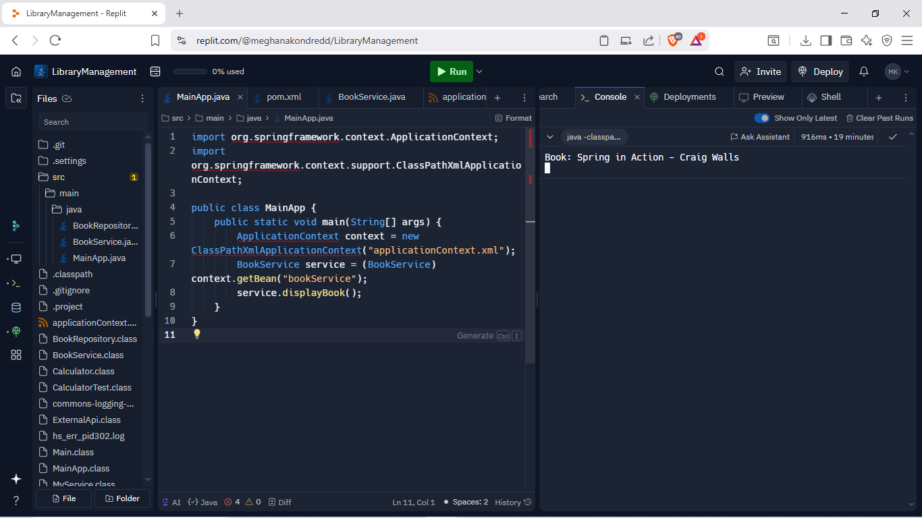

**Output:**

**Exercise 2:** Implementing Dependency Injection

**Code:**

**applicationContext.xml:**

<beans xmlns="http://www.springframework.org/schema/beans"

xmlns:xsi="http://www.w3.org/2001/XMLSchema-instance"

xsi:schemaLocation="http://www.springframework.org/schema/beans

http://www.springframework.org/schema/beans/spring-beans.xsd">

<bean id="bookRepository" class="com.library.repository.BookRepository" />

<bean id="bookService" class="com.library.service.BookService">

<property name="bookRepository" ref="bookRepository" />

</bean>

</beans>

**Pom.xml:**

<project xmlns="http://maven.apache.org/POM/4.0.0"

xmlns:xsi="http://www.w3.org/2001/XMLSchema-instance"

xsi:schemaLocation="http://maven.apache.org/POM/4.0.0

http://maven.apache.org/xsd/maven-4.0.0.xsd">

<modelVersion>4.0.0</modelVersion>

<groupId>com.library</groupId>

<artifactId>LibraryManagement</artifactId>

<version>1.0-SNAPSHOT</version>

<properties>

<maven.compiler.source>11</maven.compiler.source>

<maven.compiler.target>11</maven.compiler.target>

</properties>

<dependencies>

<dependency>

<groupId>org.springframework</groupId>

<artifactId>spring-context</artifactId>

<version>5.3.32</version>

</dependency>

</dependencies>

<build>

<plugins>

<plugin>

<groupId>org.codehaus.mojo</groupId>

<artifactId>exec-maven-plugin</artifactId>

<version>3.1.0</version>

<configuration>

<mainClass>com.library.LibraryManagementApplication</mainClass>

</configuration>

</plugin>

</plugins>

</build>

</project>

**BookRepository.java:**

package com.library.repository;

public class BookRepository {

public void saveBook(String bookName) {

System.out.println("Book saved: " + bookName);

}

}

**BookService.java:**

package com.library.service;

import com.library.repository.BookRepository;

public class BookService {

private BookRepository bookRepository;

public void setBookRepository(BookRepository bookRepository) {

this.bookRepository = bookRepository;

}

public void addBook(String bookName) {

bookRepository.saveBook(bookName);

}

}

**LibraryManagementApplication.java:**

package com.library;

import org.springframework.context.ApplicationContext;

import org.springframework.context.support.ClassPathXmlApplicationContext;

import com.library.service.BookService;

public class LibraryManagementApplication {

public static void main(String[] args) {

ApplicationContext context = new ClassPathXmlApplicationContext("applicationContext.xml");

BookService service = (BookService) context.getBean("bookService");

service.addBook("Clean Code by Robert C. Martin");

}

}

**Output:**

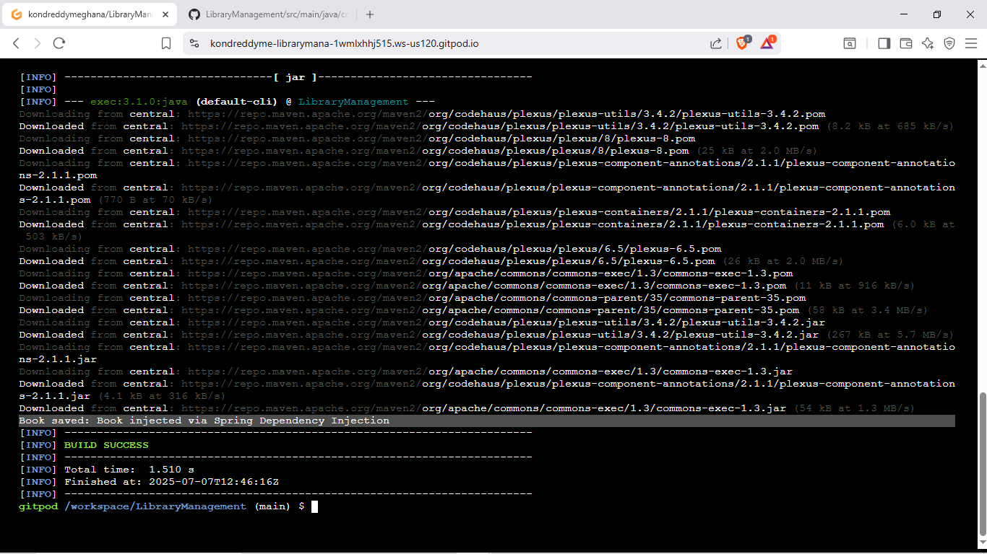

**Exercise 4:** Creating and Configuring a Maven Project

**Code:**

**Pom.xml:**

<project xmlns="http://maven.apache.org/POM/4.0.0"

xmlns:xsi="http://www.w3.org/2001/XMLSchema-instance"

xsi:schemaLocation="http://maven.apache.org/POM/4.0.0

http://maven.apache.org/xsd/maven-4.0.0.xsd">

<modelVersion>4.0.0</modelVersion>

<groupId>com.library</groupId>

<artifactId>LibraryManagementWithSpring</artifactId>

<version>1.0-SNAPSHOT</version>

<properties>

<maven.compiler.source>1.8</maven.compiler.source>

<maven.compiler.target>1.8</maven.compiler.target>

</properties>

<dependencies>

<dependency>

<groupId>org.springframework</groupId>

<artifactId>spring-context</artifactId>

<version>5.3.32</version>

</dependency>

<dependency>

<groupId>org.springframework</groupId>

<artifactId>spring-aop</artifactId>

<version>5.3.32</version>

</dependency>

<dependency>

<groupId>org.springframework</groupId>

<artifactId>spring-webmvc</artifactId>

<version>5.3.32</version>

</dependency>

</dependencies>

<build>

<plugins>

<plugin>

<artifactId>maven-compiler-plugin</artifactId>

<version>3.8.1</version>

<configuration>

<source>1.8</source>

<target>1.8</target>

</configuration>

</plugin>

</plugins>

</build>

</project>

**App.java:**

package com.library;

public class App {

public static void main(String[] args) {

System.out.println("Maven project with Spring dependencies created successfully!");

}

}

**applicationContext.xml:**

<beans xmlns="http://www.springframework.org/schema/beans"

xmlns:xsi="http://www.w3.org/2001/XMLSchema-instance"

xsi:schemaLocation="

http://www.springframework.org/schema/beans

http://www.springframework.org/schema/beans/spring-beans.xsd">

</beans>

**Output:**

