**ReactJS-HOL**

**9.ReactJS-HOL**

**Code:**

**ListofPlayers.js:**

import React from "react";

function ListofPlayers({ players }) {

return (

<ul>

{players.map((p, index) => (

<li key={index}>{p.name} {p.score}</li>

))}

</ul>

);

}

export default ListofPlayers;

**Scorebelow70.js:**

import React from "react";

function Scorebelow70({ players }) {

const filtered = players.filter(p => p.score < 70);

return (

<ul>

{filtered.map((p, index) => (

<li key={index}>{p.name} {p.score}</li>

))}

</ul>

);

}

export default Scorebelow70;

**IndianTeam.js:**

import React from 'react';

const IndianPlayers = () => {

const T20players = ["Virat", "Rohit", "Gill"];

const RanjiTrophyPlayers = ["Pujara", "Rahane", "Shreyas"];

const mergedPlayers = [...T20players, ...RanjiTrophyPlayers];

const [oddTeam, evenTeam] = [

mergedPlayers.filter((_, i) => i % 2 === 1),

mergedPlayers.filter((_, i) => i % 2 === 0)

];

return (

<div>

<h2>Merged Players</h2>

<ul>

{mergedPlayers.map((player, index) => (

<li key={index}>{player}</li>

))}

</ul>

<h3>Odd Team Players</h3>

<ul>

{oddTeam.map((player, index) => (

<li key={index}>{player}</li>

))}

</ul>

<h3>Even Team Players</h3>

<ul>

{evenTeam.map((player, index) => (

<li key={index}>{player}</li>

))}

</ul>

</div>

);

};

export default IndianPlayers;

**Oddplayers.js:**

import React from "react";

function OddPlayers({ IndianTeam }) {

return (

<ul>

{IndianTeam.filter((_, i) => i % 2 === 0).map((player, index) => (

<li key={index}>{getPosition(index * 2)}: {player}</li>

))}

</ul>

);

}

function getPosition(index) {

return ["First", "Third", "Fifth", "Seventh", "Ninth"][index / 2] || `${index + 1}th`;

}

export default OddPlayers;

**EvenPlayers.js:**

import React from "react";

function EvenPlayers({ IndianTeam }) {

return (

<ul>

{IndianTeam.filter((_, i) => i % 2 === 1).map((player, index) => (

<li key={index}>{getPosition(index * 2 + 1)}: {player}</li>

))}

</ul>

);

}

function getPosition(index) {

return ["Second", "Fourth", "Sixth", "Eighth", "Tenth"][Math.floor(index / 2)] || `${index + 1}th`;

}

export default EvenPlayers;

**ListofIndianPlayers.js:**

import React from "react";

function ListofIndianPlayers({ IndianPlayers }) {

return (

<ul>

{IndianPlayers.map((p, index) => (

<li key={index}>{p}</li>

))}

</ul>

);

}

export default ListofIndianPlayers;

**App.js:**

import React from "react";

import ListofPlayers from "./ListofPlayers";

import Scorebelow70 from "./Scorebelow70";

import OddPlayers from "./OddPlayers";

import EvenPlayers from "./EvenPlayers";

import ListofIndianPlayers from "./ListofIndianPlayers";

function App() {

const flag = true;

const players = [

{ name: "Mr. Jack", score: 50 },

{ name: "Mr. Michael", score: 70 },

{ name: "Mr. John", score: 40 },

{ name: "Mr. Alin", score: 61 },

{ name: "Mr. Smith", score: 81 },

{ name: "Mr. Sachin", score: 95 },

{ name: "Mr. Dhoni", score: 60 },

{ name: "Mr. Virat", score: 80 },

{ name: "Mr. Jadeja", score: 64 },

{ name: "Mr. Raina", score: 75 },

{ name: "Mr. Rohit", score: 80 },

];

const IndianTeam = [

"Sachin1",

"Dhoni2",

"Virat3",

"Rohit4",

"Yuvraj5",

"Raina6"

];

const IndianPlayers = [

"Mr. First Player",

"Mr. Second Player",

"Mr. Third Player",

"Mr. Fourth Player",

"Mr. Fifth Player",

"Mr. Sixth Player"

];

if (flag === true) {

return (

<div>

<h1>List of Players</h1>

<ListofPlayers players={players} />

<h1>List of Players having Scores Less than 70</h1>

<Scorebelow70 players={players} />

</div>

);

} else {

return (

<div>

<h1>Odd Players</h1>

<OddPlayers IndianTeam={IndianTeam} />

<h1>Even Players</h1>

<EvenPlayers IndianTeam={IndianTeam} />

<h1>List of Indian Players Merged:</h1>

<ListofIndianPlayers IndianPlayers={IndianPlayers} />

</div>

);

}

}

export default App;

**Output:**

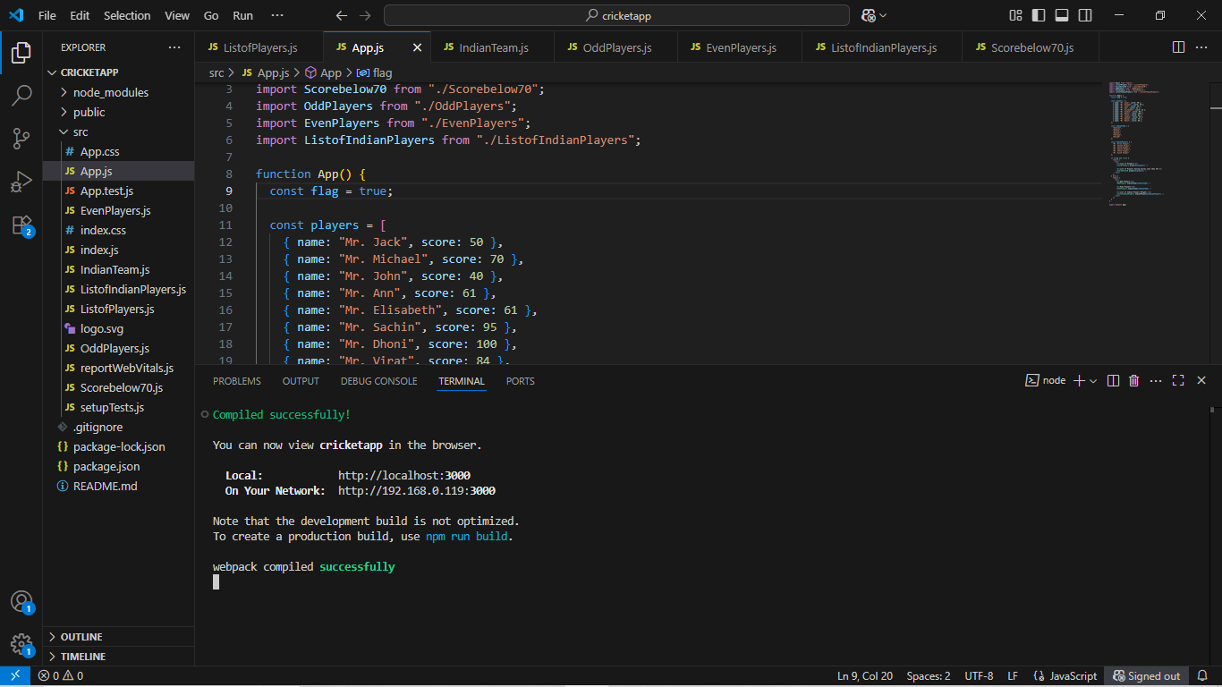

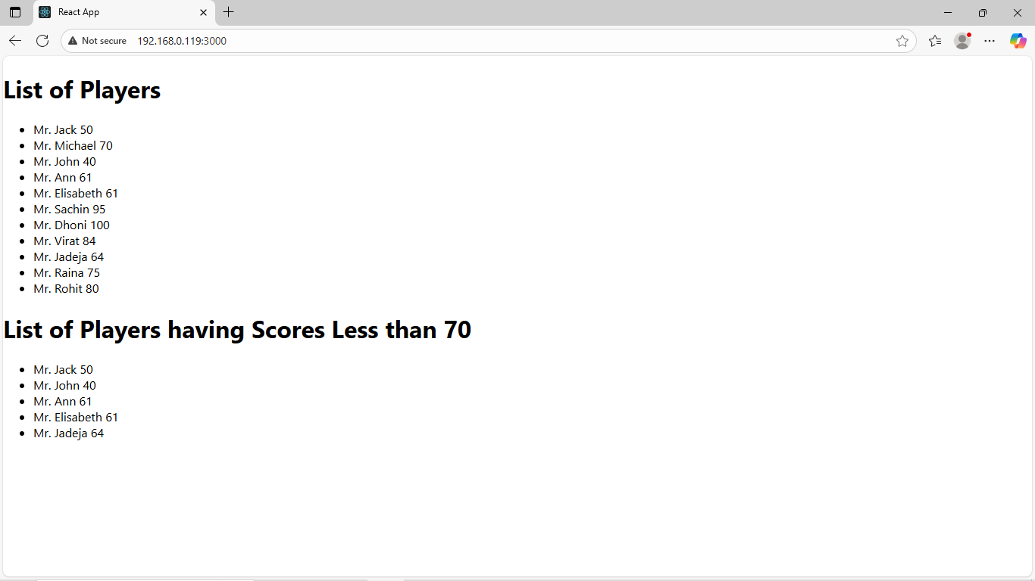

If const flag=false;

**Output:**

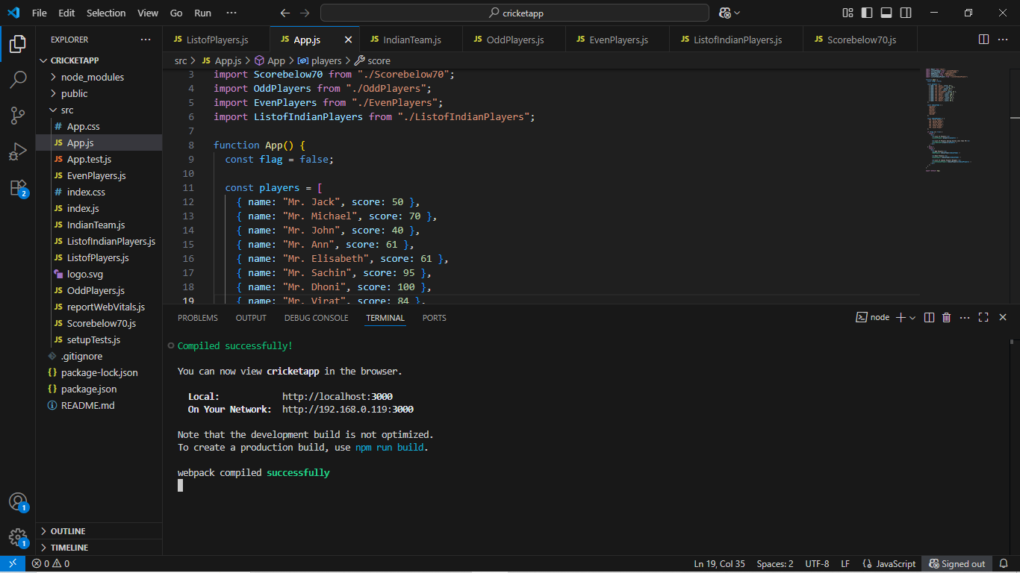

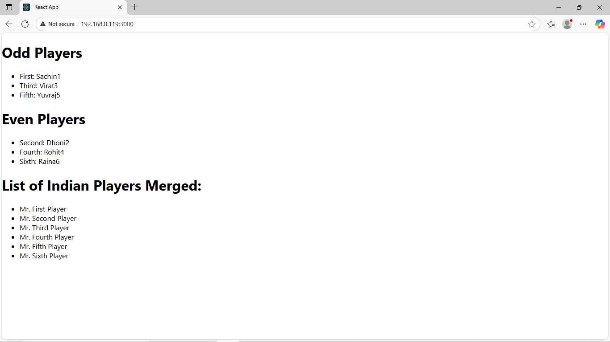

**10.ReatJS-HOL:**

**Code:**

**App.js:**

import React from 'react';

import off1 from './off1.png';

function App() {

const element = "Office Space";

const jsxatt = (

<img

src={off1}

alt="Office Space"

style={{

display: 'block',

margin: '20px auto',

width: '50%',

height: 'auto',

borderRadius: '10px'

}}

/>

);

const ItemName = {

Name: "DBS",

Rent: 50000,

Address: "Chennai"

};

let colors = [];

if (ItemName.Rent <= 60000) {

colors.push('textRed');

} else {

colors.push('textGreen');

}

const officeList = [

{ Name: "Regus", Rent: 40000, Address: "Madhapur" },

{ Name: "WeWork", Rent: 65000, Address: "Hitech City" },

{ Name: "91Springboard", Rent: 55000, Address: "Gachibowli" },

{ Name: "Cowrks", Rent: 72000, Address: "Jubilee Hills" }

];

return (

<div style={{ padding: '20px' }}>

<h1>{element}, at Affordable Range</h1>

{jsxatt}

<h1>Name: {ItemName.Name}</h1>

<h3>

Rent: <span className={colors[0]}>Rs. {ItemName.Rent}</span>

</h3>

<h3>Address: {ItemName.Address}</h3>

<hr />

<h2>Available Office Spaces:</h2>

<ul>

{officeList.map((item, index) => {

const rentColor = item.Rent <= 60000 ? 'textRed' : 'textGreen';

return (

<li key={index}>

<strong>{item.Name}</strong> -{" "}

<span className={rentColor}>₹{item.Rent}</span> - {item.Address}

</li>

);

})}

</ul>

</div>

);

}

export default App;

**Index.css:**

.textRed {

color: red;

}

.textGreen {

color: green;

}

**Output:**

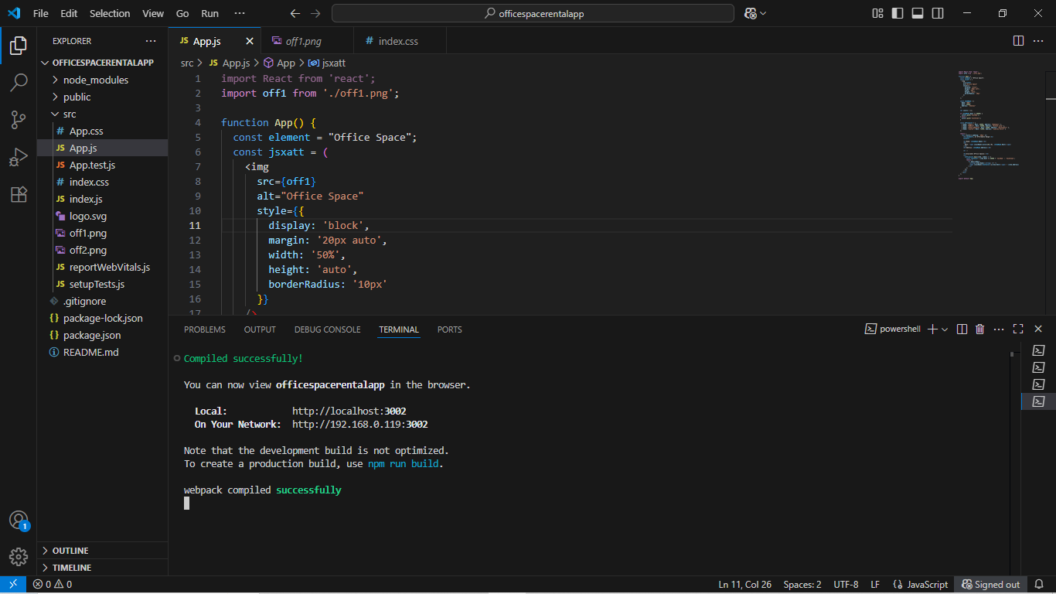

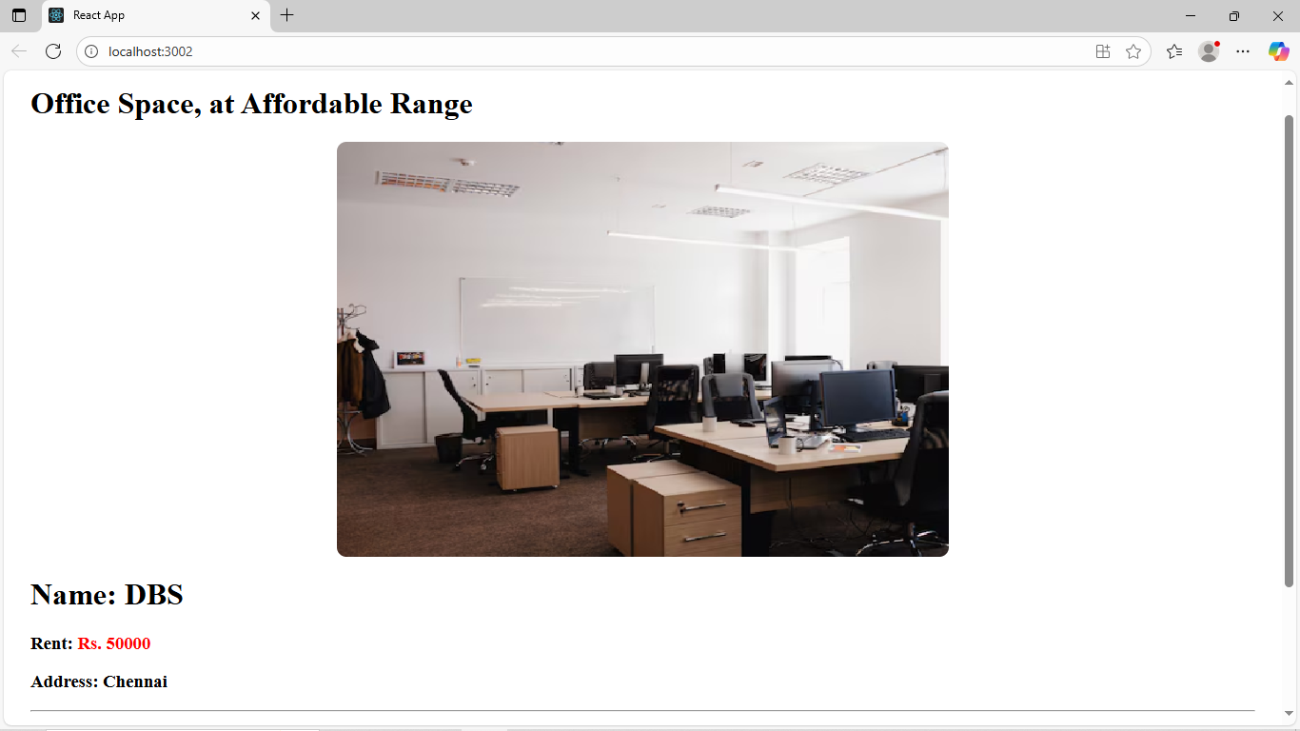

**11.ReactJS-HOL:**

**Code:**

**CurrencyConvertor.js:**

import React, { useState } from "react";

function CurrencyConvertor() {

const [amount, setAmount] = useState("");

const [currency, setCurrency] = useState("");

const handleSubmit = () => {

const rupees = parseFloat(amount);

if (isNaN(rupees)) {

alert("Please enter a valid amount");

return;

}

const euroRate = 0.011;

const euro = (rupees * euroRate).toFixed(2);

alert(`Converting to Euro Amount is ₹${euro}`);

};

return (

<div>

<h2 style={{ color: "green" }}>Currency Convertor!!!</h2>

<label>Amount:</label><br />

<input

type="text"

value={amount}

onChange={(e) => setAmount(e.target.value)}

/><br />

<label>Currency:</label><br />

<input

type="text"

value={currency}

onChange={(e) => setCurrency(e.target.value)}

/><br /><br />

<button onClick={handleSubmit}>Submit</button>

</div>

);

}

export default CurrencyConvertor;

**App.js:**

import React, { useState } from "react";

import CurrencyConvertor from "./CurrencyConvertor";

function App() {

const [count, setCount] = useState(0);

const incrementValue = () => {

setCount(prev => prev + 1);

};

const sayHello = () => {

alert("Hello Member1");

};

const handleIncrement = () => {

incrementValue();

sayHello();

};

const handleDecrement = () => {

setCount(prev => prev - 1);

};

const sayWelcome = (msg) => {

alert(msg);

};

const handleSyntheticClick = (e) => {

alert("i was clicked");

};

return (

<div style={{ padding: "20px", fontFamily: "Arial" }}>

<h1>{count}</h1>

<button onClick={handleIncrement}>Increment</button>

<br /><br />

<button onClick={handleDecrement}>Decrement</button>

<br /><br />

<button onClick={() => sayWelcome("welcome")}>Say welcome</button>

<br /><br />

<button onClick={handleSyntheticClick}>Click on me</button>

<br /><br />

<CurrencyConvertor />

</div>

);

}

export default App;

**Output:**

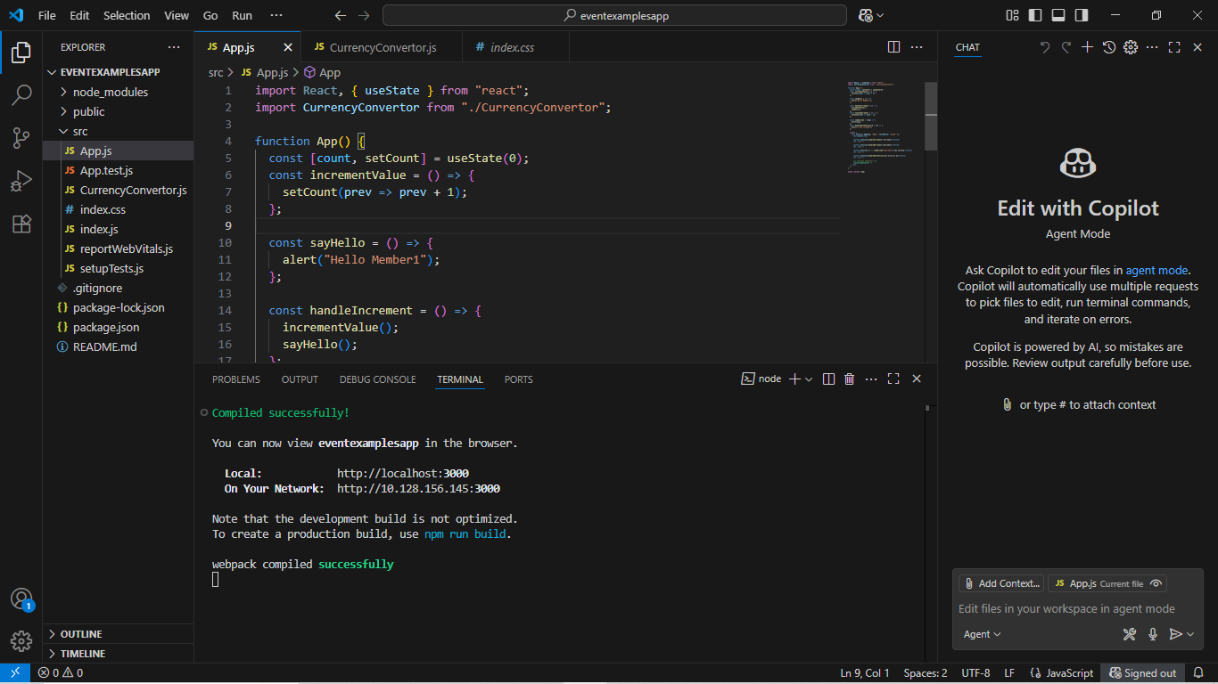

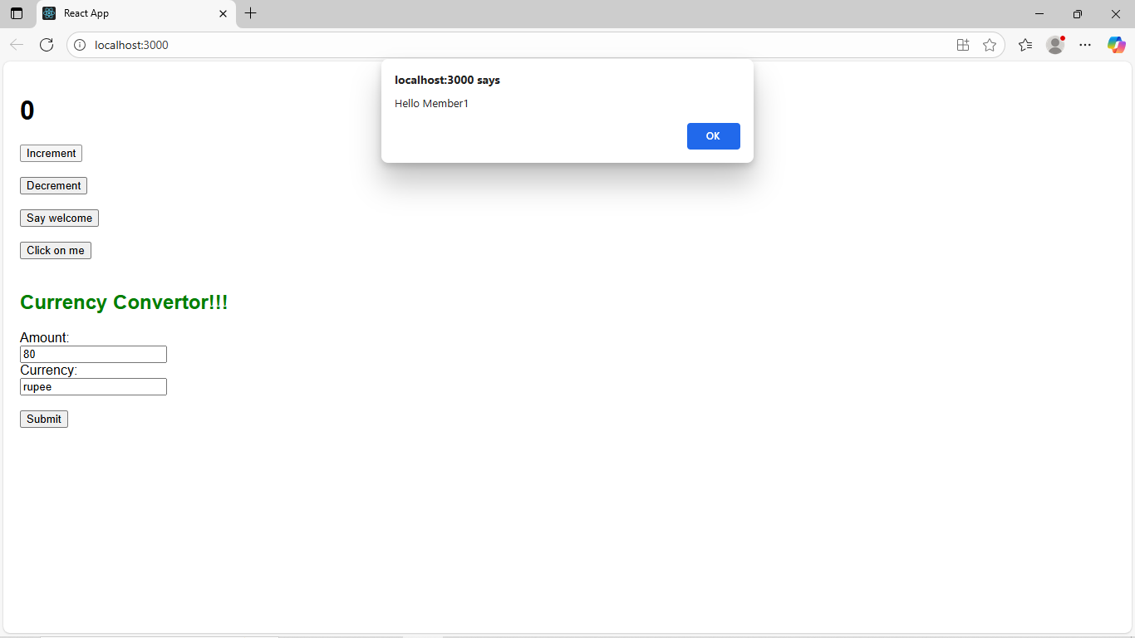

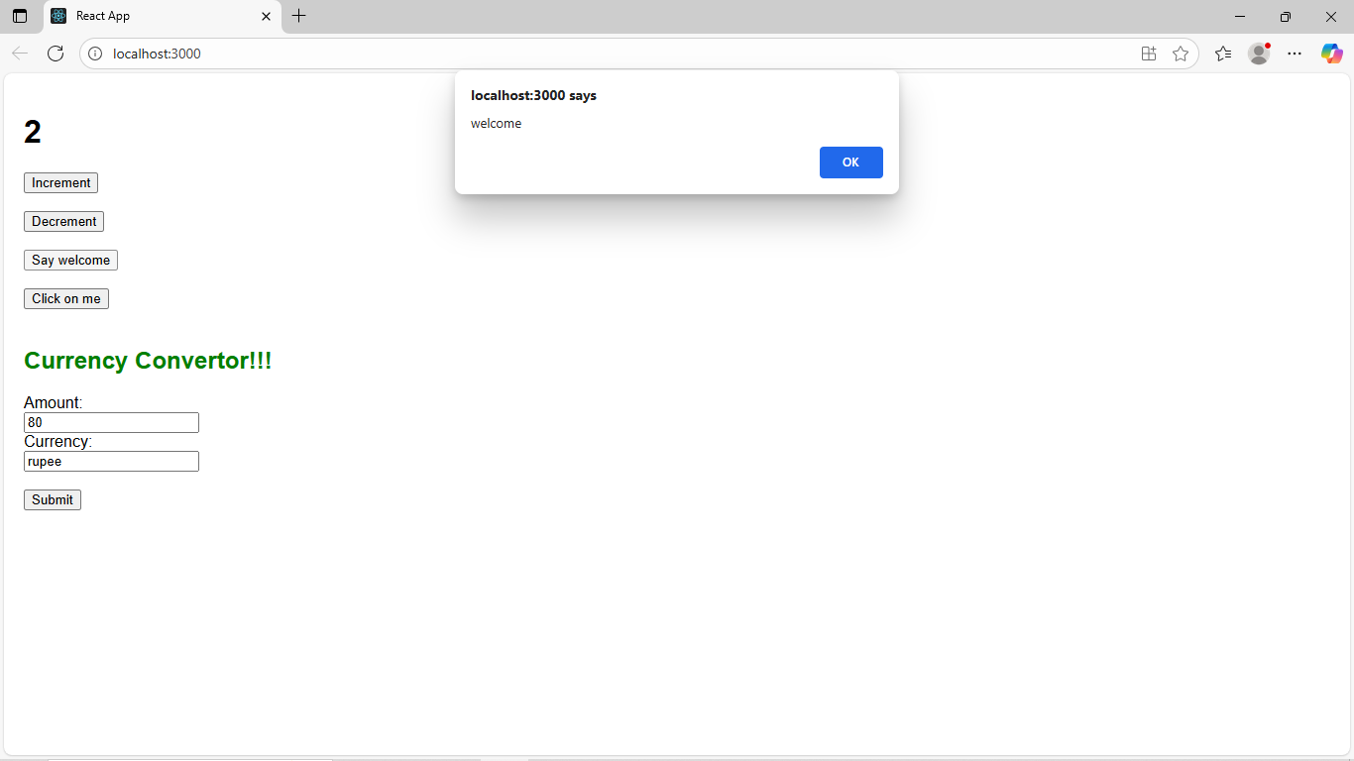

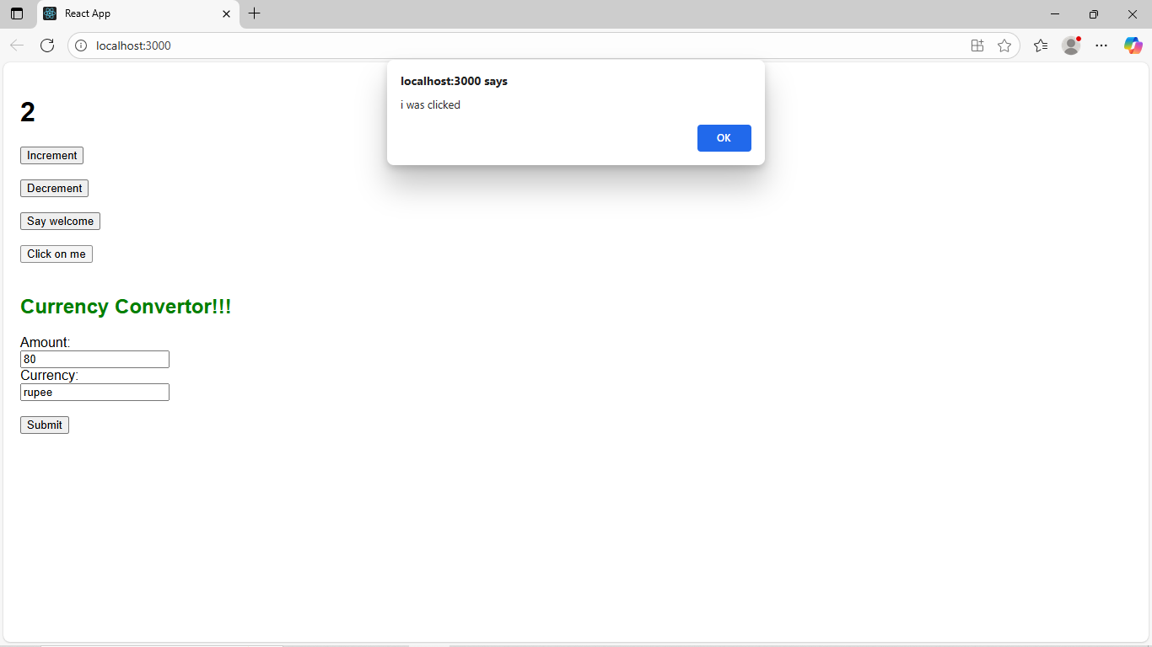

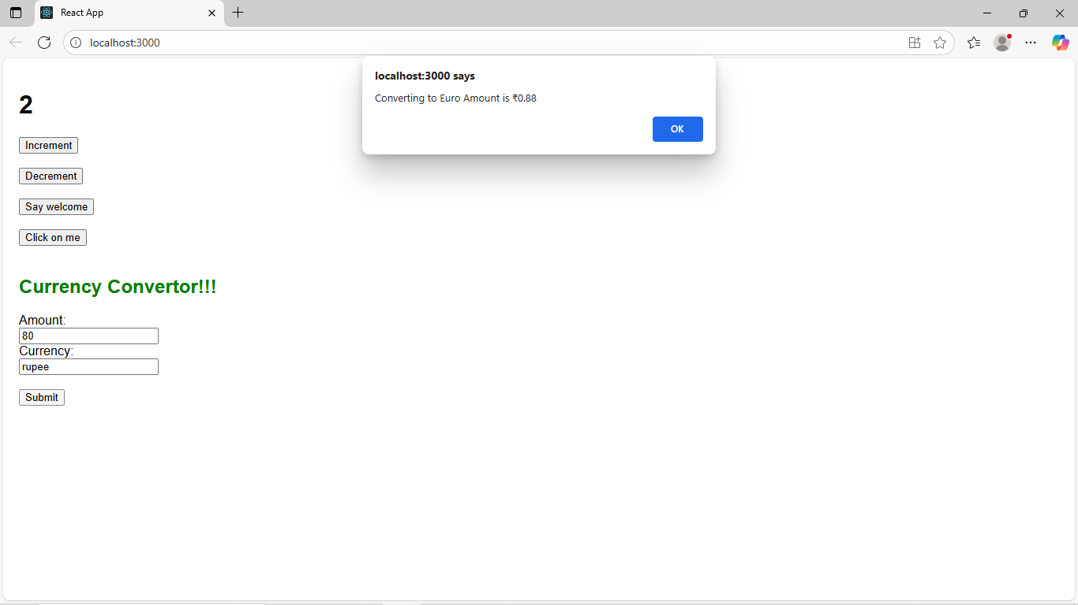

**12.ReactJS-HOL:**

**Code:**

**App.js:**

import React, { useState } from "react";

import Greeting from "./Greeting";

import LoginButton from "./LoginButton";

import LogoutButton from "./LogoutButton";

import GuestFlights from "./GuestFlights";

import BookFlights from "./BookFlights";

function App() {

const [isLoggedIn, setIsLoggedIn] = useState(false);

const handleLoginClick = () => {

setIsLoggedIn(true);

};

const handleLogoutClick = () => {

setIsLoggedIn(false);

};

return (

<div style={{ padding: "20px", fontFamily: "Arial" }}>

<Greeting isLoggedIn={isLoggedIn} />

{isLoggedIn ? (

<>

<LogoutButton onClick={handleLogoutClick} />

<BookFlights />

</>

) : (

<>

<LoginButton onClick={handleLoginClick} />

<GuestFlights />

</>

)}

</div>

);

}

export default App;

**Greeting.js:**

import React from "react";

import UserGreeting from "./UserGreeting";

import GuestGreeting from "./GuestGreeting";

function Greeting(props) {

const isLoggedIn = props.isLoggedIn;

if (isLoggedIn) {

return <UserGreeting />;

}

return <GuestGreeting />;

}

export default Greeting;

**GuestGreeting.js:**

import React from "react";

function GuestGreeting() {

return <h1>Please sign up.</h1>;

}

export default GuestGreeting;

**UserGreeting.js:**

import React from "react";

function UserGreeting() {

return <h1>Welcome back</h1>;

}

export default UserGreeting;

**LoginButton.js:**

import React from "react";

function LoginButton(props) {

return (

<button onClick={props.onClick}>

Login

</button>

);

}

export default LoginButton;

**LogoutButton.js:**

import React from "react";

function LogoutButton(props) {

return (

<button onClick={props.onClick}>

Logout

</button>

);

}

export default LogoutButton;

**GuestFlights.js:**

import React from "react";

function GuestFlights() {

return (

<div>

<h2>Available Flights</h2>

<ul>

<li>Hyderabad → Mumbai — ₹4,500</li>

<li>Bangalore → Delhi — ₹3,800</li>

<li>Chennai → Kolkata — ₹4,200</li>

</ul>

<p><i>Login to book these tickets.</i></p>

</div>

);

}

export default GuestFlights;

**BookFlights.js:**

import React from "react";

function BookFlights() {

return (

<div>

<h2>Book Your Flight</h2>

<ul>

<li>

Hyderabad → Mumbai — ₹4,500

<button style={{ marginLeft: "10px" }}>Book</button>

</li>

<li>

Bangalore → Delhi — ₹3,800

<button style={{ marginLeft: "10px" }}>Book</button>

</li>

<li>

Chennai → Kolkata — ₹4,200

<button style={{ marginLeft: "10px" }}>Book</button>

</li>

</ul>

</div>

);

}

export default BookFlights;

**Output:**

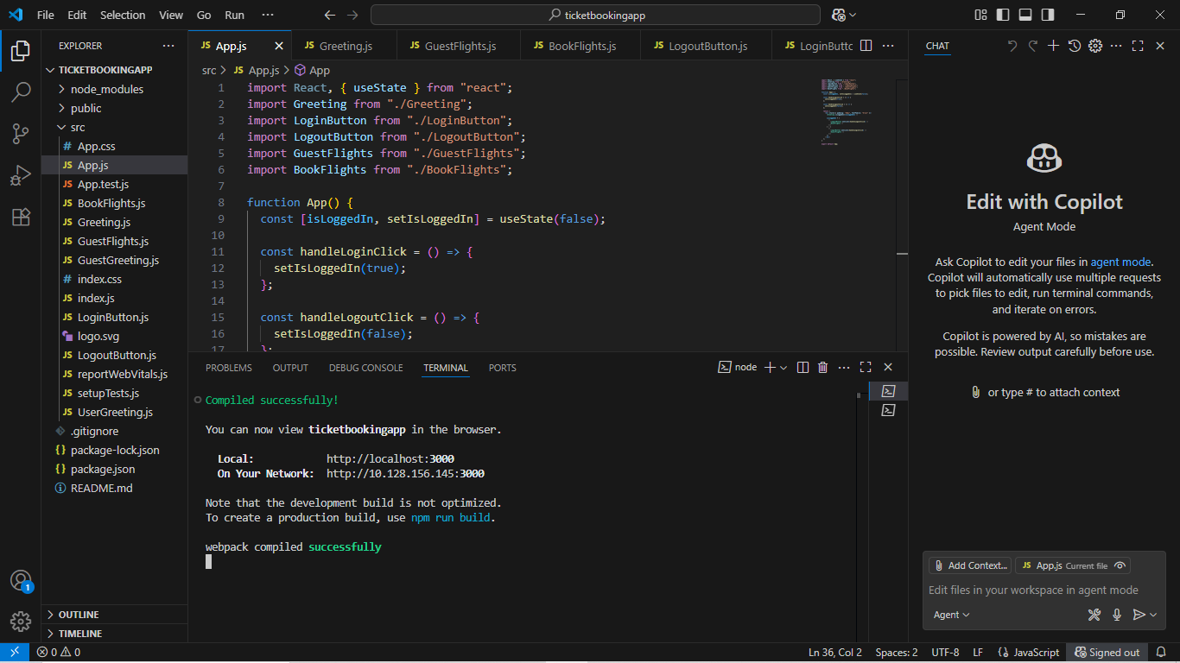

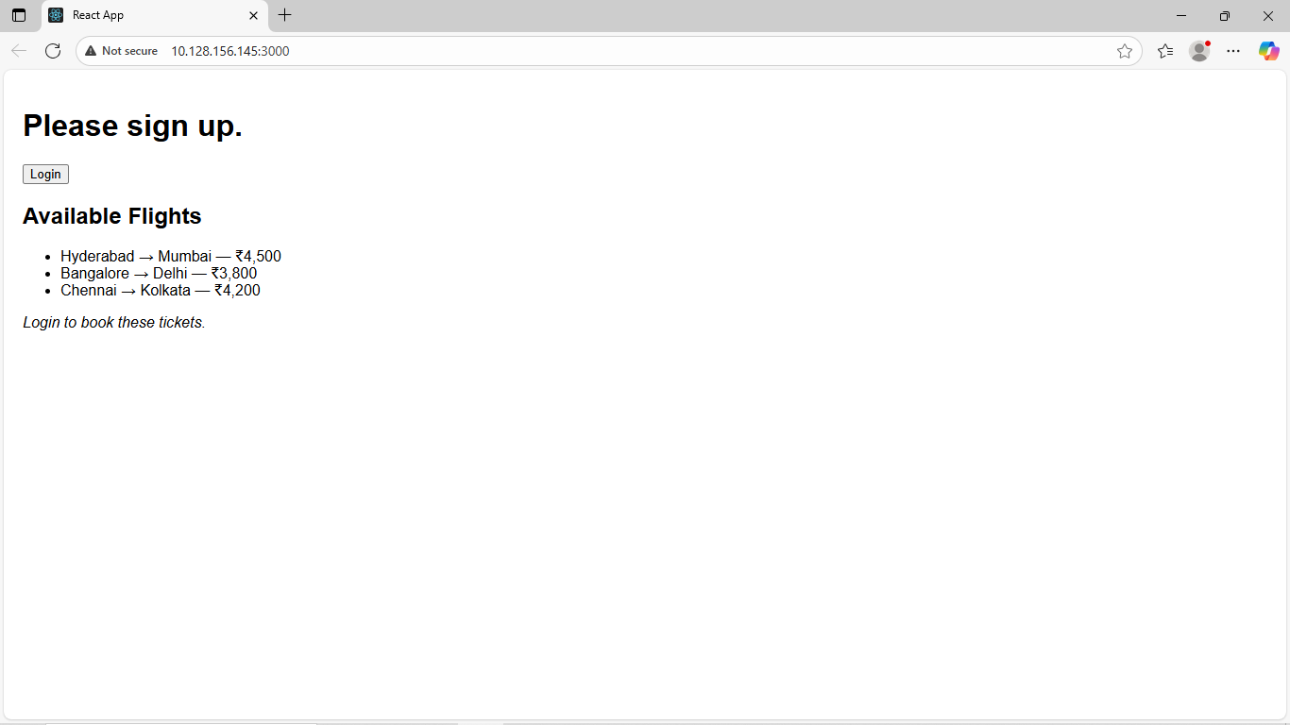

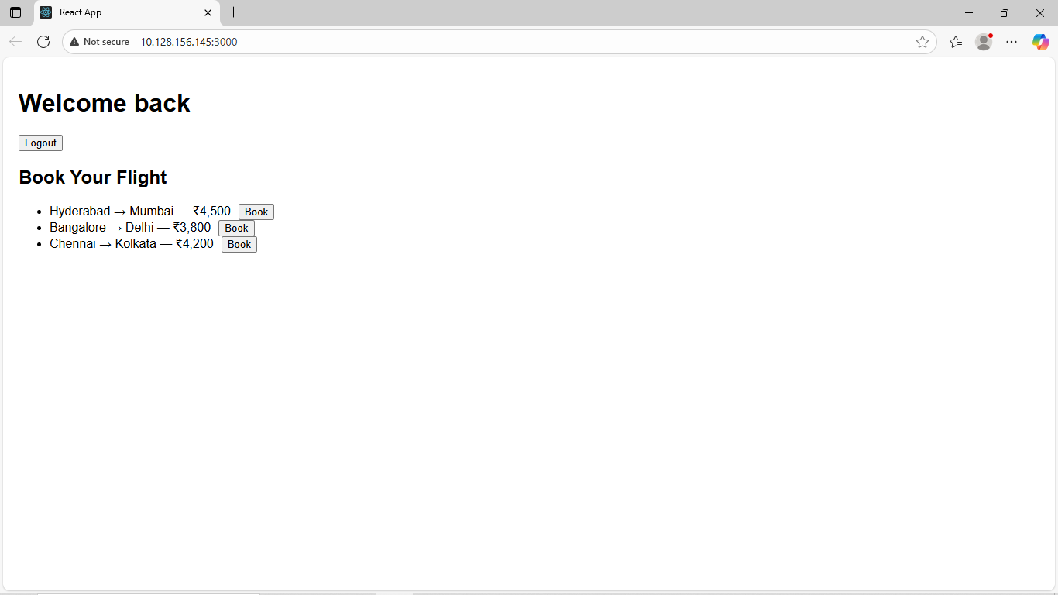

**13.ReactJS-HOL:**

**Code:**

**App.js:**

import React from "react";

import { books, blogs, courses } from "./data";

import BookDetails from "./BookDetails";

import BlogDetails from "./BlogDetails";

import CourseDetails from "./CourseDetails";

import "./App.css";

function App() {

const showBooks = true;

const showBlogs = true;

const showCourses = true;

return (

<div>

<div className="container">

{showCourses && (

<div className="section">

<h1 className="main-heading">Course Details</h1>

<CourseDetails courses={courses} />

</div>

)}

{showBooks && (

<div className="section">

<h1 className="main-heading">Book Details</h1>

<BookDetails books={books} />

</div>

)}

{showBlogs && (

<div className="section">

<h1 className="main-heading">Blog Details</h1>

<BlogDetails blogs={blogs} />

</div>

)}

</div>

</div>

);

}

export default App;

**data.js:**

export const books = [

{ id: 101, bname: "Master React", price: 670 },

{ id: 102, bname: "Deep Dive into Angular 11", price: 800 },

{ id: 103, bname: "Mongo Essentials", price: 450 }

];

export const blogs = [

{

id: 1,

title: "React Learning",

author: "Stephen Biz",

content: "Welcome to learning React!"

},

{

id: 2,

title: "Installation",

author: "Schewzdenier",

content: "You can install React from npm."

}

];

export const courses = [

{ id: 1, name: "Angular", date: "4/5/2021" },

{ id: 2, name: "React", date: "6/3/2022" }

];

**BookDetails.js:**

import React from "react";

function BookDetails(props) {

const bookdet = (

<ul>

{props.books.map((book) => (

<div key={book.id}>

<h3 style={{ fontWeight: "bold" }}>{book.bname}</h3>

<h4 style={{ fontWeight: "normal" }}>{book.price}</h4>

</div>

))}

</ul>

);

return <div>{bookdet}</div>;

}

export default BookDetails;

**BlogDetails.js:**

import React from "react";

function BlogDetails(props) {

return (

<div>

<ul>

{props.blogs.map((blog) => (

<div key={blog.id}>

<h3 style={{ fontWeight: "bold" }}>{blog.title}</h3>

<h4 style={{ fontWeight: "bold" }}>{blog.author}</h4>

<p style={{ fontWeight: "normal" }}>{blog.content}</p>

</div>

))}

</ul>

</div>

);

}

export default BlogDetails;

**CourseDetails.js:**

import React from "react";

function CourseDetails({ courses }) {

return (

<div>

<ul>

{courses.map((course) => (

<div key={course.id}>

<h3 style={{ fontWeight: "bold" }}>{course.name}</h3>

<h4 style={{ fontWeight: "normal" }}>{course.date}</h4>

</div>

))}

</ul>

</div>

);

}

export default CourseDetails;

**App.css:**

.container {

display: flex;

justify-content: space-around;

text-align: left;

}

.section {

padding: 20px;

border-right: 3px solid green;

}

.section:last-child {

border-right: none;

}

.main-heading {

font-size: 26px;

font-weight: bold;

margin-bottom: 10px;

}

**Output:**

