**ReactJS-HOL**

**1.ReactJS-HOL:**

**Code:**

**App.js:**

import React from 'react';

function App() {

return (

<div>

<h1>Welcome to the first session of React</h1>

</div>

);

}

export default App;

**Output:**

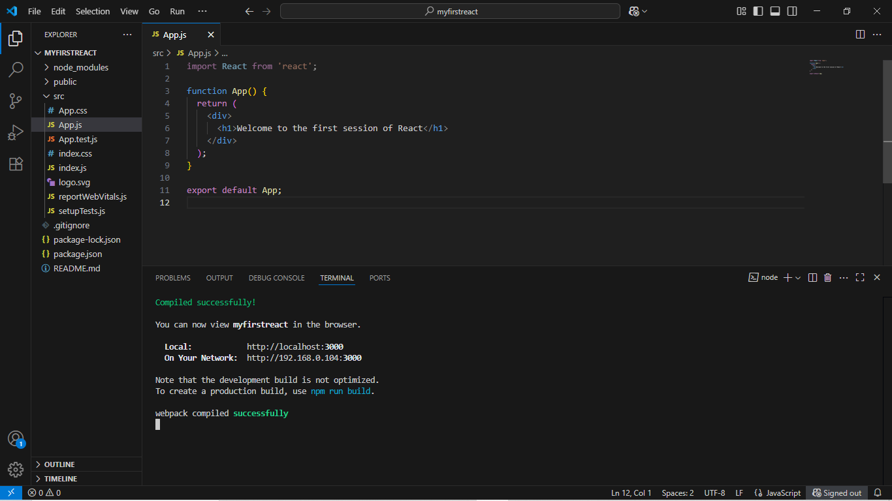

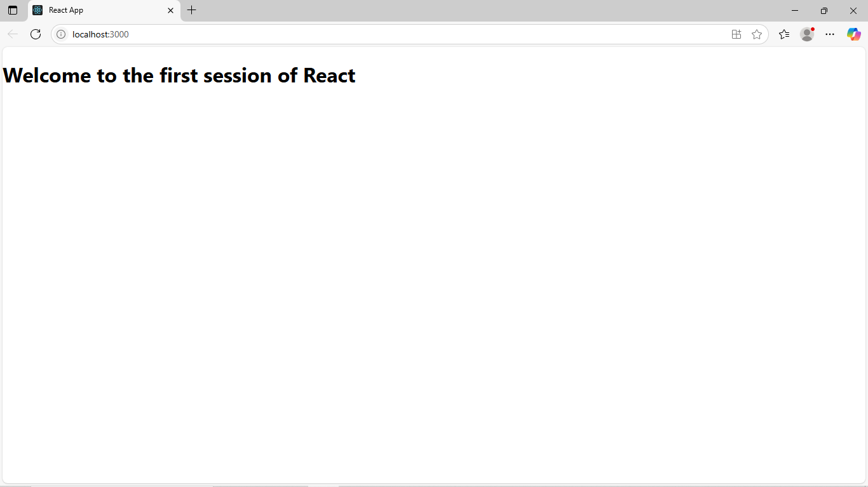

**2.ReactJS-HOL:**

**Code:**

**Home.js:**

import React, { Component } from 'react';

class Home extends Component {

render() {

return <h2>Welcome to the Home page of Student Management Portal</h2>;

}

}

export default Home;

**About.js:**

import React, { Component } from 'react';

class About extends Component {

render() {

return <h2>Welcome to the About page of the Student Management Portal</h2>;

}

}

export default About;

**Contact.js:**

import React, { Component } from 'react';

class Contact extends Component {

render() {

return <h2>Welcome to the Contact page of the Student Management Portal</h2>;

}

}

export default Contact;

**App.js:**

import React from 'react';

import Home from './Components/Home';

import About from './Components/About';

import Contact from './Components/Contact';

function App() {

return (

<div>

<Home />

<About />

<Contact />

</div>

);

}

export default App;

**Output:**

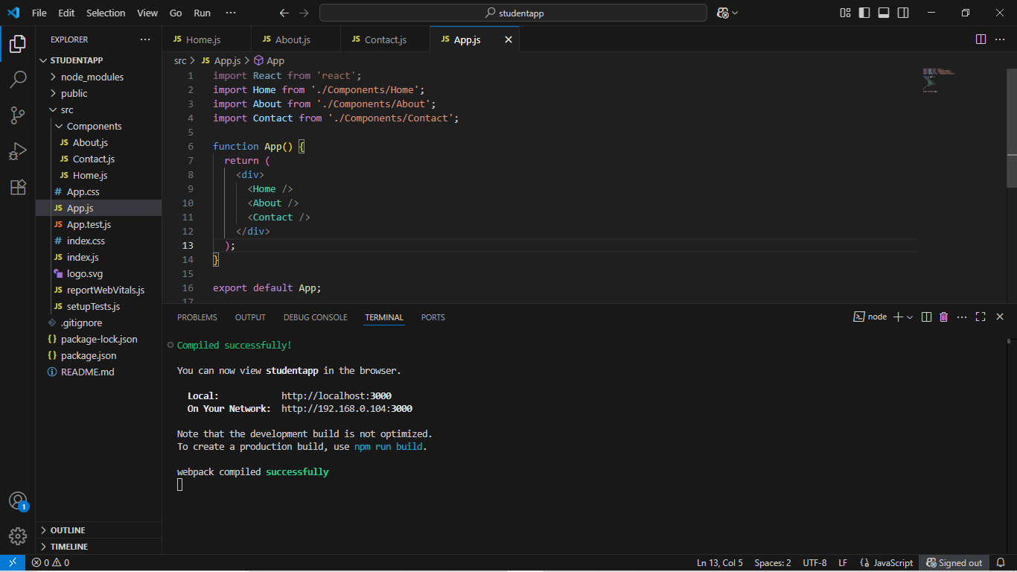

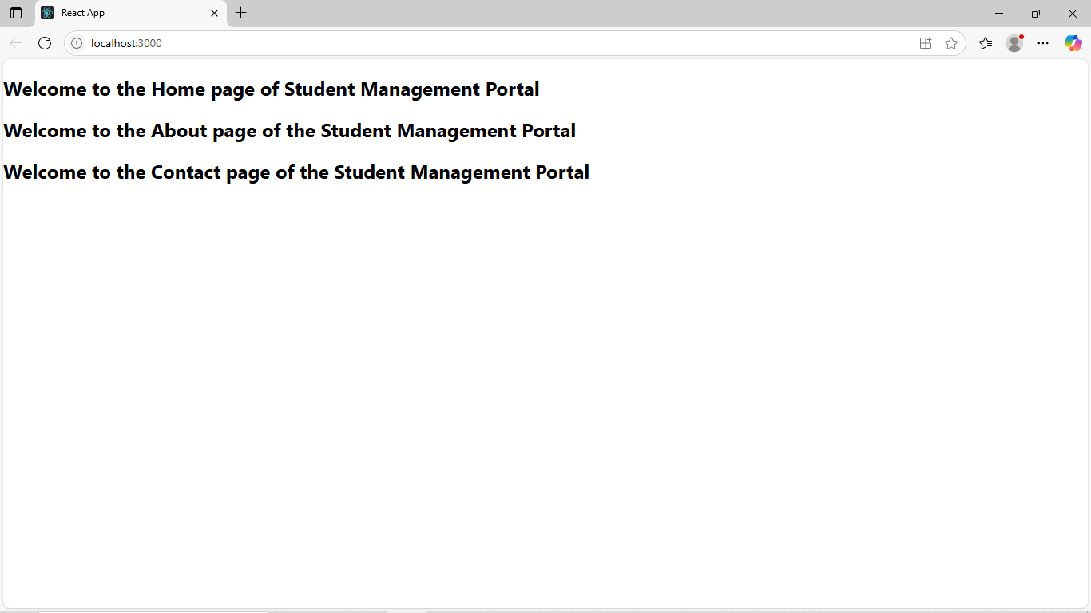

**3.ReactJS-HOL:**

**Code:**

**src/Components/CalculateScore.js:**

import '../Stylesheets/mystyle.css';

const percentToDecimal = (decimal) => {

return (decimal.toFixed(2)) + '%';

};

const calcScore = (total, goal) => {

return percentToDecimal(total / goal);

};

export const CalculateScore = ({ Name, School, total, goal }) => {

return (

<div className="formatstyle">

<h1><font color="brown">Student Details:</font></h1>

<div className="Name"><b>Name:</b> {Name}</div>

<div className="School"><b>School:</b> {School}</div>

<div className="Total"><b>Total:</b> {total}</div>

<div className="Score"><b>Score:</b> {calcScore(total, goal)}</div>

</div>

);

};

**src/Stylesheets/mystyle.css:**

.formatstyle {

text-align: center;

font-size: 18px;

padding: 20px;

background-color: #f0f8ff;

border-radius: 10px;

margin: 30px;

box-shadow: 0px 0px 8px gray;

}

.Name, .School, .Total, .Score {

margin: 10px;

font-weight: 500;

}

**App.js:**

import React from 'react';

import { CalculateScore } from './Components/CalculateScore';

function App() {

return (

<div>

<CalculateScore

Name="Steeve"

School="DNV Public School"

total={284}

goal={3}

/>

</div>

);

}

export default App;

**Output:**

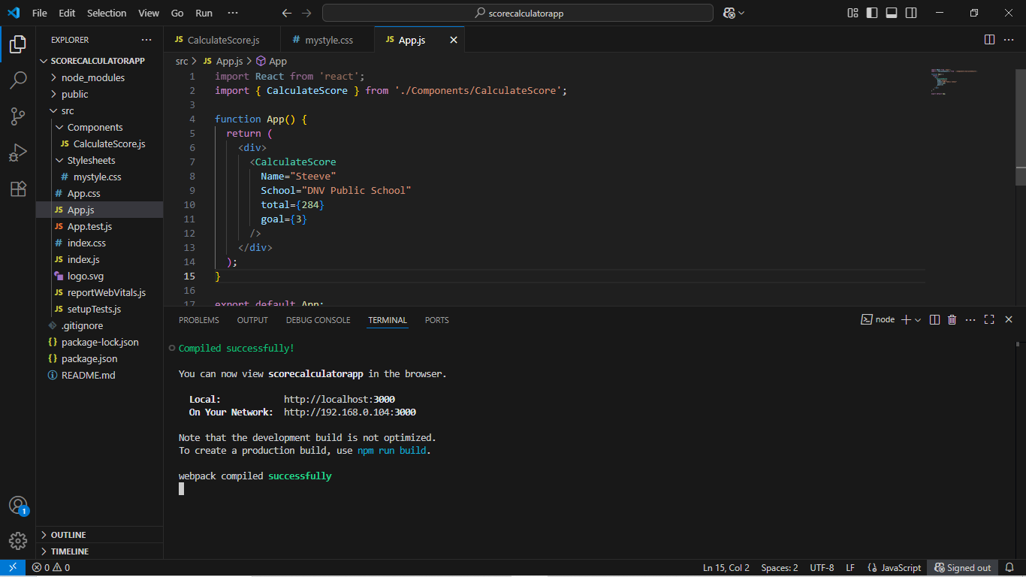

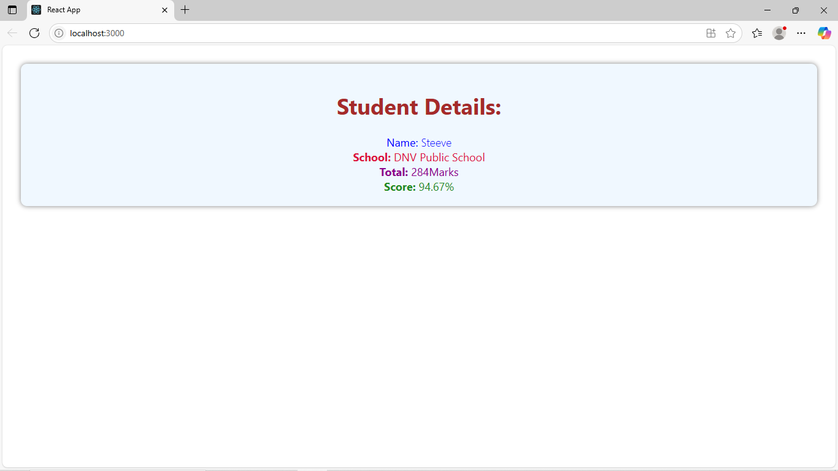

**4.ReactJS-HOL:**

**Code:**

**src/Post.js:**

export default class Post {

constructor(userId, id, title, body) {

this.userId = userId;

this.id = id;

this.title = title;

this.body = body;

}

}

**src/Posts.js:**

import React, { Component } from 'react';

import Post from './Post';

class Posts extends Component {

constructor() {

super();

this.state = {

posts: [],

hasError: false

};

}

loadPosts = () => {

fetch('https://jsonplaceholder.typicode.com/posts')

.then(res => res.json())

.then(data => {

const posts = data.map(

post => new Post(post.userId, post.id, post.title, post.body)

);

this.setState({ posts });

})

.catch(() => this.setState({ hasError: true }));

};

componentDidMount() {

this.loadPosts();

}

componentDidCatch(error, info) {

alert("An error occurred: " + error);

}

render() {

return (

<div>

<h1>Blog Posts</h1>

{this.state.hasError ? (

<p>Error loading posts.</p>

) : (

this.state.posts.map(post => (

<div key={post.id} style={{ marginBottom: '20px' }}>

<h3>{post.title}</h3>

<p>{post.body}</p>

</div>

))

)}

</div>

);

}

}

export default Posts;

**App.js:**

import React from 'react';

import Posts from './Posts';

function App() {

return (

<div className="App">

<Posts />

</div>

);

}

export default App;

**Output:**

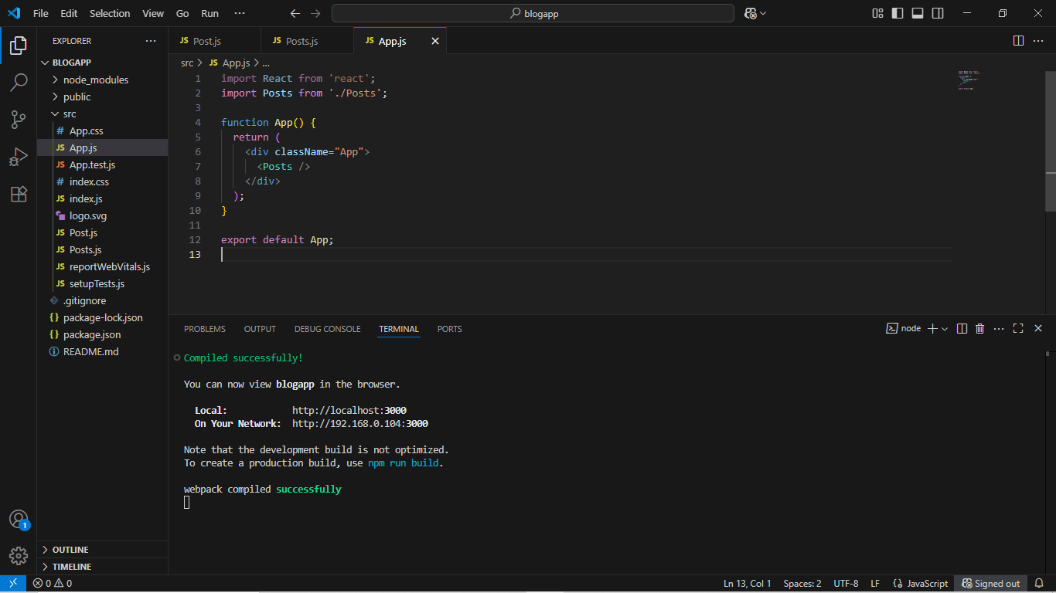

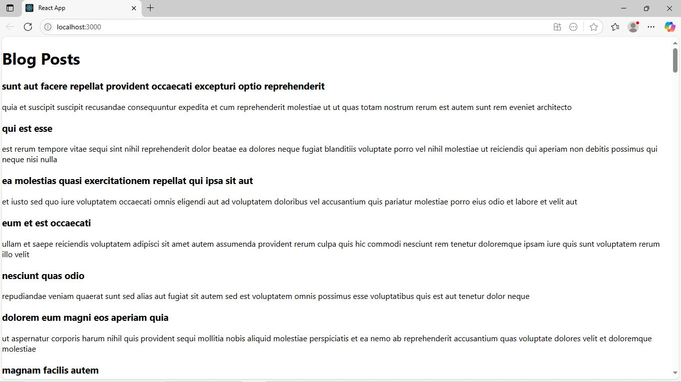

**5.ReactJS-HOL:**

**Code:**

**CohortDetails.jsx:**

import React from 'react';

import styles from './CohortDetails.module.css';

const CohortDetails = ({ name, startedOn, status, coach, trainer }) => {

const titleColor = status.toLowerCase() === 'ongoing' ? 'green' : 'blue';

return (

<div className={styles.box}>

<h3 style={{ color: titleColor }}>{name}</h3>

<dl>

<dt>Started On</dt>

<dd>{startedOn}</dd>

<dt>Current Status</dt>

<dd>{status}</dd>

<dt>Coach</dt>

<dd>{coach}</dd>

<dt>Trainer</dt>

<dd>{trainer}</dd>

</dl>

</div>

);

};

export default CohortDetails;

**CohortDetails.module.css:**

.box {

width: 300px;

display: inline-block;

margin: 10px;

padding: 10px 20px;

border: 1px solid black;

border-radius: 10px;

vertical-align: top;

}

dt {

font-weight: 500;

}

**App.js:**

import React from 'react';

import CohortDetails from './Components/CohortDetails';

function App() {

return (

<div style={{ padding: '20px' }}>

<h2 style={{ fontWeight: 'bold' }}>Cohorts Details</h2>

<CohortDetails

name="INTADMDf10 - .NET FSD"

startedOn="22-Feb-2022"

status="Scheduled"

coach="Aathma"

trainer="Jojo Jose"

/>

<CohortDetails

name="ADM21JF014 - Java FSD"

startedOn="10-Sep-2021"

status="Ongoing"

coach="Apoorv"

trainer="Elisa Smith"

/>

<CohortDetails

name="CDBJFJ21025 - Java FSD"

startedOn="24-Dec-2021"

status="Ongoing"

coach="Aathma"

trainer="John Doe"

/>

</div>

);

}

export default App;

**Output:**

