Week-8 Git

**1.Git-HOL:**

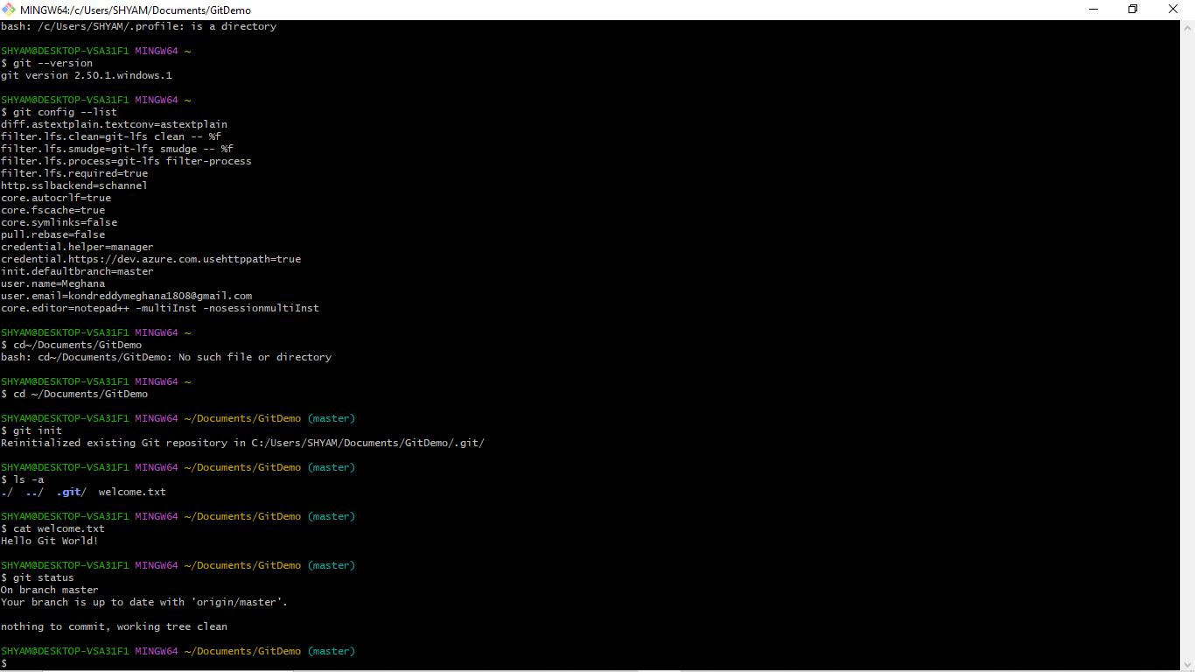

SHYAM@DESKTOP-VSA31F1 MINGW64 ~

$ cd ~/Documents/GitDemo

SHYAM@DESKTOP-VSA31F1 MINGW64 ~/Documents/GitDemo (master)

$ git init

Reinitialized existing Git repository in C:/Users/SHYAM/Documents/GitDemo/.git/

SHYAM@DESKTOP-VSA31F1 MINGW64 ~/Documents/GitDemo (master)

$ ls -a

./ ../ .git/ welcome.txt

SHYAM@DESKTOP-VSA31F1 MINGW64 ~/Documents/GitDemo (master)

$ cat welcome.txt

Hello Git World!

SHYAM@DESKTOP-VSA31F1 MINGW64 ~/Documents/GitDemo (master)

$ git status

On branch master

Your branch is up to date with 'origin/master'.

nothing to commit, working tree clean

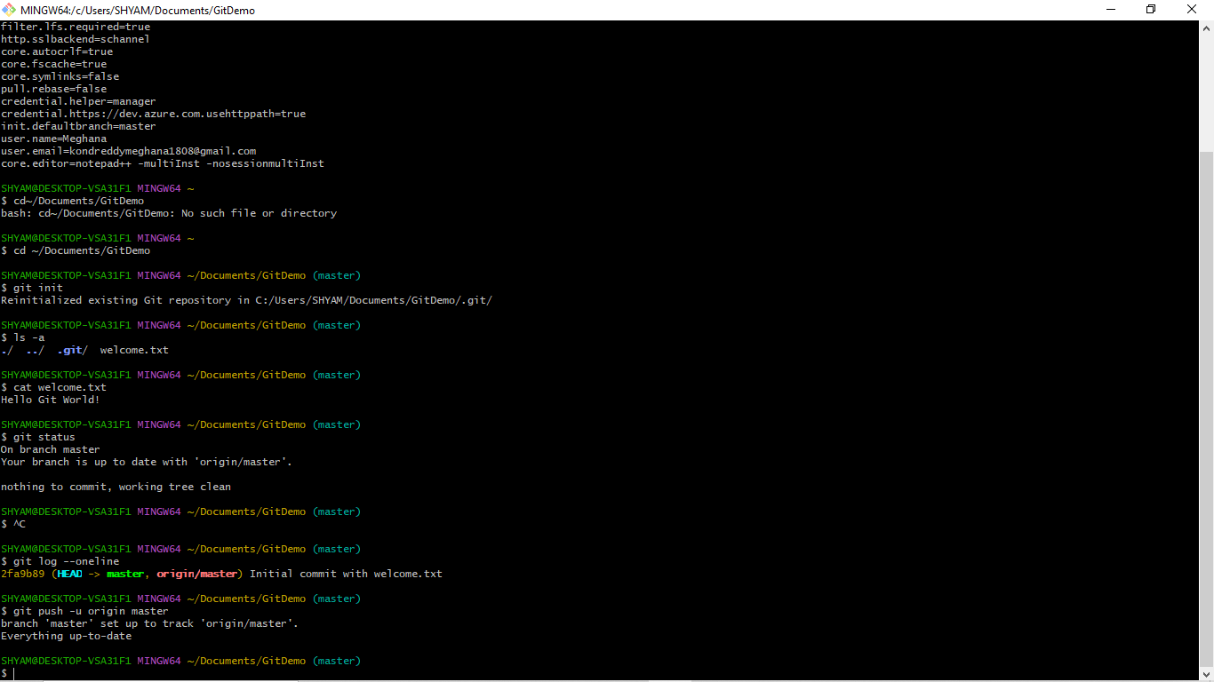

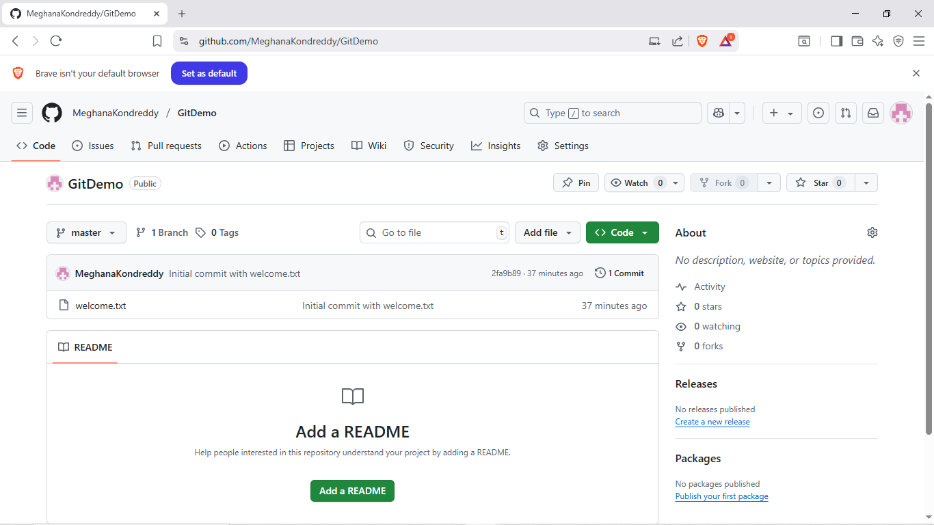

**2.Git-HOL:**

$ cd ~/Documents/GitDemo

SHYAM@DESKTOP-VSA31F1 MINGW64 ~/Documents/GitDemo (master)

$ echo "This is a log file" > debug.log

SHYAM@DESKTOP-VSA31F1 MINGW64 ~/Documents/GitDemo (master)

$ mkdir log

SHYAM@DESKTOP-VSA31F1 MINGW64 ~/Documents/GitDemo (master)

$ echo "log content" > log/error.log

SHYAM@DESKTOP-VSA31F1 MINGW64 ~/Documents/GitDemo (master)

$ notepad++ .gitignore

SHYAM@DESKTOP-VSA31F1 MINGW64 ~/Documents/GitDemo (master)

$ git add .gitignore

SHYAM@DESKTOP-VSA31F1 MINGW64 ~/Documents/GitDemo (master)

$ git commit -m "Added .gitignore to ignore log files and folder"

[master 8bf7d90] Added .gitignore to ignore log files and folder

1 file changed, 2 insertions(+)

create mode 100644 .gitignore

SHYAM@DESKTOP-VSA31F1 MINGW64 ~/Documents/GitDemo (master)

$ git push

Enumerating objects: 4, done.

Counting objects: 100% (4/4), done.

Delta compression using up to 4 threads

Compressing objects: 100% (2/2), done.

Writing objects: 100% (3/3), 315 bytes | 63.00 KiB/s, done.

Total 3 (delta 0), reused 0 (delta 0), pack-reused 0 (from 0)

To https://github.com/MeghanaKondreddy/GitDemo.git

2fa9b89..8bf7d90 master -> master

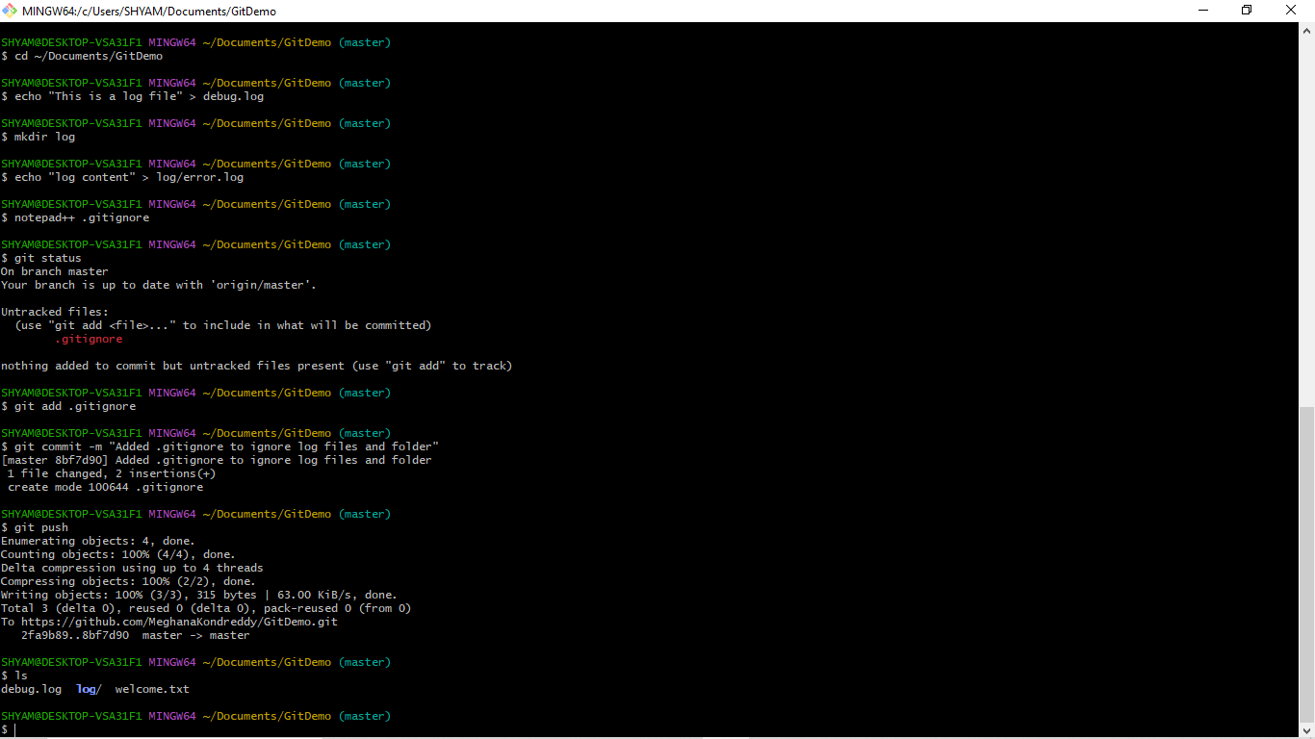

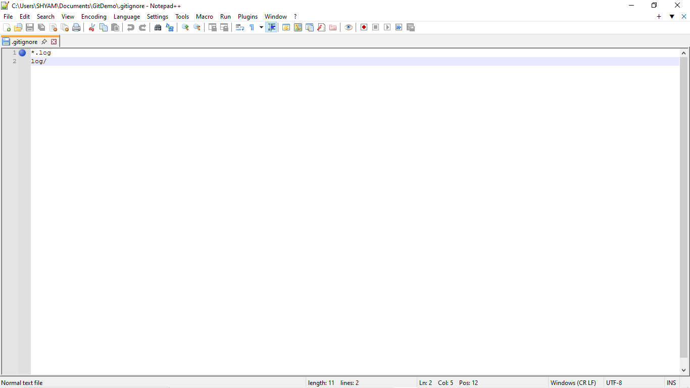

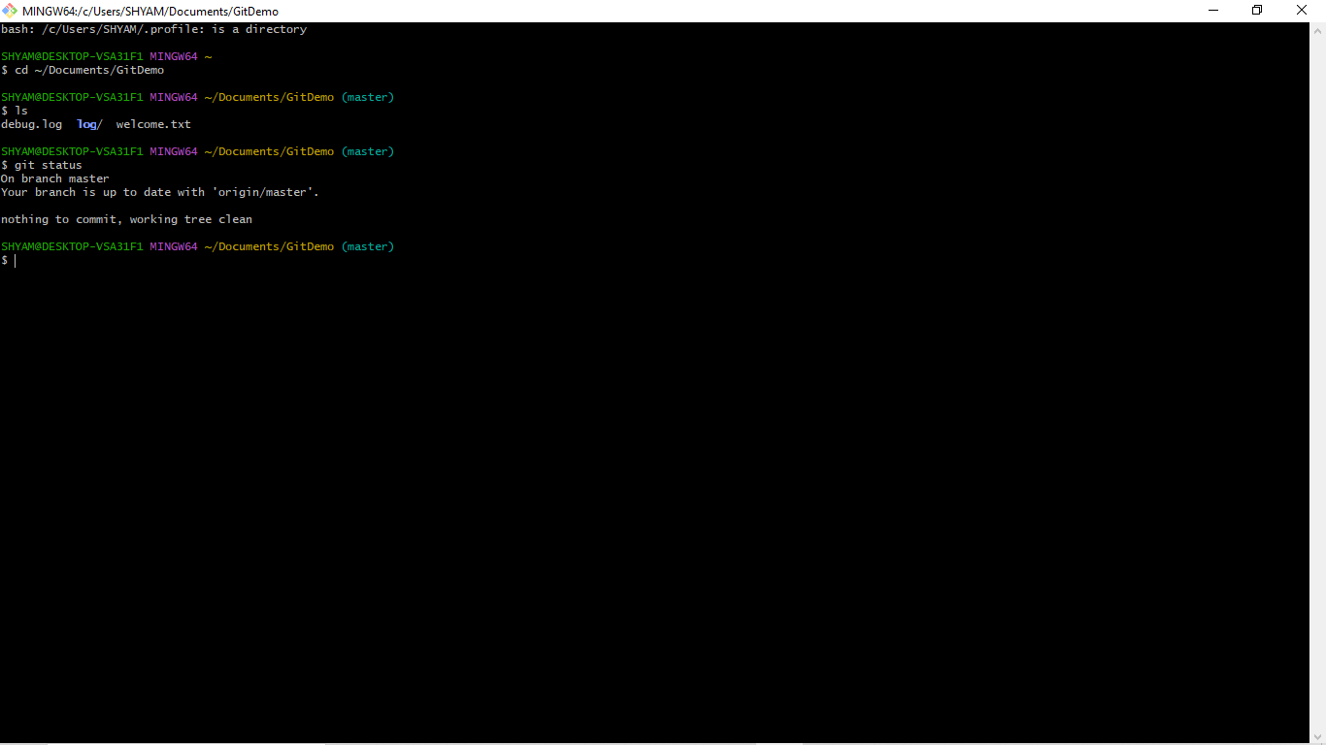

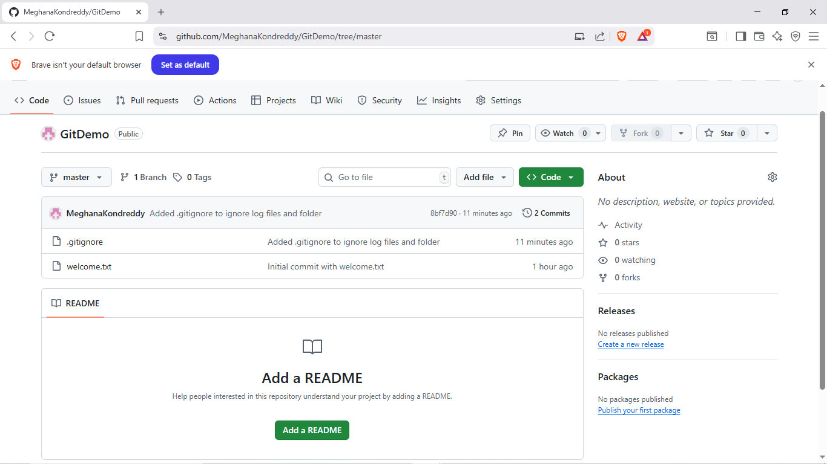

**3.Git-HOL:**

bash: /c/Users/SHYAM/.profile: is a directory

SHYAM@DESKTOP-VSA31F1 MINGW64 ~

$ cd ~/Documents/GitDemo

SHYAM@DESKTOP-VSA31F1 MINGW64 ~/Documents/GitDemo (master)

$ git branch GitNewBranch

SHYAM@DESKTOP-VSA31F1 MINGW64 ~/Documents/GitDemo (master)

$ git branch

GitNewBranch

* master

SHYAM@DESKTOP-VSA31F1 MINGW64 ~/Documents/GitDemo (master)

$ git checkout GitNewBranch

Switched to branch 'GitNewBranch'

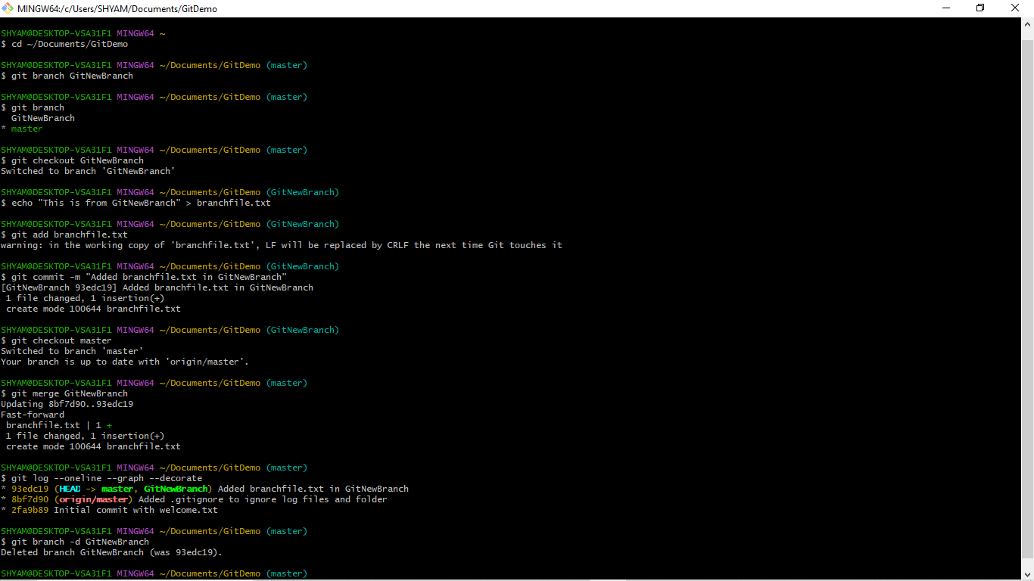

SHYAM@DESKTOP-VSA31F1 MINGW64 ~/Documents/GitDemo (GitNewBranch)

$ echo "This is from GitNewBranch" > branchfile.txt

SHYAM@DESKTOP-VSA31F1 MINGW64 ~/Documents/GitDemo (GitNewBranch)

$ git add branchfile.txt

warning: in the working copy of 'branchfile.txt', LF will be replaced by CRLF the next time Git touches it

SHYAM@DESKTOP-VSA31F1 MINGW64 ~/Documents/GitDemo (GitNewBranch)

$ git commit -m "Added branchfile.txt in GitNewBranch"

[GitNewBranch 93edc19] Added branchfile.txt in GitNewBranch

1 file changed, 1 insertion(+)

create mode 100644 branchfile.txt

SHYAM@DESKTOP-VSA31F1 MINGW64 ~/Documents/GitDemo (GitNewBranch)

$ git checkout master

Switched to branch 'master'

Your branch is up to date with 'origin/master'.

SHYAM@DESKTOP-VSA31F1 MINGW64 ~/Documents/GitDemo (master)

$ git merge GitNewBranch

Updating 8bf7d90..93edc19

Fast-forward

branchfile.txt | 1 +

1 file changed, 1 insertion(+)

create mode 100644 branchfile.txt

SHYAM@DESKTOP-VSA31F1 MINGW64 ~/Documents/GitDemo (master)

$ git log --oneline --graph --decorate

* 93edc19 (HEAD -> master, GitNewBranch) Added branchfile.txt in GitNewBranch

* 8bf7d90 (origin/master) Added .gitignore to ignore log files and folder

* 2fa9b89 Initial commit with welcome.txt

SHYAM@DESKTOP-VSA31F1 MINGW64 ~/Documents/GitDemo (master)

$ git branch -d GitNewBranch

Deleted branch GitNewBranch (was 93edc19).

**4.Git-HOL:**

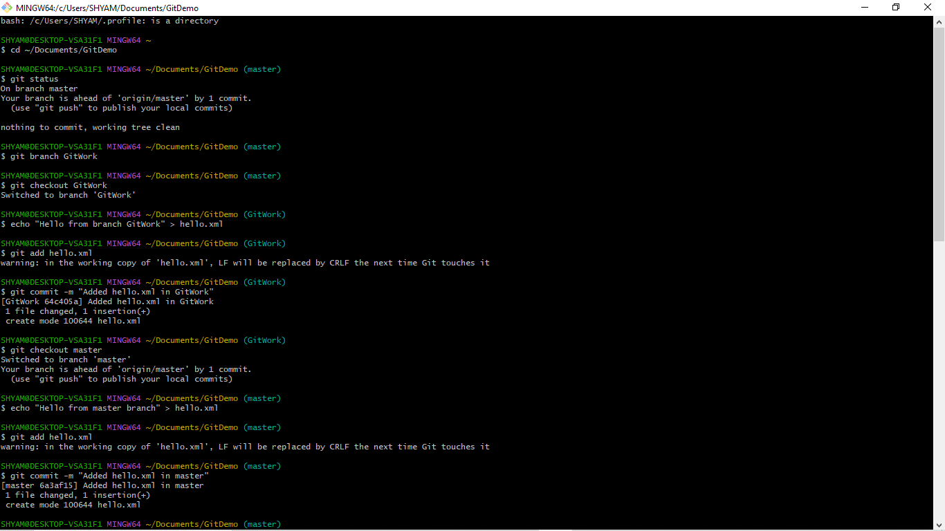

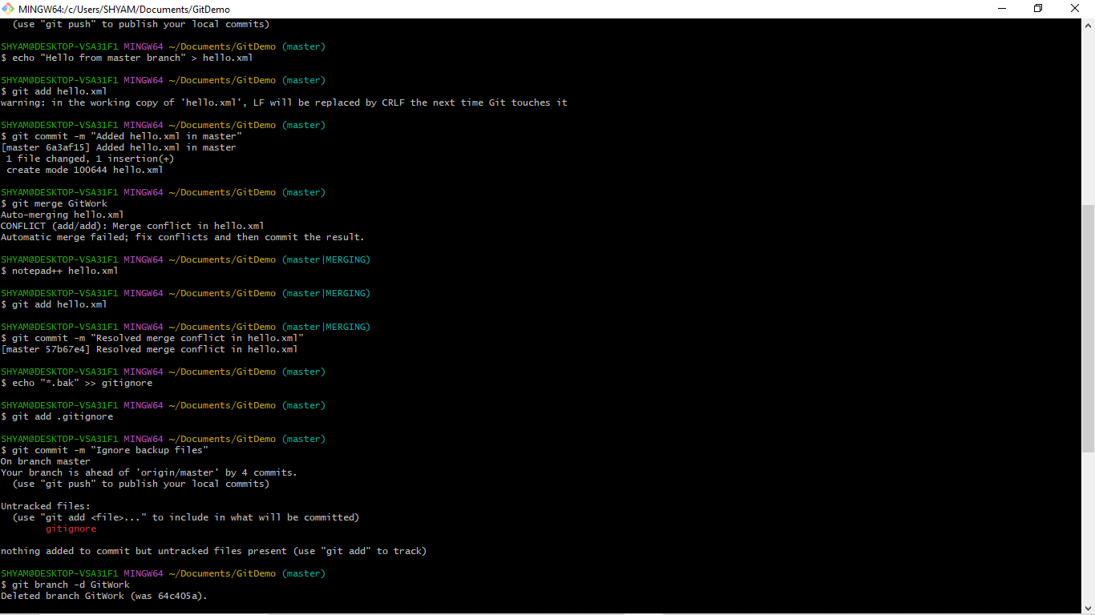

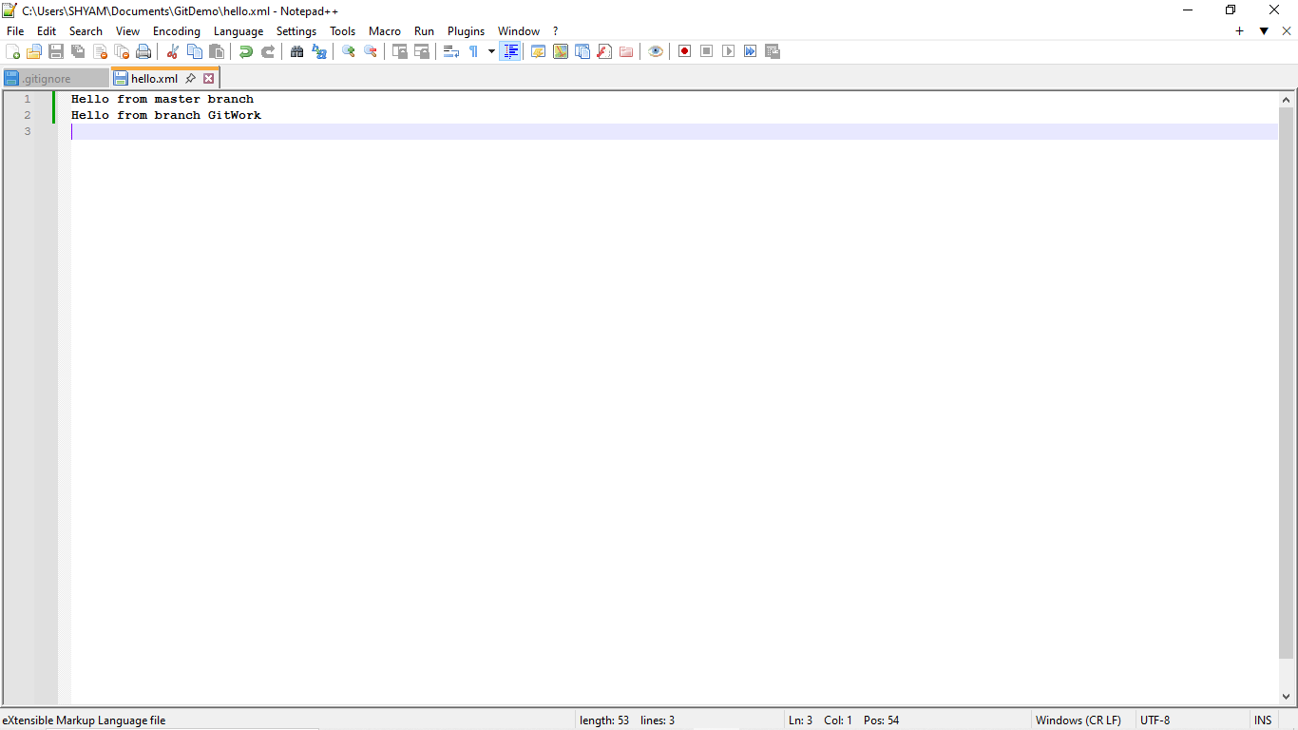

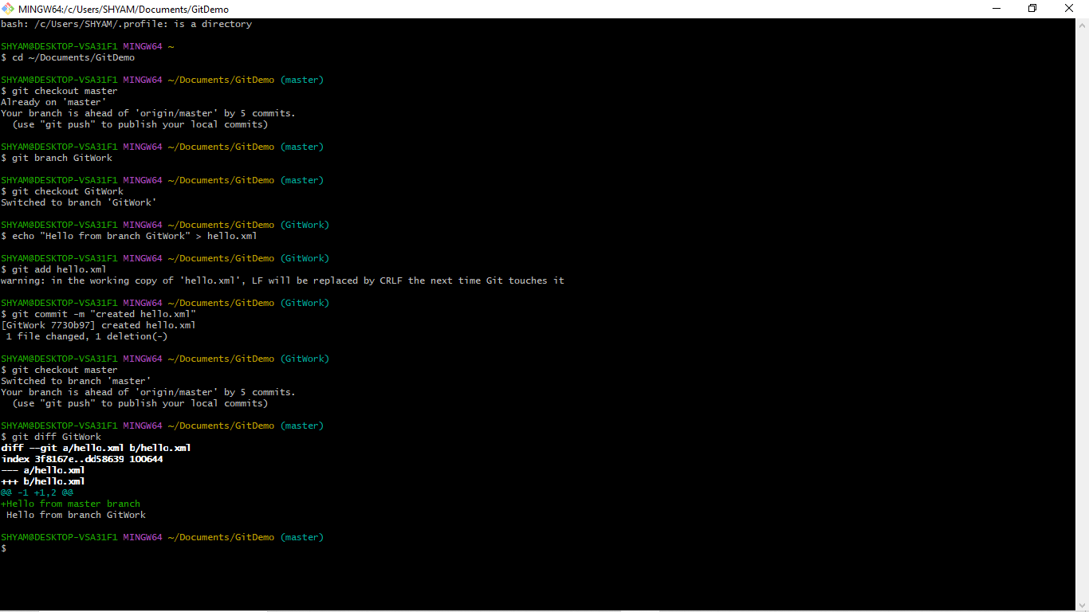

**5.Git-HOL:**

