1. Created a VM Scale set with Windows OS.

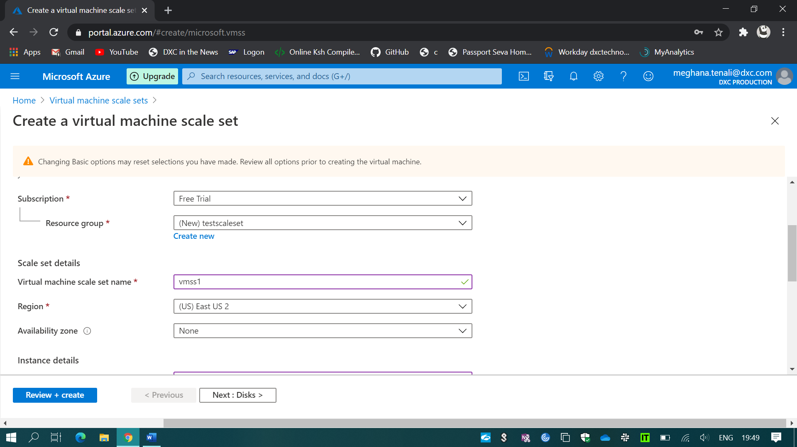

1. Created a VM Scale set with scale out rule using CPU percentage of 70% threshold.
2. And scale in rule using CPU percentage of 40% threshold.

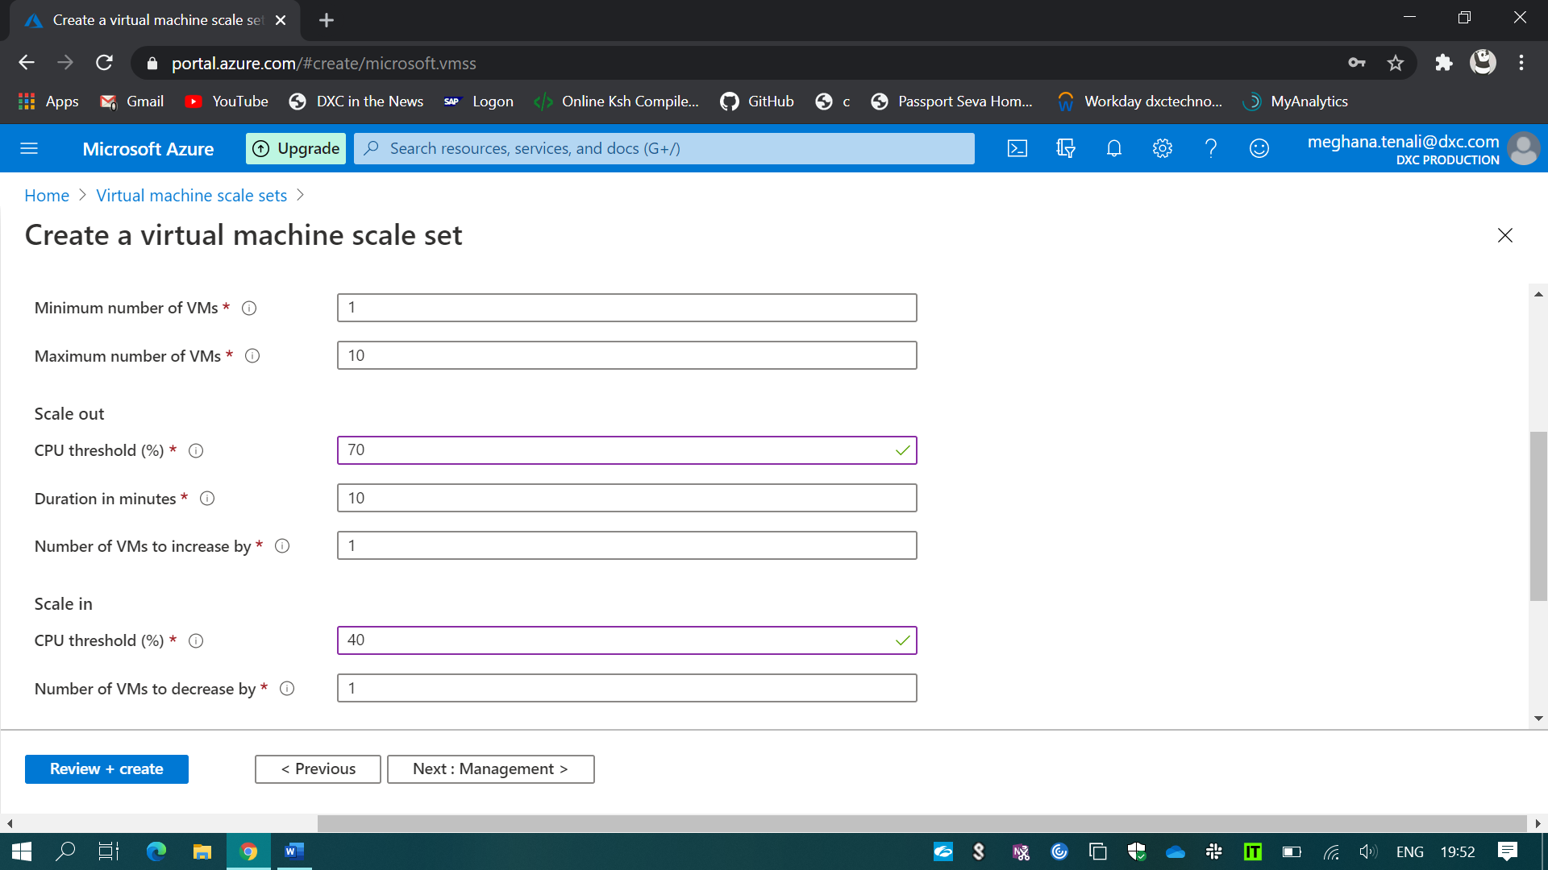

1. Created a storage account.

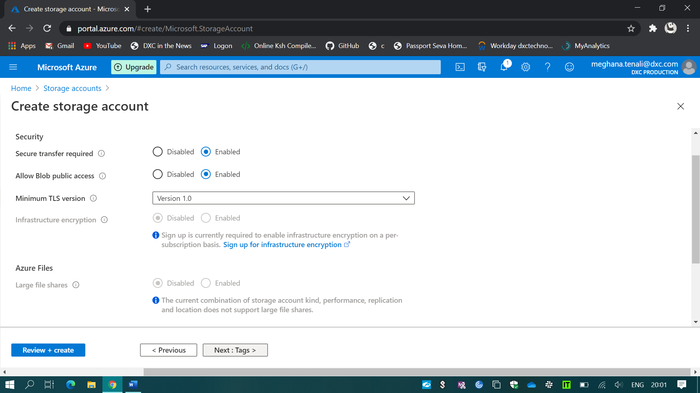

(i). Created Container with the anonymous access.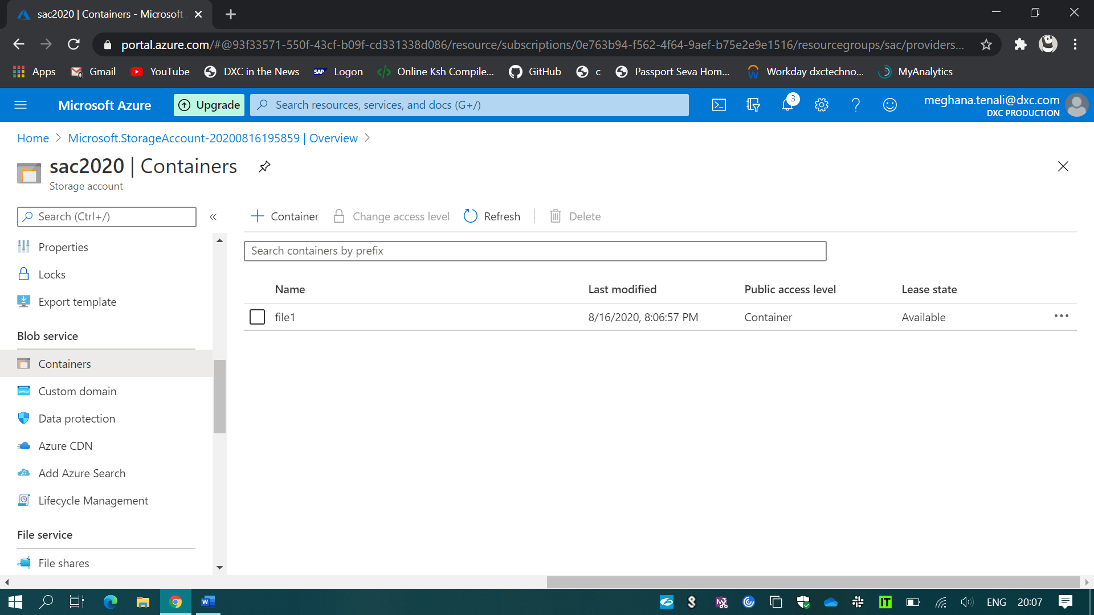

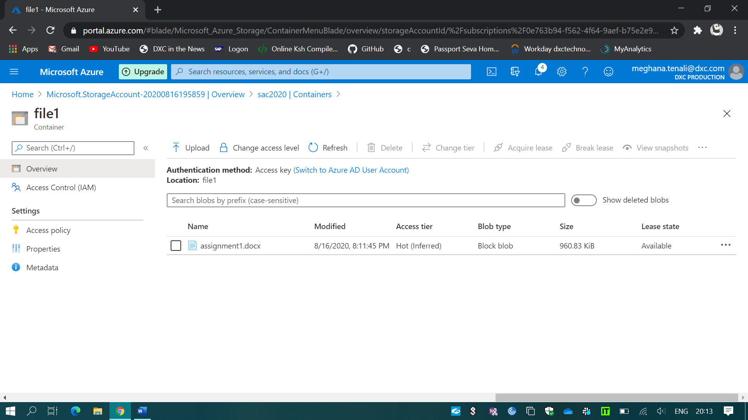

(ii). Created a static website in the storage account.

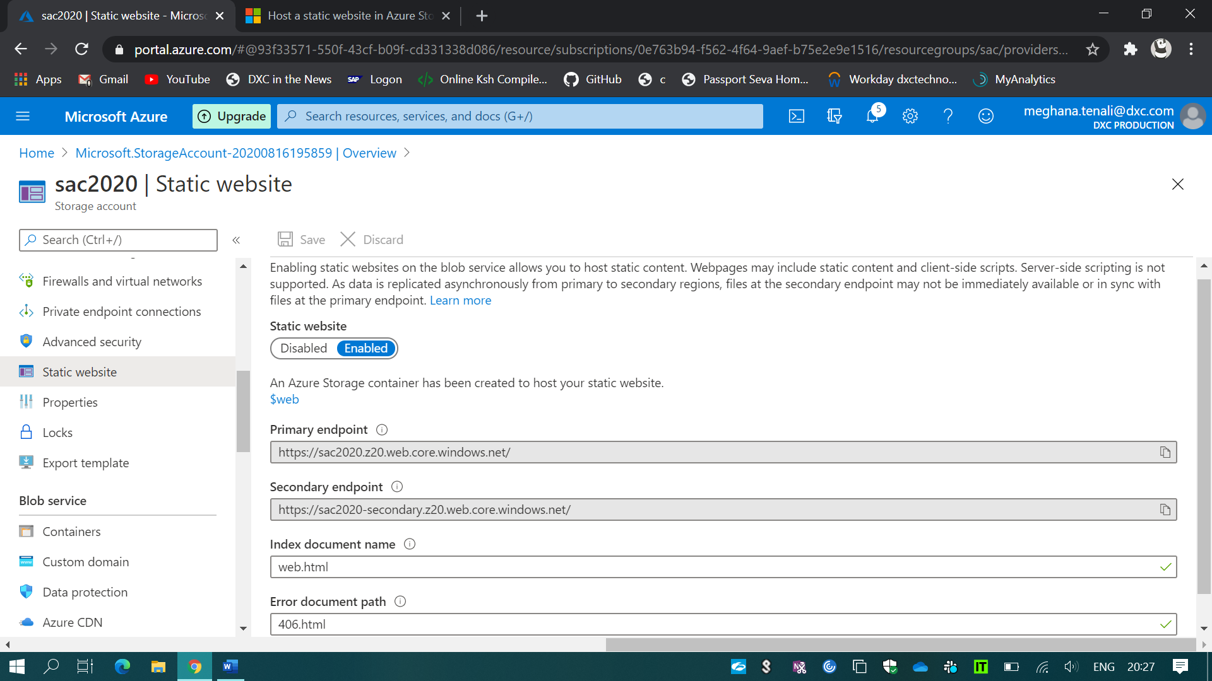

1. Created two Virtual machines with No public IP’s.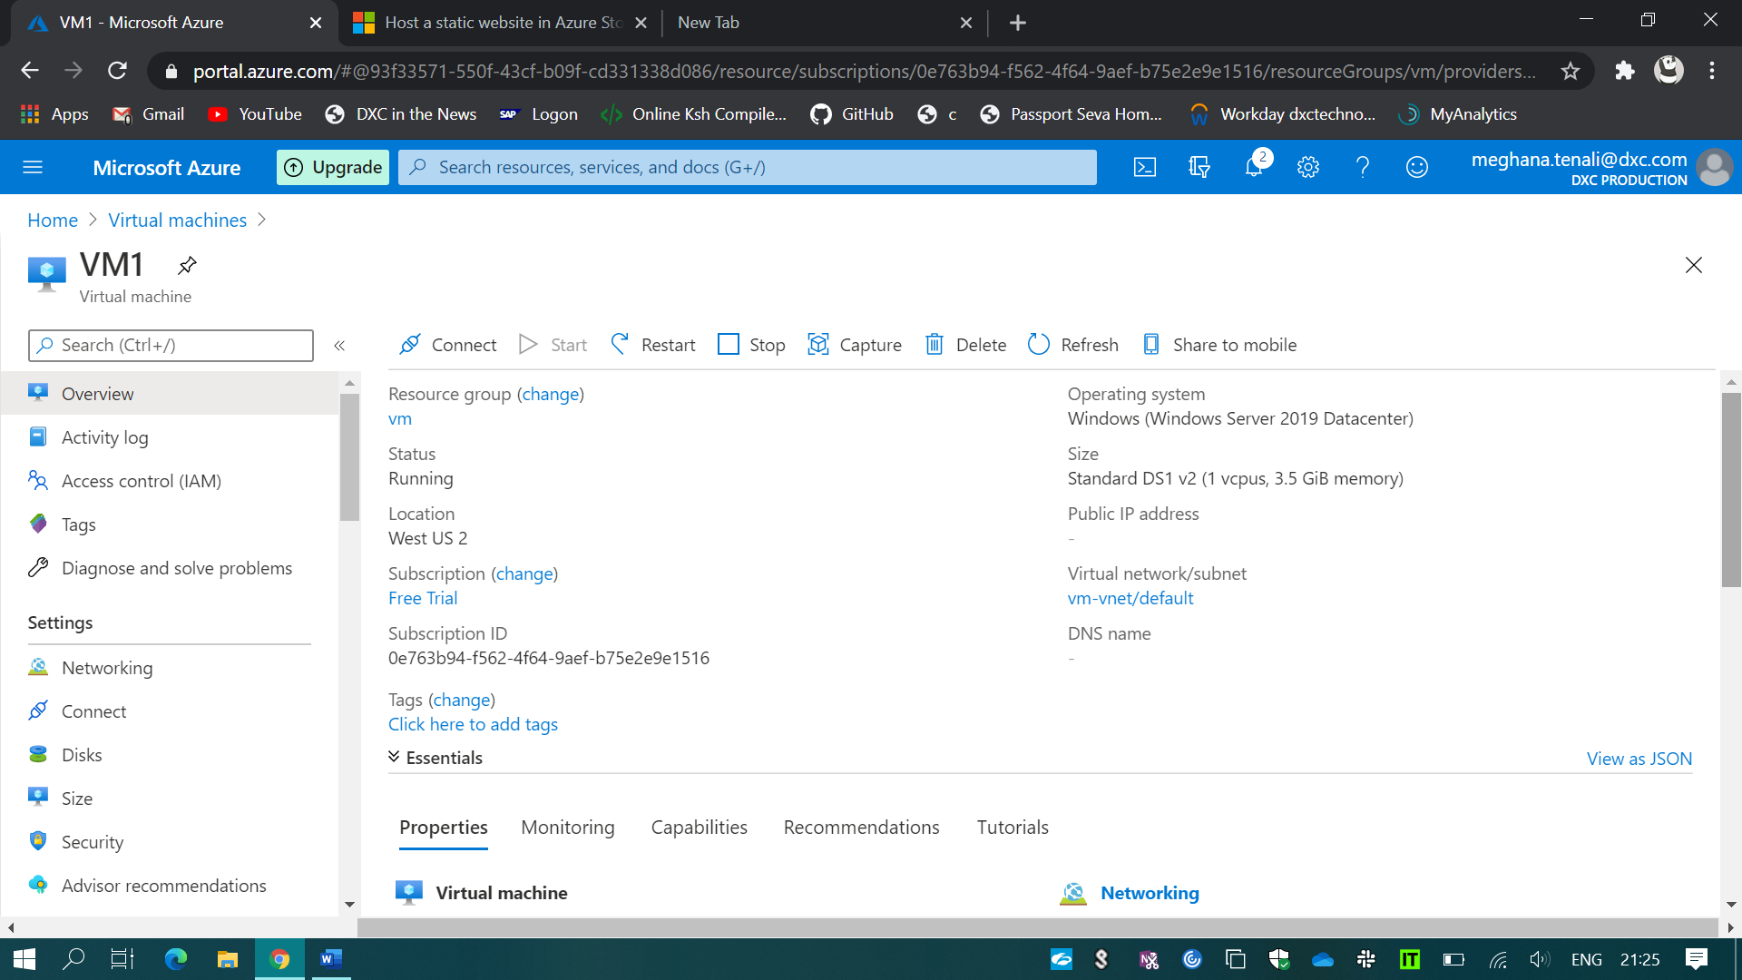

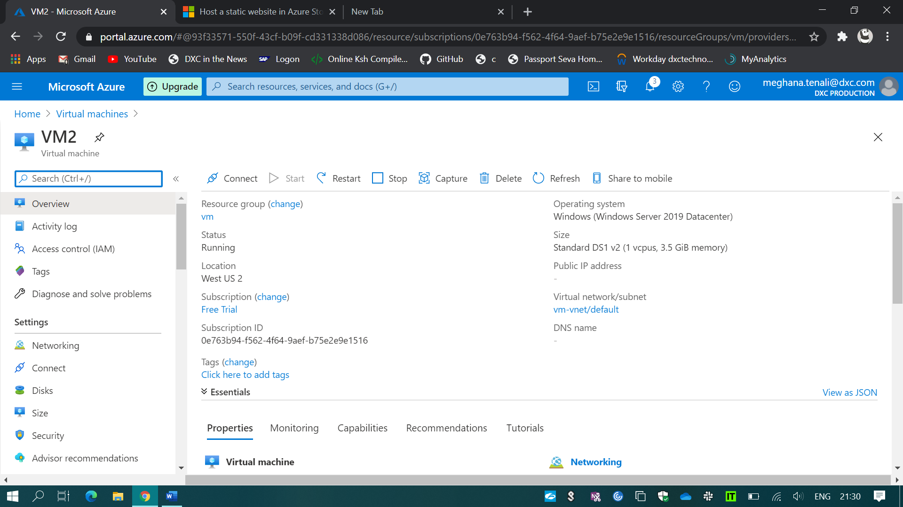

1. Attached the two VM’s to the load balancer.

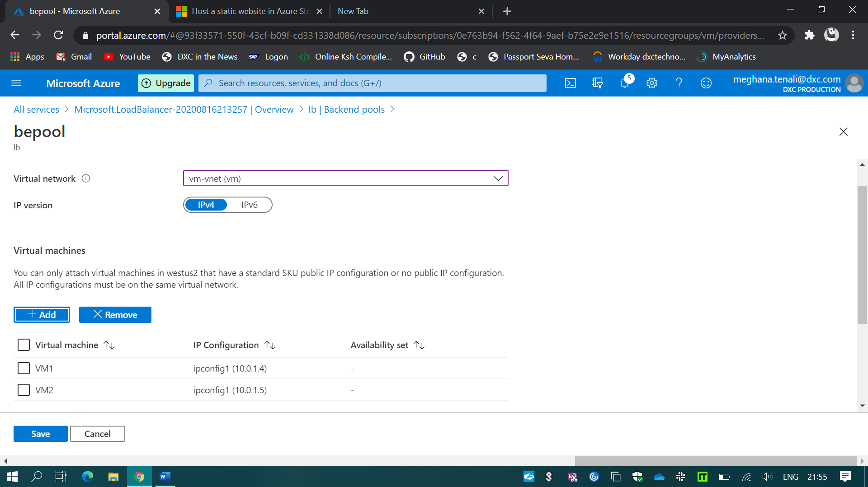

(i). And Blocked the 3389 & 50010 Ports.