1. First, we need to create a virtual machine which will automatically gets shutdown on 05:00PM

And before shutting down it has to send a message to my mail.

1. These steps will be done during the creation of VM and during the management steps.

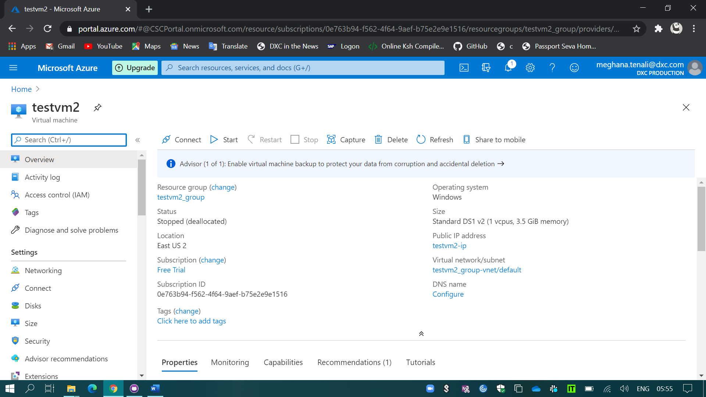

As shown in the above snip I’ve created a VM with the standard DS1 V2.

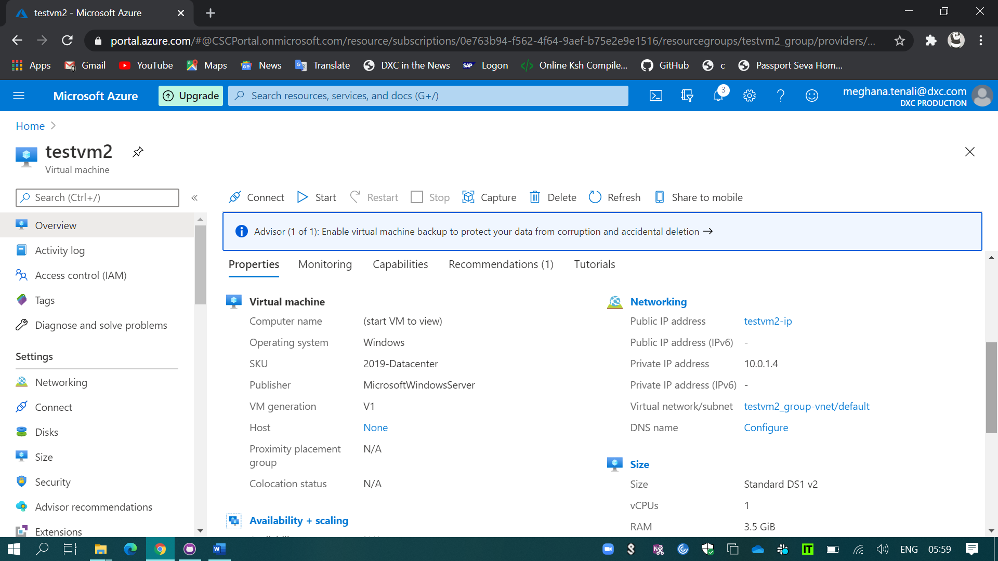

1. I’ve selected the windows 2019 datacenter for the new VM and RAM of 3.5GB.
2. Initially, I don’t have any kind of data disks in my VM.

(shown in the below snip)

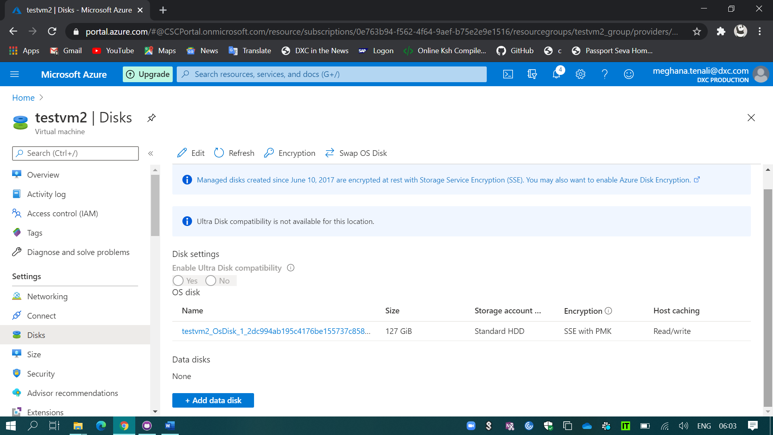

1. Now, I’ve created a data disk with 50GB size.
2. To enable that disk we have to open the VM.

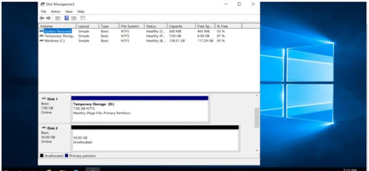

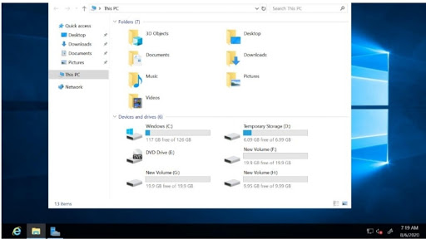

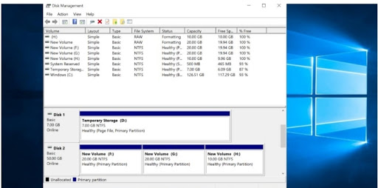

1. I’ve splitted the 50GB data disk into 3 parts.
2. Now, I’ve add another username to my VM
3. That I’ve to change that in the reset password settings in the VM .