Insights Report: 2024 Election Insights

Introduction

The 2024 elections have been a pivotal moment in our democracy, showcasing diverse voter preferences and electoral dynamics. This report aims to analyze key insights derived from the election data, highlighting significant trends, party performances, and voter behavior.

Methodology

Data Collection: Data was sourced from the Lok Sabha election results, encompassing various constituencies and parties.

Analysis Techniques: Utilized data visualization, statistical summaries, and heatmap analysis to uncover insights.

Insights and Findings

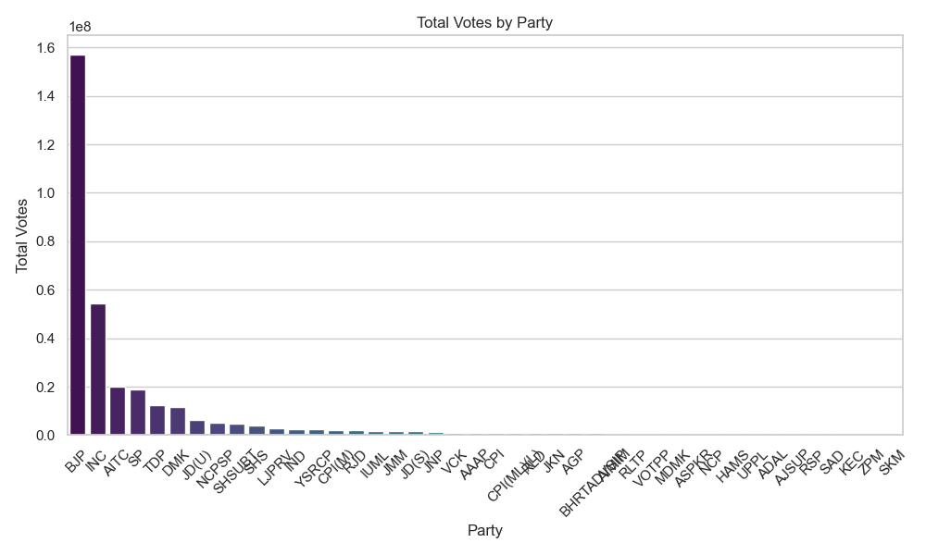

1. Total Votes by Party

Insight: BJP garnered the highest total votes nationwide, demonstrating widespread public endorsement.

**Key Observations**:

* It provides a cumulative measure of voter support for each party.
* Higher total votes indicate broader appeal and effective voter mobilization.

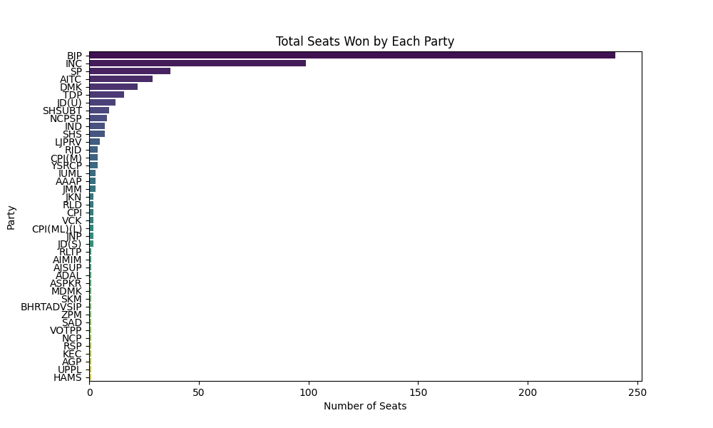

2. Total Seats Won by Each Party

Insight: The election results demonstrate a clear dominance by BJP with 240 seats, securing a significant majority across constituencies.

**Key Observations**:

* The distribution of seats among various parties highlights the leading party with the majority of seats.
* Parties with fewer seats indicate regions where they need to improve their outreach and campaign strategies.

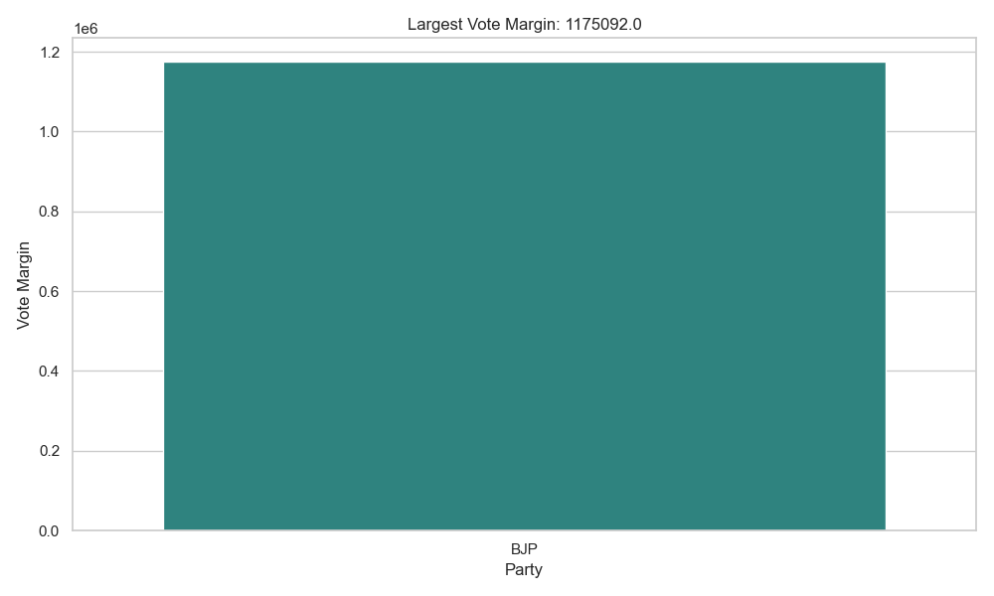

3. Largest Vote Margin

Insight: The largest vote margin was observed in favor of BJP with 1.1, underscoring significant electoral confidence.

**Key Observations**:

* Large margins indicate strong support for the winning candidate and their party.
* It reflects effective campaigning and strong voter base loyalty.

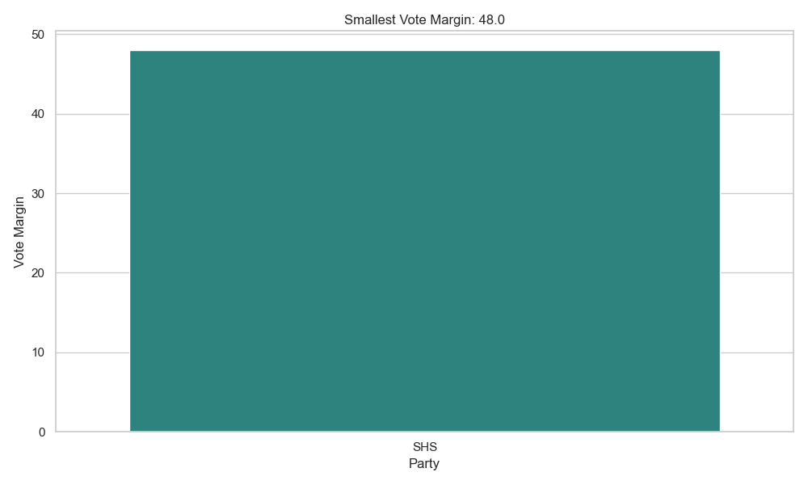

4. Smallest Vote Margin

**Insight**: This plot shows the candidate and party with the smallest vote margin, representing the most narrowly won contest.

**Key Observations**:

* Small margins underscore highly competitive races and potentially divided constituencies.
* These results often necessitate recounts or increased scrutiny.



5. Total Votes by Party

Insight: BJP garnered the highest total votes nationwide, demonstrating widespread public endorsement.

**Key Observations**:

* It provides a cumulative measure of voter support for each party.
* Higher total votes indicate broader appeal and effective voter mobilization.

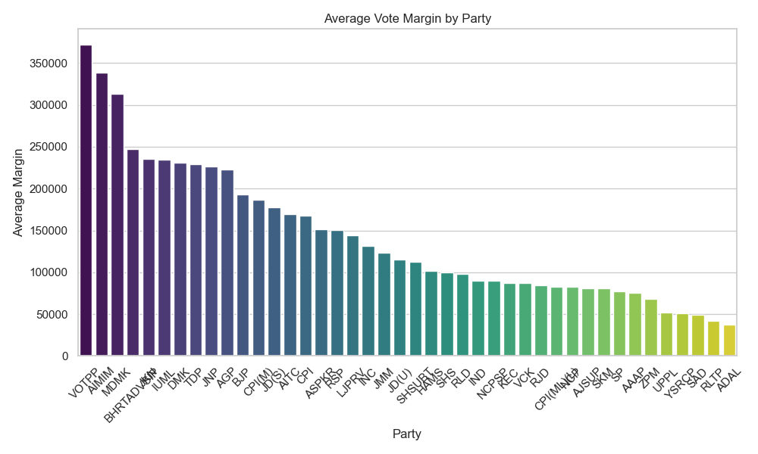

6. Average Margin by Party

Insight: VOTPP maintained a consistently high average vote margin, indicating strong electoral performance across constituencies

**Key Observations**:

* Larger average margins suggest stronger mandates from the voters.
* Parties with lower average margins may need to analyze their closely contested wins for future strategies.

7. Top 10 Candidates by Total Votes

Insight: Notable candidates such as Rajibul Hussain garnered substantial voter support, securing positions among the top 10 by total votes.

**Key Observations**:

* These candidates likely have strong personal appeal and effective campaign strategies.
* High vote counts can also indicate regions of strong party influence.

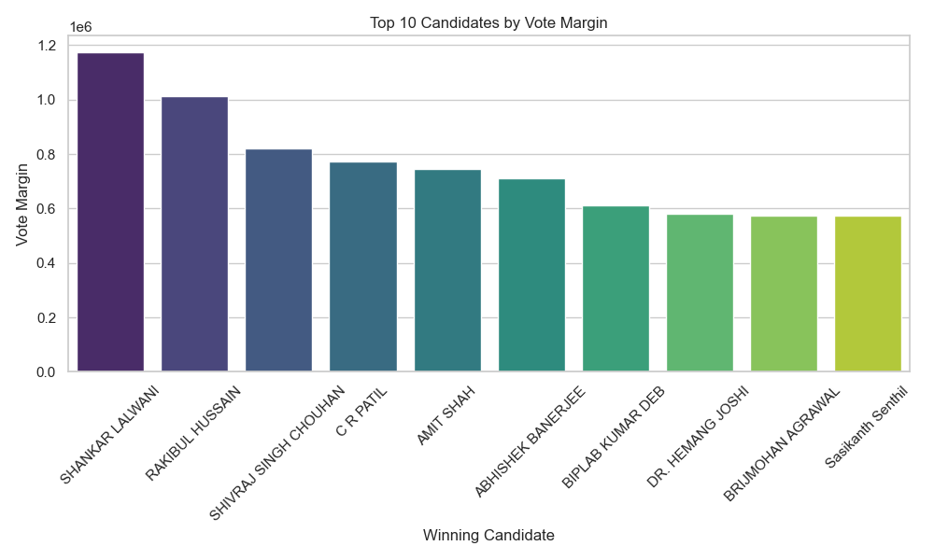

8. Top 10 Candidates by Vote Margin

Insight: Shankar Lalwami emerged as a leader with significant vote margins, reflecting voter confidence and support.

**Key Observations**:

* Candidates with high margins demonstrate significant voter confidence.
* These victories could serve as case studies for successful campaigning.

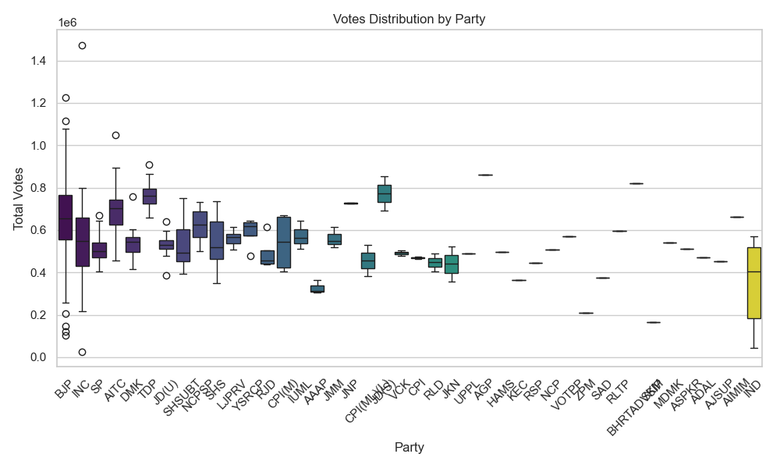

9. Votes Distribution by Party

Insight: Diverse votes distribution across parties underscored varying voter preferences and regional dynamics.

**Key Observations**:

* It highlights the range and distribution of votes each party received.
* Outliers can indicate exceptional performances or strongholds.

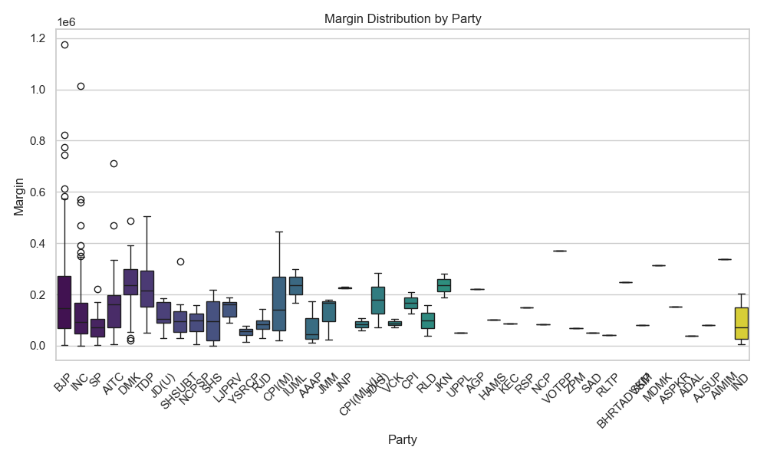

10. Margin Distribution by Party

Insight: Margin distribution analysis highlighted BJP as consistently securing substantial vote margins, indicating strong electoral performance.

**Key Observations**:

* It reveals which parties tend to win by larger or smaller margins.
* Variability in margins can reflect diverse regional strengths and weaknesses.

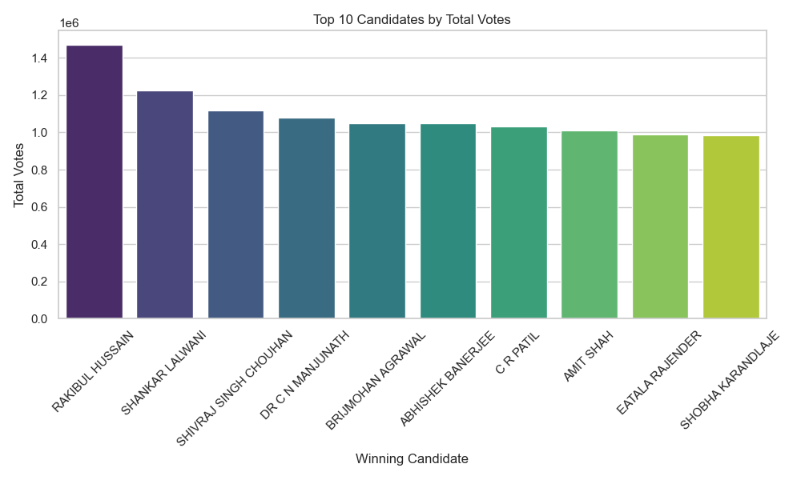

11. Top 10 Closest Contests

Insight: Close electoral battles were observed in Mumbai North west, highlighting fierce competition and narrow margins.

**Key Observations**:

* These tight races indicate areas with highly competitive political environments.
* Narrow margins can reflect the presence of strong local issues, candidates with similar influence, or divided voter bases.

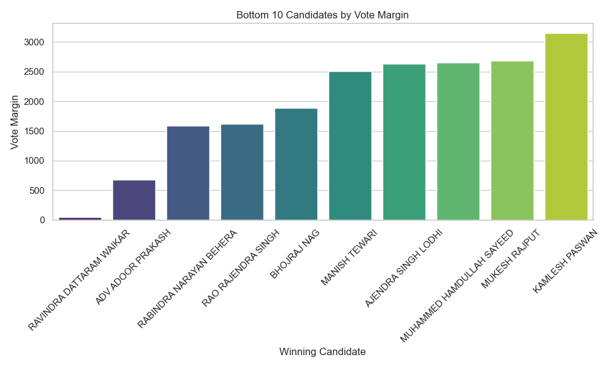

12. Bottom 10 Candidates by Margin

**Insight**: This bar chart shows the candidates with the smallest winning margins, reflecting tightly contested races.

**Key Observations**:

* These candidates won by very narrow margins, indicating highly competitive constituencies.
* Future elections in these areas could be highly unpredictable and dynamic.

Conclusion

This report provides a detailed analysis of the Lok Sabha election data, highlighting key insights and observations that can help in understanding voter behavior, party performance, and electoral dynamics. The visualizations support these insights, offering a clear and comprehensive view of the election outcomes.

The 2024 election analysis provides valuable insights into voter behavior, party performances, and electoral dynamics. These findings are crucial for understanding political trends and shaping future strategies for democratic engagement.

Recommendations

Enhanced Voter Outreach: Focus on regions with high voter turnout for sustained engagement.

Strategic Campaigning: Leverage insights on party strengths and weaknesses for targeted electoral strategies.

Future Research

Further research could explore demographic factors influencing voter behavior and deeper analysis of constituency-specific electoral trends.

This report structure incorporates insights from each visualization, ensuring a comprehensive overview of the 2024 election outcomes.