Project Title:
Meghana Library:
Project Prepared by:Meghana Akula
Platforms: VS Code
Language’s: HTML, CSS
Submitted To:Pruthvi Raj Singh
Submitted From:Meghana
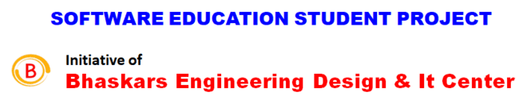
Contact: 80500 91122
Email: bhaskar@cadenggr.com
Contact: 80500 91122
Email: bhaskar@cadenggr.com

CONTENTS:
S.NO | Chapters | PG.NO
1. | Abstract | 03
2. | Problem statement of project | 04
3. | Requirements | 05
4. | What are the technologies used in building the project? | 06
5. | PROJECT CODE | 07-43
6. | OUTPUT SCREENSHOTS | 44-58
7. | REFERENCE | 59
8. | CONCLUSION | 60-61

Abstract:
Library management system is a project which aims in developing a computerized system to maintain all the daily work of library. This project has many features which are generally not available in normal library management systems like facility of user login and a facility of
teacher’s login. It also has a facility of admin login through which the admin can monitor the whole system. It also has facility of an online notice board where teachers can student can put up information about workshops or seminars being held in our colleges or nearby colleges and librarian after proper verification from the concerned institution organizing the seminar can add it to the noticeboard. It has also a facility where student after logging in their accounts can see list of books issued and its issue date and return date and also the students can request the librarian to add new books by filling the book request form. The librarian after logging into his account i.e. admin account can generate various reports such as student report, issue report,teacher report and book report.

Overall, this project of ours is being developed to help the students as well as staff of library to maintain the library in the best way possible and also reduce the human efforts.

Problem statement of project:
Create a visually appealing and user-friendly web page for a Library that showcases the following features:

- A header section with the library logo, navigation menu, and billing and about icon.
- A hero section featuring a high-quality image of a popular product or promotion.
- A product showcase section displaying at least 3 products with images, descriptions, and prices.
- A featured collection section highlighting a specific category of products.
- A call-to-action (CTA) section encouraging visitors to explore the library or make a purchase.
- A footer section with contact information, social media links, and copyright information.

Requirements:

- Use HTML5 semantic elements to structure the content.
- Write clean, modular, and responsive CSS code using a per-processor.
- Ensure cross-browser compatibility and mobile-friendliness.
- Use visual hierarchy and design principles to create an aesthetically pleasing design.
- Incorporate fonts, colors, and imagery that reflect the boutique store's brand identity.

What are the technologies used in building the project?
Platforms: VS Code
Language’s: HTML, CSS

VS Code:
This platform was very comfortable for me while building the problem statement. Very easy in understanding and executing the work.
Language’s:
HTML and CSS was thought in very full length way for us which made us easy in building things.

PROJECT CODE :
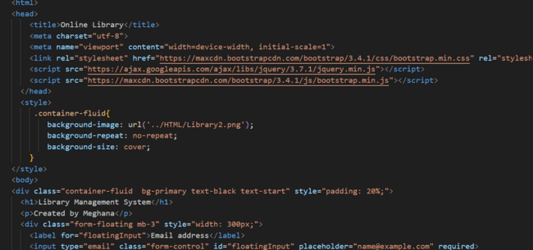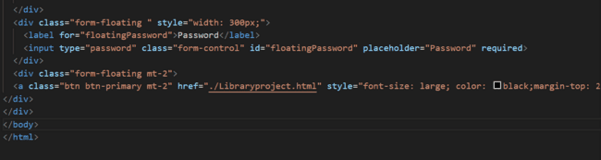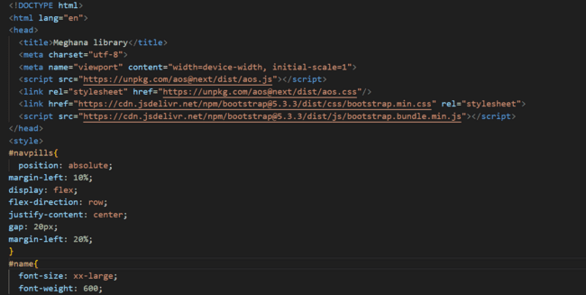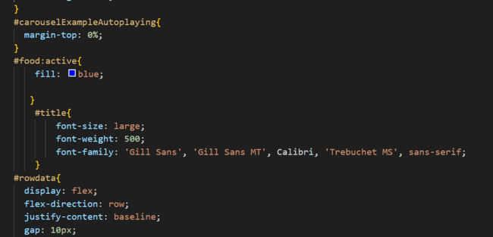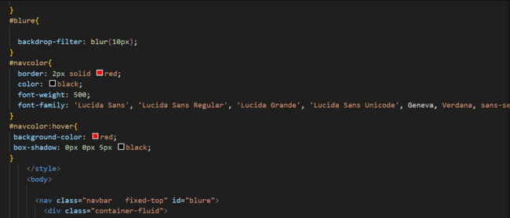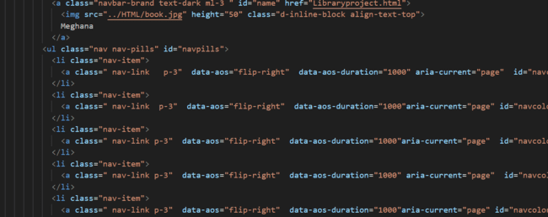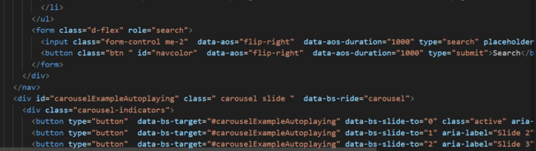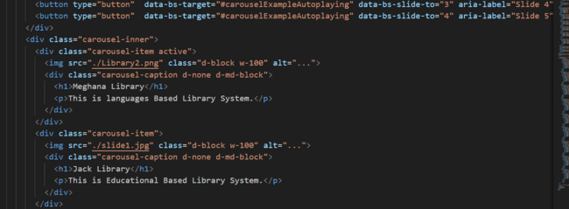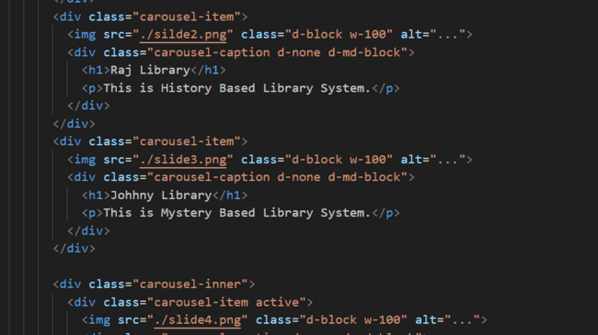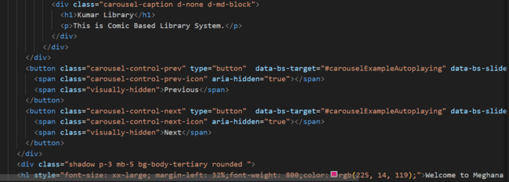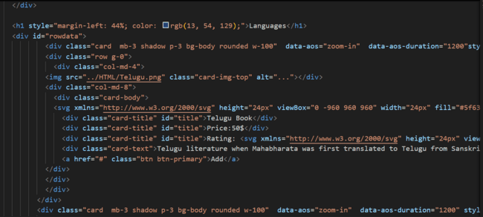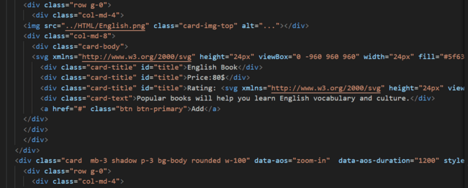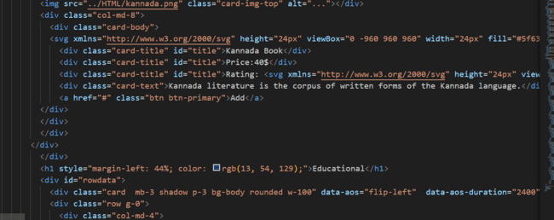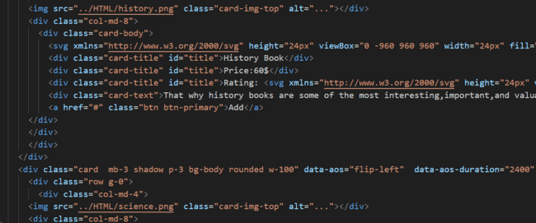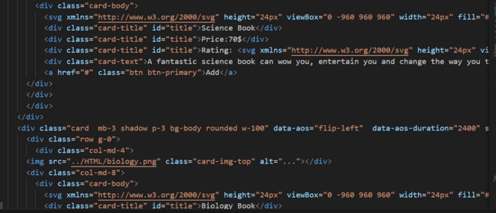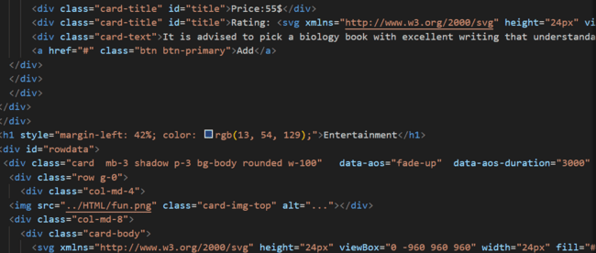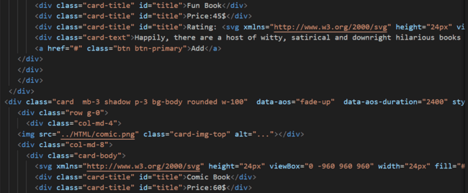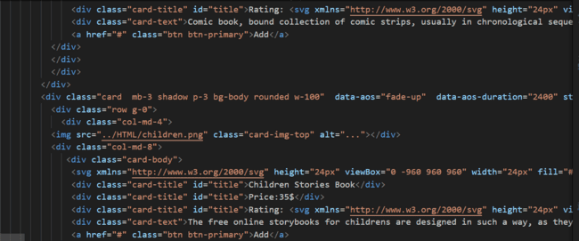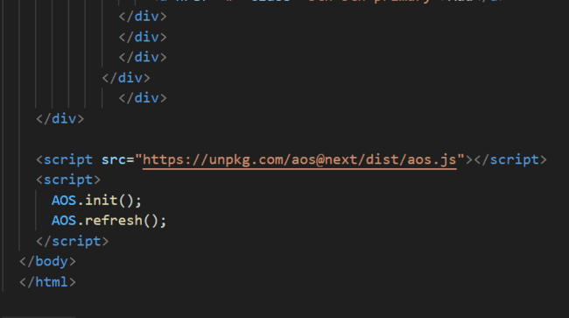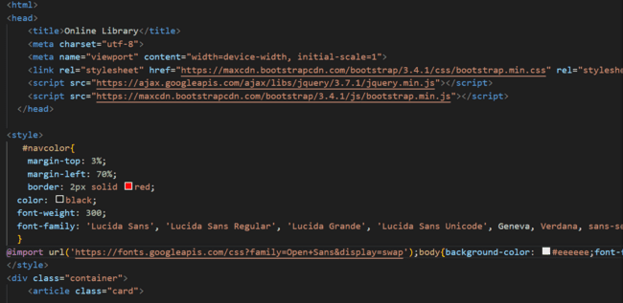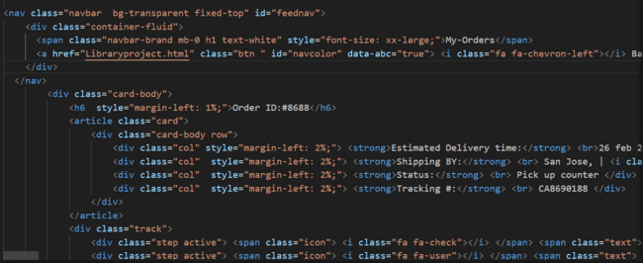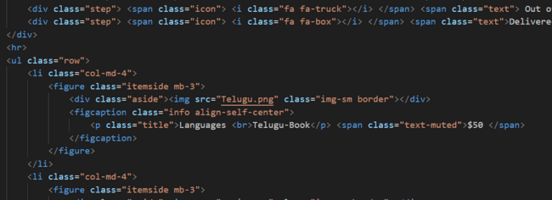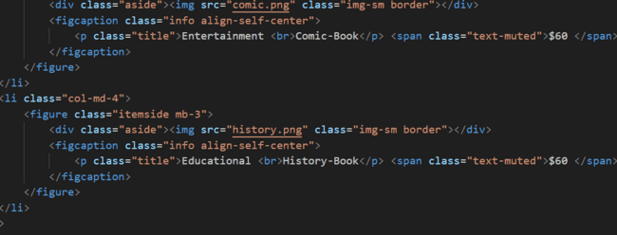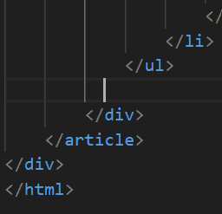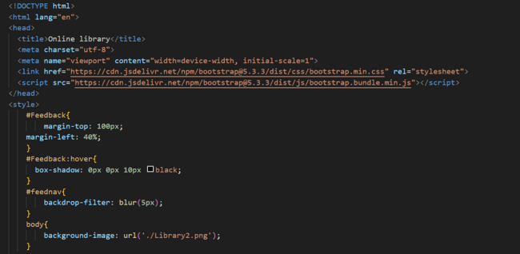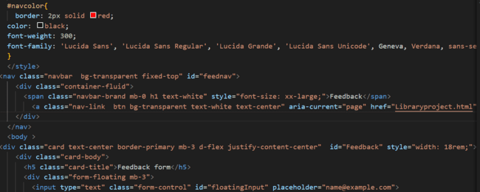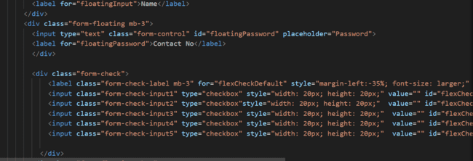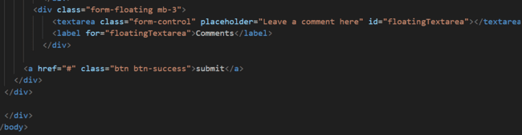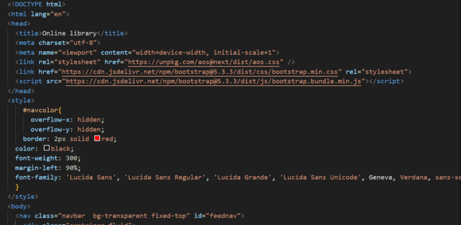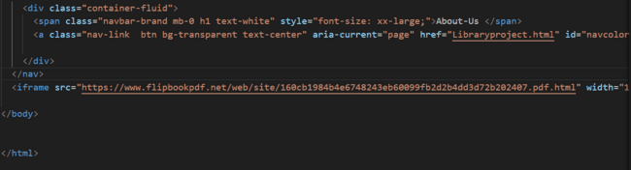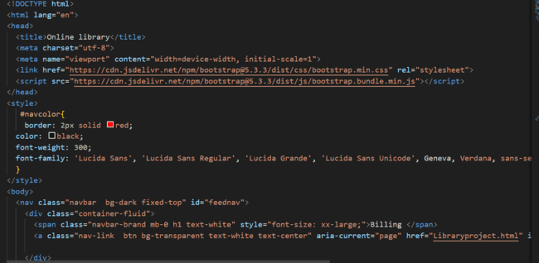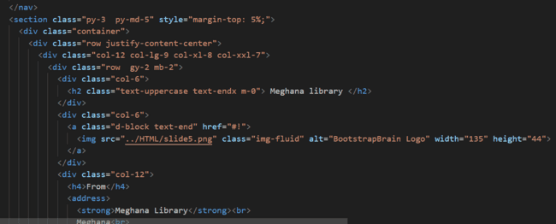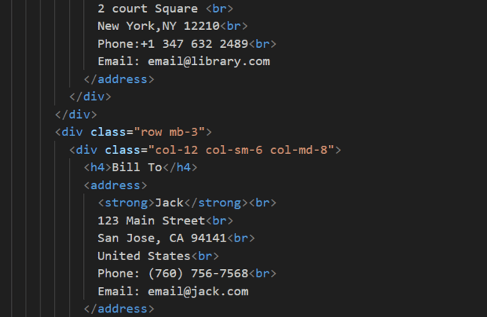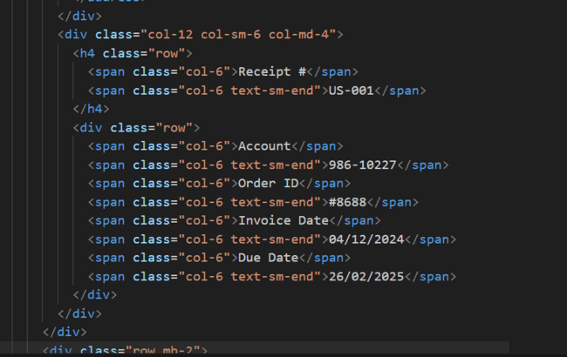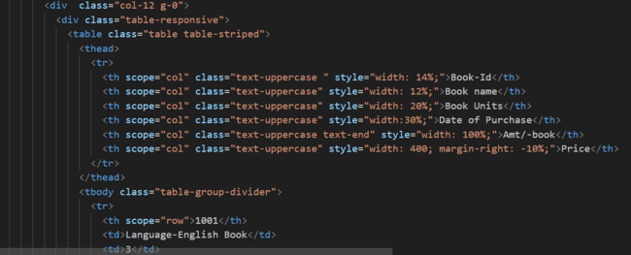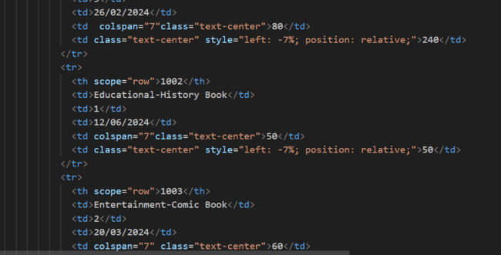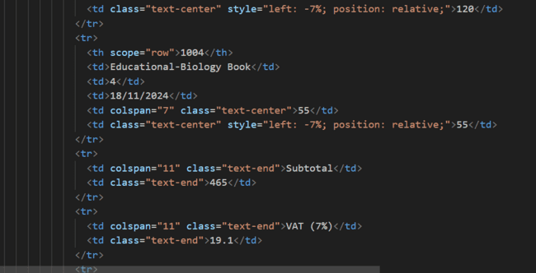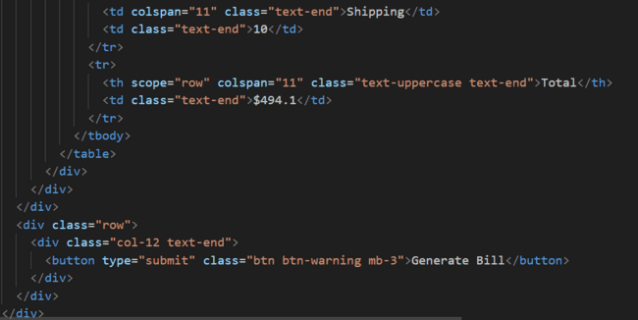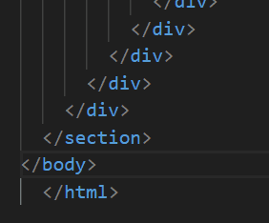

OUTPUT SCREENSHOTS:
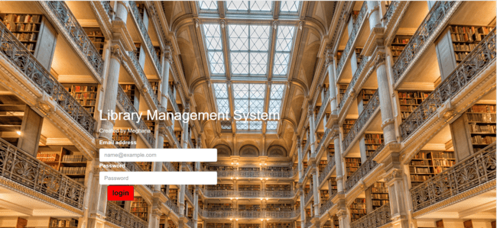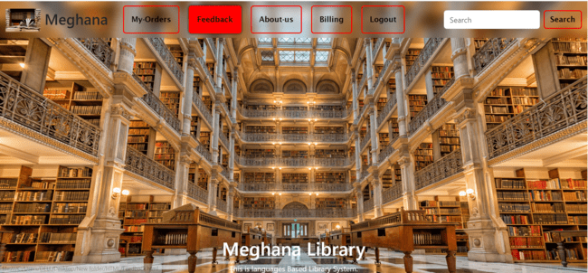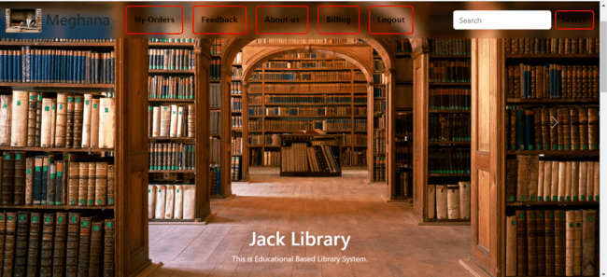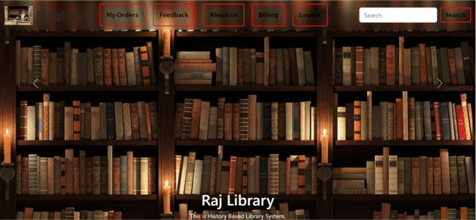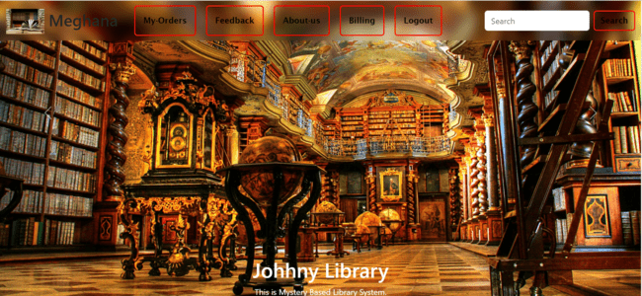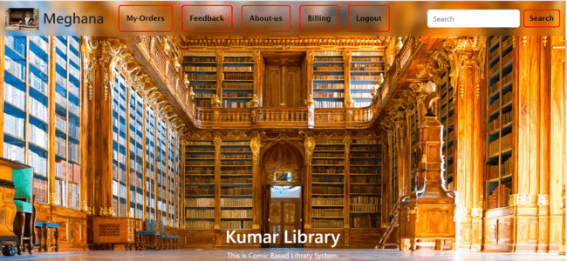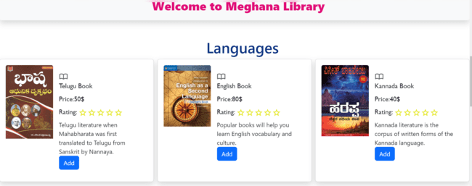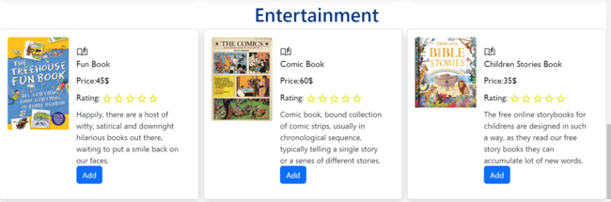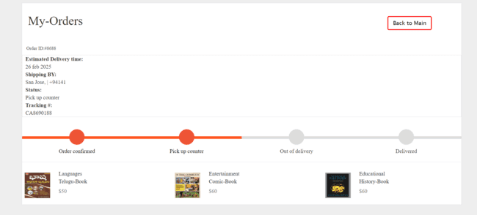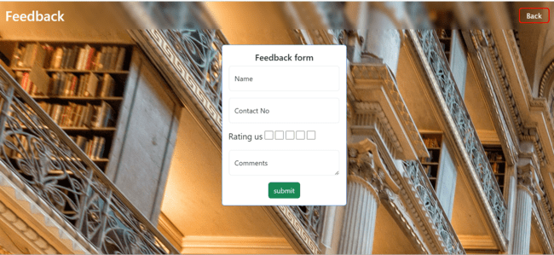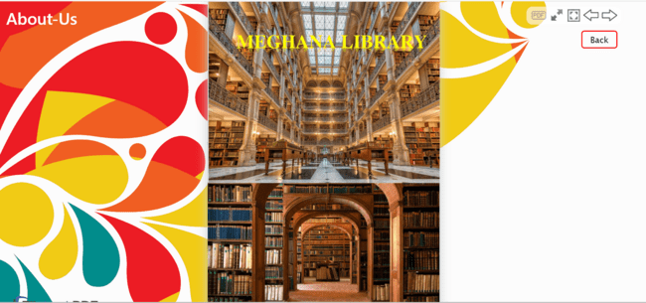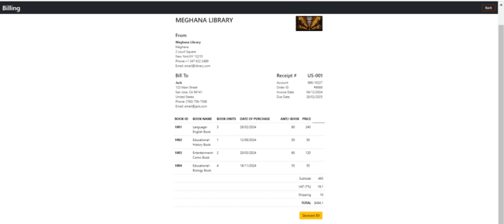

REFERENCE:
- CAD DESK helped us in building this website, they helped us in very single query while this project.
- They guided me in a way to get more innovate and ideology in creating the project.
- They thought us the tools and also in understanding the errors occurrence.

CONCLUSION:
The library management system has been computed successfully and was also tested successfully by taking "Test Cases". It is user friendly, and has required options, which can be utilized by the user to perform the desired operations. Library Management System is developed using HTML, CSS, JS as front end and PHP, MySQL as back end on windows environment.

The goals that are achieved by the software are:
- User friendly.
- Simplification of the operations.
- Portable and flexible for further enhancement.
- Less processing time and getting required information.

THANK YOU….

Contact: 80500 91122
Email: bhaskar@cadenggr.com

