Project Title:
Meghana Boutique Store:
Project Prepared by: Meghana Akula
Platforms: VS Code
Language’s: HTML, CSS
Submitted To:Pruthvi Raj Singh
Submitted From:Meghana
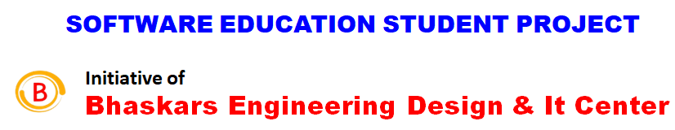
Contact: 80500 91122
Email: bhaskar@cadenggr.com
Contact: 80500 91122
Email: bhaskar@cadenggr.com
CONTENTS:
S.NO | Chapters | PG.NO
1. | Abstract | 03
2. | Problem statement of project | 04
3. | Requirements | 05
4. | What are the technologies used in building the project? | 06
5. | PROJECT CODE | 07-30
6. | OUTPUT SCREENSHOTS | 31-36
7. | REFERENCE | 40
8. | CONCLUSION | 41

Abstract:
The Meghana Boutique Store is are able to get beautiful blooms with no bursting your budget-provided that spending budget is usually realistic for your bouquets that you want to obtain. Occasionally blending cheaper bouquets with the very same colour as costly flowers may produce a lovely marriage ceremony present, and you will not just notice it is not every tulips or perhaps no matter what costly floral you needed. You should authenticate after which it re-verify the particular date that the blooms will probably be sent. You want those to possibly be new on your big day, but they will probably keep your marriage ceremony simple whenever they make an appearance late. Ensure that your chosen program can easily produce one of which time, at a proper occasion-when you make the invest in.
This will likely decrease the actual disarray that will compass the big day. You'll have lots of other considerations to help worry about-Ordering the flower design on the internet can be a simple process and also a ideal replacement for purchasing a fresh-cut bride's bouquet regarding bouquets from your neighbourhood shop.
Problem statement of project:
Create a visually appealing and user-friendly webpage for a boutique store that showcases the following features:
- A header section with the store's logo, navigation menu, and shopping cart icon.
- A hero section featuring a high-quality image of a popular product or promotion.
- A product showcase section displaying at least 4 products with images, descriptions, and prices.
- A featured collection section highlighting a specific category of products.
- A call-to-action (CTA) section encouraging visitors to explore the store or make a purchase.
- A footer section with contact information, social media links, and copyright information.

Requirements:

- Use HTML5 semantic elements to structure the content.
- Write clean, modular, and responsive CSS code using a preprocessor.
- Ensure cross-browser compatibility and mobile-friendliness.
- Use visual hierarchy and design principles to create an aesthetically pleasing design.
- Incorporate fonts, colours, and imagery that reflect the boutique store's brand identity.

What are the technologies used in building the project?
Platforms: VS Code
Language’s: HTML, CSS

VS Code:
This platform was very comfortable for me while building the problem statement. Very easy in understanding and executing the work.
Language’s:
HTML and CSS was thought in very full length way for us which made us easy in building things

PROJECT CODE :
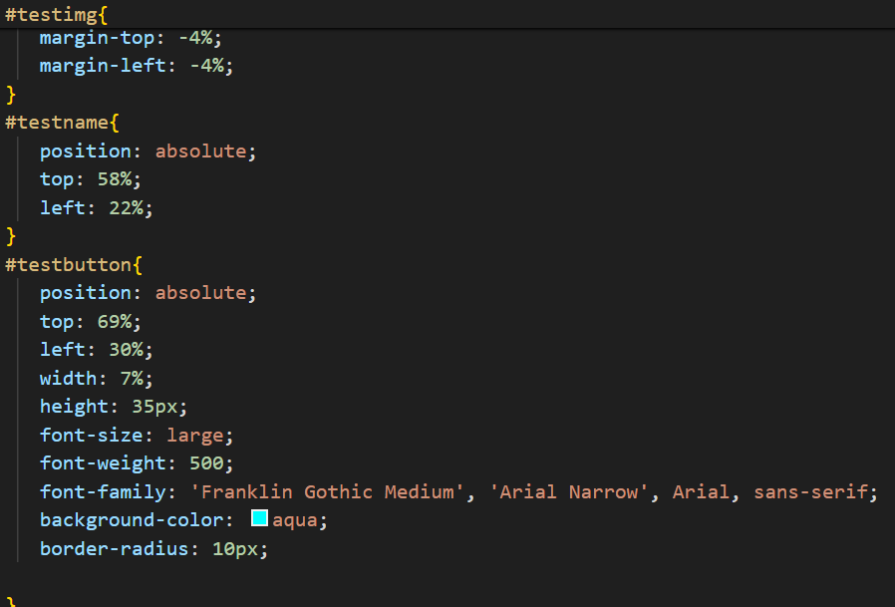
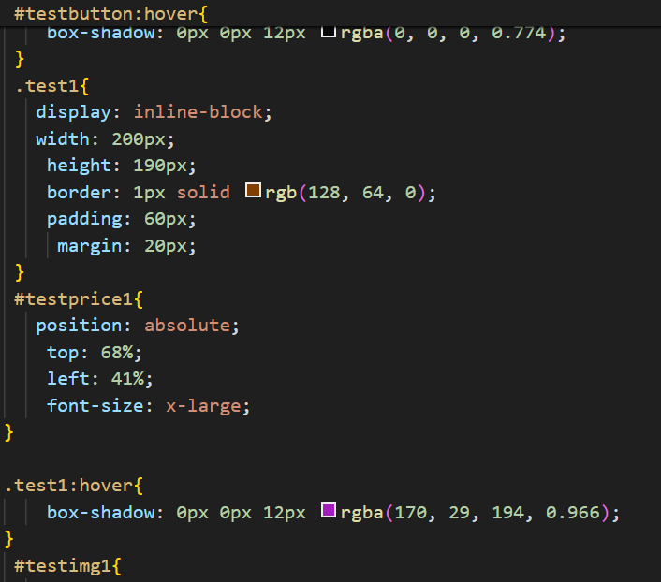
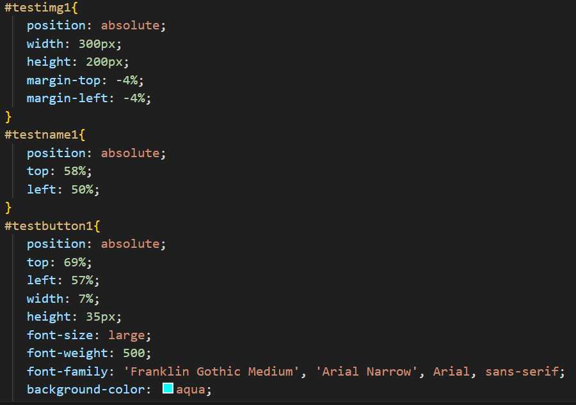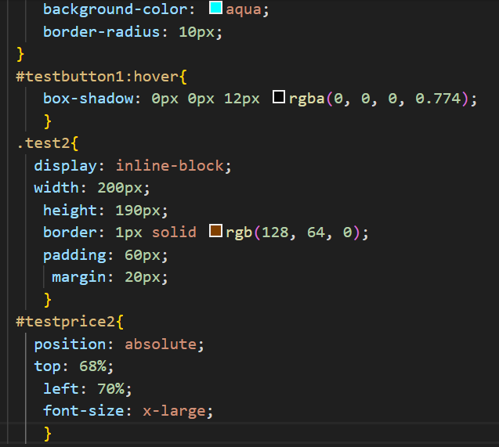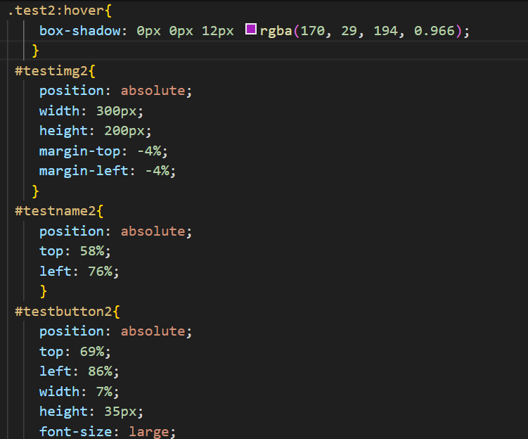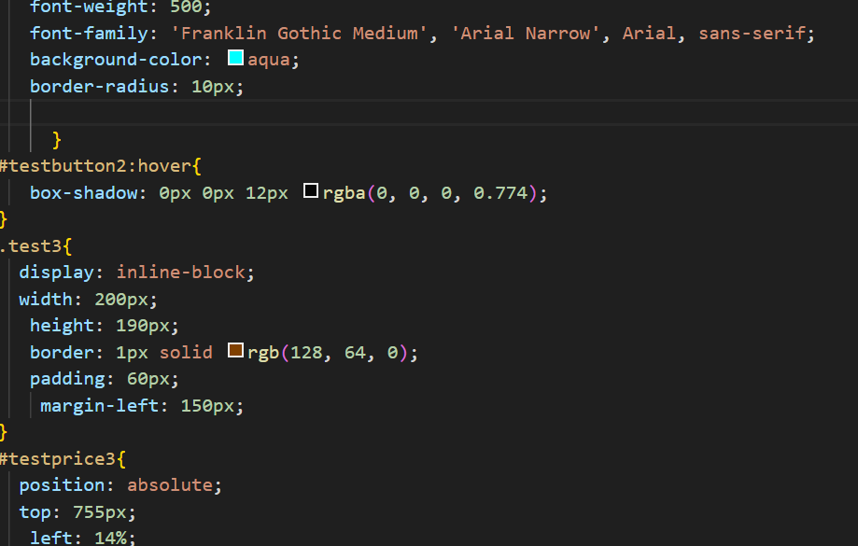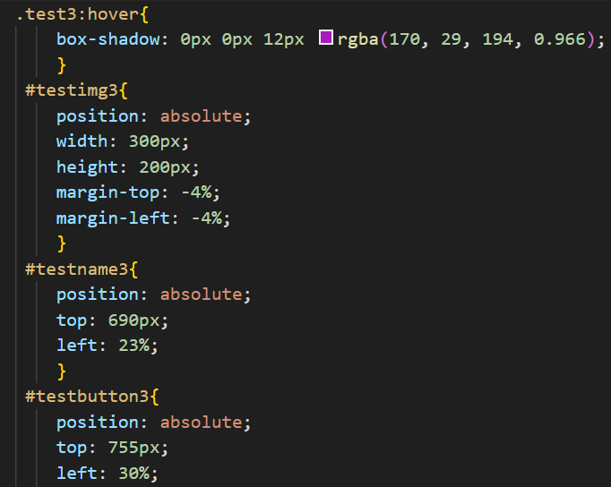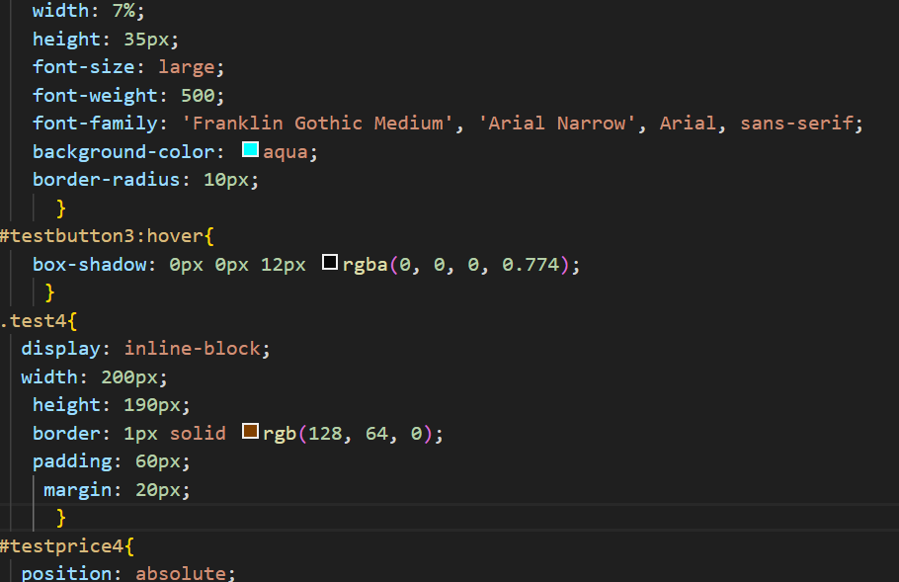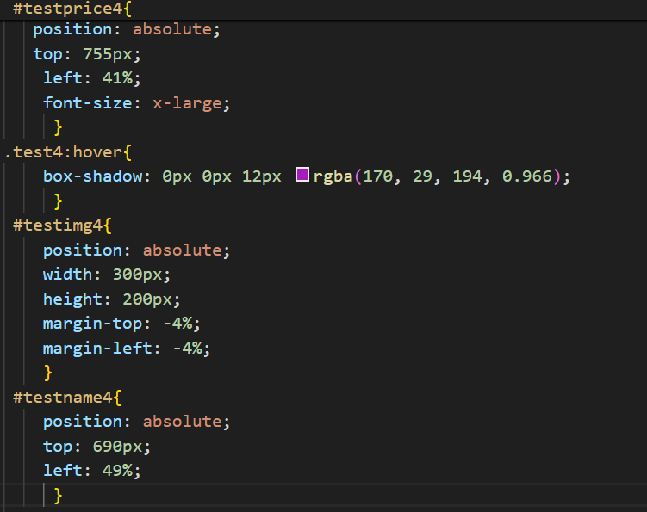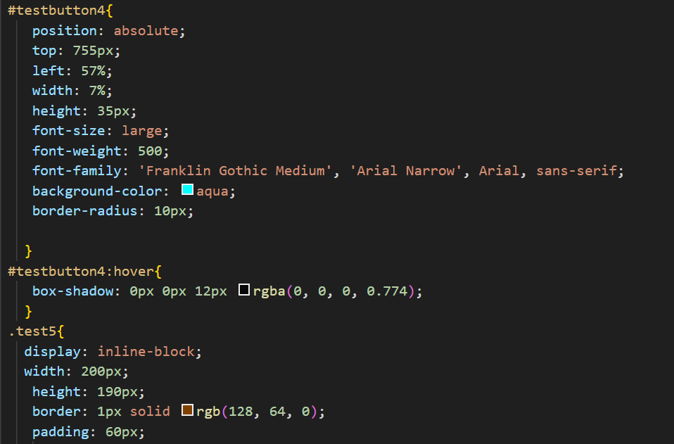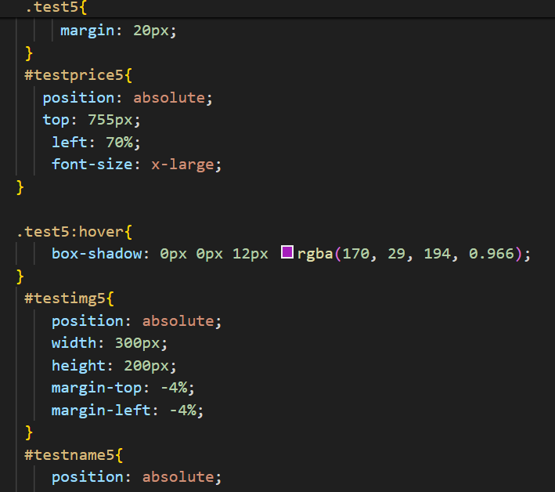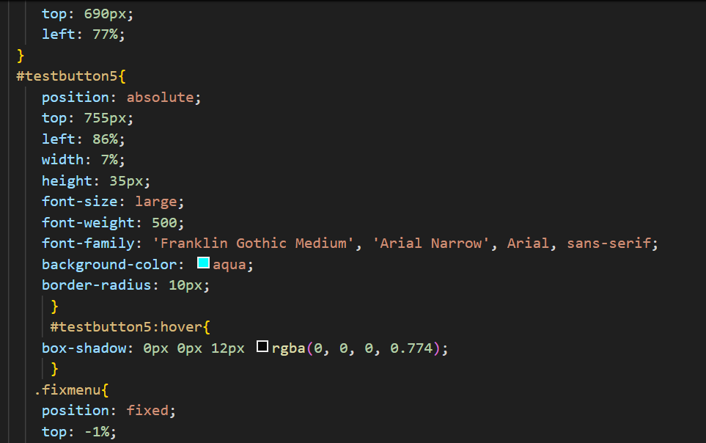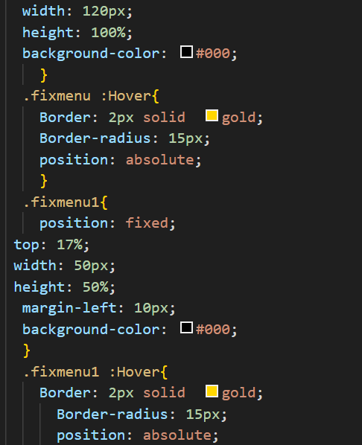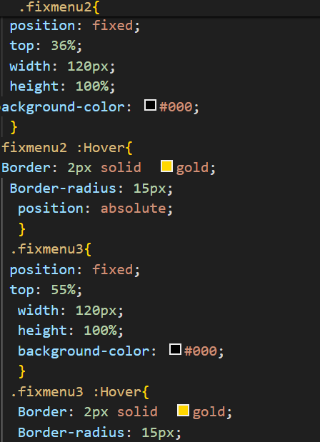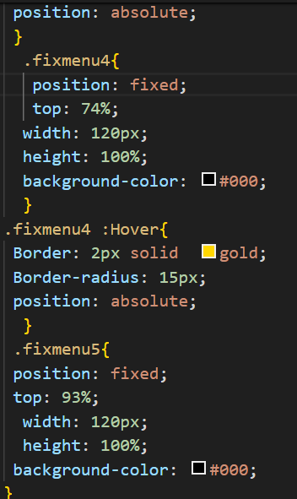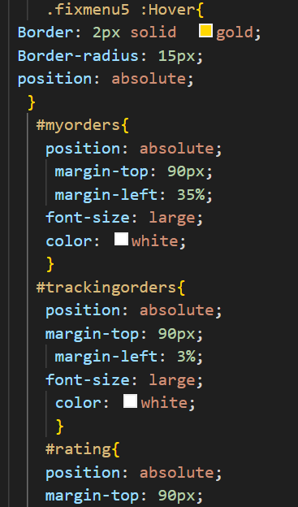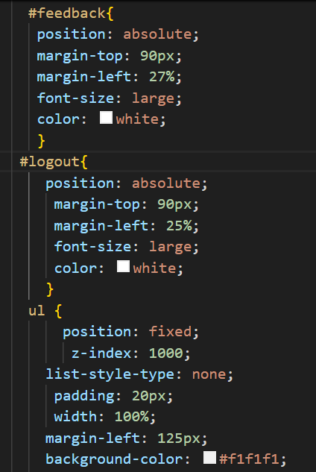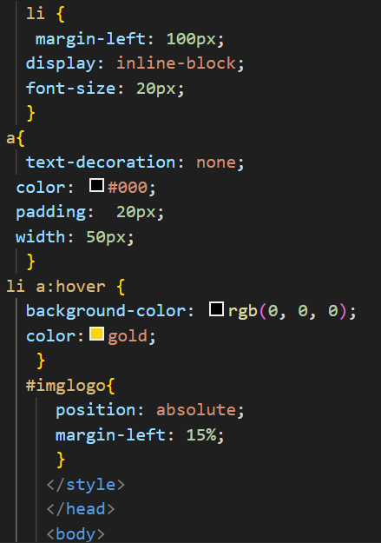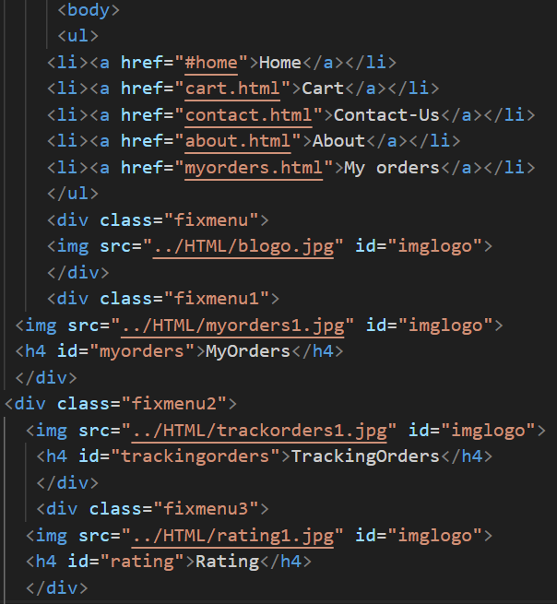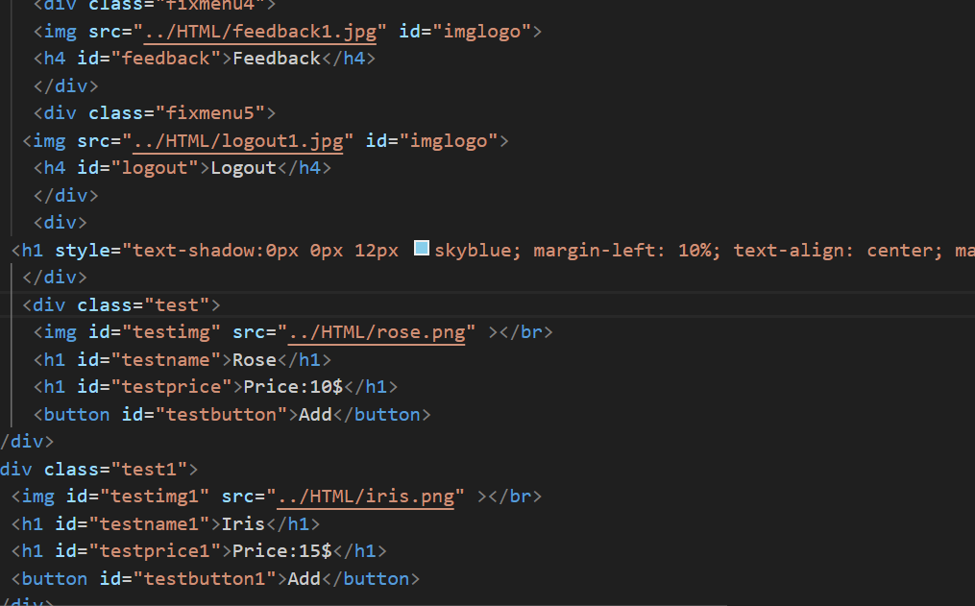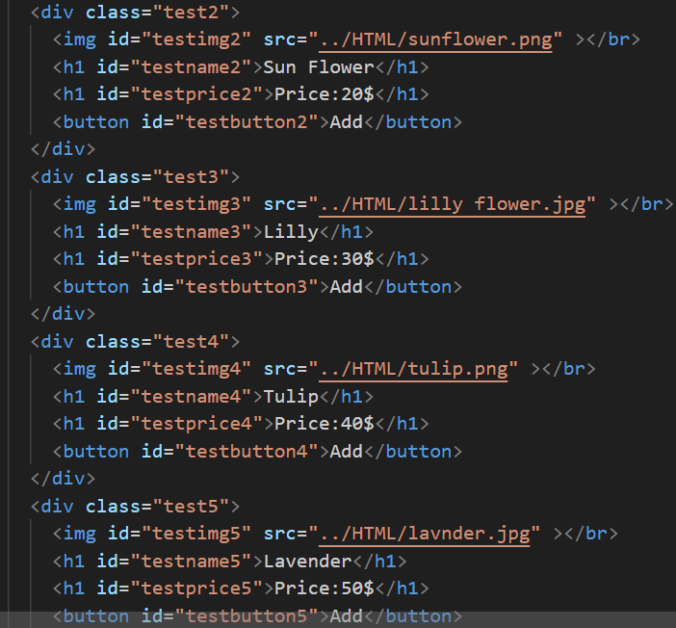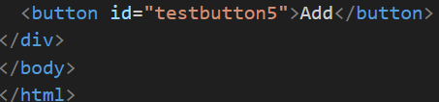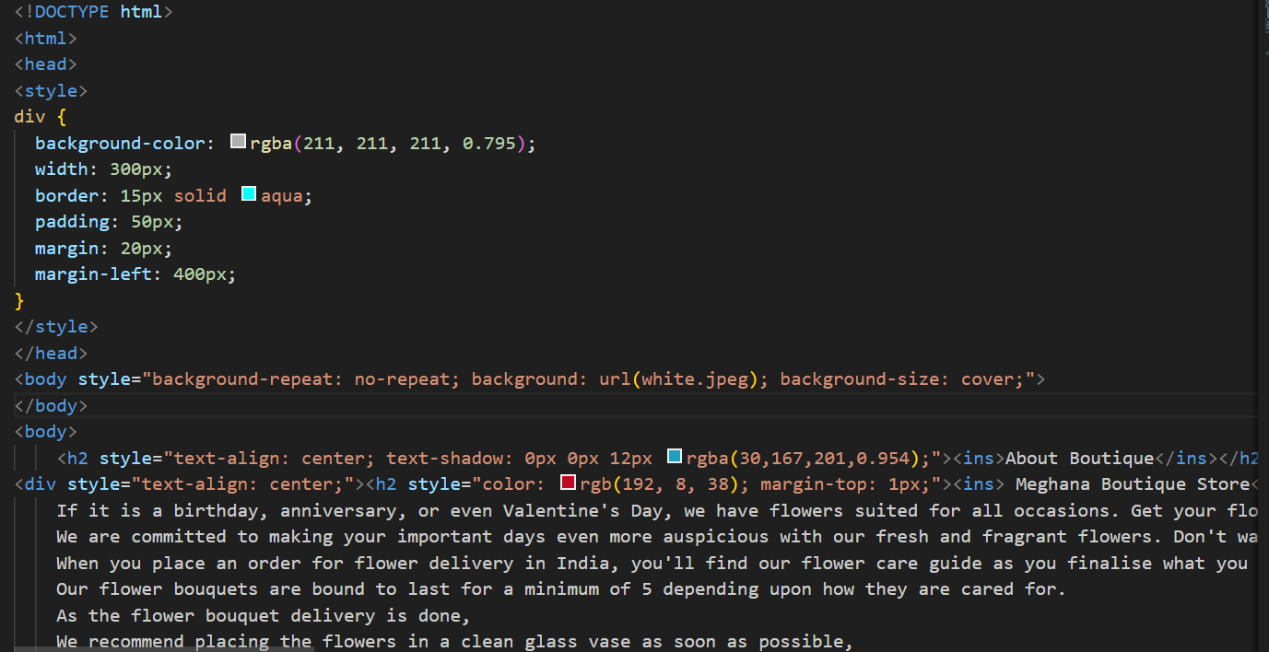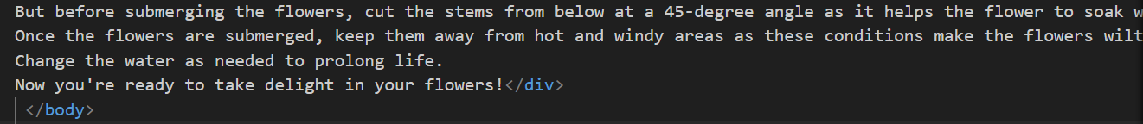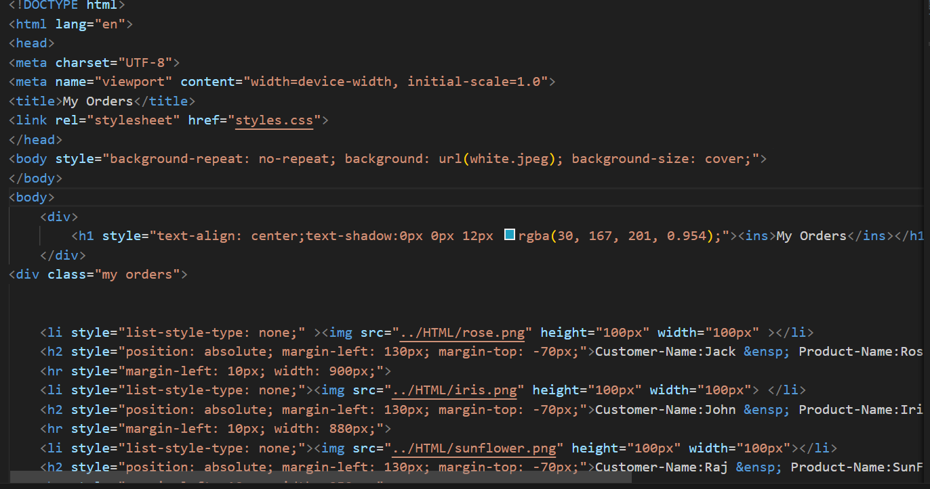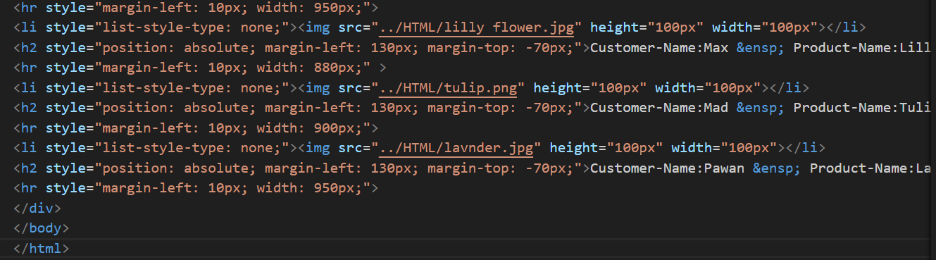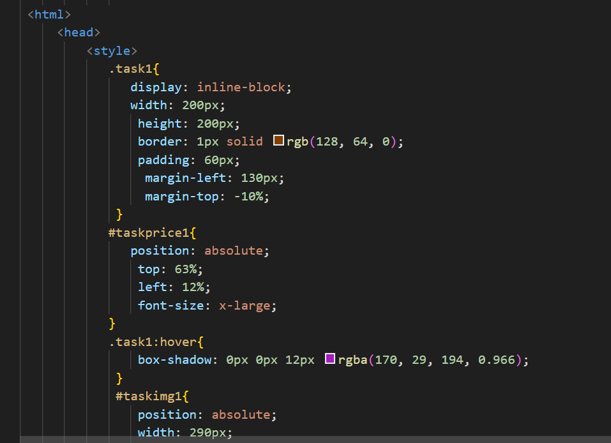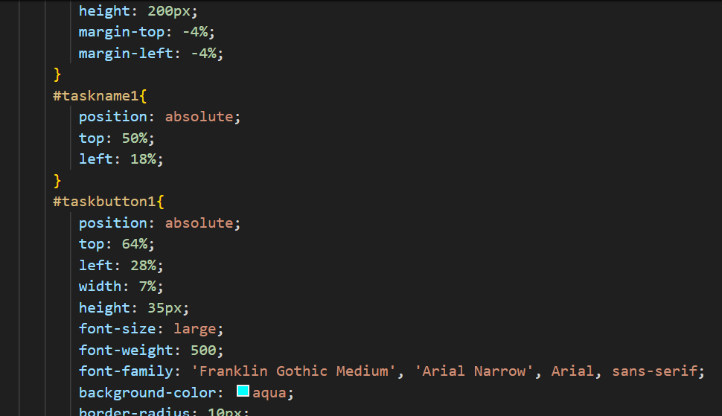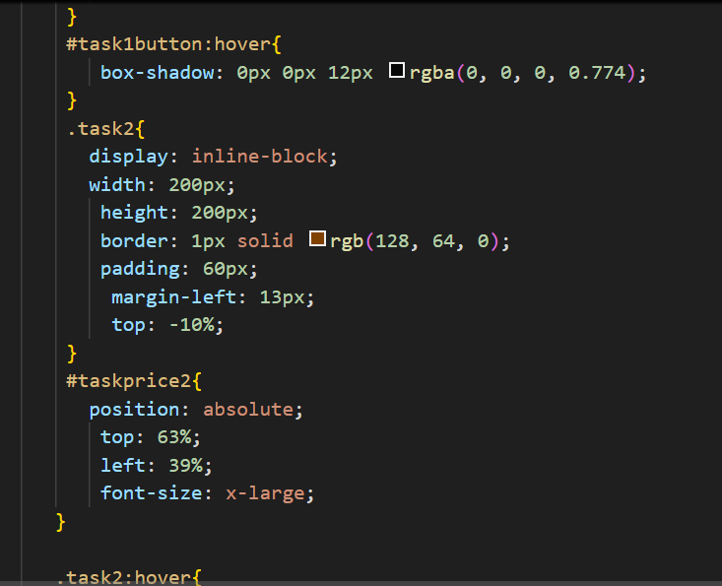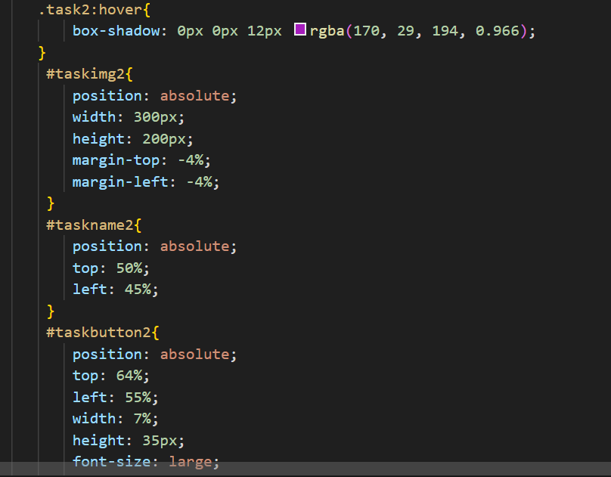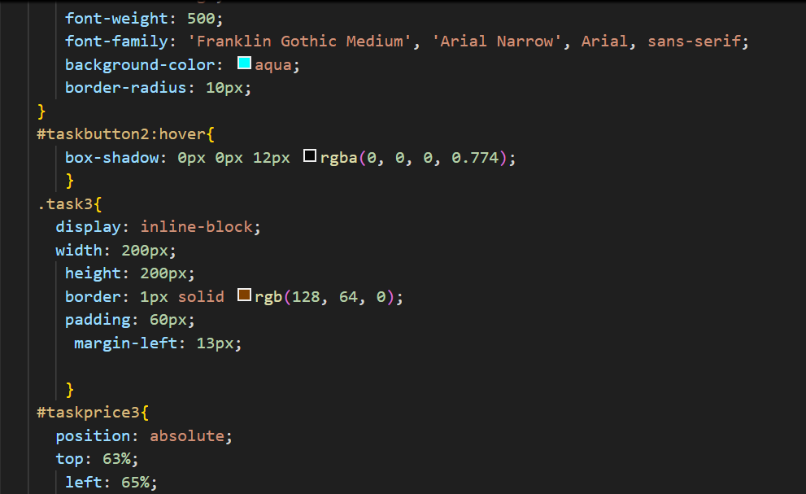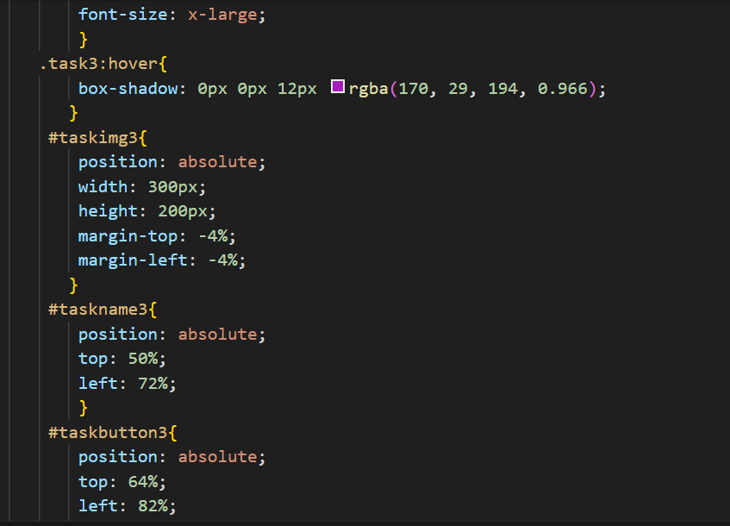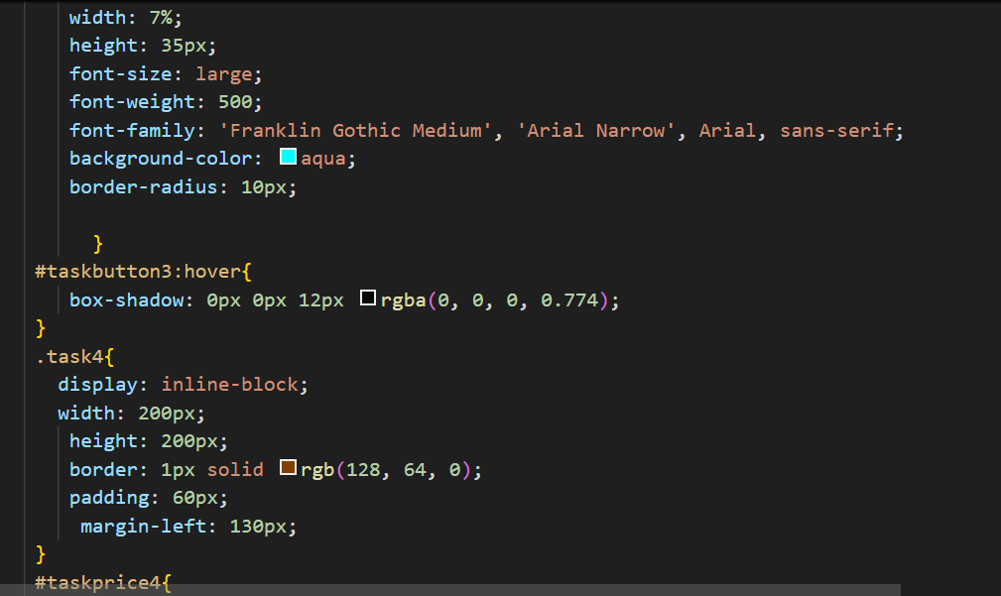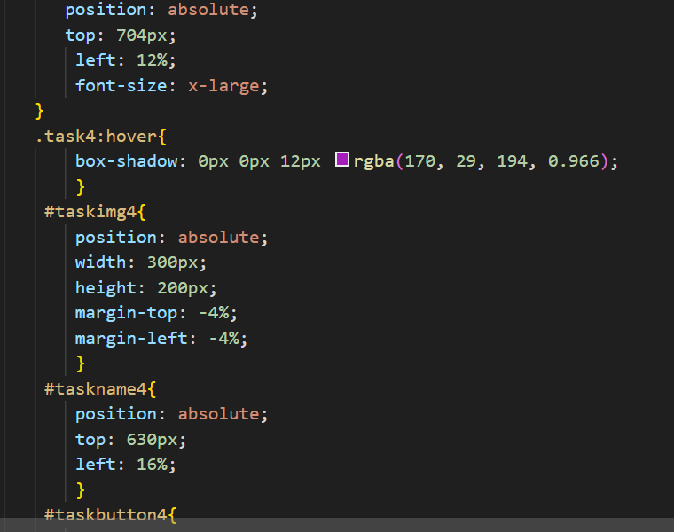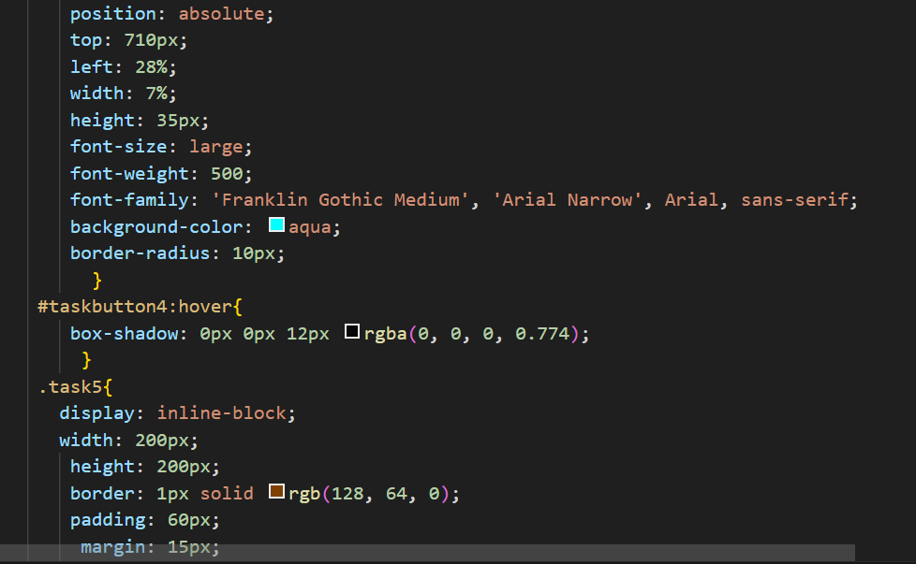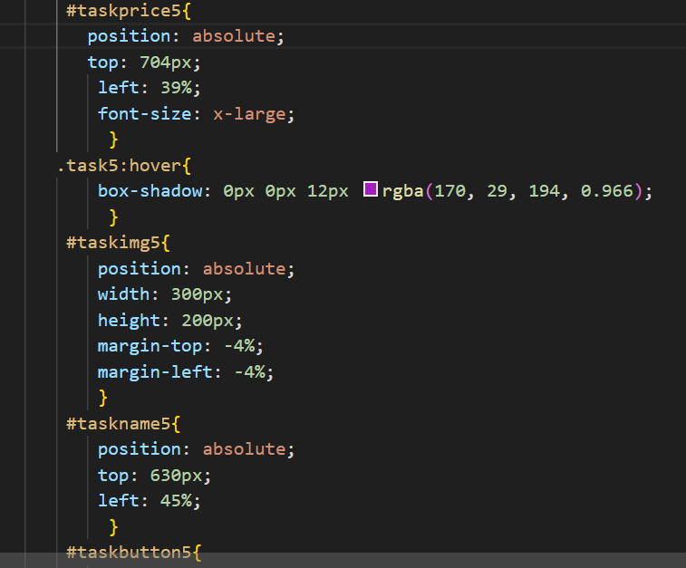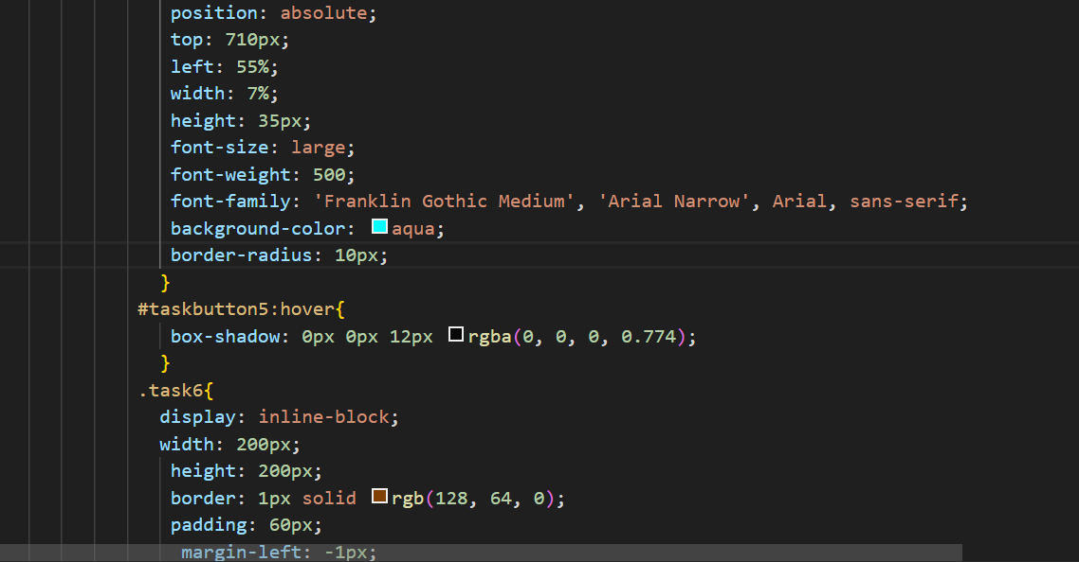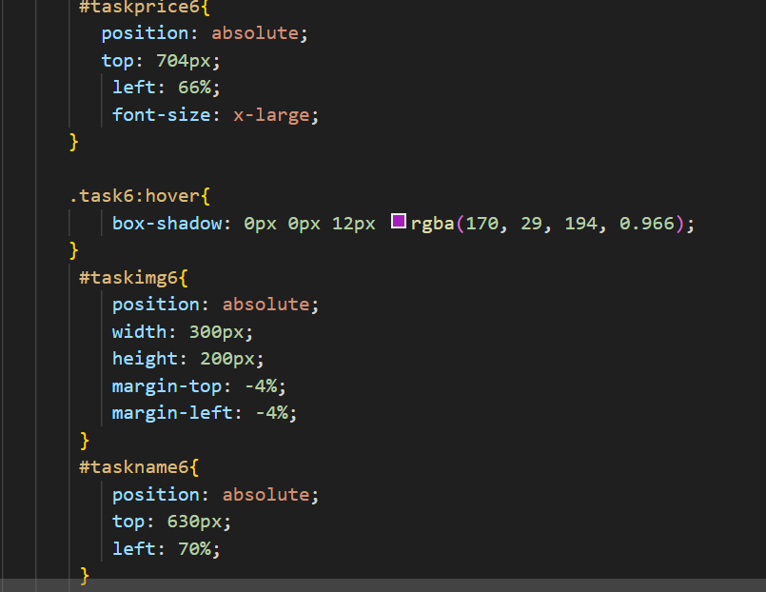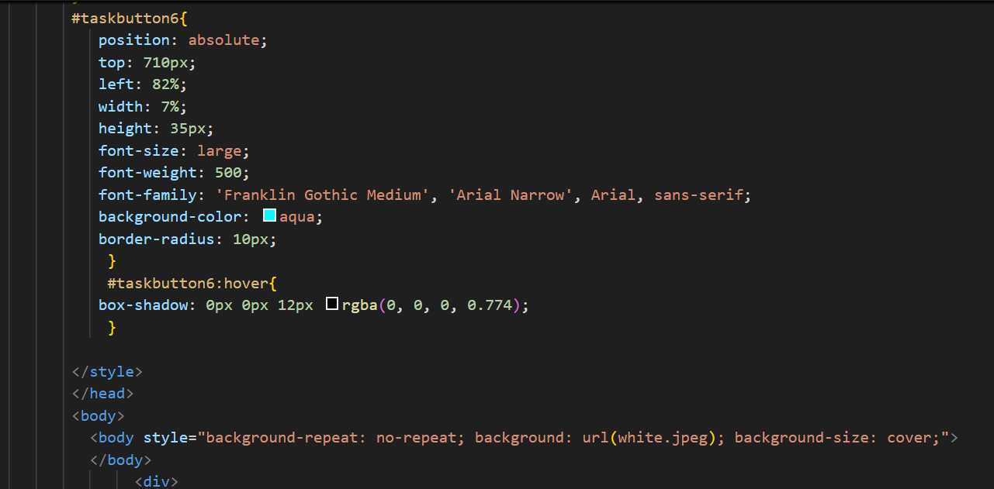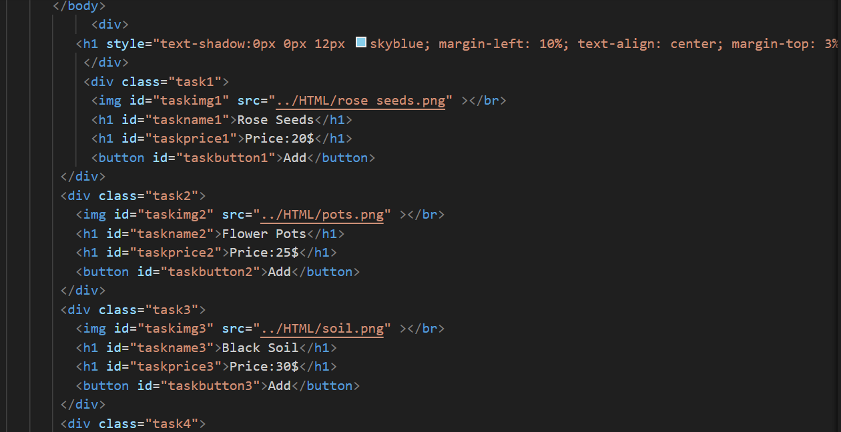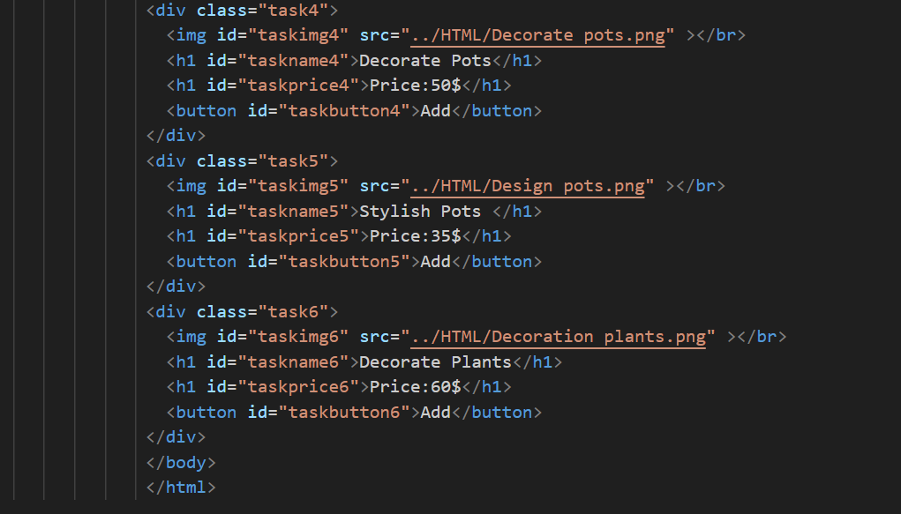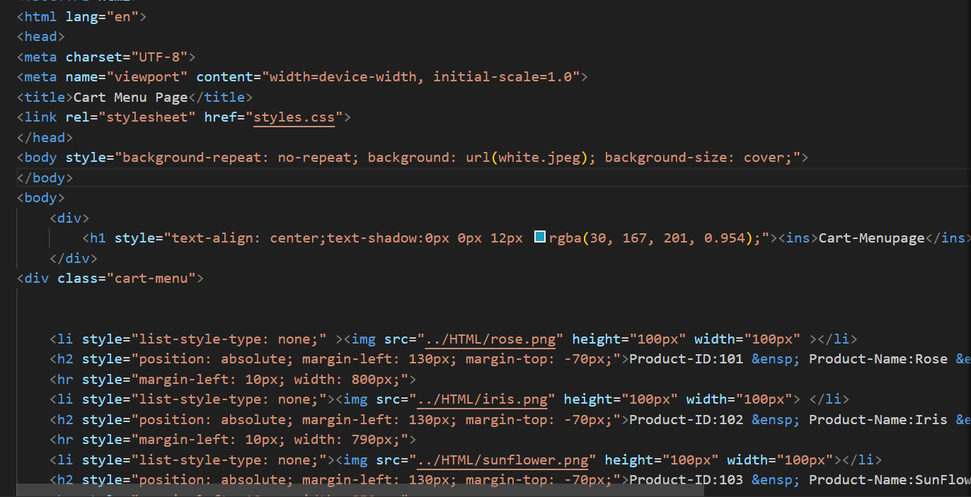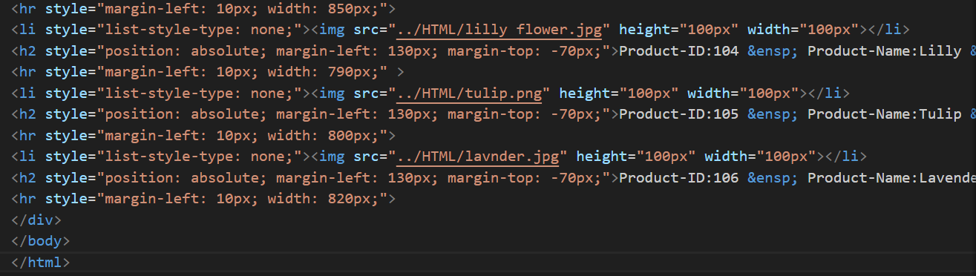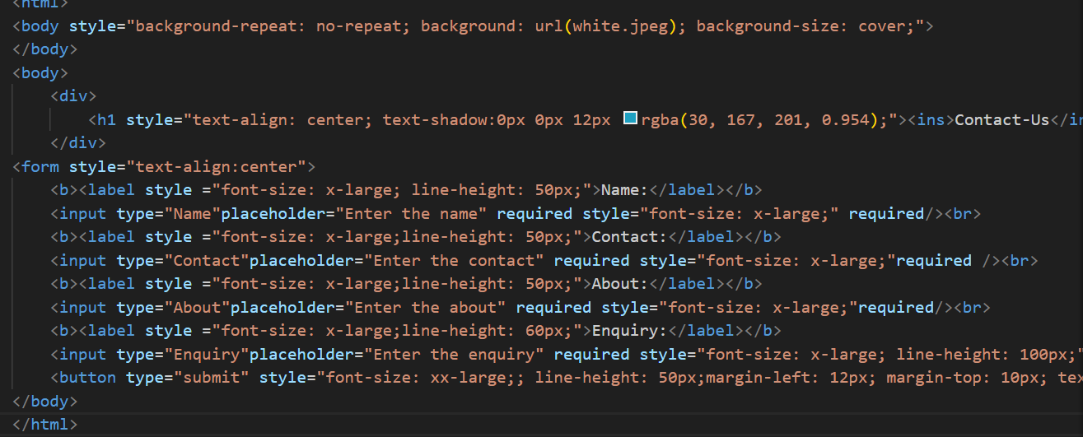

OUTPUT SCREENSHOTS:
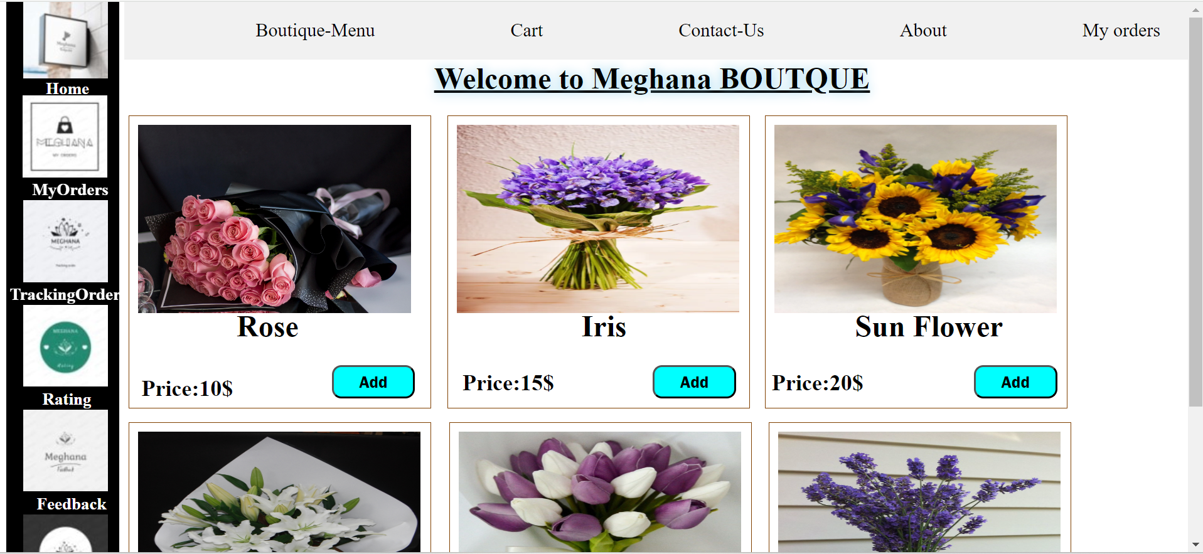
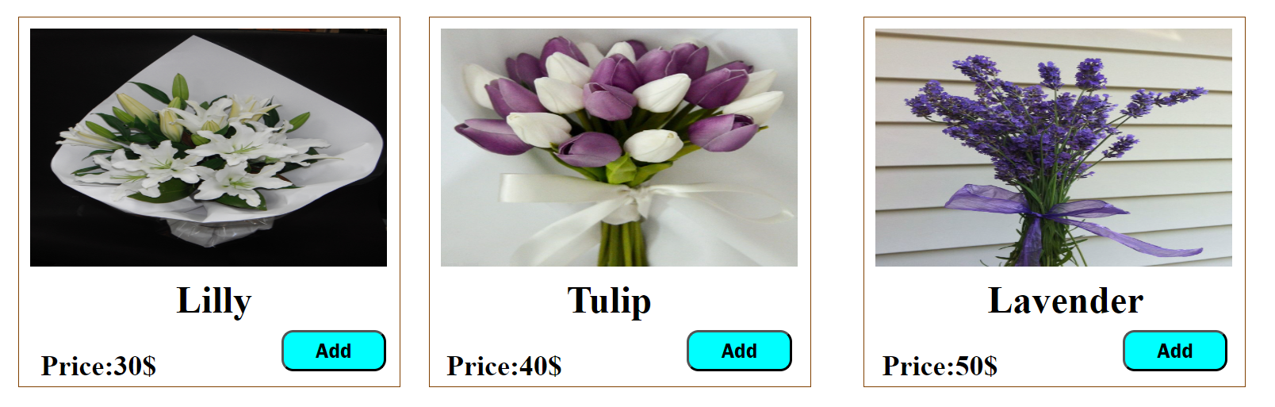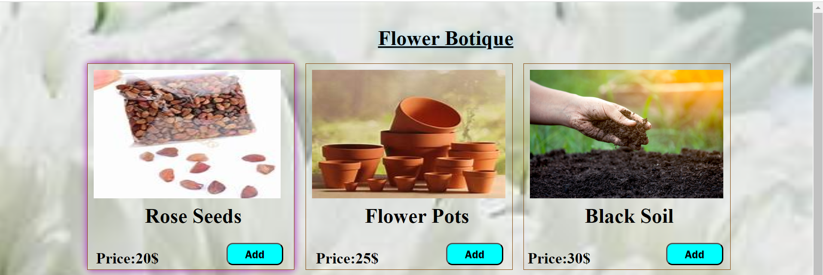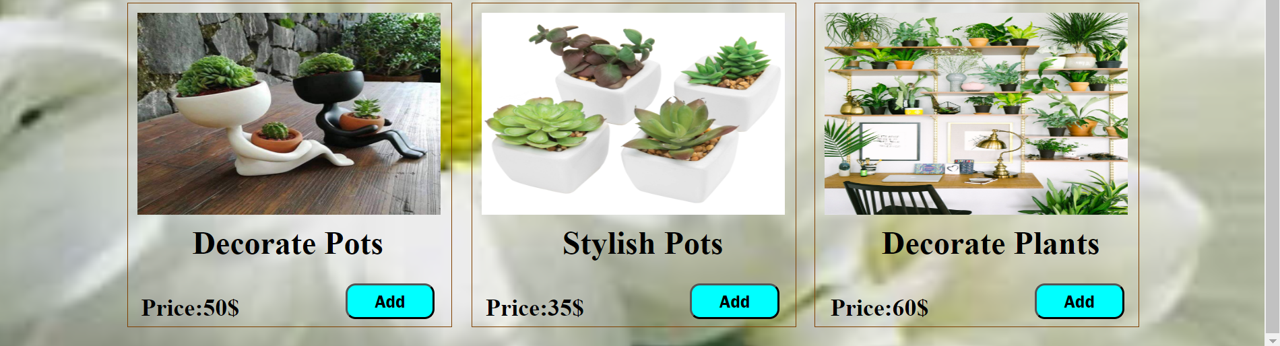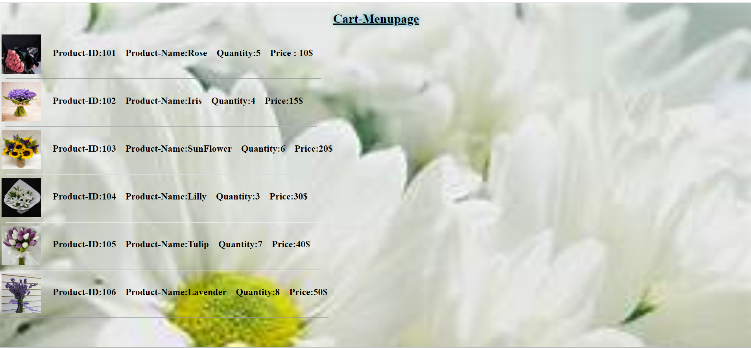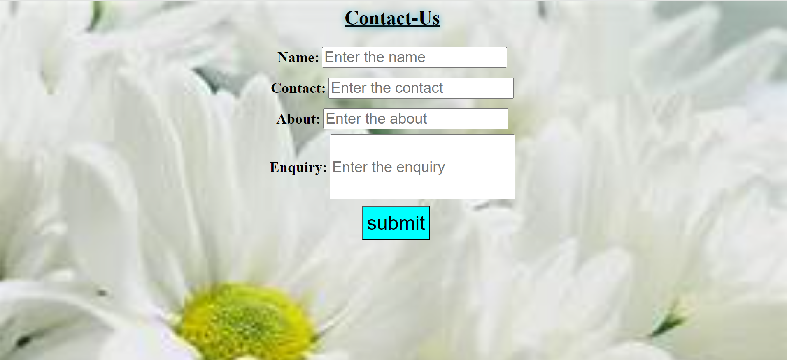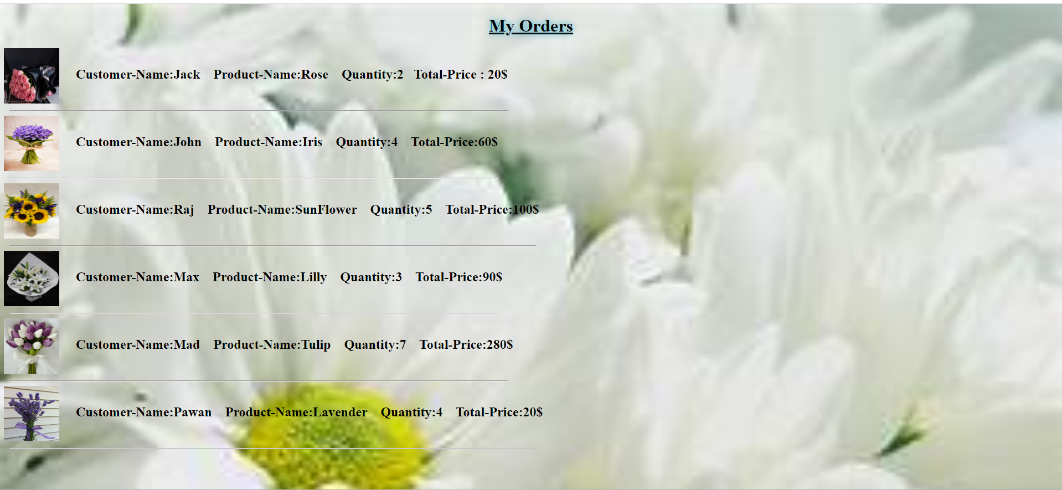

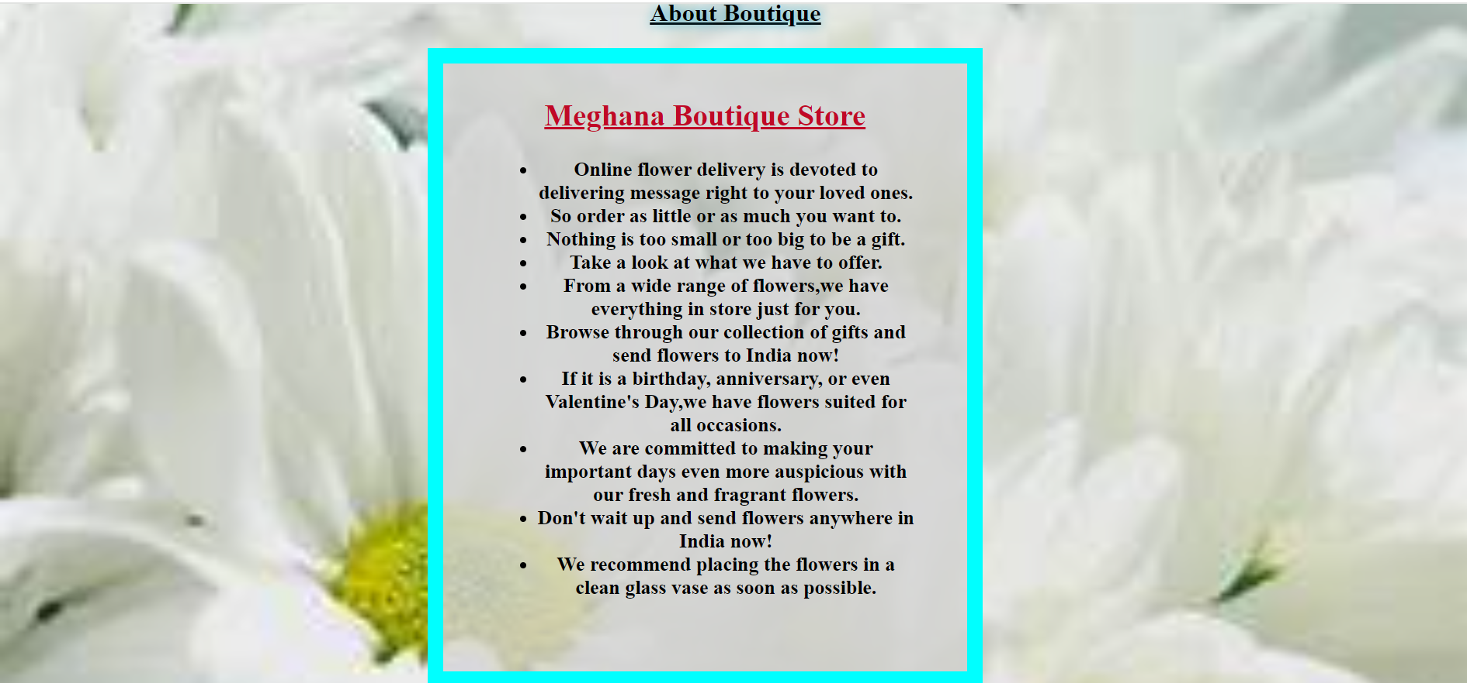

REFERENCE:
- CAD DESK helped us in building this website, they helped us in very single query while this project.
- They guided me in a way to get more innovate and ideology in creating the project.
- They thought us the tools and also in understanding the errors occurrence.

CONCLUSION:
A florist shop is a retail establishment that sells cut flowers and ornamental plants. The floral trade involves activities such as flower care, flower arranging, floral design, merchandising, and often flower delivery. But before submerging the flowers, cut the stems from below at a 45-degree angle as it helps the flower to soak water more easily,Once the flowers are submerged, keep them away from hot and windy areas as these conditions make the flowers wilt faster. Change the water as needed to prolong life. Florist shops are an ever popular industry and one of the most searched guides on our website. As such, we want to provide you with a current industry overview, trends and challenges as well as provide some research resources for those interested in the florist shop business.

THANK YOU….

Contact: 80500 91122
Email: bhaskar@cadenggr.com

