Assignment-3
Topic: AI-Powered Food Waste Prediction & Redistribution System
Name:
Roll no:
1. Introduction
The AI-Powered Food Waste Prediction & Redistribution System is a data science project that forecasts how much food each store is likely to waste and then decides where the recoverable surplus should be sent. Retail outlets, restaurants, bakeries and hotels routinely overstock perishable items such as cooked meals, bread, vegetables and dairy, and the unsold portion is thrown away while nearby food banks and NGOs still have unmet demand. Instead of reacting after the food has already spoiled, the system predicts the waste one day ahead for every store and food category, so that action can be taken in time.
The project combines a machine learning forecasting model (to predict waste in kilograms from sales, calendar and weather patterns), an optimization layer (to match the predicted surplus with NGOs based on distance, capacity and food type), and an interactive dashboard on top. The data covers 87,720 daily records from 15 stores across 8 food categories over two years, and the full pipeline runs from raw data to a ready-to-use pickup plan.
2. Tools and Technologies Used
The sections below describe not what each tool is, but specifically how it was applied inside this project.
2.1 Python, Pandas and NumPy (Data Preparation)
Python is the language used for the entire pipeline. Pandas and NumPy were used to build the dataset (store, category, date, temperature, rainfall, holiday flag, weekend flag, promotion flag, footfall, shelf life, stocked quantity and the target column waste_kg), to merge the store and category tables, and to check for missing values. They also created the engineered features that carry most of the predictive power: the previous day's waste (lag_1), the waste a week earlier (lag_7), and the rolling 7-day and 28-day averages for every store and category pair. These lag features use only past data, so the model never sees information from the day it is predicting.
2.2 Matplotlib (Exploratory Data Analysis and Evaluation Plots)
Matplotlib produced the exploratory charts that guided feature design: average waste by food category, waste by weekday, total monthly waste and waste by store type. It also produced the evaluation charts, namely the actual versus predicted scatter plot and the ranking of the features that influence waste the most. The category chart showed that short-shelf-life items, especially cooked meals, produce the most waste, which is why the redistribution step treats them with stricter rules.
2.3 Scikit-learn (Forecasting Models)
Scikit-learn was used to train and compare three approaches: a simple baseline that predicts the 7-day average, a Random Forest Regressor with 200 trees, and a HistGradientBoostingRegressor. The data was split by time rather than randomly, with the first 20 months used for training and the final four months (from 1 September 2024) kept for testing, which mimics real use where the model predicts the future from the past. Model quality was measured with Mean Absolute Error (MAE), Root Mean Squared Error (RMSE) and the R² score, and permutation importance was used to explain which inputs drive the predictions. The Gradient Boosting model performed best and was saved with Joblib for reuse.
2.4 SciPy Linear Programming (Redistribution Engine)
Once tomorrow's waste is predicted for every store and category, SciPy's linprog solver (HiGHS method) decides how much food each store should send to each NGO. The problem is modelled as a minimum-cost transportation problem: the supply from each store is limited to its predicted recoverable surplus (80% of predicted waste is assumed to be safe and edible), each NGO has a daily capacity limit, deliveries beyond 15 km are not allowed, and cooked meals can only go to NGOs that accept cooked food and only within 8 km. The distances are calculated with the Haversine formula using store and NGO coordinates. The solver returns the exact quantity to move on every route while keeping travel distance as low as possible.
2.5 Joblib (Model Persistence)
Joblib stores the trained model together with its list of input columns, so the prediction and redistribution step can load it instantly without retraining. This separates the training stage from the daily prediction stage, in the same way a real deployment would.
2.6 Streamlit (Interactive Dashboard)
The dashboard was built with Streamlit and presents the results to a non-technical user. It lets the user choose a date, adjust the recoverable share of waste and the maximum pickup distance, and then shows the predicted waste, the quantity redistributed, the estimated number of meals provided and the CO2 avoided, along with a predicted versus actual chart by category, the pickup plan table and a map of stores and NGOs.
3. Output
The exploratory analysis in Figure 1 shows how waste varies across categories, weekdays, months and store types, and it confirmed that perishable categories and weekends need the most attention.
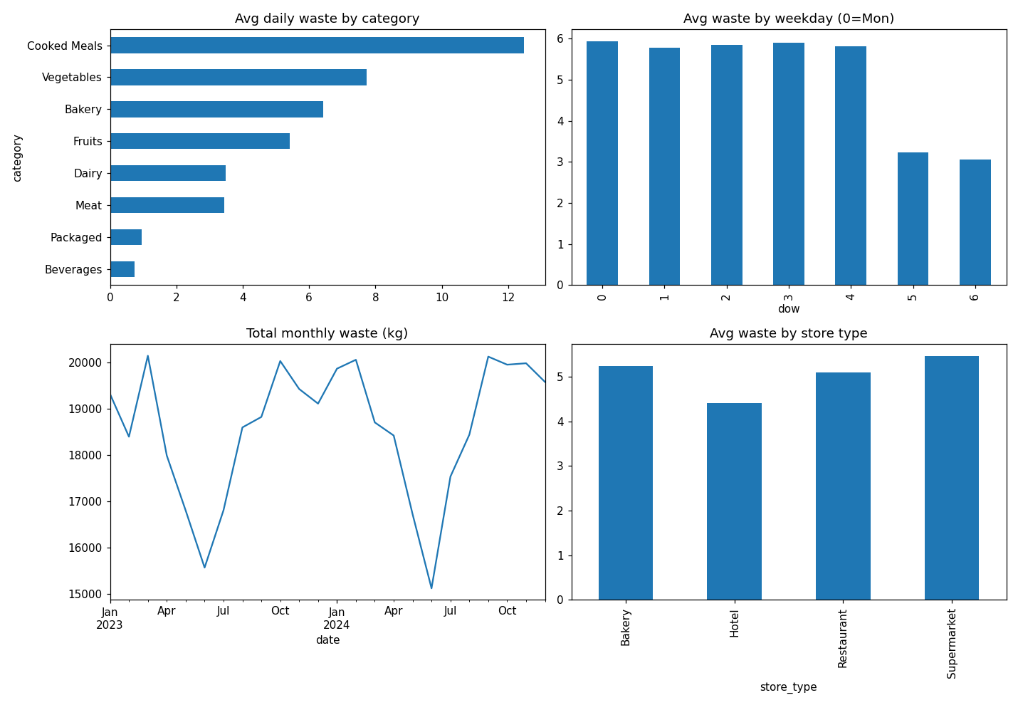
Figure 1: Exploratory data analysis of food waste
Table 1 compares the three models on the unseen test period. The Gradient Boosting model reduced the average error from 4.79 kg to 2.45 kg, an improvement of about 49% over the baseline, and explained 77% of the variation in waste.
Model | MAE (kg) | RMSE (kg) | R² Score
Baseline (7-day average) | 4.789 | 7.088 | 0.194
Random Forest | 2.594 | 4.011 | 0.742
Gradient Boosting (selected) | 2.447 | 3.770 | 0.772
Table 1: Model comparison on the test set
Figure 2 shows the actual versus predicted waste for the selected model, with points close to the diagonal indicating accurate predictions, together with the top factors behind the waste.
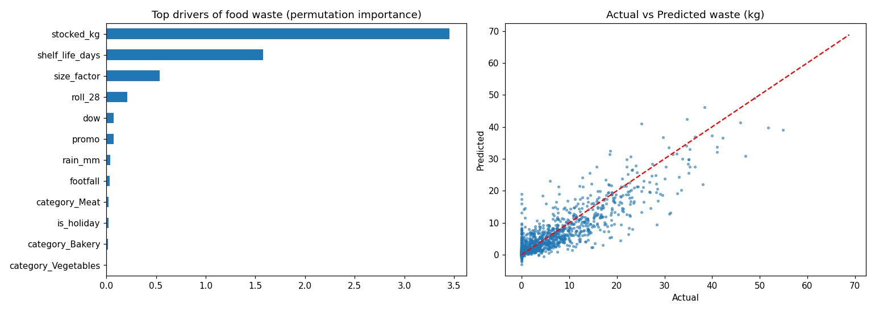
Figure 2: Feature importance and actual versus predicted waste
For the last day in the dataset, the system predicted a recoverable surplus of about 485 kg and planned the redistribution of about 479 kg (99%) to the NGOs, which is roughly 1,200 meals and about 1,200 kg of CO2 avoided under the stated assumptions of 0.4 kg per meal and 2.5 kg of CO2 per kg of food. The largest pickups from the generated plan are shown in Table 2.
Store | Category | NGO | Quantity (kg) | Distance (km)
S09 | Cooked Meals | N4 | 30.3 | 4.4
S04 | Cooked Meals | N3 | 26.2 | 3.8
S09 | Bakery | N7 | 25.6 | 4.2
S03 | Cooked Meals | N8 | 20.7 | 7.9
S13 | Bakery | N5 | 18.3 | 8.9
S01 | Bakery | N2 | 17.9 | 5.2
S10 | Cooked Meals | N3 | 16.8 | 4.9
S11 | Cooked Meals | N8 | 15.2 | 5.9
Table 2: Largest pickup routes in the generated plan
4. Conclusion
The AI-Powered Food Waste Prediction & Redistribution System demonstrates a complete pipeline from raw sales and weather data to an actionable pickup plan: Pandas and engineered lag features prepare the data, a Gradient Boosting model predicts waste with an error about half that of a simple baseline, and a linear programming engine converts those predictions into practical routes between stores and NGOs. The Streamlit dashboard makes the results usable for store managers and food bank coordinators. The result is a system that does not just report how much food was wasted after the fact, but predicts surplus in advance and directs it to the people who need it. The dataset used here is synthetic, so the next step is to retrain the same pipeline on real store data and add multi-stop vehicle routing.

