Screenshots
To run the project double click on “run.bat” file then you will get the below screen
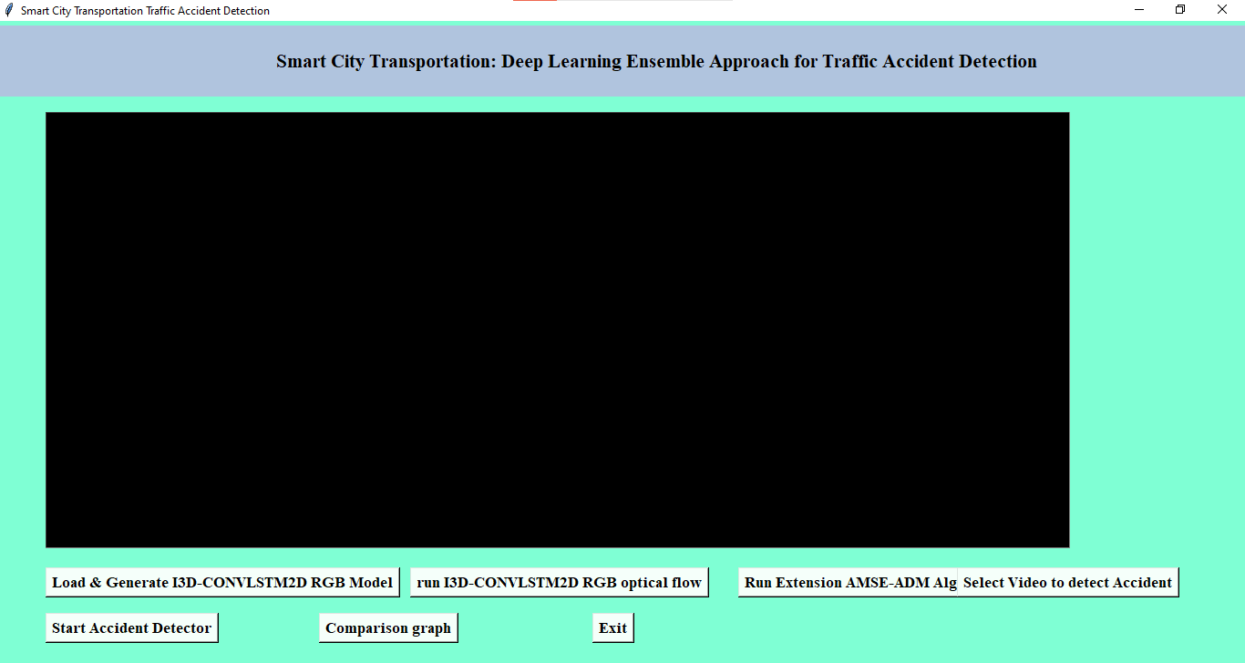

Click on “load & Generate I3D-CONVLSTM2D RGB Model” button to load and Trian the machine. After successfully completion of loading you will get the below screen .
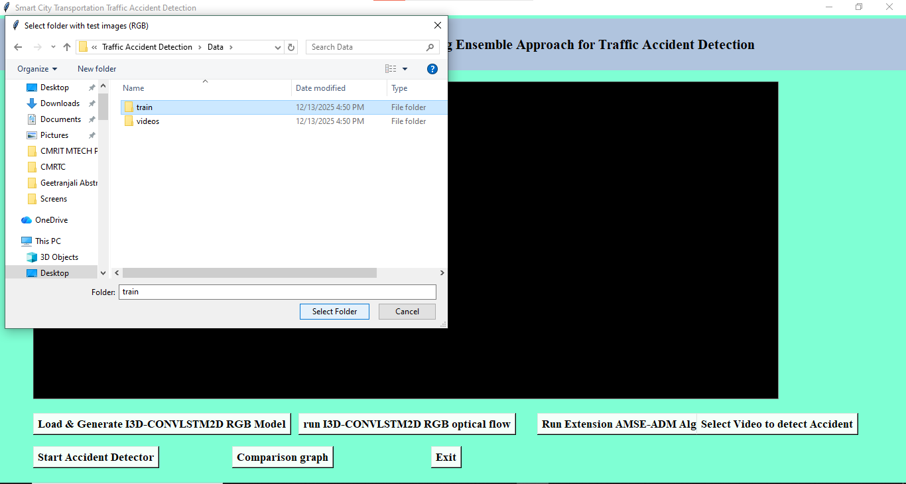

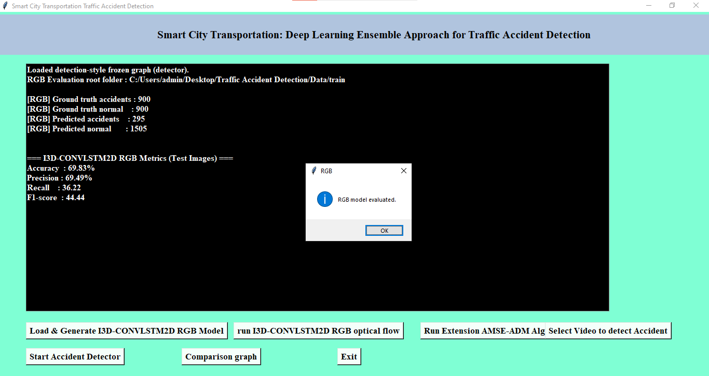
Click on “run I3D-CONVLSTM2D RGB optical flow” to lode this model and you will get the below screen
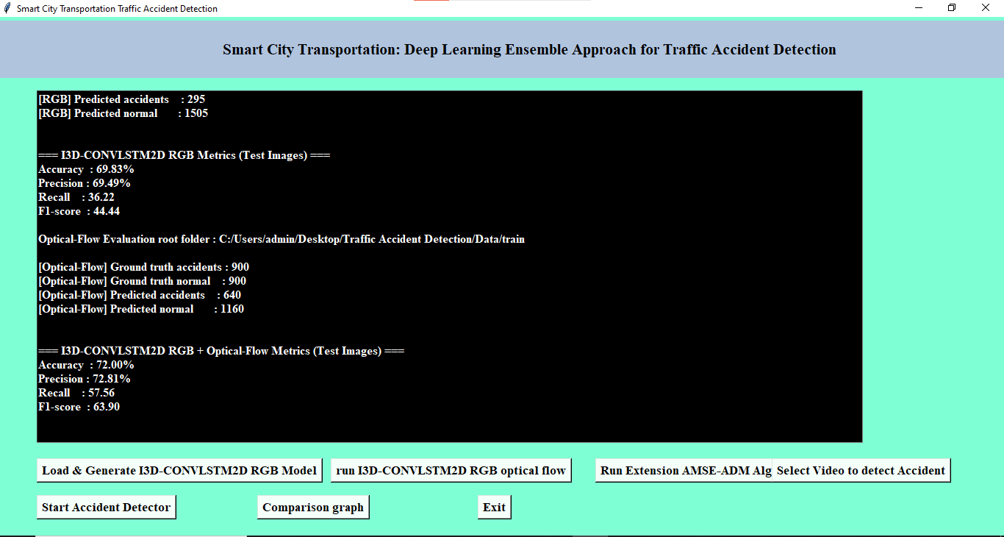

Click on “select video to detect Accident” button to select video to detect whether the accident happened or not in the video. Select the video and open to load the video.

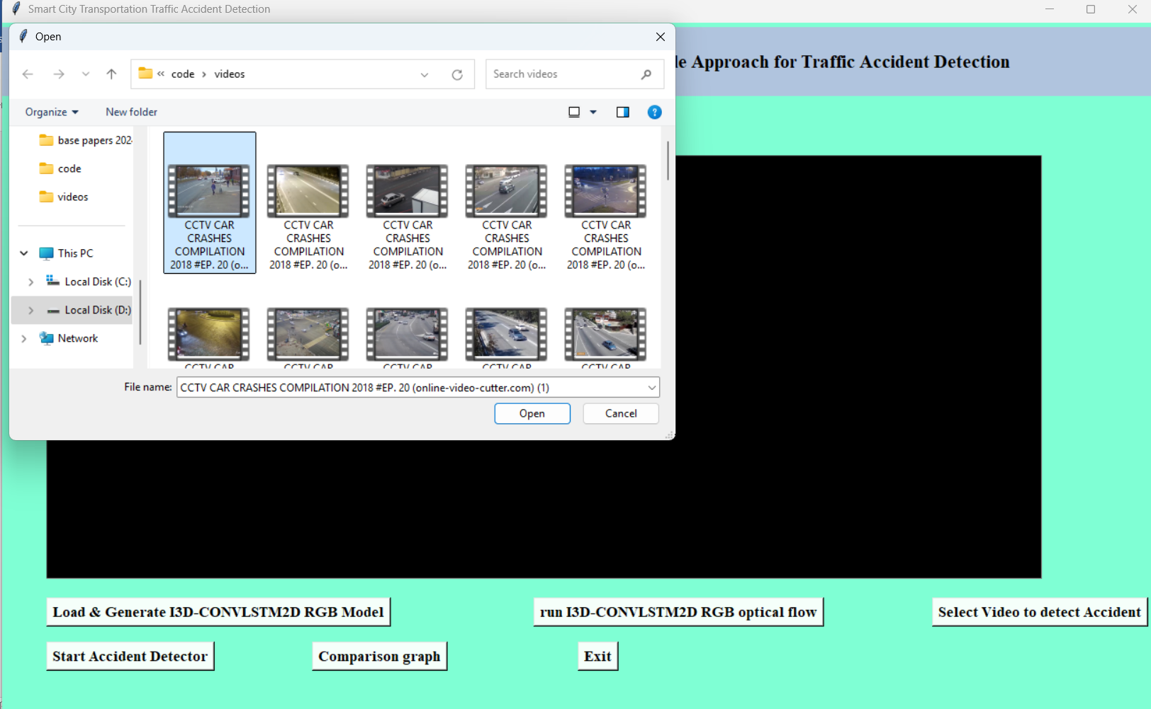

After selecting the video you will get the below screen that the video is successfully loaded
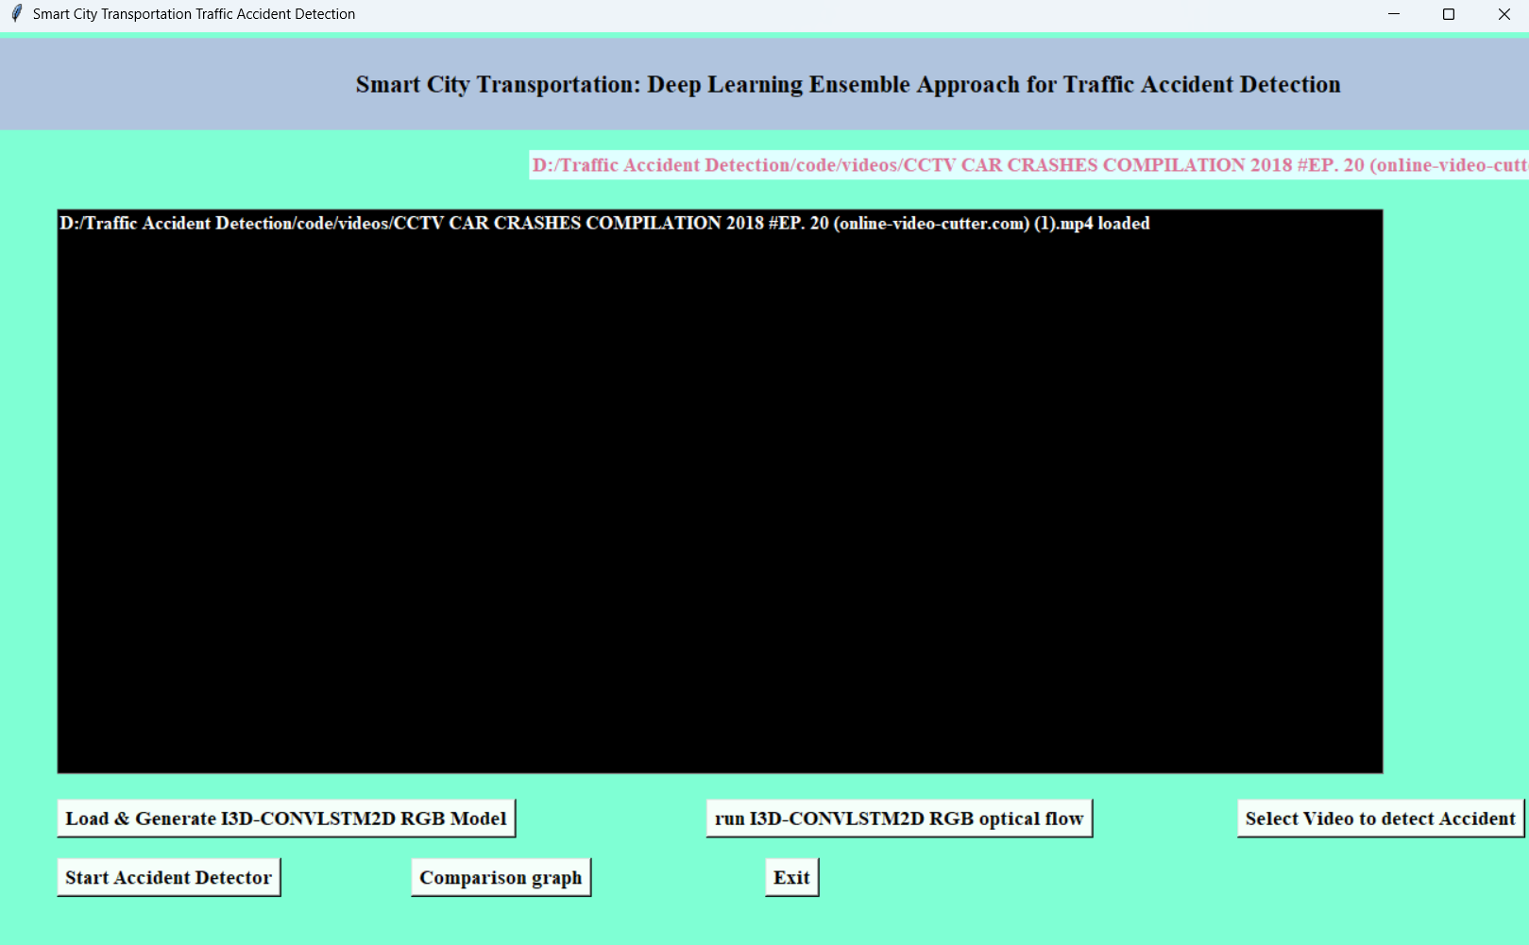

Click on Start Accident Detector to detect the accident. after detecting the accident it will indicates with the beep sound
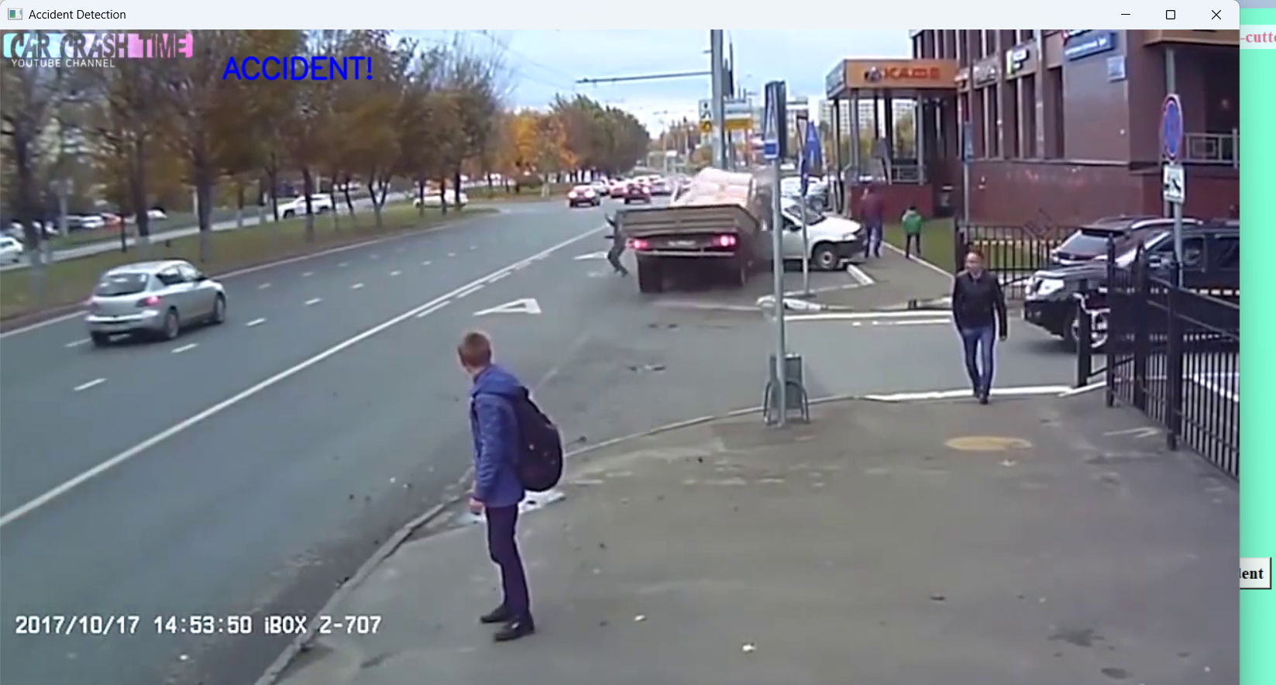

Click on “comparison graph” button to see the comparison graph. Here we are using two algorithms
I3D-CONVLSTM2D and I3D-CONVLSTM2D RGB optical flow. In these algorithms I3D-CONVLSTM2D RGB optical flow had given more accuracy and compiled with less amount of time
