**Create a Spring Web Project using Maven**

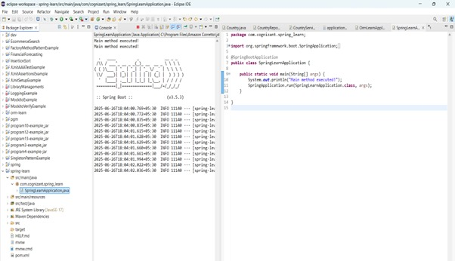

**Spring Core – Load Country from Spring Configuration XML**

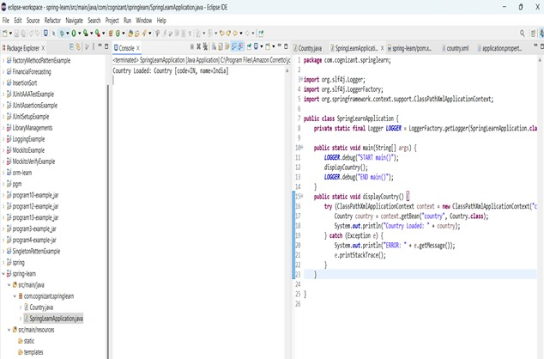

**Hello World RESTful Web Service** 

package com.cognizant.spring_learn.controller;  
  
import org.slf4j.Logger;  
import org.slf4j.LoggerFactory;  
import org.springframework.web.bind.annotation.GetMapping;  
import org.springframework.web.bind.annotation.RestController;  
  
@RestController  
public class HelloController {  
  
 private static final Logger *LOGGER* = LoggerFactory.*getLogger*(HelloController.class);  
  
 @GetMapping("/hello")  
 public String sayHello() {  
 *LOGGER*.info("Start of sayHello()");  
 String response = "Hello World!!";  
 *LOGGER*.info("End of sayHello()");  
 return response;  
 }

}

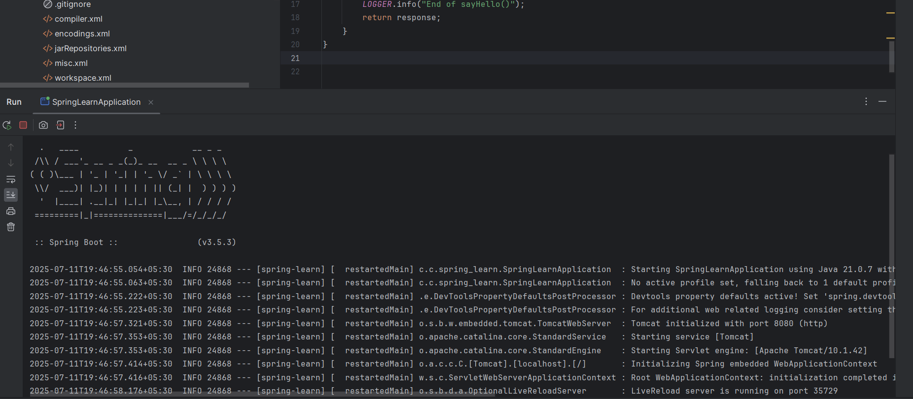

**REST - Country Web Service** 

package com.cognizant.spring_learn.model;  
  
public class Country {  
 private String code;  
 private String name;  
  
 public Country() {}  
  
 public String getCode() {  
 return code;  
 }  
  
 public void setCode(String code) {  
 this.code = code;  
 }  
  
 public String getName() {  
 return name;  
 }  
  
 public void setName(String name) {  
 this.name = name;  
 }  
}

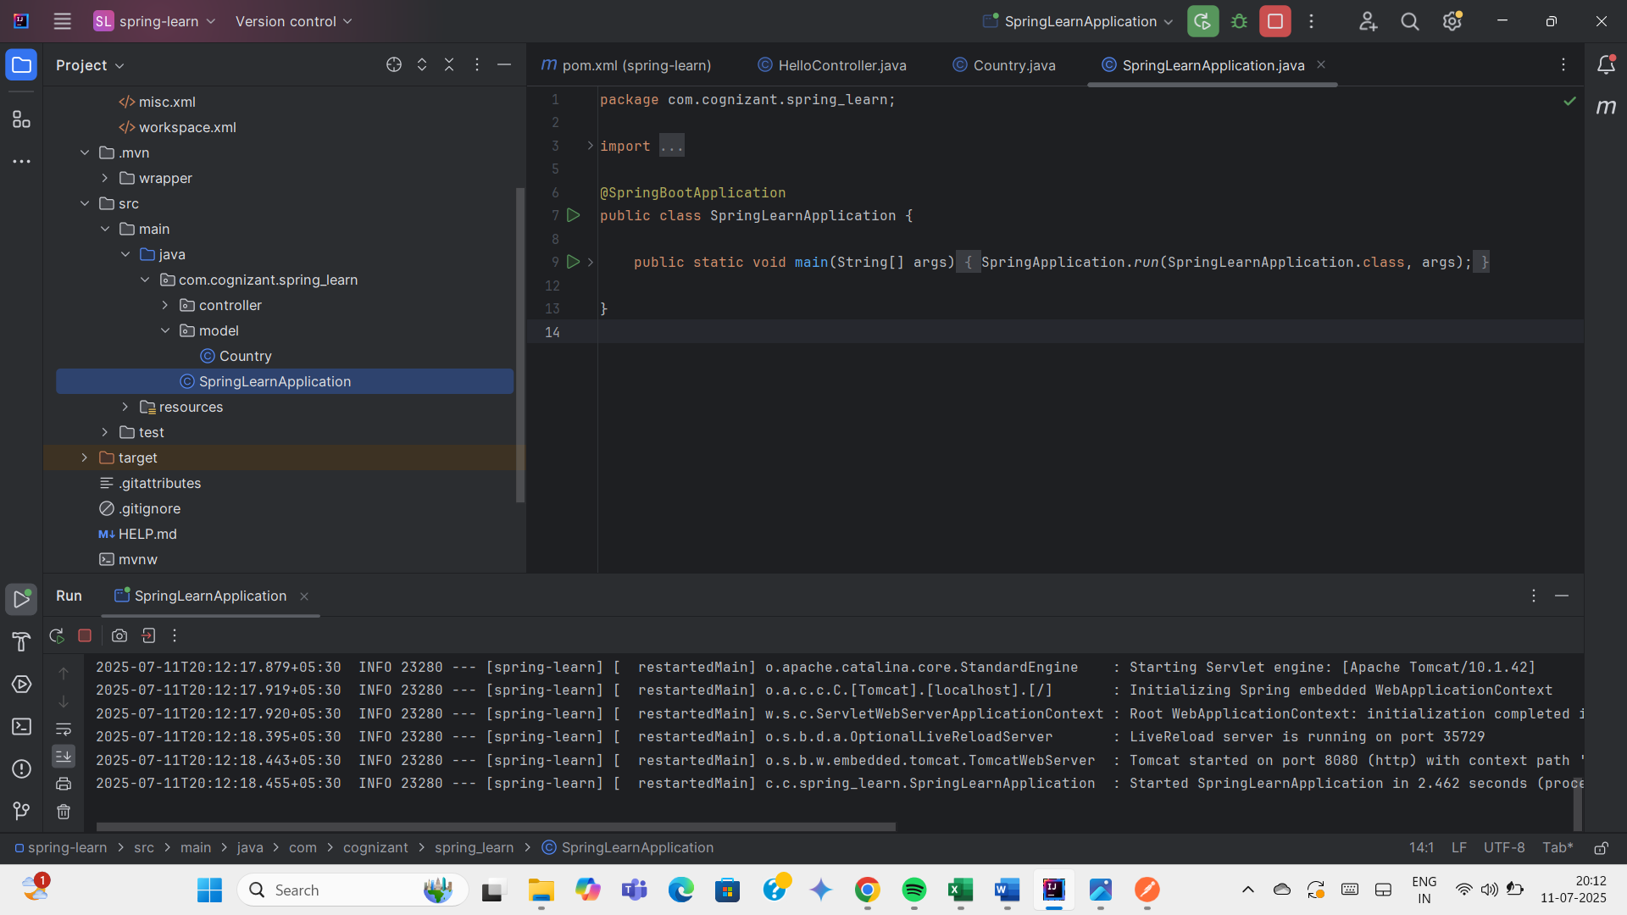

**REST - Get country based on country code** 

<?xml version="1.0" encoding="UTF-8"?>  
<beans xmlns="http://www.springframework.org/schema/beans"  
 xmlns:xsi="http://www.w3.org/2001/XMLSchema-instance"  
 xsi:schemaLocation="  
 http://www.springframework.org/schema/beans  
 http://www.springframework.org/schema/beans/spring-beans.xsd">  
  
 <bean id="countryList" class="java.util.ArrayList">  
 <constructor-arg>  
 <list>  
 <bean class="com.cognizant.spring_learn.model.Country">  
 <property name="code" value="IN"/>  
 <property name="name" value="India"/>  
 </bean>  
 <bean class="com.cognizant.spring_learn.model.Country">  
 <property name="code" value="US"/>  
 <property name="name" value="United States"/>  
 </bean>  
 <bean class="com.cognizant.spring_learn.model.Country">  
 <property name="code" value="UK"/>  
 <property name="name" value="United Kingdom"/>  
 </bean>  
 </list>  
 </constructor-arg>  
 </bean>  
</beans>

package com.cognizant.spring_learn.service;

import com.cognizant.spring_learn.model.Country;

import org.springframework.context.support.ClassPathXmlApplicationContext;

import org.springframework.stereotype.Service;

import java.util.List;

@Service

public class CountryService {

public Country getCountry(String code) {

ClassPathXmlApplicationContext context = new ClassPathXmlApplicationContext("country.xml");

List<Country> countryList = (List<Country>) context.getBean("countryList");

// Case-insensitive matching using lambda

Country result = countryList.stream()

.filter(country -> country.getCode().equalsIgnoreCase(code))

.findFirst()

.orElse(null);

context.close();

return result;

}

}

**CountryController.java –**

package com.cognizant.spring_learn.controller;

import com.cognizant.spring_learn.model.Country;

import com.cognizant.spring_learn.service.CountryService;

import org.springframework.beans.factory.annotation.Autowired;

import org.springframework.web.bind.annotation.*;

@RestController

public class CountryController {

@Autowired

private CountryService countryService;

@GetMapping("/countries/{code}")

public Country getCountry(@PathVariable String code) {

return countryService.getCountry(code);

}

}

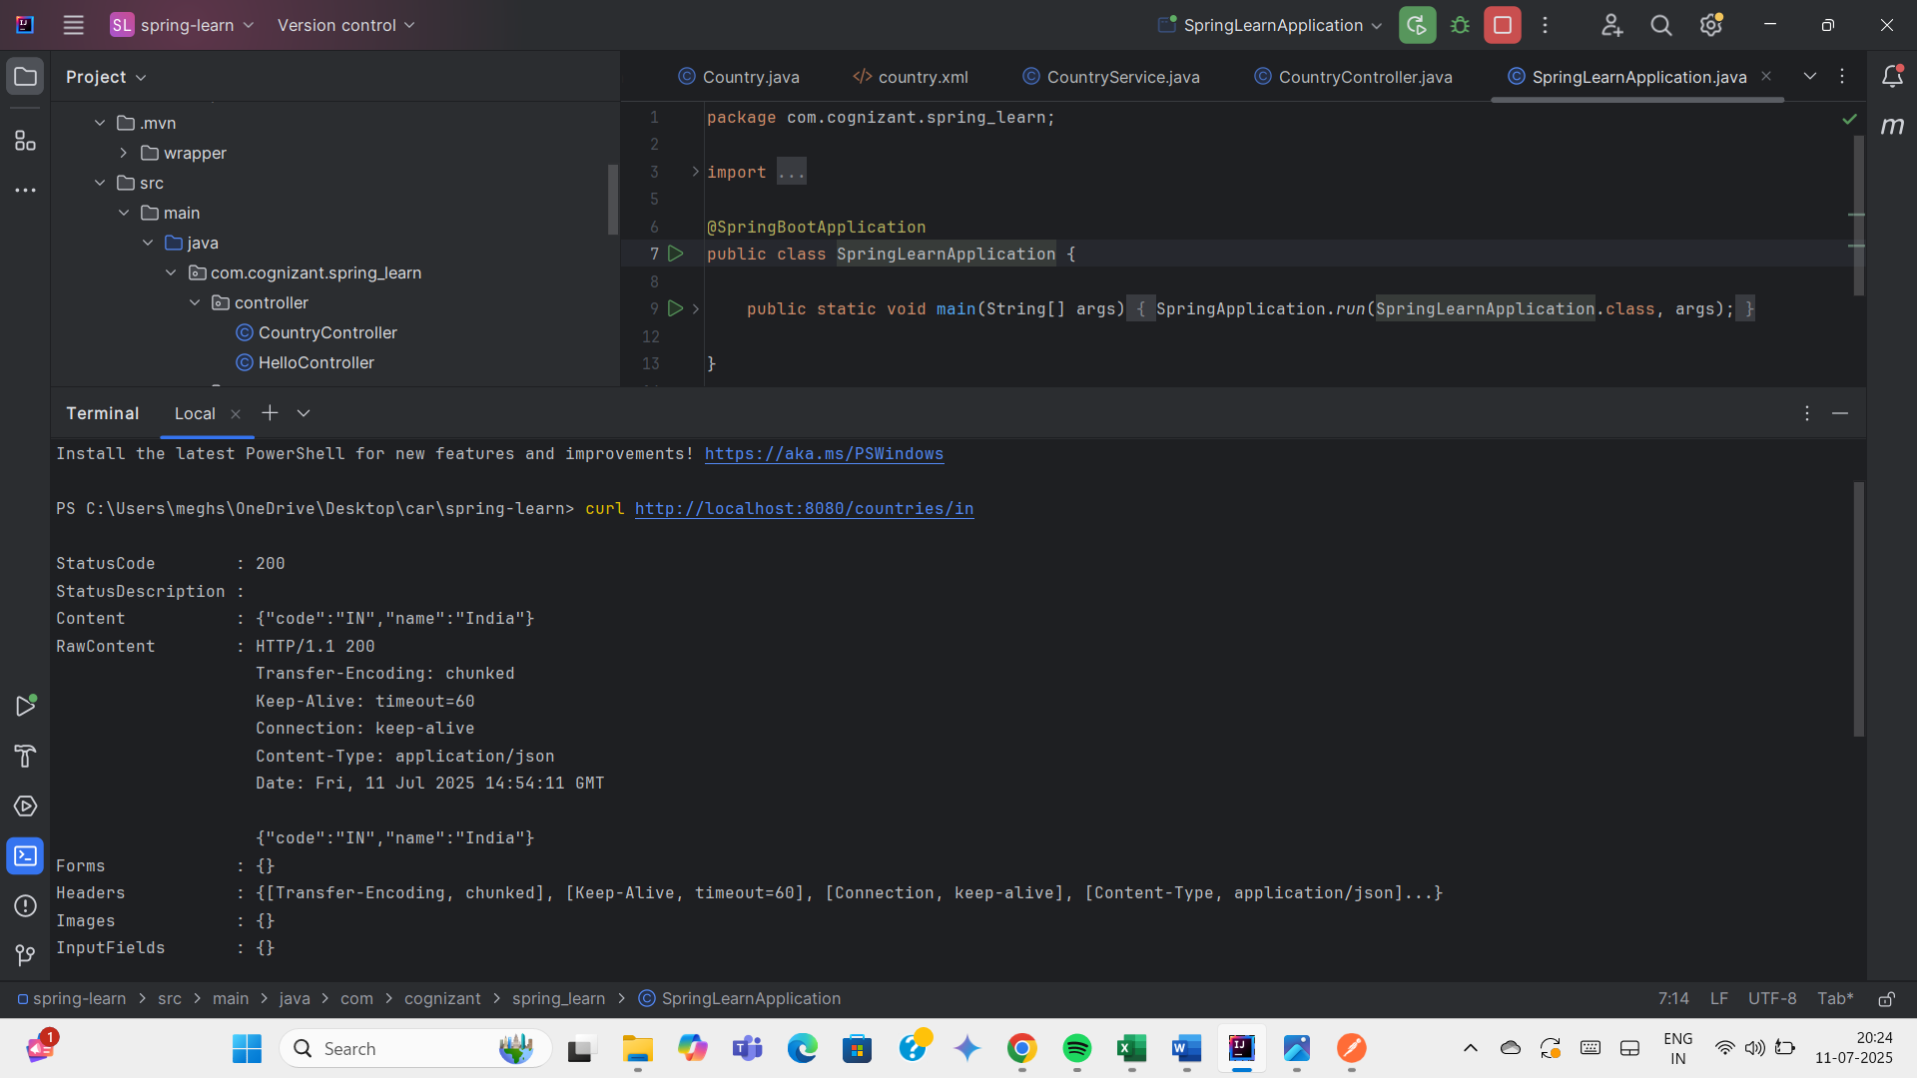

**Create authentication service that returns JWT** 

