**Problem 2: Given below are 2 tables, conversations and messages.**

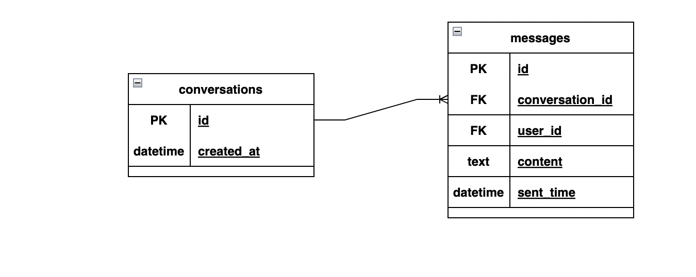

Write a SQL query to:

* Fetch number of first message sent in a conversation in a day. Date range - 1st Jan 2021 to 31st Dec 2021.
* Fetch number of first reply message sent in a conversation in a day. Date range - 1st Jan 2021 to 31st Dec 2021.
* Total conversation with 3 way messaging. 3 way messaging means User1 sent the message, then User2 replied and finally User1 messaged back.

Assume only 2 users are a part of 1 conversation. In the given database:

* conversation_id - ID of each conversation
* user_id - ID of the user who sent the message
* sent_time - Time of message when it was sent
* content - Message/text written by the user

**Solutions:**

* Fetch number of first message sent in a conversation in a day. Date range - 1st Jan 2021 to 31st Dec 2021.

Select * from conversations

Where created_at

Between “01-01-2021” And “31-12-2021”

Group by id

Order by created_at limit1;

* Fetch number of first reply message sent in a conversation in a day. Date range - 1st Jan 2021 to 31st Dec 2021.

Select * from messages

Where sent_time

Between “01-01-2021” And “31-12-2021”

Group by id

Order by sent_time desc limit 1;

* Total conversation with 3 way messaging. 3 way messaging means User1 sent the message, then User2 replied and finally User1 messaged back.

Select c.id, c.created_at,m.userid,m.sent_time

From conversations c

Join messages m

On

c.id=m.conversation_id

group by m.userid;