Tag Management Solutions

Tag:

🡪piece of javascript , sometimes called as pixcel(1x1 transparent image)

🡪It is integrated into web or mobile to perform advertising,live chat,product recommendation

🡪It also collects unique visitor behavior information.

🡪By setting cookies ,it enables tracking and transfer of data.

Tag Management

🡪Collect and move data between website app sessions

🡪Exchange data between website and 3rd party

🡪Control and manage customer data and vendors

🡪any tags can be added or removed via web interface

🡪first party data(behavior and interactions complied on visitors) will be collected and will be used to create customer profile.

🡪Used when there is need for redesigning of websites and when complex enterprise analytic solution such as adobe is used.

Types of Tag Management solutions

1. Adobe Dynamic Tag Management
2. Google Tag Manager
3. Tealium iQ Tag Management
4. Qubit
5. Signal
6. Ensighten

Find which TMS is used in websites

🡪inspect an image in the website

🡪select network tab

🡪type “gtag.js” or “analytics.js” or ”ga.js” in filter

🡪click on source tab to know type of TMS used in that website

1. Google tag manager: gtm

On typing /collect or analytics.js will get gtm.js initiator

1. Adobe dynamic tag management: dtm

On typing analytics.js will get dtm.js initiator or index.js

Open index.js and search for dtm

1. Tealium TMS : utag

On typing /ss will get utag.js initiator

1. [www.uber.com](http://www.uber.com)

Tealium TMS

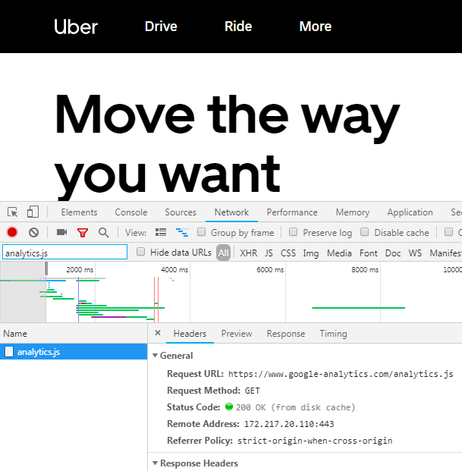

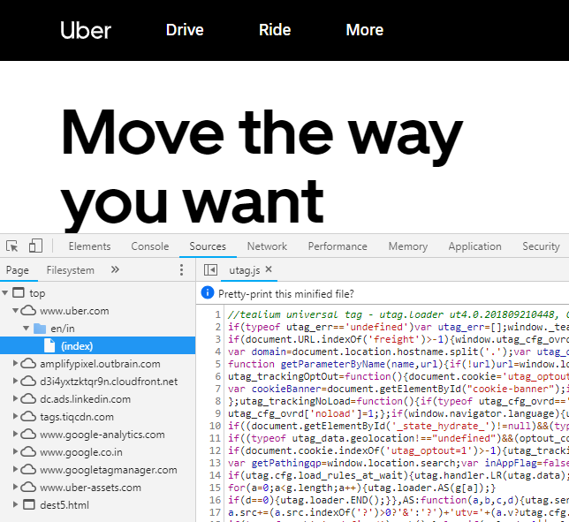

1. [www.upwork.com](http://www.upwork.com)

Google Tag Manager

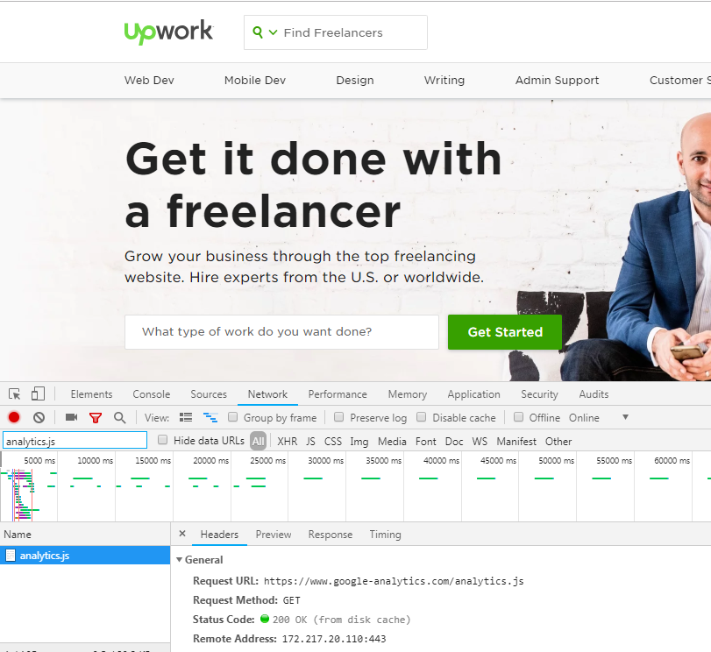

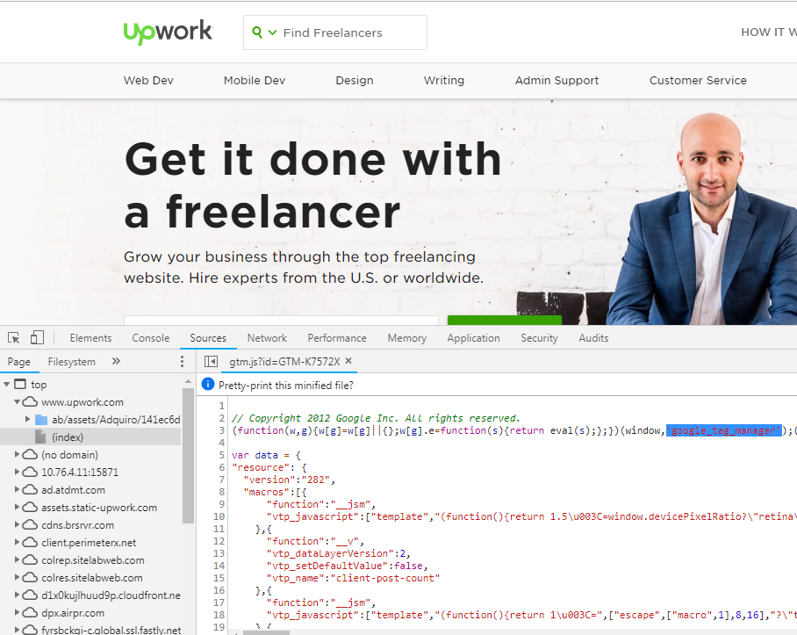

1. [www.geotrust.com](http://www.geotrust.com)

Adobe DTM

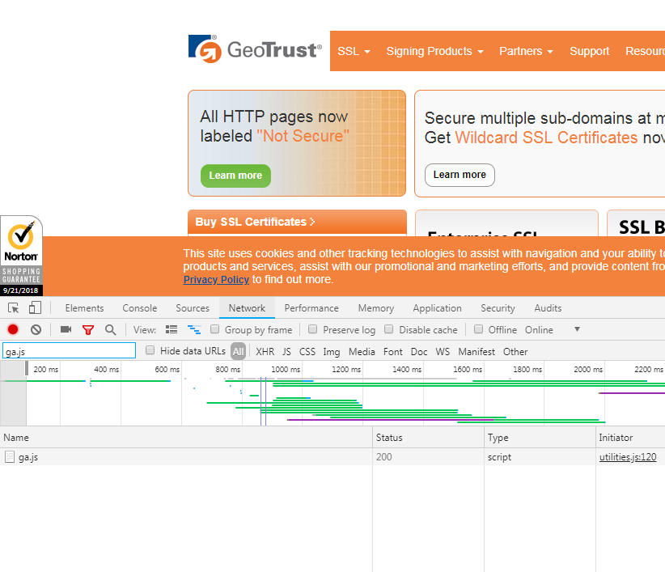

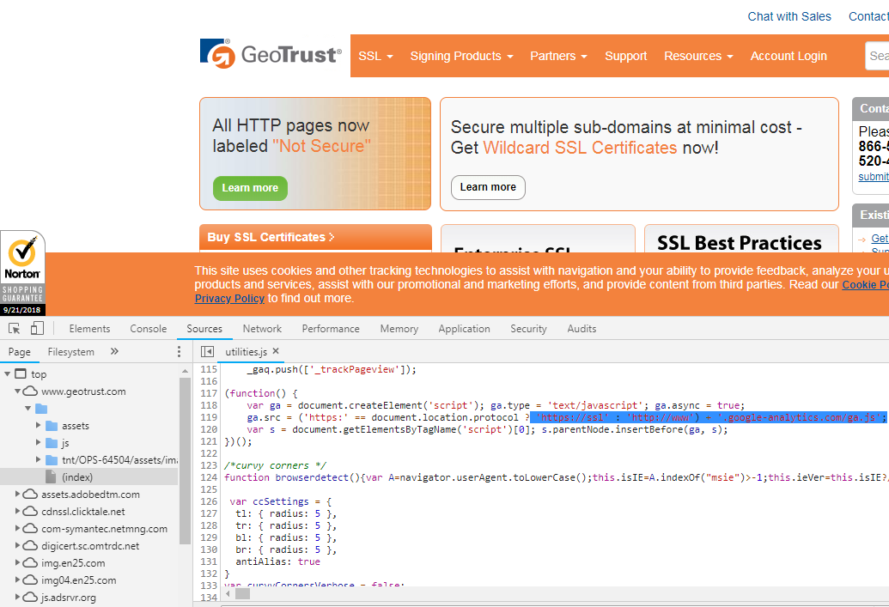

1. [www.qiita.com](http://www.qiita.com)

Google tag manager

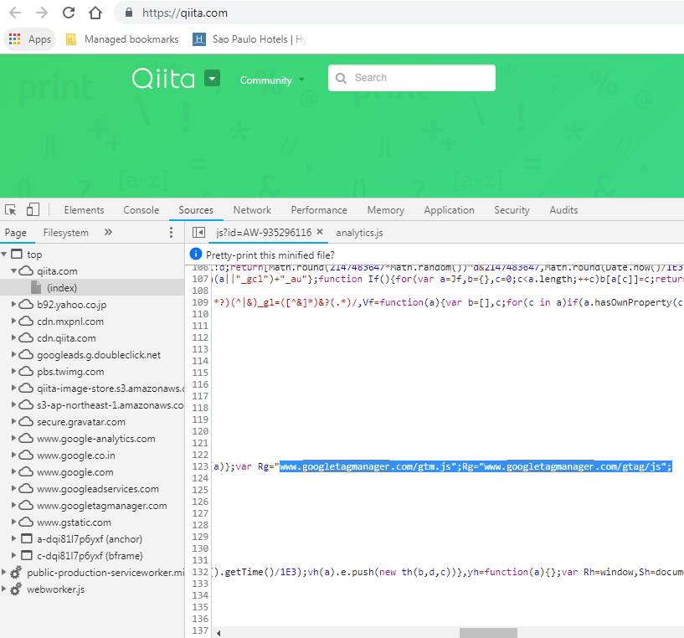

1. [www.adidas.com](http://www.adidas.com)

Tealium TMS

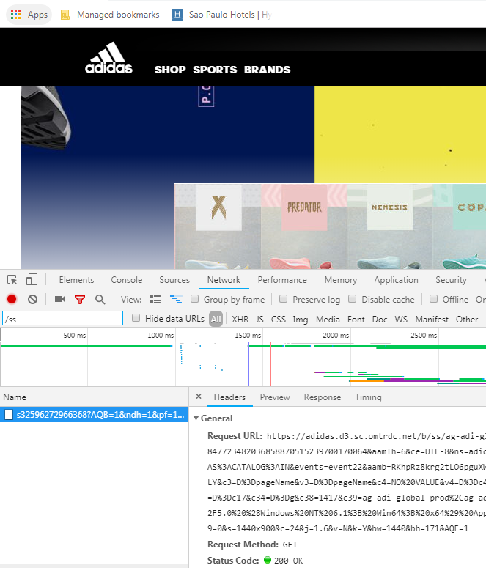

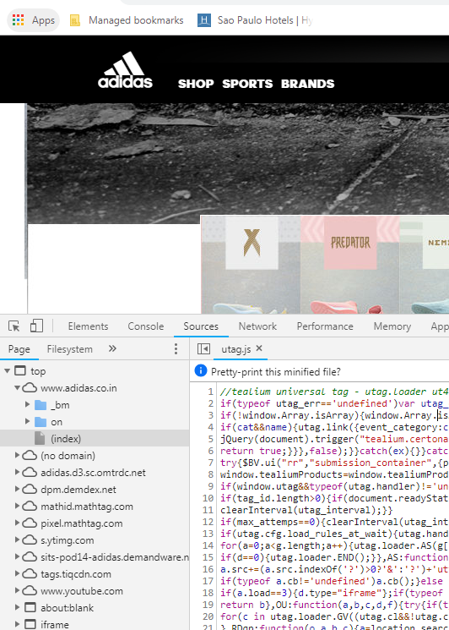

Websites using Adobe DTM

1. www.flipcart.com

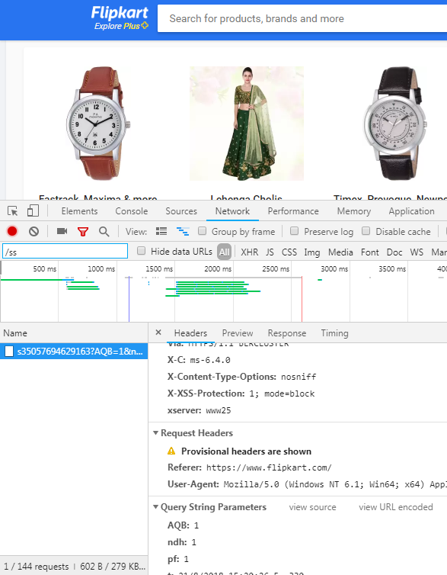

1. [www.pardot.com](http://www.pardot.com)

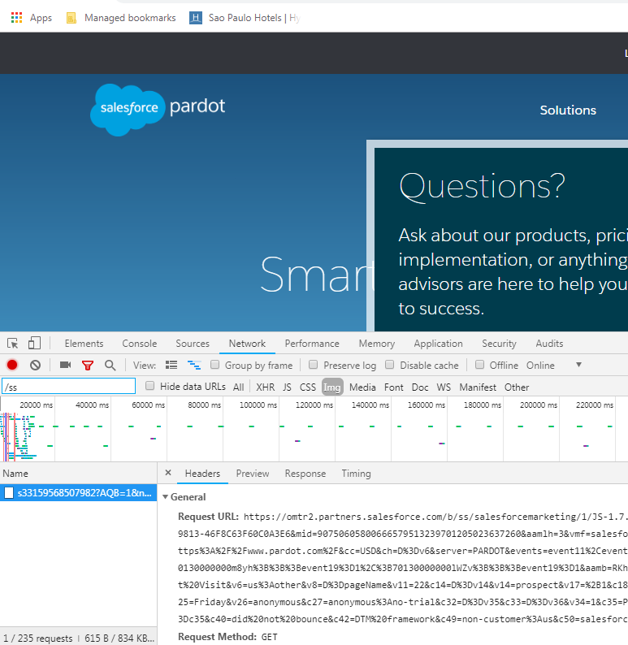

1. [www. quickenloans.com](http://www.wsbradio.com)

