1. Understanding TMS (Console+Source)
2. [www.uber.com](http://www.uber.com)

Tealium

Utag in console

/collect in network tab

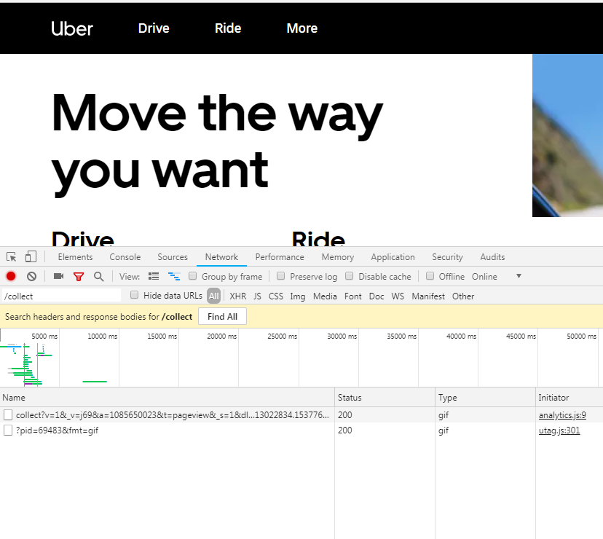

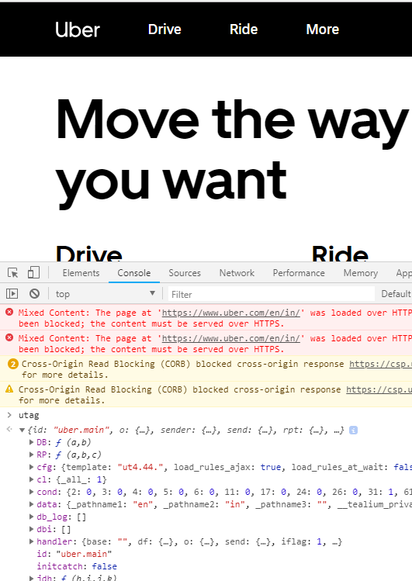

1. [www.qiita.com](http://www.qiita.com)

Google tag manager

/collect in network tab

gtag in console

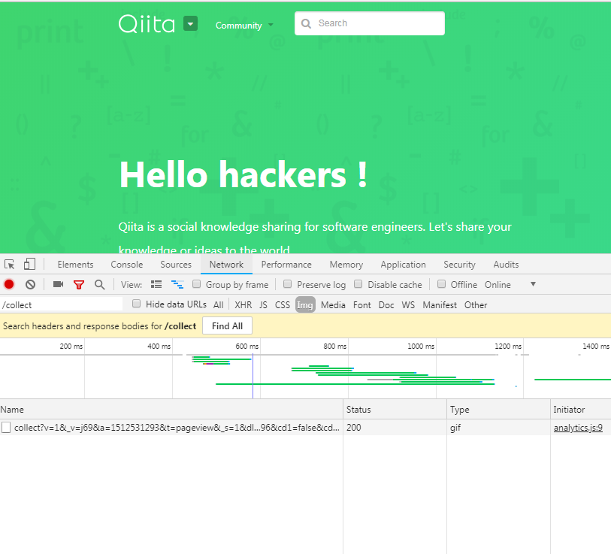

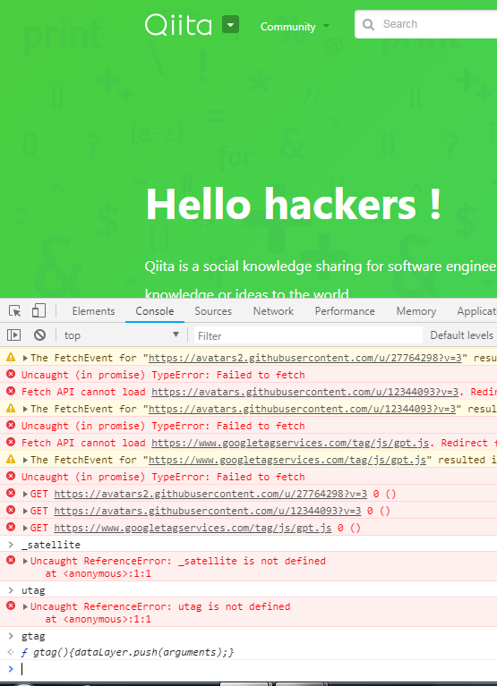

1. [www.flipcart.com](http://www.flipcart.com)

Adobe DTM

b/ss in network tab

s in console

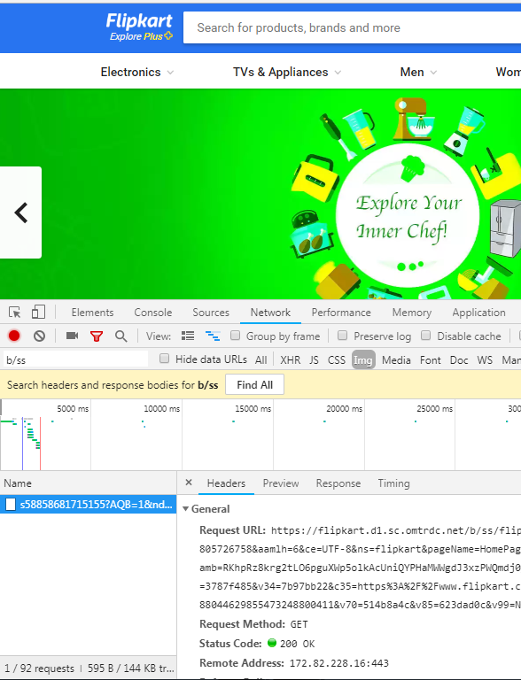

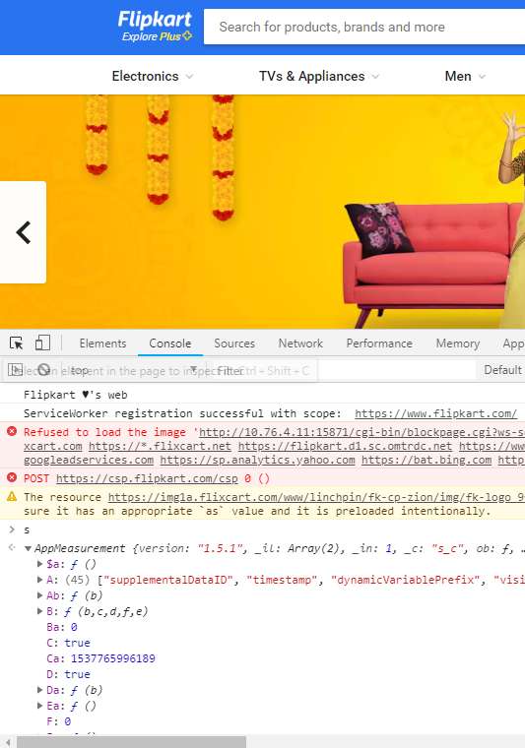

1. [www.familydollar.com](http://www.familydollar.com)

Adobe DTM

/collect in network tab

_satellite in console

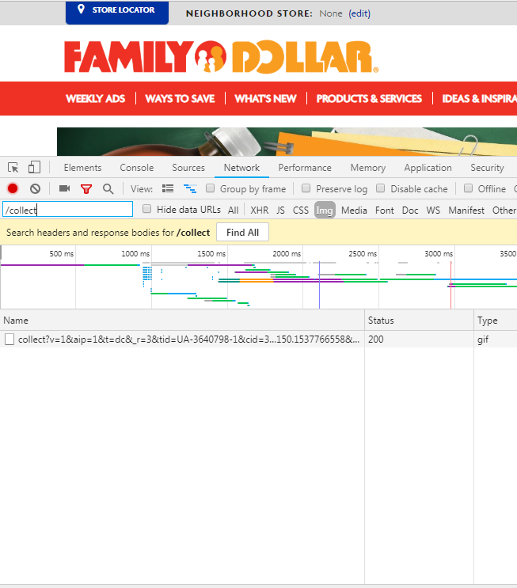

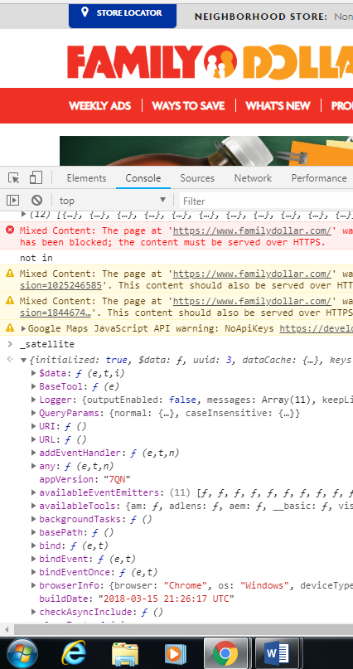

1. [www.quickenloans.com](http://www.quickenloans.com)

Adobe DTM

/ss in netwok tab

_satellite in console

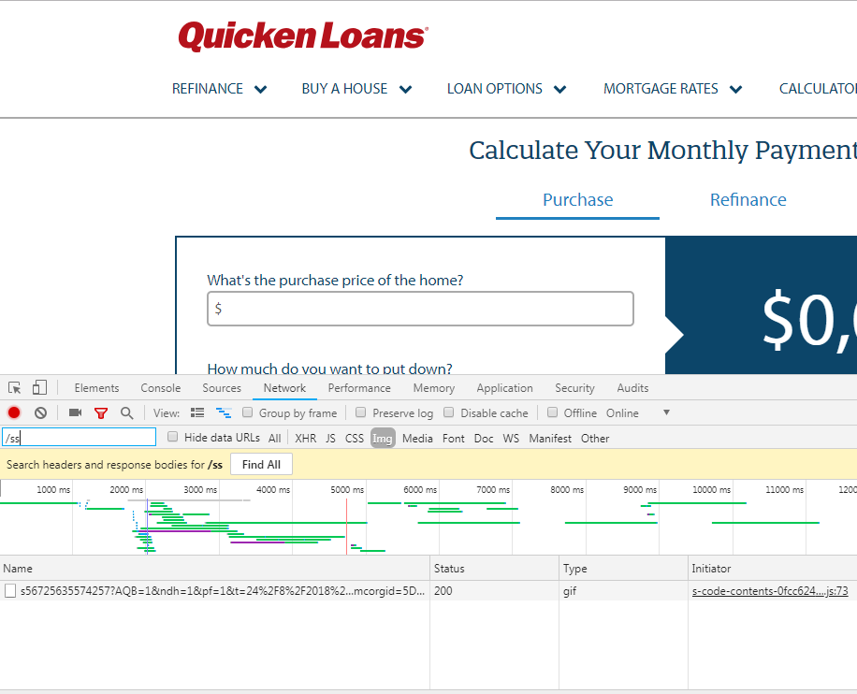

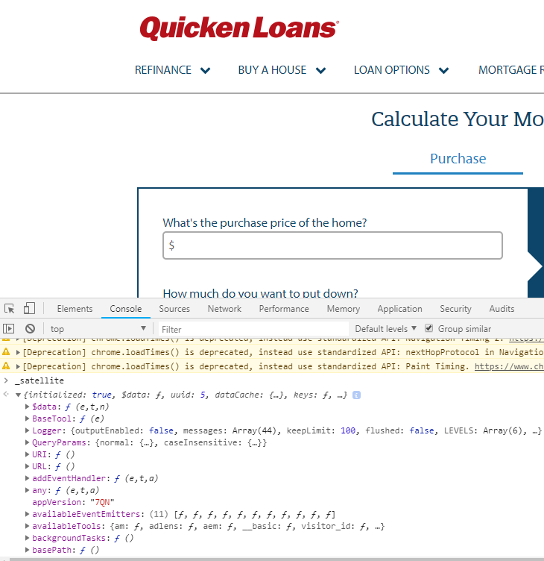

Source code analysis

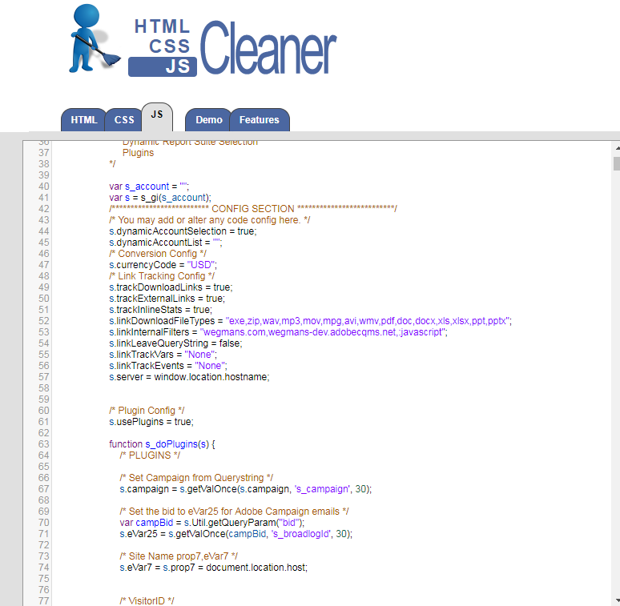

1. [www.w3schools.com](http://www.w3schools.com)

Google Tag Manager

/collect in network tab

google_tag_data in console

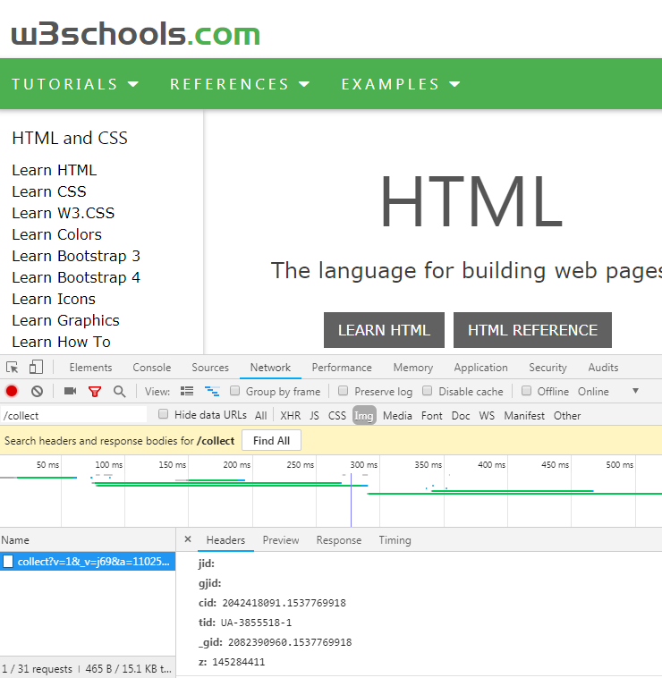

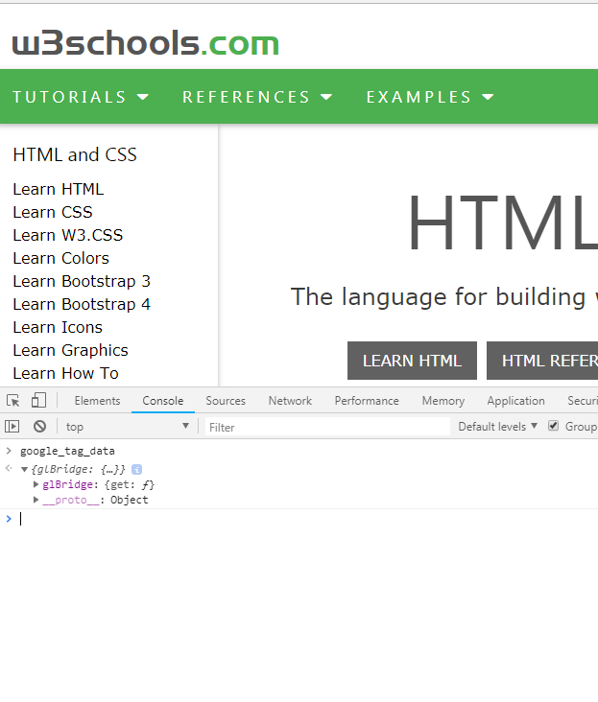

1. [www.stackoverflow.com](http://www.stackoverflow.com)

Google Tag Manager

/collect in network yab

google_tag_data in console

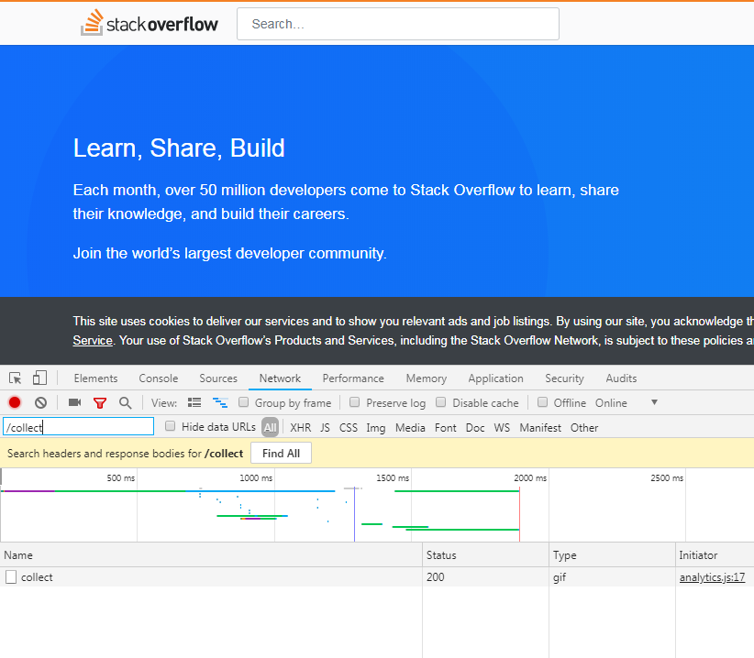

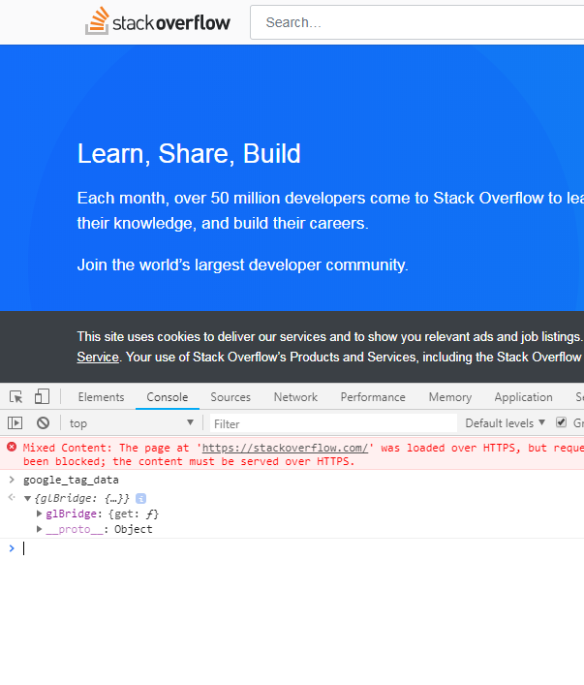

1. [www.adidas.com](http://www.adidas.com)

Tealium tag manager

/ss in network tab

utag in console (s also)

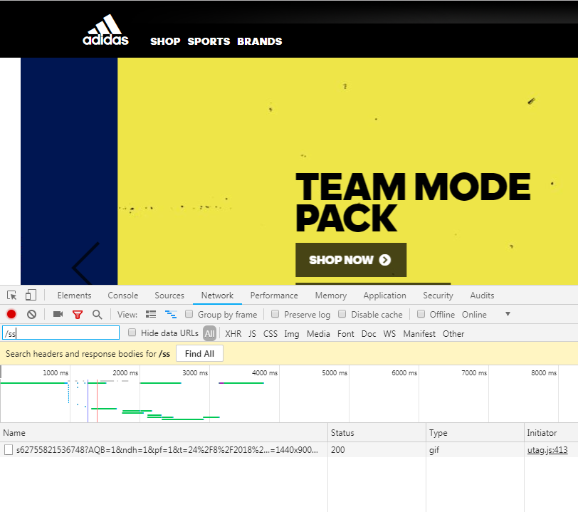

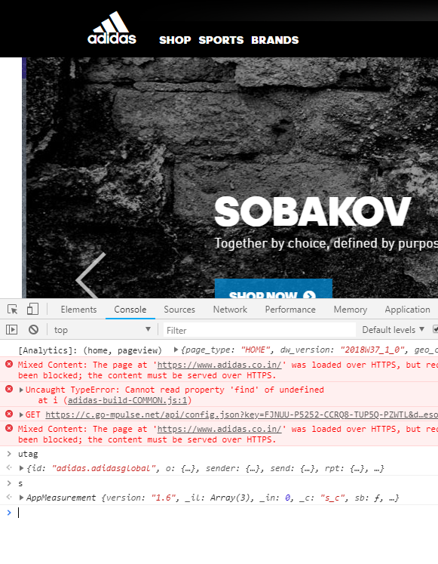

1. [www.mindbodyonline.com](http://www.mindbodyonline.com)

Tealium tag manager

/collect in network tab

utag in console

