Self Hosting Website

1. www.airtelhellotunes.in

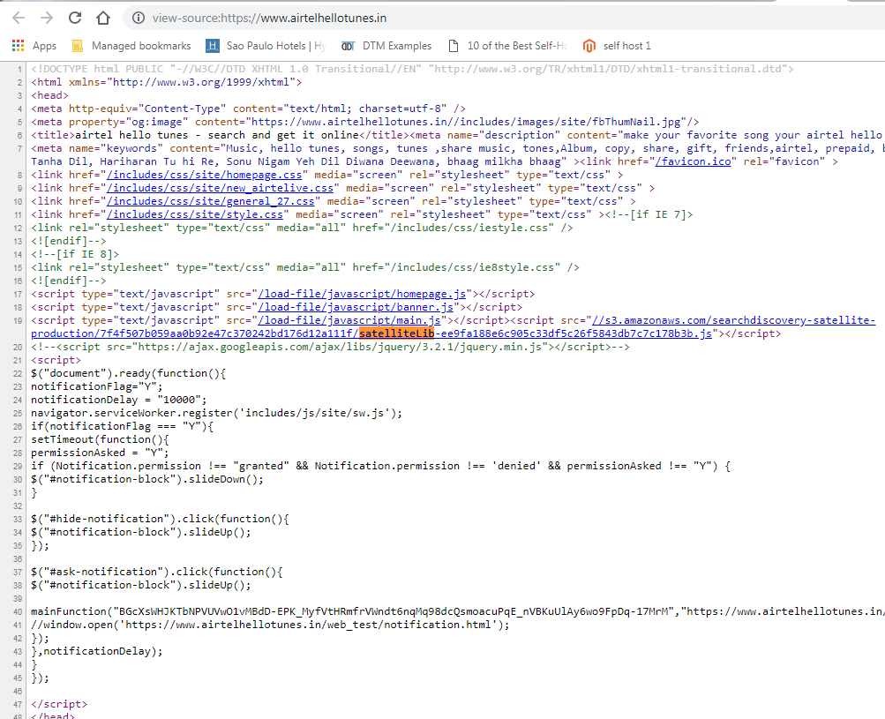

1. [www.foodnetwork.com](http://www.foodnetwork.com)

